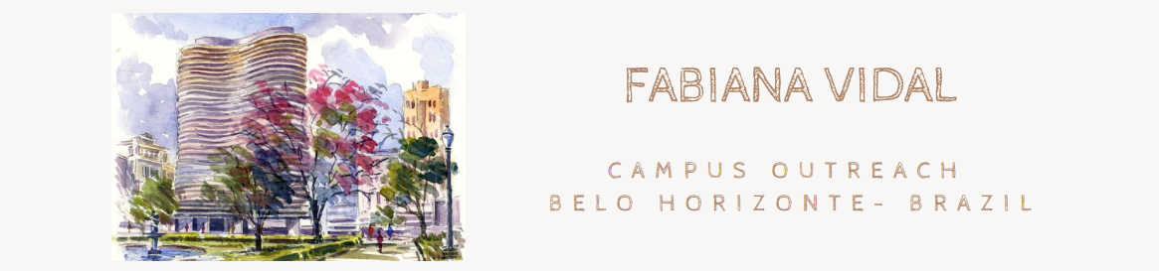
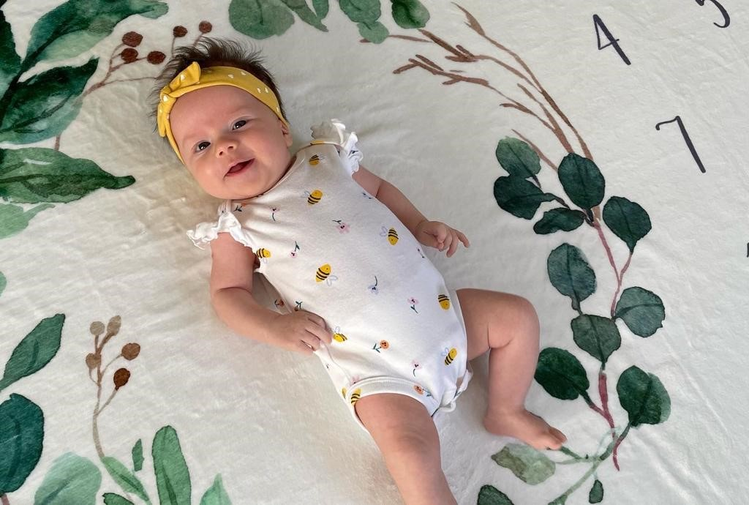

If someone had told me before that motherhood is the hardest thing I will ever do in life, I truly wouldn't have believed it. How naive!

The past two and half months went by fast, but also were extremely slow considering everything that we have been experiencing since Manu was born. It has been a blessing without measure to be parents and we praise God constantly for the miracle that her life is. Manu is a healthy and happy baby, but she doesn't like the Brazilian weather much these days haha.

Although, to be honest with you, it has been a time with so many challenges, fears and a lot of dependency on the Lord. I told a friend the other day that I'm now realizing the true meaning of the word perseverance. Being a mom is an everyday and every hour type of perseverance.
• Perseverance in the Word (to hear God's truth and not my doubts);
• Perseverance in prayer (to rely on Him and bring all my feelings to Him);
• Perseverance in faith (that He is my father, constantly present, He will not abandon me);
• Perseverance in love (He loves and cares for me and that's why I can do the same for my daughter and husband);
• Perseverance in trust (He is enough and is everything that I need daily).
The list could go on and on....

I've been learning so much about my self the past couple months and it hasn't been easy to see my idol of control flowing out of my thoughts and actions as I'm home with a newborn that doesn't have a schedule... because you know, she is not a robot, she is a human (making that affirmation for myself, lol).

I praise God that his mercies are new every morning and I've been fighting to live each day with a gospel perspective and a thankful heart.

"Every good and perfect gift is from above, coming down from the Father of the heavenly lights, who does not change like shifting shadows". James 1:17.

Manu is a gift and I know our Father will continue to enable us to be the parents he called us to be. What a privilege that is!!!

Next month, Diego will complete 10 years as a lawyer. Since the day he finished law school he has been working faithfully to the same law firm. I admire him a lot and he is a good example of perseverance and integrity to me, because it's hard to do things right in Brazil, under the law.

But for the past couple years, he has been questioning his calling and even if law is what he wants to keep doing for long term.

We have been praying a lot the past year... praying for wisdom to discern what is next, for new job opportunities (in the law field or not) and mostly for God's direction.

It's funny how God works sometimes. We wouldn't have chosen this moment of our lives to consider a new job for Diego, but we believe that He has a purpose in all of that.

Diego had a few conversations so far with a mentor to brainstorm about possibilities of what to pursue, to dream about the future and to process what he has been hearing from the Lord. So far, he has been pretty open to whatever God shows, because his biggest desire, and ours as a family, is to glorify God with our lives knowing that his job is a big part of it.

I would love to count with your prayers for our family, specially for Diego's process. We also would love to hear from you if the Lord speaks to you in regards to that. We know you care for us so we are open to hear any thought, advise or words of encouragement.

I've been encourage to see Diego's desire to hear from God, especially knowing that this is not a comfortable place to be.

