"I will build my church" Mt.16:18

In the past few months we have witnessed new disciples baptized and growing in their knowledge of and love for our Savior in the Getsemani congregation. They have also, just recently elected new leaders of the congregation and we are encouraged by the commitment and faithfulness of those that were elected.
The Bible study and Bible club in Calechoso will be put on hold till our return, but the drama/puppet team will be actively seeking opportunities to present the puppets in the city of Zihuatanejo and surrounding areas.
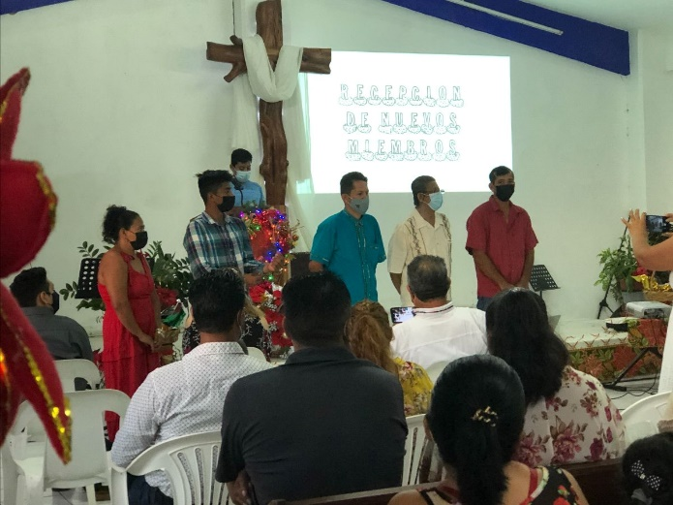
New members of the Getsemani Congregation! The 3 men to the right all had believing spouses that God used along with the ministry of church members and the men's study Guillermo leads.
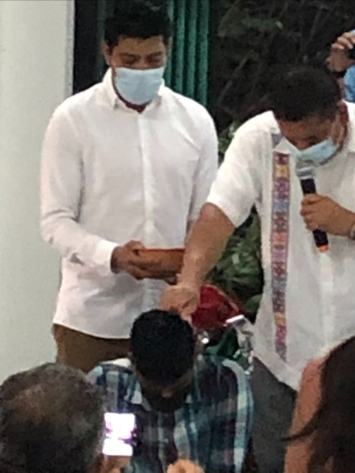
Adan Mendoza the pastor from Acapulco who has oversight of the Getsemani congregation baptizing new believers.
We traded in the 'burrito' for this 'burrari'. We are thankful for God's provision that will allow us to carry at least 12 people and provides a much more comfortable ride than the 'burrito' did!
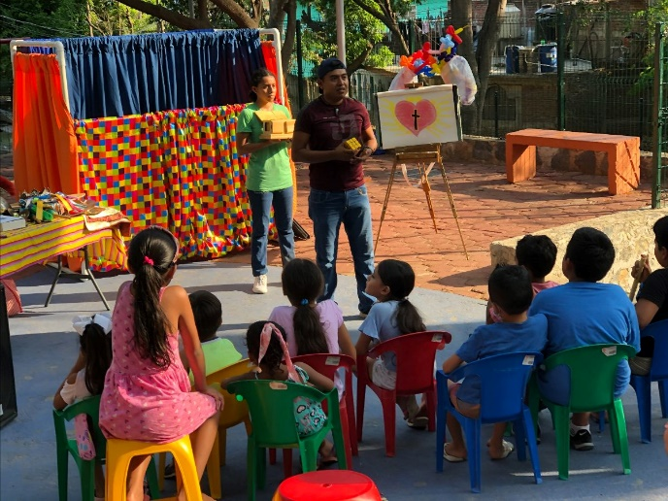
The drama/puppet team had seen the 'troubles of our heart multiplied' because one family in particular in the group is going through great trial and when one suffers, we suffer with them. We pray that 'integrity and uprightness' would protect us because our hope is in the Lord Almighty.
Below are the new leaders of the board of directors and the leaders in music, education and evangelism as they verbally make their commitment to God and the congregation and pray!
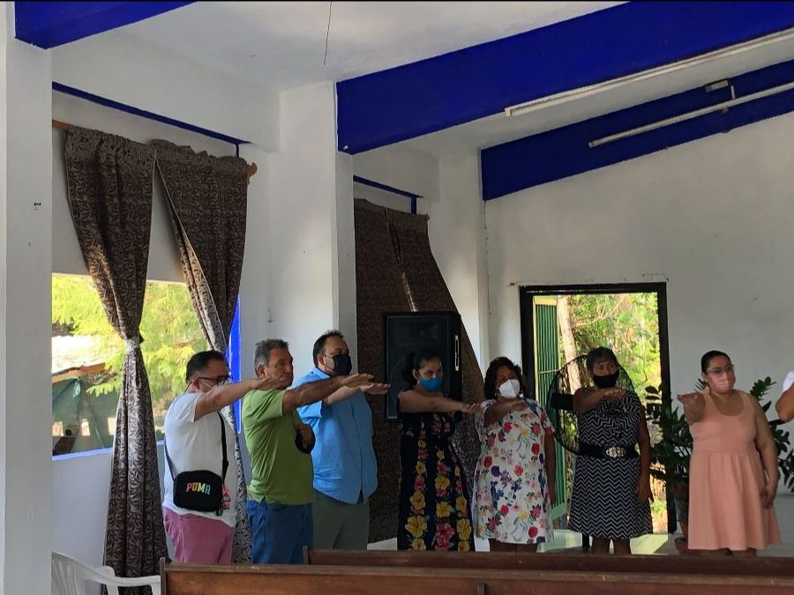
WE GREATLY APPRECIATE YOUR PRAYERS!!!!!!

