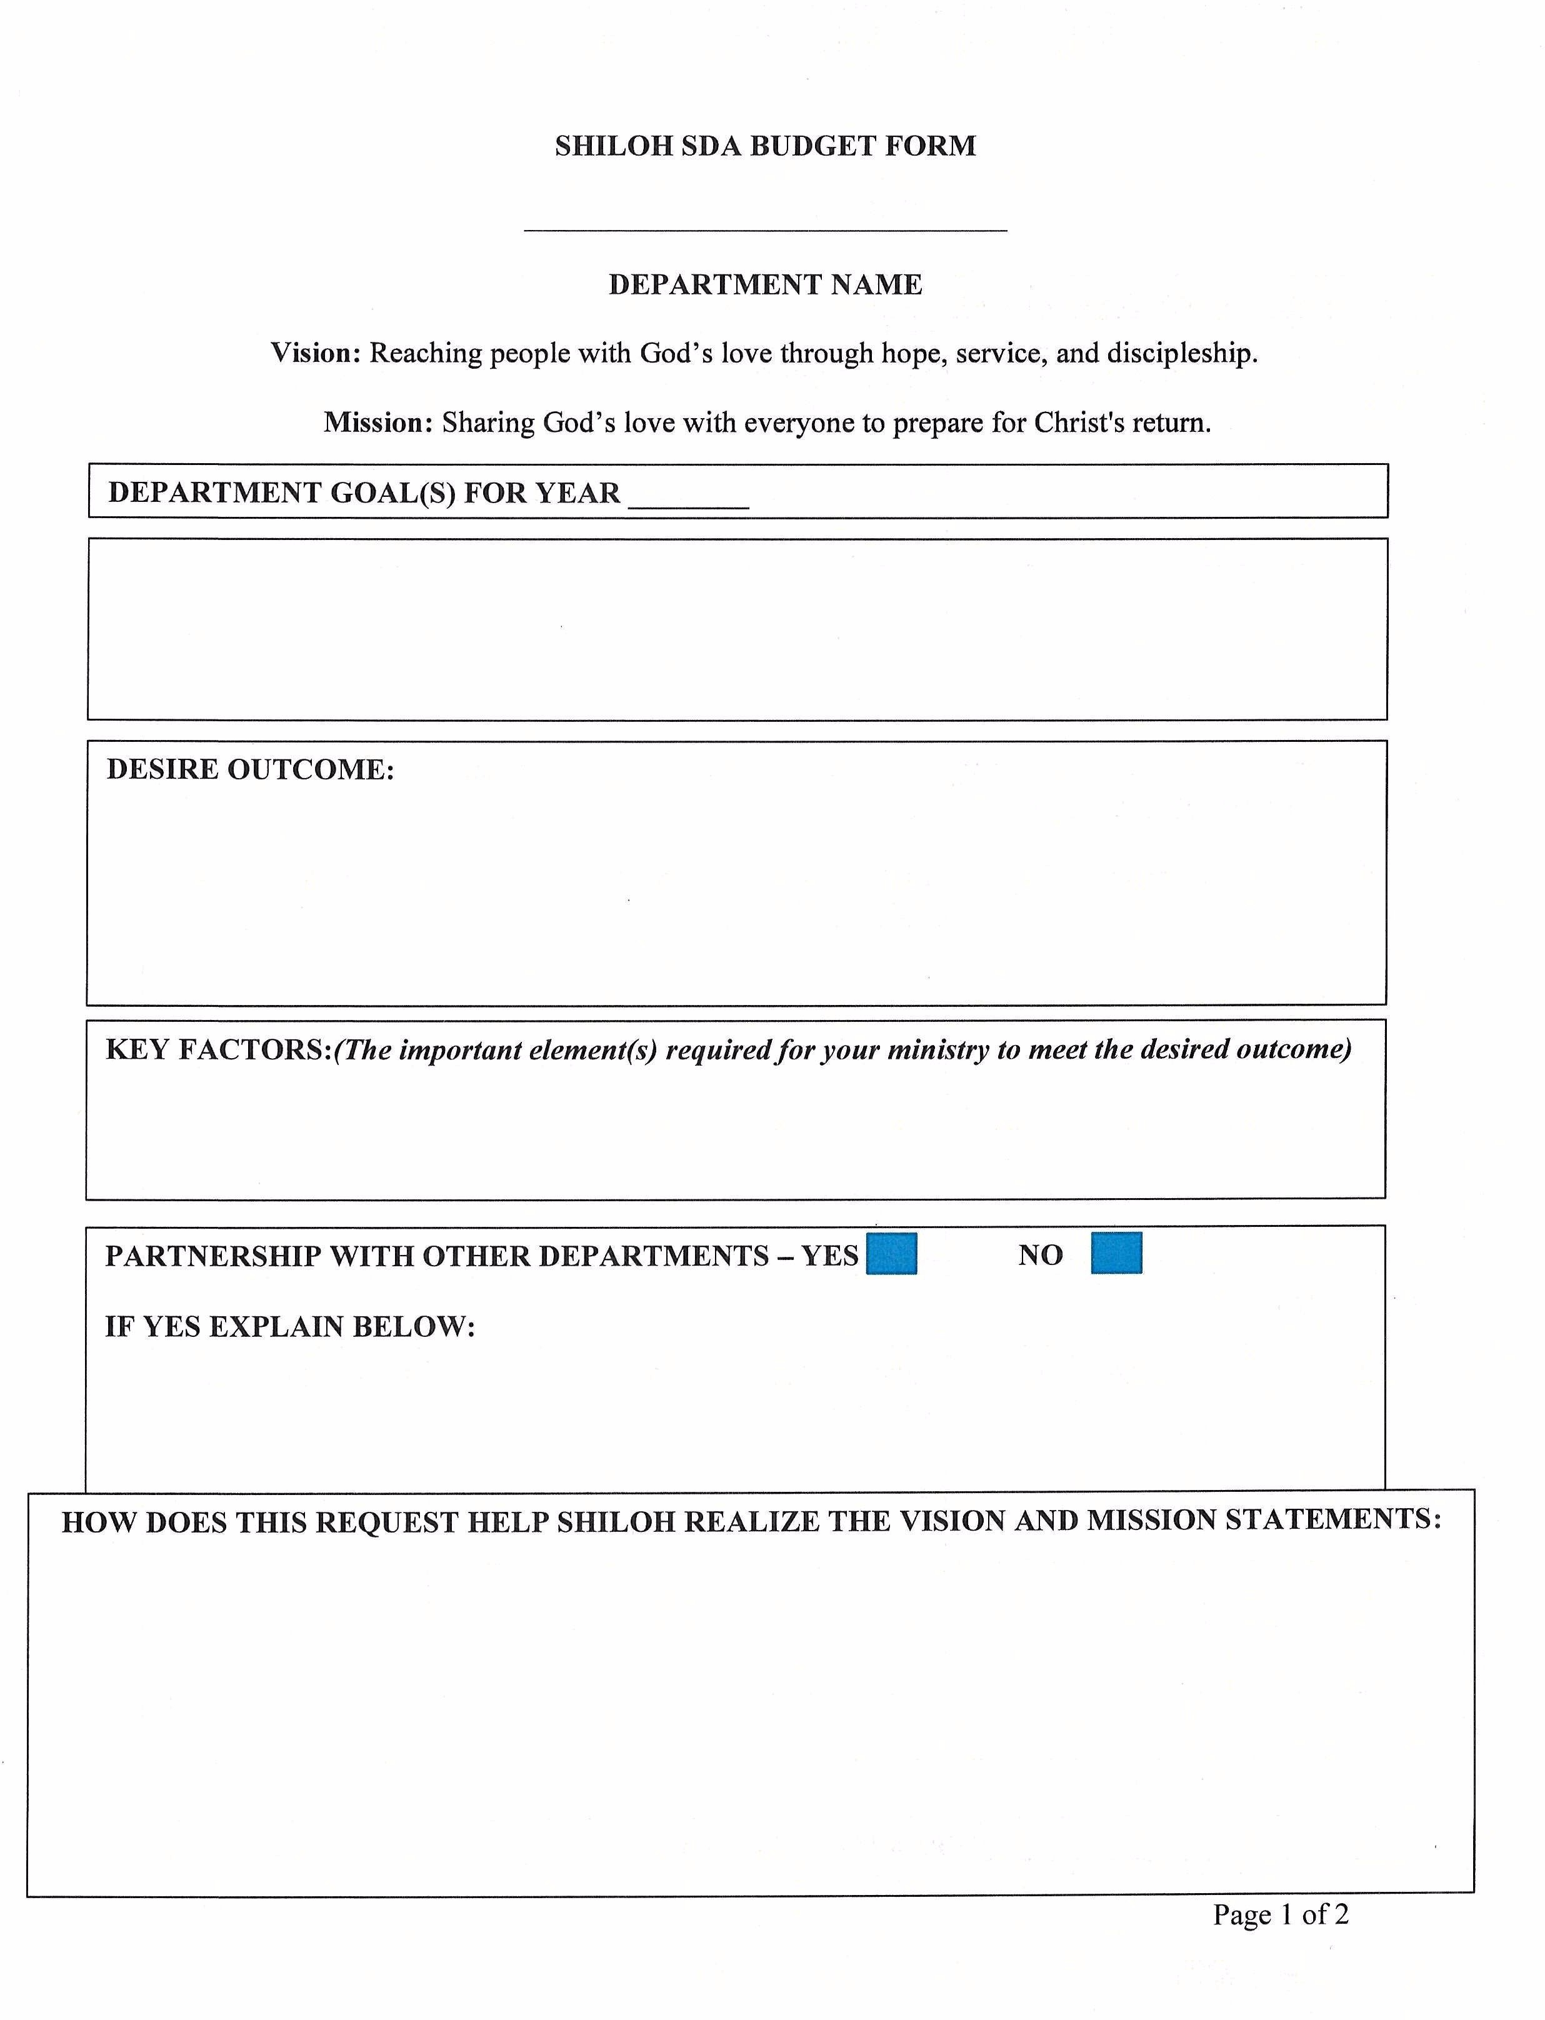
SHILOH SDA BUDGET FORM

DEPARTMENT NAME

Vision: Reaching people with God's love through hope, service, and discipleship.

Mission: Sharing God's love with everyone to prepare for Christ's return.

DEPARTMENT GOAL(S) FOR YEAR

DESIRE OUTCOME:

KEY FACTORS:(The important element(s) required for your ministry to meet the desired outcome)

PARTNERSHIP WITH OTHER DEPARTMENTS YES NO

IF YES EXPLAIN BELOW:

HOW DOES THIS REQUEST HELP SHILOH REALIZE THE VISION AND MISMON STATEMENTS:

Page 1 of 2

FUNDS REQUEST

SUPPLIES / EOUIPMENTS - (UNDER $500)

NAME QUANTITY ESTIMATED
COST PER

SUPPLIES EOUIPMENTS - (OVER $500)

TOTAL
DATE NEEDED

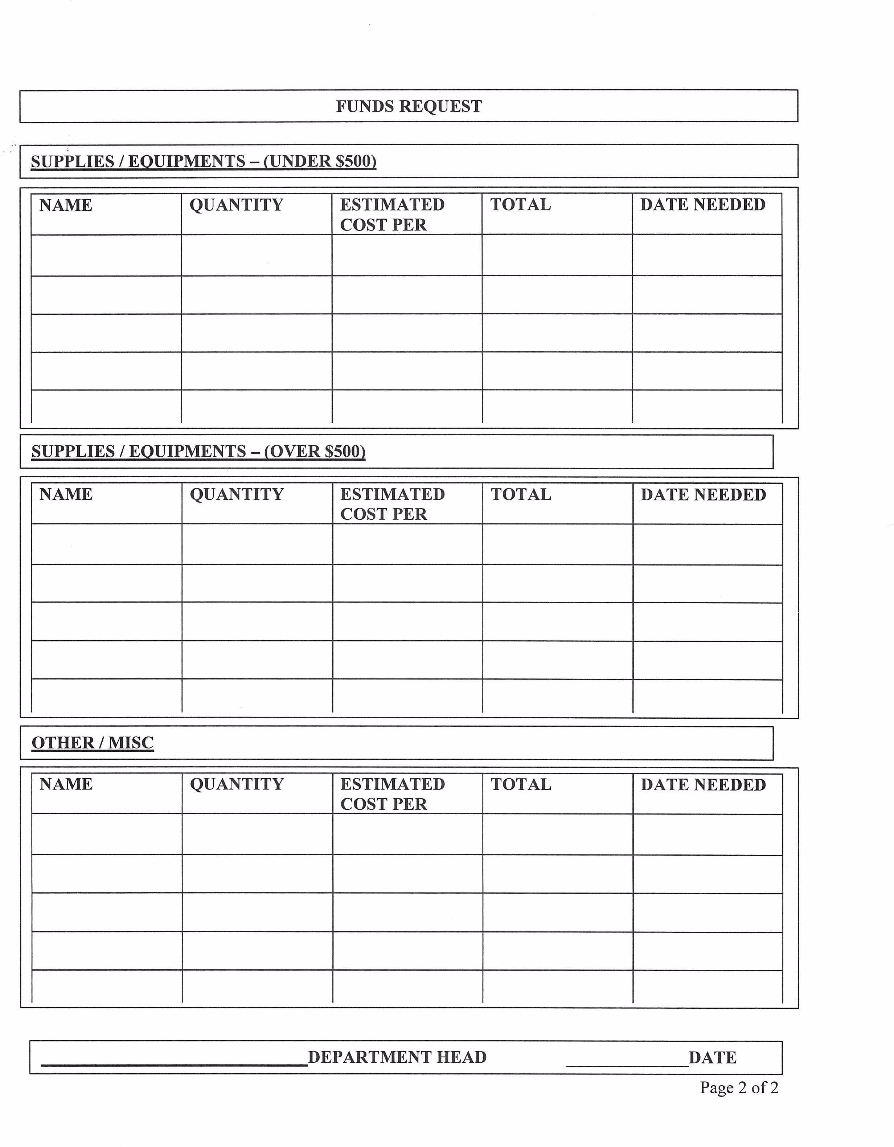
NAME

OTHER / MISC

NAME
QUANTITY

QUANTITY
ESTIMATED
COST PER

ESTIMATED
COST PER

DEPARTMENT HEAD

TOTAL

TOTAL
DATE NEEDED

DATE NEEDED

DATE
Page 2 of 2

