A warm welcome to you. Members & Visitors: Please complete a yellow “caring card” each time you attend a service. They can be found in the pew racks. Please place your card in the offering plate. If you have a Prayer Request, please put that information on the back of the card. Thank You!

ABOUT HOLY COMMUNION - Using Scripture as our guide, we believe that when we eat this bread and drink this wine, we receive the true body and blood of our Savior. It assures us of His love for us, of the forgiveness of our sins, and of His empowering presence in our daily lives. Any who have not been instructed, are in doubt, or who hold a confession differing from that of this congregation, and yet desire to receive the sacrament, are asked first to speak with the pastor or one of our elders.*Non-alcoholic wine is located in the center of each tray.* NOTE: If you would like to receive communion at any service from the pew, please tell the pastor or an elder before the service. Thank You!

THOSE MINISTERING AMONG US TODAY
Organist/Keyboardist – Rebecca Hahn
Elders Arnie Ihrke, Paul Kallemeyn
Acolyte Sawyer Reese
Usher Craig Edwards
Reader Sandie Spittle
Tech Crew Bryon & Bev Spittle, Camren Luther

Altar flowers were given by Mark and Anne Wagner in honor of their 29th wedding anniversary.

WE REMEMBER IN OUR PRAYERS: Short-term Specific Prayer Requests: Bill Brockberg, Jen Iverson, Lula Junker, Logan Waldner, and those we name in our hearts. We rejoice with Mark & Anne Wagner on their wedding anniversary. We pray for a safe, joy-filled week for the children that attend and our volunteers that are part of our VBS.

If you have a Pastoral Emergency, and cannot get through on the church phone number, please call Pastor Hahn at 507-738-0478.

PLEASE Help us spread the word about our Summer Worship Schedule – ONE Service on Sundays at 9AM, with Holy Communion – through September 6th!

Work Glove Donations Needed
Our youth are asking for donations of work gloves in all sizes for their Mission Trip to Colorado in July. If possible, they would prefer the mechanic/farm type gloves for the work they will be doing on their mission trip. A collection box is available in the Great Hall. Thank you for your support!

The Helping Hand Pregnancy Center is doing a “Diaper Drive” for sizes 4-6 diapers and wipes. Please see the flyer on our north entrance bulletin board for more information. We also have a collection box in our Great Hall.

It’s getting close … what, you may ask?
Our Worship in the Park!
Join us on Sunday, July 12th
at 10:15 AM at Chautauqua Park
We will start out in the Band Shell area for a wonderful outdoor worship service and then move to the Shelter House for a delicious catered meal. Watch for more information in the upcoming weekly worship bulletins.
St. Matthews celebrates 135 years in 2026!

Worthington Christian School is seeking passionate individuals to join their team as they continue to educate children in the light of God’s Word. Current openings include:
- Middle School Teacher
- Paraprofessional
- Music Teacher
- Spanish Teacher
- Coaches
- Substitute Teachers
If you or someone you know may be interested, please visit their website for more information and a downloadable application,
www.worthingtonchristianschool.org

Quilts of Valor Presentation
TODAY - June 14, 2026
Basement Fellowship Hall

The first presentation for the “Quilts of Valor” was done on February 8, 2026. Another set of quilts are now ready to be presented! Please join us TODAY for our second “Quilts of Valor” presentation. We will meet in the basement fellowship hall following our worship service.

Nancy Edwards and Voris Spittle are compiling a list of our church congregation members who are Active Duty Military or Veterans. Eligible are active duty, National Guard, Reservist, members of the U.S. Armed forces – Army, Marines, Navy, Air Force, Coast Guard, Space Force. Please contact Nancy (218-849-1221) or Voris (507-360-4864) if you know of someone. Thank You!

THIS WEEK AT ST. MATTHEW LUTHERAN CHURCH

Monday 9am-12pm VBS
12:00 p.m. July & August Newsletter
Deadline

Tuesday No Bible Study
9am-12pm VBS

Wednesday No Women in the Word
9am-12pm VBS
12:00 p.m. Bulletin & Screen Deadline

Thursday 9am-12pm VBS

Friday Pastor’s Day Off
9am-12pm VBS at Pioneer Village

Sunday 9:00 a.m. Worship
10:00 a.m. Coffee Fellowship & Devotion

Our next monthly newsletter will be a combined July & August Newsletter. The deadline to submit items for this newsletter is TOMORROW, June 15th. Please have items into Bev in the church office by noon. Thank You!

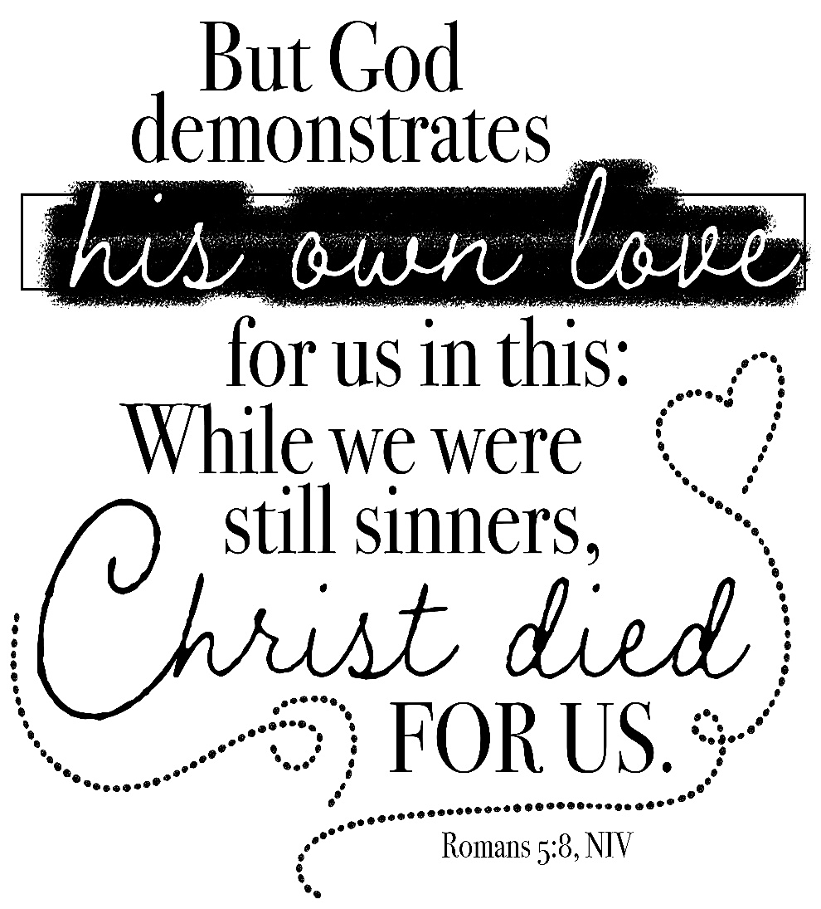

Third Sunday after Pentecost
June 14, 2026

St. Matthew Lutheran Church
Worthington, MN (507) 376-6168
Administrative Pastor, Rev. David G. Hahn – ext. 3
Administrative Assistant, Bev Spittle – ext. 2
Director of Human Care & Children’s Ministries, Roxann Leckband – ext. 5
Youth, Alexie & David Cross – ext. 4
Director of Music, Lorenda Glade – ext. 6
Email – stmattchurchoffice@gmail.com Website – www.stmatthewworthington.com
Facebook.com/stmattworthington
Today’s Order of Worship

Countdown Video
Announcements/Birthdays & Anniversaries
Welcome/Ringing of the Bell/Memory Verse of the Week
Call to Worship “Sanctuary”
Invocation
Hymn “Praise to the Lord, the Almighty” (vs. 1, 3, 5) LSB 790
Confession of Sins
God’s Assurance of Forgiveness
Song of Praise “10,000 Reasons”
Scripture Lessons Exodus 19:2-8
Romans 5:6-15
Matthew 9:35-10:8
Confession of Faith Song “We Believe”
Apostles’ Creed
Children’s Message
Sermon Hymn “O Christ, Who Called the Twelve” LSB 856
Sermon “For the Sake of Others” Romans 5:6-8
Prayers of the Church
Offering
Sacrament of Holy Communion
Preface (p. 208)
Sanctus (p. 208)
Prayer of Thanksgiving
Singing of The Lord’s Prayer (It’s Yours)
Lord’s Prayer Spoken
Words of Our Lord
Pax Domini
Distribution “On Eagles’ Wings” LSB 727
Closing Prayer
Benediction Song “The Blessing”
Closing Song “Jesus, Only Jesus”












Vacation Bible School
THIS WEEK - June 15–19
9AM-12PM
“Rainforest Falls – Exploring the Nature of God”
A kid-friendly lunch will be served.

This is open to kids aged, Preschool (must be potty trained) through those who have completed the 5th grade! We had to order supplies and have enough for 80 kids.

Registration forms are available on the table in the Great Hall. If you have not pre-registered your child, please arrive by 8:45AM.

Helpers please come at 8:15AM, unless Roxie has contacted you separately. Thank You.
Today’s Order of Worship

Countdown Video
Announcements/Birthdays & Anniversaries
Welcome/Ringing of the Bell/Memory Verse of the Week
Call to Worship “Sanctuary”
Invocation
Hymn “Praise to the Lord, the Almighty” (vs. 1, 3, 5) LSB 790
Confession of Sins
God’s Assurance of Forgiveness
Song of Praise “10,000 Reasons”
Scripture Lessons Exodus 19:2-8
Romans 5:6-15
Matthew 9:35-10:8
Confession of Faith Song “We Believe”
Apostles’ Creed
Children’s Message
Sermon Hymn “O Christ, Who Called the Twelve” LSB 856
Sermon “For the Sake of Others” Romans 5:6-8
Prayers of the Church
Offering
Sacrament of Holy Communion
Preface (p. 208)
Sanctus (p. 208)
Prayer of Thanksgiving
Singing of The Lord’s Prayer (It’s Yours)
Lord’s Prayer Spoken
Words of Our Lord
Pax Domini
Distribution “On Eagles’ Wings” LSB 727
Closing Prayer
Benediction Song “The Blessing”
Closing Song “Jesus, Only Jesus”

Vacation Bible School
THIS WEEK - June 15–19
9AM-12PM
“Rainforest Falls – Exploring the Nature of God”
A kid-friendly lunch will be served.

This is open to kids aged, Preschool (must be potty trained) through those who have completed the 5th grade! We had to order supplies and have enough for 80 kids.

Registration forms are available on the table in the Great Hall. If you have not pre-registered your child, please arrive by 8:45AM.

Helpers please come at 8:15AM, unless Roxie has contacted you separately. Thank You.

