St. Matthew Lutheran Church
1505 Dover Street, Worthington, MN

April 2026 Newsletter


PALM SUNDAY (March 29):
9:00 a.m. Worship Service, Communion
10:00 a.m. Breakfast Served by the Youth as a fundraiser for their summer Mission Trip to Colorado
MAUNDY THURSDAY (April 2) Worship at 6:30 p.m., Communion
GOOD FRIDAY (April 3) Worship at 6:30 p.m.
EASTER SUNDAY (April 5) Worship at 8 & 10:15 a.m., Communion
**PARENTS, PLEASE NOTE: There is NO Sunday School on Palm Sunday or
Easter Sunday. There is NO Confirmation or Kids in the Word on Wednesday, April 1.**

April worship schedule for the rest of the month:

April 12 8:00 a.m. Worship
10:15 a.m. Worship, Communion

April 19 8:00 a.m. Worship, Communion
10:15 a.m. Worship

April 26 8:00 a.m. Worship
10:15 a.m. Worship, Communion

From the Pastor’s Desk……
Dear brothers and sisters in Christ,
Our Lenten journey “Dying His Death, Living His Life” began back in February on Ash Wednesday as we talked a great deal about dying. Dying to Sin, Pride, Greed, Doubt, Turmoil, and Judgment. Connecting all of this dying to Christ’s death on the cross and the baptism to which we have been baptized. As Christians we have been given new life in Christ through His baptism. “Do you not know that all of us who have been baptized into Christ Jesus were baptized into His death. We were buried therefore with Him by baptism into death, in order that, just as Christ was raised from the dead by the glory of the Father, we too might walk in newness of life.” (Romans 6:3-4) We now live for Forgiveness, for Others, for the Treasures of Heaven, by Faith, in Peace, and in Grace.
As we enter into the last stretch of our Lenten journey, sometimes referred to as Holy Week, we are reminded that we are buried with Christ in His death that we might live with Him in His resurrection. The old is gone, the new has come. Each day we have a chance to die to self and live for Him. Beginning Palm Sunday we will contemplate those things that were put to death on the cross so that we might receive the blessings of new life in Christ. We will be waving our palm branches as Jesus enters Jerusalem and shouting, “Hosanna! Blessed is He who comes in the name of the Lord!” On Maundy Thursday we will gather at the Lord’s Table as Jesus gives us His body and blood in the bread and the wine of the Lord’s Supper so that we might remember His death until He comes. On Good Friday we will ponder that Jesus died for all, that those who live might no longer live for themselves but for Him who for their sake died and was raised. Finally, on Easter Sunday, we will celebrate that He lives triumphant by His resurrection. Jesus was triumphant over sin, death, and the grave. Alleluia!
Please note the Worship Service Schedule in the Newsletter. I hope to see all of you at church as we journey “Living His Life” together.
In Christ’s love,
Pastor Hahn
April Worship Service Schedule
Sunday, March 29th (Palm Sunday) - 9am Blended Service
Thursday, April 2nd (Maundy Thursday) – 6:30pm Service
Friday, April 3rd (Good Friday) – 6:30pm Service
Sunday, April 5th (Easter Sunday) - 8am & 10:15am Easter Celebration Service
Sunday, April 12th (2nd Sunday of Easter) - 8am Classic Service & 10:15am Modern Service
Sunday, April 19th (3rd Sunday of Easter) - 8am Classic Service & 10:15am Modern Service
Sunday, April 26th (4th Sunday of Easter) - 8am Classic Service & 10:15am Modern Service
Wednesday, April 29th (Confirmation Class of 2026 Faith Statements) 5:30pm
Sunday, May 3rd (Confirmation Sunday) - 8am Classic Service & 10:15am Modern Service
+++ (Confirmation Service will be at the 10:15 Modern Service) +++

Holy Week Services - “Dying His Death, Living His Life”
Sunday, March 29th (Palm Sunday) - 9am Blended Service “Blessed Is He”
In this service for Palm Sunday, we shout with the crowds to our Lord,
“Blessed is he.” Blessed by God, Jesus journeys toward death to bring us new life.

Thursday, April 2nd (Maundy Thursday) – 6:30pm Service “Remember His Death”
In this service for Maundy Thursday, we recall that Jesus gives us His Body and Blood in the bread
and wine of the Lord’s Supper so that we might remember His death until He comes.

Friday, April 3rd (Good Friday) – 6:30pm Service “He Died for All”
In this service for Good Friday, we ponder that Jesus died for all, that those who live might
no longer live for themselves but for Him who for their sake died and was raised.

Sunday, April 5th (Easter Sunday) - 8am & 10:15am Easter Celebration Service
“He Lives Triumphant” In this service for Easter Sunday, we celebrate that by His resurrection,
Jesus was triumphant over sin, death, and the grave. Alleluia!

Adult Small Group Sunday Morning Bible Study
Come and join us Sunday Mornings, between Worship Services, in the lower-level fellowship hall from 9:15-10:00am. This Bible Study is open to all, adults and youth 9th – 12th Grades, who are seeking out God’s Word and a deeper relationship with our Lord and Savior Jesus Christ. During the Season of Lent, we will be going through a Study based on the Lenten Series “Dying His Death – Living His Life.
Tuesday Morning Lectionary Bible Study
Every Tuesday morning at 8:30am there is a Bible Study that follows the Church Lectionary Series (The Scripture Readings we use for the Sunday Morning Service), that meets in the Church Conference Room. This is open to anyone who would like to attend. We also use ZOOM if anyone would like to join us from home. Contact the Church Office if you would like to consider using ZOOM. Below are the Scripture Readings we will be studying.
Tuesday, March 31st
Malachi 4:1-3 - 2 Timothy 2:8-13 - Matthew 28:1-10
Tuesday, April 7th
Acts 5:29-42 - 1 Peter 1:3-9 - John 20:19-31
Tuesday, April 14th
Acts 2:14a, 36-41 - 1 Peter 1:17-25 - Luke 24:13-35
Tuesday, April 21st
Acts 2:42-47 - 1 Peter 2:19-25 - John 10:1-10
Tuesday, April 28th
Acts 6:1-9; 7:2a, 51-60 - 1 Peter 2:2-10 - John 14:1-14

Church Partnership with Santurio Monte Sinai
The Guatemalan Church (Santurio del Monte Sinai) has re-signed their contract with St. Matthew Lutheran Church! That means they will be partnering with us in “Building Up The Kingdom of God”
for another year! “Dios es bueno!” “God is good!”

CHURCH RECORDS

- Bing Thi LoVan passed away February 27; funeral service was held March 5, 2026.

Financial Snapshot: February Income: $28,944.00
Monthly Budget Needed: $44,271.00


Bi-Annual Voters Meeting
Sunday, April 26th at 9:15 a.m.
in the church basement.
Election of Officers for the term on July 1, 2026-June 30, 2028, will take place. A “Slate of Nominations” is posted on our north entrance bulletin board.

Per our Church Constitution: “Voting Members are active Confirmed Members who have reached their eighteenth year. Voting members shall be entitled to vote at meetings of the Voters Assembly, and, if qualified, be entitled to hold office in the congregation.”

ALTAR GUILD NEWS

Serving in April will be Sandy Meyer and Velma Cortright. Those serving on Maundy Thursday are Sue Koob, LaVonne Berglund, Kathy Roslansky, and Alice White. We are in need of Members - if you would like to be a part of the Altar Guild please contact Velma Cortright, 507-329-5947 or Sandy Meyer, 507-360-0274

FLOWER CALENDAR - The 2026 Flower Calendar is on the bulletin board in our north/elevator entrance. If you would like to beautify our church on a specific Sunday with a bouquet of flowers, please sign up on the designated date on the calendar. Instructions for ordering and etc. are by the calendar. Please notify Bev in the church office 2 weeks before the date if you’d like anything printed in that week’s bulletin for “Altar Flowers given by.” If you have any questions, please call the church office.

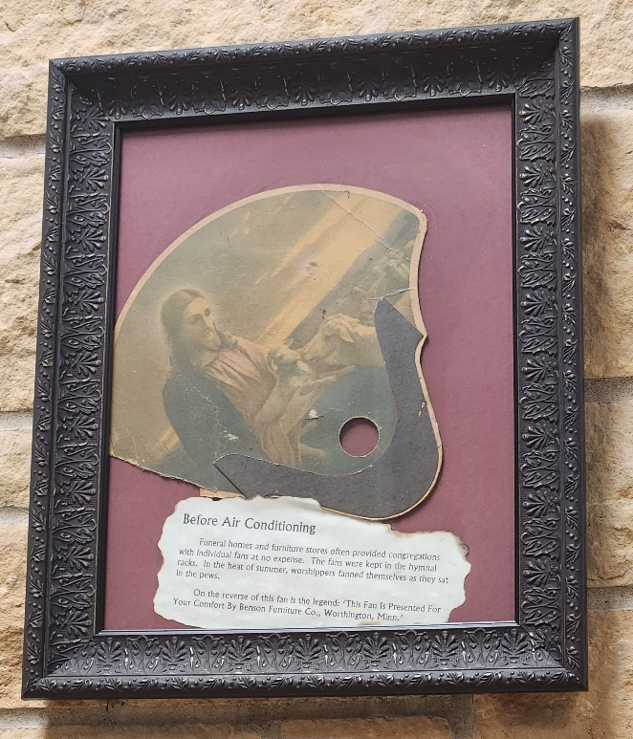
History for our 135th Church Anniversary

How we appreciate our air conditioners! How did we survive the warm Summer Sunday church services? Did the men come dressed in their suits, the women in dresses? One answer was to use a handheld fan! The local funeral homes offered fans like the one displayed in our church’s Great Hall. Was it hard for the pastor to face a congregation that was gently waving their fan, back and forth, back and forth? Would they believe that air conditioning would some day be invented? It is so appreciated!

The paper in this frame says, “Funeral homes and furniture stores often provided congregations with individual fans at no expense. The fans were kept in the hymnal racks. In the heat of summer, worshippers fanned themselves as they sat in the pews. On the reverse of this fan is the legend: ‘This Fan Is Presented For Your Comfort By Benson Furniture Co., Worthington, Minn.’”

Do you have a story or memory you would like to share with us? Please contact Bev in the church office by the 15th of the month to get it included in our next newsletter.

MUSIC AND WORSHIP NEWS

“I know that my Redeemer lives; What comfort this sweet sentence gives!
He lives, He lives, who once was dead. He lives, my everliving head! (LSB 461 vs 1)

In 1759, on a British warship, a young man by the name of Samuel Medley was facing a life-threatening event. In a recent battle, Medley sustained a serious injury to his leg. The surgeon told him that he might die and if the leg was not better by morning, he would have to amputate.

Samuel Medley had learned about Jesus from his grandfather but had never taken the message of salvation through Jesus Christ seriously. But that night on that ship, facing death, Samuel remembered what his grandfather had taught him about Jesus and His love and grace.

It was Jesus that carried Samuel Medley through that long night. At dawn, the ship’s surgeon discovered that the leg was better. There was no amputation. Samuel Medley was led to his Redeemer by the power of the gospel that he had heard from his grandfather. Later he entered the pastoral ministry, proclaiming the message of the cross and the empty tomb to all who came to listen.

He also picked up a pen. He began to put into words the joy and comfort the Christian has in Jesus’ resurrection. He was inspired by this declaration of faith made by Job in Scripture, “For I know that my Redeemer lives, and at last he will stand upon the earth. And after my skin has been thus destroyed, yet in my flesh I shall see God.” (Job 19:25-26 ESV)

Using Job’s words of faith as the opening line, from Samuel Medley’s pen came a hymn of Easter joy that we know as "I Know That My Redeemer Lives!" And to make sure that we got the message, Medley used the words “He Lives” over thirty times in the eight verses of this glorious hymn!

“He lives, all glory to His name! He lives, my Jesus, still the same: Oh, the sweet joy this sentence gives: I know that my Redeemer lives!” (LSB 461 vs 8)

Christ is risen! He is risen indeed! Alleluia!
Lorenda Glade, Director of Music

LWML NEWS

The LWML Worthington Zone Spring Get-Together will be held on April 18th at Trinity Lutheran Church, Sioux Valley. Registration and coffee at 9 a.m. Get-together opening at 9:30 a.m. Registration fee is $5.00. Gifts from the Heart: items to the SW Crisis Center. See poster on the bulletin board in our church’s north/elevator entrance. Let Kathy Roslansky know if you want to attend. We will arrange drivers. These are inspiring events!! Let Kathy know if you have any questions.

We do NOT have a monthly meeting in April. The Circle Bible studies are: Hope is on April 14 at 3 p.m. and Sarah is on April 21 at 1:30 p.m. Both will meet in the Fireside Room.

DIRECTOR OF HUMAN CARE & CHILDREN’S MINISTRY
By Roxann Leckband

Well, April is here as we rejoice in our Lord’s resurrection from the dead which provides a gift of salvation for all believers. This is a gift we can be “thankful” for every day. A gift we could have never earned. It sounds too easy, but when we read in Scripture: Ephesians 2:4-5 “But because of his great love for us, God, who is rich in mercy made us alive with Christ even when we were dead in transgressions-it is by grace you have been saved.” Ephesians 8:9-10 “For it is by grace you have been saved through faith-and this is not from yourselves; it is the gift of God-not by works so no can boast.” Yes, a gift, and as we live our lives praising and thanking God for His mercy may we be moved to share with others this message of love and forgiveness.

There are many ministry opportunities available. Please feel welcome to join us. Do not hesitate to contact us here at St. Matthew or my cell 712-260-3820 with questions you may have.

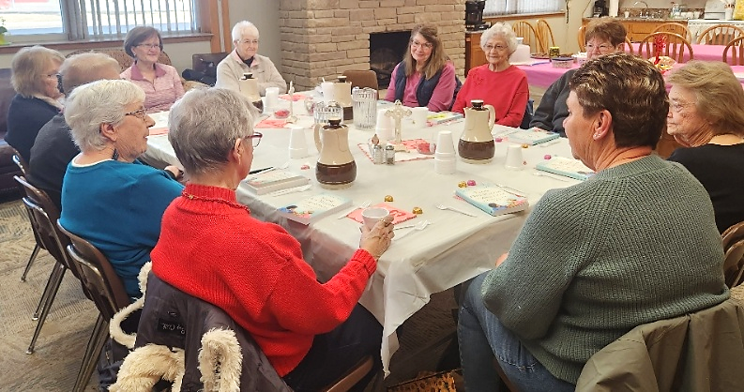
HUMAN CARE MINISTRY:
- April 7 = Widow’s Group at Perkins at 12:30. This is a time of fellowship and support. We enjoy lunch and a devotion.
- April 27 = Widow’s Group in the Fireside Room here at St. Matthews at 11:00 a.m. → We are continuing in the book, From One Widow to Another Conversations on the New You by Miriam Neff. The main entrée is a sandwich bar. Please bring a food dish to share.
- Women in the Word will be meeting on April 1, 8, 15, 22, and 29th from 9:00-10:00 a.m.
- Apil 13 = Noon Fellowship at 12:00 in the Fireside Room. Join us for great fellowship, food, and a time in God’s Word. The main entrée will be ham, au gratin potatoes, and green beans. If you are able, please bring a dish to share. There is a free-will offering if you so choose.

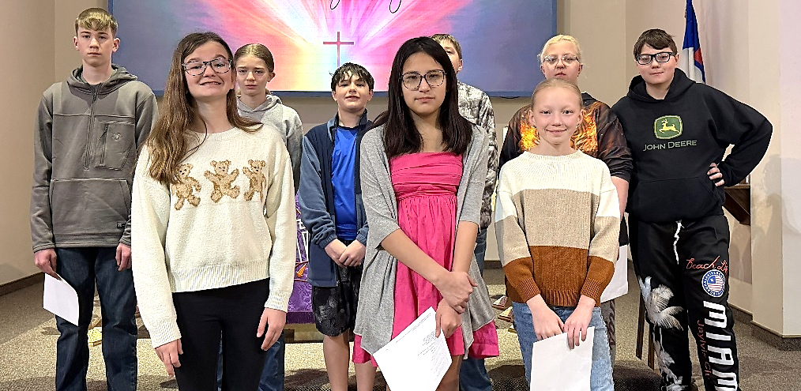
CHILDREN’S MINISTRY:
← We are featuring the 6th-8th grade Sunday School class this month. Taught by Adam Sandersfeld along with substitutes Jesse Raudenbush, and Trevor Wintz. We are so thankful for all they do!
Adam Sandersfeld: I live in Sheldon, Iowa with my wife, Ashley and our children, Aubree, Bailee, and Cash. I graduated from Hartley/Melvin/Sanborn High School and South Dakota State University. I have taught 6th-8th grade Sunday School at St. Matthew for the past 5 years. When I teach Sunday School I relate our time in class to training. We correlate our lessons to our catechism to the Bible and what that means to us as Christians today. I enjoy this age group because we can discuss, dissect, and deliberate as we grow our faith together.

CHILDREN’S MINISTRY CONTINUED:
- April 3 = Easter Family Event: Parents and children of ALL ages, join us at 10:30 a.m. for Easter egg dying, an Easter egg hunt, the Easter story, Easter crafts, and goodies! What a great way to begin the celebration of Easter. Rejoicing in all that Christ has done for us with His death and resurrection. See photos of the Skating Family event on the next page. We had a great time! There were approximately 45-50 individuals in attendance.
- Please note there will be NO Sunday School on Easter Sunday, April 5th.
- April 17 = Moms and Jesus’ Lil’ Lambs will meet at 10:30 a.m. Come join us for a Bible story, crafts, games, and snacks. Moms will meet for a time of fellowship and God’s Wod.
- April 8, 15, and 22 = Kids in the Word will meet. Please note the last class of Kids in the Word for this season will be on April 22.
- Vacation Bible School, Rainforest Falls Exploring the Nature of God, will be June 15-19. Please see description and registration details in this newsletter.

CONFIRMATION CLASSES & RITE OF CONFIRMATION:
The 5th-8th grade Confirmation classes will meet from 5:30-6:30 p.m. on April 8, 15, and 22. No confirmation on April 1, during Holy Week, as it is assumed the Confirmation youth will be attending Holy Week worship services. The LAST confirmation class for the season is April 22. On April 29, the Confirmation Faith Statements and Reception will take place at 5:30 p.m. The 7th grade youth will be attending the Faith Statement presentation and serving at the reception. Sunday, May 3rd is The Rite of Confirmation at the 10:15 worship service. ALL youth being Confirmed need to be at the church by 8:50 a.m. for a class photo! Individual photos, for those who want them, will also be taken. Watch for more information.

HEALTH MINISTRY:
April is Cancer prevention and early detection month. Reminding us all of the importance of routine cancer screenings. Early Detection = Better Outcome! Let us pave the way for a world where cancer is preventable, detectable, and beatable for ALL. For more information go to: preventcancer.org or
https://preventcancer.org/prevention-screening/. If you would like more information or need assistance, please contact myself or one of our Health Cabinet members: Mary Krueger, Nancy Irhke, Gail DeGrote, and Deb Meyer.

April 21 = Health Cabinet Meeting at 12:30 in the Conference Room.

ACOLYTE SCHEDULE for April 2026

April 2 – 6:30 p.m. = Cody Schmidt
April 5 – 8 a.m. = Sebastian Sieve ; 10:15 a.m. = Samuel Bents
April 12 – 8 a.m. = Jaxon Grimmius; 10:15 a.m. = Kylia Bosma
April 19 – 8 a.m. = Kaisley Granstra; 10:15 a.m. = Jace Riemersma-Feit
April 26 – 8 a.m. = Aubree Sandersfeld; 10:15 a.m. = Kysten Willers
May 3 – 8 a.m. = Keaton Schettler; 10:15 a.m. = Blake Schmidt

Please remember to arrive 15 minutes, or more, before the worship service is set to begin – thank you!

YPOG NEWS (Young People of God) by Alexie Cross

The youth have been busy with fundraisers for the past few months. Though we will still be working diligently at raising funds for our upcoming events and mission trip to Colorado, this next month we are shifting focus to fellowship and relationship building. This will be done through fellowship events, Senior Nights, and Wednesday and Sunday gatherings. Not only are we working on relationships within the youth group, but within the entire St. Matthew’s church family. Efforts are being made to include the high school youth more in all sorts of opportunities for them to connect within the congregation as well. During this Lenten season, we have been taking a Christ centered look at mental health. I have been amazed at how thoughtful and insightful the conversations have been. Sundays are going well too. We have continued to enjoy donuts and a variety of devotions.
Please see pictures on the next page.

Family Skate Event:
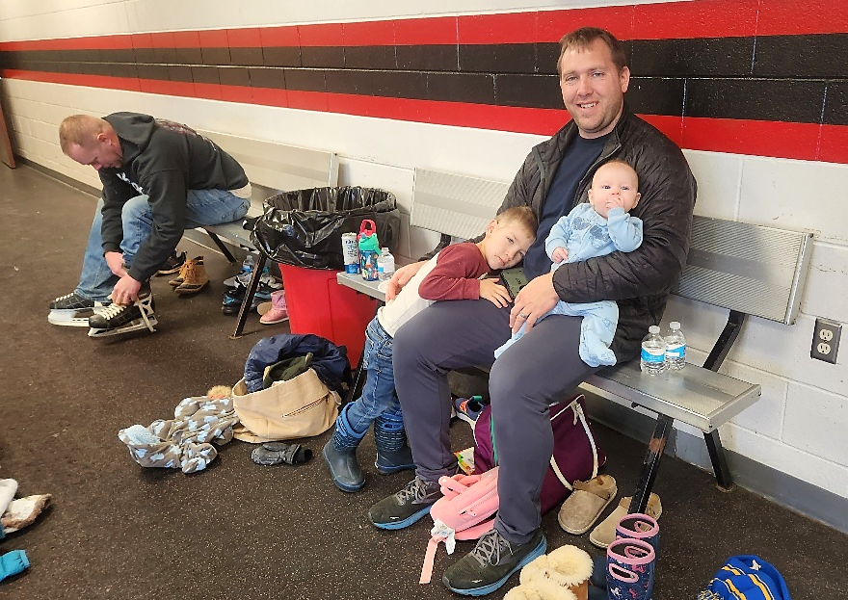





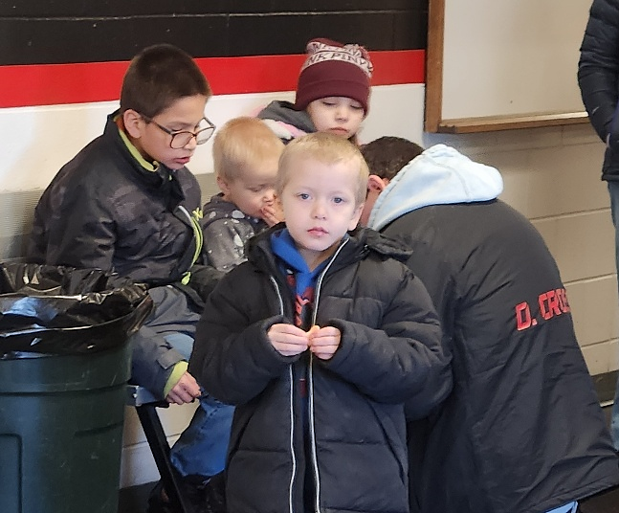


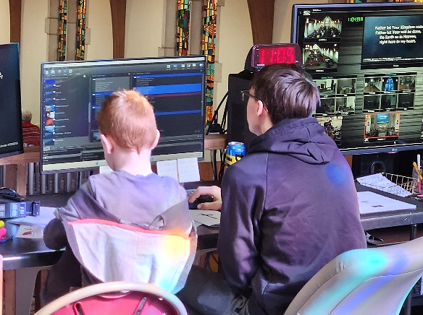
Several of our youth help with the balcony “Tech Crew.” Their help is very much appreciated! Is this a future tech operator sitting with a current crew member?

HIGHLIGHTS FROM THE 3/9/26 COUNCIL MEETING
Reminder: these are only highlights, as the Minutes will not be approved until the next meeting.

Treasurer’s Report: February income was $28,944.00, with expenses of $47,752.83, leaving the General Fund at $108,761.52. Other balances: Youth $22,268.13; Momentum One (Scholarship) $888,207.33; Momentum Two $331,600.00; and Memorial Fund $59,524.37.
Staff Reports: Pastor – Did several home visitations and had many meetings. Average Sunday attendance was 74 at the 8am service and 104 at the 10:15am service. LCMS President Voter registrations have been accepted. Craig Edwards & Pastor Hahn will be representing our church. Re-Vitality strategic planning surveys were given to a small group of members determined by the Elders. They will be mailed in, and we will review the results when received. A Memorial Gift of a digital piano on wheels was purchased and that was very much appreciated! Roxie – Widows’ group numbers are consistent with 15-16 attending. Working on planning some family events. Noon Fellowship attendance continues to be low. Did more home visits this past month. Planning the March 20 & 21 Confirmation Retreat. Lorenda – Midweek Lenten services are going well. I thank Linda Lange for substituting for me during my recovery time from surgery. I am finalizing Holy Week services. Louise Clausen has been working with the choir for Palm Sunday and Good Friday services; and Bell Choir for Easter Sunday. Thank you to Linda Lang, Rebecca Hahn, and Brenda DeSmith for their help with services during my absence. Also, a special thank you to the church staff for their help with keeping things running smoothly for me. Alexie & David Cross – Youth attendance on Sundays has decreased, but many are involved in sports, etc. Wednesday evening attendance has been around 18. Had a Senior Night but did not have good attendance for that. Working on current mission trip fundraisers, Lent Supper we served, and the Palm Sunday breakfast. Three youth will be attending the YouthLead Conference in St. Louis March 19-22.
Elders: Ron and Arnie will do staff evaluations. Re-Vitality surveys were done by elders, staff and 10 members and will be sent to District for information to be tallied.
Trustees: Rental fee for the basement has been increased to $100 since new carpet has been installed. Did routine building checks and maintenance.
Board of Education: Sunday School attendance remains low. VBS planning continues.
Ministry Planning: Discussed if there will be a church service in the park this summer. Possible dates were discussed and will be checked with the city for availability.
Old Business: St. Matthew’s Guatemalan Committee met with the Guatemalan Ecumenical Christian Church leaders and have signed a new contract. Balcony project is still ongoing and sound system not completed yet. Waiting on company for an install date. Company has had some delays come up.
New Business: Nominating Committee members to recruit Officers for open positions for the July 1, 2025-June 30, 2027, term are: Ron Iverson, Arnie Ihrke, Bryon Spittle, Philip Lorch, Kelly Meyer, and Nathan Holt. Slate of Nominations for Officers needs to be posted by March 26th, as voting will take place at the next Voters Meeting. Discussed that there needs to be a vote by members electing our Congregational Synodical Delegates (Pastor Hahn & Craig Edwards) that are registered to attend. This will take place at the next Voters meeting also. Our Bi-Annual Voters Meeting will be on Sunday, April 26th at 9:15 a.m. in the basement Fellowship Hall.
Next Council Meeting will be on Tuesday, April 13, 2026, at 5:30 p.m.

Church Staff Contact Information = Church Phone = 507-376-6168
Administrative Assistant, Bev Spittle – ext. 2 or stmattchurchoffice@gmail.com
Administrative Pastor David Hahn – ext. 3 or stmattpastorhahn@gmail.com
Youth, David & Alexie Cross – ext. 4 or stmattyouthdirector@gmail.com
Director of Human Care & Children’s Ministries, Roxann Leckband – ext. 5 or
stmatthumancare@gmail.com or stmattparishnurse@gmail.com

Director of Music, Lorenda Glade – ext. 6 or stmattmusicstaff@gmail.com

Dear St. Matthews Lutheran Church,

I am loving vicarage at Glory of Christ in Plymouth, and am now in my seventh month here. It has been going surprisingly quickly! I am excited to share that I plan to be back to visit you all on May 24th (Memorial Day weekend) when I will be on vacation. I look forward to seeing you then!

Vicarage is going well here, I am preaching twice a month, leading our Youth Group Bible Class, and teaching Confirmation. This spring, I am also taking our Young Adults through a book study. The most interesting thing I’m doing is helping out at our partner congregation: an Amharic-speaking Ethiopian Lutheran Church. It has been such an adventure to worship with them, learn from them, and teach their youth group. Working with cross-cultural ministry has been an amazing experience for me and I’ve learned a lot.

Personally, I am doing well. I love being back in Minnesota, although I am certainly looking forward to spring with all the snow we just got! It has been wonderful to get to know my vicarage congregation and have made it a practice to host a family from church every week or two. I am also living with a wonderful elderly member of our congregation named, Susan, so that has been a blessing.

I hope and pray you are doing well at your church. Thank you for continuing to support my education. This upcoming August, I will return to the seminary and be ordained when I finish up the following May. I am excited to be a pastor soon.

God bless you,

Isaac Hedstrom

Looking for loads of fun?
Kids in Preschool through those
who have completed 5th grade
please join us for VBS
June 15-19 from 9AM–12:30PM
(Lunch will be served.)

Mark your calendars for VBS!

Registration Forms will be available soon! Please watch our weekly worship bulletins, Facebook Page, and website for updates! There will also be more information in our May Newsletter.

