

**HOLY CROSS LUTHERAN CHURCH**

**NEWSLETTER OCTOBER 2022**

**1209 Coutant Street, Flushing, Michigan 48433**

**Phone (810) 659-5926 Fax (810) 496-2768**

**Website: www.holycrosslutheran.com**

**App: @thecross**

***October Worship Times: Traditional 9 a.m. Contemporary 11:15 a.m.***

**October Worship Services**

Sunday, October 2 - Pastor Steven Helms

***“Sin Among Christ’s Followers”***

Sunday, October 9 - Pastor Steven Helms

***“Return to Jesus and Give Thanks to God”***

Sunday, October 16 - Guest Pastor

Sunday, October 23 - Pastor Steven Helms

***“Beat Your Breast Instead of Blowing Your Horn”***

Sunday, October 30 - Pastor Steven Helms

***“A No Boasting Zone”***

Greetings Holy Cross Members,

Well, we made it through September with Guest Pastors, and all went well. We got to meet Pastor Helms who will be out Visiting Pastor for the next several months. It was a joy to feel his passion and ambition during the service. If you haven’t attended recently, please consider coming back and joining with us again. Everything is starting up this month, so it will be a busy time. All bible studies and Sunday School classes will begin on October 2nd. The second week of October will be our Quilting Ladies putting out their quilts to raise money for supplies to make more quilts. Their quilts are sent to various organizations and to the one closest to our hearts, the Franklin Avenue Mission. I helped deliver the quilts last year and it was a memorable time. I hadn’t been in that area of Flint in a long time, so I was surprised at the need that is there. Franklin Avenue Mission sits right in the heart of a very needy district and could use help from individuals that would want to serve. They need volunteers to help serve food and help in other areas. Please call them at 810-285-9598 to find out where and when you can help.

Please see the events page to find out what is happening at Holy Cross this month.

Thank you for all of your help and support

Karen Rocker



**September: Offerings** - $16,347.74 **Expenses** – $11,908.21

**Year To Date: Offerings** - $16,347.74 **Expenses** – $11,908.21

*Year to Date (September 2022 – September 2022)*

**EVENTS**

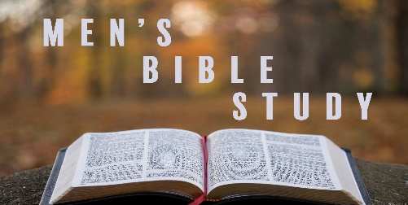

**Men’s Group will be meeting on**

**Mondays**

**@ 7pm at Holy Cross**

**Contact Scott Sharp, Perry Wright, or Chad Roberts if interested**

**Thursday Morning Bible Study**

*Begins October 6 @ 10am*

*Led by Pastor Steve Helms*



**Quilt Sale – Sunday October 9**

**Cost is 30$ if no tag; otherwise, price is as marked. Make checks out to Women of Holy Cross**

*QUILTING WEDNESDAYS AT 10am*

*Quilts are prepared for Lutheran World Relief and Franklin Ave. Mission. No experience is needed. If you can tie your shoes, you can help tie a quilt. The group would be glad to have you join them.*



**HAPPY HEARTS – MONDAY OCTOBER 10**

**POTLUCK @ HOLY CROSS**



**LADIES LUNCHLY WEDNESDAY October 12**

*2nd Wednesday of the month ladies join for lunch & fellowship at Liberty Restaurant (6277 Pierson Road) at noon*



**BREAD FOR LIFE MINISTRY**

**EVERY WEEK OF THE SCHOOL YEAR**

**ABOUT 110 STUDENTS FROM FLUSHING SCHOOLS**

**EAT FOOD ON THE WEEKENDS**

**THAT COMES FROM THIS MINISTRY!**

***How Bread4Life works…***

*Families in the Flushing Schools who receive subsidized lunch can apply*

*Thursdays during the school year, bags are packed at Holy Cross*

*Fridays the bags are taken to the school*

*School staff place the bags in the lockers of students who take them home*

***Bread4Life starts back up on Thursday, October 6***

*We need volunteers to help pack bags – please let us know if you’re interested*

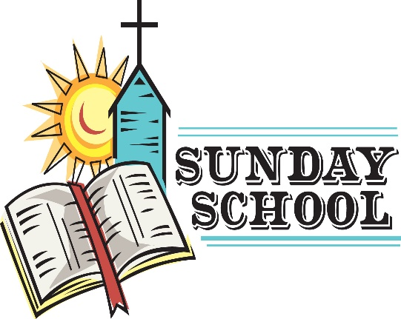

**SUNDAY SCHOOL RESUMES OCTOBER 2nd @ 10am**

***Children’s Bible Study*** *– In the education wing,*

*for 4yrs – 5th graders*

***Confirmation Classes*** *– Led by Pastor Helms,*

*for 6-8th graders.*

***Sr. Youth Bible Study*** *– Led by Marcos Machado,*

*for 9-12th graders*

***Adult Bible Study*** *– Led by Hannah Machado in*

*the fellowship hall*

***Alternative Class*** *– Taught by Dave Smithkey or*

*Al Fahlen in the library*

**Sunday School Get-together**

**at Flushing Farms, Sunday October 9**

All Holy Cross families with children/grandchildren are invited to a fun afternoon outing at Flushing Farms (at corner of Stanley + Gillette). Directly following church, families are invited to the residence of Chad and Jamie Roberts for a homemade soup, salad, and bread lunch. Directly following that, we will make our way down to Flushing Farms for barrel rides, covered wagon rides, petting zoo, bounce house, cider, donuts, and fall fun!

**Cost is $12 per person** and you get a wrist band to participate in all activities. **Pumpkins are extra, but if you show them your wristband you get a $2 discount.**

*Don't miss out! We hope to see everyone there!*

More details coming soon!



**We are taking donations for Lutheran World Relief and Igors Rautmanis**

The war in Ukraine is putting a large strain on their resources. Inflation and shortages are causing many issues. Winter is coming and utilities have increased dramatically.

*Please include a note on the memo line when writing checks*

**Call Committee Update**

*The call committee met on September 27th to continue our preparations for receiving the next call list, which we think should arrive soon.  We discussed some changes to the guidance given by the district for how the phone interview portion of the process will work and we think the updated guidelines will aid us in our search for our next long-term pastor.  Pastor Hensler reminded us to remain patient and to be in prayer for our process (not just "thinking" about prayer).  We, the committee, invite all of you to join us in prayer as we eagerly await our next long-term pastor.* *We will meet again on October 10th to continue our process.*

*In the meantime, if you have questions or concerns about the process, please reach out to any of your call committee members:****Tonia Cole, Jean Flader, Rachel Garza, Marcos Machado, Wendy Meinburg, Chad Roberts, Jim Santala, David Smithkey, Erin Wassick, and Perry Wright.***

**May we continue to trust the Lord’s building of His kingdom among us.**



***FLUSHING CHRISTIAN OUTREACH NEWS***

During the month of October, we will be taking a freewill donation to help the FCOC replace their furnace and AC units.

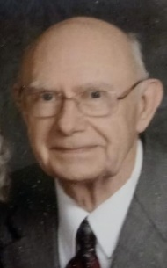

*This month, our church community lost a valuable member.*

*Harold Eller, age 87, passed away on September 25th at McLaren Hospital, Flint.*

*He will be missed.*

*They will all be missed.*

**Are Christians Embarrassed to Proclaim Christ?**

Paul was not embarrassed to publicly confess his faith in Jesus Christ. In Romans 1:16, Paul declares, “I am not ashamed of the gospel, because it is the power of God for the salvation of everyone who believes: first for the Jew, then for the Gentile.”The good news that God forgives the sins of the world and offers everyone who believes in Jesus Christ eternal life is a message that Paul is proud to share with Jews and Gentiles alike. Yes, Paul is even willing to suffer ridicule and persecution for proclaiming this gospel which is considered foolishness by Gentiles and a stumbling block to Jews.

Paul knows that gospel is the power of God for the salvation of everyone who believes, and he cannot restrain himself from preaching the message of Christ crucified for the sins of the world. Even though some may reject the good news of Christ, and Paul may suffer for preaching Christ, He knows that many Jews and Gentiles will be saved through the gospel that God has called him to preach. Paul’s boldness and courage in preaching the message of Christ to his generation is legendary and was motivated by his conviction that hearing and believing the gospel is the only way that anyone will be saved.

In Romans 10, Paul asks a series of questions that highlight the importance of proclaiming the gospel of Jesus Christ. He writes, “How, then, can they call on the one they have not believed in? And how can they believe in the one of whom they have not heard? And how can they hear without someone preaching to them? And how can they preach unless they are sent?” Unless Christians boldly proclaim the message of God’s salvation in Christ, people will not have the opportunity to hear, believe and be saved.

Are Christians in our culture ashamed of the gospel? Are we reluctant to proclaim the message of Christ in a secular nation that in many ways appears to be increasingly hostile to the message Jesus commanded His Church to go and preach? The risk of ridicule, rejection, and even persecution is growing in our post-Christian culture, but the fact remains, there is no other name, except Jesus, by which our family, friends and neighbors must be saved.

There is no other way for people to come to the Father and enter the kingdom of God, expect Jesus, who remains the way, the truth, and the life. There is no other gospel, except the good news of Jesus Christ, that is the power of God for the salvation of everyone who believes. If Christ’s followers are not ashamed of the gospel, then we ought to boldly and courageously proclaim it, even though we may have to suffer for Christ. If we sincerely believe that the gospel is the power of God for the salvation of everyone who believes, how can we not preach the good news.

***-Pastor Steven Helms***



*If anyone would like to make a donation to support missionary Igors Rautmanis, Jonathon and Deborah Bourbeau, or Ukraine, please indicate on your envelope and/or check where you would like them to go.*

*Please make check out to Holy Cross*

**Cost for lodging & meals on Mackinac Island for the Adult Gathering**

Single Occupancy $779

Double Occupancy $464.50 per person

Triple Occupancy $400 per person

Quadruple Occupancy $370 per person

Quintuple Occupancy $340 per person

***Details/registration can be found on the website as listed above***