"If the Atonement... is anything to the mind, it is everything. It is the most profound of all truths, and the most recreative. It determines more than anything else our conceptions of God, of man, of history, and even of nature. The Atonement is a reality of such a sort that it can make no compromise. The man who fights it knows that he is fighting for his life, and puts all his strength into the battle. The surrender is literally to give up himself, to cease to be the man he is, and to become another man. The cross of Christ is man's own glory, or it is his final stumbling block."

Quoted in J.I. Packer, "The Atonement in the Life of the Christian," in The Glory of the Atonement: Biblical, Theological, and Practical Perspectives

Sin must be judged and punished
“Couldn’t God just wave His hand and call it done?”
He calls it necessary, that’s all I need. But logically, this would be unjust to do.

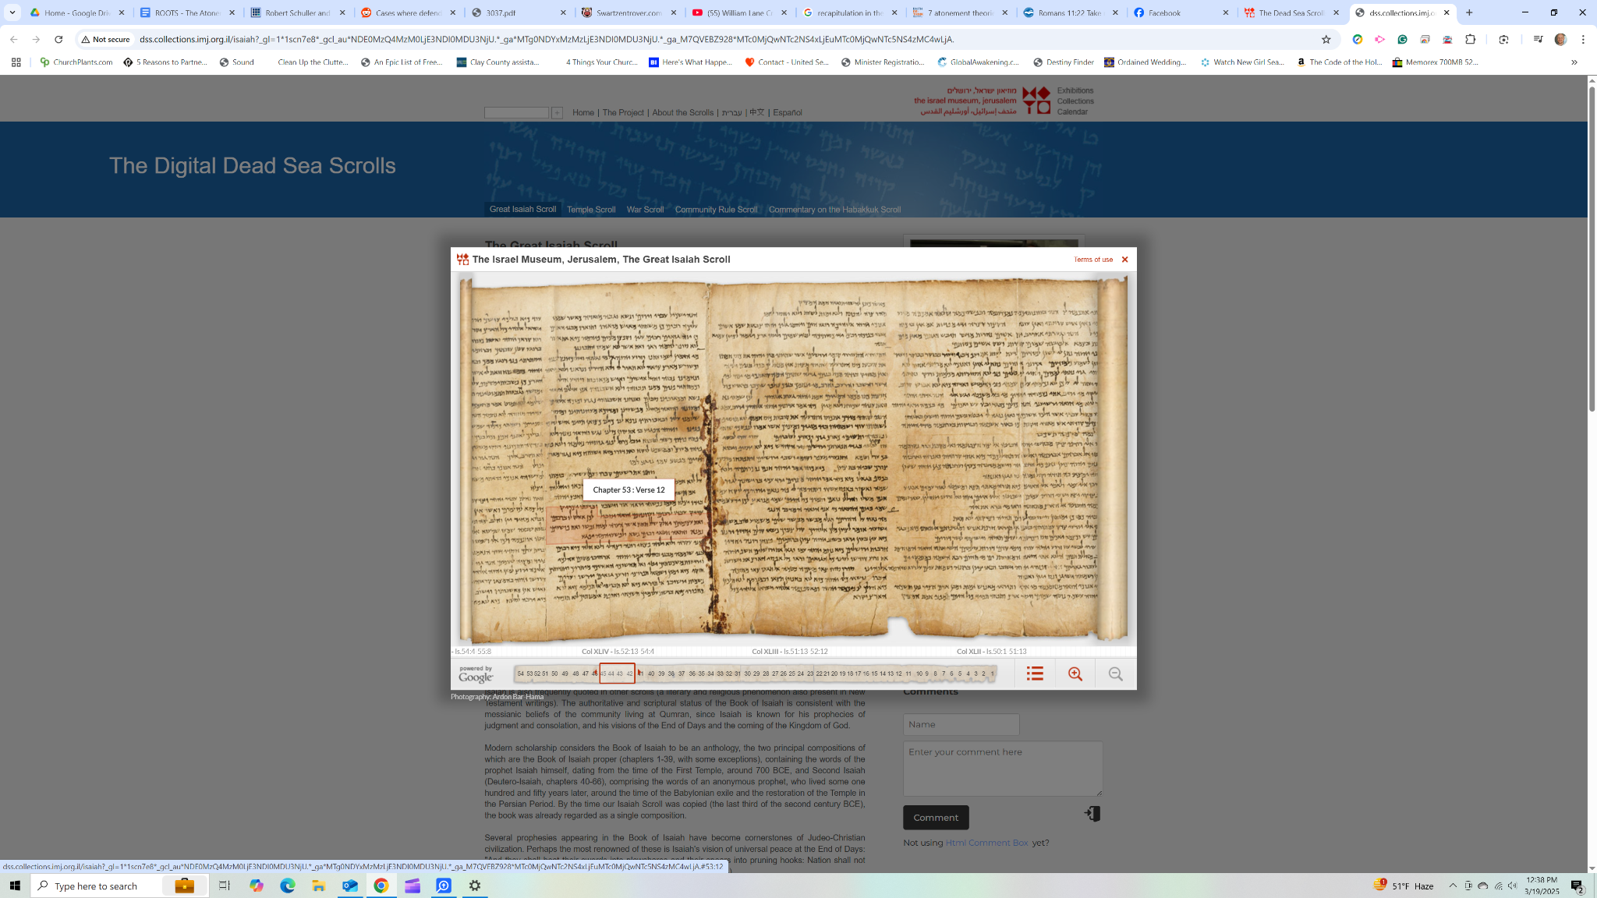
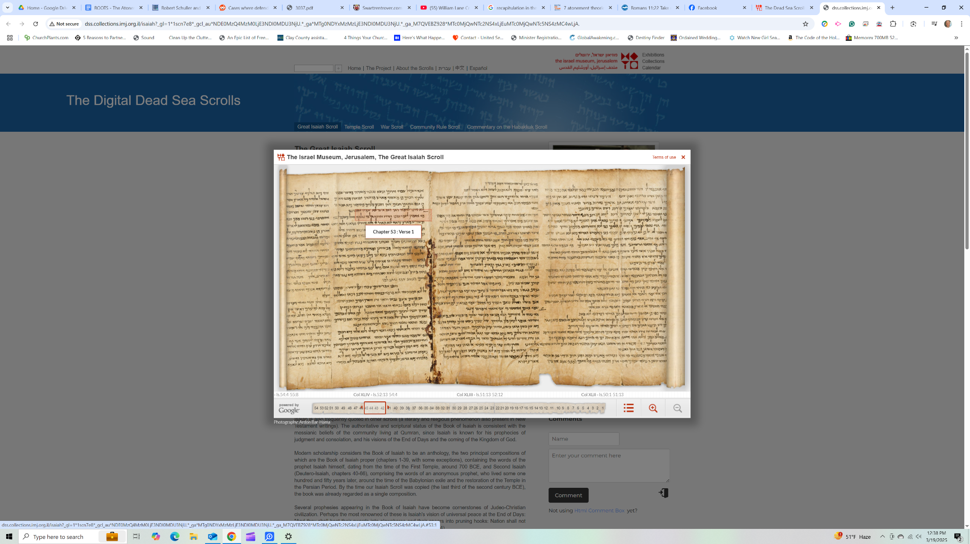
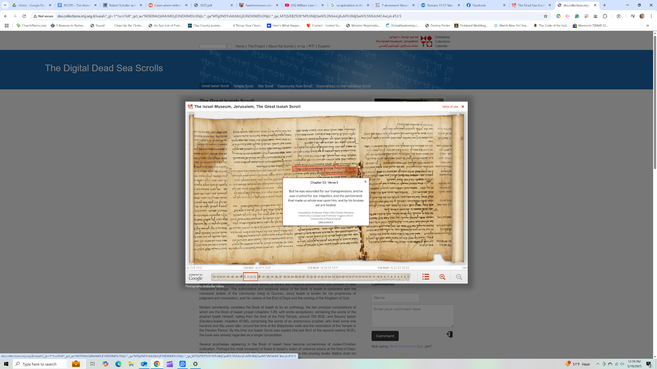

The suffering servant of Isaiah 53

THEORIES _ I don't like this phrase

MAIN:

Christus Victor:
Conquered satan, freed us from death and symptoms of sin
- Ransom is a subset of this, origen affirmed - ransom paid to satan to set us free
- Satan imprisoned us
- Couldn’t be held by satan, had no claim on him
- Tricked!
- Makes the object of Christ’s death, satan
1 john 3:8
Colossians 2

Recapitulation:
To recapitulate is to sum up, review, or restate. The recapitulation theory suggests that in Jesus’ life and death on the cross, God is retelling humanity’s story and as he retells it, God (through Jesus) is reversing the damage done by Adam and Eve, and humanity with it. In the first telling, Adam and the rest of humanity screwed things up by their faithless disobedience, but in this retelling—or summing up version—of the human drama, Jesus brings the human story to its dramatic and hopeful conclusion through his faithful obedience to God. Where Adam missed the mark; Jesus has hit the mark and profoundly turned things around.
Key Scripture passages for this view are Ephesians 1:10 and Romans 5:12-21.

Moral Influence:
Jesus death served as an example to inflame love in our hearts by showing us the lengths God would go to make us right with Him

In the moral example (or moral influence) theory, the goal of Jesus’ death was to “influence mankind toward “moral improvement.” Instead of satisfying God’s justice or honor, Jesus’ death “was designed to greatly impress mankind with a sense of God’s love, resulting in softening their hearts and leading them to repentance.”
Abelard focused instead on God’s love—in particular, that God had demonstrated his love for humanity through the death of Jesus to influence us toward a better way of living. Key Scriptures for this theory are Mark 10:42-45, Romans 12:1-21, Ephesians 5:1-2, and 1 John 3:16.
1 peter 2
Philippians 1 &2

Satisfaction:
Besmirched God’s honor, owe an unpayable debt could never repay. He who owed no debt, gave us an infinite compensatory sacrifice to satisfy the debt
In an attempt to offer a critique to the traditional ransom theory and improve upon it, church theologian, Anselm of Canterbury (1033-1109 AD/CE) created the satisfaction theory of atonement in his book Curs Deus Homo (Why the God man?). Anselm’s biggest critique against the commonly held ransom view was that he saw problems with any suggestion that mankind owed some of kind of debt to Satan. For Anselm, rather than a debt owed to Satan, he believed we owed something God. The debt we owed, he believed, was honor to God.
Romans

PSA:
We were guilty before God, therefore deserving of punishment. Punishment had to be satisfied. Christ could offer to take it in our place because He is sinless, paying the penalty. Free pardon
- Not “new” - language is there from the jump, early church fathers and such
PSA is the rudder that turns the ship to me

Christian Universalist Theory
- Errbody get in, no exception, like a Rob Bell

Substitution can encapsulate both satisfaction and recapitulation. All theories really
Penal can be there
- Gavin Ortulnd all that is penal is substitutionary, but not all that is substitutional
Sub is the broader category

Iraneus and athanasius both affirm a multifaceted view of the atonement - my personal
- Complex problem - multifaceted solution
- Problems of Sin, guilt, wrath, satan, fallen condition

Jesus, as a substitute for me, cleansed me of my sin and satisfied the just wrath of God towards it, He is just and justifier, and I am a recipient of mercy

