We are to believe and follow Christ in all things, including His words about Scripture. And this means that Scripture is to be for us what it was to Him: the unique, authoritative, and inerrant Word of God, and not merely a human testimony to Christ, however carefully guided and preserved by God. If the Bible is less than this to us, we are not fully Christ’s disciples.

The Preacher and God’s Word.
James Montgomery Boice

“3 For I delivered to you [b]as of first importance what I also received, that Christ died for our sins (week 4-5) according to the Scriptures, 4 and that He was buried, and that He was raised on the third day (week 2-3) according to the Scriptures (week 6-7), 5 and that He appeared to Cephas, then to the twelve.”

1 Corinthians 15:3-5

Much of progressive christianity - Marcionism
- Take this part, not that
- a gospel, which was a shorter version of the Gospel of Luke, and ten Pauline epistles.[2][3][6] Marcion's canon rejected the entire Old Testament, along with all other epistles and gospels
- Marcionites held that the God of the Hebrew Bible was inconsistent, jealous, wrathful and genocidal, and that the material world he created was defective, a place of suffering; the God who made such a world is a bungling or malicious demiurge.
- In Marcionite belief, Jesus was not a Jewish Messiah, but a spiritual entity that was sent by the Monad to reveal the truth about existence, thus allowing humanity to escape the earthly trap of the demiurge
- Polycarp, according to Irenaus in his work, Adversus Haereses, had an encounter with Marcion:

- And Polycarp himself replied to Marcion, who met him on one occasion, and said, "Dost thou know me?" "I do know thee, the first-born of Satan."

From Genesis to Revelation

JESUS - recognized the whole of the OT this way
- In the four Gospels, 180 of the 1,800 verses that report His discourses are either Old Testament quotes or Old Testament allusions.

Luke 24:44 Now He said to them, “These are My words which I spoke to you while I was still with you, that all things which are written about Me in the Law of Moses and the Prophets and the Psalms must be fulfilled.” 45 Then He opened their [p]minds to understand the Scriptures,

TNK
Torah (Pentateuch) - First 5, Law
Neviʾim (Prophets)
Ketuvim (Writings)

PAUL
4 For whatever was written in earlier times was written for our instruction, so that through perseverance and the encouragement of the Scriptures we might have hope. 5 Now may the God [b]who gives perseverance and encouragement grant you to be of the same mind with one another according to Christ Jesus, 6 so that with one accord you may with one [c]voice glorify the God and Father of our Lord Jesus Christ. - Romans 15:4-6

14 You, however, continue in the things you have learned and become convinced of, knowing from whom you have learned them, 15 and that from childhood you have known the sacred writings which are able to give you the wisdom that leads to salvation through faith which is in Christ Jesus. - 2 Tim 3:14-15

“Inspiration – the process by which God directed individuals, incorporating their abilities and styles, to produce His message to humankind.”
– J. Scott Duvall and J. Daniel Hays (wrote grasping God’s word)

6 Yet we do speak wisdom among those who are mature; a wisdom, however, not of this age nor of the rulers of this age, who are passing away; 7 but we speak God’s wisdom in a mystery, the hidden wisdom which God predestined before the ages to our glory; 8 the wisdom which none of the rulers of this age has understood; for if they had understood it they would not have crucified the Lord of glory; - 1 cor 2:6-8

- According to Biblical scholar John Warwick Montgomery,
- “to be skeptical of the resultant text of the New Testament books is to allow all of classical antiquity to slip into obscurity, for no documents of the ancient period are as well attested bibliographically as the New Testament.“5

The evidence for our New Testament writings is ever so much greater than the evidence for many writings of classical authors, the authenticity of which no-one dreams of questioning. And if the New Testament were a collection of secular writings, their authenticity would generally be regarded as beyond all doubt. It is a curious fact that historians have often been much readier to trust the New Testament than have many theologians.”

The New Testament Documents: Are They Reliable? 1949, p. 15.
F.F. Bruce

Old Testament scholar Gleason Archer: “Even though the two copies of Isaiah discovered in Qumran Cave 1 near the Dead Sea in 1947 were a thousand years earlier than the oldest dated manuscript previously known (a.d. 980), they proved to be word for word identical with our standard Hebrew Bible in more than 95 percent of the text. The 5 percent of variation consisted chiefly of obvious slips of the pen and variations in spelling.” (The Dead Sea Scrolls | Bible.org)

- Archaeologists have consistently discovered the names of government officials, kings, cities, and festivals mentioned in the Bible — sometimes when historians didn’t think such people or places existed.
- Nelson Glueck states, on the one hand “It may be stated categorically that no archaeological discovery has ever contraverted a biblical reference”,

Some examples:

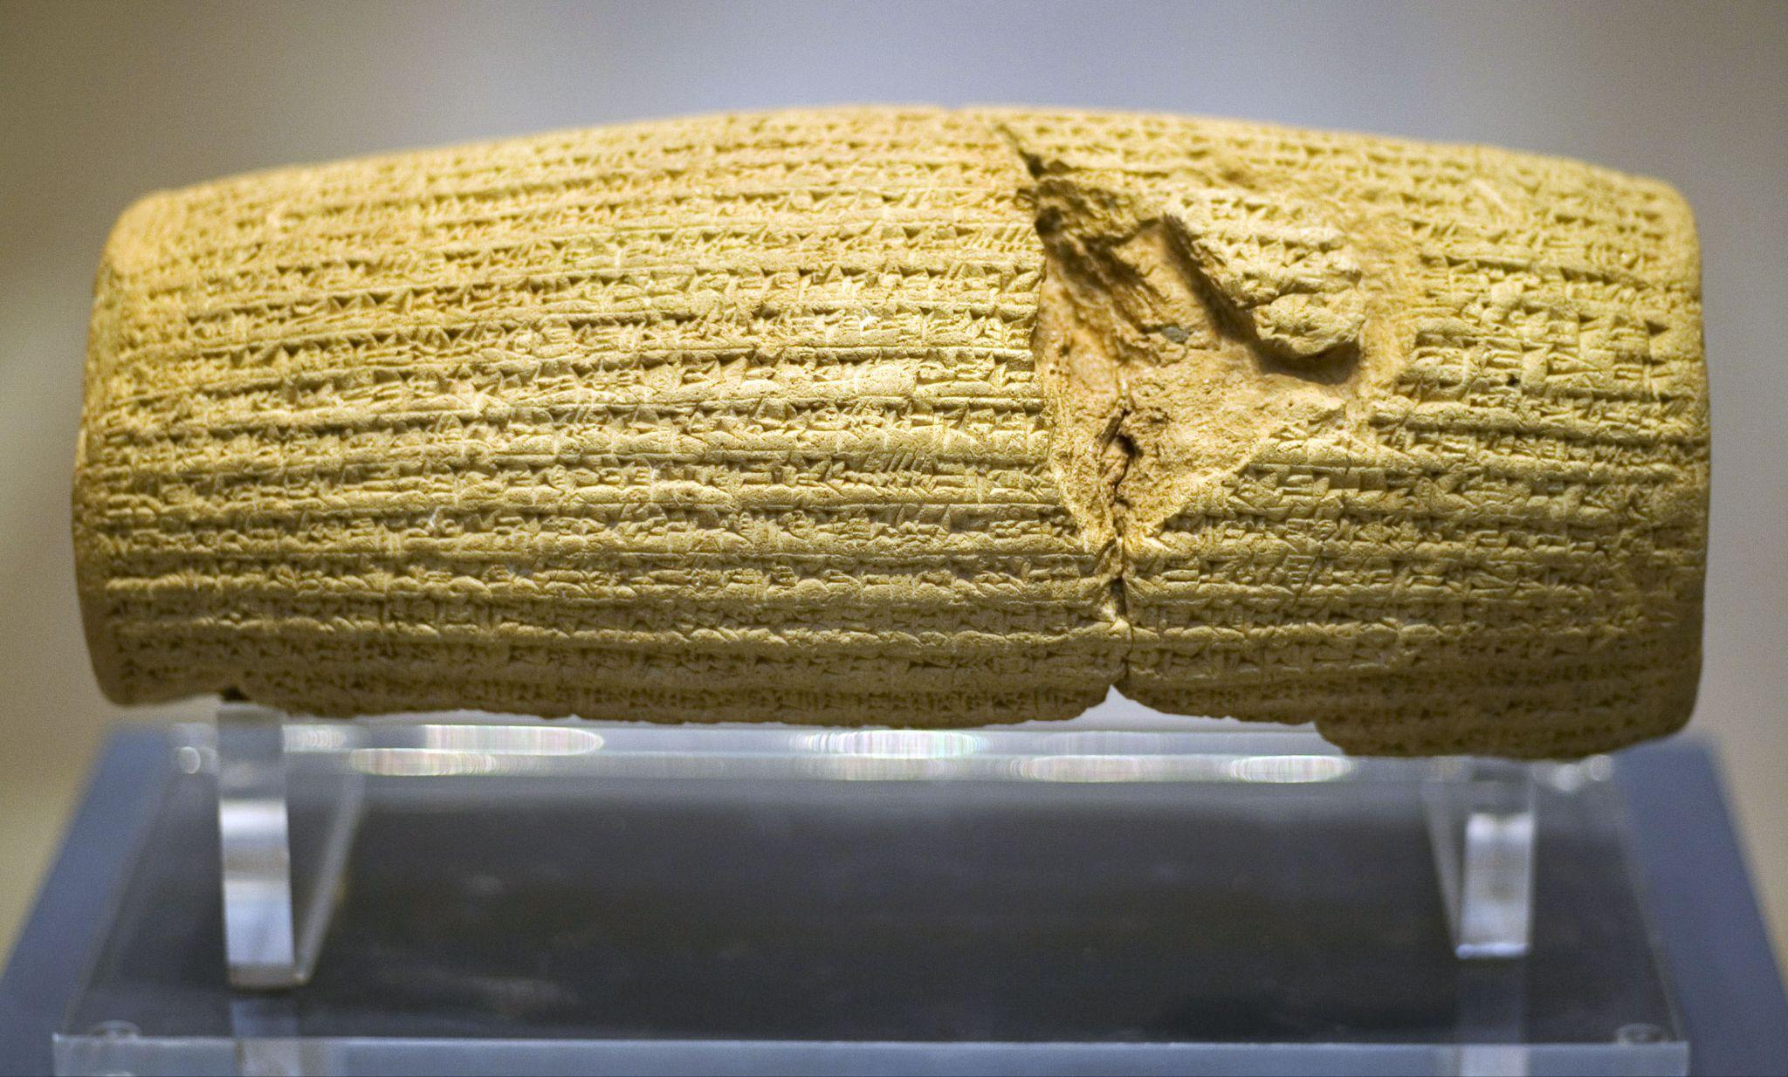
CYRUS CYLINDER (one of my faves)
Authenticates the Biblical description of Cyrus’ decree to allow the Jews to rebuild the temple in Jerusalem (see 2 Chronicles 36:23; Ezra 1:2-4).

2 Chronicles 36:23
New American Standard Bible 1995
23 “Thus says Cyrus king of Persia, ‘The Lord, the God of heaven, has given me all the kingdoms of the earth, and He has appointed me to build Him a house in Jerusalem, which is in Judah. Whoever there is among you of all His people, may the Lord his God be with him, and let him go up!’”
Ezra 1:2-4
New American Standard Bible 1995
2 “Thus says Cyrus king of Persia, ‘The Lord, the God of heaven, has given me all the kingdoms of the earth and He has appointed me to build Him a house in Jerusalem, which is in Judah. 3 Whoever there is among you of all His people, may his God be with him! Let him go up to Jerusalem which is in Judah and rebuild the house of the Lord, the God of Israel; He is the God who is in Jerusalem. 4 Every survivor, at whatever place he may [a]live, let the men of [b]that place support him with silver and gold, with goods and cattle, together with a freewill offering for the house of God which is in Jerusalem.’”

Babylon taken down by persians, just as foretold in Daniel 5 (writing on the wall)
Belshazzar slain

Cyrus tolerant of all religions, sent captives back to rebuild their own temples, Jews included, very diverse kingdom
Cylinder confirms he truly made this decree, tradition of Kings announcing their reforms, He was not as much into forcing everyone into one way of life

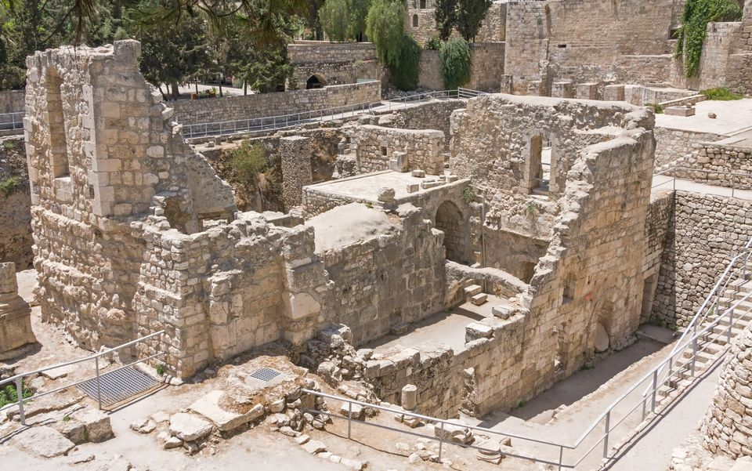
POOL OF BETHESDA
For example, the Gospel of John tells of Jesus healing a cripple next to the Pool of Bethesda. The text even describes the five porticoes (walkways) leading to the pool. Scholars didn’t think the pool existed, until archaeologists found it forty feet below ground, complete with the five porticoes.1

John 5:1-15 describes a pool in Jerusalem, near the Sheep Gate, called Bethesda, surrounded by five covered colonnades. Until the 19th century, there was no evidence outside of John for the existence of this pool and John’s unusual description “caused bible scholars to doubt the reliability of John’s account, but the pool was duly uncovered in the 1930s – with four colonnades around its edges and one across its middle.”[38] Ian Wilson reports: “Exhaustive excavations by Israeli archaeologist Professor Joachim Jeremias have brought to light precisely such a building, still including two huge, deep-cut cisterns, in the environs of Jerusalem’s Crusader Church of St Anne.”[39]

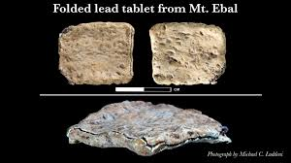
EBAL curse Tablet
In 2022, a research team led by Dr. Stripling from the Associates for Biblical Research (ABR) revealed the discovery of a lead tablet (2 cm by 2 cm) from Mount Ebal that they claim contains the oldest extant Hebrew inscription.7 The tablet was found in 2019 through a project to wet-sift the east dump piles from Zertal’s excavation at Mount Ebal. The archaeological context and epigraphical analysis indicate that the curse tablet (Defixio) is believed to date to the Late Bronze Age II period (c. 1400–1200 BC)

The inscription is a chiastic parallelism and reads,

You are cursed by the god yhw, cursed.

You will die, cursed—cursed, you will surely die.

Cursed you are by yhw—cursed.11

The location and date correspond perfectly to what Scripture states in Deuteronomy 11:29, “And when the Lord your God brings you into the land that you are entering to take possession of it, you shall set the blessing on Mount Gerizim and the curse on Mount Ebal.” According to Deuteronomy 27 and Joshua 8, Mount Ebal was the mountain of the curse (see above).12 If the tablet dates to around 1400 BC, then this would correspond to the conquest of Canaan under Joshua and firmly root the exodus some 46 years before (40 years in the wilderness + around 6 years for the conquest of Canaan), right in the range of 1446 BC, the biblical date of the exodus (see 1 Kings 6:1).

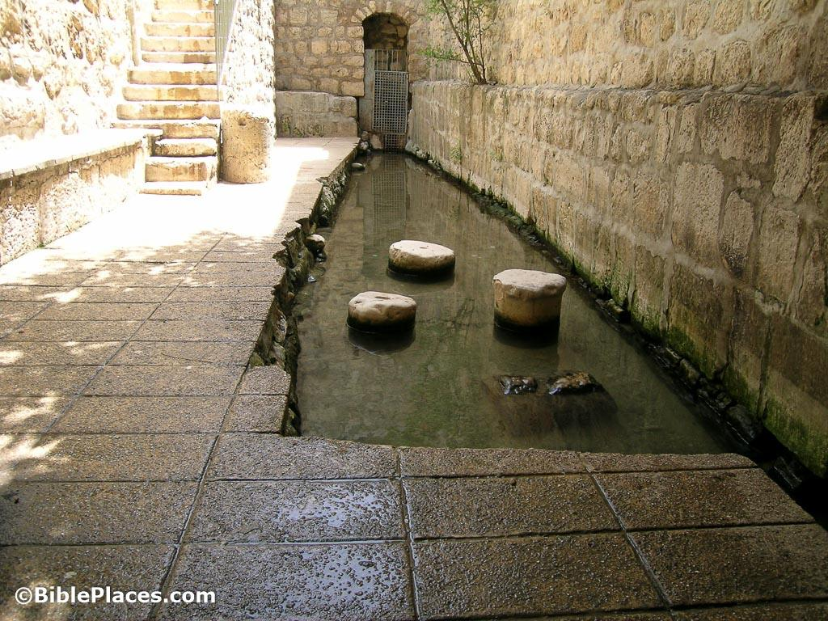
The Pool of Siloam
In the 400s AD, a church was built above a pool attached to Hezekiah’s water tunnel to commemorate the healing of a blind man reported in John 9:1-7. Until recently, this was considered to be the Pool of Siloam from the time of Christ. However, during sewerage works in June 2004 engineers stumbled upon a 1st century ritual pool when they uncovered some ancient steps during pipe maintenance near the mouth of Hezekiah’s tunnel. By the summer of 2005, archaeologists had revealed what was “without doubt the missing pool of Siloam.”[40] Mark D. Roberts reports that: “In the plaster of this pool were found coins that establish the date of the pool to the years before and after Jesus. There is little question that this is in fact the pool of Siloam, to which Jesus sent the blind man in John 9.”[41]

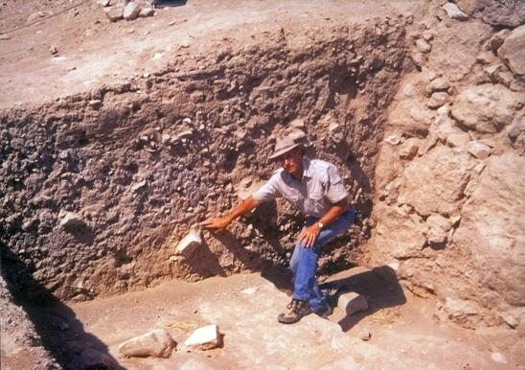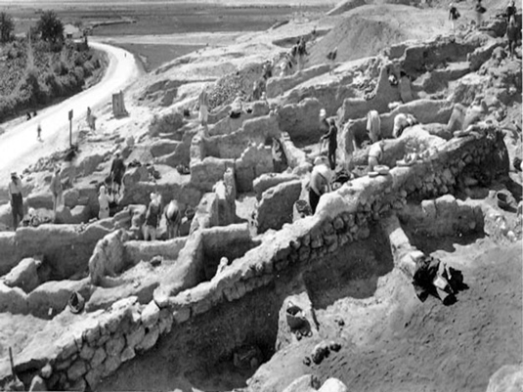
Jericho excavation - myth, not real - yet found, walls crumbled just as stated
Excavations show walls that clearly “imploded” or fell on themselves
Layer of fire damage 1M thick - The Israelites burned the city and everything in it (Joshua 6:24)
The German excavation of 1907–1909 found that on the north a short stretch of the lower city wall did not fall as everywhere else. A portion of that mudbrick wall was still standing to a height of over two meters (eight feet).7 What is more, there were houses built against the wall! It is quite possible that this is where Rahab’s house was.

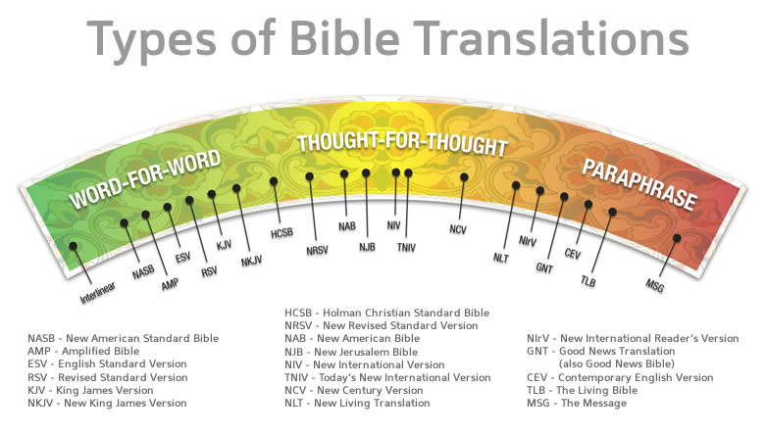

  - Few people doubt Plato’s writing of “The Republic.” It’s a classic, written by Plato around 380 B.C. The earliest copies we have of it are dated 900 A.D., which is a 1,300 year time lag from when he wrote it. There are only seven copies in existence.

  - Caesar’s “Gallic Wars” were written around 100-44 B.C. The copies we have today are dated 1,000 years after he wrote it. We have ten copies.

- We can be more certain of what we read about Jesus’ life and words, than we are certain of the writings of Caesar, Plato, Artistotle and Homer.
- 
 