

Leader’s Guide
2025
Leader’s Guide

CLASS 401:
Discovering My Life Mission
*adapted from the Saddleback Church Model
by Jennifer Cowart
Executive Pastor

A Ministry of Harvest Church

Harvest Church
3322 Highway 41 North
Byron, GA 31008
478.923.8822
www.harvestchurch4u.org

CLASS 401: Discovering My Life Mission
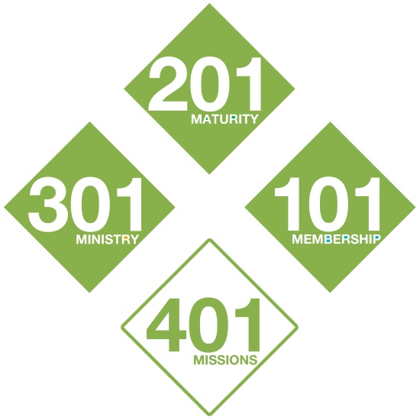
- In CLASS 101 - You committed to being a Member of God’s family.
Attending regularly
Serving
Giving
- In CLASS 201 - You committed to the habits for Spiritual Maturity.
Developing a Quiet Time
Joining a small group
Growing from giving to tithing
- In CLASS 301 - You committed to having a Ministry in our church.
Stepping into leadership
Sharing Harvest DNA
- In CLASS 401 - You will begin to discover your Mission in the world.
Being on mission
This class is the fourth of our basic purpose-driven classes.
Congratulations on making it all around the bases!

The Goal of this Class
To commit the rest of your life to being a messenger of God's Good News to other people, and using your time, talents, and treasure for His Kingdom, regardless of where it leads or what it costs.
“We make it our goal to please Him…” 2 Corinthians 5:9 (NIV)
". . . our goal is to measure up to God's plan for us..."
2 Corinthians 10:13 (LB)

Reminders of Purpose
- We were made to have a __RELATIONSHIP WITH GOD____.
“Long ago, even before He made the world, God chose us to be His very own through what Christ would do for us… His unchanging plan has always been to adopt us into His own family by sending Jesus Christ to die for us.” Ephesians 1:4-5 (LB)
- We were made to ___BECOME LIKE CHRIST_____________.
“God knew what He was doing from the very beginning. He decided from the outset to shape the lives of those who love Him along the same lines as the life of His Son… We see the original and intended shape of our lives there in Him. Romans 8:29 (Msg)
- We were made to __SERVE HIS PURPOSE________________.
“God has made us what we are. In Christ Jesus, God made us to do good works, which He planned in advance for us to live our lives doing.” Ephesians 2:10 (NCV)

Here, Near and Far…Living Life on Mission
“But you will receive power when the Holy Spirit comes on you; and you will be My witnesses in Jerusalem, and in all Judea and Samaria, and to the ends of the earth." Acts 1:8 (NIV)
5 Global Giants | Giant Slayers
- Spiritual Emptiness | P Planting Churches
- Selfish Leadership | E Equipping Servant  Leaders
- Poverty | A Assisting the Poor
- Disease | C Caring for the Sick
- Illiteracy | E Educating the Next  Generation
“Whoever is generous to the poor lends to the Lord, and He will repay him for his deed. “ Proverbs 19:17

“But if anyone has the world's goods and sees his brother in need, yet closes his heart against him, how does God's love abide in him? Little children, let us not love in word or talk but in deed and in truth.“
I John 3:17-18
“Do not be overcome by evil, but overcome evil with good. “
Romans 12:21 (ESV)
“For I was hungry and you gave Me food, I was thirsty and you gave Me drink, I was a stranger and you welcomed Me, I was naked and you clothed Me, I was sick and you visited Me, I was in prison and you came to Me.’ Then the righteous will answer Him, saying, ‘Lord, when did we see You hungry and feed You, or thirsty and give You drink? And when did we see You a stranger and welcome You, or naked and clothe You? And when did we see You sick or in prison and visit You?’ “ Matthew 25:35-45 (ESV)

HERE – in the Local Church
We encourage every individual to identify how they can uniquely be in ministry, in the church. As 301 stresses, we are each gifted and called to serve our brothers and sisters within the local church setting.
Through our tithes the church is able to assist those in financial need every month with practical needs. Our hospital visitation team, casserole team, and prayer team engage with the sick weekly also. Through ongoing on-the-job-training, our goal is for every regular attender to also serve weekly.
- Where are you serving? ___________________________________
- How can you assist further with our church family? ______________________________________________________

NEAR – in our Middle Georgia Community and Nation
Every Community Group, Family and Individual is/are encouraged to identify their unique passion and gifting as to how to be in ministry: Literacy, homelessness, special needs, hunger, parenting, clothing… the list goes on and on.
Additionally, Harvest is investing in coaching Christian leaders. We serve as a teaching church to others who seek to establish communities of faith, to reach those far from God and serve the under-served in our areas.
- How are you called to care for those in our area? ___________________________________________________

FAR – Global Work
As a church family we are involved in several ongoing-projects to help alleviate suffering and bring Christ to those in impoverished areas:
- Wycliffe Translation Projects:
Cree First Nation (Eastern Canada): Develop a written language and then translate the Gospels of Mark into a Cree heart language for 180,000 people.
Katavi: Translating the Gospel of Luke into the heart language of 160,000 Africans in Tanzania.
Jonam: Book of Luke. 200,000 in Northwest Uganda.
- Kenya & Democratic Republic of the Congo:
Church Planting and pastoral training
Water Wells with Green Houses; Eye Surgery Clinics; Famine Relief
- Uganda Initiative:
Church planting, pastoral and laity training
Helping to establish self-sustaining business models in villages of extreme poverty
- Compassion International: Sponsoring 600+ children and the Kiringa Child Development Centers (UG0551).
Jesus’ Commission to Us
Therefore go and make disciples of all nations, baptizing them in the name of the Father and of the Son and of the Holy Spirit, and teaching them to obey everything I have commanded you. And surely
I am with you always, to the very end of the age."
Matthew 28:19-20 (NIV)
“You are to go into all the world and preach the Good News to everyone, everywhere.” Mark 16:15 (LB)

Sharing Your Faith:
Sharing the Good News is our responsibility and privilege.
“Telling the Good News is my duty - something I must do. And how terrible it will be for me if I do not tell the Good News.”
1 Corinthians 9:16 (NCV)
“And God has given us the privilege of urging everyone to come into His favor and be reconciled to Him… This is the wonderful message He has given us to tell others. We are Christ's ambassadors.”
2 Corinthians 5:18b (LB)
“You are the ones chosen by God… God's instruments to do His work and speak out for Him, to tell others of the night-and-day difference He made for you.” 1 Peter 2:9 (Msg)

Faith Sharing:
But in your hearts revere Christ as Lord. Always be prepared to give an answer to everyone who asks you to give the reason for the hope that you have. But do this with gentleness and respect, keeping a clear conscience, so that those who speak maliciously against your good behavior in Christ may be ashamed of their slander.”
1 Peter 3:15-16 (NIV)
- You are the expert on your story; so prepare to tell it well.
Be prepared; be succinct.
Manage your tone and time.
Offer a clear invitation.
Share appropriately who you were and who you are now.
Don’t be negative about other religions or churches.
Avoid mystic images and experiences.
Don’t lecture, argue or fuss.
Remember you have many stories of faith – which is most appropriate to this listener?

- Finding Opportunities to Share
Pray for God to open doors and for courage to walk through them.
Listen for points of pain that lead to sharing.
Ask, “How can I pray for you?”
Apologize to people you’ve known a long time and haven’t shared your faith with.
Ask open-ended questions: “How have you been coping with that?” “Where do you turn for strength to handle this?” Then, after listening, share your power source and offer to pray for them.
Develop life patterns that allow you to invest in genuine friendships with those who do not yet know Christ.
Engage with people who are in pain or transition.
My Testimonies

30-second “Elevator” Testimony

“Personal Experience” Testimonies

1.

2.

3.

Harvest’s 401 Covenant*
Today, I am stepping across the line. I’ve made my choice and it is irrevocable. I will live the rest of my life serving God’s purposes, with God’s people, for God’s glory. I will use my life to celebrate His presence, cultivate His character, participate in His family, demonstrate His love, and communicate His word.
I refuse to waste any more time or energy on shallow living, petty thinking, trivial talking, thoughtless doing, useless regretting, hurtful resenting, or faithless worrying. Instead, I will magnify God, grow to maturity, serve in ministry, and fulfill my mission in the membership of His family.
Because this life is preparation for the next, I will value worship over wealth, “we” over “me”, character over comfort, service over status, and people over possessions, position, or pleasure.
I’ll keep running my race with my eyes on the goal, not the sidelines, nor those running by me. I will live for my audience of One! When times get tough, and I get tired, I won’t back off, back down, back out, or backslide. By God’s grace, I’ll just keep moving forward. I’m spirit-led and mission-focused and I will not compromise.
To my Lord and Savior Jesus Christ, I say:
“Lord Jesus,
However, whenever, wherever and whatever You ask me to do my answer, in advance, is ‘Yes!’ Wherever You lead, whatever the cost, I’m ready. Anytime, anywhere, anyway. Whatever it takes Lord!
I want to be used so that on that final day I’ll hear You say, ‘Well done, thou good and faithful one. Come on in, and let the eternal party begin!’”

