FINISHING THE TASK: AD 2033
Jesus last words must be our first priority!


Goal 3: Help Alleviate Suffering
Most churches are doing many of these things now.
Goal #3 helps us to be more intentional, strategic and cooperative.

Principles
- Partner before you pioneer. Look for existing ministries before creating a new one.
- Serve where there is already trust. Well-run organizations/ministries with established relationships often have greater impact.
- Think “long-term.” Recurring volunteers are usually more valuable than one-time projects.
- Don't just “meet needs” — “build relationships.” Service opens doors for the gospel and discipleship.
- Every believer is a minister…called to a ministry. Look for ways to include the entire church family – Small Groups/Sunday School Classes, men’s/women’s/student’s/kids ministries, believers with special skills/training/life experiences.

Questions Every Church Should Ask
Before launching a ministry, ask:
- Who is already serving this need in our community?
- How can we strengthen their work rather than duplicate it?
- What needs are consistently overlooked?
- Where do our members have unique gifts and expertise?
- How can this service lead to meaningful relationships and opportunities to share Christ?
- Is this something we can sustain for years, not just a single event?

A Helpful Framework
Churches can also think about missions in three simple categories:
- Here – Serving that happens directly in the body of Christ through its members or on campus.
- Near – Partner with ministries across your region or state or local community, such as disaster relief, church planting, regional outreach. schools, nonprofits, shelters, and neighborhoods.
- Far – Support international missionaries, unreached people groups, Bible translation, global church partnerships, and overseas mission trips.
This "Here, Near, and Far" framework helps churches ensure they're engaging in God's mission at every level rather than focusing exclusively on one area.

Community Partnerships
Communicate with local community leaders; do some research. What are the needs in your local community? How can your church family help meet one, or more, of these needs, in the name of Jesus? (We don’t always have to invent everything from scratch ourselves.) What strategic partners are available to work with in your community?

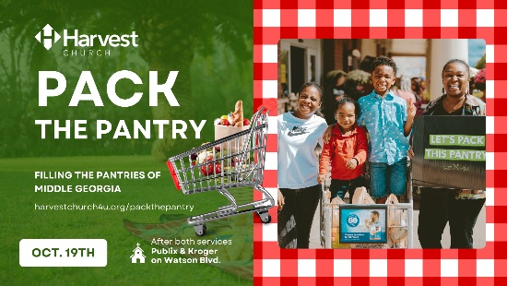
Hunger & Food Insecurity
- Local food banks/Community food pantries
- Soup kitchens
- Meals on Wheels
- Backpack food programs for schools
- Small businesses that want to support their local community
Ideas: Volunteer regularly/consistently; collect food during church events; sponsor shelves or programs; deliver meals

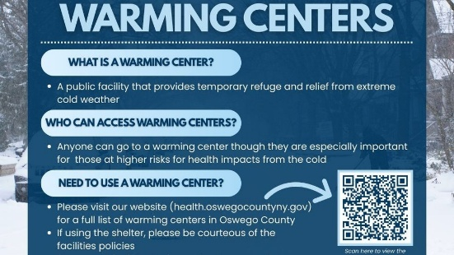
Homelessness
- Homeless shelters
- Transitional housing ministries
- Winter warming shelters
- Day resource centers
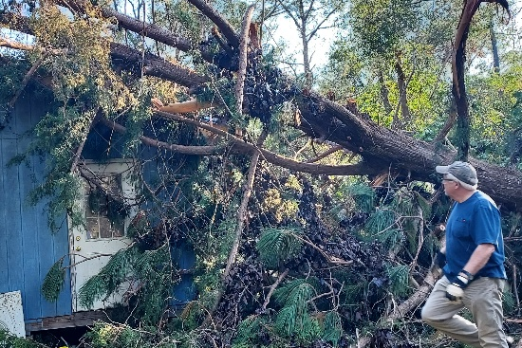
Ideas: Serve meals; provide hygiene kits; offer laundry days; host job readiness workshops. Build relationships through consistent presence.

Disaster Relief
- Salvation Army
- Local emergency management
- Community relief organizations
- GMC Disaster relief team
Ideas: Assemble disaster kits; volunteer after storms;
collect supplies; provide temporary housing and/or meals, offer laundry services.

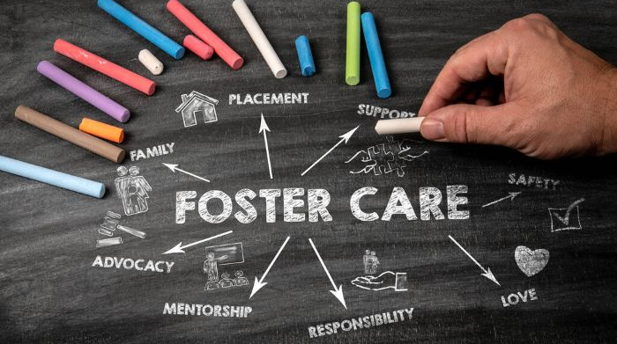
Children & Families
- Foster care agencies
- CASA programs
- Pregnancy resource centers
- Family resource centers
- Big Brothers ~ Big Sisters
Ideas: Become foster families; support foster parents; provide respite care; mentor children; host parenting classes


Schools
Can be tricky to access. It’s often very helpful to form relationships with a teacher/ administrator who helps run an organization like a Prayer Club or FCA.
Ideas: Adopt a school; offer Teacher Appreciation events; host School Supply drives; provide reading mentors; conduct Campus Prayer Walks; sponsor weekend backpack food programs

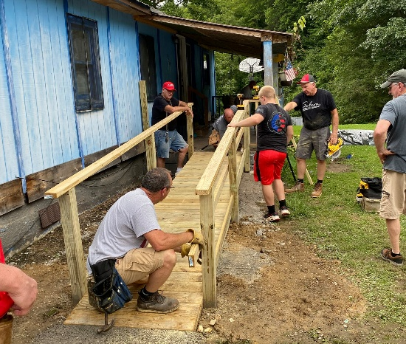
Senior Adults
Often seniors are some of our loneliest and most underserved demographics in the community.
- Nursing homes
- Assisted living facilities
- Senior centers
Ideas: Worship services; game nights; yard work, technology assistance; home repair projects

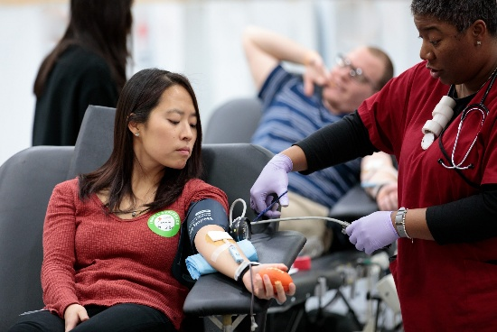
Healthcare
Partner with:
- Hospitals
- Hospice organizations
- Free medical clinics
- Blood donation organizations
Ideas: Waiting room hospitality; prayer ministry; care packages; meals for healthcare workers; transportation assistance

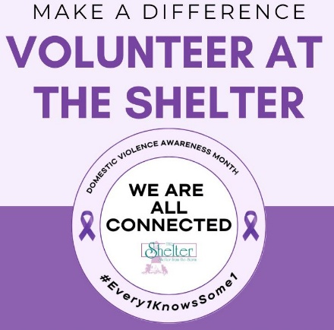
Crisis Support
- Domestic violence shelters
- Human trafficking ministries
- Addiction recovery organizations
- Grief support ministries
Ideas: Donate supplies; serve meals; childcare during classes; support groups; Celebrate Recovery partnerships

Prison Ministry
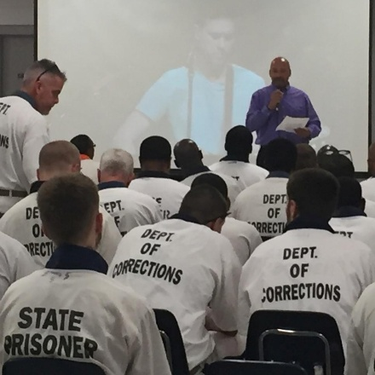
“Then the righteous will answer Him ‘Lord… When did we see You sick or in prison and go to visit You?’ The King will reply, ‘Truly I tell you, whatever you did for one of the least of these brothers and sisters of Mine, you did for Me.’” Matthew 25: 37, 39-40.
God is not done with anyone’s story. No one is beyond redemption. Everyone needs to have an opportunity to hear the gospel and surrender their lives to Jesus as Lord and Savior.
Ideas: Bible studies; letter writing; family support; holiday cards (with postage) for residents to send to family members; re-entry assistance; job mentoring after release


Community Service
Partner with:
- Parks departments
- Neighborhood associations
- Community development organizations
Ideas: Neighborhood cleanups; community gardens; home repairs; painting projects; tree planting

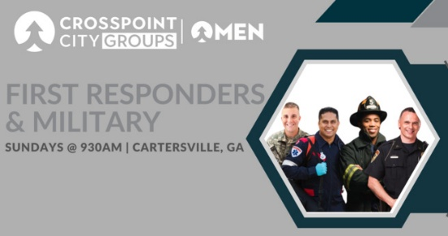
Military/First Responders
Local community support for military personnel, veterans, and first responders plays a vital role in ensuring their well-being (as well as their families’), enhancing public safety, and building resilient neighborhoods.
Ideas: Support deployed families; holiday care packages; meals; childcare, Veteran/First Responder Appreciation


College Students & Young Adults
Partner with:
- Campus ministries
- Local colleges
- International student organizations
Ideas: Free meals; move-in assistance; conversation partners; finals care packages; host families; faith-based entertainment events; safe/fun hang out space

Special Needs

Partner with:
- Local disability ministries
- Schools
- Therapy organizations
Ideas: Respite nights; buddy ministry; accessible VBS; parent support groups

