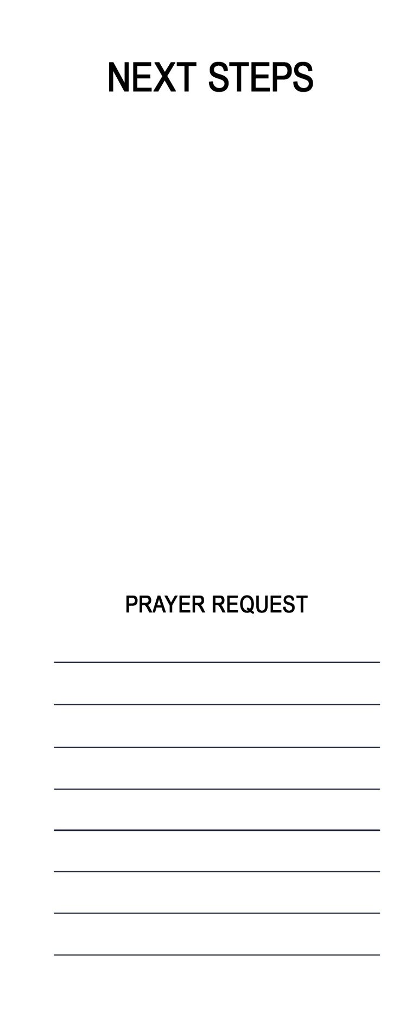
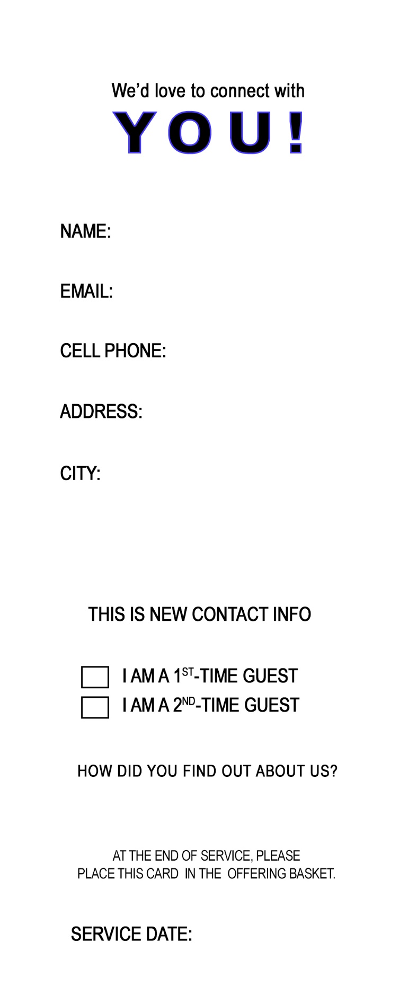
This Week I Will…
- Today, I accept Jesus as my Savior and choose to follow Him.

