SPIRITUAL DISCIPLINES FOR CHRISTIAN GROWTH -
March 22, 2021 10:30 a.m. – 12:00 p.m.
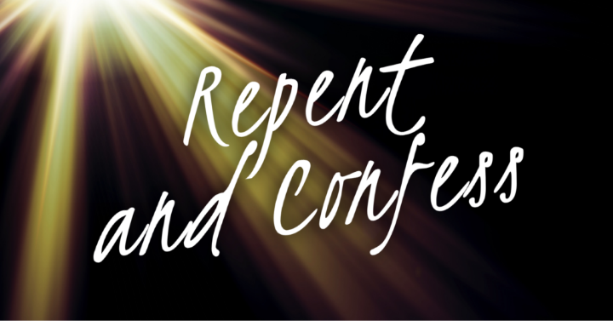
OBJECTIVES:
- List benefits of practicing spiritual disciplines
- Discuss seven (7) elements of biblical repentance.
- Identify down an action or attitude that you have failed to recognize as sin and prayerfully ask the Lord for a different mindset regarding the matter.
- Record (journal) the specific way(s) you will avoid your temptation to commit this sin again.
- Since “access is now granted”, meditate on Pastor’s call to come prepared and ready for corporate worship by praying for hearts that are true and free from harbored sin.

What is meant by the term “spiritual discipline”? Spiritual disciplines are biblical ________ that a believer does to ___________ ___________ in Christ.

Confession and Repentance: Is the discipline of taking responsibility for our actions when we have sinned against God and each other. We need to understand the importance of having a different mindset as it relates to what God expects from us.

Seven (7) Components of Biblical Repentance

Taking responsibility for our sins (1-3)
1 = Seek to know how very deeply my sin offends and hurts God.
- Sin is an insult to God –
  - We were created for good works, not those that offend God - Ephesians 2:10
  - We were created for God’s pleasure and not to hurt Him - Revelation 4:11
2 = Acknowledge that God is completely HOLY; and all my sins offend Him!-
  - How important is God’s holiness to Him?
  - Does mankind understand God’s holiness? – Romans 3:10, 12, 23
  - The call for the church to be holy – Romans 12:1-2; 1 Peter 2:5, 9
3 = Confess my sin explicitly. (What did I do? And why did I do it?)
  - What is sin? 1 John 3:4
  - How did I offend God? What did I do wrong? – Reasons for failing to recognize own sinfulness:
    - Lack of __________ ____________
    - Culture ____________
  - What is confession?
  - Why should we confess? – James 5:16
  - How do we confess? – Psalm 51:3-4, Isaiah 59:2, Hebrews 12:10
  - Why we do not confess when we know we have done wrong

Different mindset as it relates to what God expects from us. (4-7)
4 = Ask God to help me HATE my sin the way He does.
  - God hates sin – Proverbs 15:9
  - How can I hate sin too – Psalm 97:10, 1 John 2:15, Romans 12:9
    - Draw near to Him – James 4:8
    - Realize what sin does – it enslaves – Romans 6:17-18
    - Focus on Christ’s sacrifice – Romans 5:8
5 = Live my change. (What are the specific “fruits” of my repentance? What is different now?). When there is true repentance, there is proof, Matthew 3:8. According to 2 Corinthians 7:10, what are the seven (7) fruits of true repentance?

- ________________ b. ________________

c_________________ d. ________________

e. ________________ f .________________

g. ________________
6 = Identify and record (journal) specific ways to avoid my inevitable temptation to commit this sin again – Proverbs 4:14-15
- Understand your own personal w______________
- Flee t______________
- Use the power of the H__________ S___________
- Hide God’s W _______ in your h___________
- Love G______ more than you love your s______
- P__________!
- Find an a___________ p_________
7 = Thank God for making His deliverance from sin real and for giving me the grace to love Him more – Benefits of disciplining yourself to consistently confess and repent of your sins.
- F________________ 1 John 1:9

- Restored J________ Psalm 51:12

- Deeper L______ of God’s ways Psalm 37:4

- Refreshed F________ with God Acts 3:19

- Greater love of God’s W_____ Psalm 119:47

RIGHTNOW MEDIA RESOURCES - https://www.rightnowmedia.org/

https://www.rightnowmedia.org/Training/Post/View/217391?p=229053 (3 min)
https://www.rightnowmedia.org/Training/Post/View/81042 (5 min.)
https://www.rightnowmedia.org/Training/Post/View/42746 (35 min)
https://www.rightnowmedia.org/Content/illustration/139859 (4 min)
https://www.rightnowmedia.org/Content/VideoElement/98682 (4 min)
https://www.rightnowmedia.org/Content/illustration/99563 (3 min)

