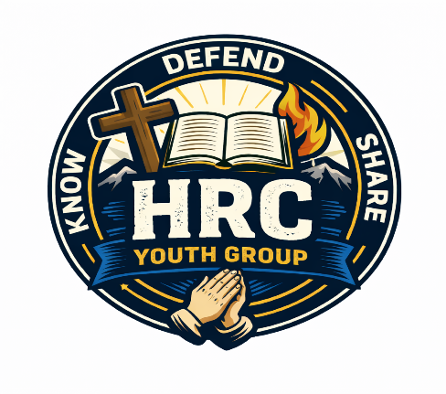
Female High School Small Group Leader

VISION
Helping Students, Know, Defend, and Share Jesus Christ
THE WIN
Connecting with a female student and helping them have a personal relationship with Jesus Christ
DID YOU KNOW?
High school girls need godly female role models who believe in God, believe in them, and show them what faith looks like in everyday life.
ACCOUNTABILITY
Is served and led by Youth Director, Louis Arocho
COMMITMENT
Attend Youth Group 4:30pm-6:00pm.
1 Hour of communication throughout the week with Parents or Students
30 minutes of prep work.
1 Monthly Meeting for 1 hour with Louis.
Weekly Commitment: 3 hours
Monthly Commitment:13 hours.
Additional Hours: Fundraisers, Day Trips, and Retreats. Committing 4 Events per Year
QUALIFICATIONS
- Supports HRC’s mission of knowing Christ and Making him Known
- Embraces the vision of HRC Youth Group
- Has completed the small Group Training and Onboarding (including background check)
- Has a personal relationship with Jesus Christ
TOP 4 DURING THE WEEK | TOP 4 ON SUNDAY
Communicate with your students and parents outside Youth Group  Care for your students  Prepare for your small group- Programming Emailed Every Monday  Continue personal spiritual growth | Provide a Safe environment for students  Lead your small group  Ensure a great small group Experience  Connect with students and parents
Turn Page

BEST PRACTICES
- Pray regularly for your few
- Have your attention focused on your few while you are with them
- Follow up with your few and parents regularly. (Once a month for each student and parent min.)
- Make yourself available to your few outside of regularly scheduled group events. Meet

RESPONSIBILITIES
- Arrive on time at scheduled HRC Youth Group gatherings
- Create a safe and welcoming environment for students
- Have regular and open communication with parents of students in your group
- Connect relationally with students in your group
- Plan ahead and be prepared for each small group meeting
- Attend Monthly Leader Meetings with Youth Director

