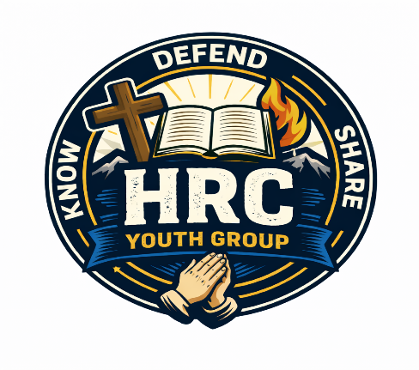
HRC Youth Medical & Safety Officer

VISION
Helping Students, Know, Defend, and Share Jesus Christ
THE WIN
Create a safe, prepared, and trustworthy environment where students and parents feel confident that health needs and safety protocols are taken seriously at every youth gathering and event.
DID YOU KNOW?
Parents entrust us with what is most valuable to them. Strong medical awareness and safety practices build trust and allow students to focus fully on connection, growth, and fun.
ACCOUNTABILITY
Is served and led by Youth Director, Louis Arocho
COMMITMENT
1 Hour Per Week calling parents to obtain medical information for each student and ensure that students are feeling safe at weekly sessions and events.
Attend 1 Youth Group Session every quarter to audit safety procedures
1 Hour Per Month making sure monthly event has all the necessary Safety precautions and medicine needed for specific Child.
Weekly Commitment 1 Hour
Monthly Commitment 2.5 Hours.
QUALIFICATIONS
- Fully supports the mission and vision of HRC Youth Group
- Highly organized and detail-oriented
- Comfortable handling confidential medical information
- Experience in healthcare, first aid, or emergency response is strongly preferred
- Has completed the volunteer onboarding process (including background check)
- Familiar with or willing to learn Subsplash systems

TOP 4 DURING THE WEEK | TOP 4 ON SUNDAY
Review and maintain student medical information in Subsplash  Update allergy and medical condition records as needed  Prepare safety plans for upcoming events and trips  Communicate with leadership regarding any medical or safety concerns | Ensure emergency medical information is accessible  Monitor safety procedures throughout the building Be available for any medical or health-related needs  Watch for hazards or unsafe behavior and correct immediately
BEST PRACTICES
- Treat all medical information with confidentiality and care
- Double-check accuracy of medical records
- Be proactive rather than reactive about safety
- Maintain a calm, reassuring presence
- Regularly review emergency protocols

RESPONSIBILITIES
- Maintain accurate and up-to-date medical records for all students in Subsplash, including: Schedule volunteers for:
  - Allergies
  - Medical conditions
  - Emergency contact information
  - Medication requirements
  - Insurance Information
- Ensure all medical information is properly collected during student registration and onboarding
- Work with the Check-In Team to verify that new students have completed required medical information
- Distribute emergency medical information during:
  - Weekly youth group meetings
  - Trips, retreats, and special events
- Maintain first aid supplies and ensure they are stocked and accessible
- Assist in creating and enforcing safety policies and emergency procedures
- Coordinate with Event & Volunteer Coordinator on safety staffing for trips and off-site events
- Serve as the primary point of contact for any medical or safety incidents
- Log incident reports when necessary and communicate with parents and leadership

