PERSEVERANCE CHRISTIAN CHURCH
~Disciples of Christ~
~Rev. Donna Webster ~
October 18, 2026
Pianist
Prelude
(The prelude is a musical curtain drawn between the cares of the world and us. Let these moments prepare us for worship by opening our hearts to God’s presence as we meditate.)
Lighting of the Candles
GATHERING THE PEOPLE OF GOD
*Call to Worship................................“Sanctuary”..............................................655
*Invocation...............................................................................Beverley Hawthorne
*Opening Hymn...........................“Holy, Holy, Holy”............................................3

PRAYING TO GOD
Welcome and Announcement..................................................Beverley Hawthorne
Prayer Concerns.......................................................................Beverley Hawthorne
Meditation and Morning Prayer.............................................................Will Daniel

COMMUNING WITH GOD
Communion Hymn...................“Let Us Break Bread Together”........................460
Sharing of the Bread & Cup.....................Everyone is welcome at the Lord’s table,
we partake together after all are served.

GIVING THANKS TO GOD
Offertory Prayer........................................................................Beverley Hawthorne
Offering
*Doxology.............................................Praise God from Whom All Blessings Flow

LISTENING TO GOD
Special Music
Scripture
Message................................“Stepping Out of Our Comforts”...............Will Daniel

SENDING FORTH THE PEOPLE OF GOD
*Hymn of Invitation..............“Softly & Tenderly Jesus is Calling”....................479
*Benediction


Welcome to Perseverance Christian Church on this THIRD Sunday in OCTOBER! We provide a nursery for children ages four and younger; it and the restrooms are located in the hallway behind the sanctuary’s left and right doors. Additionally, there is a chairlift for anyone in need, and it may be accessed to the left door of the men’s restroom. We are live-streaming our Worship Service to reach those unable to attend in person. Service recordings are available on our website at www.perseverancecce.org, in our PCC mobile app, or on our Facebook page. Come back and worship with us again!

Board Member assigned to assist the financial secretary in counting the offering are
Charlie Pegram today and Taylor Robbins next Sunday.

Announcements:

TODAY: Praise Choir – 6 PM

WEDNESDAY– Bible Study – 6:30 PM – Read Chapter 5

Lunenburg County Ministry needs the following items - spam, Vienna sausages, beans and franks, chicken, ham, potted meat. Variety packs oatmeal, peanut butter. Spinach, green peas, chicken noodle soup.

The Fellowship of Christian Athletes (FCA) at the Middle School and High School, directed by Kaitlyn Wallace, is requesting new or gently used Bibles for students who do not own one. There is a box downstairs (across from the copy room).

SAVE THE DATE: Saturday, November 7th at 5:30 p.m. Special Showing of the Series "The Chosen," in the Sanctuary for the Season 6 Premiere – Episode 1. The series will premiere on Amazon Prime on November 15th.

November 25th-Community Thanksgiving Service at Rosebud Baptist Church at 7:00 p.m. Rev. Dr. Jonathan Webster, preaching. Perseverance provides the Music.

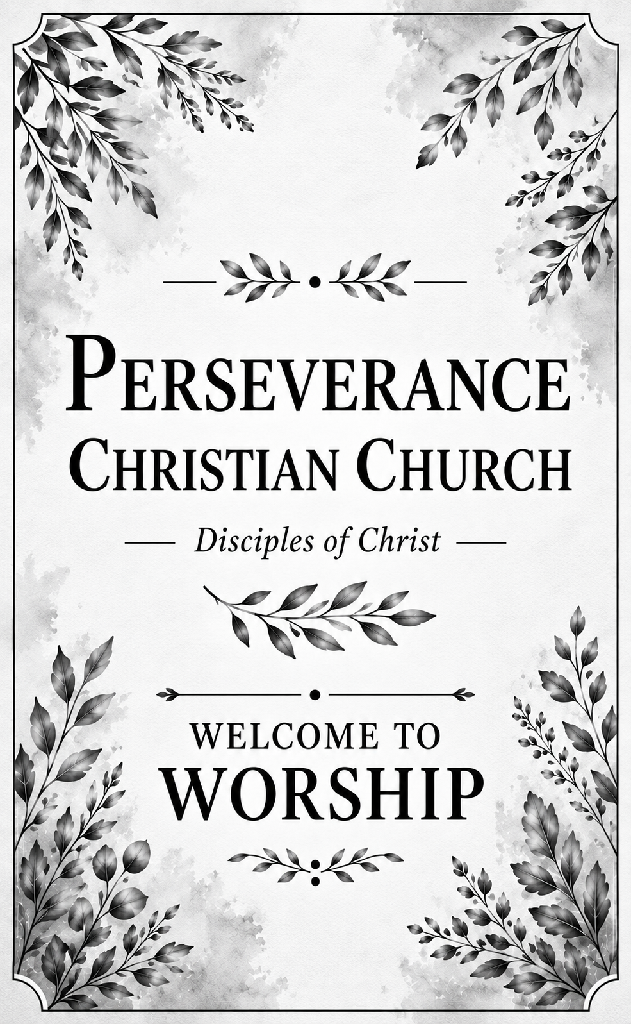
Prayer List:
- Billy Wilkinson
- Blair Liggett
- Carol Watson
- Charles Hudson Jr.
- Craig Stewart
- Curtis Craft
- Danny and Edna Moore
- Edgar Rice (Doris' cousin)
- Frankie Tanner
- Gayle Edmonds
- Gregory Dean Watson
- Jimmy Atkinson
- Kathy Pegram
- Margie Coleman
- Pamela James
- Reggie Callis
- Rick and Lynn Pollhammer
- Ricky Allgood
- Steven Lucy
- Sue Palmer
- Sue Perkins
- Virginia Chavis
- Wayne Neil
- Wayne Parrish
- Our Neighbors at Heritage Hall

Family Of:
- Becky Daniel
- Jackie Williams
- Thomas Smith

