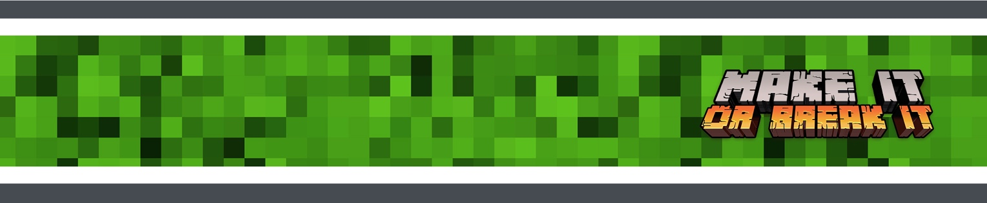
GROW AT HOME

Hey, families! Here’s a look at what we’re covering with your kids this month so you can help your kids continue growing at home during the week.

GROW AT HOME THIS MONTH

WEEK 1
This week, kids learn about how God created the world in the beginning.

- BIG IDEA: God makes good things.
- BIBLE: Genesis 1:1-2:4a

WEEK 2
This week, kids learn about the fall of the first humans and how God still cared for them.

- BIG IDEA: God unbreaks what’s been broken.
- BIBLE: Genesis 3

MEMORY VERSE: " For every house is built by someone, but God is the builder of everything.” — Hebrews 3:4 (NIV)
Click here for a memory verse sign language tutorial video you can share with your families and volunteers!

WEEK 3
This week, kids learn about what happened between Cain and Abel.

- BIG IDEA: God made us different on purpose.
- BIBLE: Genesis 4:1-16

WEEK 4
This week, kids learn about how people built the Tower of Babel, and how God responded to it.

- BIG IDEA: We can honor god with the things we make.
- BIBLE: Genesis 11:1-9

