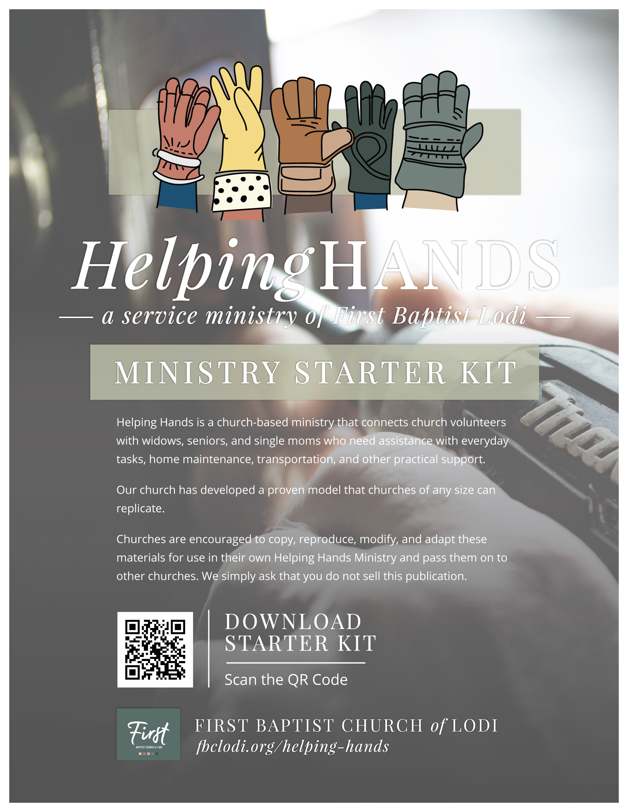

Helping Hands Ministry Starter Kit
Welcome! We're grateful that you're exploring the possibility of launching a Helping Hands Ministry in your church.
This Starter Kit was developed by First Baptist Church in Lodi, California (FBC Lodi) to help churches establish a practical care ministry that serves widows, seniors, single mothers, and others within the church family who could benefit from a helping hand.
The Helping Hands Ministry connects skilled and caring church volunteers with church members who need assistance with everyday tasks such as transportation, minor home repairs, technology support, meals following medical procedures, yard work, and other practical needs. More than simply meeting physical needs, this ministry creates opportunities to build relationships, encourage one another, pray together, and demonstrate the love of Christ through acts of service.
Over the past three years, Helping Hands at FBC Lodi has responded to more than 450 requests for assistance. It has been a tremendous blessing to serve our church family, build meaningful friendships, and witness countless examples of God's faithfulness. Time and again, we have seen God work through ordinary people who were willing to answer His call to serve others.
It is our prayer that God will use this Starter Kit to equip churches in our community, across our state, and beyond to launch their own Helping Hands Ministries. Imagine the impact if churches everywhere became known for caring for those in need with compassion, generosity, and the love of Christ.
This Starter Kit contains the forms, processes, templates, and practical guidance you will need to establish a Helping Hands Ministry in your own church. We pray this ministry model will save you time, encourage your leadership, and help you build a ministry that blesses your church family for years to come.
For questions about implementing Helping Hands at your church, contact us at (209) 334-1332.
Sincerely,

First Baptist Church Lodi, CA
"Religion that is pure and undefiled before God the Father is this: to visit orphans and widows in their affliction, and to keep oneself unstained from the world." James 1:27


Executive Summary
The Helping Hands Ministry Starter Kit provides churches with a practical, proven framework for establishing a ministry that connects volunteers with church members who need assistance with everyday tasks and short-term practical needs.
Developed and refined through the Helping Hands Ministry at First Baptist Church of Lodi, this guide shares the systems, forms, processes, and lessons we have learned while serving our church family. Rather than creating everything from the ground up, your church can adapt these resources to fit your own ministry, leadership structure, and congregation.
The Starter Kit is organized into nine phases that walk church leaders through the process of launching and operating a Helping Hands Ministry. It also includes sample forms, volunteer resources, operational tools, safety guidelines, frequently asked questions, and practical lessons learned through real ministry experience.
Inside you will find:
- A step-by-step ministry implementation plan
- Leadership recommendations
- Volunteer recruitment and coordination tools
- Communication and dispatch procedures
- Volunteer and recipient tracking examples
- Safety, liability, and risk management guidance
- Sample forms and ministry templates
- Lessons learned and ministry testimonies
- Frequently Asked Questions

Whether your church is large or small, the Helping Hands model can be adapted to meet your congregation's unique needs. Our prayer is that this Starter Kit equips your church to organize volunteers effectively, care for people compassionately, and strengthen the ministry of serving one another in the love of Christ.
Churches are encouraged to copy, reproduce, modify, and adapt these materials for use in their own Helping Hands Ministry and pass them on to other churches. We simply ask that you do not sell this publication.

Launching the Ministry
We have developed a phased plan to guide you through launching a Helping Hands Ministry. Some of the systems and guidelines in this Starter Kit were adapted from other churches and modified to fit our church’s size and needs. We encourage you to make any changes necessary to fit the character and size of your church.

Phasing Plan:
Phase 1: Helping Hands Ministry Step-by-Step Overview Page 5
Phase 2: Obtaining Church Leadership Approval Page 7
Phase 3: Build Ministry Leaders Page 9
Phase 4: Set Up the Communication System Page 12
Phase 5: Recruit Volunteers Page 13
Phase 6: Build a Volunteer Roster Page 17
Phase 7: Build a Dispatch Listing Page 18
Phase 8: Safety, Liability, and Insurance Page 19
Phase 9: Launching and Promoting the Helping Hands Ministry Page 23

Attachments:
Attachment A: Volunteer Recruitment Form Page 27
Attachment B: Volunteer Instruction Sheet Page 28
Attachment C: Recipient Information Sheet Page 29
Attachment D: Helping Hands Refrigerator Magnet (Example) Page 30
Attachment E: Lessons Learned and Testimonies Page 31
Attachment F: Volunteer Roster on Google Drive (Example) Page 33
Attachment G: Dispatch Listing on Google Drive (Example) Page 34
Attachment H: Frequently Asked Questions (FAQ) Page 35
Phase 1: Helping Hands Ministry Step-by-Step Overview
The Helping Hands Ministry exists to demonstrate the love of Jesus Christ by providing practical assistance to seniors, widows, single mothers, and others in need within our church family. Through compassionate service, the ministry seeks to:
- Demonstrate the love of Christ through acts of service.
- Support recipients who desire to live independently.
- Provide practical assistance with everyday needs.
- Connect church members with meaningful volunteer opportunities.
- Strengthen relationships within the church family through caring and service.

Step 1 – Recipient Requests Assistance
The church member in need contacts the Helping Hands Ministry by calling the dedicated Helping Hands phone number, available 24 hours a day, 7 days a week.
Step 2 – Call Is Received
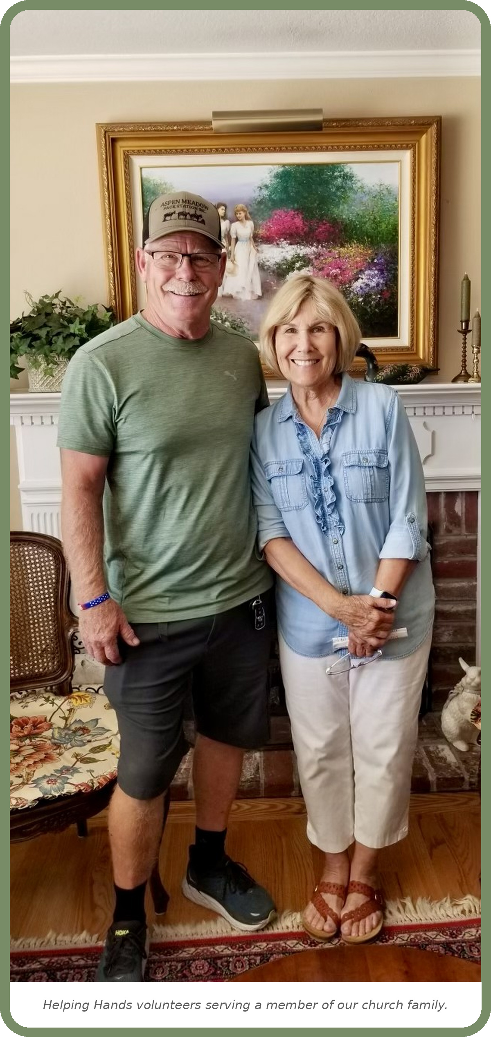
The incoming call is handled by one of the following:
- A professional answering service (recommended)
- For smaller churches, the church administrative
assistant may answer calls during office hours.

Step 3 – Coordinator Notification
The answering service immediately notifies the Helping
Hands Coordinators via:

- Text message
- Email
- Or both

Step 4 – Coordinator Contacts the member in need
One coordinator accepts responsibility for the request
by replying to the group notification.

The coordinator then:
- Contacts the member in need
- Gathers all necessary information
- Determines the type of assistance needed
- Establishes the urgency of the request
Step 5 – Volunteer Assignment
The coordinator assigns a volunteer to complete the requested service.
Step 6 – Volunteer Contacts the Senior
The assigned volunteer contacts the member in need to:
- Introduce themselves
- Schedule a convenient service date and time
- Confirm the requested assistance

Step 7 – Service is Performed
The volunteer completes the requested service safely, professionally, and with Christ-like compassion.
Step 8 – Completion Notification
Once the work is completed, the volunteer notifies the Helping Hands Coordinator that the request has been fulfilled.
Step 9 – Documentation
The coordinator records the completed request on the Dispatch Listing, including:
- Date of request
- Member's name
- Type of service provided
- Assigned volunteer(s)
- Completion date
- Notes or follow-up needed

Goal of the Ministry
The Helping Hands Ministry provides a simple, organized process that ensures every request for assistance is handled promptly, compassionately, and efficiently. By working together, coordinators and volunteers help meet practical needs while reflecting Christ's love and strengthening the bonds within our church family.
“As each has received a gift, use it to serve one another…”1 Peter 4:10

Phase 2: Obtaining Church Leadership Approval
Before launching the Helping Hands Ministry, it is essential to gain the support and approval of church leadership. A ministry that is aligned with the church's mission, values, and leadership structure will have a stronger foundation for long-term success.
Present the Helping Hands Ministry Concept to Church Leadership
- Clearly communicate the ministry's mission, vision, and biblical foundation.
- Explain the purpose of the ministry and the types of assistance that may be provided.
- Share how the ministry complements the church's overall mission and existing outreach efforts.
- Present anticipated benefits to church members.
- Discuss how requests for assistance will be received, evaluated, approved, and documented.

Identify Ministry Coordinators
Select individuals who demonstrate:
- A growing and mature Christian faith.
- A servant's heart and compassion for people in need.
- Good judgment, wisdom, and discernment.
- Integrity, confidentiality, and trustworthiness.
- Strong communication and organizational skills.
- Experience in ministry, community service, financial stewardship, or case management is beneficial.
- The ability to work well with pastors, deacons, and other ministry leaders.

Establish a Ministry Budget
- Determine the annual operating budget for the ministry.
- Discuss whether assistance will be funded through the church's Deacons Fund, Benevolence Fund, designated offerings, grants, or special donations.
- Establish spending limits and approval levels.
- Create financial accountability procedures, including documentation and reporting.
- Determine who has authority to approve expenditures and under what circumstances.
- Develop a process for replenishing ministry funds as needed.

Determine Liability and Risk Management Requirements
- Review church insurance coverage related to volunteer activities and benevolence ministries.
- Determine whether background checks are required for volunteers.
- Develop policies to protect both volunteers and recipients.
- Establish confidentiality guidelines for handling sensitive personal and financial information.

Phase 3 – Building the Helping Hands Ministry Team
A successful Helping Hands Ministry depends on dedicated leaders and volunteers who are committed to serving others with excellence and compassion. Establishing clear roles and responsibilities ensures every request is handled efficiently while maintaining accountability throughout the ministry.
Ministry Leadership Structure
The Helping Hands Ministry consists of the following leadership positions:
Ministry Director
Provides overall leadership, vision, and accountability for the ministry.
Helping Hands Coordinators
Serve as the primary point of contact for incoming service requests and oversee each project from beginning to completion. Provides administrative and organizational assistance by maintaining records, updating volunteer information, preparing reports, and assisting with ministry communications.

Ministry Director Responsibilities
The Ministry Director provides spiritual and administrative oversight for the Helping Hands Ministry by:
- Overseeing all ministry operations
- Casting the vision and direction of the ministry
- Reporting ministry activities to church leadership
- Working with the Deacon Board to approve ministry expenditures
- Reviewing and updating ministry policies and procedures
- Recruiting and developing coordinators and volunteers
- Evaluating ministry effectiveness and identifying opportunities for growth
- Promoting the ministry within the church

Helping Hands Coordinator Responsibilities
Coordinators manage each service request from the time it is received until it is completed.
Responsibilities include:
- Receiving requests from the answering service by text, email, or phone
- Contacting the recipient to gather additional information
- Evaluating the type and urgency of the request
- Determining whether the request falls within ministry guidelines
- Selecting and assigning appropriate volunteers
- Scheduling service appointments
- Monitoring project progress
- Maintaining communication with volunteers and the recipient
- Conducting follow-up after the project is completed
- Completing all required documentation
- Maintaining the Dispatch Listing

Coordinator Operating Instructions
1. Receive the Request
- Monitor text messages and emails from the answering service.
- Respond to the coordinator group, indicating you will handle the request.
- Contact the member in need promptly.
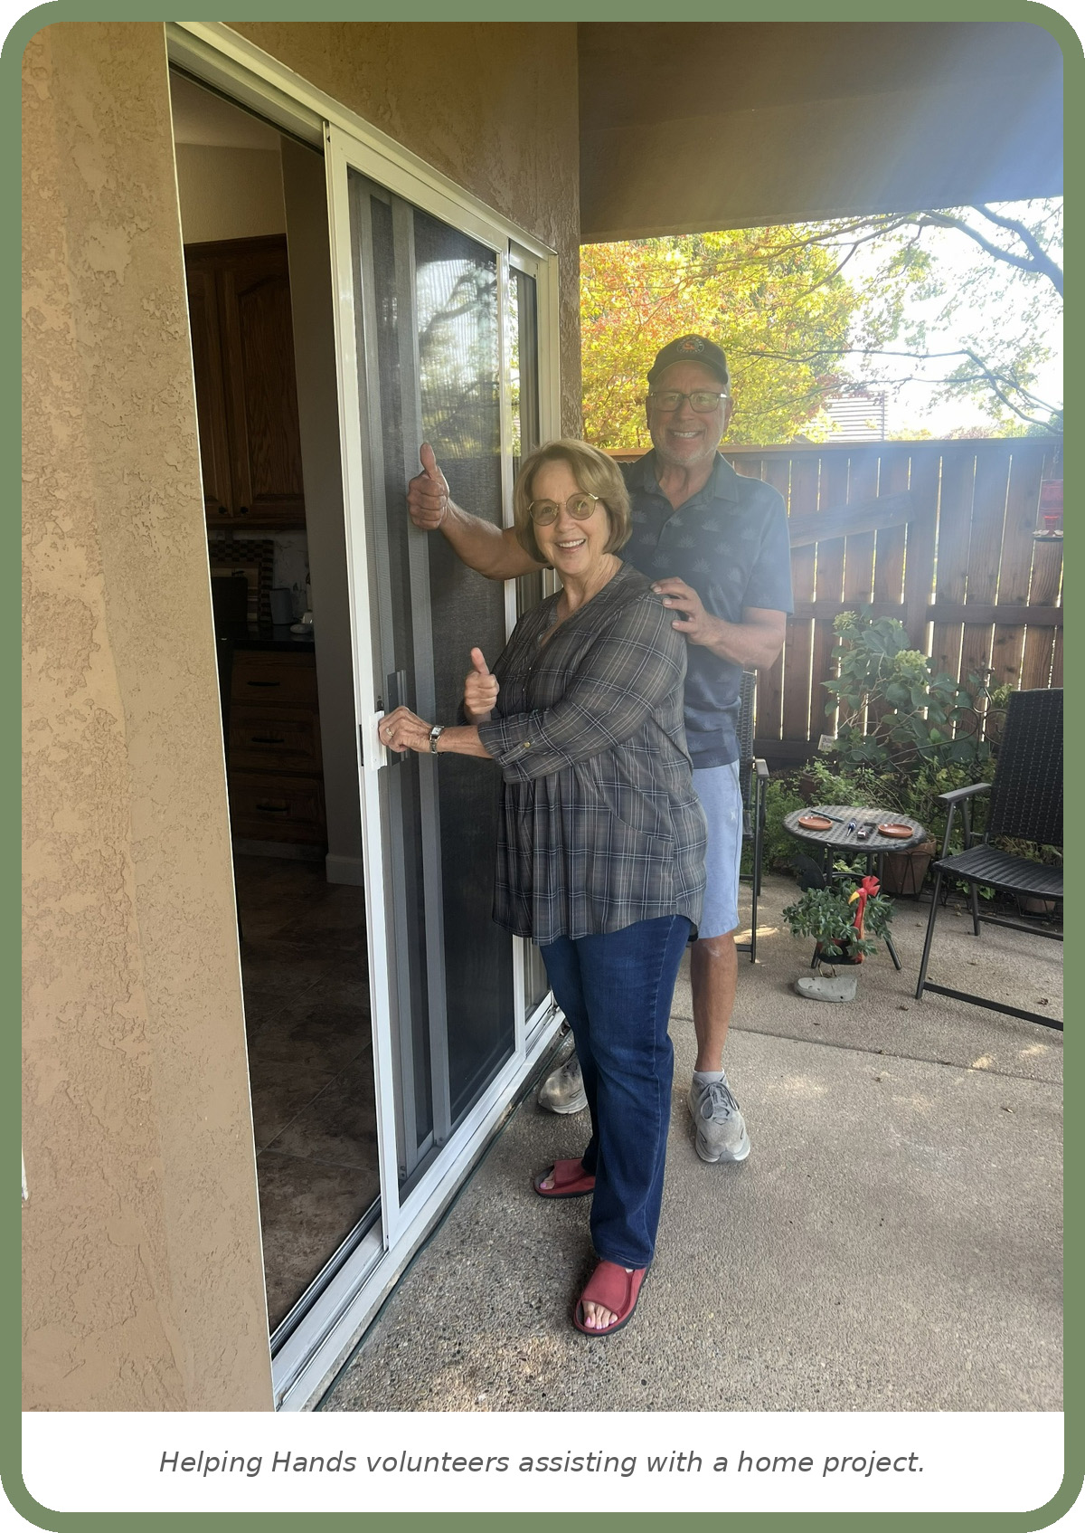
2. Evaluate the Request
Determine:
- Type of assistance needed
- Urgency of the request
- Estimated time required
- Number of volunteers needed
- Safety concerns or special considerations

3. Select Volunteers
Choose volunteers based on:
- Availability
- Skills needed
- Physical requirements of the project
- Location, when possible

Notify the assigned volunteer(s) of all project details.
4. Schedule the Project
Coordinate a date and time that work for both the recipient and the volunteers.

Confirm:
- Address
- Contact information
- Scope of work
- Arrival time
- Estimated completion time

5. Maintain Documentation
Record all project information, including:
- Date received
- Member's name
- Description of the request
- Assigned volunteer(s)
- Date completed
- Follow-up notes

Maintain accurate records using the Dispatch Listing.
6. Conduct Follow-Up
After the service has been completed:
- Confirm completion with the volunteer(s)
- Contact the member to ensure their needs were met
- Address any additional concerns
- Close the project in the ministry records

Ministry Team Goal
Every member of the Helping Hands ministry team plays an important role in ensuring that each request is handled with compassion, efficiency, and accountability. By working together, the ministry reflects Christ’s love through practical service while providing dependable support to recipients within our church family.
“Bear one another's burdens, and so fulfill the law of Christ.” Galatians 6:2

Phase 4 – Set Up the Communication System
Options:
Basic Version (for smaller churches)
- Dedicated church phone number
- Voicemail (check messages at least twice a day)

Advanced Version (FBC Lodi’s Model)
- 24/7 answering service with Advantage Plus Answering Service
- Advantage is instructed which team members should receive the text and email notifications.
- Advantage bills the church, and the bookkeeper pays a monthly invoice
- When Advantage receives a call from one of our members in need, they send a text and email to all the coordinators
- The team communicates on a group text (Helping Hands Team)
- A team member responds in the group text to indicate whether they can take the call. For example: “I can take Betty’s call.” The other team members acknowledge the text with a thumbs-up or heart emoji. This communicates that everyone on the team is aware of the request, but one team member is handling it.
- The team member then calls the member in need and obtains detailed information about the job to be done.
- The team member looks at the volunteer listing to find a volunteer for the job.
- The team member completes the Dispatch Listing.

Calling the Recipient
- “Hi, I’m Kathy from (church name) and Helping Hands. I received your call.” The recipient will usually explain the request further. Ask additional questions as needed. The more details you gather, the better prepared the volunteer will be for the project.
- Ask the volunteer to give the member in need a call within 24 hours and set up a time/day to do the job that best fits both of their schedules.
- Follow-up procedures:
- Ask the volunteer to text you when the job is completed and any details he/she would like to pass along.
- If you don’t hear from the volunteer within 2 days, call him/her to find out how the job went.
- Complete this information on the dispatch listing.
- Close the request in the Dispatch Listing.

Phase 5 – Recruiting Helping Hands Volunteers
The success of the Helping Hands Ministry depends on faithful volunteers who are willing to serve others with compassion, integrity, and a servant's heart. Recruiting a diverse group of volunteers with a variety of skills allows the ministry to respond effectively to the needs of recipients within the church.
“Through love serve one another.” Galatians 5:13

Volunteer Recruitment
Prayerfully recruit volunteers from throughout the church, encouraging members to use their gifts and talents to serve others.
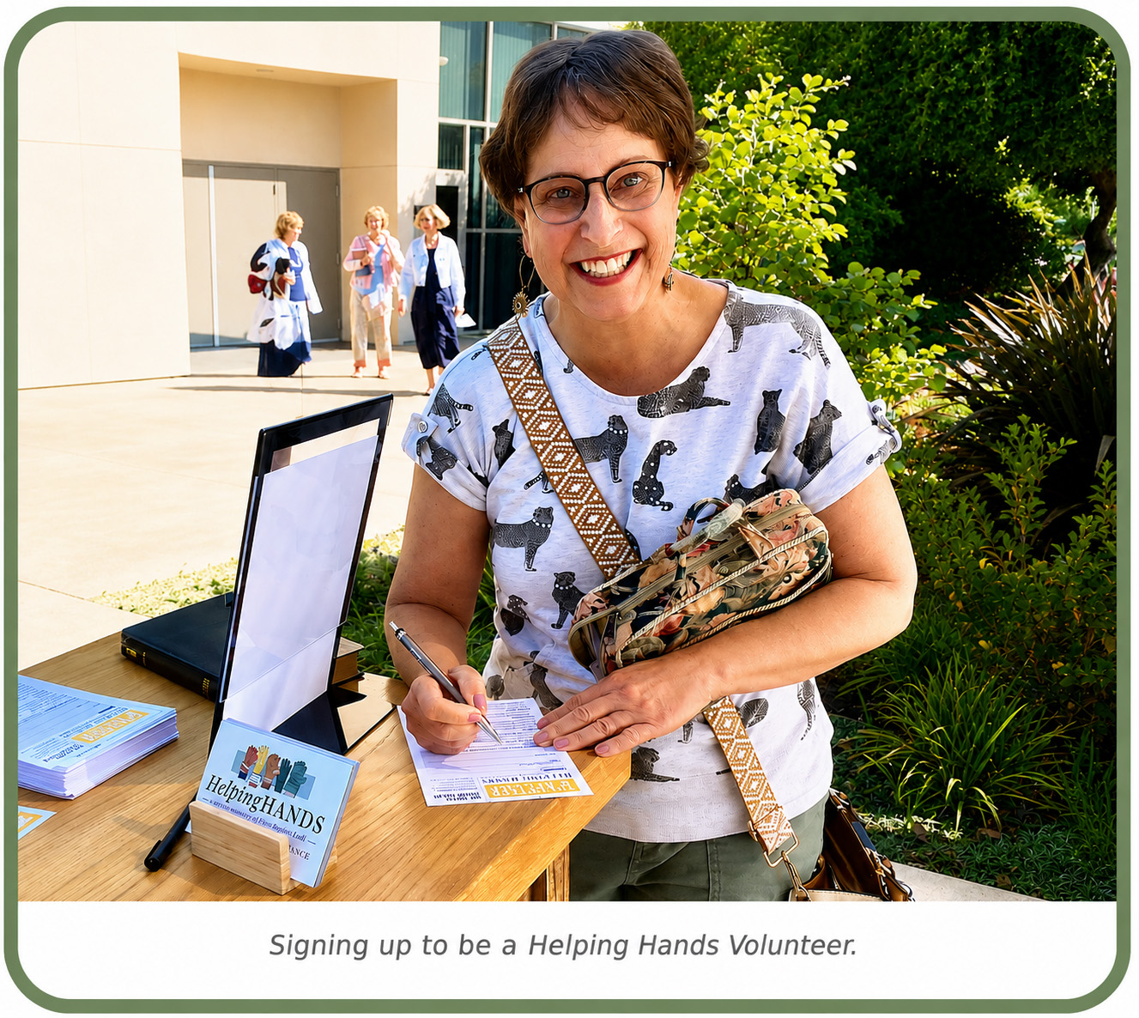
Potential Recruitment Sources
- Adult Sunday School Classes
- Men's Ministry
- Women's Ministry
- Deacon Ministry
- Community Groups or Small Groups
- Retired Tradespeople

  - Carpenters
  - Electricians
  - Plumbers
  - Painters
  - Mechanics
  - General Handymen

- Youth Leaders and Youth Groups
  - Ideal for non-skilled labor such as yard work, moving light furniture, organizing, or clean-up projects.
Encourage every volunteer to view Helping Hands as a ministry of service rather than simply completing tasks.
Volunteer Information to Collect
Each volunteer should complete a Volunteer Recruitment Form before being assigned to projects.
Collect the following information:
Personal Information
- Name
- Address
- Phone Number
- Email Address

Skills and Experience
Identify areas where the volunteer is comfortable serving, such as:
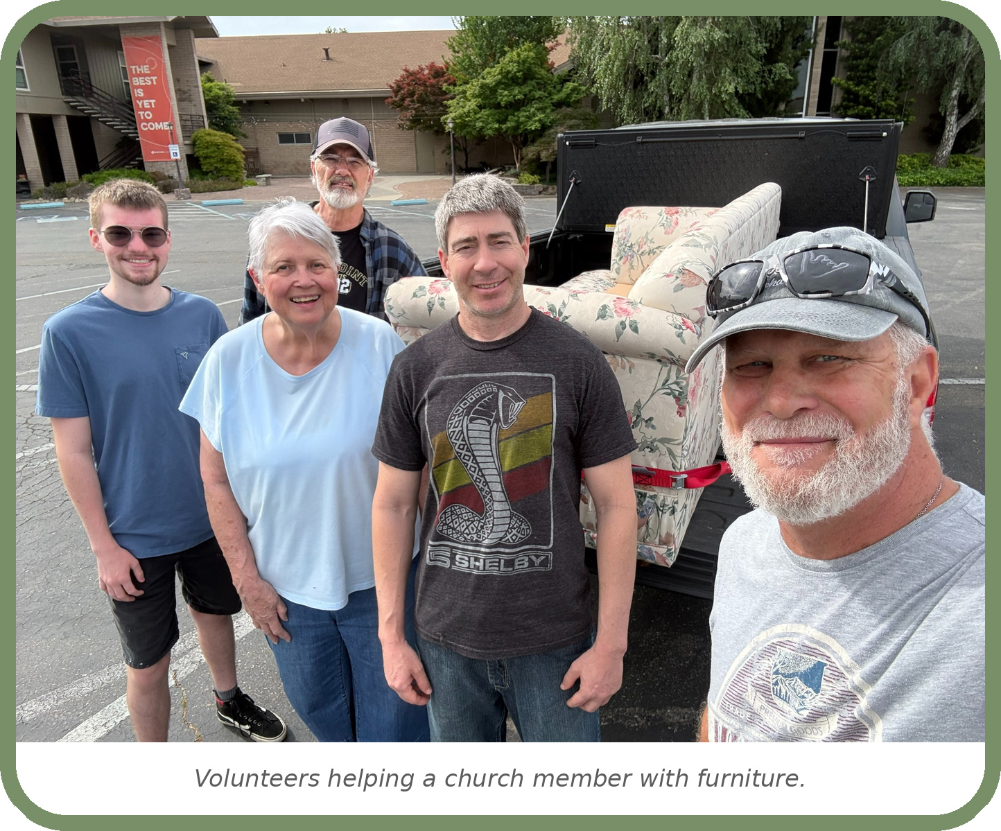
- Minor home repairs
- Yard work
- Plumbing
- Electrical work
- Painting
- Carpentry
- Transportation
- Technology assistance
- Household assistance
- Friendly visits
- Other specialized skills

Transportation
Determine whether the volunteer:
- Has reliable transportation
- Is willing to transport supplies
- Is willing to drive recipients when appropriate and approved by church policy

Volunteer Recruitment Form
All prospective volunteers should complete the ministry's Volunteer Recruitment Form before serving.
See Attachment A – Example Volunteer Recruitment Form
The completed form will help ministry coordinators
- Match volunteers with projects
- Maintain current contact information
- Identify specialized skills
- Schedule volunteers efficiently

Volunteer Responsibilities
Every Helping Hands volunteer serves as a representative of both the church and Jesus Christ.
Volunteers are expected to:
- Provide requested services with compassion and respect.
- Follow all Helping Hands Ministry policies and procedures.
- Arrive on time and communicate promptly if schedules change.
- Treat every member with dignity and kindness.
- Maintain confidentiality regarding personal information and situations.
- Practice safe work habits at all times.
- Work within their level of skill and experience.
- Notify the Coordinator of any concerns.
- Report project completion promptly.
- Observe and report additional needs that may require future assistance.

Volunteer Leader Responsibilities
Some volunteers lead during a project and serve as the primary contact between volunteers and ministry coordinators.
Their responsibilities include:
- Confirming project details before the scheduled service.
- Communicating with the member in need before the visit.
- Coordinating schedules and arrival times.
- Ensuring work is completed safely, respectfully, and efficiently.
- Representing the church with professionalism and compassion.
- Reporting project completion to the Helping Hands Coordinator.
- Reporting safety concerns, additional ministry opportunities, or follow-up needs observed during the visit.

Volunteers help ensure that every project reflects excellence, compassion, and a servant heart.

Volunteer Expectations
Helping Hands volunteers are not simply workers—they are ministers serving through practical acts of kindness.
Every volunteer should strive to:
- Demonstrate the love of Christ.
- Build meaningful relationships with recipients.
- Serve with humility and compassion.
- Respect the privacy and dignity of every individual.
- Be dependable and trustworthy.
- Work as part of a unified ministry team.

Building a Strong Volunteer Team
A healthy volunteer ministry combines individuals with a variety of gifts, skills, and life experiences. By recruiting from across the church and equipping volunteers with clear expectations and leadership, the Helping Hands Ministry can provide dependable, Christ-centered care to recipients while strengthening relationships throughout the church family.
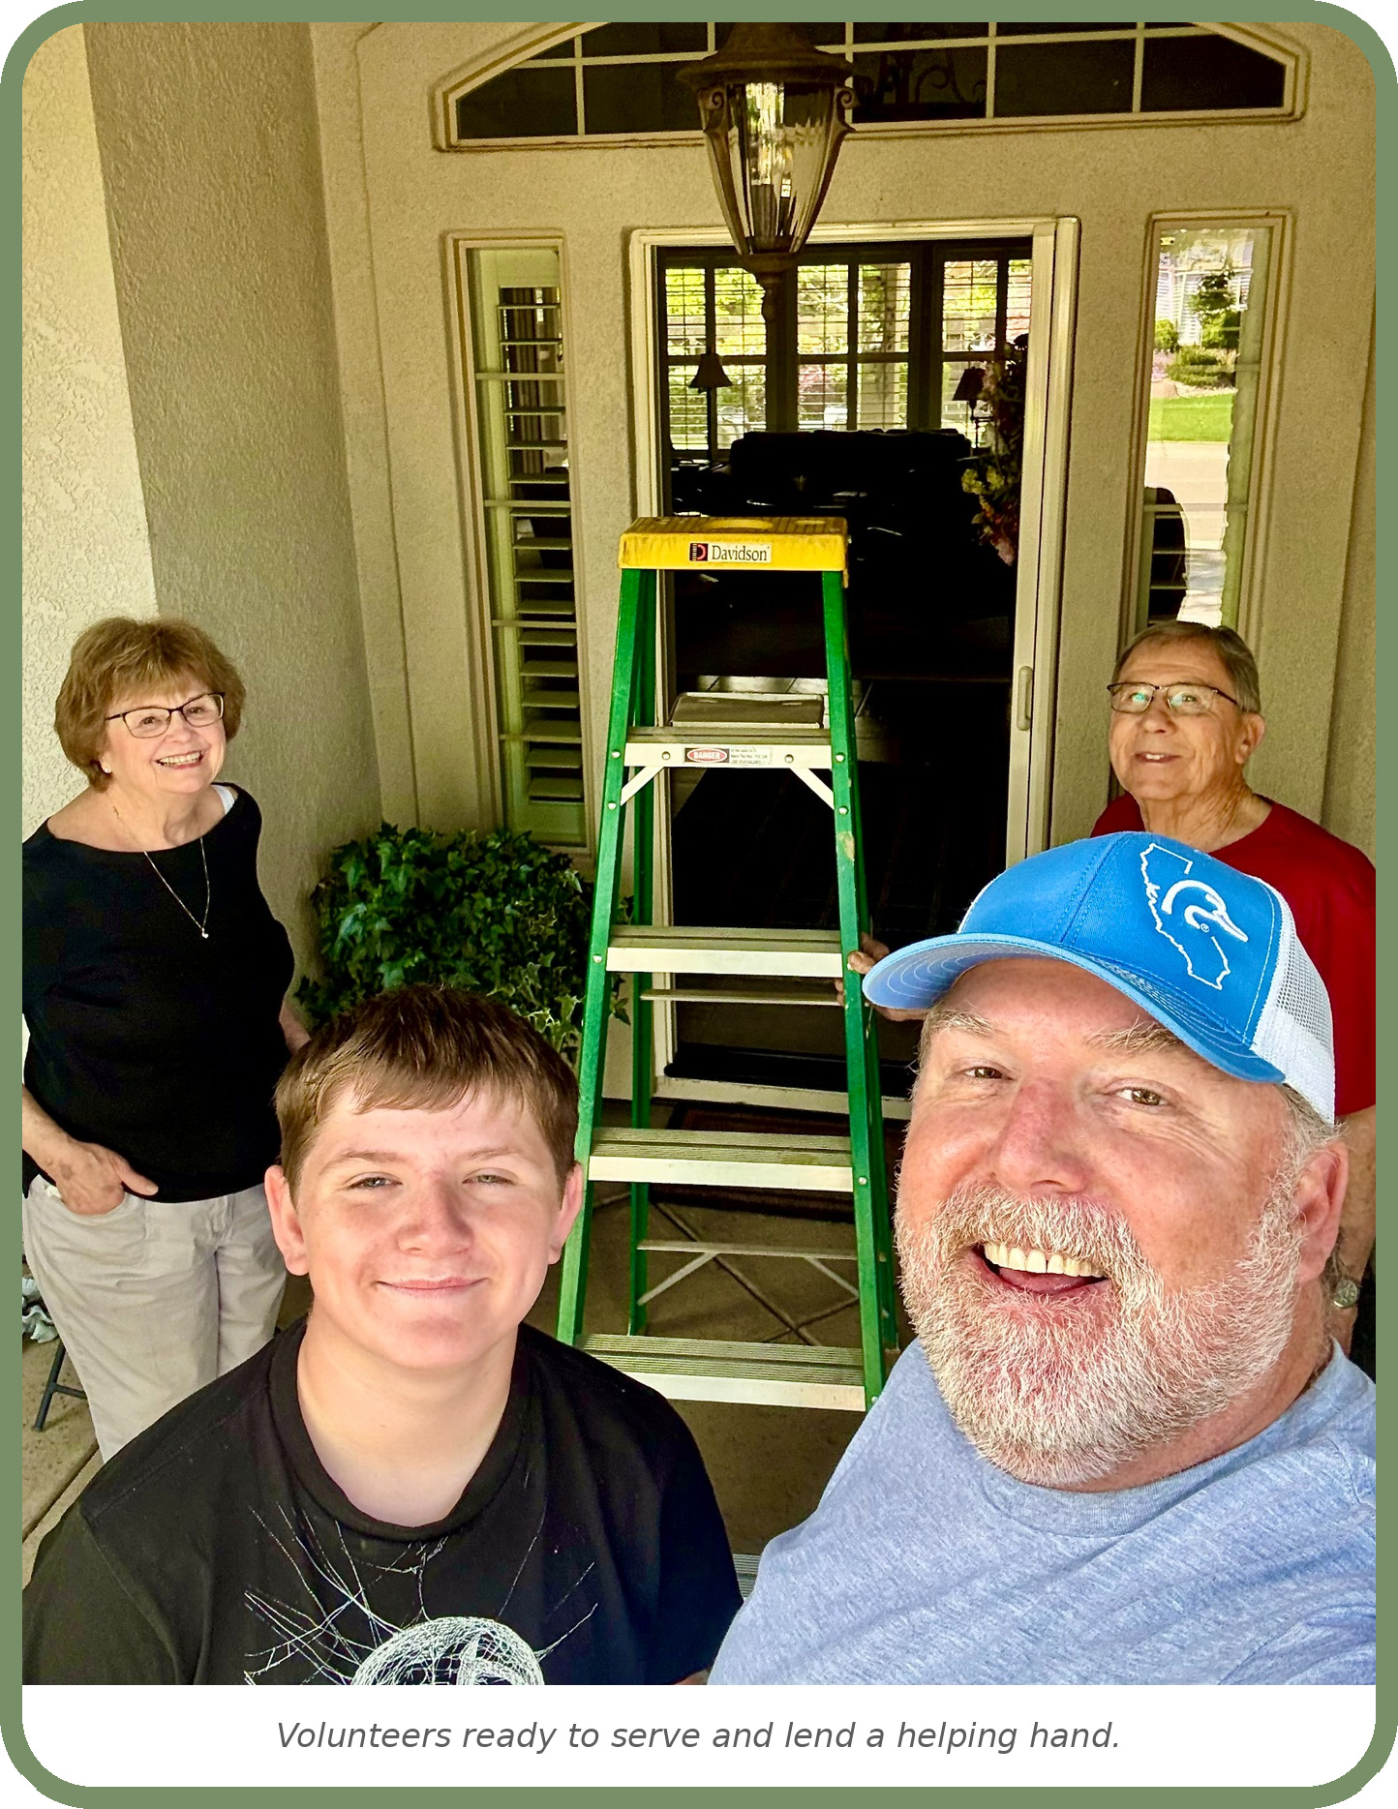
“Commit your work to the LORD, and your plans will be established.” Proverbs 16:3
Phase 6 – Build a Volunteer Roster (See Attachment F)
The Volunteer Roster provides a complete list of volunteers, along with their contact information and the skills, talents, and areas in which they are willing to serve. This can be as simple as an Excel spreadsheet. We use Google Drive, which allows all Helping Hands Coordinators to collaborate on the same spreadsheet. Attachment F provides an example of the Volunteer Roster used by FBC Lodi. To learn more about Google Drive and team collaboration, visit the resources below.
https://workspace.google.com/products/drive/?utm_source=chatgpt.comhttps://workspace.google.com/products/drive/
https://support.google.com/a/users/answer/9310249?hl=en&utm_source=chatgpt.comhttps://support.google.com/a/users/answer/9310249?hl=en

Phase 7 – Build a Dispatch Listing (See Attachment G)
The Dispatch Listing provides a complete list of recipients who have called for a helping hand. It is used to track incoming requests, the assistance needed, the volunteer assigned to the project, and the project from start to finish. This can also be as simple as an Excel spreadsheet. We use Google Drive, which allows all Helping Hands Coordinators to collaborate on the same spreadsheet. Attachment G provides an example of the Dispatch Listing used by FBC Lodi. To learn more about Google Drive and team collaboration, visit the resources below.
https://workspace.google.com/products/drive/?utm_source=chatgpt.comhttps://workspace.google.com/products/drive/
https://support.google.com/a/users/answer/9310249?hl=en&utm_source=chatgpt.comhttps://support.google.com/a/users/answer/9310249?hl=en

Phase 8: Safety, Liability, and Insurance
Our Commitment to Safety
The Helping Hands Ministry exists to serve others in the name of Jesus Christ while providing practical assistance to members in need. As we serve, we also have a responsibility to protect our volunteers, those receiving assistance, and the church.
Every volunteer should remember that no project is so urgent that it should compromise safety. If a task cannot be completed safely, it should not be attempted.
The following safety policies establish the minimum standards for every Helping Hands project.

Mandatory Safety Rules
1. Two-Volunteer Guideline (Recommended)
Whenever possible, two volunteers should be present during every home visit.
Benefits:
- Protects the safety of both the senior adult and the volunteers.
- Provides accountability during ministry visits.
- Allows volunteers to assist one another with physically demanding tasks.
- Reduces the risk of misunderstandings or false accusations.
- Reflects sound ministry practices when serving in private residences.

While emergencies or unique circumstances may occasionally require exceptions, the two-volunteer guideline should remain the ministry's standard practice.

2. Work Within Your Skill Level
- Volunteers should only perform work that matches their experience, training, and ability.
- No volunteer should feel pressured to perform a task they are not qualified to complete.
- If a project exceeds a volunteer's abilities, the Helping Hands Coordinator should be notified so the ministry can seek additional assistance or recommend a qualified professional.
“Let us not grow weary of doing good…” Galatians 6:9

3. Prohibited Projects
For the protection of volunteers, homeowners, and the church, Helping Hands volunteers should not perform projects involving significant safety or liability risks.
These include, but are not limited to:
Roof Work
Volunteers should not:
- Walk on roofs
- Perform roof repairs
- Clean roofs
- Perform work requiring roof access

Falls can result in serious injury during home-maintenance activities.

Major Electrical Work
Volunteers should not perform:
- Electrical panel repairs
- Breaker replacement
- Rewiring
- Installation of new electrical circuits
- Any work requiring a licensed electrician

Simple tasks such as replacing light bulbs or smoke detector batteries may be appropriate if they can be completed safely.

Structural Repairs
Helping Hands volunteers should not perform repairs involving:
- Foundations
- Load-bearing walls
- Major plumbing reconstruction
- Major remodeling projects

These repairs should be referred to licensed professionals.

Health and Personal Care
Helping Hands volunteers do not provide medical care, personal hygiene assistance, medication management, or other services that should be performed by healthcare or professional caregivers. When these needs are identified, the Helping Hands Coordinator should refer the recipient to family members, or qualified professional resources.
Report Unsafe Conditions
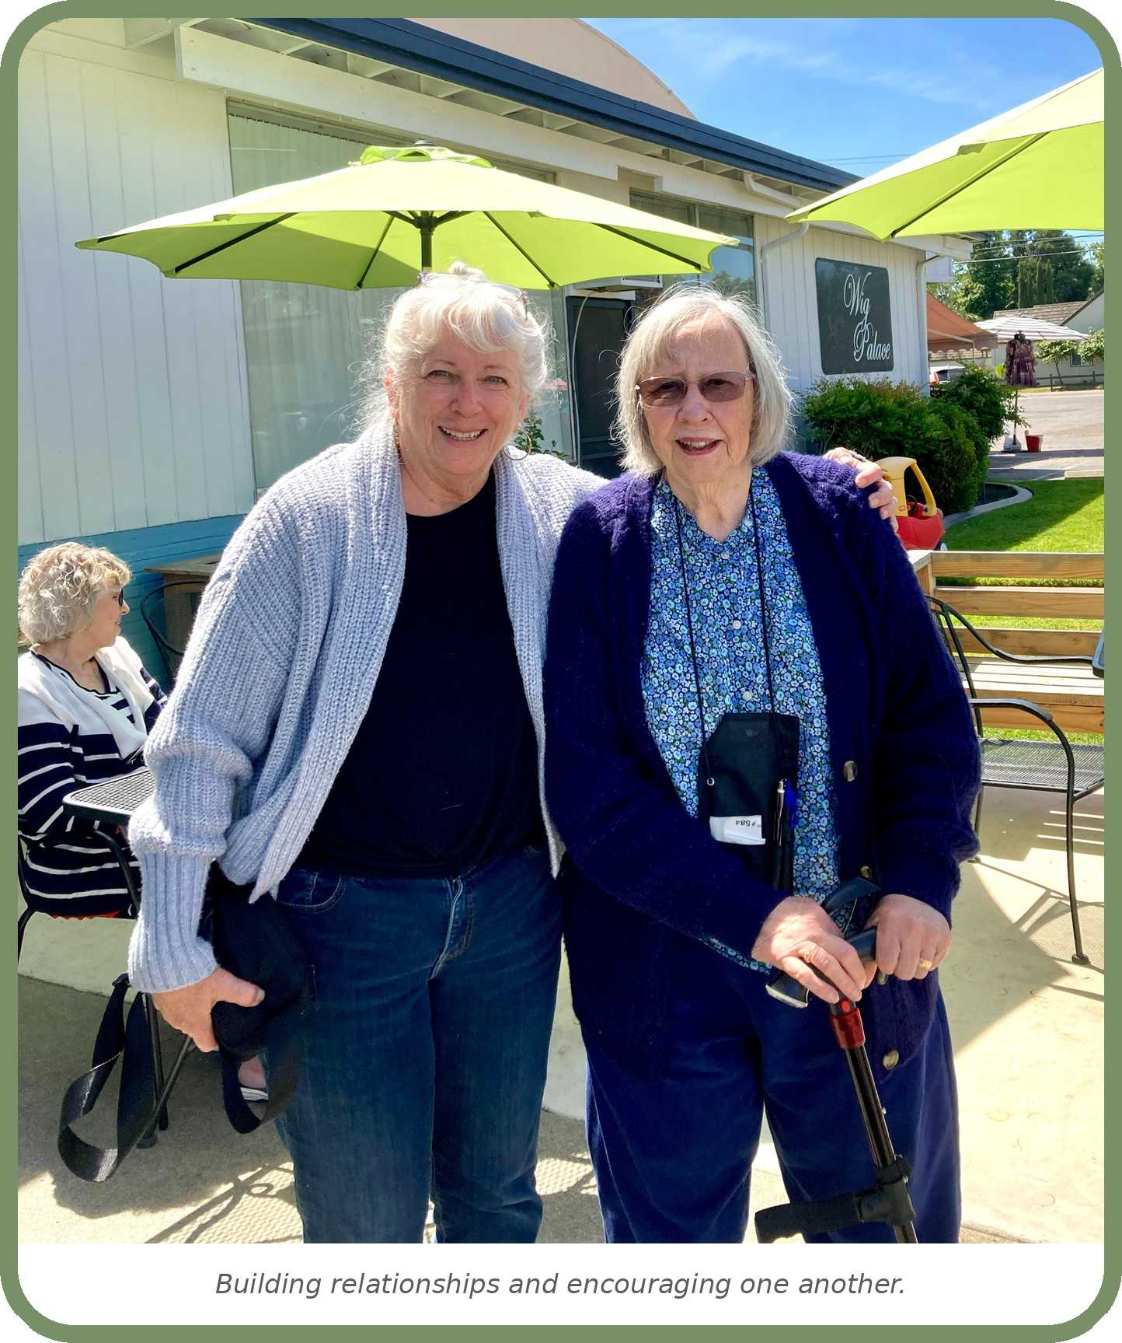
If volunteers discover unsafe conditions during a project, they should immediately stop work if necessary and notify the Helping Hands Coordinator.
Examples include:
- Electrical hazards
- Gas leaks or unusual odors
- Severe water damage
- Mold concerns
- Structural instability
- Fire hazards
- Unsafe flooring or stairways
- Evidence that additional
professional assistance is needed

The ministry's role is to help—not to place
volunteers in dangerous situations.

Transportation Safety Policy
Some Helping Hands projects may involve transporting recipients to medical appointments, grocery stores, church services, or other approved destinations.
Volunteers who provide transportation should:
- Meet all church insurance requirements.
- Maintain a valid driver's license.
- Carry current automobile insurance that meets church policy.
- Operate vehicles safely and responsibly.
- Follow all state and local traffic laws.

Church leadership should establish written transportation policies that comply with insurance requirements.

Liability Waiver (Optional)
To help protect both the church and those receiving assistance, a Liability Waiver could be used before services are provided or whenever appropriate.
The waiver should explain:
- The nature of the volunteer services being provided.
- That services are offered without guarantee.
- Any limitations of responsibility.
- Consent for volunteers to perform the requested work.

Important: If this option is used, it is recommended that the Liability Waiver be reviewed by the churches insurance provider and/or legal counsel to ensure compliance with applicable state laws and insurance requirements.
Volunteer Background Check Policy
Helping Hands volunteers serve in positions of trust and often work with vulnerable adults. Churches should establish a background screening policy that reflects both legal requirements and best ministry practices.
Background checks are especially recommended for volunteers who:
- Provide transportation.
- Work directly with vulnerable adults.
- Enter private residences.
- Serve in leadership positions within the ministry.

Church leadership should determine:
- Which volunteer positions require screening.
- How often background checks are renewed.
- Confidential handling of screening information.
- Procedures for addressing concerns identified during the screening process.

Safety Is Everyone's Responsibility
Every volunteer has the authority and responsibility to stop work if a situation appears unsafe.
No volunteer should ever feel obligated to continue a project that presents unnecessary risk. Protecting people is always more important than completing a task.
By following these safety guidelines, the Helping Hands Ministry demonstrates wise stewardship, protects the reputation of the church, and ensures that volunteers can continue serving with confidence, compassion, and excellence.

Phase 9 – Launching and Promoting the Helping Hands Ministry
Introducing the Ministry to the Church Family
Launching the Helping Hands Ministry is more than announcing a new program—it is inviting the church family to participate in a ministry of compassion, service, and Christ-centered care for recipients.
A successful launch should communicate three simple messages:
- The congregation understands the purpose and vision of the ministry.
- Church members know how they can volunteer.
- Members in need (recipients) know who to call when they need assistance.

A coordinated promotional campaign over several weeks will help build awareness, recruit volunteers, and establish confidence in the ministry.
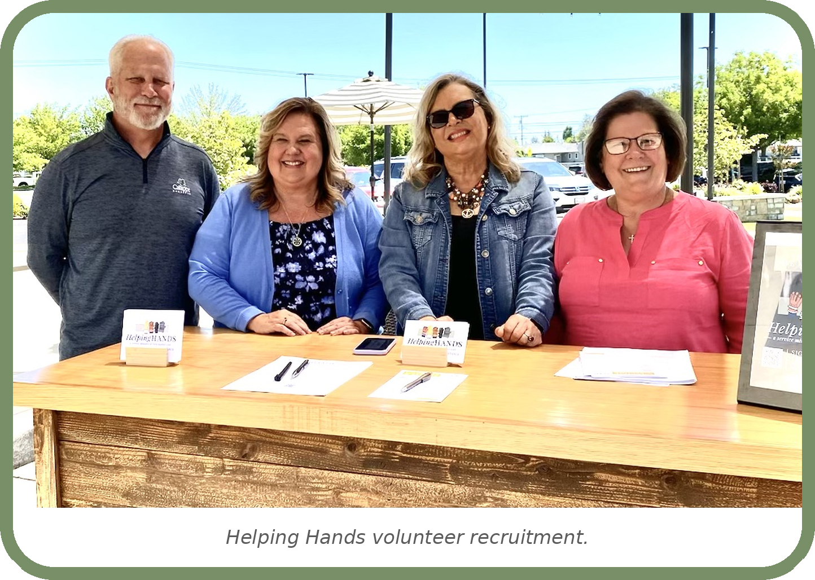
Ministry Launch Timeline
Church-Wide Announcement
Introduce the Helping Hands Ministry
during Sunday morning worship services.

The announcement should include:
- The purpose of Helping Hands
- Who the ministry serves
- Types of assistance available
- How members can request help
- Volunteer opportunities
- Contact information

Bulletin Announcement, if applicable
Include a weekly bulletin announcement for several weeks leading up to and following the launch.
The announcement should:
- Introduce the ministry
- Share the Helping Hands phone number
- Encourage volunteer participation
- Direct members to the ministry webpage

Ministry Website
Create a dedicated Helping Hands webpage on the church website.
Example:
Helping Hands
The webpage should include:
- Ministry purpose
- Types of services provided
- Frequently Asked Questions
- Volunteer opportunities
- Contact information
- Downloadable forms
- Request for assistance information
- Volunteer application
- Safety policies
- Ministry photos and testimonials

Sunday Morning Presentation Slides
Develop announcement slides to display before and after worship services.
Slides may include:
- Helping Hands logo
- Ministry phone number
- Volunteer recruitment message
- Upcoming training events
- Website information
- QR Code
- Photos of ministry volunteers serving

Simple visual reminders help keep the ministry visible throughout the year.

Volunteer Recruitment Campaign
Continue recruiting volunteers even after the ministry launches.
Sample announcement:
Would you like to use your gifts and skills to serve others?
Join the Helping Hands Ministry and become part of a team dedicated to serving the seniors, widows, single mothers, and others in need of assistance in our church family. Whether you enjoy home repairs, yard work, transportation, technology assistance, or simply encouraging others, there is a place for you to serve.
Contact the Helping Hands Ministry today to learn how you can make a difference.
QR Code Promotion
Create a QR code that links directly to the Helping Hands webpage.
The QR code can be placed on:
- Church bulletins
- Visitor information packets
- Senior adult brochures
- Ministry displays
- Volunteer recruitment materials
- Church newsletters
- Conference displays
- Ministry presentations
- Refrigerator magnets

Keeping the Ministry Visible
Launching the Helping Hands Ministry is only the beginning. Ongoing communication keeps the ministry active and reminds the congregation that opportunities to serve—and to receive care—are always available.
Consider sharing ministry updates throughout the year by:
- Highlighting completed projects (with permission)
- Sharing volunteer testimonies
- Recognizing volunteers during worship services
- Reporting ministry impact at annual church meetings
- Celebrating milestones such as the number of families served
- Consistent promotion not only increases awareness but also reinforces the church's commitment to caring for one another through practical acts of love and service.

Remember, every thriving ministry begins with a single act of faith and a willingness to meet one person's need. We pray this toolkit helps your church take that first step with confidence.
Don't feel like everything must be perfect before you begin. Start with a few committed leaders, a handful of volunteers, and a willingness to serve. As your ministry grows, your systems, resources, and volunteer team will grow as well. We pray God uses your church to demonstrate His love through practical acts of service and that this Starter Kit helps you begin that journey with confidence.
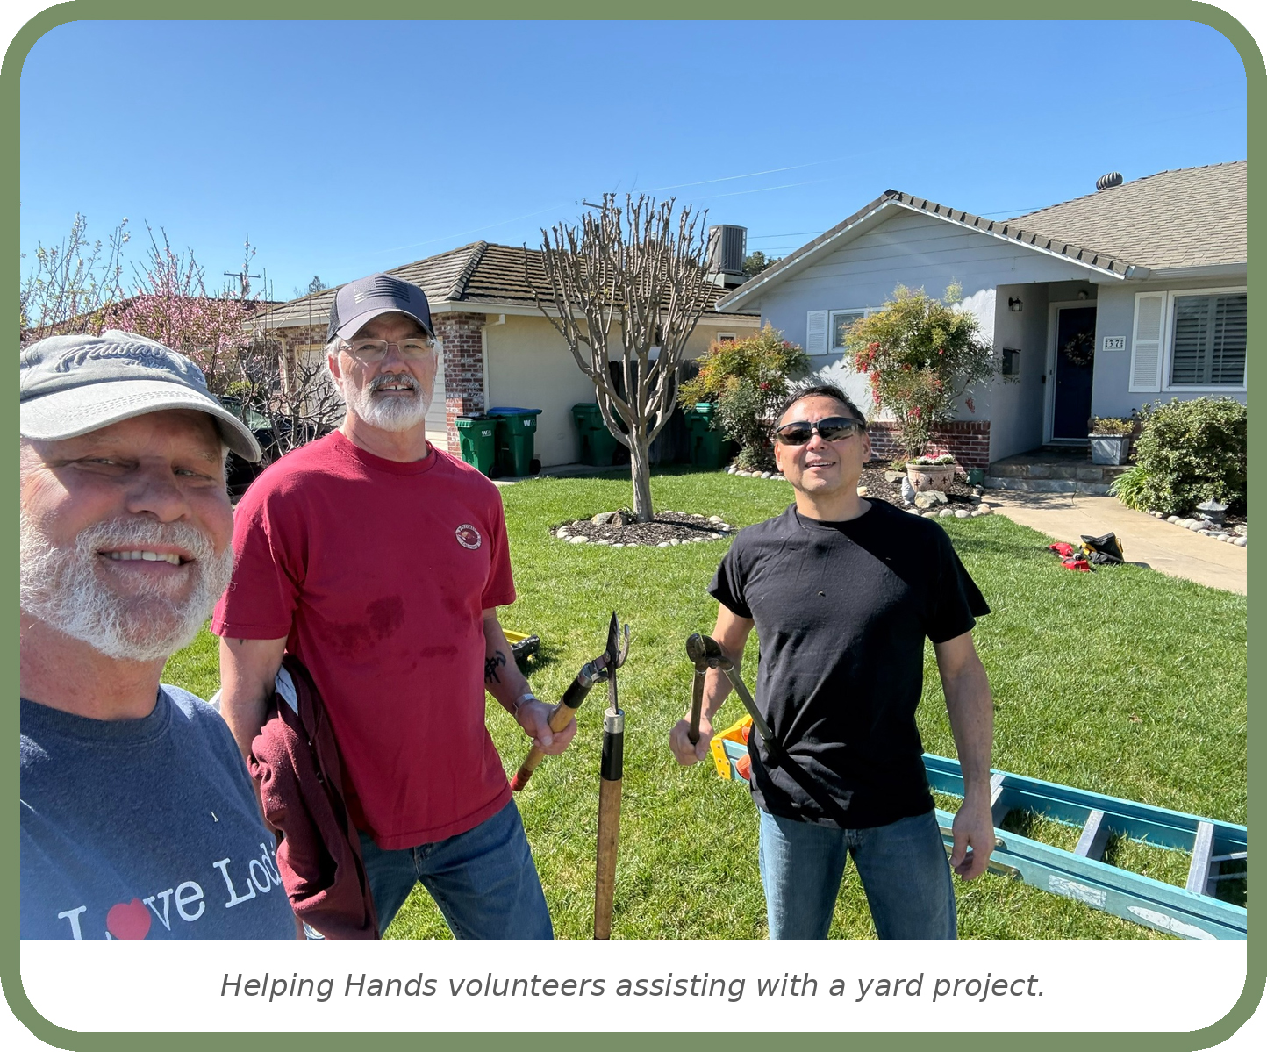

“Let your light shine before others, so that they may see your good works and give glory to your Father…” Matthew 5:16
Attachment A: Volunteer Recruitment Form
Volunteer Card
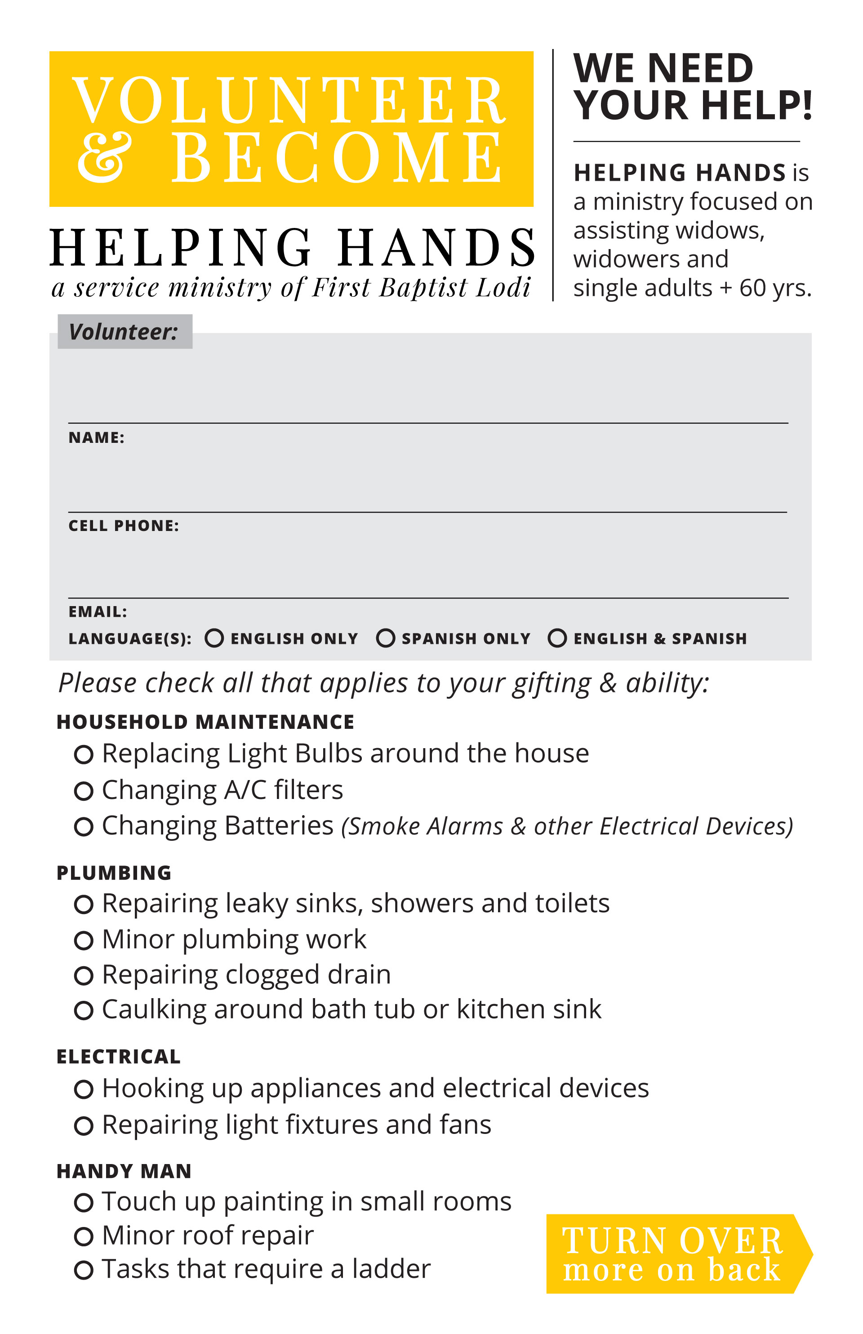
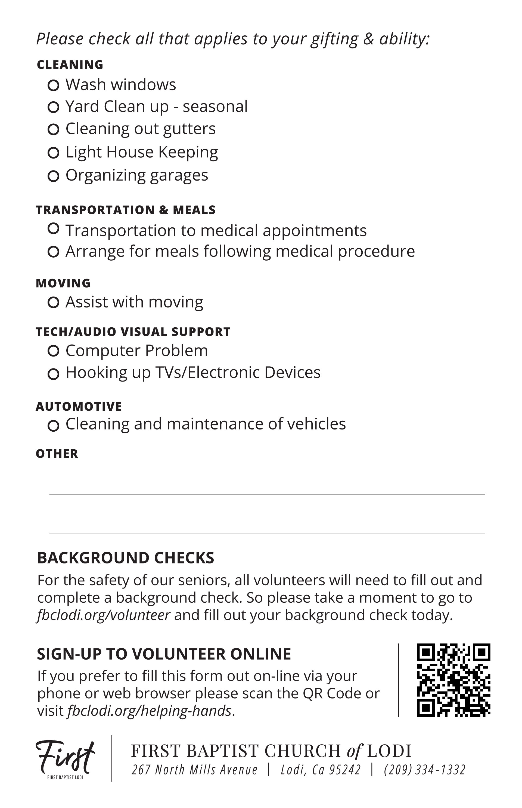
This card is 5.5 x 8.5 (Statement Size) and is setup to be printed on an 8.5 x 11 (Letterhead) front and back, then cut in half for 2 finished cards per page. Download fbclodi.org/helping-hands


Attachment B: Volunteer Instruction Sheet
Thank you for volunteering to provide a helping hand to the widows, seniors, single moms and others of our church family. Please review the guidelines below which should help when you are called to provide a service.
When the Helping Hands (HH) ministry receives a request for help from one of our church family members (the recipient), the following actions will take place.
- A HH Coordinator will call one volunteer to take the lead on the project and provide the recipient’s name, phone number, address, the project they need help with, and the times the recipient will be available. You will also be given a few names and phone numbers of other volunteers to assist you on the project. Note: Two volunteers will always be required when arriving at the recipient’s home.
- Once you have made contact with the other volunteer and know they are available, then contact the recipient to schedule a time. If needed, gather more information about the project so you can come prepared.
- Let the other volunteer know the meeting time/address and discuss the project to determine the items/tools needed to do the work.
- Always arrive on time, introduce yourselves, and show kindness and respect to the recipient and their home throughout the entire project.
- Once you complete the project, call or text the HH Coordinator who contacted you and inform them that the project has been completed. Helping Hands Coordinators’ phone numbers are listed below. Please add all Helping Hands Coordinators’ phone numbers to your phone contacts so you do not dismiss a Helping Hands call as spam.
If you need to purchase parts or products to perform the repair (out-of-pocket expense), it can be handled in one of the following ways.
- Ask the recipient for the money to make the purchase. Provide the recipient with the receipt and any dollar change.
- Provide the recipient with a cost estimate for the purchase, make the purchase yourself, and give the receipt to the recipient for reimbursement directly to you.
- If the recipient states (or indicates) they cannot afford the out-of-pocket costs, you may pay for the cost yourself (up to $100) and turn in a receipt to HH Coordinator for reimbursement. (For reimbursement you can send a photo of the receipt by text, a brief description of the work, and the name of the recipient to the HH Coordinator that contacted you.) If the expense exceeds $100 you will call the HH Coordinator for approval before making the purchase.
If you run into a problem, find the project is beyond your scope of expertise (for example, a clogged drain that will require a professional plumber) or a small project turns into a much bigger project that will take more time than allotted, you should inform the recipient that you will contact the HH Coordinator who will help you schedule a professional service provider to help complete the project.
Once again, thank you for volunteering! May God bless you and all those we serve with this ministry.
Helping Hands Coordinators (Names and Phone numbers listed below):

Attachment C: Recipient Information Sheet
Our desire and mission are to express the love of Christ by caring for the widows, seniors, single mothers, and others in our church family who could use a helping hand. (James 1:27)
This ministry will provide a means for the family of First Baptist Church to express the love of Christ through compassionate service.

Many skilled and talented members of our church have volunteered to serve in the Helping Hands ministry, and we are all very excited and humbled that you would call and allow us to serve you! If you find that you could use some help with home maintenance, cleaning, automobile troubles, or a project you could just use a little help with, then we are here for you. Below are some examples of projects that our volunteers can help you with.

- Replacing light bulbs or A/C filters
- Changing batteries in smoke detectors and other devices
- Caulking around sinks, tubs, and windows
- Transportation to medical appointments if you are unable to drive
- Hooking up appliances and electrical devices
- Repairing light fixtures and fans
- Cleaning out gutters
- Help with organizing
- Touch-up painting for small rooms
- Helping to unclog a drain
- Computer problems/Hooking up TVs/electronic devices
- Rearranging furniture
- Some housekeeping
- Cleaning and maintenance of vehicles
- Provide a meal or two following a medical procedure
- Washing windows
- Tasks that require a ladder

The Helping Hands ministry is currently focused on meeting the needs of our immediate church family. Each request we receive will be evaluated to determine if it is something that one of our Helping Hands volunteers can do. If it is beyond our skill level, we will do our best to recommend a reputable service provider and follow up to ensure you have received the help you need.

We have set up an on-call service that will take calls for the Helping Hands ministry 24/7. You can call anytime and provide your name, phone number, and the service you need help with. A short time after that, you will be contacted by a Helping Hands coordinator who will ask some questions to determine how we can best help you. The Helping Hands coordinator will also ask what times you will be available and then choose the best volunteers to lend a helping hand. Soon after that, you will be contacted by the volunteer to schedule a time/date to meet you at your home. The Helping Hands 24/7 on-call phone number is __________________

Material costs are the recipient’s responsibility; labor is provided by Helping Hands volunteers at no charge. We hope this ministry will be a blessing to you. Thank you for reaching out for a Helping Hand.

Attachment D: Helping Hands Refrigerator Magnet
Utilize the template below to add your own contact info, website address, and Logo. Other file types are available for download at fbclodi.org/helping-hands

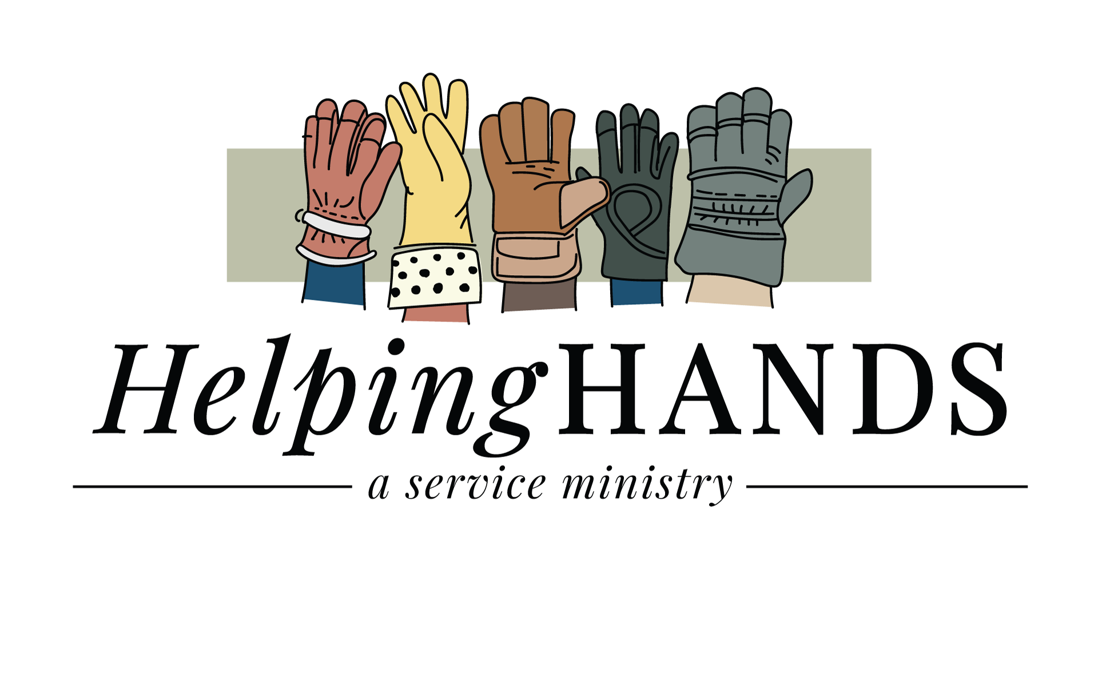

Attachment E: Lessons Learned and Testimonies
Lessons Learned
- Adult Sunday School classes provide the best volunteer base
- Helping Hands Coordinators are essential to ministry success
- Most requests involve small jobs that seniors can no longer safely perform
- The two-volunteer rule increases safety and accountability
- A 24/7 answering service prevents missed opportunities and time involvement for the church staff
- Follow-up calls significantly improve satisfaction and ministry impact
- Some projects are beyond the scope of what Helping Hands volunteers can safely or reasonably perform. Over the past three years, we have occasionally referred recipients to licensed, insured, and reputable contractors, vendors, and handymen. To support these referrals, we maintain a database of professionals who have consistently demonstrated reliability by arriving on time, providing quality workmanship, and treating our recipients with respect. This resource has proven valuable for connecting people with trusted service providers when specialized skills or equipment are required. A Helping Hands volunteer will also be present when the professional is scheduled to arrive. Tree trimming is one of the most common examples. Helping Hands is happy to assist with small trimming jobs that can be completed safely by our volunteers, but larger or hazardous tree work is referred to qualified professionals.
Some things we just don’t provide
- Weekly yard maintenance
- In-home health assistance
- Services requiring a licensed professional, such as an electrician or plumber.
- Electrical panel repairs
- Breaker replacement
- Rewiring
- Installation of new electrical circuits
- Foundations
- Load-bearing walls
- Roof framing
- Major plumbing reconstruction
- Major remodeling projects

Lives Touched by Helping Hands!
I have been so blessed by the Helping Hands ministry! They sent someone to help me with an air-conditioning issue on a weekend, when no one else was available, which I greatly appreciate. They also consulted on a major plumbing project I was nervous about and gave me great advice. Their guidance and support allowed me to move forward with the plumbing project, giving me peace of mind I would not have had without their help. What an amazing ministry!
—Lisa, Recipient

From the very beginning, when someone was sent from Helping Hands to assess my needs and recognized a serious medical issue with my husband, ultimately saving his life, I knew then this ministry was special. Since then, this new journey in my life has been challenging. Helping Hands has continued to help with rides to doctors’ appointments, meals, encouragement, and guidance in so many ways. God has provided support and understanding that I could never repay. Helping Hands is a safe, caring presence in my life. It’s a true gift from people who serve with love and selflessness. —Jodi, Recipient

Helping Hands has been a tremendous help to me since my husband passed. They have so many talented people who joyfully help you with various needs, doing so with skill and cheerfulness. I am so grateful for the help and the new friends I have made.
—Betty, Recipient

Helping Hands allows me to serve the beloved members of our congregation. The person I assist is always grateful, and we often share a special time of prayer. It simply feels good. —Volunteer

Helping Hands enables me to "carry each other's burdens" (Gal 6:2). It is a way for me to use my expertise to assist a beloved member of our congregation. —Jeff, Volunteer

I’ve been very fortunate to meet amazing people in our church community by volunteering. I’ve also been able to include my sons on various tasks, which has provided good bonding moments. Many people are really struggling with some difficult things in life. Helping Hands has given me the chance to perform relatively simple tasks that hopefully make their load a little lighter. —Jene, Volunteer

Attachment F: Volunteer Roster on Google Drive (Example)
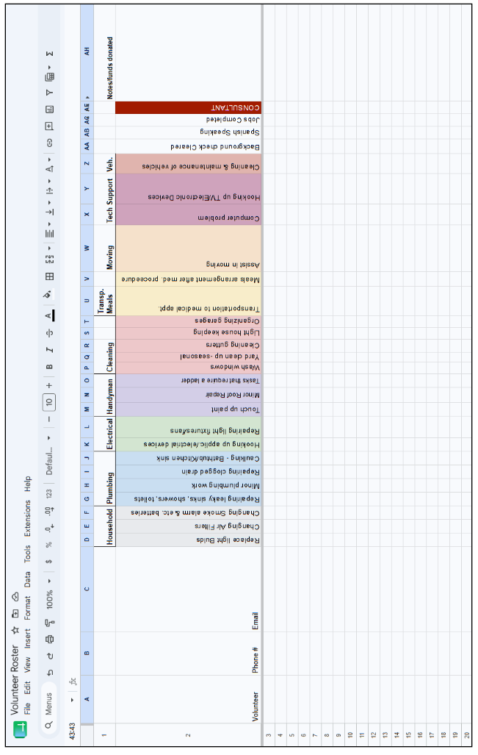
Attachment G: Dispatch Listing on Google Drive (Example)
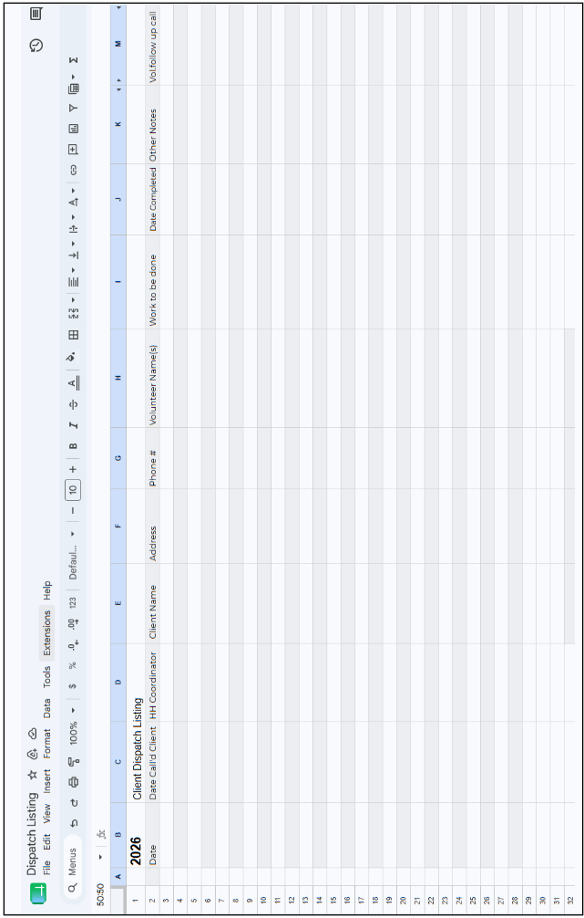
Attachment H: Frequently Asked Questions (FAQ)

1. What is the Helping Hands Ministry?
Helping Hands is a church-based ministry that connects volunteers with widows, seniors, single mothers, and other church members who need practical assistance. Volunteers provide services such as minor home repairs, transportation, yard work, meals following medical procedures, technology assistance, and other acts of service. More importantly, Helping Hands builds relationships and demonstrates the love of Christ through practical ministry.

2. What is the purpose of this Starter Kit?
This Starter Kit provides churches with a proven framework for establishing a Helping Hands Ministry. It includes practical guidance, sample forms, volunteer processes, safety recommendations, and lessons learned from operating the ministry at First Baptist Church of Lodi.

3. Does our church have to follow this toolkit exactly?
No.
Every church has unique resources, leadership structures, and ministry priorities. This toolkit is intended to be adapted to fit your church's needs while preserving the ministry's biblical purpose and practical principles.

4. What types of projects does Helping Hands perform?
Examples include:
Minor home repairs
Yard work
Replacing smoke detector batteries
Changing light bulbs
Transportation
Technology assistance
Small painting projects
Furniture moving
Meal preparation after surgery
Friendly visits
Prayer and encouragement
Each church should establish its own ministry guidelines.

5. What projects should Helping Hands avoid?
For safety and liability reasons, Helping Hands should generally avoid:
Roofing
Major electrical work
Structural repairs
Major plumbing
Tree removal
Hazardous work
Projects requiring licensed contractors
When appropriate, churches should refer these projects to qualified professionals.

6. Who can receive assistance?
Each church should determine its own ministry priorities.
Many churches begin by serving:
Widows
Recipients
Single mothers
Individuals recovering from illness or surgery
Church members experiencing temporary hardships
Some churches later expand the ministry to serve their surrounding community.

7. Who pays for materials?
Generally, the individual receiving assistance pays for materials while Helping Hands volunteers provide the labor at no cost.
Churches may also choose to assist with material costs through benevolence funds or designated gifts when appropriate.

8. How many volunteers do we need to begin?
Not many.
A church can successfully launch Helping Hands with:
One Ministry Leader
Two or three Coordinators
Ten to fifteen dependable volunteers
Additional volunteers can be recruited as the ministry grows.

9. How should we recruit volunteers?
Recruit volunteers from existing ministries where members are already serving.
Examples include:
Adult Sunday School classes
Men's Ministry
Women's Ministry
Deacon Ministry
Small Groups
Retired tradespeople
Youth groups (for appropriate projects)

10. Do volunteers need special skills?
No.
Some volunteers have specialized trade skills.
Others simply have willing hearts.
There are many opportunities for every volunteer to serve regardless of experience.

11. Should volunteers receive background checks?
Church leadership should determine whether background screening is appropriate based on ministry activities and local requirements.
Background checks are strongly recommended for volunteers who:
Transport individuals
Enter private homes
Work with vulnerable adults
Serve in ministry leadership

12. Should volunteers work alone?
Whenever possible, no.
Helping Hands recommends sending two volunteers whenever practical.
This protects both volunteers and care recipients while providing accountability and additional assistance.

13. Do we need a 24-hour answering service?
No.
Smaller churches may successfully operate using:
Church office phone
Voicemail
Coordinator rotation
Larger churches often benefit from a professional answering service that provides 24/7 coverage.

14. How are projects assigned?
Helping Hands Coordinators receive requests, evaluate the needs, determine appropriate volunteers, and coordinate scheduling from beginning to completion.

15. How quickly should we respond?
Whenever possible, a Helping Hands Coordinator should contact the individual within 24 hours of receiving the request.
Prompt communication builds confidence and helps determine the urgency of the need.

16. Should we keep records?
Yes.
Maintaining accurate records helps:
Track requests
Schedule volunteers
Monitor ministry activity
Report ministry impact
Maintain accountability
Simple spreadsheets are sufficient for many churches.

17. Why does this toolkit recommend Google Drive?
Google Drive allows multiple coordinators to:
Share volunteer lists
Update dispatch records
View information simultaneously
Access records from any location
However, any secure record-keeping system that fits your church's needs may be used.

18. How much does it cost to start a Helping Hands Ministry?
Churches can begin with very little expense.
Typical startup costs may include:
Dedicated phone number
Promotional materials
Volunteer forms
Office supplies
Optional answering service
Most of the ministry is built upon volunteers rather than financial resources.

19. What if a request exceeds our capabilities?
Helping Hands should never attempt projects beyond the experience of its volunteers.
Instead, churches should maintain a list of trusted contractors and service providers who can assist when professional expertise is needed.

20. Is Helping Hands only about completing projects?
No.
Projects provide opportunities to build relationships.
The ministry's greatest impact often comes through listening, encouraging, praying, and demonstrating Christ's love while serving others.

21. Can youth participate?
Yes.
Youth can be valuable volunteers when appropriately supervised and assigned age-appropriate projects such as yard work, organizing, cleaning, or moving light furniture.

22. How do we keep volunteers engaged?
Celebrate ministry successes.
Share testimonies.
Recognize volunteers.
Communicate regularly.
Most importantly, continually remind volunteers that they are not simply completing tasks—they are serving Christ by serving others.

23. What if someone asks for ongoing assistance?
Helping Hands is designed primarily to meet occasional or short-term needs.
Church leadership should determine how to respond to recurring requests while balancing ministry resources and volunteer availability.

24. Can we use and modify these materials?
Absolutely.
This Starter Kit was created to help churches establish Helping Hands Ministries.
Churches are encouraged to adapt the materials to fit their own ministry while acknowledging First Baptist Church of Lodi as the original source.

25. Where can we learn more or ask questions?
If you have questions about implementing a Helping Hands Ministry, please contact:

First Baptist Church of Lodi - 1 (209) 334-1332
info@fbclodi.org

26. Our church is small. Can we really do this?
Absolutely.
Helping Hands is not defined by the size of a church—it is defined by the willingness of God's people to serve one another. Some churches begin with a pastor, one coordinator, and a handful of volunteers. Others launch with dozens of volunteers and multiple ministry teams.
One of the strengths of Helping Hands is its flexibility. Start with the resources God has already provided. As your ministry grows, your volunteers, systems, and opportunities to serve will grow as well.

Our hope and prayer is that God will use this Starter Kit to help your church care for people well, equip willing servants, and demonstrate the love of Christ through practical acts of service.

