Covenant Senior Pastor Job Description

Overview
For many years, Covenant Church has been a place of community and Christ-centered preaching, teaching, discipleship, and quiet and faithful attention to the work of the church. God has enabled each of us to serve one another other through the many gifts he has given us. It’s easy to look around and see how He has enabled Covenant to serve His mission and our community with the love of Christ.
We are a congregation of the Presbyterian Church in America (PCA), a denomination “true to the Scriptures, the reformed faith, and obedient to the Great Commission of Jesus Christ.” We are committed to biblical faith as set forth in part by the Westminster Confession of Faith and the Larger and Shorter Catechisms but affirm the Bible as the ultimate authority and the pulpit ministry the priority of our church.

We belong to the Missouri Presbytery, which includes 30 churches throughout the state of Missouri. Our church sits down the road from the campus of Covenant Theological Seminary, a place that has partnered with our church community to provide interns, preaching, and Sunday School teaching since its inception in 1956.

God has used Covenant church to spawn new churches in the area; to date we have planted or co-planted 10 new PCA churches. Through the leadership of our most recent pastors, George Robertson and Ryan Laughlin, Covenant has greatly expanded its reach both in new churches, and into mercy ministries in our city.
Through the years, due to our physical constraints, the leadership and body have chosen to ground Covenant in its place, a church that will not exceed its physical limits, but will exceed its reach into the community and world, by God’s grace. This keeps our membership at 400-500 regularly, with a physical capacity of approximately 750.
Covenant’s members represent all ages and stages of life, and tenure in the church ranges fairly evenly:
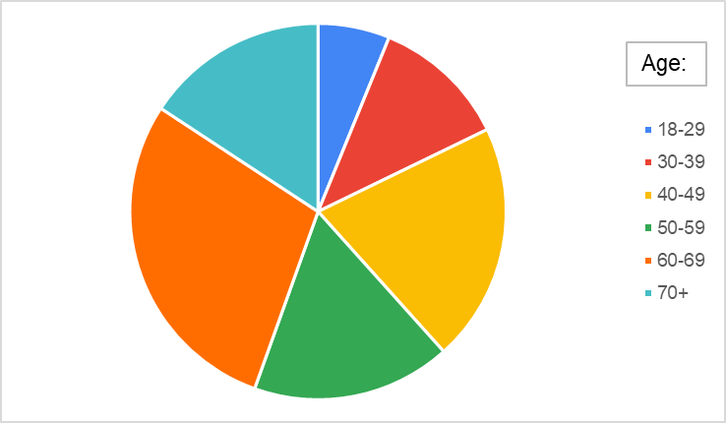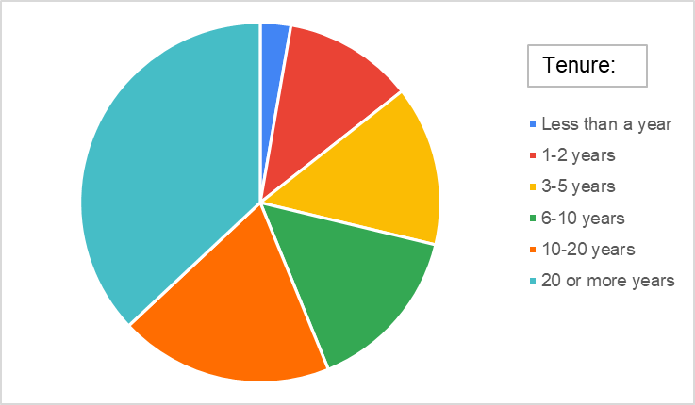
Our church vision is to be a community rooted in God’s grace and reaching out with God’s love, and our mission is to have Deep Roots and Wide Reach.
We are searching for a Senior Pastor who loves the Lord and His Church. And we welcome your interest and application.

Covenant Senior Pastor Role
Vision Create and communicate a vision for Covenant Church’s ministry and mission
Leadership Provide leadership in the ministry and management of the church that carries out this vision.
Ministry Minister the Word of God in weekly sermons, and develop ministries that carry out the vision and mission of the church - deep roots and wide reach.
Management Lead staff, plan and moderate Session meetings, and periodically evaluate church ministries against the vision and mission of the church.

Desired Senior Pastor Traits
Speaking / Teaching
Covenant places a high value on speaking all theological truth clearly and winsomely. The best candidates will show evidence of preaching with skill and tact, with reverence and conviction, with wisdom and grace.
Leadership
Covenant provides tremendous support and deference to its Senior Pastor, and expects him to lead the church both directly and through his example. The Senior Pastor sets the ministry tone for the officers and lay leaders, and allows them to work with joy in the knowledge that God has placed a wise and able leader in the pulpit of Covenant.
Humility
We are looking for a Pastor who recognizes the enormous challenge of shepherding and leading Covenant Church, and approaches this task with a humility befitting the calling placed upon him. He realizes his own weakness and need for daily renewal and reliance on the Spirit of Christ. A successful Covenant Senior Pastor will be known for his humility.
Relationally Oriented and Emotionally Mature
Along with preaching strength, Covenant expects the Senior Pastor to relate well to the congregation, and show emotional capabilities that communicate graciously and appropriately according to situation and circumstance.
Shepherding
Covenant’s Senior Pastor will work with the teaching and ruling elders to ensure that Covenant members are being shepherded well, as we aim to build up the body of Christ in this church. He will also be called on to personally minister to the staff, the lay leaders of Covenant and those members in need of timely shepherding.

Theology and Ecclesiology
Theologically Astute and Discerning
The Covenant Church senior pastor will understand and conform to the standards of the PCA. He will be respected for convictions to biblical truth, even when socially and politically unpopular, while never adopting or promoting a critical or condemning posture. And he will be familiar with the various trends and cultural influences that impact the Christian Church and families.

The Priority of the Pulpit
Our next Senior Pastor will recognize the priority of the pulpit, and be wise when involving himself and Covenant Church in online discourse, and/or creating a separate platform for ideas that he becomes known for outside of Covenant Church.
Through the pulpit we receive the word of God preached, and this preaching is vital to our church collectively and as individuals. The pulpit must be the priority of our next senior pastor’s ministry.

Gifts and Abilities
Pastoral Skills
We desire that our senior pastor have abilities to relate to and work with all members of the congregation. These skills include empathy and patience especially in the care of specific sins and misdeeds of particular members. We desire a leader who is approachable, with a capacity for warmth in personal interactions even if he leans toward logical-analysis and objectivity.

Management Skills
Our senior pastor must be organized in the professional sphere, setting and keeping a scheduled (dependable) approach to leadership. He should not be prone to caprice in an unorganized manner, be too spontaneous, or unpredictable. He will manage the pastoral staff.

Experience and Education
Master of Divinity (MDiv) from a Reformed Seminary
Preferred 3-5 years experience pastoring a PCA church or an ordination easily transferred to the PCA.
Experience supervising others in a church or business setting

