
He Knows Your Business
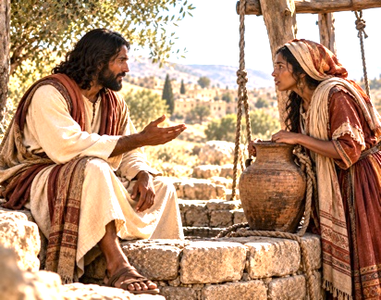
NOTES

Main idea: Jesus meets us where we are, but He loves us too much to leave us unchanged.

Question: Have you ever experienced a seemingly ordinary encounter or conversation that ended up changing your perspective or the direction of your life?

Concealment – Jesus Sees Beyond Our Circumstances

Key Thought: We may attempt to hide/conceal our struggles from others, but nothing about our lives is hidden from Jesus. (John 4:4-9, 16-18)

- The Samaritan woman arrived at Jacob’s well around noon…during the heat of the day. Although scripture does not explain why she was alone, it is possible that there was tension regarding:
  - Her ____________: She was a Samaritan woman living in an environment that struggled with cultural and religious divisions.
  - Her _____________: She had experienced 5 marriages and was living with a man who was not her husband.

- Despite everything Jesus already knew about her, He still chose (___________/was ______________) to speak with her.
  - Hebrews 4:13 (NASB) – And there is no creature hidden from His sight, but all things are open and laid bare to the eyes of Him to whom we must answer.

- Discussion Questions:
  - How does knowing that Jesus sees everything about us, yet still desires a relationship with us, change the way we approach him?

Conversation – Jesus Meets Us Where We Are

Key Thought: Jesus initiated a conversation that crossed cultural, religious, and social ______________. (John 4:7-15)

Jesus did not wait for the woman to approach Him. He initiated the conversation by asking her for a drink.



Notice how Jesus engaged her:
- He approached her personally: He was willing to speak with someone others might have avoided.
- He moved beyond the surface: What began as a discussion about physical water became a conversation about spiritual thirst.
- He offered something greater: Jesus introduced the possibility of living water that would satisfy a deeper need.

- Discussion Questions:
  - What can we learn from the way Jesus initiated this conversation with someone who was different from Him culturally and religiously?

Confrontation – Jesus Lovingly Reveals the Truth

Key thought: – Jesus does not confront us to condemn us, but to bring us into truth and transformation. (John 4:16-26)

- Notice how the conversation took a significant turn when Jesus instructed the woman to call her husband.
  - Even though Jesus revealed that He knew the truth about her relationships, He did not humiliate her or abandon the conversation. Instead, he continued speaking with her about worship, truth, and the coming Messiah. Notice tow important truths that Jesus presented:

    - Jesus addressed her circumstances – His willingness to engage her did not prevent Him from speaking truthfully about her life.
    - Jesus directed her toward something greater – He moved the conversation beyond religions locations and traditions to the importance of worshiping the Father in spirit and truth.
- Result: The woman eventually expressed her expectation that the Messiah would come. Jesus then reveals that He is the Messiah.
  - She ran back to the village and told everyone what she experienced.
    - Her _______________ changed
    - Her _______________ shifted – she left her water jar and hurried back to the village
    - Her _______________ influenced others – Many Samaritans initially believed because of her testimony, and others believed after hearing Jesus themselves.

- Discussion Questions:
  - How can we distinguish between condemnation, which drives us away from God, and conviction, which draws us toward repentance and transformation?
  - What does the woman’s willingness to share her encounter with Jesus teach us about the power of personal testimony?

