

Bible Study Guide

The Blood of the Lamb
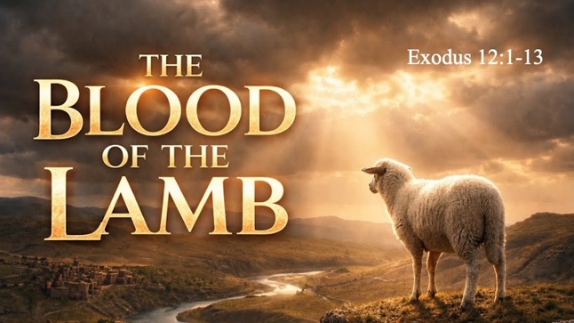
Text: Exodus 12:1-13 (read)

Bible Study Focus: When John the Baptist saw Jesus and declared, “Behold, the Lamb of God, who takes away the sin of the world!” (John 1:29), he was not using a random phrase. He was drawing on nearly 1500 years of sacred history—a history rooted in one of the most pivotal nights Israel ever experienced: The Passover. This study traces God’s redemptive roadmap from Egypt to Calvary.

Key verse: The blood shall be a sign for you on the houses where you live; and when I see the blood I will pass over you, and no plague will befall you to destroy you when I strike the land of Egypt. – Exodus 12:13

- The Blood Shall Be A Sign
    - Sign – owth – an indicator or signal; a distinguishing __________ – something to be recognized or ____________.
    - There is a biblical progression, almost like a roadmap, that displays the importance of a blood atoning sacrifice.
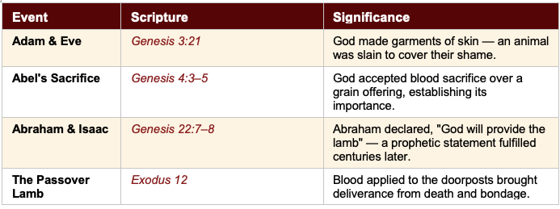

- **When John the Baptist states, “Behold, the Lamb of God who takes away the sin of the world” (John 1:29), almost _________ years have passed, and every year Hebrew households prepared a Passover lamb.

- Question: What does this progression reveal about God’s character and His long-term plan for humanity?

- Question: What does it mean to you that blood was chosen as the sign—not wealth, status, knowledge, or religious effort?

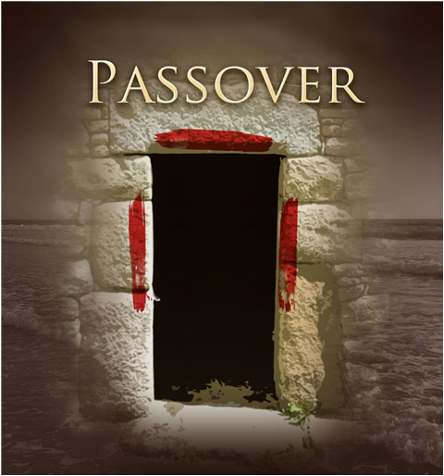
- When I See The Blood
  - The blood needs to be _________; The blood needs to be applied:
    - See – ra’a – to look, to see; to ___________; to regard; to give ____________ to.
      - Exodus 12:7 – Moreover, they shall take some of the blood and put it on the two ___________ and on the __________ of the houses in which they eat it.

    - Door - represents ___________—but the focus is on the blood. The emphasis is not on who is inside the house, but on what ___________ the entrance.

  - Our salvation does not depend on the strength of our ___________, but on the sufficiency of the ____________ of Christ.

  - Question: What does it look, practically, to “apply” the blood of Christ to your life? What is required on our part?

- I Will Pass Over You
  - Pass over – pasha – to ___________ or ___________ over; In essence, it means to come close enough to see the blood, and intentionally jump over that place.

  - Death had no ____________ when the blood was applied. Despite the sins that were committed before the blood was applied…judgement ____________ over the blood.

  - In the same way that the blood of the lamb was applied on the house, and everyone inside was saved, scripture states that if the blood of Jesus is applied to the dwelling place of your heart, you will be saved.

    - Hebrews 9:13-15 (NLT) - 13 For if the blood of goats and bulls and the ashes of a heifer sprinkling those who have been defiled sanctify for the cleansing of the flesh, 14 how much more will the blood of Christ, who through the eternal Spirit offered Himself without blemish to God, cleanse your conscience from dead works to serve the living God?

    - Colossians 1:19,20 - 19 For it was the Father’s good pleasure for all the fullness to dwell in Him, 20 and through Him to reconcile all things to Himself, whether things on earth or things in heaven, having made peace through the blood of His cross.

  - Question: The protection of the Passover was for everyone inside the house—regardless of their past. What does this tell us about the scope of what Jesus accomplished on the cross?

