

Bible Study Guide

By Faith, Abel…
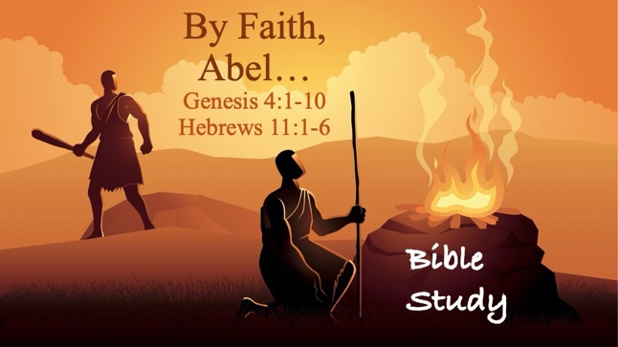
Text: Genesis 4:1-10 & Hebrews 11:1-6 (read)

Bible Study Focus: Abel’s story is brief—only a handful of verses in Genesis—yet thousands of years later, the author of Hebrews holds him up as one of the great heroes of faith. What made his offering different from Cain’s? What does it mean to offer something “by faith”? Why does a man who has been dead for millennia still speak to us today?

Key verse: “By faith Abel offered to God a more excellent sacrifice than Cain, through which he obtained witness that he was righteous, God testifying of his gifts; and through it he being dead still speaks.” – Hebrews 11:4 (NKJV)

- Faith
  - Hebrews 11:4 states: “By faith Abel offered to God a more excellent sacrifice than Cain…”
  - What is faith?

    - Definition (Hebrews 11:1) - Now faith is the substance of things hoped for, the evidence of things not seen.
      - Substance (assurance) - hypostasis (hoop-os-tas-is)- ______________ or substructure; confidence; trusted material
        - Faith is the foundation that holds up your hope before anything shows up in reality.

      - Evidence (evidence) - elegchos (el-eng-khos) - ____________; that by which a thing is proved or tested

    - Faith is not wishful thinking—it is the substructure of hope. Like a jury that reaches a verdict before the evidence is fully presented, faith operates with confident assurance in what God has promised.

  - Question: What’s the difference between “faith” and “optimism”?
  - Question: (Full Transparency) Of the two, which do you operate in the most? Why?

- Abel Offered A Sacrifice
  - Genesis 4:4 – Abel, on his part also brought an offering, from the firstborn of his flock and from their fat portions. And the Lord had regard for Abel and his offering;
    - offering – minhâ (min-khaw) - a gift
      - first born – premium stock
      - fat portions - heleb (kheh-leb)- the best; ______________
      - regard - sa'a (shaw-aw) - to look or gaze; to capture one's _______________; to highly respect or regard

  - Abel did not just bring a gift—he brought what he would have preferred to keep. The “first born” and the “fat portions” were the most valuable parts of his flock. This was a genuine sacrifice, not an afterthought.

Question: The text says God “had regard” for Abel and his offering together—not just the offering itself. What does that suggest?

Inner Reflection Question: In what areas of your life do you tend to give God your “leftovers” rather than your first fruits—your time, talent, and treasure?

- That Pleased God
- Hebrews 11:6 - But without faith it is impossible to please Him, for he who comes to God must believe that He is, and that He is a rewarder of those who diligently seek Him.

  - Impossible - adynatos (ad-oo-nat-os) - without ______________; the negative of having power (dunamis); to lack the ____________; unable to be done

  - Any person who approaches or has a desire to draw near to God must do two things:
    - Believe that He is or that He exists:
      - (He) is – eimi (i-mee) – to be; to exist; to be ______________

    - Believe that God is a rewarder of those who seek him diligently (…with purpose).
      - Rewarder - misthapodotes (mis-thap-od-ot-ace) - the one who pays __________;
      - Seek – ekzeteo – to search out; to _______________; to look for something with the intention of finding it.
      - God rewards “____________” not “_____________”.

  - Question: What practical habits help you to “diligently” seek God?

