
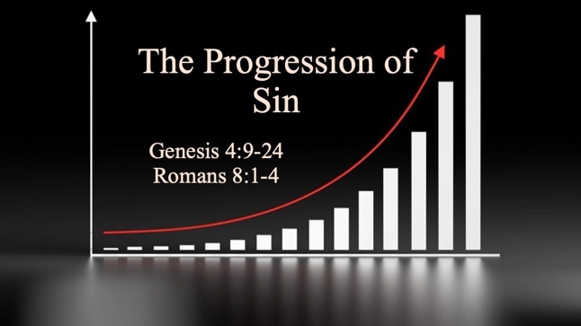

Bible Study Guide

The Progression of Sin

Text: Genesis 4:9-24 & Romans 8:1-4 (read)

Bible Study Focus: This study walks thorugh one of Scripture’s most foundational themes: the nature of sin, the purpose and limits of God’s law, and the ultimate victory found in Jesus Christ. We will follow the biblical narrative from Cain and Abel in Genesis 4 all the way to the great declaration of freedom in Romans 8.

Key verse: “For what the Law could not do, weak as it was through the flesh, God did: sending His own Son in the likeness of sinful flesh and as an offering for sin, He condemned sin in the flesh, so that the requirement of the Law might be fulfilled in us who do not walk according to the flesh but according to the Spirit.” – Romans 8:3,4 (NKJV)

- The Law and Sin
  - Cain murders Abel—God responds with judgment. (Genesis 4:10-12)
    - We now recognize that this is a constant with sin. Sin = ____________.
      - Sin will always produce _____________—even before formal law was introduced and established. (Adam, Eve, Cain)
  - Law is established out of _____________ for Cain (verse 15)
    - 15 So the Lord said to him, “Therefore whoever kills Cain, vengeance will be taken on him seven times as much.” And the Lord placed a mark on Cain, so that no one finding him would kill him.
    - God even places a mark on Cain for _____________.

  - What is Law? (5 Core Components)
    - Authority – Who establishes it…who has the ____________ to declare it?
    - Content – It commands behavior: Do this; Don’t do this; Do this under certain conditions.
    - Obligation – It is binding…it is not a _______________
    - Enforcement – It must be upheld for it to be ______________
    - Consequence – Judgment follows

  - Law: Establishes _____________; Protects People; Establishes _______________
    - Psalm 19:7 - "The law of the Lord is ______________ (complete or blameless), restoring the soul."
    - Perfect – tamim – to be _____________ or whole;

  - Question: How would you see God’s law as an act of love and protection, and not just restriction?

- The Growth of Sin
  - One of the greatest misconceptions is that good law would prevent sin, but the biblical record shows us the opposite—sin began to multiply. 5 generations after Cain, Lamech emerged:
    - Lamech takes _____________ wives – distortion of God’s design (times 2)
    - Lamech kills a man and a ____________ – death occurs at the hand of man (times 2)
    - Lamech creates his own “____________”: - seventy-seven times vengeance (times 11)
  - **Sin grows when left unchecked.

  - Even with the presence of divine law…sin grew. Why?
    - The perfect law can ____________ sin.
    - The perfect law can _____________ sin.
    - The perfect law cannot _______________ sin.

Question: Have you ever noticed sin growing in your own life despite knowing the right thing to do? Have you ever tried to create your own laws to replace the current laws that exist? What do these experiences inform you about human nature?

* Paul describes this tension between law and sin in Romans 7:22-24 (read).

- The Defeat of Sin
  - Romans 8:1-4 - Therefore there is now no condemnation at all for those who are in Christ Jesus. For the law of the Spirit of life in Christ Jesus has set you free from the law of sin and death. For what the Law could not do, weak as it was through the flesh, God did: sending His own Son in the likeness of sinful flesh and as an offering for sin, He condemned sin in the flesh, so that the requirement of the Law might be fulfilled in us who do not walk according to the flesh but according to the Spirit.

    - Weak – astheneo – unhealthy; without vigor; _____________ to accomplish a task

  - The death and resurrection of Jesus Christ enacted a new law: The Law of the Spirit of Life in Christ Jesus.
    - There is no ________________ if you are a child of God
    - This law frees (___________) you from the law of sin and death
    - Accomplished by God the Father sending His own Son:
      - In the ___________ of sinful flesh
      - As an _______________ for sin
      - Sin was ______________ and condemned in the flesh
      - The Law (requirement judgment) was _____________ (satisfied)
      - In those who ____________ in the Spirit by faith.
        - Walk – peripeteo – to make one’s way; to make _____________

