
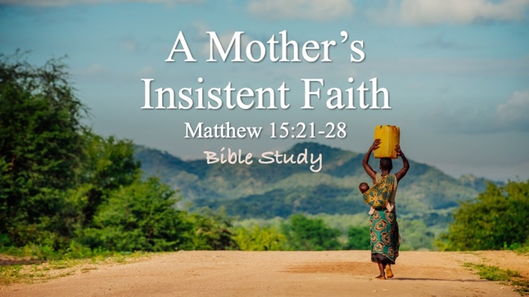

Bible Study Guide

A Mother’s Insistent Faith

Text: Matthew 15:21-28

Bible Study Focus: This passage introduces us to a desperate mother from Canaan whose daughter was severely demonized. She was an outsider—a Gentile woman with no covenant claim to Israel’s Messiah. She did not possess Jewish tradition, heritage, or worship practices, yet somehow, she recognized something about Jesus. Despite being rejected, offended, and humiliated, her response to those “feelings” resulted in Jesus calling her faith “great”. This study explores how her response to rejection, offense, and humiliation revealed a faith that refused to let go.

Key verse: “Then Jesus answered her, “O woman, great is your faith. Let it be done for you as you desire.” And her daughter was healed instantly. – Matthew 15:28 (NKJV)

Why Tyre and Sidon?

“Then Jesus went from there and departed into the regions of Tyre and Sidon.” – Matthew 15:21
- “…from there…”: from “where”? At the beginning of this chapter, Jesus is in the city of Gennesaret.
  - A day or so before:
    - He just found out that his cousin, John the Baptist was beheaded (murdered) by King Herod (Matthew 14:10-12)
    - He tried to sneak away to a quiet place because he wanted time and space to mourn, but people followed him (est. 5,000 men) …and he ministered to them and miraculously fed them. (Matthew 14:13-21)
    - He sent the disciples away to cross the Sea of Galilee while he dealt with the crowds and so that he can finally have some time alone. Then walked on the water to catch up with them. (Matthew 14:22-33)
    - They landed in Gennesaret, and people recognized him, so another healing crusade occurred. (Matthew 14:34-36)
    - Next, Pharisees from Jerusalem confronted Jesus, scrutinizing his ministry and challenging him based on their interpretation of the Law of Moses. (Matthew 15:1-11)
      - The disciples informed Jesus that he may have “offended” the religious leaders. (Matthew 15:12-20)
    - “Then Jesus went from there and departed into the regions of Tyre and Sidon.” (Matthew 15:21)
      - The region of Tyre and Sidon (modern-day Lebanon) lies approximately 35–50 miles (56–80 km) north/northwest of the Sea of Galilee in Israel. Walking from the Galilee area (e.g., Gennesaret) to Tyre typically took 11–12 hours, covering about 35 miles.
    - Why do you think Jesus went 35-50 miles north away from Jewish people?

Canaanite Woman
- “There, a woman of Canaan came out of the same regions and cried out to Him, saying, “Have mercy on me, O Lord, Son of David. My daughter is severely possessed by a demon.” – verse 22

- A woman of Canaan – an important detail mentioned in scripture because historically, Canaanites represented __________ nations that typically _____________ Israel.

  - Yet she approached Jesus anyway.
    - She heard about Jesus. How?
    - She _________ out to Jesus with the proper Messianic title. How?

Ignored and Rejected
- “But He (Jesus) did not answer her a word. And His disciples came and begged Him, saying, “Send her away, for she cries out after us. But He (Jesus) answered, “I was sent only to the lost sheep of the house of Israel.” – verses 23,24
  - Why do you think Jesus ignored her? Would you find the behavior of Jesus and the disciples offensive?
  - Offense – skandalon – the stick that sets the ___________.

- “Then she came and worshipped Him, saying, “Lord, help me.” – verse 25
  - How did she respond to offense? She worshipped and made her request.
    - Worship – proskuneo – to ___________ down; a posture of ____________;

- Reflection Question: How can worship protect the heart from bitterness? Do you have a scriptural reference?
- Reflection Question: What do you think happens spiritually when we continue worshipping in painful seasons?

Insulted and Reviled
- But He (Jesus) answered, “It is not fair to take the children’s bread and to throw it to dogs.” - verse 26
  - This is a direct insult. There is no doubt about it.
- Question: How would you describe the response that Jesus gave to the woman?
- Question: In what ways do you process the racial, ethnic, and cultural undertones that are found in this interaction between Jesus and the Canaanite woman?

Insistent and Rewarded
- “She said, ‘Yes, Lord, yet even dogs eat the crumbs that fall from the masters’ table.’ Then Jesus answered her, ‘O woman, great is your faith. Let it be done for you as you desire.’ And her daughter was healed instantly.” – verses 27,28
  - Question: Why would you consider the woman’s statement as a “faith-filled” response, based on the way Jesus responded to her response?
  - Question: We know why she stayed, but the true question is, “How” did she stay and respond the way that she did?

- Her faith said: I will not _________ up; I will not stop __________; I will not allow rejection, humiliation, or offense _____________ hope.

