

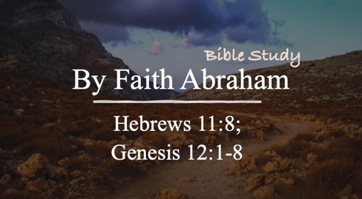

Bible Study Guide

By Faith Abraham…

Text: Hebrews 11:8; Genesis 12:1-8

Bible Study Focus: Throughout Hebrews 11, we discover that faith is more than belief—it is belief expressed through action.
- Abel's faith led him to offer a more excellent sacrifice.
- Noah's faith led him to build an ark for a flood he had never seen.
- Abraham's faith led him to leave everything familiar and follow God into an unknown future.
Faith often requires us to trust God's promises before we can see God's plan.

Key verses: "By faith Abraham, when he was called, obeyed by going out to a place which he was to receive for an inheritance; and he went out, not knowing where he was going."– Hebrews 11:8 (NASB)

Read Genesis 12:1-4

- Our Journey of Faith Requires Difficult Obedience
  - The Command: “Go from your country, and from your relatives and from your father’s house, to the land which I will show you.”
    - Country – Abram’s ___________, traditions, and physical _____________
    - Relatives – Abram’s familiar relationships and _____________ system
    - Father’s House – Abram’s _____________, inheritance, and place of belonging.

  - Following Jesus often creates similar tensions where our faith may require us to leave:
    - Cultural values that ___________ God’s truth
    - Familiar habits and relationships outside of God’s _____________ will
    - Former _____________ and ______________.

  - Matthew 16:24 – Then Jesus said to His disciples, “If anyone wants to come after Me, he must deny himself, take up his cross, and follow Me.”
    - Deny – aparneomai – to affirm that one has ________ acquaintance or connection with someone. (…including yourself)

    - Three characteristics of Christ’s “followers”: (…a journey of faith)
      - The denial of self
      - Taking up one’s __________
      - _____________ Jesus Christ – you cannot make your own path!

Question: Which of Abram’s sacrifices would have been the most difficult for you?
  - With every ask of the Lord, there is a promise of blessing:
      - I will make you into a great nation.
      - I will bless you
      - I will make your name great
      - You shall be a blessing
      - I will bless those who bless you
      - The one who curses you I will curse
      - In you all the families of the earth will be blessed

    - Matthew 6:33 – “But seek __________ His kingdom and His righteousness, and all these things will be provided to you.

- Our Journey of Faith Requires Altar Building
  - Read Genesis 12:4-8
  - Twice in this passage Abram builds an altar.
    - Altar – mizbeach – a place of ____________;
      - A place of _____________
      - A place where something ___________ so that worship can occur
      - A place that you do not show up empty-handed
      - A place where you expect to ___________ something behind

  - An altar represented two things:
    - A Place of Contact (verses 6,7)
      - Outnumbered by the Canaanites, Abram needed assurance, so:
        - The Lord _____________ to Abram: God initiated the encounter
        - Abram responds by building an altar.

    - A Place of Communication (verse 8)
      - Abram pitches his tent between Bethel (__________ of God) and Ai (Heap of _________) …the tension between believing for God’s presence and promises or the fear of everything not working out.

        - In response Abram builds and altar and _________ upon God: Abram initiates the encounter.

        - **When life places us between Bethel and Ai, communication with the Lord keeps us moving toward God’s promises rather than toward destruction.

