

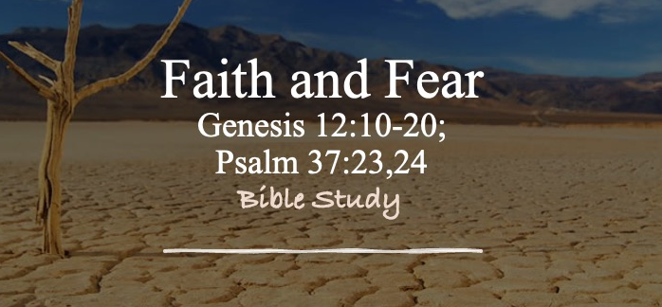

Bible Study Guide

Faith and Fear

Text: Psalm 37:23,24; Genesis 12:10-20

Bible Study Focus: A believer’s journey of faith is not a journey without mistakes. Even faithful people can lose their footing when fear begins to influence their decisions. Yet God’s grace is greater than our failures, and He knows how to hold on to His children when they fall.
Key verses: "The steps of a man are established by the LORD, and He delights in his way. When he falls, he will not be hurled down, because the LORD is the One who holds his hand..."– Psalm 37:23,24 (NASB)

- Note: the psalmist does not say if he falls, but when he falls.
  - Question: How would you process this as a believer?

- Key words from this text:
  - Established (kûn) – firm, stable, secure
  - Delights (hapes) – takes pleasure in, is pleased with
  - Way (derek) – path, road, journey, manner of life
  - Falls (napal) – to fall down, collapse, move from a position of strength to weakness
  - Hurled Down (tul) – cast away, thrown aside

Read Genesis 12:10-20

Discussion Question(s): Why did Abram go down to Egypt? Was going down to Egypt an issue? What action or discipline was missing?

Fear – a distressing ___________ aroused by impending danger, evil, pain, etc. whether the threat is ________ or ________________.

Faith (Hebrews 11:1) – the substance of things hoped for, the evidence of things not seen.

- Substance – hypostasis – the substructure or foundation of something
- Evidence – elegchos – proof

**Both fear and faith deal with ___________ reality.

Faith comes from God’s __________ (Romans 10:17) – So then faith comes by hearing, and hearing by the word of Christ.”

Fear becomes a __________ (Proverbs 29:25) – “The fear of man brings a snare, but whoever trusts in the LORD shall be safe.”

- Fear of Having No Provision (Genesis 12:10)
  - For the first time in the narrative, Abram’s movement is explained by something other than God’s direction. Fear will lead you to _______________ direction:
    - God called Abram to Canaan; Famine called Abram to Egypt
    - Fear of lack often causes people to _____________ places of promise.

  - Fear of lacking shows up in many ways:
    - Fear of missing out
    - Fear of being overlooked
    - Fear of not being respected
    - Fear of not being satisfied
    - Fear of not having enough
    - Fear of not getting what others seem to enjoy
    - Fear of not being there for our family

**Key Takeaway – When fear of lacking _____________ our thinking, we begin making decisions based on scarcity rather than trust.

Reflection Questions: Have you ever made a decision because you feared God would not provide? How does God’s past faithfulness help strengthen present faith?

- Fear of Having No Protection (Genesis 12:11-15)
  - Fear-driven decisions often create _______________ we never intended. Sarai is taken into Pharaoh’s palace…possibly his harem.
    - Question: What is the indicator that Abram’s decision was driven by fear? How can that help you discern whether your decision are driven by fear?

  - Genesis 12:16 – “Therefore he (Pharoah) treated Abram well for her (Sarai) sake; and he gave him sheep, oxen, male donkeys, male servants and female servants, female donkeys, and camels.”
    - Abram receives wealth—his fear of lack is solved…but:
      - His wife is _______________
      - His deception is ______________
      - His anxiety ________________
    - Giving in to fear promises relief but usually produces deeper bondage.

- God’s Grace—Greater Than Our Fear and Fall (Genesis 12:17-20)
  - Abram does not rescue himself…God intervenes (he is holding Abram’s hand)
    - The LORD _____________ Sarai
    - The LORD ______________ Pharoah
    - The LORD ______________ His covenant promise

  - This account is not primarily about Abram’s failure…it is about God’s faithfulness despite Abram’s failure.

  - Psalm 37:24 – “When he falls, he will not be hurled down, because the LORD is the One who holds his hand.”
    - Abram will have to deal with the ____________ (consequences) of falling…but he is not cast away.

