
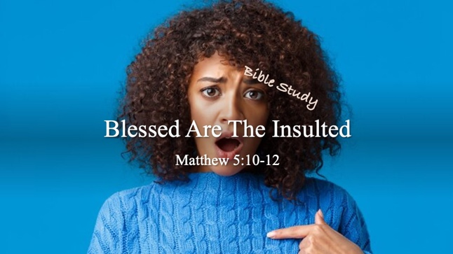

Bible Study Guide

Blessed Are The Insulted

Text: Matthew 5:10-12

Bible Study Focus: Most believers readily embrace the promises of comfort, mercy, righteousness, and peace found in the Beatitudes. However, Jesus concludes this section with one of His most challenging statements: “Blessed are you when people insult you and persecute you, and falsely say all kinds of evil against you because of me.” (Matthew 5:11) This study explores why those who endure opposition for Christ are called blessed and how our response to offense reveals the depth of our faith.

Key verses: “Blessed are you when people insult you and persecute you, and falsely say all kinds of evil against you because of me. Rejoice and be glad, for your reward in heaven is great; for in the same way they persecuted the prophets who were before you.” – Matthew 5:11,12 (NASB)

Kingdom Possession

- “Blessed are those who have been persecuted for the sake of righteousness, for theirs is the kingdom of heaven…” – Matthew 5:10

  - Key idea: Those who endure persecution for the sake of righteousness are not losing—they are gaining possession of something greater than this world can offer. Jesus speaks of the Kingdom as a ___________ possession.

  - Kingdom of Heaven – basileia ouranon (Gk.) – the royal ______, reign, and dominion of God.

    - John 18:36 (NKJV) – (Jesus speaking to Pontius Pilate) “Jesus answered, ‘My kingdom is not of this world. If My kingdom were of this world, My servants would fight, so that I should not be delivered to the Jews; but now My kingdom is not from here.”

      - Its _________ is heavenly, not earthly: His authority comes from God, not from human governments

      - Its ____________ and ____________ are different: Christ’s kingdom advances through truth, repentance, faith, and the work of the Holy Spirit…not military force and political power.

      - Its citizens have ___________ citizenship

        - “For our citizenship is in heaven, from which we also eagerly wait for a Savior, the Lord Jesus Christ;” – Philippians 3:20
          - Citizenship – politeuma – the constitution of a commonwealth; to be a part of an official government;

Kingdom Possession

- “Blessed are you when people insult you and persecute you, and falsely say all kinds of evil against you because of me. Rejoice and be glad, for your reward in heaven is great; for in this same way they persecuted the prophets who were before you.” – Matthew 5:11,12

- reward – misthos (Gk.) – wages, compensation, ___________ due for work _____________;

  - Faithfulness under suffering is never overlooked by God. Every insult endured for Christ, every false accusation, and every act of obedience is __________, ____________, and ______________ to your account in heaven (kingdom).

    - Hebrews 11:6 – “But without faith it is impossible to please Him, for he who comes to God must believe that He is, and that He is a _____________ of those who diligently seek Him.”
      - We are compensated as we search for the Lord and His will. We get paid to “look” for Him.

- Question: How does the reality of God’s Kingdom change the way we view suffering?

Case Study: Canaanite Woman (Matthew 15:21-28)
- She was:
  - ____________: He did not answer her with even a word. – Matthew 15:23
  - ____________: His disciples urged Him, saying, “Send her away, because she keeps shouting behind us.” Jesus answered, “I was sent only to the lost sheep of the house of Israel.” - Matthew 15:24
  - _____________: Jesus answered, “It is not good to take the children’s bread and throw it to the dogs.” – Matthew 15:26

Her Response
- “Then she came and worshipped Him, saying, ‘Lord, help me.’” – Matthew 15:25
  - Worship – proskuneo – to bow down in reverence; to express devotion and submission;
    - Instead of being “offended” she drew closer to the one who can save her.
  - Undeterred reply – “Yes, Lord, yet even dogs eat the crumbs that fall from the master’s table.” Matthew 15:27

- Question: In what ways can worship impact your connection to God’s Kingdom?

The Savior’s Response
- “Then Jesus answered her, ‘O woman, great is your faith. Let it be done for you as you desire.’ And her daughter was healed instantly.” – Matthew 15:28
  - Great is your faith: faith is measured in the Kingdom – based on our response.
  - Let it be done for you as you desire: wages = “blank check”

