

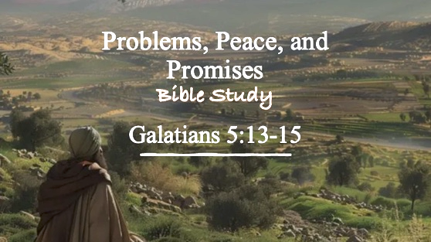

Bible Study Guide

Problems, Peace, and Promises Part 1

Text: Genesis 13
Bible Study Focus: Genesis 13 reminds us that although believers cannot avoid problems, they can pursue peace while trusting God’s promises. Abram demonstrates that obedience is never a loss when God’s promises are involved.
Key verses: The Lord said to Abram, after Lot had separated from him, “Now lift up your eyes and look from the place where you are, northward and southward and eastward and westward; for all the land which you see, I will give it to you and to your descendants forever."– Genesis 13:14,15 (NASB)

- Big Idea: Faith chooses peace over possessions because God’s promises are greater than temporary advantages.

Read Genesis 13:1-18

- Problems Are Inevitable (Genesis 13:5-7)
  - “The land could not sustain them while dwelling together…”
    - sustain – nasa – to bear; to carry; to _____________. The land could not carry the weight of both households.

  - Abram increased in wealth, and Lot, being connected to Abram, also grew in wealth. Their prosperity brought problems.

    - Genesis 13:7 – And there was strife between the herdsmen of Abram’s livestock and the herdsmen of Lot’s livestock.
      - Strife – riyb – dispute, ______________, controversy, contention

    - Problems and issues are a part of life. Sometimes our problems are not signs of God’s absence…sometimes they are simply signs that we’ve grown.

    - Read Matthew 6:25-34
      - (verse 27) Worrying about problems will not _________ an inch to your height.
      - (verse 32) Your Heavenly Father is _________ of all of your needs and problems.
      - (verse 34) Don’t worry about tomorrow’s problems. Each day has enough trouble of its own.
      - (verse 33) Seek _______ God’s ___________ and His righteousness—everything else will be provided (resources, strategies, solutions, favor, grace, etc.)

  - Problems are a part of life, but God has given us a way to deal with our problems and our needs.

  - Genesis 13:7 – Now the Canaanite and the Perizzite were dwelling then in the land.

    - Scripture intentionally informs us that the Canaanites and the Perizzites were living nearby. Why? Because:
      - ___________ conflict becomes especially dangerous when ___________ enemies exist.

      - Abram’s household was divided while surrounded by pagan nations. Division weakened their witness.

    - Matthew 12:25 – Jesus said to them, “Every kingdom divided against itself is laid waste; and no city or house divided against itself will stand.” – this is divine kingdom principle.

      - Jesus goes on to explain that Satan does not even do this as a part of his own kingdom strategy: “And if Satan is casting out Satan, he has become divided against himself; how then will his kingdom stand?” – Matthew 12:26

    - Ephesians 4:26,27 – Be angry and yet do not sin; do not let the sun go down on your anger, and do not give the devil an opportunity.
      - Opportunity – topos – a designated place or ________;

    - 1 Peter 5:8 – Be of sober spirit, be on the alert. Your adversary, the devil, prowls around like a roaring lion, seeking someone to devour.
      - Seeking – zeteo – to search for something with the intention of finding it.

    - Galatians 5:14, 15 – For the whole Law is fulfilled in one word, in the statement, “YOU SHALL LOVE YOUR NEIGHBOR AS YOURSELF.” But if you bite and devour one another, take care that you are not consumed by one another.
      - Small consistent bites from each other will eventually result in total destruction from within.

    - Psalm 133:1-3 – Behold, how good and how pleasant it is for brothers to live together in unity. It is like the precious oil on the head running down upon the beard, as on Aaron’s beard, the oil which rand down upon the edge of his robes. It is like the dew of Hermon coming down upon the mountains of Zion; For the Lord commanded the blessing there—forever.
      - Unity among people is described and compared to two things:
        - The anointing ceremony of God’s chosen High Priest for Israel – the flow of anointing
        - Moisture descending upon God’s Holy Mountain: where He commands blessings

    - James 3:16 – (read verses 13-18 for full context) – For where jealousy and selfish ambition exist, there is disorder and every evil thing.

      - Jealousy – zelos – zeal; fervor of spirit

