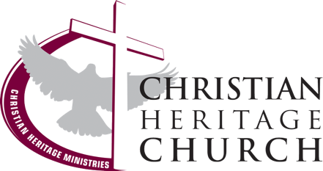
How Much Do You Know?

NOTES

Knowledge – facts, information, and skills acquired by a person through experience or education; the theoretical or practical understanding of a subject.

What does the bible say about knowledge?
Proverbs 4:7 (NKJV) - Wisdom is the principal thing; Therefore, get wisdom. And in all your getting, get __________________.

- Understanding – biynah – knowledge gained; the ability to discern or distinguish; (to gain knowledge of something...and how it works)

Consider these two verses as well:
1 Corinthians 8:1,2 (NASB): Now concerning food sacrificed to idols, we know that we all have knowledge. Knowledge makes one conceited, but love edifies people. If anyone thinks that he knows anything, he has not yet known as he ought to know.
1 Corinthians 8:2 (NLT): Anyone who claims to ____________ all the answers doesn’t really know very much.

1 Corinthians 13:9 states: "For we know in ________ and we prophesy in ________..."
- Part - meros - a portion or lot; one of the constituent’s parts of a whole

We see in scripture that attaining wisdom and knowledge is very important, but we are also reminded that our knowledge is _____________ at best.

- Knowledge can become a disadvantage whenever it supersedes the knowledge of God.
  - Proverbs 3:5,6 (NASB) – Trust in the Lord with all your heart. And do not lean on your own understanding. In all your ways acknowledge Him, and he will make your paths straight.
  - 2 Cor. 10:5 (NIV) – We demolish arguments and every pretension that sets itself up against the knowledge of God, and we take captive every thought to make it obedient to Christ.

- Knowledge can become a disadvantage when it leads to someone being “right or wise in their own eyes”:
  - Proverbs 21:2 - Every way of a man is right in his own eyes, but the Lord weighs the heart.
- Proverbs 12:15 - The way of a fool is right in his own eyes, but a wise man listens to advice.
- Proverbs 3:7 - Be not wise in your own eyes; fear the Lord and turn away from evil.
- Proverbs 26:12 - Do you see a man who is wise in his own eyes? There is more hope for a fool than for him.

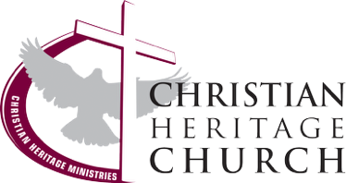
Two elements that are important in preventing “right in your own eyes” syndrome:

- Humility - a _______________ that you do not have all of the answers
- A _____________ spirit - a ________________ to be shown the answers

Text: James 4:6-10

“God is opposed to the proud, but gives grace to the humble.” 7 Submit therefore to God. But resist the devil, and he will flee from you. 8 Come close to God and He will come close to you. Cleanse your hands, you sinners; and purify your hearts, you double-minded. 9 Be miserable, and mourn, and weep; let your laughter be turned into mourning, and your joy into gloom.10 Humble yourselves in the presence of the Lord, and He will exalt you.

Humility - Verse 6,10
- Proud - hyperephanos - showing one's self ___________ others; “shining” above others
- Opposed - antitasso - to ___________ against an opponent;
- Grace - charis - unmerited ____________ and lovingkindness
- Humble - tapeinos - __________ to the ground

A Teachable Spirit - Verse 7,8
- Submit - hupatosso - to subject one's self to obey; to _____________ to one's admonition; to be under someone.
- Resist - anthistemi - _____________ against; hold your ground; don’t move an inch; the opposite of running away or giving in.
- Proximity – Draw close to God and He will come close to you. The first step belongs to you.
  - ____________ your hands
  - ____________ your hearts

Operating in humility and love creates a necessary prevention strategy against pride and arrogance.

1 Cor. 8:1 - “...we know that we all have knowledge. Knowledge ^{[a]}makes arrogant, but love edifies.”

NOTES

