
From the Booth to the Table
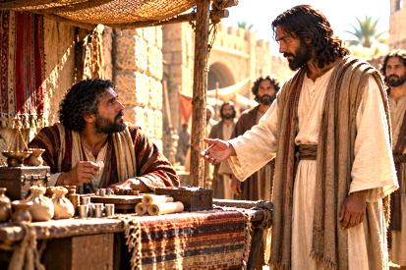
NOTES

Main idea: Discipleship begins when Jesus sees us, calls us to follow Him, and then uses our lives to reach others.

Seen—Jesus Saw Matthew Where He Was

Luke 5:27 – “He went out and saw a tax collector named Levi (Matthew), sitting at the tax booth.”

Matthew wasn’t in a synagogue seeking Jesus. He was sitting at the tax booth, embracing a profession that made him despised by much of his community. Yet…that is exactly where Jesus saw him.

- Matthew’s occupation, reputation, associations, and failures did not prevent Jesus from seeing him. I am reminded that we serve the God that sees (El Roi)

  - Read Genesis 16 – Hagar and the Abram/Sarai mess.
    - God ________ her
    - Hagar ____________ to God’s word.

  - Exodus 3:7-8 – “I have certainly seen the oppression of My people who are in Egypt, and have heard their outcry because of their taskmaster, for I am aware of their sufferings. So, I have come down to rescue them…”

    - Before Israel ever saw their deliverer, God had already _____________ them.

- Discussion Questions:
  - What difference does it make to know that God sees us completely including the parts of our lives we’d rather others not see? (Psalm 139:1-3)

Sought – Jesus Called Matthew to Follow Him

Jesus didn’t simply notice Matthew…He ____________ a relationship with him.

Luke 5:27,28 – “And he said to him, ‘Follow me.’ And leaving everything, he rose and followed him.”



- Matthew’s past and present did not disqualify him from Jesus’ invitation.
  - Jesus simply said, “Follow me”
    - Follow me – akoloutheo – to join on a path or ____________ (keluethos);
    - Discipleship is more than Jesus saying, “Believe what I believe”. Instead, it is Jesus saying, “Come with me. Walk _______ me. Learn _________ me. Become __________ me.

  - Matthew accepted the invitation and “left everything”. Why?

- Discussion Questions:
  - What might “leaving everything” look like for a disciple of Jesus today?

Shared – Matthew Brought His People to Jesus

Luke 5:29 – “And Levi made him a great feast in his house, and there was a large company of tax collectors and others reclining at the table with them.

- Matthew does not know much theology yet. He has not attended a discipleship class. He has not been trained in evangelism. But Matthew knows two things:
  - “I met Jesus”
  - “I know some people who need to meet Him too.”

- There are two concepts that are important to grasp in this passage regarding discipleship:

  - Matthew’s relationship circle became an immediate mission field.
    - Matthew left his “old life” without losing his concern for the people who were still living in it.
    - In follows the pattern of ministry and witness that Jesus referred to in Acts 1:8:
      - “But you will receive power when the Holy Spirit has come upon you; and you will be My witnesses both in Jerusalem and in all Judea, and Samaria, and as far as the remotest part of the earth.”

  - Jesus was willing to sit at Matthew’s table.
    - Jesus did not enter Matthew’s world because He approved of everything in it. He entered Matthew’s world because He intended to transform it. The Pharisees and scribes did not understand this concept…even to this day.
      - Approval and discipleship can look similar…from afar off.

- Discussion Questions:
  - Why do you think Peter was willing to leave the fish after receiving the greatest catch of his life?

