ST. PAUL’S
ANGLICAN CHURCH
VISALIA, CALIFORNIA

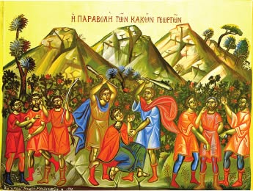

Nineteenth Sunday after Pentecost
October 4, 2026
10:30 A.M

Welcome!

St. Paul’s Anglican Church extends a warm welcome to all visitors and newcomers, whether worshiping in person or at home via livestream.

Visitors’ Guide

St. Paul’s Church is a parish in the Diocese of San Joaquin of the Anglican Church in North America, which includes both Catholic and Protestant traditions. We accept Jesus Christ as Savior, and we promise to follow him as Lord. We believe in One God,

- the Father who created us and all things,
- the Son who redeems us from sin and death,
- the Holy Spirit who renews and sanctifies us.

We believe the Holy Scriptures to be the Word of God and to contain all things necessary for salvation, and we accept the Apostles’ and Nicene Creeds as essential beliefs of the Christian faith.

Those not desiring to receive Holy Communion, and those who have not been baptized into the Christian faith, are invited to cross their arms across their chest, and a blessing will be given instead.

Visitors are invited to sign the guest book at the entrance table and introduce themselves to the clergy following the service.

The Holy Eucharist

Prelude: “Prelude and Fugue in G Major” Bach
Opening Hymn: - #518 – “Christ is Made the Sure Foundation” p. 4
Opening Acclamation p. 5
The Collect for Purity p. 5
Summary of the Law p. 5
Kyrie p. 6
Gloria p. 7
Collect of the Day p. 8
Lesson: Isaiah 5:1-7 p. 8
Gradual: Psalm 80 p. 9
Epistle: Philippians 3:14.21 p. 10
Sequence Celebration Hymn: #572 – “Blessed Assurance” p. 11
Gospel: Matthew 21:33-44 p. 12
Sermon: The Rev. Robert Longbottom
Nicene Creed p. 13
Prayers of the People p. 14
The Peace p. 16
Offertory: “Marguerite/Solo”
The Offertory p. 17
Sursum Corda p. 17
Sanctus p. 16
The Lord’s Prayer p. 20
Fraction p. 20
Prayer for Humble Access p. 21
Agnus Dei p. 21
Communion Hymn: #458 – “My Song is Love Unknown” p. 22
Post Communion Prayer p. 23
Blessing p. 23
Closing Hymn: #448 – “O Love, How Deep” p. 24
Dismissal p. 24
Postlude: “Earth and All Stars” Burkhardt

Opening Hymn: Christ is Made the Sure Foundation
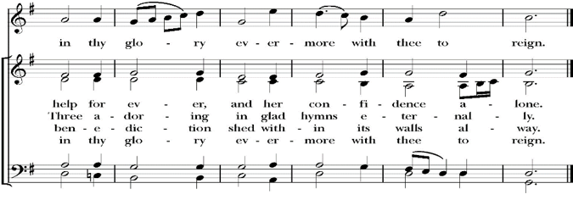
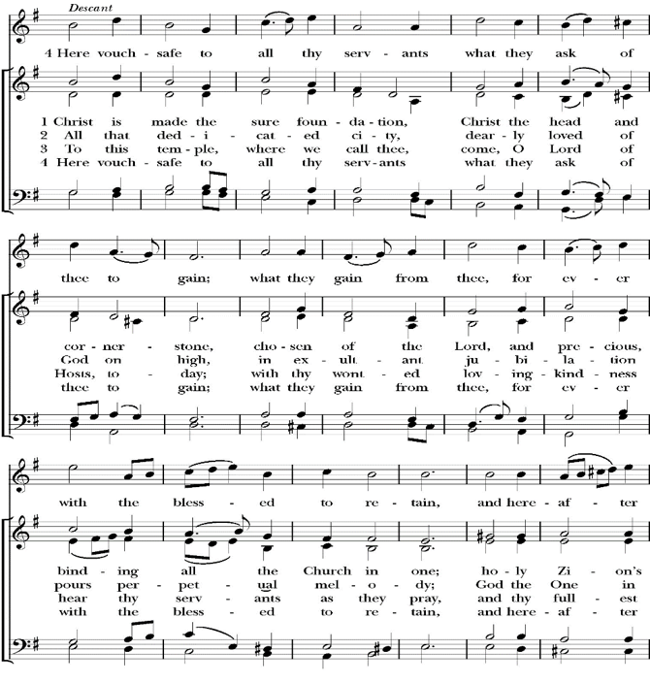

Opening Acclamation

Celebrant Blessed be God, the Father, the Son and the Holy Spirit. People And blessed be his kingdom, now and forever. Amen.

Collect for Purity

Almighty God, to you all hearts are open, all desires
known, and from you no secrets are hid: Cleanse the thoughts
of our hearts by the inspiration of your Holy Spirit, that we
may perfectly love you, and worthily magnify your holy Name;
through Christ our Lord. Amen.

Summary of the law

Hear what our Lord Jesus Christ says: You shall love
the Lord your God with all your heart and with all your soul
and with all your mind. This is the first and great
commandment. And the second is like it: You shall love your
neighbor as yourself. On these two commandments depend all
the Law and the Prophets.

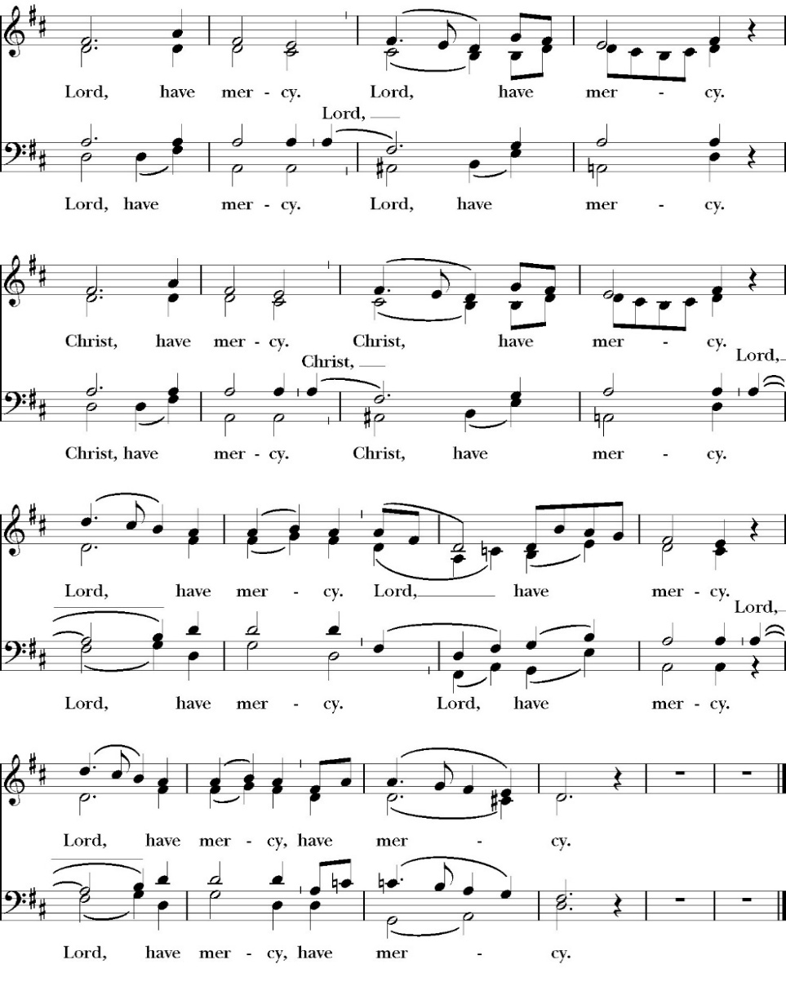
Kyrie

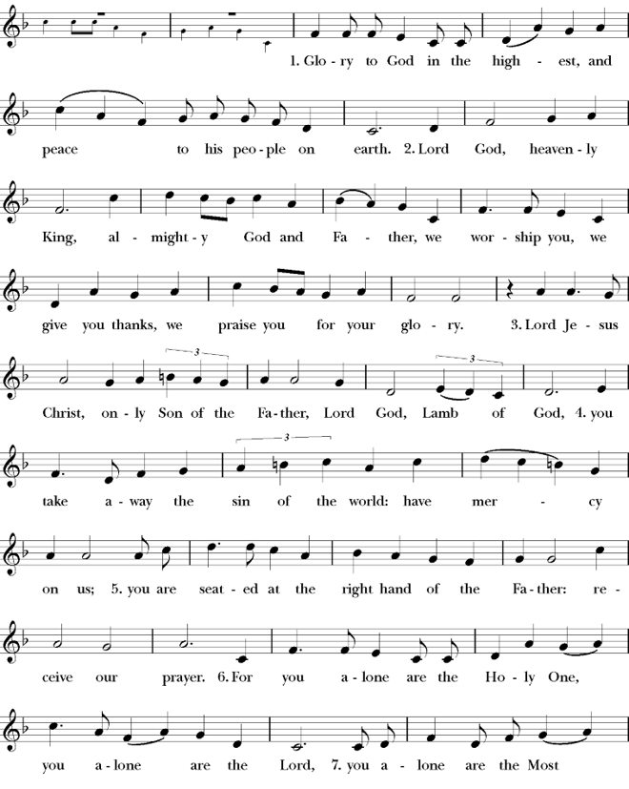
Gloria

Celebrant The Lord be with you.
People And with your spirit.
Celebrant Let us pray.

The Collect of the Day

Keep, O Lord, your household the Church in continual godliness, that through your protection it may be free from all adversities, and devoutly serve you in good works, to the glory of your Name; through Jesus Christ our Lord, who lives and reigns with you and the Holy Spirit, one God, now and for ever. Amen.

Lesson: Isaiah 5:1-7
Let me sing for my beloved my love song concerning his vineyard: My beloved had a vineyard on a very fertile hill. 2 He dug it and cleared it of stones, and planted it with choice vines; he built a watchtower in the midst of it, and hewed out a wine vat in it; and he looked for it to yield grapes, but it yielded wild grapes.

3And now, O inhabitants of Jerusalem and men of Judah, judge between me and my vineyard. 4 What more was there to do for my vineyard, that I have not done in it? When I looked for it to yield grapes, why did it yield wild grapes?

5 And now I will tell you what I will do to my vineyard. I will remove its hedge, and it shall be devoured; I will break down its wall, and it shall be trampled down. 6 I will make it a waste; it shall not be pruned or hoed, and briers and thorns shall grow up; I will also command the clouds that they rain no rain upon it.

7 For the vineyard of the LORD of hosts is the house of Israel, and the men of Judah are his pleasant planting; and he looked for justice, but behold, bloodshed; for righteousness, but behold, an outcry!

Reader: The Word of the Lord
People: Thanks be to God

Gradual: Psalm 80
1 Hear, O Shepherd of Israel, you that lead Joseph like a sheep; * show yourself also, you that sit upon the cherubim.
2 Before Ephraim, Benjamin, and Manasseh, *
stir up your strength and come to help us.
3 Restore us again, O God; *
show the light of your countenance, and we shall be whole.
4 O LORD God of hosts, *
how long will you be angry with your people that pray?
5 You feed them with the bread of tears *
and give them plenteous tears to drink.
6 You have made us the derision of our neighbors, *
and our enemies laugh us to scorn.
7 Restore us again, O God of hosts; *
show the light of your countenance, and we shall be whole.
8 You have brought a vine out of Egypt; *
you have cast out the nations and planted it.
9 You made room for it, *
and when it had taken root, it filled the land.
10 The hills were covered with the shadow of it, *
and the boughs thereof were like the mighty cedar trees.
11 It stretched out its branches to the sea *
and its boughs to the river.
12 Why have you broken down its hedge, *
so that all those who go by pluck off its grapes?
13 The wild boar out of the wood roots it up, *
and the wild beasts of the field devour it.
14 Turn again, O God of hosts, look down from heaven; *
behold, and visit this vine,
15 And the place of the vineyard that your right hand has planted, * and the branch that you made so strong for yourself.
16 As for those who burn it with fire and cut it down, *
let them perish at the rebuke of your countenance.
17 Let your hand be upon the man of your right hand *
and upon the son of man, whom you made so strong for
yourself.

Glory be to the Father, and to the Son, and to the Holy Spirit;
as it was in the beginning, is now, and ever shall be, world
without end. Amen

Epistle: Philippians 3:14-21

I press on toward the goal for the prize of the upward call of God in Christ Jesus. 15 Let those of us who are mature think this way, and if in anything you think otherwise, God will reveal that also to you. 16 Only let us hold true to what we have attained. 17 Brothers, join in imitating me, and keep your eyes on those who walk according to the example you have in us. 18 For many, of whom I have often told you and now tell you even with tears, walk as enemies of the cross of Christ. 19 Their end is destruction, their god is their belly, and they glory in their shame, with minds set on earthly things. 20 But our citizenship is in heaven, and from it we await a Savior, the Lord Jesus Christ, 21 who will transform our lowly body to be like his glorious body, by the power that enables him even to subject all things to himself.

Reader: The Word of the Lord
People: Thanks be to God

Sequence Hymn: Blessed Assurance
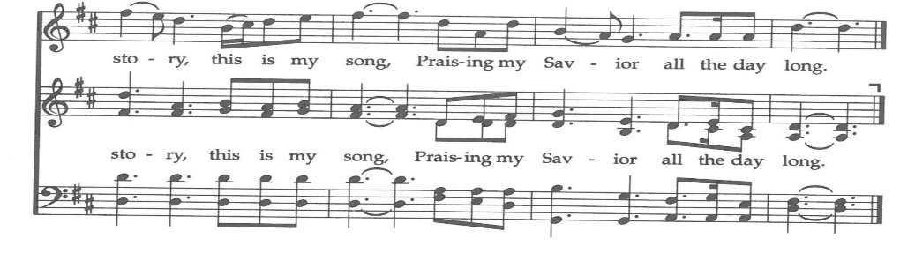
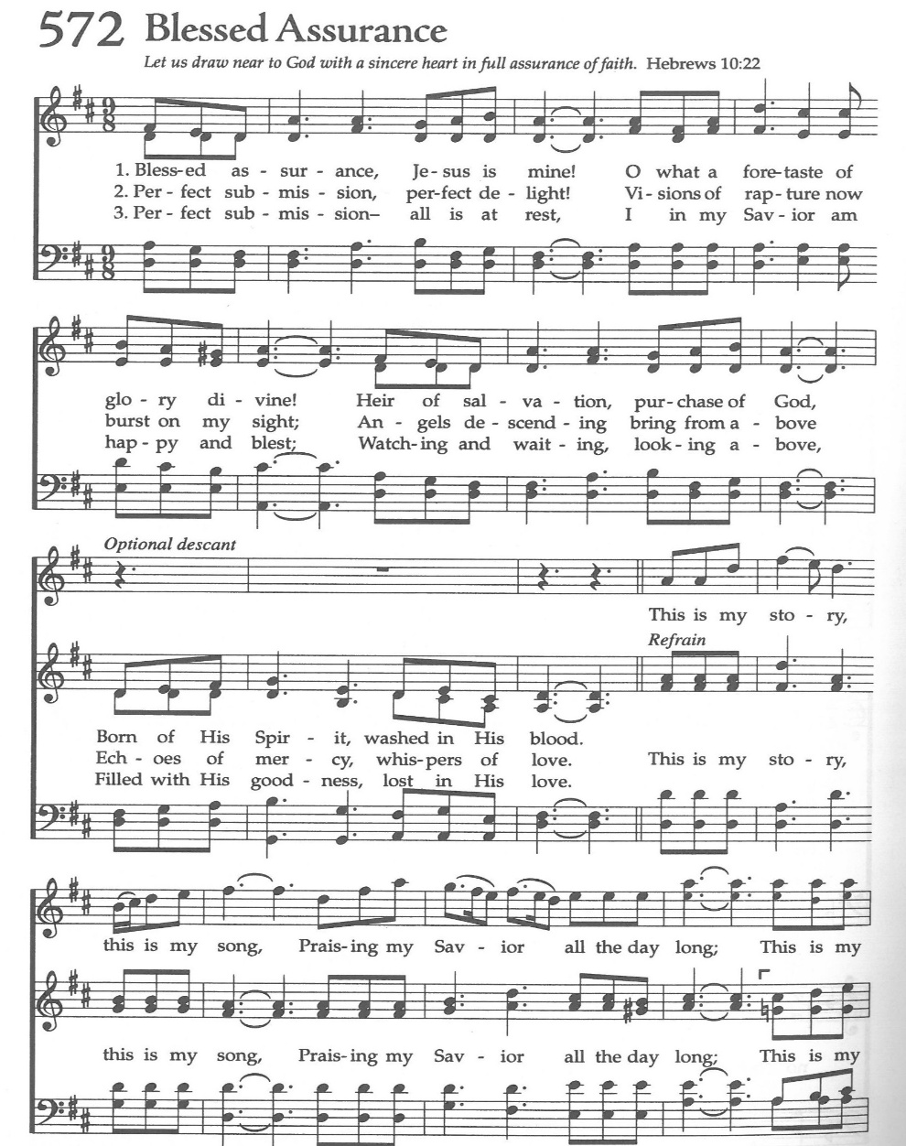
(verse 1&2 before Gospel, verse 3 after)
Clergy: The Holy Gospel of Our Lord Jesus Christ,
according to St. Matthew
People: Glory to you, Lord Christ.

Gospel Matthew 21:33-44
“Hear another parable. There was a master of a house who planted a vineyard and put a fence around it and dug a winepress in it and built a tower and leased it to tenants, and went into another country. 34 When the season for fruit drew near, he sent his servants to the tenants to get his fruit. 35 And the tenants took his servants and beat one, killed another, and stoned another. 36 Again he sent other servants, more than the first. And they did the same to them. 37 Finally he sent his son to them, saying, ‘They will respect my son.’ 38 But when the tenants saw the son, they said to themselves, ‘This is the heir. Come, let us kill him and have his inheritance.’ 39 And they took him and threw him out of the vineyard and killed him. 40 When therefore the owner of the vineyard comes, what will he do to those tenants?” 41 They said to him, “He will put those wretches to a miserable death and let out the vineyard to other tenants who will give him the fruits in their seasons.”

42 Jesus said to them, “Have you never read in the Scriptures: “‘The stone that the builders rejected has become the cornerstone; this was the Lord's doing, and it is marvelous in our eyes’?

43 Therefore I tell you, the kingdom of God will be taken away from you and given to a people producing its fruits. 44 And the one who falls on this stone will be broken to pieces; and when it falls on anyone, it will crush him.”

Clergy: The Gospel of the Lord
People: Praise to you, Lord Christ

Sermon
The Rev. Robert Longbottom

The Nicene Creed

We believe in one God,
the Father, the Almighty,
maker of heaven and earth,
of all that is, visible and invisible.
We believe in one Lord, Jesus Christ,
the only-begotten Son of God,
eternally begotten of the Father,
God from God, Light from Light,
true God from true God,
begotten, not made,
of one Being with the Father.
through him all things were made.
For us and for our salvation he came down from heaven:
was incarnate from the Holy Spirit and the Virgin Mary,
and was made man.
For our sake he was crucified under Pontius Pilate;
he suffered death and was buried.
On the third day he rose again in accordance with the
Scriptures;
he ascended into heaven
and is seated at the right hand of the Father.
He will come again in glory to judge the living and the dead,
and his kingdom will have no end.
We believe in the Holy Spirit, the Lord, the giver of life,
who proceeds from the Father and the Son,
who with the Father and the Son is worshiped and glorified. who has spoken through the Prophets.
We believe in one holy catholic and apostolic Church.
We acknowledge one Baptism for the forgiveness of sins.
We look for the resurrection of the dead,
and the life of the world to come. Amen.

The Prayers of the People

Leader Let us pray for the Church and for the world, saying, “hear our prayer.”
For the peace of the whole world, and for the well-being and unity of the people of God.
Lord, in your mercy:
People Hear our prayer.

Leader For Stephen our archbishop, Julian our provincial dean, and Eric our bishop. For Fr. Rob, Deacon John, Deacon Kashy, and for all the clergy and people of our diocese and congregation and for the worldwide Anglican Communion.
Lord, in your mercy:
People Hear our prayer.

Leader For all those who proclaim the Gospel at home and abroad; and for all who teach and disciple others.
Lord, in your mercy:
People Hear our prayer.

Leader For our brothers and sisters in Christ who are persecuted for their faith.
Lord, in your mercy:
People Hear our prayer.

Leader For our nation, for those in authority, and for all in public service especially Donald our president and Gavin our governor.
Lord, in your mercy:
People Hear our prayer.

Leader In the St. Paul’s cycle of prayer, we pray for all ministries to children, youth and families both in our church and through our church into the community around us. We pray for Sunday Funday, Sunday School, Youth Group and St. Paul’s Chapel programs. We pray for all our family ministry volunteers. We pray for the children and youth you have given to our care and for their formation in the Christian faith. We pray for all children and youth to whom we are reaching out with the Good News of Jesus Christ.
Lord, in your mercy:
People Hear our prayer.

Leader In the ACNA Cycle of Prayer, today we pray for the Diocese of the Mid-Atlantic, Bishop Chris Warner and his wife Catherine; Bishop John Guernsey and his wife, Meg; Bishop John Howe and his wife, Karen; and Bishop Philip Zampino and his wife, Jean.
Lord, in your mercy:
People Hear our prayer.

Leader For all those who are in trouble, sorrow, need, sickness, or
any other adversity [especially ____________]. We also
pray for all who are currently serving in our armed forces
and serving as first responders.
Lord, in your mercy:
People Hear our prayer.

Leader For all those who have departed this life in the certain hope
of the resurrection, (we pray especially for ____________),
in Thanksgiving let us pray.
Lord, in your mercy:
People Hear our prayer.

The Celebrant concludes with this or some other appropriate Collect.
Heavenly Father, grant these our prayers for the sake of Jesus Christ,
our only Mediator and Advocate, who lives and reigns with you in
the unity of the Holy Spirit, one God, now and for ever. Amen.

The Confession and Absolution

Celebrant Let us humbly confess our sins to Almighty God.

Most merciful God,
we confess that we have sinned against you
in thought, word and deed,
by what we have done, and by what we have left undone.
We have not loved you with our whole heart;
we have not loved our neighbors as ourselves.
We are truly sorry and we humbly repent.
For the sake of your Son Jesus Christ,
have mercy on us and forgive us;
that we may delight in your will, and walk in your ways,
to the glory of your Name. Amen.

Almighty God, our heavenly Father, who in his great mercy has
promised forgiveness of sins to all those who sincerely repent and
with true faith turn to him, have mercy upon you, pardon and deliver
you from all your sins, confirm and strengthen you in all goodness,
and bring you to everlasting life; through Jesus Christ our Lord.
Amen.

The Comfortable Words

Hear the Word of God to all who truly turn to him. Come to me, all
who labor and are heavy laden, and I will give you rest.
-Matthew 11:28

God so loved the world, that he gave his only-begotten Son, that
whoever believes in him should not perish but have eternal life.
-John 3:16t

Celebrant The Peace of the Lord be always with you.
People And with your spirit.

offertory
marguerite/solo

The Doxology
(Verse 3 only)

Offertory

Celebrant All things come from you, O Lord,
People And of your own have we given you.

The Eucharistic Liturgy
Celebrant The Lord be with you.
People And with your spirit.
Celebrant Lift up your hearts.
People We lift them up to the Lord.
Celebrant Let us give thanks to the Lord our God.
People It is right to give him thanks and praise.

It is right, our duty and our joy, always and everywhere to give thanks to you, Father Almighty, Creator of heaven and earth.

Through Jesus Christ our Lord, who on the first day of the week overcame death and the grave, and by his glorious resurrection opened to us the way of everlasting life.

Therefore we praise you, joining our voices with Angels and Archangels and with all the company of heaven, who for ever sing this hymn to proclaim the glory of your Name:

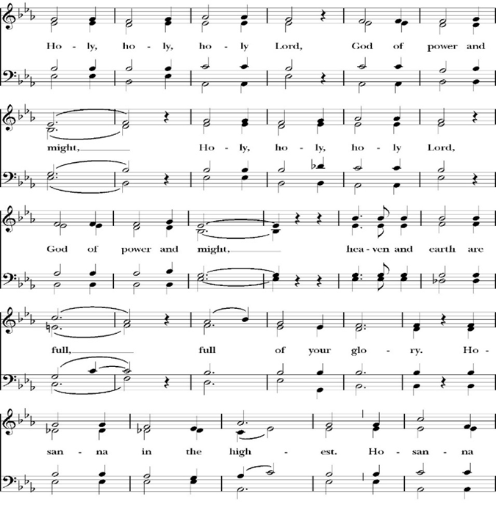
Sanctus

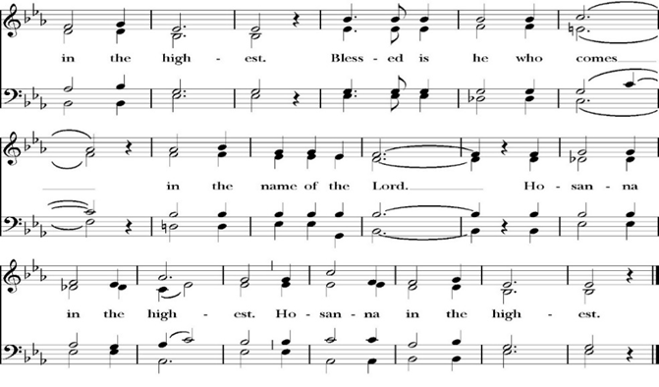
Holy and gracious Father: In your infinite love you made us for yourself; and when we had sinned against you and become subject to evil and death, you, in your mercy, sent your only Son Jesus Christ into the world for our salvation. By the Holy Spirit and the Virgin Mary he became flesh and dwelt among us. In obedience to your will, he stretched out his arms upon the Cross and offered himself once for all, that by his suffering and death we might be saved. By his resurrection he broke the bonds of death, trampling Hell and Satan under his feet. As our great high priest, he ascended to your right hand in glory, that we might come with confidence before the throne of grace.

On the night that he was betrayed, our Lord Jesus Christ took bread; and when he had given thanks, he broke it,* and gave it to his disciples, saying, “Take, eat; this is my Body, which is given for you: Do this in remembrance of me.”

Likewise, after supper, Jesus took the cup, and when he had given thanks, he gave it to them, saying, “Drink this, all of you; for this is my Blood of the New Covenant, which is shed for you, and for many, for the forgiveness of sins: Whenever you drink it, do this in remembrance of me.”

Therefore, we proclaim the mystery of faith:

Christ has died.
Christ is risen.
Christ will come again.

We celebrate the memorial of our redemption, O Father, in this sacrifice of praise and thanksgiving, and we offer you these gifts.

Sanctify them by your Word and Holy Spirit to be for your people the Body and Blood of your Son Jesus Christ. Sanctify us also, that we may worthily receive this holy Sacrament, and be made one body with him, that he may dwell in us and we in him. In the fullness of time, put all things in subjection under your Christ, and bring us with all your saints into the joy of your heavenly kingdom, where we shall see our Lord face to face.

All this we ask through your Son Jesus Christ: By him, and with him, and in him, in the unity of the Holy Spirit, all honor and glory is yours, Almighty Father, now and for ever. Amen.

And now, as our Savior Christ has taught us, we are bold to pray,

Our Father, who art in heaven,
hallowed be thy Name,
thy kingdom come,
thy will be done,
on earth as it is in heaven.
Give us this day our daily bread.
And forgive us our trespasses,
as we
forgive those
who trespass against us.
And lead us not into temptation,
but deliver us from evil.
For thine is the kingdom,
and the power, and the glory,
for ever and ever. Amen.

Fraction

Celebrant Alleluia! Christ our Passover is sacrificed for us.
People Therefore let us keep the feast. Alleluia!

The Prayer for Humble Access

We do not presume to come to this your table, O merciful Lord,
trusting in our own righteousness,
but in your abundant and great mercies.
We are not worthy so much as to gather up
the crumbs under your table;
but you are the same Lord
whose character is always to have mercy.
Grant us, therefore, gracious Lord,
so to eat the flesh of your dear Son Jesus Christ,
and to drink his blood,
that our sinful bodies may be made clean by his body,
and our souls washed through his most precious blood,
and that we may evermore dwell in him, and he in us.
Amen.

Agnus Dei

The Ministration of Communion

The gifts of God for the People of God. Take them in remembrance that Christ died for you and feed on him in your hearts by faith, with thanksgiving.

Communion Hymn: My Song is Love Unknown
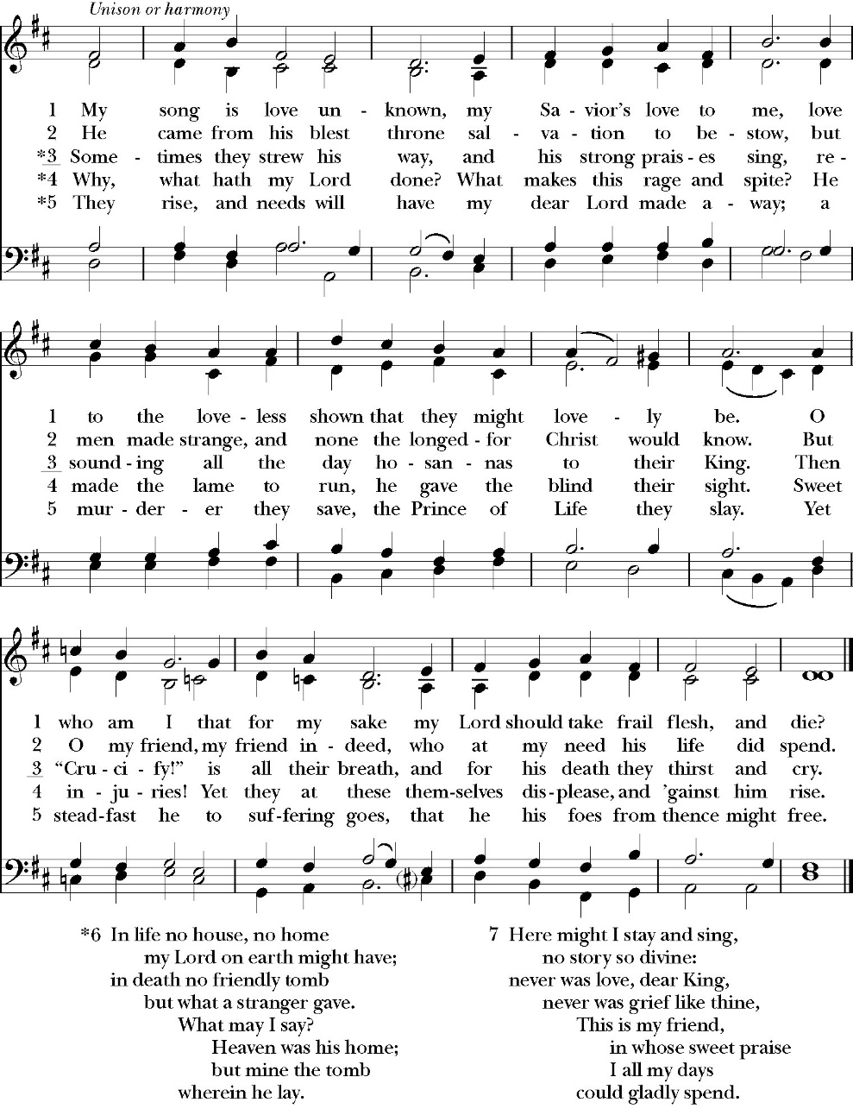
(Verses 1-3)

The Post Communion Prayer
Let us pray.

Heavenly Father,
We thank you for feeding us with the spiritual food
of the most precious Body and Blood
of your Son our Savior Jesus Christ;
and for assuring us in these holy mysteries
that we are living members of the body of your Son,
and heirs of your eternal Kingdom.
And now, Father, send us out to do the work you have
given us to do,
to love and serve you as faithful witnesses of Christ our
Lord.
To him, to you, and to the Holy Spirit,
be honor and glory, now and for ever. Amen.

The Blessing

The peace of God, which passes all understanding, keep your hearts and minds in the knowledge and love of God, and of his Son Jesus Christ our Lord; and the blessing of God Almighty, the Father, the Son, and the Holy Spirit, be among you, and remain with you always. Amen.

Closing Hymn: O Love, How Deep
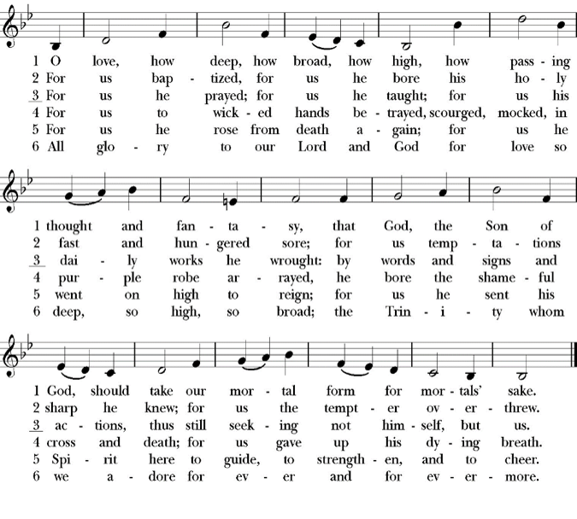
Dismissal
Deacon Alleluia, Alleluia. Let us go forth into the world,
rejoicing in the power of the Holy Spirit.
People Thanks be to God Alleluia, Alleluia.

St. Paul’s Parish Calendar
Sunday October 4– Sunday October 11

SUNDAY, October 4 –Nineteenth Sunday after Pentecost
9:15 AM Sunday Funday, Youth Room
9:15 AM Gospel of John Bible Study, Conference Room
10:30 AM Children’s Sunday School, Chapel
Pre-K –2nd Grade, Sunday School Room
3rd -5th Grade, Youth Room
10:30 AM Holy Eucharist, Church
4:00 PM Blessing of the Animals, Courtyard

MONDAY, October 5

TUESDAY, October 6
6:30 PM Bell Choir Rehearsal, Music Room

WEDNESDAY, October 7
9:30 AM Holy Eucharist with healing prayer, Chapel
10:15 AM Bible Study, Conference Room
5:00-6:00PM Practicing the Way: Our Call to Witness
5:30-6:30PM Wonderful Wednesday Dinner
6:30-7:15PM Of the Household: Practicing the story of God in everyday family rhythms
6:30-7:15pm Habits of the Household for kids
7:00 PM Choir Rehearsal

THURSDAY, October 8

FRIDAY, October 9
6:30 AM Men’s Bible Study, Valhalla Restaurant

SATURDAY, October 10

SUNDAY, October 11 –Twentieth Sunday after Pentecost
9:15 AM Sunday Funday, Youth Room
9:15 AM Gospel of John Bible Study, Conference Room
10:30 AM Children’s Sunday School, Chapel
Pre-K –2nd Grade, Sunday School Room
3rd -5th Grade, Youth Room
10:30 AM Holy Eucharist, Church

Church Office Hours
Monday-Thursday 8:00 AM-4:00 PM
Blessing of the Animals Today
Sunday, October 4, 4:00PM
Join us in the church courtyard on Sunday October 4 at 4:00PM with your pets for a blessing of the animals. Please have dogs on leashes, cats secured in carriers and pets of all kinds as long as they are secure. We will have water, treats and pup cups of whipped cream for all our dogs and cats.

Cakes needed for St. Paul’s School Carnival Cake Walk
St. Paul’s Church sponsors the cake walk at St. Paul’s School fall carnival and every year members of the church are invited to make baked goods for the event. Smaller cakes are preferable or cutting cakes in half or quarters is the perfect size for the event. Cakes, brownies, cookies and all kinds of baked goods are welcome.
Please deliver cakes to the church on Wednesday-Friday, October 14 & during 8am-4pm or on Friday October 16 before 9am-12pm.

Trunk or Treat, Sunday October 25, 4:00-6:00PM
Trunk or treat is a wonderful event for a safe and fun trick or treating and harvest fun activities. All families both inside and outside the church are welcome to join us. Our annual Trunk or treat is coming up. Trunk or treat keeps growing and so our need for trunks and help with activities continues to grow as well. A sign-up sheet is in the Narthex of the church and in the office. Please reach out to Deacon John for any questions

The Gospel of John Sunday morning Bible study, 9:15-10:00AM
The Sunday morning Gospel of John Bible study is currently working through chapter 10 with Deacon John Iseman leading through November.

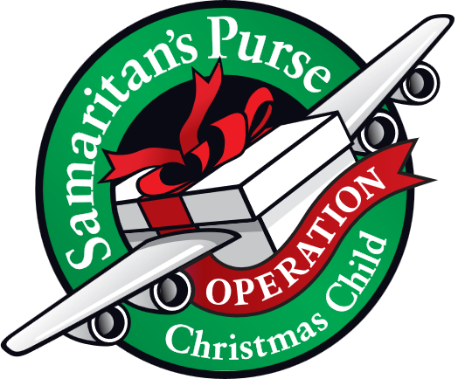
Operation Christmas Child donations begin in October
October Donations: Games & Activities & Toys.

Operation Christmas Child is a ministry of Samaritan’s Purse. The mission of Operation Christmas Child is to demonstrate God’s love in a tangible way to children in need around the world through partnering with the local church worldwide to provide shoebox size containers filled with school supplies, hygiene products, and a small gift to share the Good News of Jesus Christ and make disciples of the nations.

St. Paul’s Anglican Church is committed to providing 100 boxes to children throughout the world and will do this by having monthly themed donations from August through November. We will then have a ‘Filling the Box” party when we will gather together and fill 100 boxes with school supplies, hygiene products and small toys.

Convention of the Anglican Diocese of San Joaquin
Thursday evening and Friday, October 29 & 30
Trinity Anglican Church, Bakersfield, CA
The annual convention of the Anglican Diocese of San Joaquin will take place the evening of Thursday and all day Friday, October 29 & 30. Convention is not just the annual business meeting of the church. It is a time gather together as a Diocesan family with Anglican churches in the central valley of California and Neveda, hear from our bishop on his plans and vision for the diocese, learn more about the many ministries occurring in Anglican churches in our area and have fellowship with our brothers and sisters. If you are interested in attending, please reach out to Fr. Rob and he will help you register.

Wonderful Wednesdays Classes Begin Wednesday, October 7
Wonderful Wednesdays will look a little different this fall but will continue to have discipleship opportunities both before dinner and after dinner. Please read through our program information to understand how our program itinerary will shift in order to accommodate special programs this year.

Wonderful Wednesday Dinners
5:30-6:30PM Wonderful Wednesday Dinner
The dinner start time is the big change this year for Wonderful

Practicing The Way: Our Call to Witness
5:00-6:00PM
This small group will continue in the spiritual practice of witness outlined in John Mark Comer’s work Practicing the Way. We will gather as a small group in the conference room and learn more about witnessing the resurrection in the world around us or as we might traditionally know it Evangelism.

In a post-Christian culture, the idea of “sharing the gospel” seems intimidating — even offensive. But the Spirit in us seeks to draw near those who are far from God; and we embody his heart by inviting people to our table, listening deeply, and testifying simply to the good news of Jesus. This class will be led by Fr. Rob Longbottom. For more info on the content of this class please scan the QR code to go to class website.

Habits Of the Household: Practicing the story of God in everyday family rhythms
6:30-7:15PM
Parenting is not easy. For anyone. And most of us who are currently parenting children and teens need opportunities to receive healthy, Christ-centered teaching and discussion on parenting.
Habits of the Household by Justin Whitmel Earley is a practical guide for parents that emphasizes the importance of daily family rhythms in spiritual formation. The book outlines how ordinary routines, from waking up to bedtime, can be transformed into meaningful moments of worship and connection, helping families grow closer together and fostering a deeper relationship with God.

All Parents are invited to join us no matter if you have a newborn or kids in college.
For more info on the content of this class please scan the QR code to go to class website.

Habits of the Household for kids
6:30-7:15pm
This program will run concurrently with the Habits of the Household group and will help our kids to work towards the same habits as parents for continuity and common understanding. This class will be led by Fr. Rob and Deacon Kashy, and all kids are welcome from age 4 through middle school.

Wednesday night Nursery
6:30-7:30PM
The Nursery will be open every Wonderful Wednesday so that parents can have a safe and fun place for their little one’s age 0-3 while they are participating in the Habits of the household class or other Wednesday evening activities.
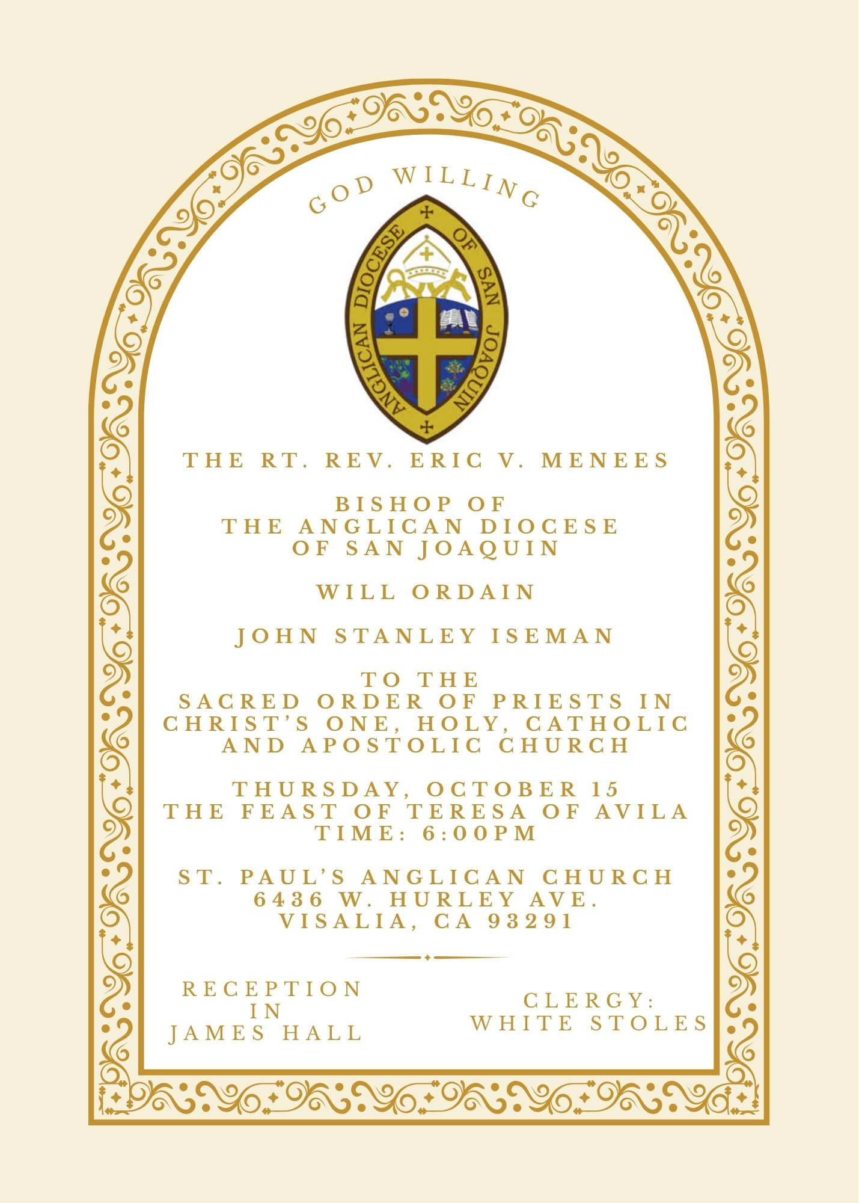


St. Paul’s Anglican Church
Friendship and Fellowship Gathering
Celebrating Rev. John Iseman’s
ordination to the Priesthood
Saturday October 17th
5:30 PM
at the home of
Jerry and Darlene Hallberg
1926 S. Savannah
Visalia, Ca 93277
BBQ Dinner
Please! Call or Text Darlene
to see what side dishes are needed.
Bring your favorite beverage.
RSVP by calling or texting Darlene at 559-280-2313
by Monday October 12


A Food Bank for
Hurley Families
The next Neighborhood Market to
benefit students at Hurley School
will be Tuesday, October 20, 2:30 PM to 3:30 PM at St Paul’s Church parking lot. If you are interested in helping that day, please contact Sue Nyberg. My home phone number is 559-733-8244.

Due to the heat, we are in need of more volunteers in September. This will allow volunteers
to work in shifts during this hot month.



PROVIDED BY VISALIA EMERGENCY AID
AND ST. PAUL’S CHURCH
Tuesday, October 20, 2026
From 2:30 PM to 3:30 PM
LOCATION:
ST. PAUL'S CHURCH PARKING LOT
ACROSS TWHE STREET FROM HURLEY

St. Paul’s Anglican Church
Parish Office
6436 W. Hurley Ave
Visalia, California 93291
559-732-4821
Office Hours: 8:00 – 4:00
Monday – Thursday

Worship: Sundays at 10:30AM
Livestream: Link at spvisalia.com
and on our Facebook page
Please be advised that this service is being recorded for broadcast
and/or archival purposes. By attending, you consent
to the inclusion of your likeness in these recordings.

St. Paul’s Clergy and Staff
The Rev. Robert Longbottom, Rector
rector@spvisalia.com, (559)802-2928
The Rev. John Iseman, Pastoral Associate for Family Ministries
family@spvisalia.com, (518)222-6722
The Rev. Kashy Rowland-Smith, Deacon
kashyrs@aol.com
Antoinette Horsting, Parish Administrator
bookkeeper@spvisalia.com
Marguerite Crownover, Organist and Accompanist
organist@spvisalia.com
Ellen Daniels, Choral Director
choirdirector@spvisalia.com
Jackie Iseman, Nursery Coordinator
nursery@spvisalia.com
Shane Motl, Sexton

St. Paul’s is a member church of the
Anglican Diocese of San Joaquin
The Rt. Rev. Eric V. Menees, Bishop

Next Week’s Lessons
Isaiah 25:1-9
Psalm 23
Philippians 4:4-13
Matthew 22:1-14

