St. Paul’s Anglican Church
Visalia, California
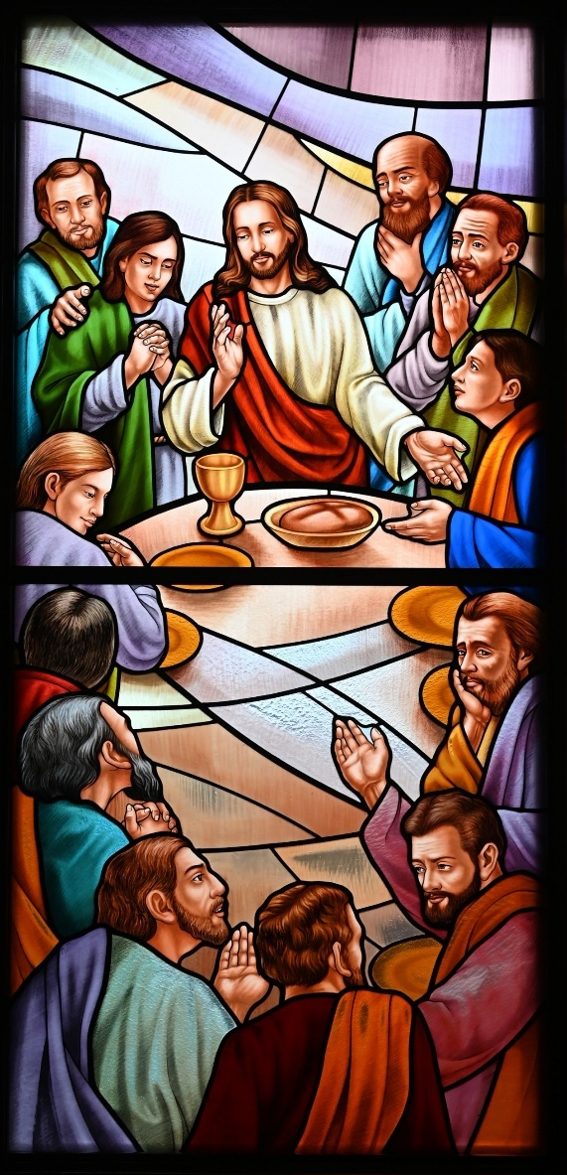

The Fourth Sunday in Lent
March 15, 2026
10:30 A.M

Welcome!

St. Paul’s Anglican Church extends a warm welcome to all visitors and newcomers, whether worshiping in person or at home via livestream.

Visitors’ Guide

St. Paul’s Church is a parish in the Diocese of San Joaquin of the Anglican Church in North America, which includes both Catholic and Protestant traditions. We accept Jesus Christ as Savior, and we promise to follow him as Lord. We believe in One God,

- the Father who created us and all things,
- the Son who redeems us from sin and death,
- the Holy Spirit who renews and sanctifies us.

We believe the Holy Scriptures to be the Word of God and to contain all things necessary for salvation, and we accept the Apostles’ and Nicene Creeds as essential beliefs of the Christian faith.

Holy Communion is open to all baptized Christians who have examined their lives, repented of their sins, and desire to live
in love and charity with all people.

Those not desiring to receive Holy Communion, and those who have not been baptized into the Christian faith, are invited to cross their arms across their chest, and a blessing will be given instead.

Visitors are invited to sign the guest book at the entrance table and introduce themselves to the clergy following the service.

The Holy Eucharist

Postlude: “I Call to Thee Lord Jesus Christ” Bach
Opening Hymn: #690 – “Guide Me, Thou Great Jehovah” p. 4
Acclamation p. 5
The Collect for Purity p. 5
Summary of the Law p. 5
Trisagion p. 5
Confession and Absolution p. 6
Collect of the Day p. 7
Lesson: 1 Samuel 16:1-13 p. 7
Gradual: Psalm 23 p. 8
Epistle: Ephesians 5:1-14 p. 9
Sequence Hymn: #547 – “Awake, O Sleeper Rise from Death” p. 10
Gospel: John 9:1-13, 28-41 p. 10
Sermon: Rev. Robert Longbottom
Nicene Creed p. 12
Prayers of the People p. 13
The Peace p. 14
Offertory Anthem: “When I Survey the Wondrous Cross” Bells
The Offertory p. 15
Sanctus p. 16
The Lord’s Prayer p. 19
Prayer for Humble Access p. 19
Agnus Dei p. 20
Communion Hymn: #313 – “Let Thy Blood in Mercy Poured” p. 21
Post Communion Prayer p. 22
Blessing p. 22
Closing Hymn: #493- “O For a Thousand Tongues to Sing” p. 23
Dismissal p. 23
Prelude: “He Who Will Suffer God to Guide Him” Bach

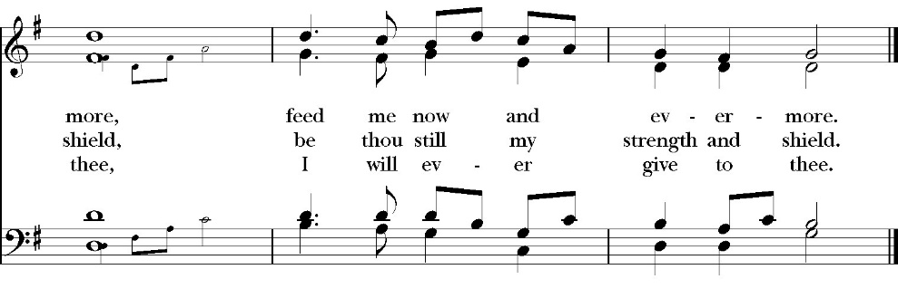
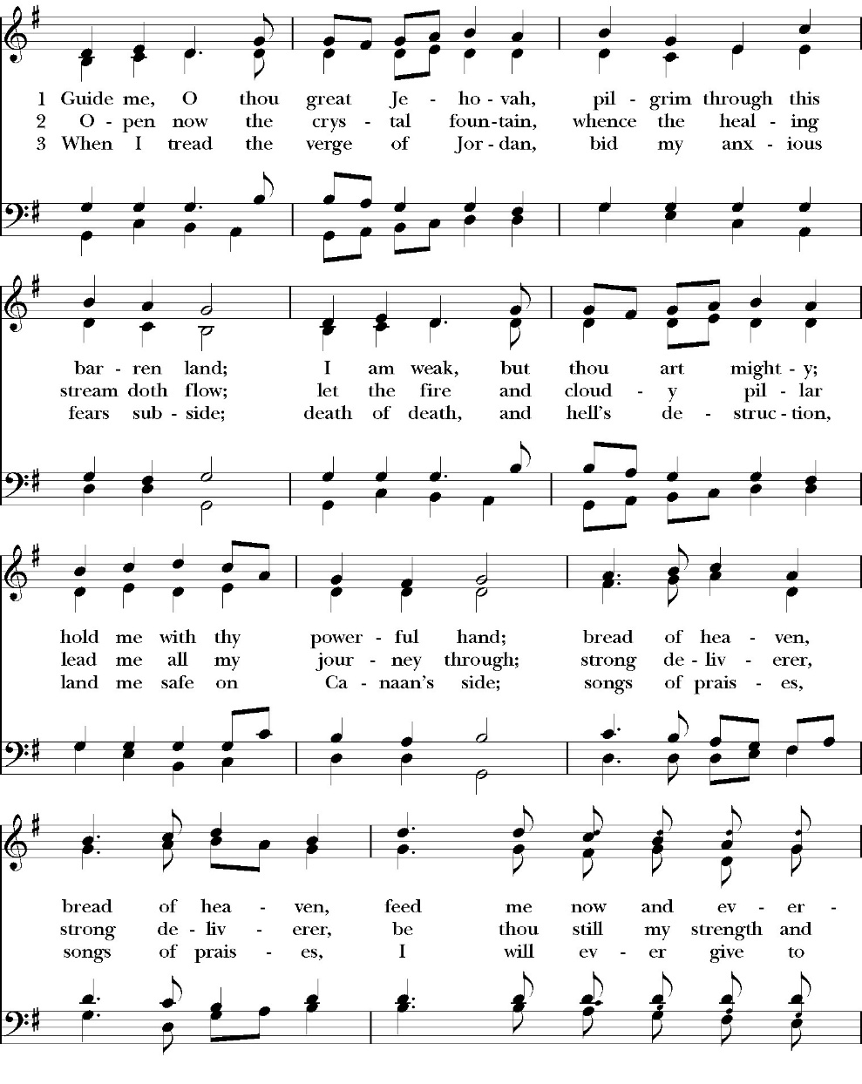
Opening Hymn: Guide Me, Thou Great Jehovah
The Acclamation

Celebrant: Bless the Lord who forgives all our sins.
People: His mercy endures for ever.

The Collect for Purity

Almighty God, to you all hearts are open, all desires known, and from you no secrets are hid: Cleanse the thoughts of our hearts by the inspiration of your Holy Spirit, that we may perfectly love you, and worthily magnify your holy Name; through Christ our Lord. Amen.

The Summary of the Law

Hear what our Lord Jesus Christ says: You shall love the Lord your God with all your heart and with all your soul and with all your mind. This is the first and great commandment. And the second is like it: You shall love your neighbor as yourself. On these two commandments depend all the Law and the Prophets.
Matthew 22:37-40t

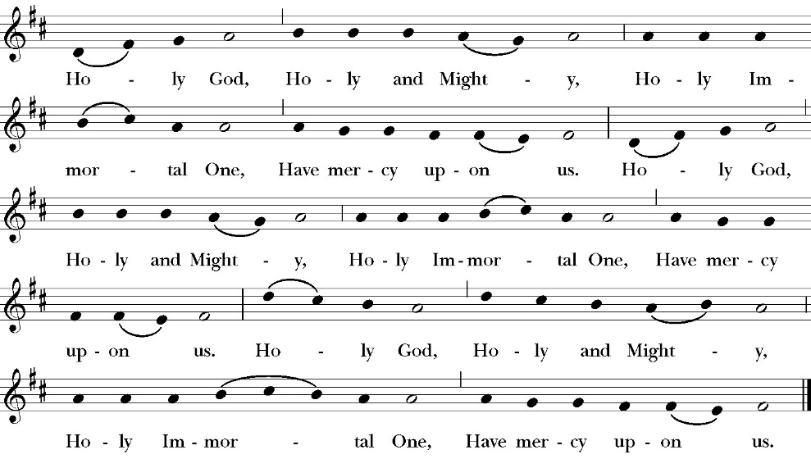
The Trisagion

Confession and Absolution

Leader Let us humbly confess our sins to Almighty God.

Almighty God, Father of our Lord Jesus Christ,
maker and judge of us all:
We acknowledge and lament our many sins and offenses,
which we have committed by thought, word, and deed
against your divine majesty,
provoking most justly your righteous anger against us. We are deeply sorry for these our transgressions;
the burden of them is more than we can bear.
Have mercy upon us,
Have mercy upon us, most merciful Father;
for your Son our Lord Jesus Christ’s sake,
forgive us all that is past;
and grant that we may evermore serve and please you in
newness of life,
to the honor and glory of your Name;
through Jesus Christ our Lord. Amen.

Celebrant Almighty God, our heavenly Father, who in his great
mercy has promised forgiveness of sins to all those who sincerely
repent and with true faith turn to him, have mercy upon you, pardon
and deliver you from all your sins, confirm and strengthen you in all
goodness, and bring you to everlasting life; through Jesus Christ our
Lord. Amen.

The Comfortable Words

Hear the Word of God to all who truly turn to him,

If anyone sins, we have an advocate with the Father, Jesus Christ the righteous. He is the propitiation for our sins, and not for ours only, but also for the sins of the whole world.
1 John 2:1-2t

Officiant The Lord be with You.
People And with your spirit.
Officiant Let us pray:

The Collect of the Day

Gracious Father, whose blessed Son Jesus Christ came down from heaven to be the true bread which gives life to the world: Evermore give us this bread, that he may live in us, and we in him; who lives and reigns with you and the Holy Spirit, one God, now and for ever. Amen.

Lesson: 1 Samuel 16:1-13

The LORD said to Samuel, “How long will you grieve over Saul, since I have rejected him from being king over Israel? Fill your horn with oil, and go. I will send you to Jesse the Bethlehemite, for I have provided for myself a king among his sons.” 2 And Samuel said, “How can I go? If Saul hears it, he will kill me.” And the LORD said, “Take a heifer with you and say, ‘I have come to sacrifice to the LORD.’ 3 And invite Jesse to the sacrifice, and I will show you what you shall do. And you shall anoint for me him whom I declare to you.” 4 Samuel did what the LORD commanded and came to Bethlehem. The elders of the city came to meet him trembling and said, “Do you come peaceably?” 5 And he said, “Peaceably; I have come to sacrifice to the LORD. Consecrate yourselves, and come with me to the sacrifice.” And he consecrated Jesse and his sons and invited them to the sacrifice.

6 When they came, he looked on Eliab and thought, “Surely the LORD’s anointed is before him.” 7 But the LORD said to Samuel, “Do not look on his appearance or on the height of his stature, because I have rejected him. For the LORD sees not as man sees: man looks on the outward appearance, but the LORD looks on the heart.” 8 Then Jesse called Abinadab and made him pass before Samuel. And he said, “Neither has the LORD chosen this one.”

9 Then Jesse made Shammah pass by. And he said, “Neither has the LORD chosen this one.” 10 And Jesse made seven of his sons pass before Samuel. And Samuel said to Jesse, “The LORD has not chosen these.” 11 Then Samuel said 2 to Jesse, “Are all your sons here?” And he said, “There remains yet the youngest, but behold, he is keeping the sheep.” And Samuel said to Jesse, “Send and get him, for we will not sit down till he comes here.” 12 And he sent and brought him in. Now he was ruddy and had beautiful eyes and was handsome. And the LORD said, “Arise, anoint him, for this is he.” 13 Then Samuel took the horn of oil and anointed him in the midst of his brothers. And the Spirit of the LORD rushed upon David from that day forward. And Samuel rose up and went to Ramah.

Reader The Word of the Lord
People Thanks be to God

Gradual: Psalm 23

1 The LORD is my shepherd; *
therefore I can lack nothing.
2 He shall feed me in green pastures *
and lead me forth beside the waters of comfort.
3 He shall refresh my soul *
and bring me forth in the paths of righteousness for his Name’s
sake.
4 Even though I walk through the valley of the shadow of death, I
will fear no evil, *
for you are with me; your rod and your staff comfort me.
5 You shall prepare a table before me, in the presence of those who
trouble me; *
you have anointed my head with oil, and my cup shall be full.
6 Surely your goodness and mercy shall follow me all the days of my
life, *
and I will dwell in the house of the LORD for ever.

Glory be to the Father, and to the Son, and to the Holy Spirit;
as it was in the beginning, is now, and ever shall be, world
without end. Amen

Epistle: Ephesians 5:1-14

Therefore be imitators of God, as beloved children. 2 And walk in love, as Christ loved us and gave himself up for us, a fragrant offering and sacrifice to God. 3 But sexual immorality and all impurity or covetousness must not even be named among you, as is proper among saints. 4 Let there be no filthiness nor foolish talk nor crude joking, which are out of place, but instead let there be thanksgiving. 5 For you may be sure of this, that everyone who is sexually immoral or impure, or who is covetous (that is, an idolater), has no inheritance in the kingdom of Christ and God. 6 Let no one deceive you with empty words, for because of these things the wrath of God comes upon the sons of disobedience. 7 Therefore do not become partners with them; 8 for at one time you were darkness, but now you are light in the Lord. Walk as children of light 9 (for the fruit of light is found in all that is good and right and true),

10 and try to discern what is pleasing to the Lord. 11 Take no part in the unfruitful works of darkness, but instead expose them. 12 For it is shameful even to speak of the things that they do in secret. 13 But when anything is exposed by the light, it becomes visible, 14 for anything that becomes visible is light. Therefore it says, “Awake, O sleeper, and arise from the dead, and Christ will shine on you.”

Reader The Word of the Lord
People Thanks be to God

Sequence Hymn: Awake, O Sleeper, Rise from Death
(verses 1 & 2 before Gospel, verse 3 after)
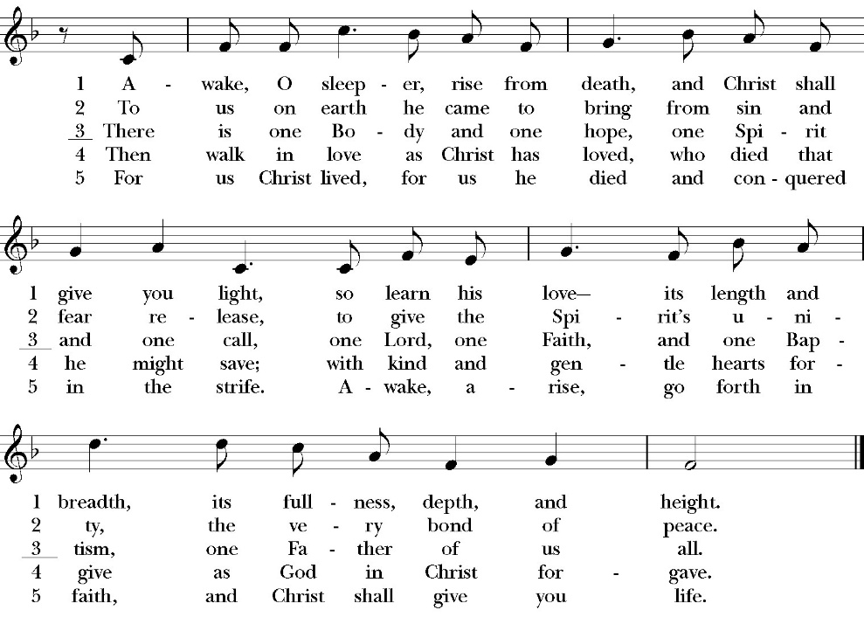

The Holy Gospel of Our Lord Jesus Christ, according to St. John.
People Glory to you, Lord Christ.

John 9:1-13, 28-41

As he passed by, he saw a man blind from birth. 2 And his disciples asked him, “Rabbi, who sinned, this man or his parents, that he was born blind?” 3 Jesus answered, “It was not that this man sinned, or his parents, but that the works of God might be displayed in him. 4 We must work the works of him who sent me while it is day; night is coming, when no one can work. 5 As long as I am in the world, I am the light of the world.” 6 Having said these things, he spit on the ground and made mud with the saliva. Then he anointed the man’s eyes with the mud 7 and said to him, “Go, wash in the pool of Siloam” (which means Sent). So he went and washed and came back seeing.

8 The neighbors and those who had seen him before as a beggar were saying, “Is this not the man who used to sit and beg?”
9 Some said, “It is he.” Others said, “No, but he is like him.” He kept saying, “I am the man.” 10 So they said to him, “Then how were your eyes opened?” 11 He answered, “The man called Jesus made mud and anointed my eyes and said to me, ‘Go to Siloam and wash.’ So I went and washed and received my sight.” 12 They said to him “Where is he?” He said, “I do not know.”

13 They brought to the Pharisees the man who had formerly been blind.

28 And they reviled him, saying, “You are his disciple, but we are disciples of Moses. 29 We know that God has spoken to Moses, but as for this man, we do not know where he comes from.” 30 The man answered, “Why, this is an amazing thing! You do not know where he comes from, and yet he opened my eyes. 31 We know that God does not listen to sinners, but if anyone is a worshiper of God and does his will, God listens to him. 32 Never since the world began has it been heard that anyone opened the eyes of a man born blind. 33 If this man were not from God, he could do nothing.” 34 They answered him, “You were born in utter sin, and would you teach us?” And they cast him out.

35 Jesus heard that they had cast him out, and having found him he said, “Do you believe in the Son of Man?” 36 He answered, “And who is he, sir, that I may believe in him?” 37 Jesus said to him, “You have seen him, and it is he who is speaking to you.” 38 He said, “Lord, I believe,” and he worshiped him. 39 Jesus said, “For judgment I came into this world, that those who do not see may see, and those who see may become blind.” 40 Some of the Pharisees near him heard these things, and said to him, “Are we also blind?” 41 Jesus said to them, “If you were blind, you would have no guilt; but now that you say, ‘We see,’ your guilt remains.

Clergy The Gospel of the Lord
People Praise to you, Lord Christ.

Sermon
rev. robert longbottom

The Nicene Creed

We believe in one God,
the Father, the Almighty,
maker of heaven and earth,
of all that is, visible and invisible.

We believe in one Lord, Jesus Christ,
the only-begotten Son of God,
eternally begotten of the Father,
God from God, Light from Light,
true God from true God,
begotten, not made,
of one Being with the Father.
through him all things were made.
For us and for our salvation he came down from heaven:
was incarnate from the Holy Spirit and the Virgin Mary,
and was made man.
For our sake he was crucified under Pontius Pilate;
he suffered death and was buried.
On the third day he rose again in accordance with the
Scriptures;
he ascended into heaven
and is seated at the right hand of the Father.
He will come again in glory to judge the living and the dead,
and his kingdom will have no end.

We believe in the Holy Spirit, the Lord, the giver of life,
who proceeds from the Father [and the Son],
who with the Father and the Son is worshiped and glorified.
who has spoken through the Prophets.
We believe in one holy catholic and apostolic Church.
We acknowledge one Baptism for the forgiveness of sins.
We look for the resurrection of the dead,
and the life of the world to come. Amen.

The Prayers of the People

Leader Let us pray for the Church and for the world, saying, “hear our prayer.”
For the peace of the whole world, and for the well-being and unity of the people of God.
Lord, in your mercy:
People Hear our prayer.

Leader For Stephen our archbishop and Eric, our bishop. For Fr. Rob, Deacon John, Deacon Kashy, and for all the clergy and people of our diocese and congregation and for the worldwide Anglican Communion.
Lord, in your mercy:
People Hear our prayer.

Leader For all those who proclaim the Gospel at home and abroad; and for all who teach and disciple others.
Lord, in your mercy:
People Hear our prayer.

Leader For our brothers and sisters in Christ who are persecuted for their faith.
Lord, in your mercy:
People Hear our prayer.

Leader For our nation, for those in authority, and for all in public service especially Donald our president and Gavin our governor.
Lord, in your mercy:
People Hear our prayer.

Leader: In the St. Paul’s cycle of prayer, we pray for our Sunday morning worship and welcoming ministries. We pray for the Altar Guild, our Lay Eucharistic Ministers, our Lectors, and our Acolytes. We pray for our music ministry and the musicians and vocalists. We pray for our ushers, greeters, and prayer table ministries.
Lord, in your mercy:
People Hear our prayer.

Leader In the ACNA Cycle of Prayer, today we pray for the Anglican Network in Canada and Bishop Daniel Gifford, his wife, Cathryn; Bishop Mike Stewart and his wife Marianne; Bishop Stephen Leung and his wife, Nona; Bishop Grant LeMarquand and his wife, Wendy; Bishop Charles Masters, his wife, Judy; Bishop Trevor Walters and his wife, Dede; Bishop Ron Ferris and his wife, Jan; Bishop Don Harvey and his wife, Trudy; and Bishop Malcolm Harding and his wife, Marylou.
Lord, in your mercy:
People Hear our prayer.

Leader For all those who are in trouble, sorrow, need, sickness, or
any other adversity [especially ____________]. We also
pray for all who are currently serving in our armed forces
and serving as first responders.
Lord, in your mercy:
People Hear our prayer.

Leader For all those who have departed this life in the certain hope
of the resurrection, (we pray especially for ____________),
in thanksgiving let us pray.
Lord, in your mercy:
People Hear our prayer.

Celebrant will add a concluding prayer

Celebrant The Peace of the Lord be always with you.
People And with your spirit.

Offertory Anthem:
Bell Choir
“When I Survey the Wondrous Cross”
Hamburg. Arr. By Jason W. Krug

The Doxology
(Verse 3 only)

The Offertory

Celebrant All things come from you, O Lord,
People And of your own have we given you.

The Eucharistic Liturgy

Celebrant The Lord be with you.
People And with your spirit.
Celebrant Lift up your hearts.
People We lift them up to the Lord.
Celebrant Let us give thanks to the Lord our God.
People It is right to give him thanks and praise.

It is right, our duty and our joy, always and everywhere to give thanks to you, Father Almighty, Creator of heaven and earth. You bid your faithful people cleanse their hearts, and prepare with joy for the Paschal feast; that, fervent in prayer and in works of mercy, and renewed by your Word and Sacraments, they may come to the fullness of grace which you have prepared for those who love you.

Therefore we praise you, joining our voices with angels and archangels and with all the company of heaven, who forever sing this hymn to proclaim the glory of your Name:

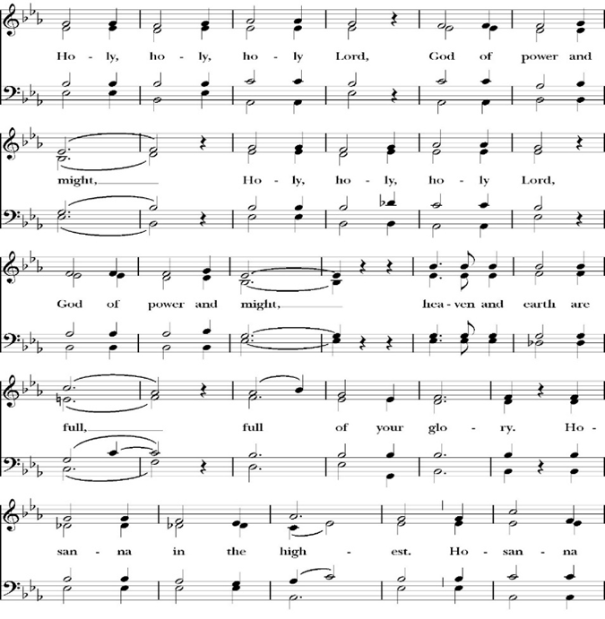
The Sanctus

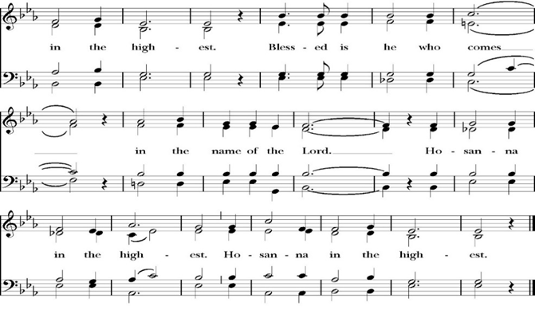
All praise and glory is yours, O God our heavenly Father, for in your tender mercy, you gave your only Son Jesus Christ to suffer death upon the Cross for our redemption. He made there, by his one oblation of himself once offered, a full, perfect, and sufficient sacrifice, oblation, and satisfaction, for the sins of the whole world; and he instituted, and in his Holy Gospel commanded us to continue, a perpetual memory of his precious death and sacrifice, until his coming again.

So now, O merciful Father, in your great goodness, we ask you to bless and sanctify, with your Word and Holy Spirit, these gifts of bread and wine, that we, receiving them according to your Son our Savior Jesus Christ’s holy institution, in remembrance of his death and passion, may be partakers of his most blessed Body and Blood.
For on the night that he was betrayed, our Lord Jesus Christ took bread; and when he had given thanks, he broke it,* and gave it to his disciples, saying, “Take, eat; this is my Body, which is given for you: Do this in remembrance of me.”

Likewise, after supper, Jesus took the cup, and when he had given thanks, he gave it to them, saying, “Drink this, all of you; for this is my Blood of the New Covenant, which is shed for you, and for many, for the forgiveness of sins: Whenever you drink it, do this in remembrance of me.”

Therefore, O Lord and heavenly Father, according to the institution of your dearly beloved Son our Savior Jesus Christ, we your humble servants celebrate and make here before your divine Majesty, with these holy gifts, the memorial your Son commanded us to make; remembering his blessed passion and precious death, his mighty resurrection and glorious ascension, and his promise to come again.

And we earnestly desire your fatherly goodness mercifully to accept this, our sacrifice of praise and thanksgiving; asking you to grant that, by the merits and death of your Son Jesus Christ, and through faith in his Blood, we and your whole Church may obtain forgiveness of our sins, and all other benefits of his passion.

And here we offer and present to you, O Lord, ourselves, our souls and bodies, to be a reasonable, holy, and living sacrifice. We humbly pray that all who partake of this Holy Communion may worthily receive the most precious Body and Blood of your Son Jesus Christ, be filled with your grace and heavenly benediction, and be made one body with him, that he may dwell in us, and we in him.

And although we are unworthy, because of our many sins, to offer you any sacrifice, yet we ask you to accept this duty and service we owe, not weighing our merits, but pardoning our offenses, through Jesus Christ our Lord.

By him, and with him, and in him, in the unity of the Holy Spirit, all honor and glory is yours, Almighty Father, now and for ever. Amen.

And now, as our Savior Christ has taught us, we are bold to pray,

Our Father, who art in heaven,
hallowed be thy Name,
thy kingdom come,
thy will be done,
on earth as it is in heaven.
Give us this day our daily bread.
And forgive us our trespasses,
as we forgive those
who trespass against us.
And lead us not into temptation,
but deliver us from evil.
For thine is the kingdom,
and the power, and the glory,
for ever and ever. Amen.

Celebrant Christ our Passover is sacrificed for us.
People Therefore let us keep the feast.

We do not presume to come to this your table, O merciful Lord,
trusting in our own righteousness,
but in your abundant and great mercies.
We are not worthy so much as to gather up
the crumbs under your table;
but you are the same Lord
whose character is always to have mercy.
Grant us, therefore, gracious Lord,
so to eat the flesh of your dear Son Jesus Christ,
and to drink his blood,
that our sinful bodies may be made clean by his body,
and our souls washed through his most precious blood,
and that we may evermore dwell in him, and he in us.
Amen.

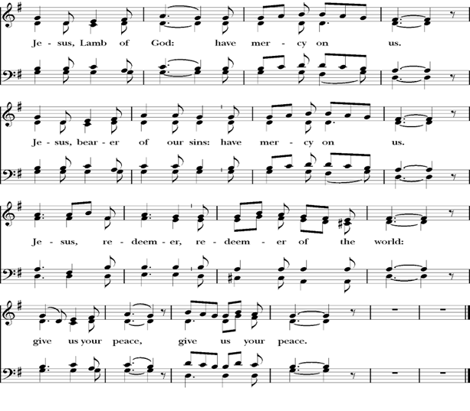
Agnus Dei

Behold the Lamb of God, behold him who takes away the sins of the world. Blessed are those who are invited to the marriage supper of the Lamb.
John 1:29; Revelation 19:9

Communion Hymn: Let Thy Blood in Mercy Poured
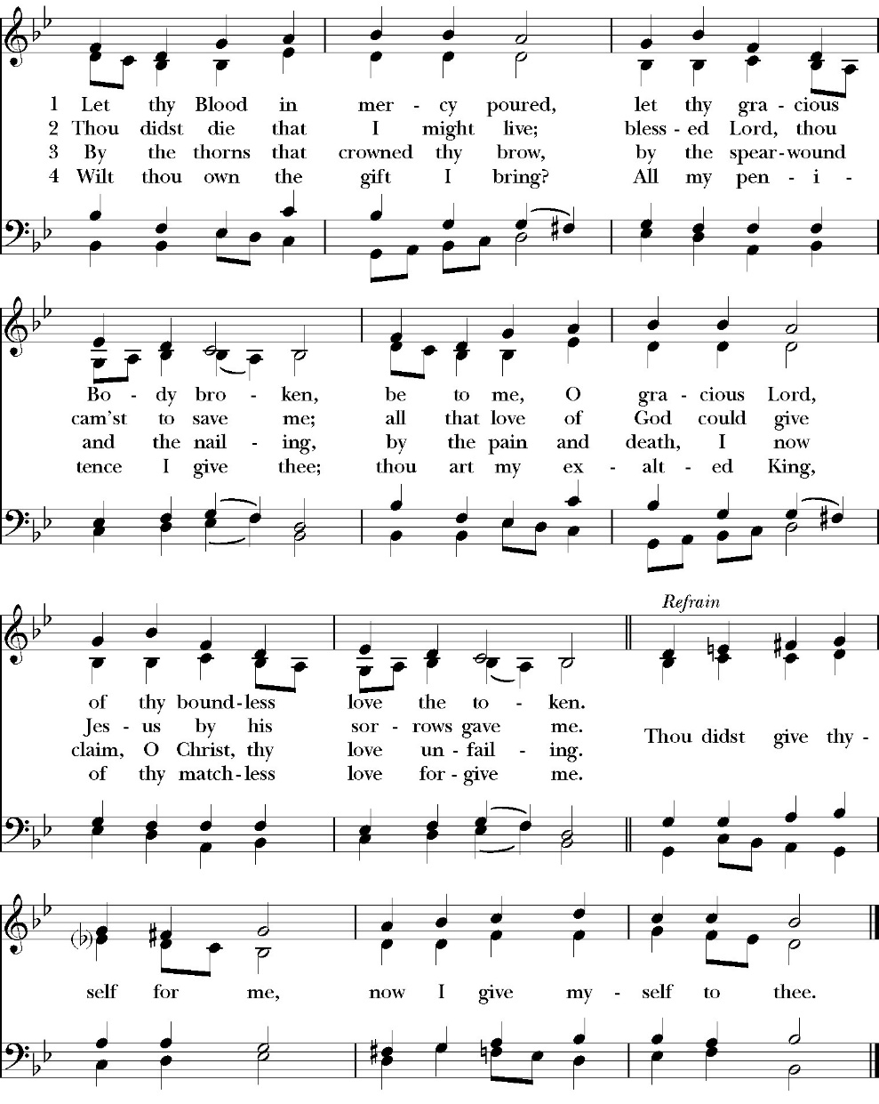

The Post Communion Prayer

Let us pray.

Almighty and everliving God,
we thank you for feeding us, in these holy mysteries,
with the spiritual food of the most precious Body and Blood
of your Son our Savior Jesus Christ;
and for assuring us, through this Sacrament, of your favor and
goodness towards us:
that we are true members of the mystical body of your Son,
the blessed company of all faithful people;
and are also heirs, through hope,
of your everlasting kingdom.
And we humbly ask you, heavenly Father,
to assist us with your grace,
that we may continue in that holy fellowship,
and do all the good works that you have prepared for us to
walk in;
through Jesus Christ our Lord,
to whom, with you and the Holy Spirit,
be all honor and glory, now and for ever. Amen.

The Blessing

The peace of God, which passes all understanding, keep your hearts
and minds in the knowledge and love of God, and of his Son Jesus
Christ our Lord; and the blessing of God Almighty, the Father, the
Son, and the Holy Spirit, be among you, and remain with you always.
Amen.

Closing Hymn: O For a Thousand Tongues to Sing
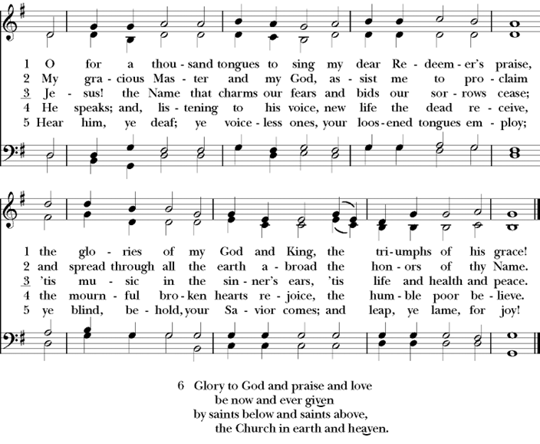

Celebrant Go in peace to love and serve the Lord.
People Thanks be to God.
St. Paul’s Parish Calendar
Sunday March 15 – Sunday March 22

SUNDAY, March 15 – Fourth Sunday in Lent
9:15 AM Sunday Funday, Youth Room
9:15 AM Gospel of John Bible study, Conference Room
9:30 AM Bell Choir rehearsal, Chapel
10:30 AM Children’s Sunday School, Chapel
Pre-K –2nd Grade, Sunday School Room.
3rd -5th Grade, Youth Room
10:30 AM Holy Eucharist, Church

MONDAY, March 16
6:30 PM Women’s Bible Study, Conference Room

TUESDAY, March 17
6:00 PM Bell Choir Practice, Music Room

WEDNESDAY, March 18
9:30 AM Holy Eucharist with healing prayer, Chapel
10:15 AM Bible Study, Conference Room
5:00 PM Practicing the Way, James Hall
6:00 PM Soup Supper, James Hall
6:45 PM Practicing the Way, James Hall
7:00 PM Vocal Choir Rehearsal, Church

THURSDAY, March 19

FRIDAY, March 20
6:30 AM Men’s Bible Study, Valhalla Restaurant
6:00 PM Stations of the Cross, Church

SATURDAY, March 21

SUNDAY, March 22 – Fifth Sunday in Lent
9:15 AM Sunday Funday, Youth Room
9:15 AM Gospel of John Bible study, Conference Room
9:30 AM Vocal Choir rehearsal, Chapel
10:30 AM Children’s Sunday School, Chapel
Pre-K –2nd Grade, Sunday School Room.
3rd -5th Grade, Youth Room
10:30 AM Holy Eucharist, Church

Church Office Hours
Monday-Thursday 8:00 AM-4:00 PM

Announcements

Lenten Stations of the Cross on Fridays at 6:00PM
Stations of the Cross is a meditative journey that allows the pilgrim to walk the way of the cross into the way of life and peace. All members are invited to join us for this beautiful and impactful thirty-minute devotional practice on Fridays at 6PM throughout Lent.

Sunday Morning Bible Study: The Gospel of John
St. Paul’s is embarking on a study of the Gospel of John that will span the next year. These classes will be on Sunday mornings from 9:15-10:00AM. We will take the better part of the next year to move slowly through John and savor the profound spiritual truths that it offers. We will be using a book called Be Alive by Warren Wiersbe as our guide. This book is essentially a study guide to the Gospel of John and will provide us with structure and insight as we move our way through the Gospel. Books will be available beginning the day of the first class.

Projected Class Timeline

Lent Chapters 1-3
Easter Chapters 4-8
June Chapter 9
August Chapter 10
Fall Chapters 11-14
Advent Chapters 15 & 15
Epiphany Chapters 16-17
Lent 2027 Chapters 18 & 19
Easter season Chapters 20 & 21

The class will progress based on how quickly or slowly as needed and our projected timelines may change as we move forward.

Lenten Soup Suppers will begin February 25, at 6:00PM
Lenten soup suppers are a beloved tradition at St. Paul’s. They offer an opportunity for a simple and delicious dinner with fellowship and an opportunity to participate in a Lenten Bible study or spiritual devotion. All are welcome to join us. If you would like to sign up to bring soup, please talk with Kathy Bernardi.

Practicing The Way, The Prayer Practice:
Pursue a deeper life of union with God
This is a Lenten opportunity for discipleship and spiritual growth in Jesus Christ. To pray is to open your heart to God. Prayer is simply the medium through which we communicate and commune with God. The practice of prayer is learning to set aside dedicated time to intentionally be with God in order to become like him and partner with him in the world. The Prayer Practice small group is a video-based class on prayer developed by John Mark Comer, author and facilitator of Practicing the Way and its resources. There will be two opportunities to participate on Wednesday evenings. The 5PM small group will be led by Fr. Rob Longbottom. The 6:45PM small group will be led by Deacon John Iseman.

March 18 Session 4: Being with God
March 25 Prayer and Praise in the church. An hour of prayer and praise music as we lift our prayers and hearts to God in worship.

Lenten Wednesday Evening Schedule
5:00 PM Prayer small group led by Father Rob

6:00 PM Soup Suppers

6:45 PM Prayer small group class led by Deacon John

6:45PM Children’s class on prayer led by Deacon Kashy and
Fr. Rob
7:00 PM Vocal Choir Rehearsal, chapel

Lenten Mite Boxes to Support One Child
One of the spiritual practices of Lent is Almsgiving. We practice this at St. Paul’s Anglican Church through the mite box ministry. Everyone is invited to take a mite box, fill it with spare change, and return it to church on Easter.

What does the mite box almsgiving support?

This year the almsgiving from the mite boxes will support the ministry called One Child. At the October convention of the Anglican Diocese of San Joaquin, Bishop Eric Menees presented this ministry and invited churches of the diocese to partner in their work.

More about One Child

One Child is a global community of Child Champions giving of ourselves so children in poverty can thrive. We are sponsors, teachers, pastors, cooks, businesspeople, artists, social workers and many others around the world. One Child does this by advocating for children in hard places and provide holistic care, so they have hope and thrive. For more information on One Child please visit their website at www.onechild.org

Ushers and Greeters Training Meeting, Sunday, March 22 after church
After church on Sunday, March 22, there will be a training and refresher meeting for all ushers. This will be a time for new ushers to learn more about usher duties on Sunday morning and will be a refresher for the rest of the ushers. This meeting will be facilitated by Fr. Rob and our head ushers Joey Haas and Glen Catalina. Anyone interested in becoming an usher is welcome to join us as well.

A Food Bank for Hurley Families
The next Neighborhood Market to benefit students at Hurley School will be Wednesday, March 18, from 2:30 PM to 3:30 PM at St Paul’s Church parking lot. If you are interested in helping that day, please contact Sue Nyberg. My home phone number is 559-733-8244.

PROVIDED BY VISALIA EMERGENCY AID
AND ST. PAUL’S CHURCH
Wednesday, March 18, 2026
From 2:30 PM to 3:30 PM
LOCATION:
ST. PAUL'S CHURCH PARKING LOT
ACROSS THE STREET FROM HURLEY




Night of Worship and Prayer, Wednesday, March 25 7pm
The Wednesday night class for Lent has explored the practice of prayer as a spiritual disciple. On the last Wednesday night program of Lent on March 25 everyone is invited to the soup supper and then join us for an hour of prayer and worship. Our time of prayer and worship will bring together a variety of prayer practices that will help form us more closely to be with Jesus, become like him and do as he did. Our evening will also include an opportunity to receive healing prayer from our clergy regarding any need that may be present in your life or the lives of those you love.

Holy Week Worship and Prayer Schedule

Palm Sunday Holy Eucharist March 29, 10:30AM
Palm Sunday worship will begin at our usual time but will begin with a blessing of the palms in James Hall and a procession to the church.

Holy Wednesday Eucharist, Chapel 9:30AM
St. Paul’s has a Wednesday morning Eucharist every week. This will not change during Holy Week. We will be using the readings for Holy Wednesday for the service.

Maundy Thursday Holy Eucharist, Church, April 2, 7:00PM
The word Maundy comes from the Latin word “Mandate” which means commandment. At this service, we remember Jesus’ last supper with his disciples in which he instituted the Eucharist, gave his new commandment to love one another and washed the feet of his disciples. This service will have the choir singing.

The Watch, Chapel, Thursday April 2, 9:00PM through Friday April 3, 7:00AM
The watch is a traditional time of prayer kept after the events of the Lord’s Supper and before Jesus’ arrest when Jesus invites his disciples to come “Keep Watch” with him as he prepares spiritually for the crucifixion. The watch will take place in the chapel where the blessed sacraments will be placed on the altar. This time of prayer will begin immediately following the Maundy Thursday service and conclude at 7AM on Good Friday morning with a service of Morning Prayer.

Good Friday, April 3
Morning prayer, Chapel, 7:00AM
On Good Friday morning, we will conclude ‘The Watch’ and begin the day in prayer. This service will include consuming the reserve blessed sacrament and take place in the chapel

Stations of the Cross, Church, 12PM
Jesus’ trial occurred on the morning of Good Friday. He was sentenced to death and immediately walked, carrying his cross, from the place of his trial to the place of his crucifixion outside the walls of Jerusalem. Jesus was hung on the cross at 12PM on Good Friday. Having the Stations of the Cross at noon on Good Friday remembers Jesus’ way of the cross.

Good Friday Service, Church, 7:00PM
The Good Friday Service occurs the evening of Good Friday after Jesus’ body is laid in the tomb. It is not a service of Holy Eucharist, but prayers and music which invite us into the meaning and goodness of the cross. At this service we will have the veneration of the cross in which all will be invited to kneel at the foot of the cross and pray. This service will have both traditional and contemporary music along with our choir.

Easter Worship, Sunday, April 5th
8:00AM Sunrise Service of scripture and the Great Litany.
No Holy Eucharist
This sunrise service will welcome us into the Easter celebration of the resurrection of Jesus Christ. At this service, we will begin outside with the sunrise and then enter into the church to light the first fire of Easter on the Paschal Candle. We will read through God’s saving plan throughout scripture and pray the Great Litany. This service is not intended to be our Holy Eucharist, but to lead us into the Holy Eucharist that will take place at 10:30AM.

10:30AM Festival Easter Holy Eucharist with Baptism
Our Church community will gather together as one for a celebration of the Resurrection of Jesus on Easter Morning. Our service will include a baptism, festive music, and Holy Eucharist. After the service, we will have an Easter Egg hunt for kids and fellowship celebrating Easter.

St. Paul’s Anglican Church
Parish Office
6436 W. Hurley Ave
Visalia, California 93291
559-732-4821
Office Hours: 8:00 – 4:00
Monday – Thursday

Worship: Sundays at 10:30AM
Livestream: Link at spvisalia.com
and on our Facebook page
Please be advised that this service is being recorded for broadcast
and/or archival purposes. By attending, you consent
to the inclusion of your likeness in these recordings.

St. Paul’s Clergy and Staff
The Rev. Robert Longbottom, Rector
rector@spvisalia.com
(559)802-2928
The Rev. John Iseman, Pastoral Associate for Family Ministries
family@spvisalia.com
The Rev. Kashy Rowland-Smith, Deacon
kashyrs@aol.com
Antoinette Horsting, Parish Administrator
bookkeeper@spvisalia.com
Marguerite Crownover, Organist and Accompanist
Cynthia Culp, Choral Director
Jackie Iseman, Nursery Coordinator
Shane Motl, Sexton

St. Paul’s is a member church of the
Anglican Diocese of San Joaquin
The Rt. Rev. Eric V. Menees, Bishop

Next Week’s Lessons
Ezekiel 37:1-14
Psalm 130
Romans 6:15-23
John 11:2-44

