St. Paul’s Anglican Church
Visalia, California
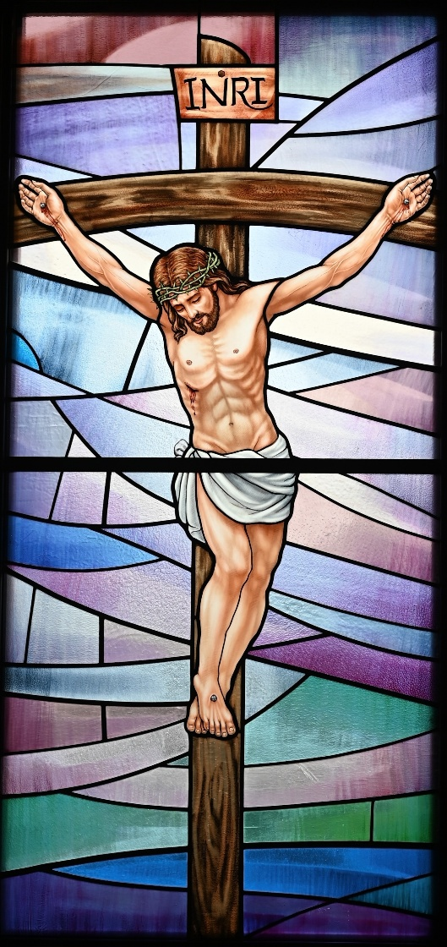

The Second Sunday in Lent
March 1, 2026
10:30 A.M

Welcome!

St. Paul’s Anglican Church extends a warm welcome to all visitors and newcomers, whether worshiping in person or at home via livestream.

Visitors’ Guide

St. Paul’s Church is a parish in the Diocese of San Joaquin of the Anglican Church in North America, which includes both Catholic and Protestant traditions. We accept Jesus Christ as Savior, and we promise to follow him as Lord. We believe in One God,

- the Father who created us and all things,
- the Son who redeems us from sin and death,
- the Holy Spirit who renews and sanctifies us.

We believe the Holy Scriptures to be the Word of God and to contain all things necessary for salvation, and we accept the Apostles’ and Nicene Creeds as essential beliefs of the Christian faith.

Holy Communion is open to all baptized Christians who have examined their lives, repented of their sins, and desire to live
in love and charity with all people.

Those not desiring to receive Holy Communion, and those who have not been baptized into the Christian faith, are invited to cross their arms across their chest, and a blessing will be given instead.

Visitors are invited to sign the guest book at the entrance table and introduce themselves to the clergy following the service.

The Holy Eucharist

Prelude: “Glory Be to Jesus” Haan
Opening Hymn: #401 “God of Abraham Praise” p. 4
Acclamation p. 5
The Collect for Purity p. 5
Summary of the Law p. 5
Trisagion p. 5
Confession and Absolution p. 6
Collect of the Day p. 7
Lesson: Genesis 12:1-9 p. 7
Gradual: Psalm 33:12-21 p. 8
Epistle: Romans 4:1-17 p. 8
Sequence Hymn: #635 – “If Thou but Trust in God to Guide Thee” p. 10
Gospel: John 3:1-16 p. 11
Sermon: Rev. John Iseman
Nicene Creed p. 12
Prayers of the People p. 13
The Peace p. 14
Offertory Anthem: Choir – “Have You Not Heard” by Courtney/Stewart
The Offertory p. 15
Sanctus p. 16
The Lord’s Prayer p. 17
Prayer for Humble Access p. 18
Agnus Dei p. 19
Communion Hymn: #147 – “Now Let Us All with One Accord” p. 20
Post communion Prayer p. 20
Blessing p. 20
Closing Hymn: #O Love, How Deep” p. 22
Dismissal p. 22
Postlude: “Toccata in E Minor” Pachelbel

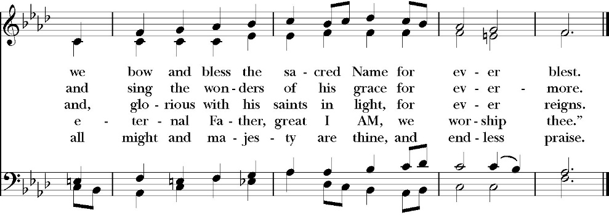
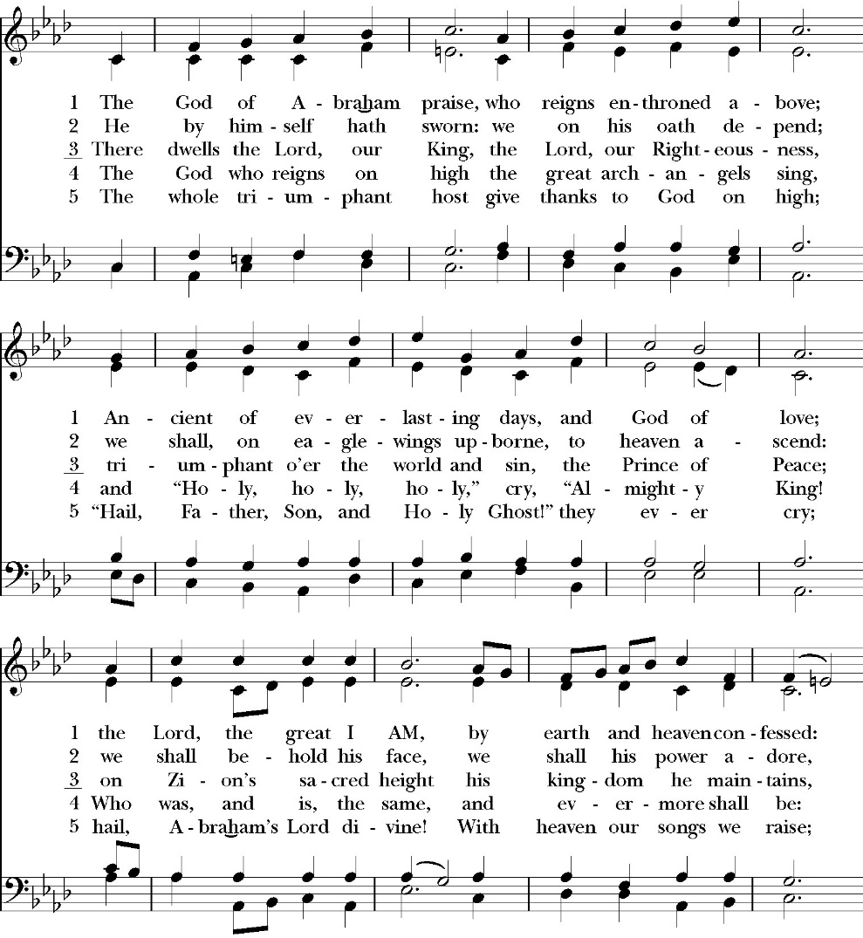
Opening Hymn: God of Abraham Praise

The Acclamation

Celebrant: Bless the Lord who forgives all our sins.
People: His mercy endures for ever.

The Collect for Purity

Almighty God, to you all hearts are open, all desires known, and from you no secrets are hid: Cleanse the thoughts of our hearts by the inspiration of your Holy Spirit, that we may perfectly love you, and worthily magnify your holy Name; through Christ our Lord. Amen.

The Summary of the Law

Hear what our Lord Jesus Christ says: You shall love the Lord your God with all your heart and with all your soul and with all your mind. This is the first and great commandment. And the second is like it: You shall love your neighbor as yourself. On these two commandments depend all the Law and the Prophets.
Matthew 22:37-40t

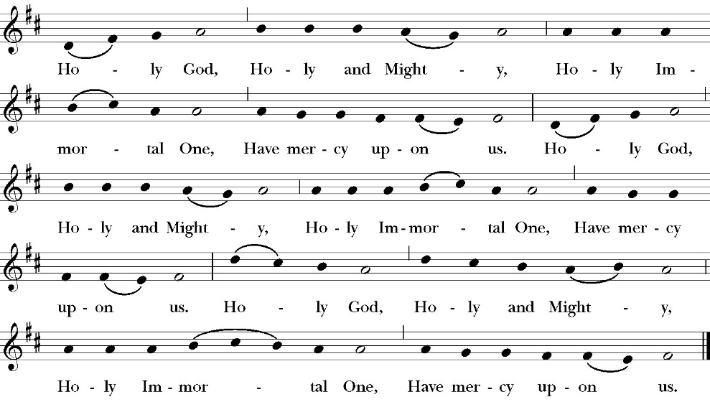
The Trisagion

Confession and Absolution

Leader Let us humbly confess our sins to Almighty God.

Almighty God, Father of our Lord Jesus Christ,
maker and judge of us all:
We acknowledge and lament our many sins and offenses,
which we have committed by thought, word, and deed
against your divine majesty,
provoking most justly your righteous anger against us. We are deeply sorry for these our transgressions;
the burden of them is more than we can bear.
Have mercy upon us,
Have mercy upon us, most merciful Father;
for your Son our Lord Jesus Christ’s sake,
forgive us all that is past;
and grant that we may evermore serve and please you in
newness of life,
to the honor and glory of your Name;
through Jesus Christ our Lord. Amen.

Celebrant Almighty God, our heavenly Father, who in his great
mercy has promised forgiveness of sins to all those who sincerely
repent and with true faith turn to him, have mercy upon you, pardon
and deliver you from all your sins, confirm and strengthen you in all
goodness, and bring you to everlasting life; through Jesus Christ our
Lord. Amen.

The Comfortable Words

Come to me, all who labor and are heavy laden, and I will give you rest. -Matthew 11:28

Officiant The Lord be with You.
People And with your spirit.
Officiant Let us pray:

The Collect of the Day

Almighty God, you know that we have no power in ourselves to help ourselves: Keep us both outwardly in our bodies and inwardly in our souls, that we may be defended from all adversities that may happen to the body, and from all evil thoughts that may assault and hurt the soul; through Jesus Christ our Lord, who lives and reigns with you and the Holy Spirit, one God, for ever and ever. Amen.

Old Testament Reading: Genesis 12:1-9

Now the LORD said to Abram, “Go from your country and your kindred and your father’s house to the land that I will show you. 2 And I will make of you a great nation, and I will bless you and make your name great, so that you will be a blessing. 3 I will bless those who bless you, and him who dishonors you I will curse, and in you all the families of the earth shall be blessed.” 4 So Abram went, as the LORD had told him, and Lot went with him. Abram was seventy-five years old when he departed from Haran. 5 And Abram took Sarai his wife, and Lot his brother’s son, and all their possessions that they had gathered, and the people that they had acquired in Haran, and they set out to go to the land of Canaan. When they came to the land of Canaan, 6 Abram passed through the land to the place at Shechem, to the oak of Moreh. At that time the Canaanites were in the land. 7 Then the LORD appeared to Abram and said, “To your offspring I will give this land.” So he built there an altar to the LORD, who had appeared to him. 8 From there he moved to the hill country on the east of Bethel and pitched his tent, with Bethel on the west and Ai on the east. And there he built an altar to the LORD and called upon the name of the LORD. 9 And Abram journeyed on, still going toward the Negeb.

Reader The Word of the Lord
People Thanks be to God
Gradual: Psalm 33:12-21

12 Blessed is the nation whose God is the LORD, *
and blessed are the people he has chosen for himself to be
his inheritance.
13 The LORD looks down from heaven and beholds all the
children of men; *
from the habitation of his dwelling he considers all those
who dwell on the earth.
14 He fashions all the hearts of them *
and understands all their works.
15 There is no king who can be saved by a mighty host; *
neither is any mighty man delivered by great strength.
16 A horse is considered a vain hope to save a man; *
neither shall it deliver anyone by its great strength.
17 Behold, the eye of the LORD is upon those who fear him, *
and upon those who put their trust in his mercy,
18 To deliver their soul from death, *
and to feed them in the time of famine.
19 Our soul has patiently waited for the LORD, *
for he is our help and our shield.
20 Our heart shall rejoice in him, *
because we have hoped in his holy Name.
21 Let your merciful kindness, O LORD, be upon us, *
as we have put our trust in you.
Glory be to the Father, and to the Son, and to the Holy Spirit;
as it was in the beginning, is now, and ever shall be, world
without end. Amen
Epistle: Romans 4:1-17

What then shall we say was gained by Abraham, our forefather according to the flesh? 2 For if Abraham was justified by works, he has something to boast about, but not before God. 3 For what does the Scripture say? “Abraham 3 believed God, and it was counted to him as righteousness.” 4 Now to the one who works, his wages are not counted as a gift but as his due. 5 And to the one who does not work but believes in him who justifies the ungodly, his faith is counted as righteousness, 6 just as David also speaks of the blessing of the one to whom God counts righteousness apart from works: 7 “Blessed are those whose lawless deeds are forgiven, and whose sins are covered; 8 blessed is the man against whom the Lord will not count his sin.” 9 Is this blessing then only for the circumcised, or also for the uncircumcised? For we say that faith was counted to Abraham as righteousness. 10 How then was it counted to him? Was it before or after he had been circumcised? It was not after, but before he was circumcised. 11 He received the sign of circumcision as a seal of the righteousness that he had by faith while he was still uncircumcised. The purpose was to make him the father of all who believe without being circumcised, so that righteousness would be counted to them as well, 12 and to make him the father of the circumcised who are not merely circumcised but who also walk in the footsteps of the faith that our father Abraham had before he was circumcised. 13 For the promise to Abraham and his offspring that he would be heir of the world did not come through the law but through the righteousness of faith. 14 For if it is the adherents of the law who are to be the heirs, faith is null and the promise is void. 15 For the law brings wrath, but where there is no law there is no transgression. 16 That is why it depends on faith, in order that the promise may rest on grace and be guaranteed to all his offspring—not only to the adherent of the law but also to the one who shares the faith of Abraham, who is the father of us all, 17 as it is written, “I have made you the father of many nations”—in the presence of the God in whom he believed, who gives life to the dead and calls into existence the things that do not exist.
Reader The Word of the Lord
People Thanks be to God

Sequence Hymn: If Thou but Trust in God to Guide Thee
(verses 1 before gospel, verse 2 after)
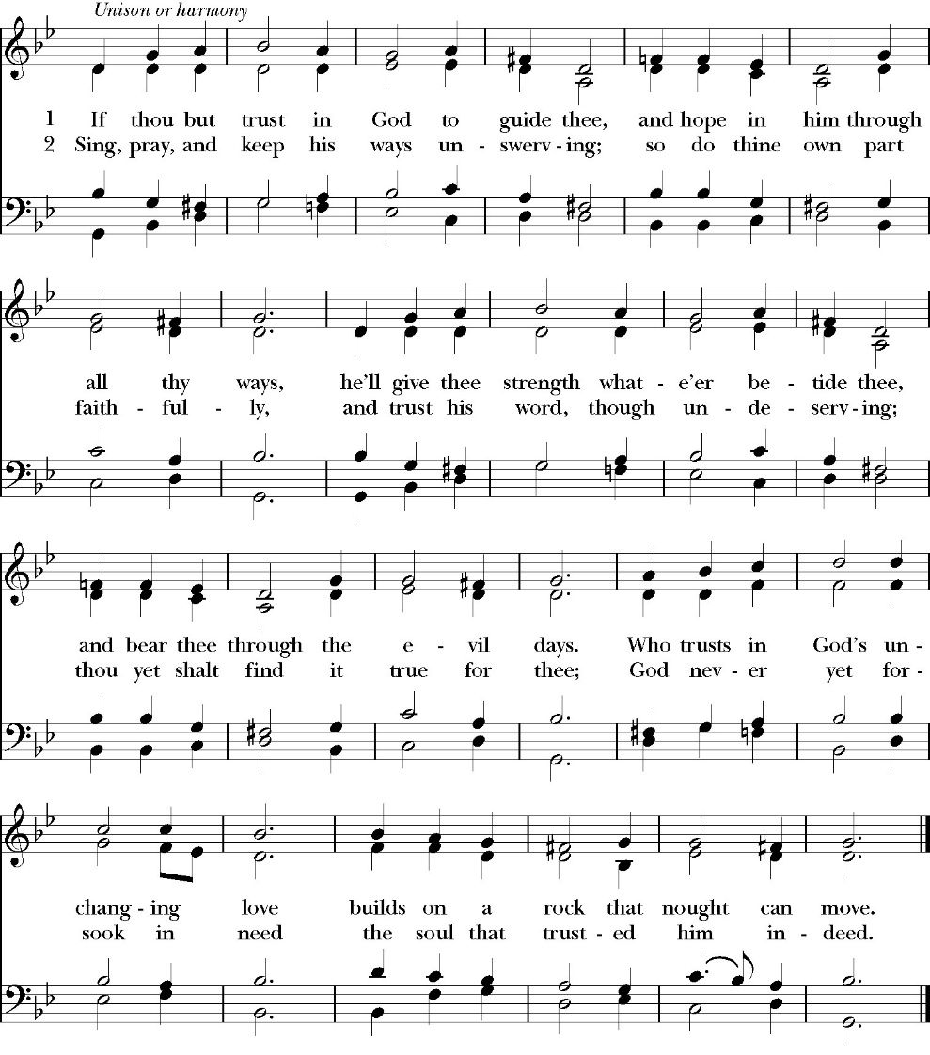

Clergy The Holy Gospel of Our Lord Jesus Christ, according to
St. John.
People Glory to you, Lord Christ.

John 3:1-16
Now there was a man of the Pharisees named Nicodemus, a ruler of the Jews. 2 This man came to Jesus by night and said to him, “Rabbi, we know that you are a teacher come from God, for no one can do these signs that you do unless God is with him.” 3 Jesus answered him, “Truly, truly, I say to you, unless one is born again he cannot see the kingdom of God.” 4 Nicodemus said to him, “How can a man be born when he is old? Can he enter a second time into his mother’s womb and be born?” 5 Jesus answered, “Truly, truly, I say to you, unless one is born of water and the Spirit, he cannot enter the kingdom of God. 6 That which is born of the flesh is flesh, and that which is born of the Spirit is spirit. 7 Do not marvel that I said to you, ‘You must be born again.’ 8 The wind blows where it wishes, and you hear its sound, but you do not know where it comes from or where it goes. So it is with everyone who is born of the Spirit.” 9 Nicodemus said to him, “How can these things be?” 10 Jesus answered him, “Are you the teacher of Israel and yet you do not understand these things? 11 Truly, truly, I say to you, we speak of what we know, and bear witness to what we have seen, but you do not receive our testimony. 12 If I have told you earthly things and you do not believe, how can you believe if I tell you heavenly things? 13 No one has ascended into heaven except he who descended from heaven, the Son of Man. 14 And as Moses lifted up the serpent in the wilderness, so must the Son of Man be lifted up, 15 that whoever believes in him may have eternal life. 16 “For God so loved the world, that he gave his only Son, that whoever believes in him should not perish but have eternal life.

Clergy The Gospel of the Lord
People Praise to you, Lord Christ.

Sermon
The Rev. John Iseman

The Nicene Creed

We believe in one God,
the Father, the Almighty,
maker of heaven and earth,
of all that is, visible and invisible.

We believe in one Lord, Jesus Christ,
the only-begotten Son of God,
eternally begotten of the Father,
God from God, Light from Light,
true God from true God,
begotten, not made,
of one Being with the Father.
through him all things were made.
For us and for our salvation he came down from heaven:
was incarnate from the Holy Spirit and the Virgin Mary,
and was made man.
For our sake he was crucified under Pontius Pilate;
he suffered death and was buried.
On the third day he rose again in accordance with the
Scriptures;
he ascended into heaven
and is seated at the right hand of the Father.
He will come again in glory to judge the living and the dead,
and his kingdom will have no end.

We believe in the Holy Spirit, the Lord, the giver of life,
who proceeds from the Father [and the Son],
who with the Father and the Son is worshiped and glorified.
who has spoken through the Prophets.
We believe in one holy catholic and apostolic Church.
We acknowledge one Baptism for the forgiveness of sins.
We look for the resurrection of the dead,
and the life of the world to come. Amen.

The Prayers of the People

Leader Let us pray for the Church and for the world, saying, “hear our prayer.”
For the peace of the whole world, and for the well-being and unity of the people of God.
Lord, in your mercy:
People Hear our prayer.

Leader For Stephen our archbishop and Eric, our bishop. For Fr. Rob, Deacon John, Deacon Kashy, and for all the clergy and people of our diocese and congregation and for the worldwide Anglican Communion.
Lord, in your mercy:
People Hear our prayer.

Leader For all those who proclaim the Gospel at home and abroad; and for all who teach and disciple others.
Lord, in your mercy:
People Hear our prayer.

Leader For our brothers and sisters in Christ who are persecuted for their faith.
Lord, in your mercy:
People Hear our prayer.

Leader For our nation, for those in authority, and for all in public service especially Donald our president and Gavin our governor.
Lord, in your mercy:
People Hear our prayer.

Leader: In the St. Paul’s cycle of prayer, we pray for our Bishop Eric Menees, the Ministries of the Anglican Diocese of San Joaquin and its churches, for the Anglican Church in North America and its dioceses, for the Global Anglican Futures Conference, for the Worldwide Anglican Communion and all their provinces, diocese and churches.
Lord, in your mercy:
People Hear our prayer.

Leader In the ACNA Cycle of Prayer, today we pray for the Diocese of the Western Gulf Coast, Bishop Clark Lowenfield and his wife, Tricia.
Lord, in your mercy:
People Hear our prayer.

Leader For all those who are in trouble, sorrow, need, sickness, or any other adversity [especially _____________]. We also pray for all who are currently serving in our armed forces and serving as first responders.
Lord, in your mercy:
People Hear our prayer.
Leader For all those who have departed this life in the certain hope of the resurrection, (we pray especially for ____________), in thanksgiving let us pray.
Lord, in your mercy:
People Hear our prayer.

Celebrant will add a concluding prayer

The Peace

Celebrant The Peace of the Lord be always with you.
People And with your spirit.

Offertory Anthem
Choir: Have You not heard
by Courtney/Stewart

The Doxology
(Verse 3 only)

The Offertory

Celebrant All things come from you, O Lord,
People And of your own have we given you.

The Eucharistic Liturgy

Celebrant The Lord be with you.
People And with your spirit.
Celebrant Lift up your hearts.
People We lift them up to the Lord.
Celebrant Let us give thanks to the Lord our God.
People It is right to give him thanks and praise.

It is right, our duty and our joy, always and everywhere to give thanks to you, Father Almighty, Creator of heaven and earth. You bid your faithful people cleanse their hearts, and prepare with joy for the Paschal feast; that, fervent in prayer and in works of mercy, and renewed by your Word and Sacraments, they may come to the fullness of grace which you have prepared for those who love you.
Therefore we praise you, joining our voices with angels and archangels and with all the company of heaven, who forever sing this hymn to proclaim the glory of your Name:

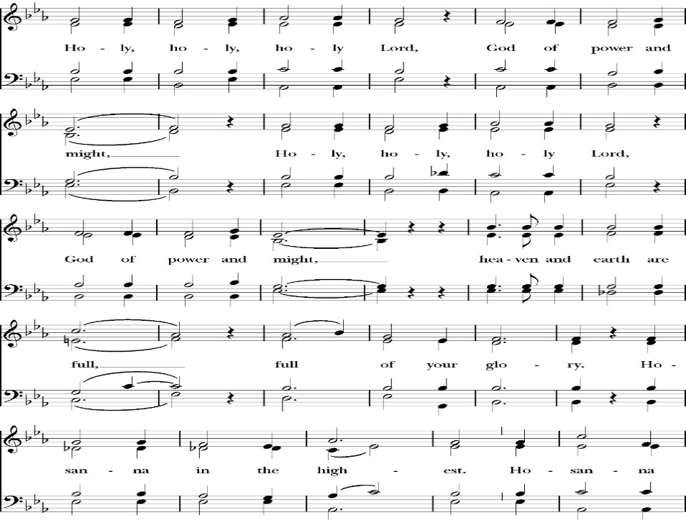
The Sanctus

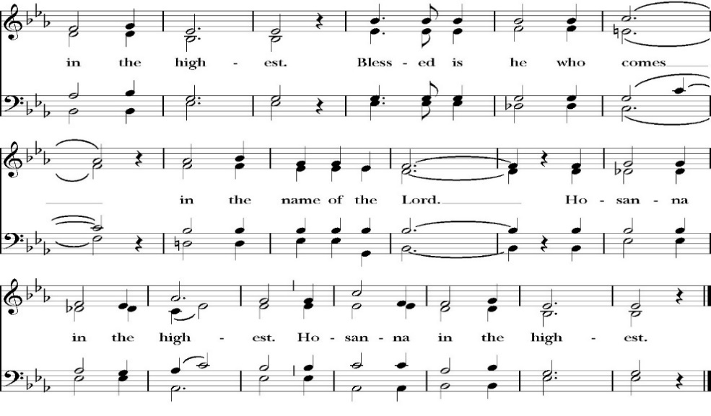
All praise and glory is yours, O God our heavenly Father, for in your tender mercy, you gave your only Son Jesus Christ to suffer death upon the Cross for our redemption. He made there, by his one oblation of himself once offered, a full, perfect, and sufficient sacrifice, oblation, and satisfaction, for the sins of the whole world; and he instituted, and in his Holy Gospel commanded us to continue, a perpetual memory of his precious death and sacrifice, until his coming again.

So now, O merciful Father, in your great goodness, we ask you to bless and sanctify, with your Word and Holy Spirit, these gifts of bread and wine, that we, receiving them according to your Son our Savior Jesus Christ’s holy institution, in remembrance of his death and passion, may be partakers of his most blessed Body and Blood.
For on the night that he was betrayed, our Lord Jesus Christ took bread; and when he had given thanks, he broke it,* and gave it to his disciples, saying, “Take, eat; this is my Body, which is given for you: Do this in remembrance of me.”

Likewise, after supper, Jesus took the cup, and when he had given thanks, he gave it to them, saying, “Drink this, all of you; for this is my Blood of the New Covenant, which is shed for you, and for many, for the forgiveness of sins: Whenever you drink it, do this in remembrance of me.”

Therefore, O Lord and heavenly Father, according to the institution of your dearly beloved Son our Savior Jesus Christ, we your humble servants celebrate and make here before your divine Majesty, with these holy gifts, the memorial your Son commanded us to make; remembering his blessed passion and precious death, his mighty resurrection and glorious ascension, and his promise to come again.

And we earnestly desire your fatherly goodness mercifully to accept this, our sacrifice of praise and thanksgiving; asking you to grant that, by the merits and death of your Son Jesus Christ, and through faith in his Blood, we and your whole Church may obtain forgiveness of our sins, and all other benefits of his passion.

And here we offer and present to you, O Lord, ourselves, our souls and bodies, to be a reasonable, holy, and living sacrifice. We humbly pray that all who partake of this Holy Communion may worthily receive the most precious Body and Blood of your Son Jesus Christ, be filled with your grace and heavenly benediction, and be made one body with him, that he may dwell in us, and we in him.

And although we are unworthy, because of our many sins, to offer you any sacrifice, yet we ask you to accept this duty and service we owe, not weighing our merits, but pardoning our offenses, through Jesus Christ our Lord.

By him, and with him, and in him, in the unity of the Holy Spirit, all honor and glory is yours, Almighty Father, now and for ever. Amen.

And now, as our Savior Christ has taught us, we are bold to pray,

Our Father, who art in heaven,
hallowed be thy Name,
thy kingdom come,
thy will be done,
on earth as it is in heaven.
Give us this day our daily bread.
And forgive us our trespasses,
as we forgive those
who trespass against us.
And lead us not into temptation,
but deliver us from evil.
For thine is the kingdom,
and the power, and the glory,
for ever and ever. Amen.

Celebrant Christ our Passover is sacrificed for us.
People Therefore let us keep the feast.

We do not presume to come to this your table, O merciful Lord,
trusting in our own righteousness,
but in your abundant and great mercies.
We are not worthy so much as to gather up
the crumbs under your table;
but you are the same Lord
whose character is always to have mercy.
Grant us, therefore, gracious Lord,
so to eat the flesh of your dear Son Jesus Christ,
and to drink his blood,
that our sinful bodies may be made clean by his body,
and our souls washed through his most precious blood,
and that we may evermore dwell in him, and he in us.
Amen.

Agnus Dei
Behold the Lamb of God, behold him who takes away the sins of the world. Blessed are those who are invited to the marriage supper of the Lamb.
John 1:29; Revelation 19:9

Communion Hymn: Now Let Us All With One Accord
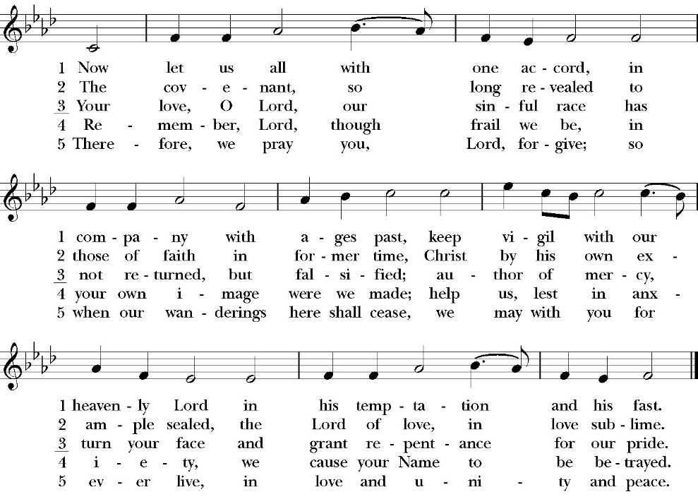

The Post Communion Prayer

Let us pray.

Almighty and everliving God,
we thank you for feeding us, in these holy mysteries,
with the spiritual food of the most precious Body and Blood
of your Son our Savior Jesus Christ;
and for assuring us, through this Sacrament, of your favor and
goodness towards us:
that we are true members of the mystical body of your Son,
the blessed company of all faithful people;
and are also heirs, through hope,
of your everlasting kingdom.
And we humbly ask you, heavenly Father,
to assist us with your grace,
that we may continue in that holy fellowship,
and do all the good works that you have prepared for us to
walk in;
through Jesus Christ our Lord,
to whom, with you and the Holy Spirit,
be all honor and glory, now and for ever. Amen.

The Blessing

The peace of God, which passes all understanding, keep your hearts
and minds in the knowledge and love of God, and of his Son Jesus
Christ our Lord; and the blessing of God Almighty, the Father, the
Son, and the Holy Spirit, be among you, and remain with you always.
Amen.

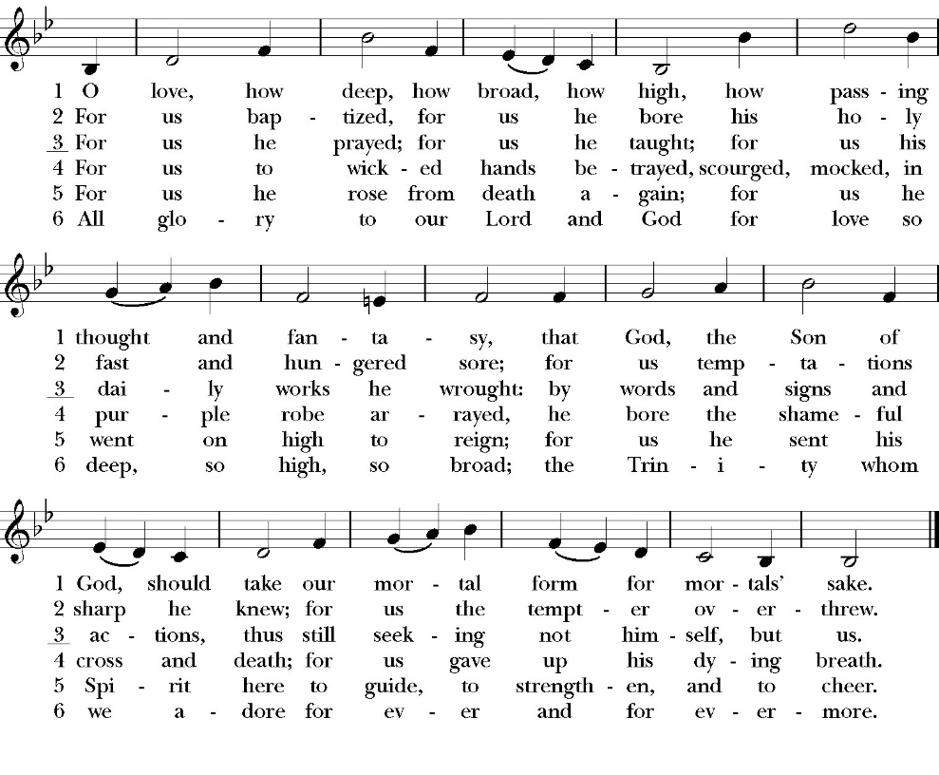
Closing Hymn: O Love, How Deep

Celebrant Go in peace to love and serve the Lord.
People Thanks be to God.
St. Paul’s Parish Calendar
Sunday March 1 – Sunday March 8

SUNDAY, March 1 – Second Sunday in Lent
9:15 AM Sunday Funday, Youth Room
9:15 AM Gospel of John bible study, Conference room
9:30 AM Vocal Choir rehearsal, Chapel
10:30 AM Children’s Sunday School, Chapel
Pre-K –2nd Grade, Sunday School Room.
3rd -5th Grade, Youth Room
10:30 AM Holy Eucharist, Church

MONDAY, March 2

TUESDAY, March 3
6:00 PM Bell Choir Practice, Music Room
6:00 PM Assistance League Meeting, James Hall

WEDNESDAY, March 4
9:00AM to 4:00PM Rummage Drop Off, James Hall
9:30 AM Holy Eucharist with healing prayer, Chapel
10:15 AM Bible Study, Conference Room
5:00 PM Practicing the Way, James Hall
5:45 PM Soup Supper, James Hall
6:45 PM Practicing the Way, James Hall
7:00 PM Vocal Choir Rehearsal, Church

THURSDAY, March 5
9:00AM to 4:00PM Rummage Drop Off James Hall

FRIDAY, March 6
6:30 AM Men’s Bible Study, Valhalla Restaurant
8:00AM to 4:00PM Rummage Sale, James Hall
6:00 PM Stations of the Cross, Church

SATURDAY, March 7
8:00AM – 2:00PM Rummage Sale, James Hall

SUNDAY, March 8 – Third Sunday in Lent
9:15 AM Sunday Funday, Youth Room
9:15 AM Gospel of John bible study, Conference room
9:30 AM Vocal Choir rehearsal, Chapel
10:30 AM Children’s Sunday School, Chapel
Pre-K –2nd Grade, Sunday School Room.
3rd -5th Grade, Youth Room
10:30 AM Holy Eucharist, Church
Church Office Hours
Monday-Thursday 8:00 AM-4:00 PM

Announcements

Lenten Stations of the Cross on Fridays at 6:00PM
Stations of the Cross is a meditative journey that allows the pilgrim to walk the way of the cross into the way of life and peace. All members are invited to join us for this beautiful and impactful thirty minute devotional practice on Fridays at 6PM throughout Lent.

Sunday Morning Bible Study: The Gospel of John
Today St. Paul’s will embark on study of the Gospel of John that will span the next year. These classes will be on Sunday mornings from 9:15-10:00am. We will take the better part of the next year to move slowly through John and savor the profound spiritual truths that it offers. We will be using a book called “Be Alive” by Warren Wiersbe as our guide. This book is essentially a study guide to the Gospel of John and will provide us with structure and insight as we move our way the Gospel. Books will be available beginning the day of the first class.

Projected Class Timeline

Lent Chapters 1-3
Easter Chapters 4-8
June Chapter 9
August Chapter 10
Fall Chapters 11-14
Advent Chapters 15 & 15
Epiphany Chapters 16-17
Lent 2027 Chapters 18 & 19
Easter season Chapters 20 & 21

The class will progress based on how quickly or slowly is needed and our projected timelines may change as we move forward.

Lenten Soup Suppers will begin February 25, at 6:00PM
Lenten soup suppers are a beloved tradition at St. Paul’s. They offer an opportunity for a simple and delicious dinner with fellowship and an opportunity to participate in a Lenten bible study or spiritual devotion. All are welcome to join us. If you would like to sign up to bring soup, please talk with Kathy Bernardi.

Practicing The Way, The Prayer Practice:
Pursue a deeper life of union with God
This is a Lenten opportunity for discipleship and spiritual growth in Jesus Christ. To pray is to open your heart to God. Prayer is simply the medium through which we communicate and commune with God. The practice of prayer is learning to set aside dedicated time to intentionally be with God in order to become like him and partner with him in the world. The Prayer Practice small group is a video-based class on prayer developed by John Mark Comer, author and facilitator of Practicing the Way and its resources. There will be two opportunities to participate on Wednesday evenings. The 5PM small group will be led by Fr. Rob Longbottom. The 6:45PM small group will be led by Deacon John Iseman.

March 4 Session 2: Talking with God
March 11 Session 3: Listening to God
March 18 Session 4: Being with God
March 25 Prayer and Praise in the church. An hour of prayer and praise music as we lift our prayers and hearts to God in worship.
Lenten Wednesday Evening Schedule
5:00 PM Prayer small group led by Father Rob

6:00 PM Soup Suppers

6:45 PM Prayer small group class led by Deacon John

6:45PM Children’s class on prayer led by Deacon Kashy and
Fr. Rob
7:00 PM Vocal Choir Rehearsal, chapel
St. Paul’s Anglican Church
6436 W Hurley Ave
Visalia, CA


Friday March 6, 8:00 AM to 4:00 PM
Saturday March 7, 8:00 AM to 2:00 PM
Drop Off Donated Items in James Hall on:
Wednesday March 4 and Thursday March 5
Between 9:00 AM – 4:00 PM
Items need to be in Good Condition, Clean, gently worn clothing, household items, toys in working order gladly accepted!

Volunteers Needed for Set Up
Wednesday, March 4 and Thursday March 5
Between 9:00 AM – 4:00 PM
Proceeds will Go Toward the New Gate Project and
To Support our Medical Student in Honduras
If you have any questions,
Contact: Mary Murray at 799-6973

A Food Bank for Hurley Families
The next Neighborhood Market to benefit students at Hurley School will be Wednesday, March 18, from 2:30 PM to 3:30 PM at St Paul’s Church parking lot. If you are interested in helping that day, please contact Sue Nyberg. My home phone number is 559-733-8244.

PROVIDED BY VISALIA EMERGENCY AID
AND ST. PAUL’S CHURCH
Wednesday, March 18, 2026
From 2:30 PM to 3:30 PM
LOCATION:
ST. PAUL'S CHURCH PARKING LOT
ACROSS THE STREET FROM HURLEY



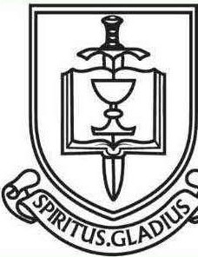

ST. PAUL'S ANGLICAN CHURCH
"WHERE GOD BUILDS THINGS"
-

St. Paul’s Anglican Church
Parish Office
6436 W. Hurley Ave
Visalia, California 93291
559-732-4821
Office Hours: 8:00 – 4:00
Monday – Thursday

Worship: Sundays at 10:30AM
Livestream: Link at spvisalia.com
and on our Facebook page
Please be advised that this service is being recorded for broadcast
and/or archival purposes. By attending, you consent
to the inclusion of your likeness in these recordings.

St. Paul’s Clergy and Staff
The Rev. Robert Longbottom, Rector
rector@spvisalia.com
(559)802-2928
The Rev. John Iseman, Pastoral Associate for Family Ministries
family@spvisalia.com
The Rev. Kashy Rowland-Smith, Deacon
kashyrs@aol.com
Antoinette Horsting, Parish Administrator
bookkeeper@spvisalia.com
Marguerite Crownover, Organist and Accompanist
Cynthia Culp, Choral Director
Jackie Iseman, Nursery Coordinator
Shane Motl, Sexton

St. Paul’s is a member church of the
Anglican Diocese of San Joaquin
The Rt. Rev. Eric V. Menees, Bishop

Next Week’s Lessons
Exodus 17:1-7
Psalm 95
Romans 1:16-32
John 4:5-42

