St. Paul’s Anglican Church
Visalia, California
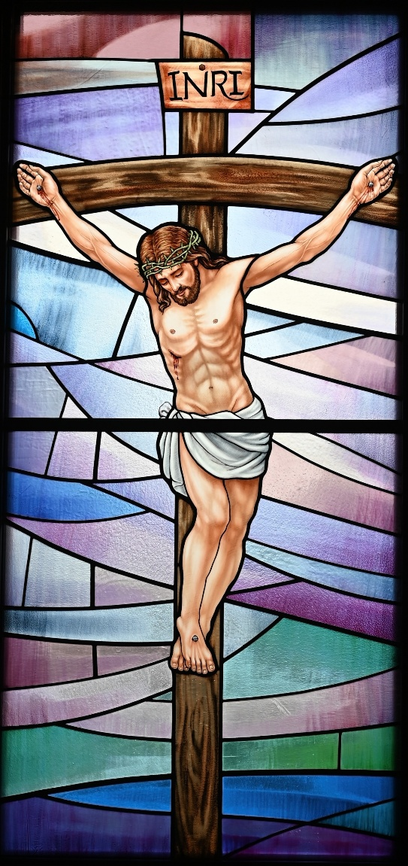

The Fifth Sunday in Lent
March 22, 2026
10:30 A.M

Welcome!

St. Paul’s Anglican Church extends a warm welcome to all visitors and newcomers, whether worshiping in person or at home via livestream.

Visitors’ Guide

St. Paul’s Church is a parish in the Diocese of San Joaquin of the Anglican Church in North America, which includes both Catholic and Protestant traditions. We accept Jesus Christ as Savior, and we promise to follow him as Lord. We believe in One God,

- the Father who created us and all things,
- the Son who redeems us from sin and death,
- the Holy Spirit who renews and sanctifies us.

We believe the Holy Scriptures to be the Word of God and to contain all things necessary for salvation, and we accept the Apostles’ and Nicene Creeds as essential beliefs of the Christian faith.

Holy Communion is open to all baptized Christians who have examined their lives, repented of their sins, and desire to live
in love and charity with all people.

Those not desiring to receive Holy Communion, and those who have not been baptized into the Christian faith, are invited to cross their arms across their chest, and a blessing will be given instead.

Visitors are invited to sign the guest book at the entrance table and introduce themselves to the clergy following the service.

The Holy Eucharist

Postlude: “Hark, a Voice Saith, all are Mortal” Bach
Opening Hymn: #495 – “Hail, Thou Once Despised Jesus” p. 4
Acclamation p. 5
The Collect for Purity p. 5
Summary of the Law p. 5
Trisagion p. 5
Confession and Absolution p. 6
The Comfortable Words p. 6
Collect of the Day p. 7
Lesson: Ezekiel 37:1-14 p. 7
Gradual: Psalm 130 p. 8
Epistle: Romans 6:15-23 p. 9
Sequence Hymn: #508 – “Breathe on Me, Breath of God” p. 10
Gospel: John 11:18-44 p. 10
Sermon: Rev. John Iseman
Nicene Creed p. 12
Prayers of the People p. 13
The Peace p. 14
Offertory Anthem: “LAMB John 1:29” Choir and Cellist Liam Curtiss
The Offertory p. 15
Sanctus p. 16
The Lord’s Prayer p. 19
Prayer for Humble Access p. 19
Agnus Dei p. 20
Communion Hymn: Praise Song “Amazing Grace the Chains are Gone” p. 21
Post Communion Prayer p. 22
Blessing p. 22
Closing Hymn: #494- “Crown Him with Many Crowns” p. 23
Dismissal p. 24
Prelude: “In Death’s Strong Grasp the Savior Lay” Bach

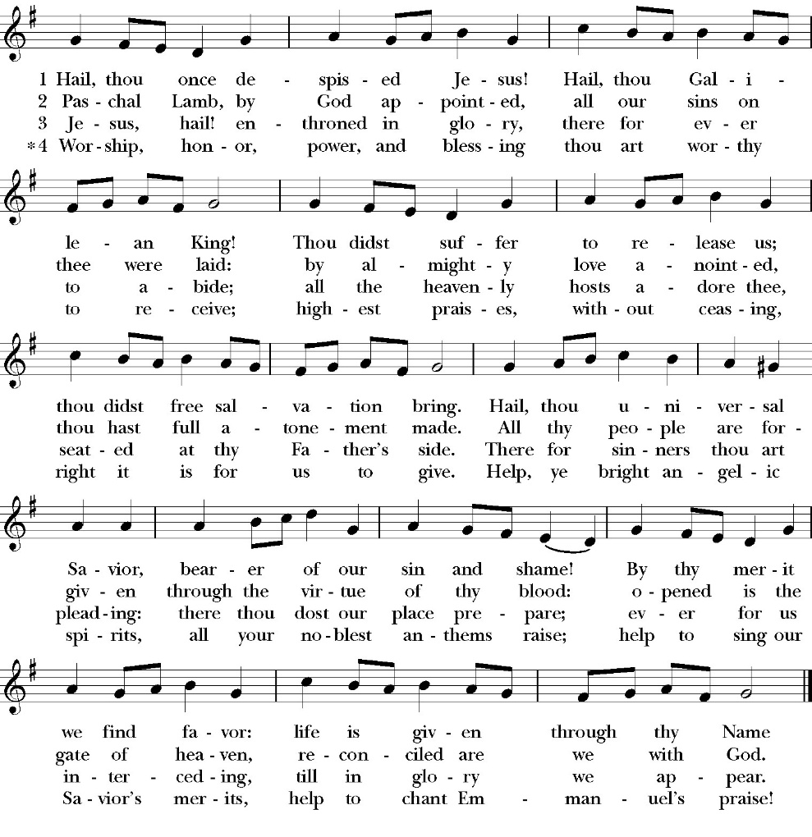
Opening Hymn: Hail, Thou Once Despised Jesus

The Acclamation

Celebrant: Bless the Lord who forgives all our sins.
People: His mercy endures for ever.

The Collect for Purity

Almighty God, to you all hearts are open, all desires known, and from you no secrets are hid: Cleanse the thoughts of our hearts by the inspiration of your Holy Spirit, that we may perfectly love you, and worthily magnify your holy Name; through Christ our Lord. Amen.

The Summary of the Law

Hear what our Lord Jesus Christ says: You shall love the Lord your God with all your heart and with all your soul and with all your mind. This is the first and great commandment. And the second is like it: You shall love your neighbor as yourself. On these two commandments depend all the Law and the Prophets.
Matthew 22:37-40t

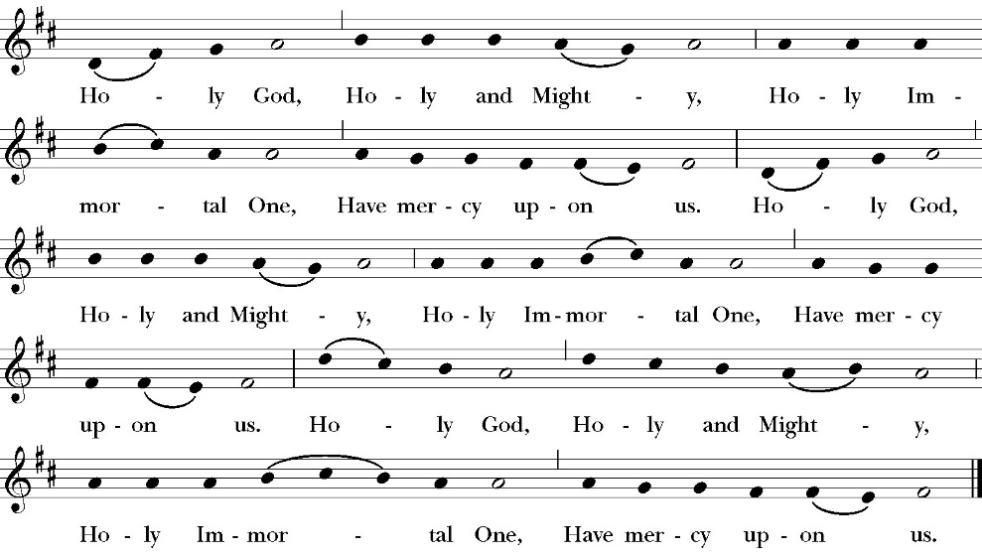
The Trisagion

Confession and Absolution

Leader Let us humbly confess our sins to Almighty God.

Almighty God, Father of our Lord Jesus Christ,
maker and judge of us all:
We acknowledge and lament our many sins and offenses,
which we have committed by thought, word, and deed
against your divine majesty,
provoking most justly your righteous anger against us. We are deeply sorry for these our transgressions;
the burden of them is more than we can bear.
Have mercy upon us,
Have mercy upon us, most merciful Father;
for your Son our Lord Jesus Christ’s sake,
forgive us all that is past;
and grant that we may evermore serve and please you in
newness of life,
to the honor and glory of your Name;
through Jesus Christ our Lord. Amen.

Celebrant Almighty God, our heavenly Father, who in his great
mercy has promised forgiveness of sins to all those who sincerely
repent and with true faith turn to him, have mercy upon you, pardon
and deliver you from all your sins, confirm and strengthen you in all
goodness, and bring you to everlasting life; through Jesus Christ our
Lord. Amen.

The Comfortable Words

Hear the Word of God to all who truly turn to him,

If anyone sins, we have an advocate with the Father, Jesus Christ the righteous. He is the propitiation for our sins, and not for ours only, but also for the sins of the whole world.
1 John 2:1-2t
Officiant The Lord be with You.
People And with your spirit.
Officiant Let us pray:

The Collect of the Day

Almighty God, you alone can bring into order the unruly wills and affections of sinners: Grant your people grace to love what you command and desire what you promise; that, among the swift and varied changes of this world, our hearts may surely there be fixed where true joys are to be found; through Jesus Christ our Lord, who lives and reigns with you and the Holy Spirit, one God, now and for ever. Amen.

Lesson: Ezekiel 37:1-14

The hand of the LORD was upon me, and he brought me out in the Spirit of the LORD and set me down in the middle of the valley; it was full of bones. 2 And he led me around among them, and behold, there were very many on the surface of the valley, and behold, they were very dry. 3 And he said to me, “Son of man, can these bones live?” And I answered, “O Lord God, you know.” 4 Then he said to me, “Prophesy over these bones, and say to them, O dry bones, hear the word of the LORD.

5 Thus says the Lord God to these bones: Behold, I will cause breath to enter you, and you shall live. 6 And I will lay sinews upon you, and will cause flesh to come upon you, and cover you with skin, and put breath in you, and you shall live, and you shall know that I am the LORD.”

7 So I prophesied as I was commanded. And as I prophesied, there was a sound, and behold, a rattling, and the bones came together, bone to its bone. 8 And I looked, and behold, there were sinews on them, and flesh had come upon them, and skin had covered them. But there was no breath in them. 9 Then he said to me, “Prophesy to the breath; prophesy, son of man, and say to the breath, Thus says the Lord God: Come from the four winds, O breath, and breathe on these slain, that they may live.” 10 So I prophesied as he commanded me, and the breath came into them, and they lived and stood on their feet, an exceedingly great army.

11 Then he said to me, “Son of man, these bones are the whole house of Israel. Behold, they say, ‘Our bones are dried up, and our hope is lost; we are indeed cut off.’ 12 Therefore prophesy, and say to them, Thus says the Lord God: Behold, I will open your graves and raise you from your graves, O my people. And I will bring you into the land of Israel. 13 And you shall know that I am the LORD, when I open your graves, and raise you from your graves, O my people. 14 And I will put my Spirit within you, and you shall live, and I will place you in your own land. Then you shall know that I am the LORD; I have spoken, and I will do it, declares the LORD.”

Reader The Word of the Lord
People Thanks be to God

Gradual: Psalm 130

1 Out of the deep have I called unto you, O LORD; *
Lord, hear my voice. 2 O let your ears consider well * the voice of my supplications.
3 If you, LORD, were to mark what is done amiss, *
O Lord, who could abide it?
4 For there is mercy with you; *
therefore you shall be feared.
5 I wait for the LORD; my soul waits for him; *
in his word is my trust.
6 My soul waits for the Lord, *
more than watchmen for the morning, more than watchmen for the morning.
7 O Israel, trust in the LORD, for with the LORD there is mercy, * and with him is plenteous redemption;
8 And he shall redeem Israel *
from all their sins.

Glory be to the Father, and to the Son, and to the Holy Spirit;
as it was in the beginning, is now, and ever shall be, world
without end. Amen

Epistle: Romans 6:15-23

What then? Are we to sin because we are not under law but under grace? By no means! 16 Do you not know that if you present yourselves to anyone as obedient slaves, you are slaves of the one whom you obey, either of sin, which leads to death, or of obedience, which leads to righteousness? 17 But thanks be to God, that you who were once slaves of sin have become obedient from the heart to the standard of teaching to which you were committed, 18 and, having been set free from sin, have become slaves of righteousness. 19 I am speaking in human terms, because of your natural limitations. For just as you once presented your members as slaves to impurity and to lawlessness leading to more lawlessness, so now present your members as slaves to righteousness leading to sanctification.

20 For when you were slaves of sin, you were free in regard to righteousness. 21 But what fruit were you getting at that time from the things of which you are now ashamed? For the end of those things is death. 22 But now that you have been set free from sin and have become slaves of God, the fruit you get leads to sanctification and its end, eternal life. 23 For the wages of sin is death, but the free gift of God is eternal life in Christ Jesus our Lord.

Reader The Word of the Lord
People Thanks be to God

Sequence Hymn: Breathe on Me, Breath of God
(verses 1 & 3 before Gospel, verse 4 after)

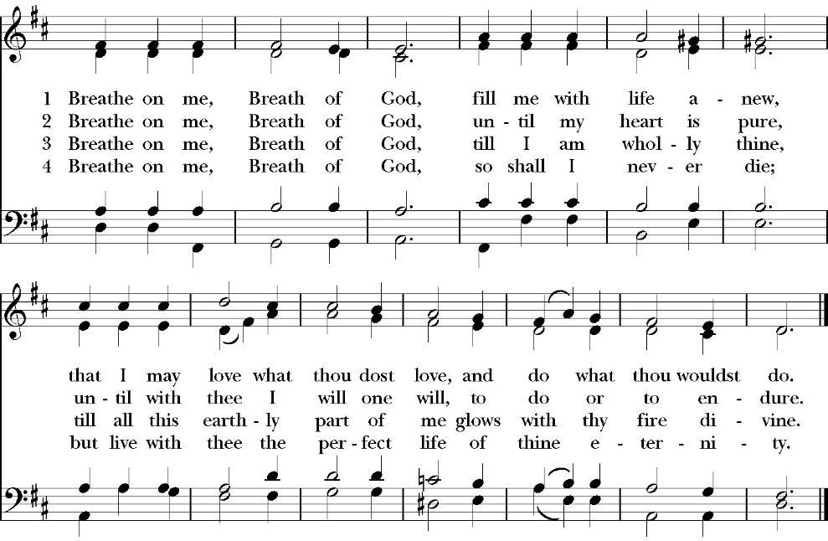

The Holy Gospel of Our Lord Jesus Christ, according to St. John.
People Glory to you, Lord Christ.

John 11:18-44

18 Bethany was near Jerusalem, about two miles off, 19 and many of the Jews had come to Martha and Mary to console them concerning their brother. 20 So when Martha heard that Jesus was coming, she went and met him, but Mary remained seated in the house. 21 Martha said to Jesus, “Lord, if you had been here, my brother would not have died. 22 But even now I know that whatever you ask from God, God will give you.” 23 Jesus said to her, “Your brother will rise again.” 24 Martha said to him, “I know that he will rise again in the resurrection on the last day.” 25 Jesus said to her, “I am the resurrection and the life. Whoever believes in me, though he die, yet shall he live, 26 and everyone who lives and believes in me shall never die. Do you believe this?” 27 She said to him, “Yes, Lord; I believe that you are the Christ, the Son of God, who is coming into the world.”
28 When she had said this, she went and called her sister Mary, saying in private, “The Teacher is here and is calling for you.” 29 And when she heard it, she rose quickly and went to him. 30 Now Jesus had not yet come into the village, but was still in the place where Martha had met him. 31 When the Jews who were with her in the house, consoling her, saw Mary rise quickly and go out, they followed her, supposing that she was going to the tomb to weep there. 32 Now when Mary came to where Jesus was and saw him, she fell at his feet, saying to him, “Lord, if you had been here, my brother would not have died.” 33 When Jesus saw her weeping, and the Jews who had come with her also weeping, he was deeply moved in his spirit and greatly troubled. 34 And he said, “Where have you laid him?” They said to him, “Lord, come and see.” 35 Jesus wept. 36 So the Jews said, “See how he loved him!” 37 But some of them said, “Could not he who opened the eyes of the blind man also have kept this man from dying?”

38 Then Jesus, deeply moved again, came to the tomb. It was a cave, and a stone lay against it. 39 Jesus said, “Take away the stone.” Martha, the sister of the dead man, said to him, “Lord, by this time there will be an odor, for he has been dead four days.” 40 Jesus said to her, “Did I not tell you that if you believed you would see the glory of God?” 41 So they took away the stone. And Jesus lifted up his eyes and said, “Father, I thank you that you have heard me. 42 I knew that you always hear me, but I said this on account of the people standing around, that they may believe that you sent me.”

43 When he had said these things, he cried out with a loud voice, “Lazarus, come out.”

44 The man who had died came out, his hands and feet bound with linen strips, and his face wrapped with a cloth. Jesus said to them, “Unbind him, and let him go.”

Clergy The Gospel of the Lord
People Praise to you, Lord Christ.

Sermon
rev. john iseman

The Nicene Creed

We believe in one God,
the Father, the Almighty,
maker of heaven and earth,
of all that is, visible and invisible.

We believe in one Lord, Jesus Christ,
the only-begotten Son of God,
eternally begotten of the Father,
God from God, Light from Light,
true God from true God,
begotten, not made,
of one Being with the Father.
through him all things were made.
For us and for our salvation he came down from heaven:
was incarnate from the Holy Spirit and the Virgin Mary,
and was made man.
For our sake he was crucified under Pontius Pilate;
he suffered death and was buried.
On the third day he rose again in accordance with the
Scriptures;
he ascended into heaven
and is seated at the right hand of the Father.
He will come again in glory to judge the living and the dead,
and his kingdom will have no end.

We believe in the Holy Spirit, the Lord, the giver of life,
who proceeds from the Father [and the Son],
who with the Father and the Son is worshiped and glorified.
who has spoken through the Prophets.
We believe in one holy catholic and apostolic Church.
We acknowledge one Baptism for the forgiveness of sins.
We look for the resurrection of the dead,
and the life of the world to come. Amen.

The Prayers of the People

Leader Let us pray for the Church and for the world, saying, “hear our prayer.”
For the peace of the whole world, and for the well-being and unity of the people of God.
Lord, in your mercy:
People Hear our prayer.

Leader For Stephen our archbishop and Eric, our bishop. For Fr. Rob, Deacon John, Deacon Kashy, and for all the clergy and people of our diocese and congregation and for the worldwide Anglican Communion.
Lord, in your mercy:
People Hear our prayer.

Leader For all those who proclaim the Gospel at home and abroad; and for all who teach and disciple others.
Lord, in your mercy:
People Hear our prayer.

Leader For our brothers and sisters in Christ who are persecuted for their faith.
Lord, in your mercy:
People Hear our prayer.

Leader For our nation, for those in authority, and for all in public service especially Donald our president and Gavin our governor.
Lord, in your mercy:
People Hear our prayer.

Leader: In the St. Paul’s cycle of prayer, we pray for all ministries to children, youth and families both in our church and through our church into the community around us. We pray for Sunday Funday, Sunday School, Youth Group and Nursery. We pray for all our family ministry volunteers. We pray for the children and youth you have given to our care and for their formation in the Christian faith. We pray for all children and youth to whom we are reaching out with the Good News of Jesus Christ.
Lord, in your mercy:
People Hear our prayer.

Leader In the ACNA Cycle of Prayer, today we pray for the Diocese of the Central States, Bishop Peter Manto and his wife, Janice.
Lord, in your mercy:
People Hear our prayer.

Leader For all those who are in trouble, sorrow, need, sickness, or
any other adversity [especially ____________]. We also
pray for all who are currently serving in our armed forces
and serving as first responders.
Lord, in your mercy:
People Hear our prayer.

Leader For all those who have departed this life in the certain hope
of the resurrection, (we pray especially for ____________),
in thanksgiving let us pray.
Lord, in your mercy:
People Hear our prayer.

Celebrant will add a concluding prayer

Celebrant The Peace of the Lord be always with you.
People And with your spirit.

Offertory Anthem:
lamb john 1:29
arr. by richard don
choir and accompanied by cellist liam curtiss

The Doxology
(Verse 3 only)

The Offertory

Celebrant All things come from you, O Lord,
People And of your own have we given you.

The Eucharistic Liturgy

Celebrant The Lord be with you.
People And with your spirit.
Celebrant Lift up your hearts.
People We lift them up to the Lord.
Celebrant Let us give thanks to the Lord our God.
People It is right to give him thanks and praise.
It is right, our duty and our joy, always and everywhere to give thanks to you, Father Almighty, Creator of heaven and earth. You bid your faithful people cleanse their hearts, and prepare with joy for the Paschal feast; that, fervent in prayer and in works of mercy, and renewed by your Word and Sacraments, they may come to the fullness of grace which you have prepared for those who love you.

Therefore we praise you, joining our voices with angels and archangels and with all the company of heaven, who forever sing this hymn to proclaim the glory of your Name:

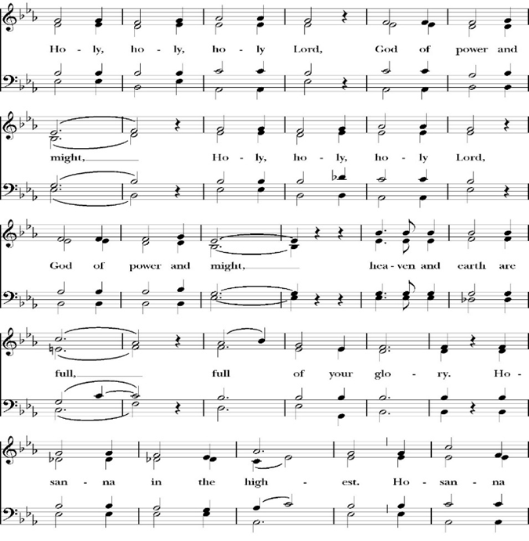
The Sanctus

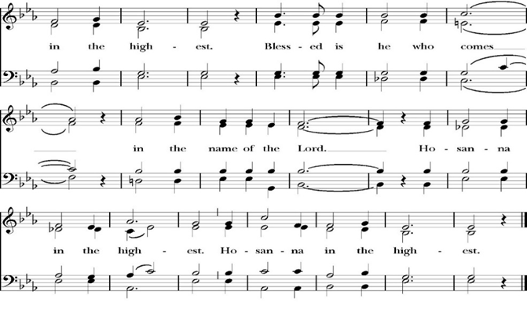
All praise and glory is yours, O God our heavenly Father, for in your tender mercy, you gave your only Son Jesus Christ to suffer death upon the Cross for our redemption. He made there, by his one oblation of himself once offered, a full, perfect, and sufficient sacrifice, oblation, and satisfaction, for the sins of the whole world; and he instituted, and in his Holy Gospel commanded us to continue, a perpetual memory of his precious death and sacrifice, until his coming again.

So now, O merciful Father, in your great goodness, we ask you to bless and sanctify, with your Word and Holy Spirit, these gifts of bread and wine, that we, receiving them according to your Son our Savior Jesus Christ’s holy institution, in remembrance of his death and passion, may be partakers of his most blessed Body and Blood.
For on the night that he was betrayed, our Lord Jesus Christ took bread; and when he had given thanks, he broke it,* and gave it to his disciples, saying, “Take, eat; this is my Body, which is given for you: Do this in remembrance of me.”

Likewise, after supper, Jesus took the cup, and when he had given thanks, he gave it to them, saying, “Drink this, all of you; for this is my Blood of the New Covenant, which is shed for you, and for many, for the forgiveness of sins: Whenever you drink it, do this in remembrance of me.”

Therefore, O Lord and heavenly Father, according to the institution of your dearly beloved Son our Savior Jesus Christ, we your humble servants celebrate and make here before your divine Majesty, with these holy gifts, the memorial your Son commanded us to make; remembering his blessed passion and precious death, his mighty resurrection and glorious ascension, and his promise to come again.

And we earnestly desire your fatherly goodness mercifully to accept this, our sacrifice of praise and thanksgiving; asking you to grant that, by the merits and death of your Son Jesus Christ, and through faith in his Blood, we and your whole Church may obtain forgiveness of our sins, and all other benefits of his passion.

And here we offer and present to you, O Lord, ourselves, our souls and bodies, to be a reasonable, holy, and living sacrifice. We humbly pray that all who partake of this Holy Communion may worthily receive the most precious Body and Blood of your Son Jesus Christ, be filled with your grace and heavenly benediction, and be made one body with him, that he may dwell in us, and we in him.

And although we are unworthy, because of our many sins, to offer you any sacrifice, yet we ask you to accept this duty and service we owe, not weighing our merits, but pardoning our offenses, through Jesus Christ our Lord.

By him, and with him, and in him, in the unity of the Holy Spirit, all honor and glory is yours, Almighty Father, now and for ever. Amen.

And now, as our Savior Christ has taught us, we are bold to pray,

Our Father, who art in heaven,
hallowed be thy Name,
thy kingdom come,
thy will be done,
on earth as it is in heaven.
Give us this day our daily bread.
And forgive us our trespasses,
as we forgive those
who trespass against us.
And lead us not into temptation,
but deliver us from evil.
For thine is the kingdom,
and the power, and the glory,
for ever and ever. Amen.

Celebrant Christ our Passover is sacrificed for us.
People Therefore let us keep the feast.

We do not presume to come to this your table, O merciful Lord,
trusting in our own righteousness,
but in your abundant and great mercies.
We are not worthy so much as to gather up
the crumbs under your table;
but you are the same Lord
whose character is always to have mercy.
Grant us, therefore, gracious Lord,
so to eat the flesh of your dear Son Jesus Christ,
and to drink his blood,
that our sinful bodies may be made clean by his body,
and our souls washed through his most precious blood,
and that we may evermore dwell in him, and he in us.
Amen.

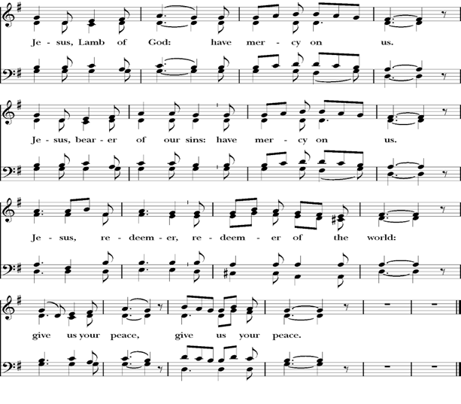
Agnus Dei

Behold the Lamb of God, behold him who takes away the sins of the world. Blessed are those who are invited to the marriage supper of the Lamb.
John 1:29; Revelation 19:9

Communion Hymn: Amazing Grace
(My Chains Are Gone)
CCLI Song # 47681515 CCLI License # 20413513

Verse 1
Amazing grace how sweet the sound
That saved a wretch like me
I once was lost but now I’m found
Was blind but now I see

Verse 2
‘Twas grace that taught my heart to fear
And grace my fears relieved
How precious did that grace appear
The hour I first believed

Chorus
My chains are gone, I’ve been set free
My God, my Savior has ransomed me
And like a flood His mercy reigns
Unending love
Amazing grace

Verse 3
The Lord has promised good to me
His word my hope secures
He will my shield and portion be
As long as life endures

Chorus

Verse 4
The earth shall soon dissolve like snow
The sun forbear to shine
But God, who called me here below
Will be forever mine, will be forever mine
You are forever mine

The Post Communion Prayer

Let us pray.

Almighty and everliving God,
we thank you for feeding us, in these holy mysteries,
with the spiritual food of the most precious Body and Blood
of your Son our Savior Jesus Christ;
and for assuring us, through this Sacrament, of your favor and
goodness towards us:
that we are true members of the mystical body of your Son,
the blessed company of all faithful people;
and are also heirs, through hope,
of your everlasting kingdom.
And we humbly ask you, heavenly Father,
to assist us with your grace,
that we may continue in that holy fellowship,
and do all the good works that you have prepared for us to
walk in;
through Jesus Christ our Lord,
to whom, with you and the Holy Spirit,
be all honor and glory, now and for ever. Amen.

The Blessing

The peace of God, which passes all understanding, keep your hearts
and minds in the knowledge and love of God, and of his Son Jesus
Christ our Lord; and the blessing of God Almighty, the Father, the
Son, and the Holy Spirit, be among you, and remain with you always.
Amen.

Closing Hymn: Crown Him with Many Crowns
(All Verses)
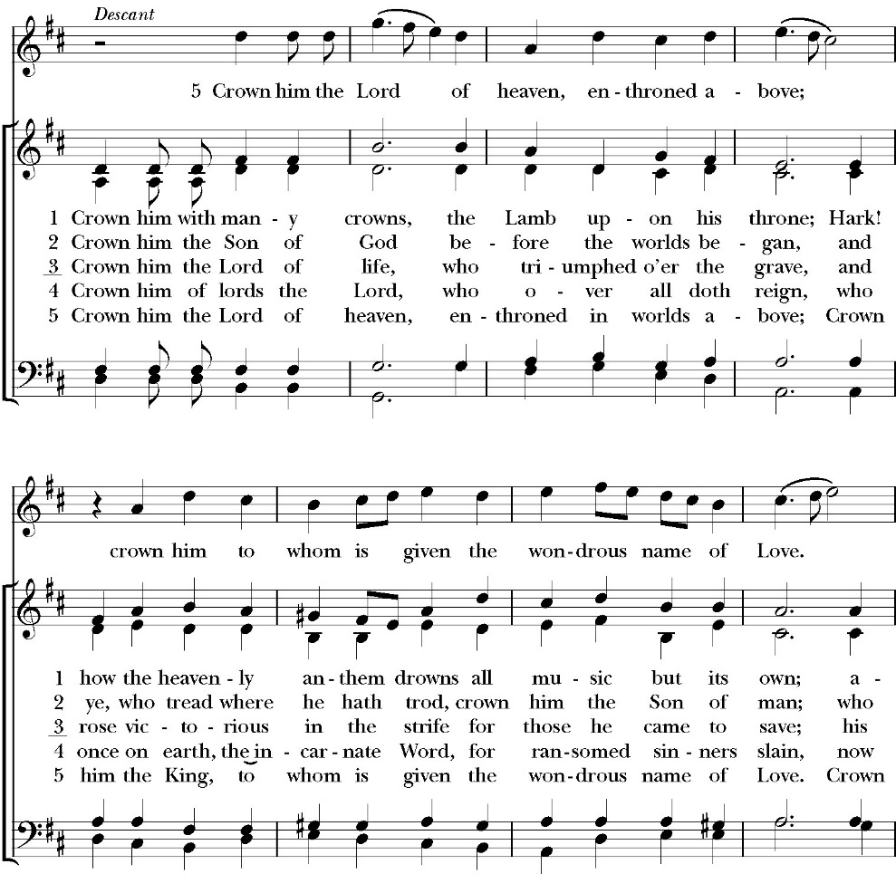

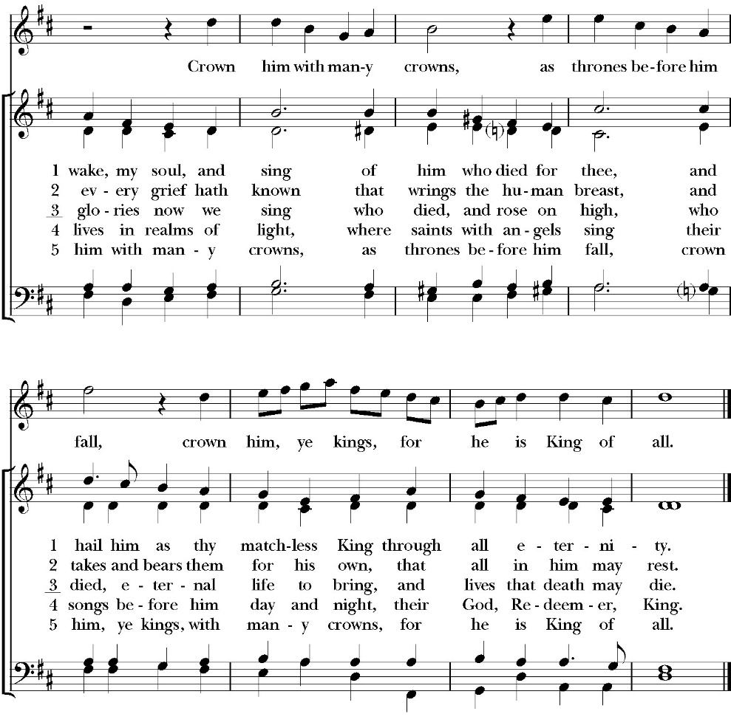

Celebrant Go in peace to love and serve the Lord.
People Thanks be to God.
St. Paul’s Parish Calendar
Sunday March 22 – Sunday March 29

SUNDAY, March 22 – Fifth Sunday in Lent
9:15 AM Sunday Funday, Youth Room
9:15 AM Gospel of John Bible study, Conference Room
9:30 AM Vocal Choir rehearsal, Chapel
10:30 AM Children’s Sunday School, Chapel
Pre-K –2nd Grade, Sunday School Room.
3rd -5th Grade, Youth Room
10:30 AM Holy Eucharist, Church

MONDAY, March 23

TUESDAY, March 24
6:00 PM No Bell Choir Practice, Music Room

WEDNESDAY, March 25
9:30 AM Holy Eucharist with healing prayer, Chapel
10:15 AM Bible Study, Conference Room
6:00 PM Soup Supper, James Hall
7:00 PM Night of Worship and Prayer
7:00 PM Vocal Choir Rehearsal, Church

THURSDAY, March 26

FRIDAY, March 27
6:30 AM Men’s Bible Study, Valhalla Restaurant
6:00 PM Stations of the Cross, Church

SATURDAY, March 28
9:00 AM Palm Crosses Making, Conference Room

SUNDAY, March 29 – Palm Sunday
9:15 AM Sunday Funday Banner Making, Youth Room
9:15 AM Gospel of John Bible study, Conference Room
10:30 AM Children’s Sunday School, Chapel
Pre-K –2nd Grade, Sunday School Room
3rd -5th Grade, Youth Room
10:30 AM Holy Eucharist with Palm Sunday procession from James Hall and dramatic reading of the Passion

Church Office Hours
Monday-Thursday 8:00 AM-4:00 PM

Announcements

Stations of the Cross Using Liturgy for Children
This Friday, March 27 at 6:00PM
This Friday we will be using the children’s liturgy for Stations of the Cross and invite our families to join us to learn more about the Stations of the Cross and their meaning. All members of the church are welcome to join us as we share in helping our children learn more about Jesus’ walk to the cross.

Sunday Morning Bible Study: The Gospel of John
St. Paul’s is embarking on a study of the Gospel of John that will span the next year. These classes will be on Sunday mornings from 9:15-10:00AM. We will take the better part of the next year to move slowly through John and savor the profound spiritual truths that it offers. We will be using a book called Be Alive by Warren Wiersbe as our guide. This book is essentially a study guide to the Gospel of John and will provide us with structure and insight as we move our way through the Gospel. Books will be available beginning the day of the first class.
Projected Class Timeline

Lent Chapters 1-3
Easter Chapters 4-8
June Chapter 9
August Chapter 10
Fall Chapters 11-14
Advent Chapters 15 & 15
Epiphany Chapters 16-17
Lent 2027 Chapters 18 & 19
Easter season Chapters 20 & 21

The class will progress based on how quickly or slowly is needed and our projected timelines may change as we move forward.

Ushers and Greeters Training Meeting Today After Church, Sunday, March 22
After church today on Sunday, March 22, there will be a training and refresher meeting for all ushers. This will be a time for new ushers to learn more about usher duties on Sunday morning and will be a refresher for the rest of the ushers. This meeting will be facilitated by Fr. Rob and our head ushers Joey Haas and Glen Catalina. Anyone interested in becoming an usher is welcome to join us as well.

Lenten Wednesday Evening Schedule
5:00 PM Prayer small group led by Father Rob

6:00 PM Soup Suppers

7:00 PM Prayer and praise night

7:00 PM Vocal Choir Rehearsal, Chapel

Night of Worship and Prayer, Wednesday, March 25, 7PM
The Wednesday night class for Lent has explored the practice of prayer as a spiritual discipline. On the last Wednesday night program of Lent on March 25, everyone is invited to the soup supper and to then join us for an hour of prayer and worship. Our time of prayer and worship will bring together a variety of prayer practices that will help form us more closely to be with Jesus, become like him and do as he did. Our evening will also include an opportunity to receive healing prayer from our clergy regarding any need that may be present in your life or the lives of those you love.

The Altar Guild Making of Palm Crosses
Saturday March 28, at 9:00 AM in the Conference Room. All are welcome.

NEED A BOOST IN YOUR SPIRITUAL LIFE?
Come to coffee hour on April 12, 2026, to learn more about Anglican 4th day. People who have taken advantage of this opportunity will be circulating around coffee hour to answer your questions.

Holy Week Worship and Prayer Schedule

Palm Sunday Holy Eucharist March 29, 10:30AM
Palm Sunday worship will begin at our usual time but will begin with a blessing of the palms in James Hall and then a procession to the church. This is the Sunday we have a dramatic reading of the Passion.

Holy Wednesday Eucharist, Chapel 9:30AM
St. Paul’s has a Wednesday morning Eucharist every week. This will not change during Holy Week. We will be using the readings for Holy Wednesday for the service.

Maundy Thursday Holy Eucharist, Church, April 2, 7:00PM
The word Maundy comes from the Latin word “Mandate” which means commandment. At this service, we remember Jesus’ last supper with his disciples in which he instituted the Eucharist, gave his new commandment to love one another and washed the feet of his disciples. This service will have the choir singing.

The Watch, Chapel, Thursday April 2, 9:00PM through Friday April 3, 7:00AM
The watch is a traditional time of prayer kept after the events of the Lord’s Supper and before Jesus’ arrest when Jesus invited his disciples to come “Keep Watch” with him as he prepared spiritually for the crucifixion. The watch will take place in the chapel where the blessed sacraments will be placed on the altar. This time of prayer will begin immediately following the Maundy Thursday service and conclude at 7AM on Good Friday morning with the service of Morning Prayer.

Good Friday, April 3
Morning Prayer, Chapel, 7:00AM
On Good Friday morning, we will conclude “The Watch” and begin the day in prayer. This service will include consuming the reserve blessed sacrament and will take place in the chapel

Stations of the Cross, Church, 12PM
Jesus’ trial occurred on the morning of Good Friday. He was sentenced to death and immediately walked, carrying his cross, from the place of his trial to the place of his crucifixion outside the walls of Jerusalem. Jesus was hung on the cross at 12 Noon.
Having the Stations of the Cross at noon on Good Friday remembers Jesus’s Way of the Cross.

Good Friday Service, Church, 7:00PM
The Good Friday Service occurs the evening of Good Friday after Jesus’ body was laid in the tomb. It is not a service of Holy Eucharist, but prayers and music which invite us into the meaning and goodness of the cross. At this service, we will have the veneration of the cross in which all will be invited to kneel at the foot of the cross and pray. This service will have both traditional and contemporary music along with our choir.

Easter Worship, Sunday, April 5

8:00AM Sunrise Service of Scripture and the Great Litany
No Holy Eucharist
This sunrise service will welcome us into the Easter celebration of the resurrection of Jesus Christ. At this service, we will begin outside with the sunrise and then enter the church to light the first fire of Easter on the Paschal Candle. We will read through God’s saving plan throughout scripture and pray the Great Litany. This service is not intended to be our Holy Eucharist, but to lead us into the Holy Eucharist that will take place at 10:30AM.

10:30AM Festival Easter Holy Eucharist with Baptism
Our Church community will gather together as one for a celebration of the Resurrection of Jesus on Easter Morning. Our service will include a baptism, festive music, and Holy Eucharist. After the service, we will have an Easter Egg hunt for kids and fellowship for all celebrating Easter.

The church office will be closed on Monday, April 6

St. Paul’s Anglican Church
Parish Office
6436 W. Hurley Ave
Visalia, California 93291
559-732-4821
Office Hours: 8:00 – 4:00
Monday – Thursday

Worship: Sundays at 10:30AM
Livestream: Link at spvisalia.com
and on our Facebook page
Please be advised that this service is being recorded for broadcast
and/or archival purposes. By attending, you consent
to the inclusion of your likeness in these recordings.

St. Paul’s Clergy and Staff
The Rev. Robert Longbottom, Rector
rector@spvisalia.com
(559)802-2928
The Rev. John Iseman, Pastoral Associate for Family Ministries
family@spvisalia.com
The Rev. Kashy Rowland-Smith, Deacon
kashyrs@aol.com
Antoinette Horsting, Parish Administrator
bookkeeper@spvisalia.com
Marguerite Crownover, Organist and Accompanist
Cynthia Culp, Choral Director
Jackie Iseman, Nursery Coordinator
Shane Motl, Sexton

St. Paul’s is a member church of the
Anglican Diocese of San Joaquin
The Rt. Rev. Eric V. Menees, Bishop

Palm Sunday’s Lessons
Isaiah 52:13-53:12
Psalm 22:1-21
Philippians 2:5-11
Passion According to Matthew

