ST. PAUL’S
ANGLICAN CHURCH
VISALIA, CALIFORNIA

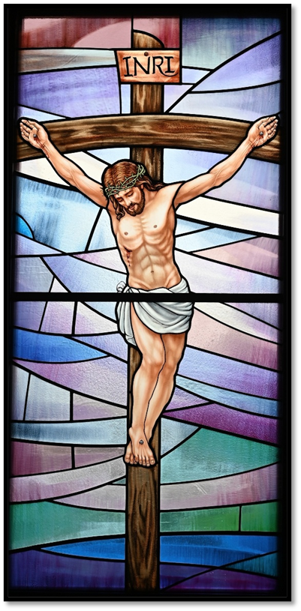

PALM SUNDAY SERVICE
March 29, 2026
10:30 A.M

Welcome!

St. Paul’s Anglican Church extends a warm welcome to all visitors and newcomers, whether worshiping in person or at home via livestream.

Visitors’ Guide

St. Paul’s Church is a parish in the Diocese of San Joaquin of the Anglican Church in North America, which includes both Catholic and Protestant traditions. We accept Jesus Christ as Savior, and we promise to follow him as Lord. We believe in One God,

- the Father who created us and all things,
- the Son who redeems us from sin and death,
- the Holy Spirit who renews and sanctifies us.

We believe the Holy Scriptures to be the Word of God and to contain all things necessary for salvation, and we accept the Apostles’ and Nicene Creeds as essential beliefs of the Christian faith.

Holy Communion is open to all baptized Christians who have examined their lives, repented of their sins, and desire to live
in love and charity with all people.

Those not desiring to receive Holy Communion, and those who have not been baptized into the Christian faith, are invited to cross their arms across their chest, and a blessing will be given instead.

Visitors are invited to sign the guest book at the entrance table and introduce themselves to the clergy following the service.
The Liturgy of the Palms
Opening Acclamation and Collect p. 4
The Procession p. 6

The Word of God

Prelude: “Hosanna, Loud Hosanna!” Martin
Opening Hymn: #154 - “All Glory, Laud, and Honor” p. 7
The Acclamation p. 7
Collect for Purity p. 7
Summary of the Law p. 8
Trisagion p. 8
Confession and Absolution p. 8
Comfortable Words p. 9
Collect of the Day p. 9
Lesson: Isaiah 52:13-53:12 p. 10
Gradual: Psalm 22:1-21 p. 11
Epistle: Philippians 2:5-11 p. 12
Sequence Hymn: #435 - “At the Name of Jesus” p. 13
The Passion According to St. Matthew p. 13
Sermon: Rev. Robert Longbottom
Nicene Creed p. 14
Prayers of the People p. 15
The Peace p. 17
Offertory Anthem: “Hosanna to the King” Choir with Children’s Choir
The Offertory p. 17
The Sursum Corda p. 17
The Sanctus p. 19
The Lord’s Prayer p. 22
The Fraction p. 22
Prayer for Humble Access p. 22
Agnus Dei p. 23
Communion Hymn: #168 - “O Sacred Head Sore Wounded” p. 24
Post Communion Prayer p. 25
The Blessing p. 25
Closing Hymn: #388 - “O Worship the King” p. 26
Dismissal p. 26
Postlude: “Ride On! Ride On in Majesty!” Martin

THE LITURGY OF THE PALMS

Celebrant Hosanna to the Son of David, the King of Israel.
People Blessed is he who comes in the Name of the Lord.
Hosanna in the highest.

Dear brothers and sisters, from the beginning of Lent until now we have been preparing our hearts by repentance and self-sacrifice. Today, with the whole Church, we herald the beginning of the celebration of the Paschal Mystery. On this day our Lord Jesus Christ entered Jerusalem and was welcomed as King with palms and shouts of praise. Today we greet him as our King, though we know his crown was a crown of thorns, and his throne a Cross.

Therefore, I invite you to follow our Lord this Holy Week, from his triumphal entry, through his suffering and death, to the glory of his resurrection.

Celebrant The Lord be with you.
People And with your spirit.
Celebrant Let us pray.

Assist us mercifully with your help, O Lord God of our salvation, that we may enter with joy upon the contemplation of those mighty acts, whereby you have given us life and immortality; through Jesus Christ our Lord, who lives and reigns with you and the Holy Spirit, one God, now and for ever. Amen.

Celebrant The Gospel of our Lord Jesus Christ according to Matthew
People Glory to you, Lord Christ.

Matthew 21:1-11
Now when they drew near to Jerusalem and came to Bethphage, to the Mount of Olives, then Jesus sent two disciples, ² saying to them, “Go into the village in front of you, and immediately you will find a donkey tied, and a colt with her. Untie them and bring them to me. ³ If anyone says anything to you, you shall say, ‘The Lord needs them,’ and he will send them at once.” ⁴ This took place to fulfill what was spoken by the prophet, saying,

⁵ “Say to the daughter of Zion,
‘Behold, your king is coming to you,
humble, and mounted on a donkey,
on a colt, the foal of a beast of burden.’”

⁶ The disciples went and did as Jesus had directed them. ⁷ They brought the donkey and the colt and put on them their cloaks, and he sat on them. ⁸ Most of the crowd spread their cloaks on the road, and others cut branches from the trees and spread them on the road. ⁹ And the crowds that went before him and that followed him were shouting, “Hosanna to the Son of David! Blessed is he who comes in the name of the Lord! Hosanna in the highest!” ¹⁰ And when he entered Jerusalem, the whole city was stirred up, saying, “Who is this?” ¹¹ And the crowds said, “This is the prophet Jesus, from Nazareth of Galilee.”

Celebrant The Gospel of the Lord.
People Praise to you, Lord Christ.

Let us pray.

We praise you, Almighty God, for the acts of love by which you have redeemed us through your Son Jesus Christ our Lord. On this day he entered the holy city of Jerusalem in triumph, and was hailed as King by those who spread their garments and branches of palm along his way. Sanctify these branches with your blessing, we humbly pray, that they may be for us signs of his victory. Grant that we who bear them in his Name may ever hail him as our King, and follow him in the way that leads to eternal life; who lives and reigns with you, in the unity of the Holy Spirit, one God, now and for ever. Amen.

Celebrant: Hosanna to the Son of David, the King of Israel.
People: Blessed is he who comes in the Name of the Lord.
Hosanna in the highest.

THE PROCESSION

Deacon: Let us go forth in peace.
People: In the Name of Christ. Amen.

Periodically in the procession the celebrant will say

Celebrant: Hosanna to the Son of David, the King of Israel.
People: Blessed is he who comes in the Name of the Lord.
Hosanna in the highest.

At a suitable place, the procession may halt while the following, or some other appropriate Collect, is said.

Almighty God, whose most dear Son went not up to joy but first he suffered pain, and entered not into glory before he was crucified: Mercifully grant that we, walking in the way of the Cross, may find it none other than the way of life and peace; through Jesus Christ our Lord. Amen

Opening Hymn: All Glory, Laud, and Honor

The Acclamation

Celebrant Blessed be our God.
People Now and forever. Amen.

The Collect for Purity

Almighty God, to you all hearts are open, all desires known, and from you no secrets are hid: Cleanse the thoughts of our hearts by the inspiration of your Holy Spirit, that we may perfectly love you, and worthily magnify your holy Name; through Christ our Lord. Amen.

The Summary of The Law

Hear what our Lord Jesus Christ says: You shall love the Lord your God with all your heart and with all your soul and with all your mind. This is the first and great commandment. And the second is like it: You shall love your neighbor as yourself. On these two commandments depend all the Law and the Prophets.

The Trisagion
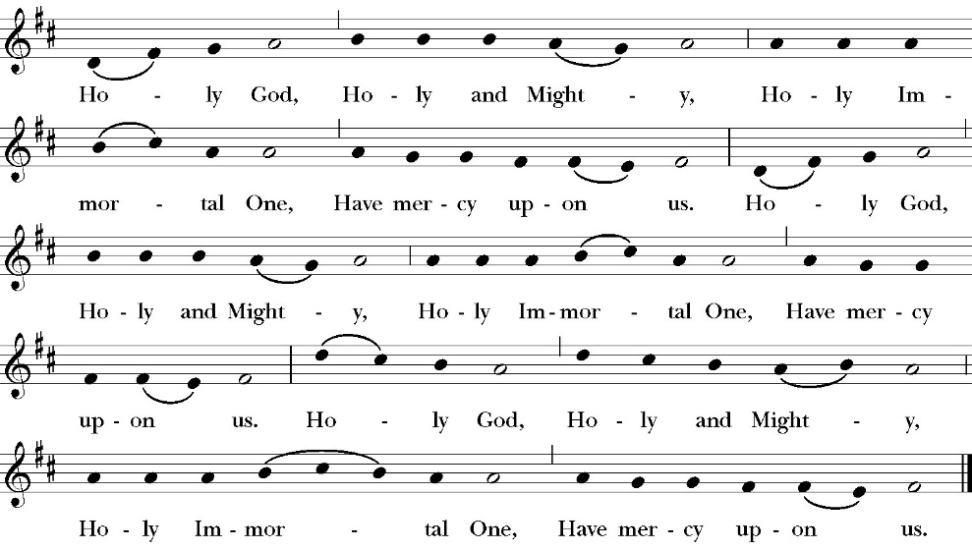

Confession and Absolution

Leader Let us humbly confess our sins to Almighty God.

All:
Almighty God, Father of our Lord Jesus Christ,
maker and judge of us all:
We acknowledge and lament our many sins and offenses,
which we have committed by thought, word, and deed
against your divine majesty,
provoking most justly your righteous anger against us. We are deeply sorry for these our transgressions;
the burden of them is more than we can bear.
Have mercy upon us,
Have mercy upon us, most merciful Father;
for your Son our Lord Jesus Christ’s sake,
forgive us all that is past;
and grant that we may evermore serve and please you in
newness of life,
to the honor and glory of your Name;
through Jesus Christ our Lord. Amen.

Celebrant Almighty God, our heavenly Father, who in his great
mercy has promised forgiveness of sins to all those who sincerely
repent and with true faith turn to him, have mercy upon you, pardon
and deliver you from all your sins, confirm and strengthen you in all
goodness, and bring you to everlasting life; through Jesus Christ our
Lord. Amen.

The Comfortable Words

Hear the Word of God to all who truly turn to him,

If anyone sins, we have an advocate with the Father, Jesus Christ the righteous. He is the propitiation for our sins, and not for ours only, but also for the sins of the whole world.
1 John 2:1-2t

The Collect of the Day

Celebrant The Lord be with you.
People And with your spirit.
Celebrant Let us pray.
Almighty and everlasting God, in your tender love for us you sent your Son our Savior Jesus Christ to take upon himself our nature, and to suffer death upon the cross, giving us the example of his great humility. Mercifully grant that we may walk in the way of his suffering, and come to share in his resurrection; through Jesus Christ our Lord, who lives and reigns with you and the Holy Spirit, one God, for ever and ever. Amen.
Lesson: Isaiah 52:13-53:12

Behold, my servant shall act wisely; he shall be high and lifted up, and shall be exalted. 14 As many were astonished at you—his appearance was so marred, beyond human semblance, and his form beyond that of the children of mankind—15 so shall he sprinkle many nations. Kings shall shut their mouths because of him, for that which has not been told them they see, and that which they have not heard they understand.

53:1 Who has believed what he has heard from us? And to whom has the arm of the LORD been revealed? 2 For he grew up before him like a young plant, and like a root out of dry ground; he had no form or majesty that we should look at him, and no beauty that we should desire him. 3 He was despised and rejected by men, a man of sorrows and acquainted with grief; and as one from whom men hide their faces he was despised, and we esteemed him not.

4 Surely he has borne our griefs and carried our sorrows; yet we esteemed him stricken, smitten by God, and afflicted. 5 But he was pierced for our transgressions; he was crushed for our iniquities; upon him was the chastisement that brought us peace, and with his wounds we are healed. 6 All we like sheep have gone astray; we have turned—every one—to his own way; and the LORD has laid on him the iniquity of us all.

7 He was oppressed, and he was afflicted, yet he opened not his mouth; like a lamb that is led to the slaughter, and like a sheep that before its shearers is silent, so he opened not his mouth 8 By oppression and judgment he was taken away; and as for his generation, who considered that he was cut off out of the land of the living, stricken for the transgression of my people? 9 And they made his grave with the wicked and with a rich man in his death, although he had done no violence, and there was no deceit in his mouth.

10 Yet it was the will of the LORD to crush him; he has put him to grief; when his soul makes an offering for guilt, he shall see his offspring; he shall prolong his days; the will of the LORD shall prosper in his hand. 11 Out of the anguish of his soul he shall see and be satisfied; by his knowledge shall the righteous one, my servant, make many to be accounted righteous, and he shall bear their iniquities. 12 Therefore I will divide him a portion with the many, and he shall divide the spoil with the strong, because he poured out his soul to death and was numbered with the transgressors; yet he bore the sin of many, and makes intercession for the transgressors.
Reader: The Word of the Lord
People: Thanks be to God

Gradual: Psalm 22:1-11
1 My God, my God, why have you forsaken me, *
and are so far from my cry, and from the words of my
complaint?
2 O my God, I cry in the daytime, but you do not hear; *
in the night season also, but I find no rest.
3 But you remain holy, *
enthroned upon the praises of Israel.
4 Our fathers hoped in you; *
they trusted in you, and you delivered them.
5 They called upon you, and were delivered; *
they put their trust in you, and were not confounded.
6 But as for me, I am a worm, and no man, *
scorned by all, and the outcast of the people.
7 All those who see me laugh me to scorn; *
they curl their lips, and shake their heads, saying,
8 “He trusted in God, that he would deliver him; *
let him deliver him, if he will have him.”
9 But you are he that took me out of my mother’s womb; *
you were my hope, when I was yet upon my mother’s breasts.
10 I have been cast upon you ever since I was born; *
you are my God, even from my mother’s womb.
11 O go not far from me, for trouble is near at hand, *
and there is none to help me.

Glory be to the Father, and to the Son, and to the Holy Spirit;
as it was in the beginning, is now, and ever shall be, world without end. Amen

Epistle: Philippians 2:5-11
⁵ Let the same mind be in you that was in Christ Jesus, ⁶ who, though he was in the form of God, did not regard equality with God as something to be exploited,⁷ but emptied himself, taking the form of a slave, being born in human likeness. And being found in human form,⁸ he humbled himself and became obedient to the point of death— even death on a cross.
⁹Therefore God also highly exalted him and gave him the name that is above every name,¹⁰ so that at the name of Jesus every knee should bend, in heaven and on earth and under the earth, ¹¹ and every tongue should confess that Jesus Christ is Lord, to the glory of God the Father.

Reader: The Word of the Lord
People: Thanks be to God

Sequence Hymn: At the Name of Jesus
(Verses 1-3 before Gospel, Verse 4 after)

The Passion of our Lord Jesus Christ
according to Saint Matthew
See booklet.

Sermon
Rev. Robert Longbottom

The Nicene Creed

We believe in one God,
the Father, the Almighty,
maker of heaven and earth,
of all that is, visible and invisible.
We believe in one Lord, Jesus Christ,
the only-begotten Son of God,
eternally begotten of the Father,
God from God, Light from Light,
true God from true God,
begotten, not made,
of one Being with the Father;
through him all things were made.
For us and for our salvation he came down from heaven,
was incarnate from the Holy Spirit and the Virgin Mary,
and was made man.
For our sake he was crucified under Pontius Pilate;
he suffered death and was buried.
On the third day he rose again in accordance with the
Scriptures;
he ascended into heaven
and is seated at the right hand of the Father.
He will come again in glory to judge the living and the dead,
and his kingdom will have no end.
We believe in the Holy Spirit, the Lord, the giver of life,
who proceeds from the Father and the Son,
who with the Father and the Son is worshiped and glorified,
who has spoken through the prophets.
We believe in one holy catholic and apostolic Church.
We acknowledge one Baptism for the forgiveness of sins.
We look for the resurrection of the dead,
and the life of the world to come. Amen.

The Prayers of the People

The Deacon or other person appointed says these prayers,

Let us pray for the Church and for the world.

Almighty and everliving God, we are taught by your holy Word to offer prayers and supplications and to give thanks for all people. We humbly ask you mercifully to receive our prayers. Inspire continually the universal Church with the spirit of truth, unity, and concord; and grant that all who confess your holy Name may agree in the truth of your holy Word, and live in unity and godly love.

Silence

Reader Lord, in your mercy:
People Hear our prayer.

We pray that you will lead the nations of the world in the way of righteousness; and so guide and direct their leaders, especially Donald our President and Gavin our Governor, that your people may enjoy the blessings of freedom and peace. Grant that our leaders may impartially administer justice, uphold integrity and truth, restrain wickedness and vice, and protect true religion and virtue.

Silence

Reader Lord, in your mercy:
People Hear our prayer.

Give grace, heavenly Father, to all Bishops, Priests, and Deacons, and especially to your servant(s), Archbishop Stephen, our Bishop Eric, our priests Fr. Rob, Pastor John and Pastor Kashy that by their life and teaching, they may proclaim your true and life-giving Word, and rightly and duly administer your holy Sacraments. And to all your people give your heavenly grace, especially to this Congregation, that with reverent and obedient hearts we may hear and receive your holy Word, and serve you in holiness and righteousness all the days of our lives.
Silence

Reader Lord, in your mercy:
People Hear our prayer.

Prosper, we pray, all those who proclaim the Gospel of your kingdom throughout the world, and strengthen us to fulfill your great commission, making disciples of all nations, baptizing them and teaching them to obey all that you have commanded.

Silence

Reader Lord, in your mercy:
People Hear our prayer.
In the St. Paul’s cycle of prayer, we lift up the ministries of pastoral care, all of our members who are in the hospital, care facilities or who are shut into their own homes. We pray for those who are recovering from recent surgeries and for those who are in crisis.
Silence

Reader Lord, in your mercy:
People Hear our prayer.

In the ACNA Cycle of Prayer, today we pray for the Anglican Province of Tanzania and The Most Rev. Dr. Maimbo Mndolwa, Archbishop, and his wife, Frida.

Silence

Reader Lord, in your mercy:
People Hear our prayer.

We ask you in your goodness, O Lord, to comfort and sustain all who in this transitory life are in trouble, sorrow, need, sickness, or any other adversity [especially _____________].

Silence

Reader Lord, in your mercy:
People Hear our prayer.

We remember before you all your servants who have departed this life in your faith and fear, [especially _____________,] that your will for them may be fulfilled; and we ask you to give us grace to follow the good examples of St. Paul and all your saints, that we may share with them in your heavenly kingdom.

Silence

Reader Lord, in your mercy:
People Hear our prayer.

Celebrant: Almighty God, by your gift alone we come to wisdom and true understanding: Look with favor, we pray, on all schools and protect them from violence and evil. We especially pray for St. Paul’s School and all schools in our community, that knowledge may be increased among us, and wholesome learning flourish and abound. Bless those who teach and those who learn; and grant that in humility of heart they may ever look to you, the fountain of all wisdom; through Jesus Christ our Lord. Amen.

The Peace

Celebrant The Peace of the Lord be always with you.
People And with your spirit.

Offertory Anthem

Choir with Children’s Choir: “Hosanna to the King”

The Doxology
(Verse 3 only)

The Offertory

Celebrant All things come from you, O Lord
People And of your own have we given you.

The Eucharistic Liturgy

Celebrant The Lord be with you.
People And with your spirit.
Celebrant Lift up your hearts.
People We lift them up to the Lord.
Celebrant Let us give thanks to the Lord our God.
People It is right to give him thanks and praise.

It is right, our duty and our joy, always and everywhere to give thanks to you, Father Almighty, Creator of heaven and earth. You bid your faithful people cleanse their hearts, and prepare with joy for the Paschal feast; that, fervent in prayer and in works of mercy, and renewed by your Word and Sacraments, they may come to the fullness of grace which you have prepared for those who love you.

Therefore we praise you, joining our voices with angels and archangels and with all the company of heaven, who forever sing this hymn to proclaim the glory of your Name:

The Sanctus

All praise and glory is yours, O God our heavenly Father, for in your tender mercy, you gave your only Son Jesus Christ to suffer death upon the Cross for our redemption. He made there, by his one oblation of himself once offered, a full, perfect, and sufficient sacrifice, oblation, and satisfaction, for the sins of the whole world; and he instituted, and in his Holy Gospel commanded us to continue, a perpetual memory of his precious death and sacrifice, until his coming again.

So now, O merciful Father, in your great goodness, we ask you to bless and sanctify, with your Word and Holy Spirit, these gifts of bread and wine, that we, receiving them according to your Son our Savior Jesus Christ’s holy institution, in remembrance of his death and passion, may be partakers of his most blessed Body and Blood.
For on the night that he was betrayed, our Lord Jesus Christ took bread; and when he had given thanks, he broke it,* and gave it to his disciples, saying, “Take, eat; this is my Body, which is given for you: Do this in remembrance of me.”

Likewise, after supper, Jesus took the cup, and when he had given thanks, he gave it to them, saying, “Drink this, all of you; for this is my Blood of the New Covenant, which is shed for you, and for many, for the forgiveness of sins: Whenever you drink it, do this in remembrance of me.”

Therefore, O Lord and heavenly Father, according to the institution of your dearly beloved Son our Savior Jesus Christ, we your humble servants celebrate and make here before your divine Majesty, with these holy gifts, the memorial your Son commanded us to make; remembering his blessed passion and precious death, his mighty resurrection and glorious ascension, and his promise to come again.

And we earnestly desire your fatherly goodness mercifully to accept this, our sacrifice of praise and thanksgiving; asking you to grant that, by the merits and death of your Son Jesus Christ, and through faith in his Blood, we and your whole Church may obtain forgiveness of our sins, and all other benefits of his passion.

And here we offer and present to you, O Lord, ourselves, our souls and bodies, to be a reasonable, holy, and living sacrifice. We humbly pray that all who partake of this Holy Communion may worthily receive the most precious Body and Blood of your Son Jesus Christ, be filled with your grace and heavenly benediction, and be made one body with him, that he may dwell in us, and we in him.

And although we are unworthy, because of our many sins, to offer you any sacrifice, yet we ask you to accept this duty and service we owe, not weighing our merits, but pardoning our offenses, through Jesus Christ our Lord.
By him, and with him, and in him, in the unity of the Holy Spirit, all honor and glory is yours, Almighty Father, now and for ever. Amen.

And now, as our Savior Christ has taught us, we are bold to pray,

Our Father, who art in heaven,
hallowed be thy Name,
thy kingdom come,
thy will be done,
on earth as it is in heaven.
Give us this day our daily bread.
And forgive us our trespasses,
as we forgive those
who trespass against us.
And lead us not into temptation,
but deliver us from evil.
For thine is the kingdom,
and the power, and the glory,
for ever and ever. Amen.

The Fraction

If the consecrated Bread was not broken earlier, the Celebrant breaks it now. A period of silence is kept.

Then may be sung or said

Celebrant Christ our Passover is sacrificed for us.
People Therefore let us keep the feast.

The Prayer For Humble Access

We do not presume to come to this your table, O merciful Lord,
trusting in our own righteousness,
but in your abundant and great mercies.
We are not worthy so much as to gather up
the crumbs under your table;
but you are the same Lord
whose character is always to have mercy.
Grant us, therefore, gracious Lord,
so to eat the flesh of your dear Son Jesus Christ,
and to drink his blood,
that our sinful bodies may be made clean by his body,
and our souls washed through his most precious blood,
and that we may evermore dwell in him, and he in us.
Amen.
Agnus Dei
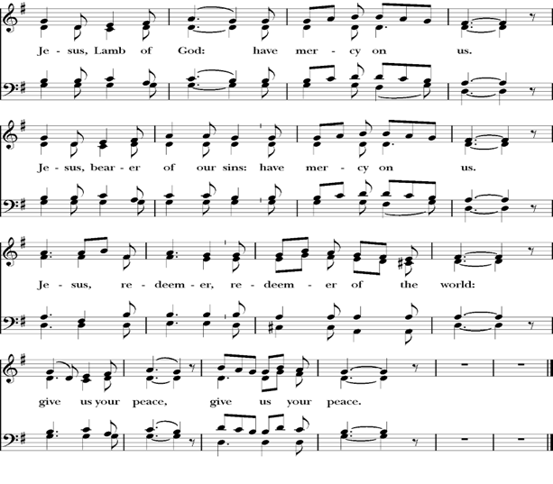

Behold the Lamb of God, behold him who takes away the sins of the world. Blessed are those who are invited to the marriage supper of the Lamb.
-John 1:29; Revelation 19:9

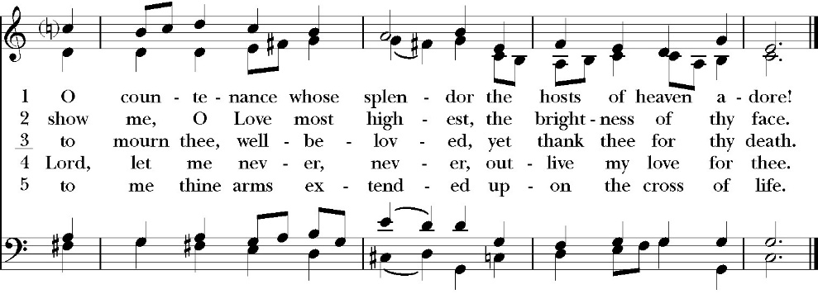
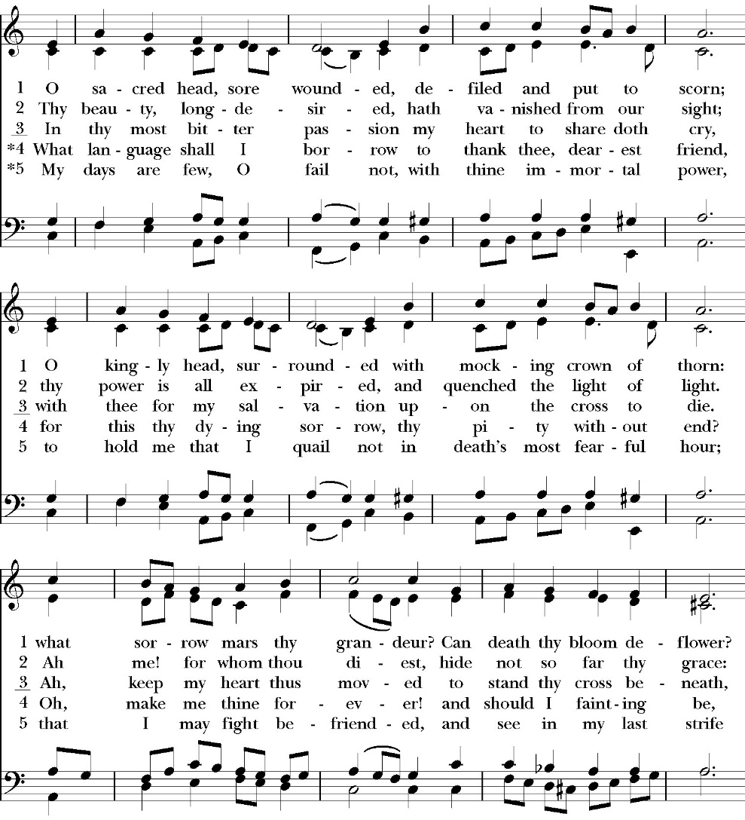
Communion Hymn: O Sacred Head, Sore Wounded

The Post Communion Prayer

Let us pray.

Almighty and everliving God,
we thank you for feeding us, in these holy mysteries,
with the spiritual food of the most precious Body and Blood
of your Son our Savior Jesus Christ;
and for assuring us, through this Sacrament, of your favor and
goodness towards us:
that we are true members of the mystical body of your Son,
the blessed company of all faithful people;
and are also heirs, through hope,
of your everlasting kingdom.
And we humbly ask you, heavenly Father,
to assist us with your grace,
that we may continue in that holy fellowship,
and do all the good works that you have prepared for us to
walk in;
through Jesus Christ our Lord,
to whom, with you and the Holy Spirit,
be all honor and glory, now and for ever. Amen.

The Blessing

The peace of God, which passes all understanding, keep your hearts
and minds in the knowledge and love of God, and of his Son Jesus
Christ our Lord; and the blessing of God Almighty, the Father, the
Son, and the Holy Spirit, be among you, and remain with you always.
Amen.

Closing Hymn: O Worship the King
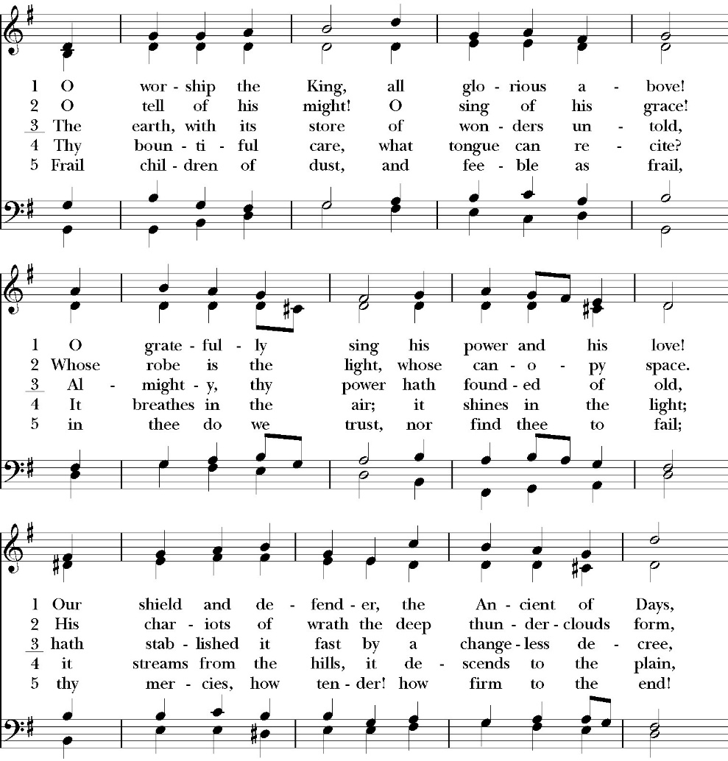
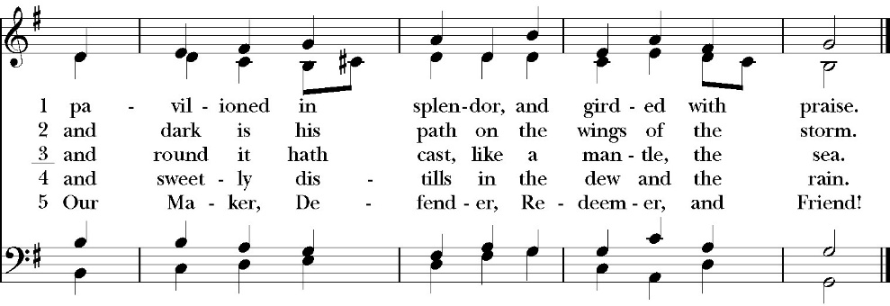

Celebrant Go in peace to love and serve the Lord.
People Thanks be to God.

St. Paul’s Parish Calendar
Sunday March 29 – Sunday April 5

SUNDAY, March 29 – Palm Sunday
9:15 AM Sunday Funday, Youth Room
9:15 AM Gospel of John Bible study, Conference Room
10:30 AM Children’s Sunday School, Chapel
Pre-K –2nd Grade, Sunday School Room.
3rd -5th Grade, Youth Room
10:30 AM Holy Eucharist with procession from James Hall to the church and the reading of the Passion of Jesus Christ
MONDAY, March 30
6:30 PM Women’s Bible Study, Conference Room

TUESDAY, March 31
6:00 PM Bell Choir Practice, Music Room

WEDNESDAY, April 1
9:30 AM Holy Eucharist with healing prayer, Chapel
10:15 AM Bible Study, Conference Room

THURSDAY, April 2 – Maundy Thursday
7:00 PM Holy Eucharist with Foot Washing, Church
9:00 PM The Watch Vigil, Chapel

FRIDAY, April 3 Good Friday
6:30 AM No Men’s Bible Study, Valhalla Restaurant
7:00 AM Morning Prayer, Chapel
12:00 PM Stations of the Cross, Church
7:00 PM Good Friday Liturgy and Veneration of the Cross,
Main Church

SATURDAY, April 4

SUNDAY, April 5 – Easter Sunday
8:00AM Sunrise Service of scripture and the Great Litany. No Holy Eucharist
10:30 AM Festival Easter Holy Eucharist with Baptisms
11:30 AM Easter Egg Hunt
Church Office Hours
Monday-Thursday 8:00 AM-4:00 PM

Sunday Morning Bible Study: The Gospel of John
St. Paul’s is embarking on a study of the Gospel of John that will span the next year. These classes will be on Sunday mornings from 9:15-10:00AM. We will take the better part of the next year to move slowly through John and savor the profound spiritual truths that it offers. We will be using a book called Be Alive by Warren Wiersbe as our guide. This book is essentially a study guide to the Gospel of John and will provide us with structure and insight as we move our way through the Gospel. Books will be available beginning the day of the first class.
Projected Class Timeline

Easter Chapters 4-8
June Chapter 9
August Chapter 10
Fall Chapters 11-14
Advent Chapters 15 & 15
Epiphany Chapters 16-17
Lent 2027 Chapters 18 & 19
Easter season Chapters 20 & 21

Holy Week Worship and Prayer Schedule

Palm Sunday Holy Eucharist March 29, 10:30AM
Palm Sunday worship will begin at our usual time but will begin with a blessing of the palms in James Hall and a procession to the church.

Holy Wednesday Eucharist, Chapel 9:30AM
St. Paul’s has a Wednesday morning Eucharist every week. This will not change during Holy Week. We will be using the readings for Holy Wednesday for this service.

Maundy Thursday Holy Eucharist, Church, April 2, 7:00PM
The word Maundy comes from the Latin word “Mandate” which means commandment. At this service, we remember Jesus’ last supper with his disciples in which he instituted the Eucharist, gave his new commandment to love one another and washed the feet of his disciples. This service will have the choir singing.

The Watch, Chapel, Thursday April 2, 9:00PM through Friday April 3, 7:00AM
The watch is a traditional time of prayer kept after the events of the Lord’s Supper and before Jesus’ arrest when Jesus invites his disciples to come “Keep Watch” with him as he prepares spiritually for the crucifixion. The watch will take place in the chapel where the blessed sacraments will be placed on the altar. This time of prayer will begin immediately following the Maundy Thursday service and conclude at 7AM on Good Friday morning with the service of Morning Prayer.

Good Friday, April 3
Morning prayer, Chapel, 7:00AM
On Good Friday morning, we will conclude The Watch and begin the day in prayer. This service will include consuming the reserve blessed sacrament and will take place in the chapel.

Stations of the Cross, Church, 12PM
Jesus’ trial occurred on the morning of Good Friday. He was sentenced to death and immediately walked, carrying his cross, from the place of his trial to the place of his crucifixion outside the walls of Jerusalem. Jesus was hung on the cross at 12PM on Good Friday. Having the Stations of the Cross at noon on Good Friday remembers Jesus’ way of the cross.

The Good Friday Service occurs the evening of Good Friday after Jesus’ body is laid in the tomb. It is not a service of Holy Eucharist, but prayers and music which invite us into the meaning and goodness of the cross. At this service we will have the veneration of the cross in which all will be invited to kneel at the foot of the cross and pray. This service will have both traditional and contemporary music along with our choir.

Easter Worship, Sunday, April 5
8:00AM Sunrise Service of Scripture and the Great Litany
No Holy Eucharist
This sunrise service will welcome us into the Easter celebration of the resurrection of Jesus Christ. At this service, we will begin outside with the sunrise and then enter into the church to light the first fire of Easter on the Paschal Candle. We will read through God’s saving plan throughout scripture and pray the Great Litany. This service is not intended to be our Holy Eucharist, but to lead us into the Holy Eucharist that will take place at 10:30AM.

10:30AM Festival Easter Holy Eucharist with Baptism
Our Church community will gather together as one for a celebration of the Resurrection of Jesus on Easter Morning. Our service will include a baptism, festive music, and Holy Eucharist. After the service, we will have an Easter Egg hunt for kids and fellowship celebrating Easter.

Coming Soon! An opportunity for you to investigate a new way to learn more about your own spirituality, the Anglican Church and connect with old friends and meet new friends. Go on a 4 day "vacation" leaving Visalia for this educational and spirit-filled adventure from July 9-12, 2026. During church service on Sunday April 12, 2026, our very own Joey Haas and Amy Gunn will speak very briefly to the congregation about this valuable opportunity to inspire and infuse your own spiritual life. After Sunday service please come to coffee hour to learn more about Anglican 4th day. Parishioners who have taken advantage of this opportunity will be circulating around coffee hour to answer your questions.

The church office will be closed on Monday, April 6

A Food Bank for Hurley Families

The next Neighborhood Market to benefit students at Hurley School will be Wednesday April 15, 2:30 PM to 3:30 PM at St Paul’s Church parking lot. If you are interested in helping that day, please contact Sue Nyberg. My home phone number is 559-733-8244.

Due to the heat, we are in need of more volunteers for
the months of May, June, August and September.
This will allow volunteers to work in shifts during these hot months.

PROVIDED BY VISALIA EMERGENCY AID
AND ST. PAUL’S CHURCH
Wednesday, April 15, 2026
From 2:30 PM to 3:30 PM
LOCATION:
ST. PAUL'S CHURCH PARKING LOT
ACROSS THE STREET FROM HURLEY





St. Paul’s Anglican Church
Parish Office
6436 W. Hurley Ave
Visalia, California 93291
559-732-4821
Office Hours: 8:00 – 4:00
Monday – Thursday

Worship: Sundays at 10:30AM
Livestream: Link at spvisalia.com
and on our Facebook page
Please be advised that this service is being recorded for broadcast
and/or archival purposes. By attending, you consent
to the inclusion of your likeness in these recordings.

St. Paul’s Clergy and Staff
The Rev. Robert Longbottom, Rector
rector@spvisalia.com
(559)802-2928
The Rev. John Iseman, Pastoral Associate for Family Ministries
family@spvisalia.com
The Rev. Kashy Rowland-Smith, Deacon
kashyrs@aol.com
Antoinette Horsting, Parish Administrator
bookkeeper@spvisalia.com
Marguerite Crownover, Organist and Accompanist
Cynthia Culp, Choral Director
Jackie Iseman, Nursery Coordinator
Shane Motl, Sexton

St. Paul’s is a member church of the
Anglican Diocese of San Joaquin
The Rt. Rev. Eric V. Menees, Bishop

Next Week’s Lessons
Acts 10:34-43
Psalm 118:14-17,22-24
Colossians 3:21-4
John 20:1-18

