St. Paul’s Anglican Church
Visalia, California
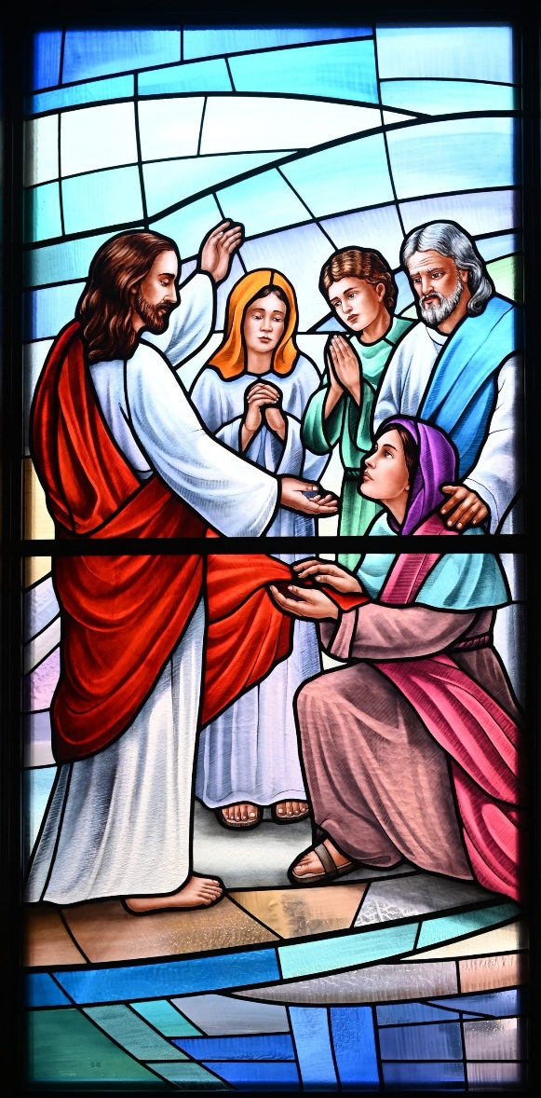

The Third Sunday in Lent
March 8, 2026
10:30 A.M

Welcome!

St. Paul’s Anglican Church extends a warm welcome to all visitors and newcomers, whether worshiping in person or at home via livestream.

Visitors’ Guide

St. Paul’s Church is a parish in the Diocese of San Joaquin of the Anglican Church in North America, which includes both Catholic and Protestant traditions. We accept Jesus Christ as Savior, and we promise to follow him as Lord. We believe in One God,

- the Father who created us and all things,
- the Son who redeems us from sin and death,
- the Holy Spirit who renews and sanctifies us.

We believe the Holy Scriptures to be the Word of God and to contain all things necessary for salvation, and we accept the Apostles’ and Nicene Creeds as essential beliefs of the Christian faith.

Holy Communion is open to all baptized Christians who have examined their lives, repented of their sins, and desire to live
in love and charity with all people.

Those not desiring to receive Holy Communion, and those who have not been baptized into the Christian faith, are invited to cross their arms across their chest, and a blessing will be given instead.

Visitors are invited to sign the guest book at the entrance table and introduce themselves to the clergy following the service.

The Holy Eucharist

Postlude: “I Know That My Redeemer Lives” by Haan
Opening Hymn: #691 – “My Faith Looks Up to Thee” p. 4
Acclamation p. 5
The Collect for Purity p. 5
Summary of the Law p. 5
Trisagion p. 5
Confession and Absolution p. 6
Collect of the Day p. 7
Lesson: Exodus 17:1-7 p. 7
Gradual: Psalm 95 p. 8
Epistle: Romans 1:16-32 p. 8
Sequence Hymn: #458 – “My Song Is Love Unknown” p. 10
Gospel: John 4:5-42 p. 11
Sermon: Rev. Robert Longbottom
Nicene Creed p. 13
Prayers of the People p. 14
The Peace p. 15
Offertory Anthem: Praise Song – “Goodness of God”
The Offertory p. 17
Sanctus p. 18
The Lord’s Prayer p. 20
Prayer for Humble Access p. 20
Agnus Dei p. 21
Communion Hymn: Celebration Hymn: “We Remember You” p. 22
Post Communion Prayer p. 23
Blessing p. 23
Closing Hymn: #423 – “Immortal, Invisible God Only Wise” p. 24
Dismissal p. 24
Prelude: “Postlude in D Minor” by Fey

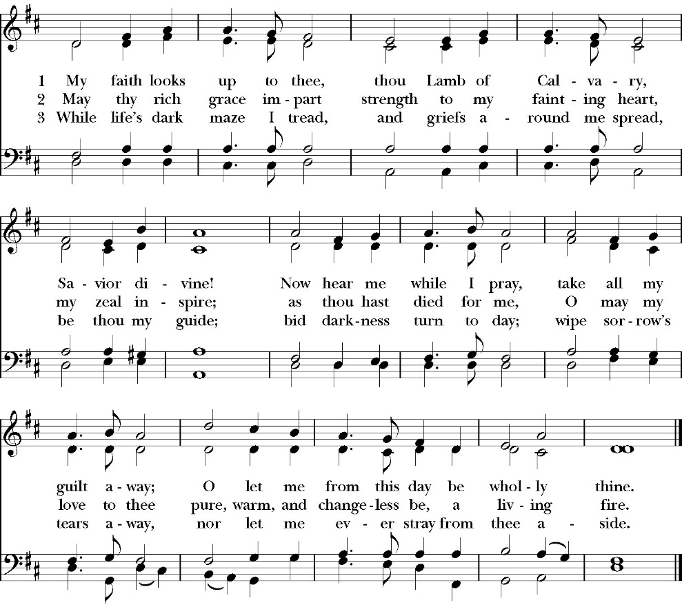
Opening Hymn: My Faith Looks Up to Thee

The Acclamation

Celebrant: Bless the Lord who forgives all our sins.
People: His mercy endures for ever.

The Collect for Purity

Almighty God, to you all hearts are open, all desires known, and from you no secrets are hid: Cleanse the thoughts of our hearts by the inspiration of your Holy Spirit, that we may perfectly love you, and worthily magnify your holy Name; through Christ our Lord. Amen.

The Summary of the Law

Hear what our Lord Jesus Christ says: You shall love the Lord your God with all your heart and with all your soul and with all your mind. This is the first and great commandment. And the second is like it: You shall love your neighbor as yourself. On these two commandments depend all the Law and the Prophets.
Matthew 22:37-40t

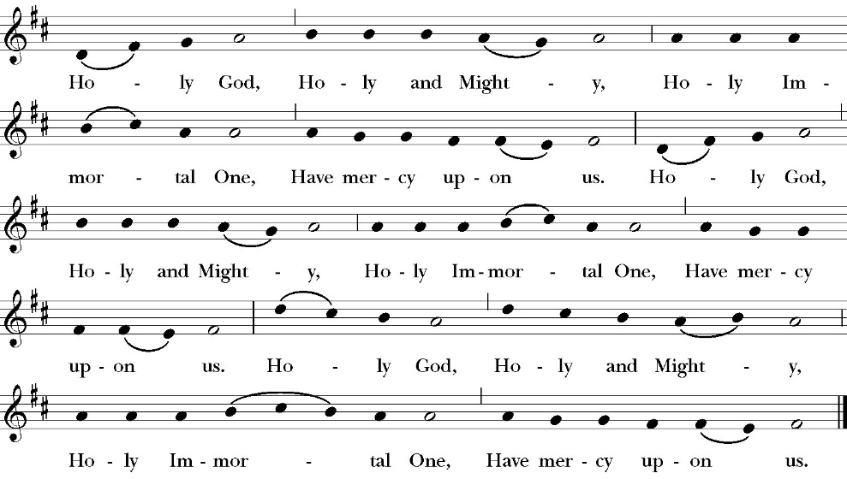
The Trisagion

Confession and Absolution

Leader Let us humbly confess our sins to Almighty God.

Almighty God, Father of our Lord Jesus Christ,
maker and judge of us all:
We acknowledge and lament our many sins and offenses,
which we have committed by thought, word, and deed
against your divine majesty,
provoking most justly your righteous anger against us. We are deeply sorry for these our transgressions;
the burden of them is more than we can bear.
Have mercy upon us,
Have mercy upon us, most merciful Father;
for your Son our Lord Jesus Christ’s sake,
forgive us all that is past;
and grant that we may evermore serve and please you in
newness of life,
to the honor and glory of your Name;
through Jesus Christ our Lord. Amen.

Celebrant Almighty God, our heavenly Father, who in his great
mercy has promised forgiveness of sins to all those who sincerely
repent and with true faith turn to him, have mercy upon you, pardon
and deliver you from all your sins, confirm and strengthen you in all
goodness, and bring you to everlasting life; through Jesus Christ our
Lord. Amen.

The Comfortable Words

Hear the Word of God to all who truly turn to him.

Come to me, all who labor and are heavy laden, and I will give you rest.
-Matthew 11:28

Officiant The Lord be with You.
People And with your spirit.
Officiant Let us pray:
The Collect of the Day

Heavenly Father, you have made us for yourself, and our hearts are restless until they rest in you: Look with compassion upon the heartfelt desires of your servants, and purify our disordered affections, that we may behold your eternal glory in the face of Christ Jesus; who lives and reigns with you and the Holy Spirit, one God, for ever and ever. Amen.

Lesson: Exodus 17:1-7
All the congregation of the people of Israel moved on from the wilderness of Sin by stages, according to the commandment of the LORD, and camped at Rephidim, but there was no water for the people to drink. 2 Therefore the people quarreled with Moses and said, “Give us water to drink.” And Moses said to them, “Why do you quarrel with me? Why do you test the LORD?” 3 But the people thirsted there for water, and the people grumbled against Moses and said, “Why did you bring us up out of Egypt, to kill us and our children and our livestock with thirst?” 4 So Moses cried to the LORD, “What shall I do with this people? They are almost ready to stone me.” 5 And the LORD said to Moses, “Pass on before the people, taking with you some of the elders of Israel, and take in your hand the staff with which you struck the Nile, and go. 6 Behold, I will stand before you there on the rock at Horeb, and you shall strike the rock, and water shall come out of it, and the people will drink.” And Moses did so, in the sight of the elders of Israel. 7 And he called the name of the place Massah and Meribah, because of the quarreling of the people of Israel, and because they tested the LORD by saying, “Is the LORD among us or not?”
Reader The Word of the Lord
People Thanks be to God

Gradual: Psalm 95
1 O come, let us sing unto the LORD; *
let us heartily rejoice in the strength of our salvation.
2 Let us come before his presence with thanksgiving *
and show ourselves glad in him with psalms.
3 For the LORD is a great God *
and a great King above all gods.
4 In his hand are all the depths of the earth, *
and the heights of the hills are his also.
5 The sea is his, for he made it, *
and his hands prepared the dry land.
6 O come, let us worship and fall down, *
and kneel before the LORD our Maker.
7 For he is our God, *
and we are the people of his pasture, and the sheep of his hand.
8 Today, if you will hear his voice, harden not your hearts *
as in the provocation, and as in the day of temptation in the
wilderness,
9 When your fathers tested me, *
and put me to the proof, though they had seen my works.
10 Forty years long was I grieved with this generation and said, *
“It is a people that err in their hearts, for they have not known
my ways,”
11 Of whom I swore in my wrath *
that they should not enter into my rest.
Glory be to the Father, and to the Son, and to the Holy Spirit;
as it was in the beginning, is now, and ever shall be, world
without end. Amen
Epistle: Romans 1:16-32
For I am not ashamed of the gospel, for it is the power of God for salvation to everyone who believes, to the Jew first and also to the Greek. 17 For in it the righteousness of God is revealed from faith for faith, as it is written, “The righteous shall live by faith.”

18 For the wrath of God is revealed from heaven against all ungodliness and unrighteousness of men, who by their unrighteousness suppress the truth. 19 For what can be known about God is plain to them, because God has shown it to them. 20 For his invisible attributes, namely, his eternal power and divine nature, have been clearly perceived, ever since the creation of the world, in the things that have been made. So they are without excuse. 21 For although they knew God, they did not honor him as God or give thanks to him, but they became futile in their thinking, and their foolish hearts were darkened. 22 Claiming to be wise, they became fools, 23 and exchanged the glory of the immortal God for images resembling mortal man and birds and animals and creeping things.

24 Therefore God gave them up in the lusts of their hearts to impurity, to the dishonoring of their bodies among themselves, 25 because they exchanged the truth about God 3 for a lie and worshiped and served the creature rather than the Creator, who is blessed forever! Amen.

26 For this reason God gave them up to dishonorable passions. For their women exchanged natural relations for those that are contrary to nature; 27 and the men likewise gave up natural relations with women and were consumed with passion for one another, men committing shameless acts with men and receiving in themselves the due penalty for their error.

28 And since they did not see fit to acknowledge God, God gave them up to a debased mind to do what ought not to be done. 29 They were filled with all manner of unrighteousness, evil, covetousness, malice. They are full of envy, murder, strife, deceit, maliciousness. They are gossips, 30 slanderers, haters of God, insolent, haughty, boastful, inventors of evil, disobedient to parents, 31 foolish, faithless, heartless, ruthless. 32 Though they know God’s righteous decree that those who practice such things deserve to die, they not only do them but give approval to those who practice them.

Reader The Word of the Lord
People Thanks be to God

Sequence Hymn: My Song is Love Unknown
(verses 1-3 before Gospel, verse 4-5 after)

The Holy Gospel of Our Lord Jesus Christ, according to St. John.
People Glory to you, Lord Christ.

Gospel: John 4:5-42
So he came to a town of Samaria called Sychar, near the field that Jacob had given to his son Joseph. 6 Jacob’s well was there; so Jesus, wearied as he was from his journey, was sitting beside the well. It was about the sixth hour.

7 A woman from Samaria came to draw water. Jesus said to her, “Give me a drink.” 8 (For his disciples had gone away into the city to buy food.) 9 The Samaritan woman said to him, “How is it that you, a Jew, ask for a drink from me, a woman of Samaria?” (For Jews have no dealings with Samaritans.) 10 Jesus answered her, “If you knew the gift of God, and who it is that is saying to you, ‘Give me a drink,’ you would have asked him, and he would have given you living water.” 11 The woman said to him, “Sir, you have nothing to draw water with, and the well is deep. Where do you get that living water? 12 Are you greater than our father Jacob? He gave us the well and drank from it himself, as did his sons and his livestock.” 13 Jesus said to her, “Everyone who drinks of this water will be thirsty again, 14 but whoever drinks of the water that I will give him will never be thirsty again. The water that I will give him will become in him a spring of water welling up to eternal life.” 15 The woman said to him, “Sir, give me this water, so that I will not be thirsty or have to come here to draw water.”

16 Jesus said to her, “Go, call your husband, and come here.” 17 The woman answered him, “I have no husband.” Jesus said to her, “You are right in saying, ‘I have no husband’; 18 for you have had five husbands, and the one you now have is not your husband. What you have said is true.” 19 The woman said to him, “Sir, I perceive that you are a prophet. 20 Our fathers worshiped on this mountain, but you say that in Jerusalem is the place where people ought to worship.” 21 Jesus said to her, “Woman, believe me, the hour is coming when neither on this mountain nor in Jerusalem will you worship the Father. 22 You worship what you do not know; we worship what we know, salvation is from the Jews. 23 But the hour is coming, and is now here, when the true worshipers will worship the Father in spirit and truth, for the Father is seeking such people to worship him. 24 God is spirit, and those who worship him must worship in spirit and truth.” 25 The woman said to him, “I know that Messiah is coming (he who is called Christ). When he comes, he will tell us all things.” 26 Jesus said to her, “I who speak to you am he.”

27 Just then his disciples came back. They marveled that he was talking with a woman, but no one said, “What do you seek?” or, “Why are you talking with her?” 28 So the woman left her water jar and went away into town and said to the people, 29 “Come, see a man who told me all that I ever did. Can this be the Christ?” 30 They went out of the town and were coming to him.

31 Meanwhile the disciples were urging him, saying, “Rabbi, eat.” 32 But he said to them, “I have food to eat that you do not know about.” 33 So the disciples said to one another, “Has anyone brought him something to eat?” 34 Jesus said to them, “My food is to do the will of him who sent me and to accomplish his work. 35 Do you not say, ‘There are yet four months, then comes the harvest’? Look, I tell you, lift up your eyes, and see that the fields are white for harvest. 36 Already the one who reaps is receiving wages and gathering fruit for eternal life, so that sower and reaper may rejoice together. 37 For here the saying holds true, ‘One sows and another reaps.’ 38 I sent you to reap that for which you did not labor. Others have labored, and you have entered into their labor.”

39 Many Samaritans from that town believed in him because of the woman’s testimony, “He told me all that I ever did.” 40 So when the Samaritans came to him, they asked him to stay with them, and he stayed there two days. 41 And many more believed because of his word. 42 They said to the woman, “It is no longer because of what you said that we believe, for we have heard for ourselves, and we know that this is indeed the Savior of the world.”

Clergy The Gospel of the Lord
People Praise to you, Lord Christ.

Sermon

rev. robert longbottom

The Nicene Creed

We believe in one God,
the Father, the Almighty,
maker of heaven and earth,
of all that is, visible and invisible.

We believe in one Lord, Jesus Christ,
the only-begotten Son of God,
eternally begotten of the Father,
God from God, Light from Light,
true God from true God,
begotten, not made,
of one Being with the Father.
through him all things were made.
For us and for our salvation he came down from heaven:
was incarnate from the Holy Spirit and the Virgin Mary,
and was made man.
For our sake he was crucified under Pontius Pilate;
he suffered death and was buried.
On the third day he rose again in accordance with the
Scriptures;
he ascended into heaven
and is seated at the right hand of the Father.
He will come again in glory to judge the living and the dead,
and his kingdom will have no end.

We believe in the Holy Spirit, the Lord, the giver of life,
who proceeds from the Father [and the Son],
who with the Father and the Son is worshiped and glorified.
who has spoken through the Prophets.
We believe in one holy catholic and apostolic Church.
We acknowledge one Baptism for the forgiveness of sins.
We look for the resurrection of the dead,
and the life of the world to come. Amen.

The Prayers of the People

Leader Let us pray for the Church and for the world, saying, “hear our prayer.”
For the peace of the whole world, and for the well-being and unity of the people of God.
Lord, in your mercy:
People Hear our prayer.

Leader For Stephen our archbishop and Eric, our bishop. For Fr. Rob, Deacon John, Deacon Kashy, and for all the clergy and people of our diocese and congregation and for the worldwide Anglican Communion.
Lord, in your mercy:
People Hear our prayer.

Leader For all those who proclaim the Gospel at home and abroad; and for all who teach and disciple others.
Lord, in your mercy:
People Hear our prayer.

Leader For our brothers and sisters in Christ who are persecuted for their faith.
Lord, in your mercy:
People Hear our prayer.

Leader For our nation, for those in authority, and for all in public service especially Donald our president and Gavin our governor.
Lord, in your mercy:
People Hear our prayer.

Le Leader: In the St. Paul’s cycle of prayer we pray for all ministries of mission and outreach to our community and in the world. We pray specifically for the medical mission to Honduras, St. Paul’s School, Visalia Senior Housing, Turning Point ministries and all ministries which we support as a parish. We pray for Fr. Frank and Ann Bernardi and Millagro Menees.
Lord, in your mercy:
People Hear our prayer.

Leader In the ACNA Cycle of Prayer, today we pray for the Diocese of San Joaquin and Bishop Eric Menees and his wife, Florence.

Lord, in your mercy:
People Hear our prayer.

Leader For all those who are in trouble, sorrow, need, sickness, or
any other adversity [especially ____________]. We also
pray for all who are currently serving in our armed forces
and serving as first responders.
Lord, in your mercy:

People Hear our prayer.
Leader For all those who have departed this life in the certain hope
of the resurrection, (we pray especially for ____________),
in thanksgiving let us pray.

Lord, in your mercy:
People Hear our prayer.

Celebrant will add a concluding prayer

Celebrant The Peace of the Lord be always with you.
People And with your spirit.

offertory Anthem: The goodness of god
CCLI Song # 7117726 CCLI License # 20413513

I love You Lord, Oh Your mercy never fails me
All my days, I've been held in Your hands
From the moment that I wake up
Until I lay my head
I will sing of the goodness of God

Chorus
All my life You have been faithful
All my life You have been so so good
With every breath that I am able
I will sing of the goodness of God

Verse 2
I love Your voice, You have led me through the fire
In darkest night, You are close like no other
I've known You as a father
I've known You as a friend
I have lived in the goodness of God

Bridge
Your goodness is running after, It’s running after me
Your goodness is running after, It’s running after me
With my life laid down, I’m surrendered now
I give You everything. Your goodness is running after
It's running after me

The Doxology
(Verse 3 only)

The Offertory

Celebrant All things come from you, O Lord,
People And of your own have we given you.

The Eucharistic Liturgy

Celebrant The Lord be with you.
People And with your spirit.
Celebrant Lift up your hearts.
People We lift them up to the Lord.
Celebrant Let us give thanks to the Lord our God.
People It is right to give him thanks and praise.

It is right, our duty and our joy, always and everywhere to give thanks to you, Father Almighty, Creator of heaven and earth. You bid your faithful people cleanse their hearts, and prepare with joy for the Paschal feast; that, fervent in prayer and in works of mercy, and renewed by your Word and Sacraments, they may come to the fullness of grace which you have prepared for those who love you.

Therefore we praise you, joining our voices with angels and archangels and with all the company of heaven, who forever sing this hymn to proclaim the glory of your Name:

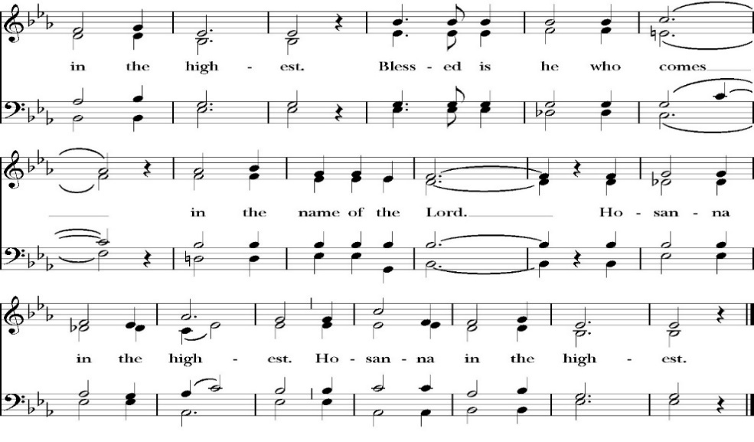
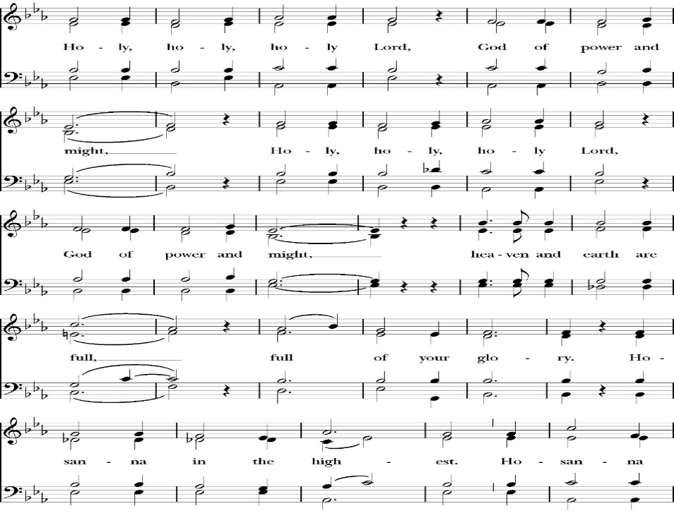
The Sanctus
All praise and glory is yours, O God our heavenly Father, for in your tender mercy, you gave your only Son Jesus Christ to suffer death upon the Cross for our redemption. He made there, by his one oblation of himself once offered, a full, perfect, and sufficient sacrifice, oblation, and satisfaction, for the sins of the whole world; and he instituted, and in his Holy Gospel commanded us to continue, a perpetual memory of his precious death and sacrifice, until his coming again.

So now, O merciful Father, in your great goodness, we ask you to bless and sanctify, with your Word and Holy Spirit, these gifts of bread and wine, that we, receiving them according to your Son our Savior Jesus Christ’s holy institution, in remembrance of his death and passion, may be partakers of his most blessed Body and Blood.
For on the night that he was betrayed, our Lord Jesus Christ took bread; and when he had given thanks, he broke it,* and gave it to his disciples, saying, “Take, eat; this is my Body, which is given for you: Do this in remembrance of me.”

Likewise, after supper, Jesus took the cup, and when he had given thanks, he gave it to them, saying, “Drink this, all of you; for this is my Blood of the New Covenant, which is shed for you, and for many, for the forgiveness of sins: Whenever you drink it, do this in remembrance of me.”

Therefore, O Lord and heavenly Father, according to the institution of your dearly beloved Son our Savior Jesus Christ, we your humble servants celebrate and make here before your divine Majesty, with these holy gifts, the memorial your Son commanded us to make; remembering his blessed passion and precious death, his mighty resurrection and glorious ascension, and his promise to come again.

And we earnestly desire your fatherly goodness mercifully to accept this, our sacrifice of praise and thanksgiving; asking you to grant that, by the merits and death of your Son Jesus Christ, and through faith in his Blood, we and your whole Church may obtain forgiveness of our sins, and all other benefits of his passion.

And here we offer and present to you, O Lord, ourselves, our souls and bodies, to be a reasonable, holy, and living sacrifice. We humbly pray that all who partake of this Holy Communion may worthily receive the most precious Body and Blood of your Son Jesus Christ, be filled with your grace and heavenly benediction, and be made one body with him, that he may dwell in us, and we in him.

And although we are unworthy, because of our many sins, to offer you any sacrifice, yet we ask you to accept this duty and service we owe, not weighing our merits, but pardoning our offenses, through Jesus Christ our Lord.

By him, and with him, and in him, in the unity of the Holy Spirit, all honor and glory is yours, Almighty Father, now and for ever. Amen.

And now, as our Savior Christ has taught us, we are bold to pray,

Our Father, who art in heaven,
hallowed be thy Name,
thy kingdom come,
thy will be done,
on earth as it is in heaven.
Give us this day our daily bread.
And forgive us our trespasses,
as we forgive those
who trespass against us.
And lead us not into temptation,
but deliver us from evil.
For thine is the kingdom,
and the power, and the glory,
for ever and ever. Amen.

Celebrant Christ our Passover is sacrificed for us.
People Therefore let us keep the feast.

We do not presume to come to this your table, O merciful Lord,
trusting in our own righteousness,
but in your abundant and great mercies.
We are not worthy so much as to gather up
the crumbs under your table;
but you are the same Lord
whose character is always to have mercy.
Grant us, therefore, gracious Lord,
so to eat the flesh of your dear Son Jesus Christ,
and to drink his blood,
that our sinful bodies may be made clean by his body,
and our souls washed through his most precious blood,
and that we may evermore dwell in him, and he in us.
Amen.

Agnus Dei

Behold the Lamb of God, behold him who takes away the sins of the world. Blessed are those who are invited to the marriage supper of the Lamb.
John 1:29; Revelation 19:9

Communion Hymn:
Celebration Hymn: We Remember You
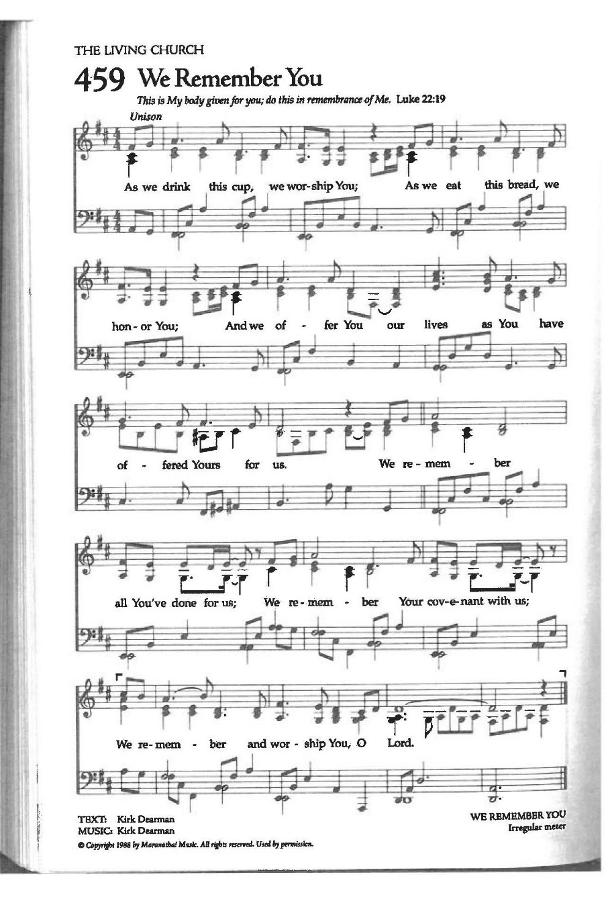
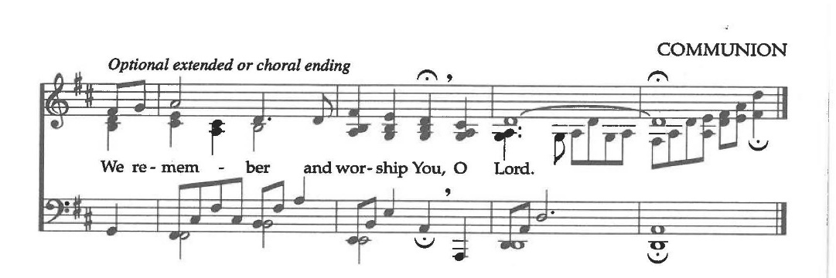
The Post Communion Prayer

Let us pray.

Almighty and everliving God,
we thank you for feeding us, in these holy mysteries,
with the spiritual food of the most precious Body and Blood
of your Son our Savior Jesus Christ;
and for assuring us, through this Sacrament, of your favor and
goodness towards us:
that we are true members of the mystical body of your Son,
the blessed company of all faithful people;
and are also heirs, through hope,
of your everlasting kingdom.
And we humbly ask you, heavenly Father,
to assist us with your grace,
that we may continue in that holy fellowship,
and do all the good works that you have prepared for us to
walk in;
through Jesus Christ our Lord,
to whom, with you and the Holy Spirit,
be all honor and glory, now and for ever. Amen.

The Blessing

The peace of God, which passes all understanding, keep your hearts
and minds in the knowledge and love of God, and of his Son Jesus
Christ our Lord; and the blessing of God Almighty, the Father, the
Son, and the Holy Spirit, be among you, and remain with you always.
Amen.
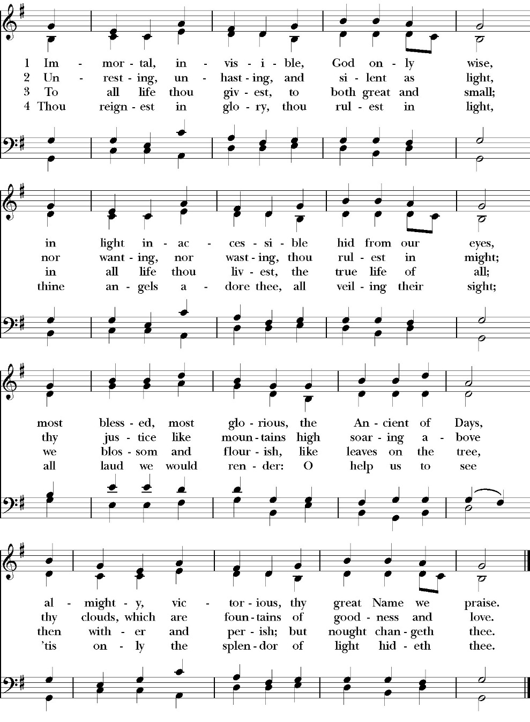
Closing Hymn: Immortal, Invisible, God Only Wise

Celebrant Go in peace to love and serve the Lord.
People Thanks be to God.
St. Paul’s Parish Calendar
Sunday March 8 – Sunday March 15

SUNDAY, March 8 – Third Sunday in Lent
9:15 AM Sunday Funday, Youth Room
9:15 AM Gospel of John Bible study, Conference room
9:30 AM Vocal Choir rehearsal, Chapel
10:30 AM Children’s Sunday School, Chapel
Pre-K –2nd Grade, Sunday School Room.
3rd -5th Grade, Youth Room
10:30 AM Holy Eucharist, Church

MONDAY, March 9
6:00 PM Women’s Bible Study, Conference Room

TUESDAY, March 10
6:00 PM Bell Choir Practice, Music Room
6:00 PM Vestry Meeting, Conference Room

WEDNESDAY, March 11
9:30 AM Holy Eucharist with healing prayer, Chapel
10:15 AM Bible Study, Conference Room
5:00 PM Practicing the Way, James Hall
6:00 PM Soup Supper, James Hall
6:45 PM Practicing the Way, James Hall
7:00 PM Vocal Choir Rehearsal, Church

THURSDAY, March 12

FRIDAY, March 13
6:30 AM Men’s Bible Study, Valhalla Restaurant
6:00 PM Stations of the Cross, Church

SATURDAY, March 14

SUNDAY, March 15 – Fourth Sunday in Lent
9:15 AM Sunday Funday, Youth Room
9:15 AM Gospel of John Bible study, Conference Room
9:30 AM Vocal Choir rehearsal, Chapel
10:30 AM Children’s Sunday School, Chapel
Pre-K –2nd Grade, Sunday School Room.
3rd -5th Grade, Youth Room
10:30 AM Holy Eucharist, Church
Church Office Hours
Monday-Thursday 8:00 AM-4:00 PM

Announcements

Lenten Stations of the Cross on Fridays at 6:00PM
Stations of the Cross is a meditative journey that allows the pilgrim to walk the way of the cross into the way of life and peace. All members are invited to join us for this beautiful and impactful thirty-minute devotional practice on Fridays at 6PM throughout Lent.

Sunday Morning Bible Study: The Gospel of John
St. Paul’s is embarking on a study of the Gospel of John that will span the next year. These classes will be on Sunday mornings from 9:15-10:00AM. We will take the better part of the next year to move slowly through John and savor the profound spiritual truths that it offers. We will be using a book called Be Alive by Warren Wiersbe as our guide. This book is essentially a study guide to the Gospel of John and will provide us with structure and insight as we move our way through the Gospel. Books will be available beginning the day of the first class.

Projected Class Timeline

Lent Chapters 1-3
Easter Chapters 4-8
June Chapter 9
August Chapter 10
Fall Chapters 11-14
Advent Chapters 15 & 15
Epiphany Chapters 16-17
Lent 2027 Chapters 18 & 19
Easter season Chapters 20 & 21

The class will progress based on how quickly or slowly is needed and our projected timelines may change as we move forward.

Lenten Soup Suppers will begin February 25, at 6:00PM
Lenten soup suppers are a beloved tradition at St. Paul’s. They offer an opportunity for a simple and delicious dinner with fellowship and an opportunity to participate in a Lenten Bible study or spiritual devotion. All are welcome to join us. If you would like to sign up to bring soup, please talk with Kathy Bernardi.

Practicing The Way, The Prayer Practice:
Pursue a deeper life of union with God
This is a Lenten opportunity for discipleship and spiritual growth in Jesus Christ. To pray is to open your heart to God. Prayer is simply the medium through which we communicate and commune with God. The practice of prayer is learning to set aside dedicated time to intentionally be with God in order to become like him and partner with him in the world. The Prayer Practice small group is a video-based class on prayer developed by John Mark Comer, author and facilitator of Practicing the Way and its resources. There will be two opportunities to participate on Wednesday evenings. The 5PM small group will be led by Fr. Rob Longbottom. The 6:45PM small group will be led by Deacon John Iseman.

March 11 Session 3: Listening to God
March 18 Session 4: Being with God
March 25 Prayer and Praise in the church. An hour of prayer and praise music as we lift our prayers and hearts to God in worship.

Lenten Wednesday Evening Schedule
5:00 PM Prayer small group led by Father Rob

6:00 PM Soup Suppers

6:45 PM Prayer small group class led by Deacon John

6:45PM Children’s class on prayer led by Deacon Kashy and
Fr. Rob
7:00 PM Vocal Choir Rehearsal, chapel
Lenten Mite Boxes to Support One Child
One of the spiritual practices of Lent is Almsgiving. We practice this at St. Paul’s Anglican Church through the mite box ministry. Everyone is invited to take a mite box, fill it with spare change, and return it to church on Easter.

What does the mite box almsgiving support?

This year the almsgiving from the mite boxes will support the ministry called One Child. At the October convention of the Anglican Diocese of San Joaquin, Bishop Eric Menees presented this ministry and invited churches of the diocese to partner in their work.

More about One Child

One Child is a global community of Child Champions giving of ourselves so children in poverty can thrive. We are sponsors, teachers, pastors, cooks, businesspeople, artists, social workers and many others around the world. One Child does this by advocating for children in hard places and provide holistic care, so they have hope and thrive. For more information on One Child please visit their website at www.onechild.org

A Food Bank for Hurley Families
The next Neighborhood Market to benefit students at Hurley School will be Wednesday, March 18, from 2:30 PM to 3:30 PM at St Paul’s Church parking lot. If you are interested in helping that day, please contact Sue Nyberg. My home phone number is 559-733-8244.

PROVIDED BY VISALIA EMERGENCY AID
AND ST. PAUL’S CHURCH
Wednesday, March 18, 2026
From 2:30 PM to 3:30 PM
LOCATION:
ST. PAUL'S CHURCH PARKING LOT
ACROSS THE STREET FROM HURLEY




Ushers and Greeters Training Meeting, Sunday, March 22 after church
After church on Sunday, March 22 there will be a training and refresher meeting for all ushers. This will be a time for new ushers to learn more about usher duties on Sunday morning and will be refresher for the rest of the ushers. This meeting will be facilitated by Fr. Rob and our head ushers Joey Haas and Glen Catalina. Anyone interested in becoming an usher is welcome to join us as well.

Holy Week Worship and Prayer Schedule
Palm Sunday Holy Eucharist March 29, 10:30AM
Palm Sunday worship will begin at our usual time but will begin with a blessing of the palms in James Hall and a procession to the church.

Holy Wednesday Eucharist, Chapel 9:30AM
St. Paul’s has a Wednesday morning Eucharist every week. This will not change during Holy Week. We will be using the readings for Holy Wednesday for the service.

Maundy Thursday Holy Eucharist, Church, April 2, 7:00PM
The word Maundy comes from the Latin word “Mandate” which means commandment. At this service, we remember Jesus’ last supper with his disciples in which he instituted the Eucharist, gave his new commandment to love one another and washed the feet of his disciples. This service will have the choir singing.

The Watch, Chapel, Thursday April 2, 9:00PM through Friday April 3, 7:00AM
The watch is a traditional time of prayer kept after the events of the Lord’s supper and before Jesus’ arrest when Jesus invites his disciples to come “Keep Watch” with him as he prepares spiritually for the crucifixion. The watch will take place in the chapel where the blessed sacraments will be placed on the altar. This time of prayer will begin immediately following the Maundy Thursday service and conclude at 7AM on Good Friday morning with a service of Morning prayer.

Good Friday, April 3
Morning prayer, Chapel, 7:00AM
On Good Friday morning, we will conclude ‘The Watch’ and begin the day in prayer. This service will include consuming the reserve blessed sacrament and take place in the chapel

Stations of the Cross, Church, 12PM
Jesus’ trial occurred on the morning of Good Friday. He was sentenced to death and immediately walked, carrying his cross, from the place of his trial to the place of his crucifixion outside the walls of Jerusalem. Jesus was hung on the cross at 12PM on Good Friday. Having the Stations of the Cross at noon on Good Friday remembers Jesus’ way of the cross.

Good Friday Service, Church, 7:00PM
The Good Friday Service occurs the evening of Good Friday after Jesus’ body is laid in the tomb. It is not a service of Holy Eucharist, but prayers and music which invite us into the meaning and goodness of the cross. At this service we will have the veneration of the cross in which all will be invited to kneel at the foot of the cross and pray. This service will have both traditional and contemporary music along with our choir.

Easter Worship, Sunday, April 5th
8:00AM Sunrise Service of scripture and the Great Litany.
No Holy Eucharist
This sunrise service will welcome us into the Easter celebration of the resurrection of Jesus Christ. At this service, we will begin outside with the sunrise and then enter into the church to light the first fire of Easter on the Paschal Candle. We will read through God’s saving plan throughout scripture and pray the Great Litany. This service is not intended to be our Holy Eucharist, but to lead us into the Holy Eucharist that will take place at 10:30AM.

10:30AM Festival Easter Holy Eucharist with Baptism
Our Church community will gather together as one for a celebration of the Resurrection of Jesus on Easter Morning. Our service will include a baptism, festive music, and Holy Eucharist. After the service, we will have an Easter Egg hunt for kids and fellowship celebrating Easter.

St. Paul’s Anglican Church
Parish Office
6436 W. Hurley Ave
Visalia, California 93291
559-732-4821
Office Hours: 8:00 – 4:00
Monday – Thursday

Worship: Sundays at 10:30AM
Livestream: Link at spvisalia.com
and on our Facebook page
Please be advised that this service is being recorded for broadcast
and/or archival purposes. By attending, you consent
to the inclusion of your likeness in these recordings.

St. Paul’s Clergy and Staff
The Rev. Robert Longbottom, Rector
rector@spvisalia.com
(559)802-2928
The Rev. John Iseman, Pastoral Associate for Family Ministries
family@spvisalia.com
The Rev. Kashy Rowland-Smith, Deacon
kashyrs@aol.com
Antoinette Horsting, Parish Administrator
bookkeeper@spvisalia.com
Marguerite Crownover, Organist and Accompanist
Cynthia Culp, Choral Director
Jackie Iseman, Nursery Coordinator
Shane Motl, Sexton

St. Paul’s is a member church of the
Anglican Diocese of San Joaquin
The Rt. Rev. Eric V. Menees, Bishop

Next Week’s Lessons
1 Samuel 16:1-13
Psalm 23
Ephesians 5:21-14
John 9:213, 28-41

