ST. PAUL’S
ANGLICAN CHURCH
VISALIA, CALIFORNIA

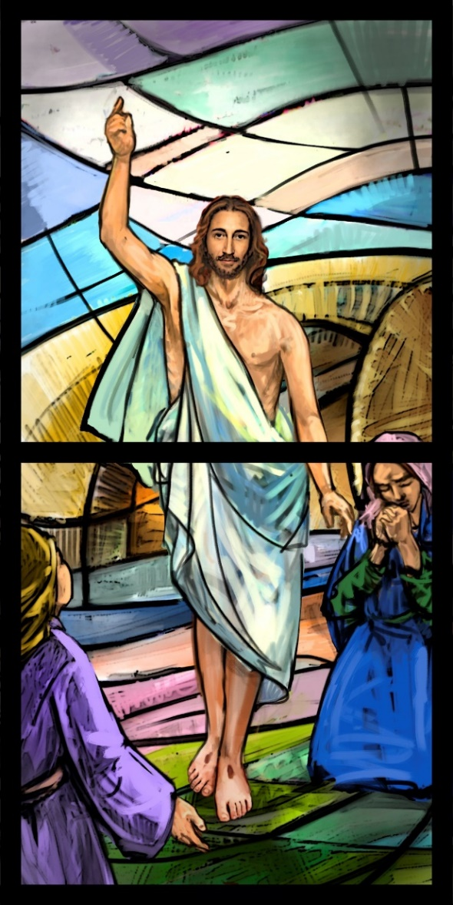

SECOND SUNDAY OF EASTER
April 12, 2026
10:30 A.M

Welcome!

St. Paul’s Anglican Church extends a warm welcome to all visitors and newcomers, whether worshiping in person or at home via livestream.

Visitors’ Guide

St. Paul’s Church is a parish in the Diocese of San Joaquin of the Anglican Church in North America, which includes both Catholic and Protestant traditions. We accept Jesus Christ as Savior, and we promise to follow him as Lord. We believe in One God,

- the Father who created us and all things,
- the Son who redeems us from sin and death,
- the Holy Spirit who renews and sanctifies us.

We believe the Holy Scriptures to be the Word of God and to contain all things necessary for salvation, and we accept the Apostles’ and Nicene Creeds as essential beliefs of the Christian faith.

Those not desiring to receive Holy Communion, and those who have not been baptized into the Christian faith, are invited to cross their arms across their chest, and a blessing will be given instead.

Visitors are invited to sign the guest book at the entrance table and introduce themselves to the clergy following the service.

The Holy Eucharist

Prelude: “Hail This Brightest Day of Days” Bach
Opening Hymn:#178 –“Alleluia, Alleluia, Give Thanks to the Risen Lord” p. 4
Opening Acclamation p. 5
The Collect for Purity p. 5
Summary of the Law p. 5
Kyrie p. 5
Gloria p. 6
Collect of the Day p. 7
Lesson: Acts 2 :14a, 22-32 p. 7
Gradual: Psalm 111 p. 8
Epistle: 1 Peter 1:3-9 p. 8
Sequence Hymn: #188 – “Love’s Redeeming Work is Done” p. 9
Gospel: John 20:19.31 p. 9
Sermon: Rev. Robert Longbottom
Nicene Creed p. 10
Prayers of the People p. 11
The Peace p. 13
Offertory Anthem Organ: “Prelude in C” Bach
The Offertory p. 14
Sursum Corda p. 14
Sanctus p. 15
The Lord’s Prayer p. 18
Fraction p. 18
Prayer for Humble Access p. 18
Agnus Dei p. 19
Communion Hymn: #174 – “At the Lamb’s High Feast” p. 20
Post communion Prayer p. 21
Blessing p. 21
Closing Hymn: #180 – “He is Risen, He is Risen” p. 22
Dismissal p. 22
Postlude: “In Thee is Gladness” Bach

Opening Hymn: Alleluia, Alleluia, Give Thanks to the Risen Lord

Opening Acclamation

Celebrant Alleluia! Christ is risen!
People The Lord is risen indeed! Alleluia!

Collect for Purity

Celebrant: Almighty God, to you all hearts are open, all desires
known, and from you no secrets are hid: Cleanse the thoughts
of our hearts by the inspiration of your Holy Spirit, that we
may perfectly love you, and worthily magnify your holy Name;
through Christ our Lord. Amen.

Summary of the law

Celebrant: Hear what our Lord Jesus Christ says: You shall love
the Lord your God with all your heart and with all your soul
and with all your mind. This is the first and great
commandment. And the second is like it: You shall love your
neighbor as yourself. On these two commandments depend all
the Law and the Prophets.

Kyrie
Gloria

Celebrant The Lord be with you.
People And with your spirit.
Celebrant Let us pray.

The Collect of the Day

Almighty and everlasting God, who in the Paschal mystery established the new covenant of reconciliation: Grant that all who have been reborn into the fellowship of Christ’s Body may show forth in their lives what they profess by their faith; through Jesus Christ our Lord, who lives and reigns with you and the Holy Spirit, one God, for ever and ever. Amen.

Lesson: Acts 2:14a, 22-32

But Peter, standing with the eleven, lifted up his voice and addressed them: ²² “Men of Israel, hear these words: Jesus of Nazareth, a man attested to you by God with mighty works and wonders and signs that God did through him in your midst, as you yourselves know— ²³ this Jesus, delivered up according to the definite plan and foreknowledge of God, you crucified and killed by the hands of lawless men. ²⁴ God raised him up, loosing the pangs of death, because it was not possible for him to be held by it. ²⁵ For David says concerning him, “‘I saw the Lord always before me, for he is at my right hand that I may not be shaken; ²⁶ therefore my heart was glad, and my tongue rejoiced; my flesh also will dwell in hope. ²⁷ For you will not abandon my soul to Hades, or let your Holy One see corruption. ²⁸ You have made known to me the paths of life; you will make me full of gladness with your presence.’ ²⁹ “Brothers, I may say to you with confidence about the patriarch David that he both died and was buried, and his tomb is with us to this day. ³⁰ Being therefore a prophet, and knowing that God had sworn with an oath to him that he would set one of his descendants on his throne, ³¹ he foresaw and spoke about the resurrection of the Christ, that he was not abandoned to Hades, nor did his flesh see corruption. ³² This Jesus God raised up, and of that we all are witnesses.

Reader: The Word of the Lord
People: Thanks be to God
Gradual: Psalm 111
1 Praise the LORD. I will give thanks unto the LORD with my
whole heart, *
in the company of the upright, and among the congregation.
2 The works of the LORD are great, *
sought out by all who have pleasure in them.
3 His work is worthy to be praised and held in honor, *
and his righteousness endures for ever.
4 He has made his marvelous works to be had in remembrance;
* The LORD is gracious and merciful.
5 He has given food to those who fear him; *
he shall ever be mindful of his covenant.
6 He has shown his people the power of his works, *
that he may give them the heritage of the nations.
7 The works of his hands are faithfulness and justice; *
all his commandments are true.
8 They stand fast for ever and ever, *
and are done in truth and equity.
9 He sent redemption to his people; he has commanded his
covenant for ever; *
holy and awesome is his Name.
10 The fear of the LORD is the beginning of wisdom; *
a good understanding have all those who live accordingly;
his praise endures for ever.

Glory be to the Father, and to the Son, and to the Holy Spirit;
as it was in the beginning, is now, and ever shall be,
world without end. Amen
Epistle: 1 Peter 1:3-9
Blessed be the God and Father of our Lord Jesus Christ! According to his great mercy, he has caused us to be born again to a living hope through the resurrection of Jesus Christ from the dead, ⁴ to an inheritance that is imperishable, undefiled, and unfading, kept in heaven for you, ⁵ who by God's power are being guarded through faith for a salvation ready to be revealed in the last time. ⁶ In this you rejoice, though now for a little while, if necessary, you have been grieved by various trials, ⁷ so that the tested genuineness of your faith—more precious than gold that perishes though it is tested by fire—may be found to result in praise and glory and honor at the revelation of Jesus Christ. ⁸ Though you have not seen him, you love him. Though you do not now see him, you believe in him and rejoice with joy that is inexpressible and filled with glory, ⁹ obtaining the outcome of your faith, the salvation of your souls.
Reader: The Word of the Lord
People: Thanks be to God

Sequence Hymn: Love’s Redeeming Work is Done
(Verse 1-2 before the Gospel, verse 3 after)
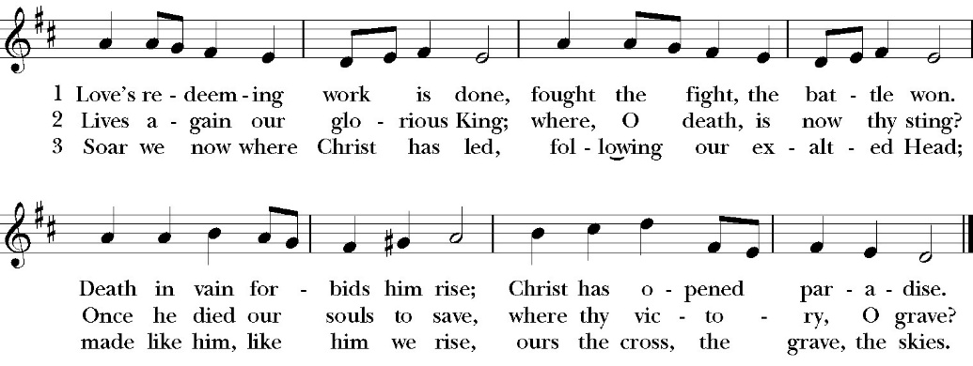

Clergy: The Gospel of the Lord, according to St. John
People: Glory to you, Lord God

Gospel: John 20:19-31
On the evening of that day, the first day of the week, the doors being locked where the disciples were for fear of the Jews, Jesus came and stood among them and said to them, “Peace be with you.” ²⁰ When he had said this, he showed them his hands and his side. Then the disciples were glad when they saw the Lord. ²¹ Jesus said to them again, “Peace be with you. As the Father has sent me, even so I am sending you.” ²² And when he had said this, he breathed on them and said to them, “Receive the Holy Spirit. ²³ If you forgive the sins of any, they are forgiven them; if you withhold forgiveness from any, it is withheld.” ²⁴ Now Thomas, one of the twelve, called the Twin, was not with them when Jesus came. ²⁵ So the other disciples told him, “We have seen the Lord.” But he said to them, “Unless I see in his hands the mark of the nails, and place my finger into the mark of the nails, and place my hand into his side, I will never believe.” ²⁶ Eight days later, his disciples were inside again, and Thomas was with them. Although the doors were locked, Jesus came and stood among them and said, “Peace be with you.” ²⁷ Then he said to Thomas, “Put your finger here, and see my hands; and put out your hand, and place it in my side. Do not disbelieve, but believe.” ²⁸ Thomas answered him, “My Lord and my God!” ²⁹ Jesus said to him, “Have you believed because you have seen me? Blessed are those who have not seen and yet have believed.” ³⁰ Now Jesus did many other signs in the presence of the disciples, which are not written in this book; ³¹ but these are written so that you may believe that Jesus is the Christ, the Son of God, and that by believing you may have life in his name.

Clergy: The Gospel of the Lord
People: Praise to you Lord Christ

Sermon
The Rev. Robert Longbottom

The Nicene Creed

We believe in one God,
the Father, the Almighty,
maker of heaven and earth,
of all that is, visible and invisible.

We believe in one Lord, Jesus Christ,
the only-begotten Son of God,
eternally begotten of the Father,
God from God, Light from Light,
true God from true God,
begotten, not made,
of one Being with the Father.
through him all things were made.
For us and for our salvation he came down from heaven:
was incarnate from the Holy Spirit and the Virgin Mary,
and was made man.
For our sake he was crucified under Pontius Pilate;
he suffered death and was buried.
On the third day he rose again in accordance with the
Scriptures;
he ascended into heaven
and is seated at the right hand of the Father.
He will come again in glory to judge the living and the dead,
and his kingdom will have no end.

We believe in the Holy Spirit, the Lord, the giver of life,
who proceeds from the Father [and the Son],
who with the Father and the Son is worshiped and glorified.
who has spoken through the Prophets.
We believe in one holy catholic and apostolic Church.
We acknowledge one Baptism for the forgiveness of sins.
We look for the resurrection of the dead,
and the life of the world to come. Amen.

The Prayers of the People

Leader Let us pray for the Church and for the world, saying, “hear our prayer.”
For the peace of the whole world, and for the well-being and unity of the people of God.
Lord, in your mercy:
People Hear our prayer.

Leader For Stephen our archbishop and Eric, our bishop. For Fr. Rob, Deacon John, Deacon Kashy, and for all the clergy and people of our diocese and congregation and for the worldwide Anglican Communion.
Lord, in your mercy:
People Hear our prayer.

Leader For all those who proclaim the Gospel at home and abroad; and for all who teach and disciple others.
Lord, in your mercy:
People Hear our prayer.

Leader For our brothers and sisters in Christ who are persecuted for their faith.
Lord, in your mercy:
People Hear our prayer.

Leader For our nation, for those in authority, and for all in public service especially Donald our president and Gavin our governor.
Lord, in your mercy:
People Hear our prayer.

Lord, in your mercy:
People Hear our prayer.

Leader: For the planning and building of our new church campus, for the stewardship of all the resources being used for its construction and for the mission of our church to blossom and thrive as we move into our future.
Lord, in your mercy:
People Hear our prayer.

Leader: In the St. Paul’s cycle of prayer, we lift up the ministries of pastoral care, all our members who are in the hospital, care facilities or who are shut into their own homes. We pray for those who are recovering from recent surgeries and for those who are in crisis.
Lord, in your mercy:
People Hear our prayer.

Leader In the ACNA Cycle of Prayer, today we pray for the Diocese of New England, Bishop Andrew Williams and his wife, Elena; and Bishop William Murdoch and his wife, Sally.
Lord, in your mercy:
People Hear our prayer.

Leader For all those who are in trouble, sorrow, need, sickness, or
any other adversity [especially ____________]. We also
pray for all who are currently serving in our armed forces
and serving as first responders.
Lord, in your mercy:
People Hear our prayer.

Leader For all those who have departed this life in the certain hope
of the resurrection, (we pray especially for ____________),
in Thanksgiving let us pray.
Lord, in your mercy:
People Hear our prayer.

Celebrant will add a concluding prayer

Celebrant The Peace of the Lord be always with you.
People And with your spirit.

The Confession and Absolution

Celebrant Let us humbly confess our sins to Almighty God.

Most merciful God,
we confess that we have sinned against you
in thought, word and deed,
by what we have done, and by what we have left undone.
We have not loved you with our whole heart;
we have not loved our neighbors as ourselves.
We are truly sorry and we humbly repent.
For the sake of your Son Jesus Christ,
have mercy on us and forgive us;
that we may delight in your will, and walk in your ways,
to the glory of your Name. Amen.

Almighty God, our heavenly Father, who in his great mercy has
promised forgiveness of sins to all those who sincerely repent and
with true faith turn to him, have mercy upon you, pardon and deliver
you from all your sins, confirm and strengthen you in all goodness,
and bring you to everlasting life; through Jesus Christ our Lord.
Amen.

God so loved the world, that he gave his only-begotten Son, that
whoever believes in him should not perish but have eternal life.
-John 3:16t

Offertory Anthem

Organ: Prelude in C
by Bach

The Doxology
(Verse 3 only)

Offertory

Celebrant All things come from you, O Lord,
People And of your own have we given you.

The Eucharistic Liturgy

Celebrant The Lord be with you.
People And with your spirit.
Celebrant Lift up your hearts.
People We lift them up to the Lord.
Celebrant Let us give thanks to the Lord our God.
People It is right to give him thanks and praise.

It is right, our duty and our joy, always and everywhere to give thanks to you, Father Almighty, Creator of heaven and earth.

But chiefly are we bound to praise you for the glorious resurrection of your Son Jesus Christ our Lord; for he is the true Paschal Lamb, who was offered for us, and has taken away the sin of the world; who by his death has destroyed death, and by his rising to life again has won for us everlasting life

Therefore we praise you, joining our voices with Angels and Archangels and with all the company of heaven, who for ever sing this hymn to proclaim the glory of your Name:

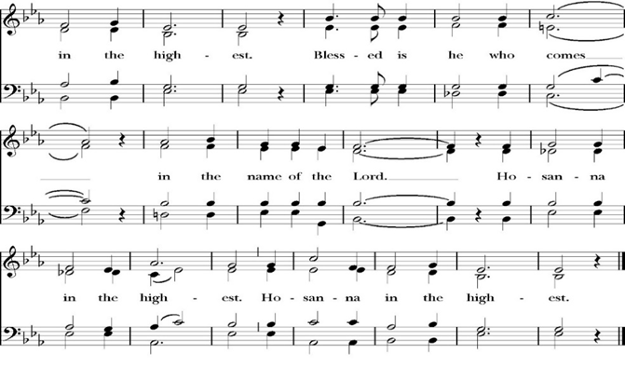
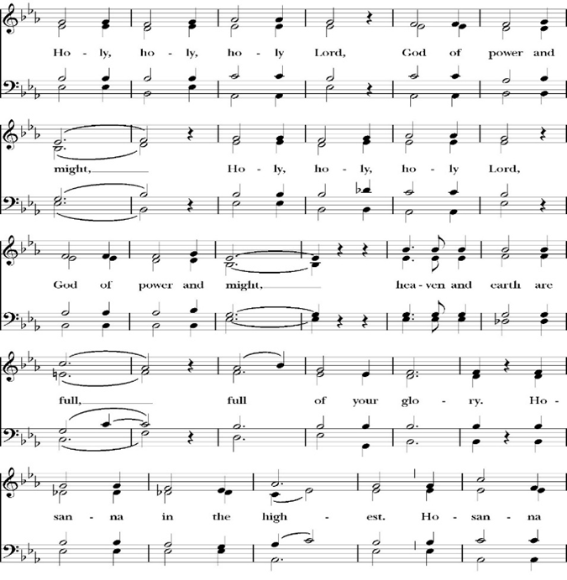
Sanctus

Holy and gracious Father: In your infinite love you made us for yourself; and when we had sinned against you and become subject to evil and death, you, in your mercy, sent your only Son Jesus Christ into the world for our salvation. By the Holy Spirit and the Virgin Mary he became flesh and dwelt among us. In obedience to your will, he stretched out his arms upon the Cross and offered himself once for all, that by his suffering and death we might be saved. By his resurrection he broke the bonds of death, trampling Hell and Satan under his feet. As our great high priest, he ascended to your right hand in glory, that we might come with confidence before the throne of grace.

On the night that he was betrayed, our Lord Jesus Christ took bread; and when he had given thanks, he broke it,* and gave it to his disciples, saying, “Take, eat; this is my Body, which is given for you: Do this in remembrance of me.”

Likewise, after supper, Jesus took the cup, and when he had given thanks, he gave it to them, saying, “Drink this, all of you; for this is my Blood of the New Covenant, which is shed for you, and for many, for the forgiveness of sins: Whenever you drink it, do this in remembrance of me.”

Therefore we proclaim the mystery of faith:

Christ has died.
Christ is risen.
Christ will come again.

We celebrate the memorial of our redemption, O Father, in this sacrifice of praise and thanksgiving, and we offer you these gifts.

Sanctify them by your Word and Holy Spirit to be for your people the Body and Blood of your Son Jesus Christ. Sanctify us also, that we may worthily receive this holy Sacrament, and be made one body with him, that he may dwell in us and we in him. In the fullness of time, put all things in subjection under your Christ, and bring us with all your saints into the joy of your heavenly kingdom, where we shall see our Lord face to face. All this we ask through your Son Jesus Christ: By him, and with him, and in him, in the unity of the Holy Spirit, all honor and glory is yours, Almighty Father, now and for ever. Amen.
And now, as our Savior Christ has taught us, we are bold to pray,

Our Father, who art in heaven,
hallowed be they Name,
thy kingdom come,
thy will be done,
on earth as it is in heaven.
Give us this day our daily bread.
And forgive us our trespasses,
as we forgive those
who trespass against us.
And lead us not into temptation,
but deliver us from evil.
For thine is the kingdom,
and the power, and the glory,
for ever and ever. Amen.

Celebrant Alleluia! Christ our Passover is sacrificed for us.
People Therefore let us keep the feast. Alleluia!

We do not presume to come to this your table, O merciful Lord,
trusting in our own righteousness,
but in your abundant and great mercies.
We are not worthy so much as to gather up
the crumbs under your table;
but you are the same Lord
whose character is always to have mercy.
Grant us, therefore, gracious Lord,
so to eat the flesh of your dear Son Jesus Christ,
and to drink his blood,
that our sinful bodies may be made clean by his body,
and our souls washed through his most precious blood,
and that we may evermore dwell in him, and he in us.
Amen.
Agnus Dei

The Ministration of Communion

The gifts of God for the People of God. Take them in remembrance that Christ died for you and feed on him in your hearts by faith, with thanksgiving.

Communion Hymn: At the Lamb’s High Feast
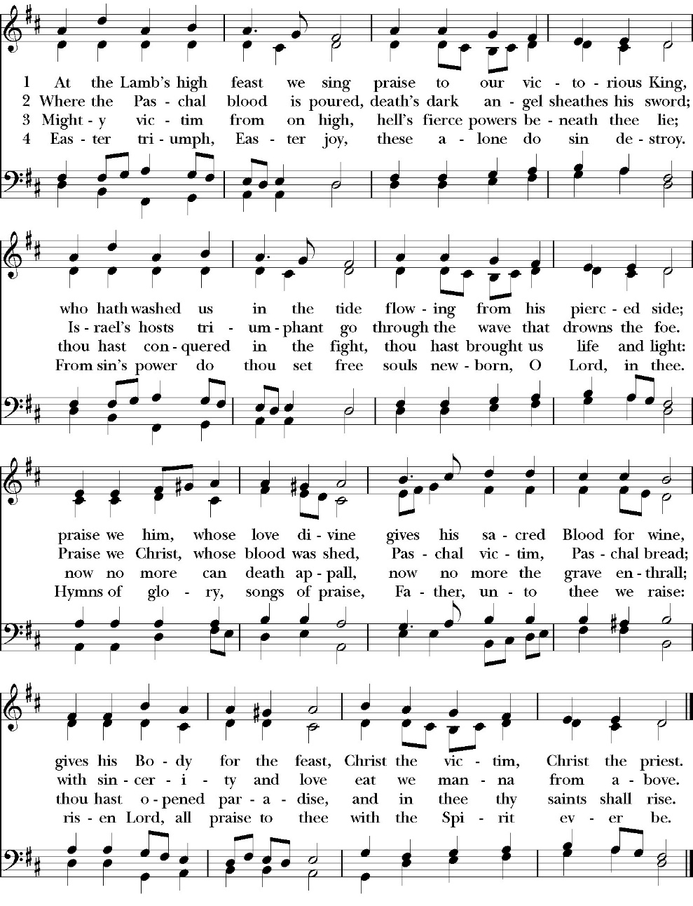
(verse 1 & 2 only)

The Post Communion Prayer

Let us pray.

Heavenly Father,
We thank you for feeding us with the spiritual food
of the most precious Body and Blood
of your Son our Savior Jesus Christ;
and for assuring us in these holy mysteries
that we are living members of the body of your Son,
and heirs of your eternal Kingdom.
And now, Father, send us out to do the work you have
given us to do,
to love and serve you as faithful witnesses of Christ our
Lord.
To him, to you, and to the Holy Spirit,
be honor and glory, now and for ever. Amen.

The Blessing

The blessing of God Almighty, the Father, the Son, and the Holy
Spirit, be among you, and remain with you always. Amen.

Closing Hymn: He is Risen, He is Risen

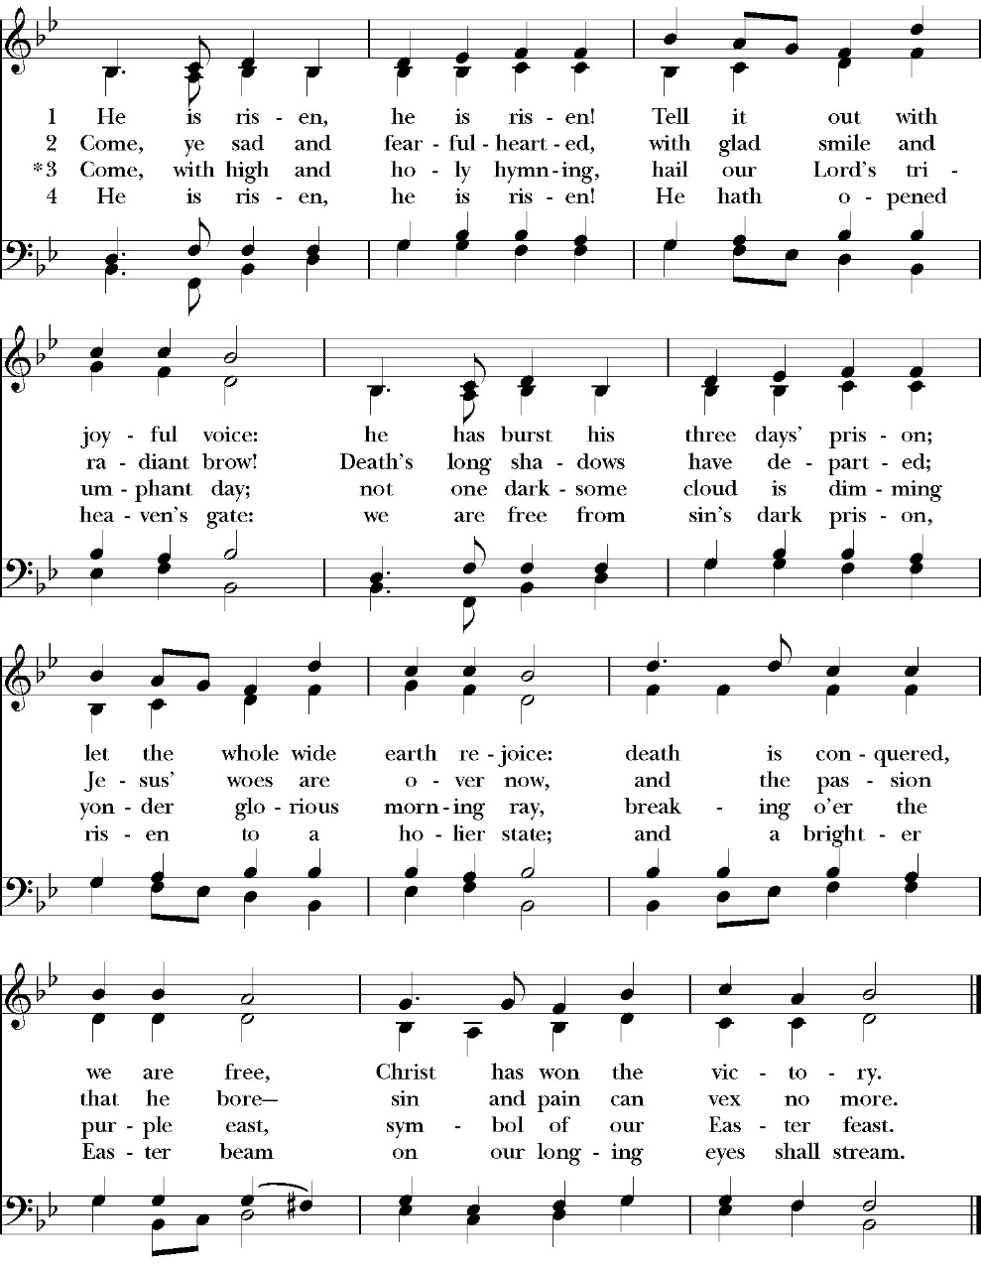

Celebrant Alleluia, Alleluia! Let us Go forth in the name of Christ.
People Thanks be to God. Alleluia! Alleluia!

St. Paul’s Parish Calendar
Sunday April 12 – Sunday April 19

SUNDAY, April 12 – Second Sunday of Easter
9:15 AM Sunday Funday, Youth Room
9:15 AM Gospel of John Bible study, Conference Room
9:30 AM Vocal Choir rehearsal, Chapel
10:30 AM Children’s Sunday School, Chapel
Pre-K –2nd Grade, Sunday School Room
3rd -5th Grade, Youth Room
10:30 AM Holy Eucharist, Church

MONDAY, April 13

TUESDAY, April 14
6:00 PM Bell Choir Practice, Music Room
6:00 PM Vestry Meeting, Conference Room

WEDNESDAY, April 15
9:30 AM Holy Eucharist with healing prayer, Chapel
10:15 AM Bible Study, Conference Room
2:30 to 3:30 Neighborhood Market, Parking Lot
7:00 PM Choir Practice, Chapel

THURSDAY, April 16

FRIDAY, April 17
6:30 AM Men’s Bible Study, Valhalla Restaurant

SATURDAY, April 18

SUNDAY, April 19 – Second Sunday of Easter
9:15 AM Sunday Funday, Youth Room
9:15 AM Gospel of John Bible study, Conference Room
9:30 AM Bell Choir Rehearsal, Church
10:30 AM Children’s Sunday School, Chapel
Pre-K –2nd Grade, Sunday School Room
3rd -5th Grade, Youth Room
10:30 AM Holy Eucharist, Church

Church Office Hours
Monday-Thursday 8:00 AM-4:00 PM

Sunday Morning Bible Study: The Gospel of John
St. Paul’s is embarking on a study of the Gospel of John that will span the next year. These classes will be on Sunday mornings from 9:15-10:00AM. We will take the better part of the next year to move slowly through John and savor the profound spiritual truths that it offers. We will be using a book called Be Alive by Warren Wiersbe as our guide. This book is essentially a study guide to the Gospel of John and will provide us with structure and insight as we move our way through the Gospel. Books will be available beginning the day of the first class.

Projected Class Timeline

Easter Chapters 4-8
June Chapter 9
August Chapter 10
Fall Chapters 11-14
Advent Chapter 15
Epiphany Chapters 16-17
Lent 2027 Chapters 18-19
Easter season Chapters 20- 21

The class will progress based on how quickly or slowly is needed and our projected timelines may change as we move forward.

Coming Soon! An opportunity for you to investigate a new way to learn more about your own spirituality, the Anglican Church, and connect with old friends and meet new friends. Go on a 4 day "vacation" leaving Visalia for this educational and spirit-filled adventure from July 9-12, 2026. During the church service on Sunday, April 12, 2026, our very own Joey Haas and Amy Gunn will speak very briefly to the congregation about this valuable opportunity to inspire and infuse your own spiritual life. After Sunday service, please come to coffee hour to learn more about Anglican 4th Day. Parishioners who have taken advantage of this opportunity will be circulating around coffee hour to answer your questions.
New Cross Adorning Church Office Reception Area Designed and Crafted by David Daniels
Our own David Daniels was commissioned by the church to design and build a cross to adorn our office reception area. The cross matches the work David did for the processional cross designed for St. Paul’s School in honor of Fr. Richard James. All are invited to stop by the church office to view the beautiful cross and talk to David anytime about his studio and beautifully crafted woodwork.

Car Show Hosted by St. Clement’s Anglican Church Day Care, Woodlake
Sunday, April 26, 9:00AM-2:00PM
St. Clement’s is inviting members of St. Paul’s to attend a car show that is a community outreach project and fundraiser for their daycare program. The car show will be combined with worship at 10:00AM. There will be worship, classic cars, food vendors and craft vendors. The event is located at St. Clement’s Anglican church, Woodlake.
Location: 498 N. Valencia Blvd, Woodlake, CA.

Friends and Fellowship looking for a few good hosts.
Friends and fellowship is an important opportunity for our church community to gather together throughout the year to simply enjoy each other’s company and share in fellowship. We are looking for new hosts for this low key fun event. Those who host simply open up their home while attendees bring food and refreshments for all to share. If you think you might have this gift of hospitality please speak to Kim Robinson or Fr. Rob Longbottom and we would love to talk with you more about hosting.

St. Paul’s School Spring Auction, Saturday May 9
“Stetsons and Starlight”
The St. Paul’s School spring auction is always a wonderful evening of fun and fundraising to support the work and ministry of the school. Tickets can be purchased beginning at $125 and up. Sponsorship opportunities are avalaible at a variety of levels and all members of St. Paul’s are invited to come out in your fanciest western wear! For more information please talk with Fr. Rob, Deacon John or call St. Paul’s School at 739-1619.

A Food Bank for Hurley Families

The next Neighborhood Market to benefit students at Hurley School will be Wednesday April 15, 2:30 PM to 3:30 PM at St Paul’s Church parking lot. If you are interested in helping that day, please contact Sue Nyberg. My home phone number is 559-733-8244.

Due to the heat, we are in need of more volunteers for
the months of May, June, August and September.
This will allow volunteers to work in shifts during these hot months.

PROVIDED BY VISALIA EMERGENCY AID
AND ST. PAUL’S CHURCH
Wednesday, April 15, 2026
From 2:30 PM to 3:30 PM
LOCATION:
ST. PAUL'S CHURCH PARKING LOT
ACROSS THE STREET FROM HURLEY





St. Paul’s Anglican Church
Parish Office
6436 W. Hurley Ave
Visalia, California 93291
559-732-4821
Office Hours: 8:00 – 4:00
Monday – Thursday

Worship: Sundays at 10:30AM
Livestream: Link at spvisalia.com
and on our Facebook page
Please be advised that this service is being recorded for broadcast
and/or archival purposes. By attending, you consent
to the inclusion of your likeness in these recordings.

St. Paul’s Clergy and Staff
The Rev. Robert Longbottom, Rector
rector@spvisalia.com
(559)802-2928
The Rev. John Iseman, Pastoral Associate for Family Ministries
family@spvisalia.com
The Rev. Kashy Rowland-Smith, Deacon
kashyrs@aol.com
Antoinette Horsting, Parish Administrator
bookkeeper@spvisalia.com
Marguerite Crownover, Organist and Accompanist
Cynthia Culp, Choral Director
Jackie Iseman, Nursery Coordinator
Shane Motl, Sexton

St. Paul’s is a member church of the
Anglican Diocese of San Joaquin
The Rt. Rev. Eric V. Menees, Bishop

Next Week’s Lessons
Acts 2:14a, 36-47
Psalm 116:11-16
1 Peter 1:13-25
Luke 24:13-35

