ST. PAUL’S
ANGLICAN CHURCH
VISALIA, CALIFORNIA

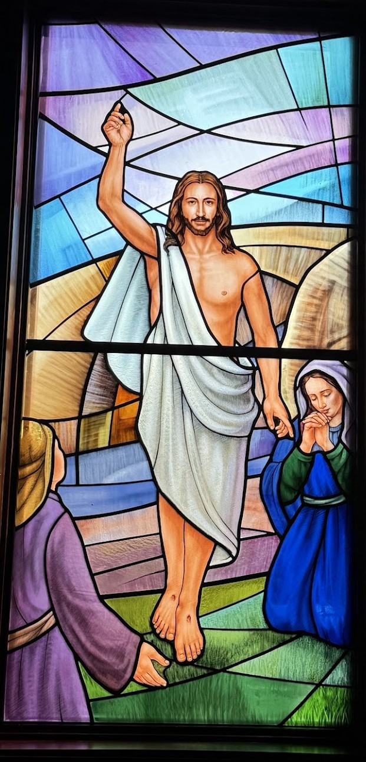

THIRD SUNDAY OF EASTER
April 19, 2026
10:30 A.M

Welcome!

St. Paul’s Anglican Church extends a warm welcome to all visitors and newcomers, whether worshiping in person or at home via livestream.

Visitors’ Guide

St. Paul’s Church is a parish in the Diocese of San Joaquin of the Anglican Church in North America, which includes both Catholic and Protestant traditions. We accept Jesus Christ as Savior, and we promise to follow him as Lord. We believe in One God,

- the Father who created us and all things,
- the Son who redeems us from sin and death,
- the Holy Spirit who renews and sanctifies us.

We believe the Holy Scriptures to be the Word of God and to contain all things necessary for salvation, and we accept the Apostles’ and Nicene Creeds as essential beliefs of the Christian faith.

Holy Communion is open to all baptized Christians who have examined their lives, repented of their sins, and desire to live
in love and charity with all people.

Those not desiring to receive Holy Communion, and those who have not been baptized into the Christian faith, are invited to cross their arms across their chest, and a blessing will be given instead.

Visitors are invited to sign the guest book at the entrance table and introduce themselves to the clergy following the servi
The Holy Eucharist

Prelude: “Holy God, We Praise Thy Name” Machemer
Opening Hymn: #210 – “The Day of Resurrection” p. 4
Opening Acclamation p. 5
The Collect for Purity p. 5
Summary of the Law p. 5
Kyrie p. 5
Gloria p. 6
Collect of the Day p. 7
Lesson: Acts 2 :14a, 36-47 p. 7
Gradual: Psalm 116:11-16 p. 8
Epistle: 1 Peter 1:13-25 p. 8
Sequence Hymn: #209 – “We Walk by Faith” p. 10
Gospel: Luke 24:13-35 p. 10
Sermon: Rev. Robert Longbottom
Nicene Creed p. 12
Prayers of the People p. 13
The Peace p. 15
Offertory Anthem “Be Thou My Vision” Soloist, Rose Longbottom
The Offertory p. 16
Sursum Corda p. 16
Sanctus p. 17
The Lord’s Prayer p. 19
Fraction p. 19
Prayer for Humble Access p. 20
Agnus Dei p. 20
Communion Hymn: Celebration Hymn – “Come Share the Lord” p. 21
Post Communion Prayer p. 22
Blessing p. 22
Closing Hymn: #493 “O For a Thousand Tongues to Sing” p. 23
Dismissal p. 23
Postlude: “Rejoice, Ye Pure in Heart” Hobby

Welcome to Canon Beth Conkle
Anglican Catechist Training School (ACTS)
Canon Beth Conkle is with us today to share about ACTS and how it can deepen faith and train leaders to serve the local congregation.
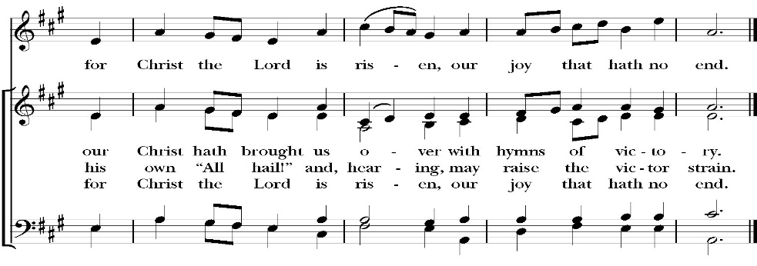
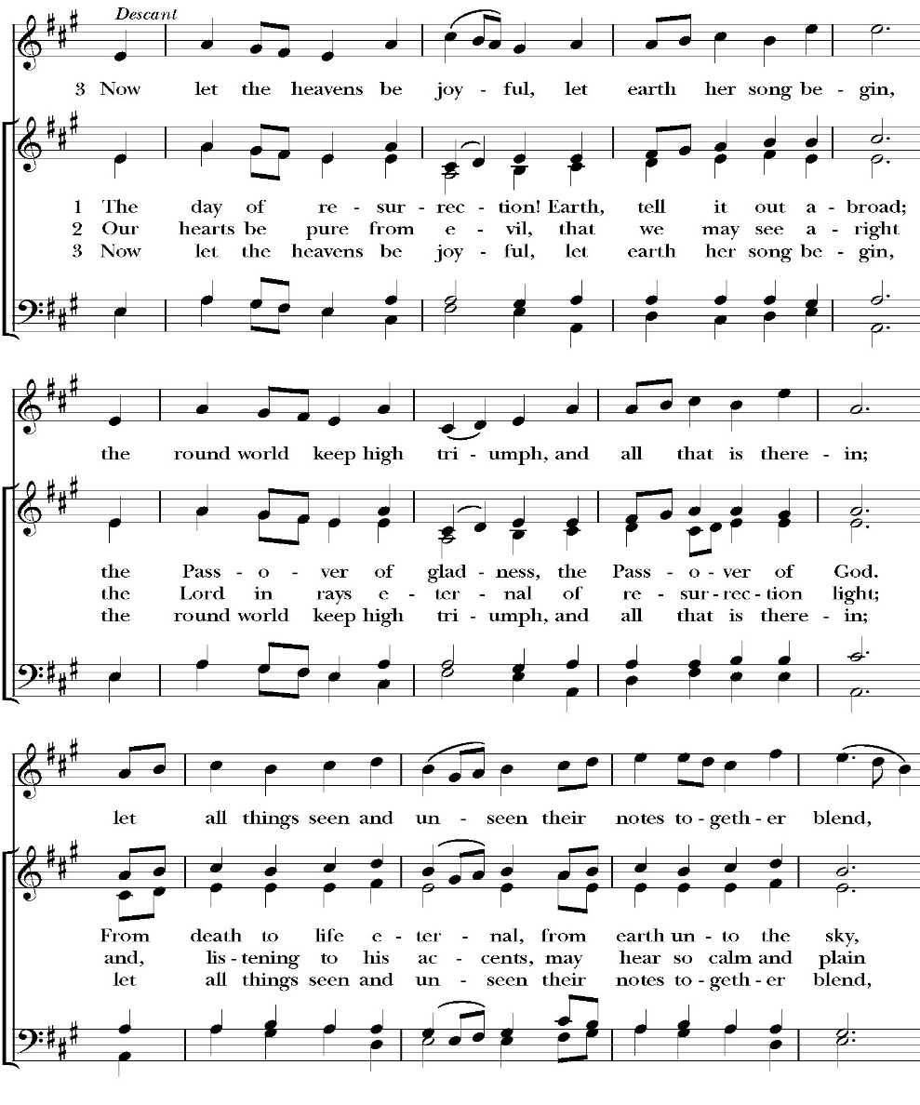
Opening Hymn: The Day of Resurrection

Opening Acclamation

Celebrant Alleluia! Christ is risen!
People The Lord is risen indeed! Alleluia!

Collect for Purity

Celebrant: Almighty God, to you all hearts are open, all desires
known, and from you no secrets are hid: Cleanse the thoughts
of our hearts by the inspiration of your Holy Spirit, that we
may perfectly love you, and worthily magnify your holy Name;
through Christ our Lord. Amen.

Summary of the law

Celebrant: Hear what our Lord Jesus Christ says: You shall love
the Lord your God with all your heart and with all your soul
and with all your mind. This is the first and great
commandment. And the second is like it: You shall love your
neighbor as yourself. On these two commandments depend all
the Law and the Prophets.

Kyrie

Gloria

Celebrant The Lord be with you.
People And with your spirit.
Celebrant Let us pray.

The Collect of the Day

Almighty God, you gave your only Son to be for us both a sacrifice for sin and an example of godly living: Give us grace thankfully to receive his inestimable benefits, and daily to follow the blessed steps of his most holy life; through Jesus Christ our Lord, who lives and reigns with you and the Holy Spirit, one God, for ever and ever. Amen.

Lesson: Acts 2:14a,36-47

But Peter, standing with the eleven, lifted up his voice and addressed them:

³⁶ Let all the house of Israel therefore know for certain that God has made him both Lord and Christ, this Jesus whom you crucified.”

³⁷ Now when they heard this they were cut to the heart, and said to Peter and the rest of the apostles, “Brothers, what shall we do?” ³⁸ And Peter said to them, “Repent and be baptized every one of you in the name of Jesus Christ for the forgiveness of your sins, and you will receive the gift of the Holy Spirit. ³⁹ For the promise is for you and for your children and for all who are far off, everyone whom the Lord our God calls to himself.” ⁴⁰ And with many other words he bore witness and continued to exhort them, saying, “Save yourselves from this crooked generation.” ⁴¹ So those who received his word were baptized, and there were added that day about three thousand souls.

⁴² And they devoted themselves to the apostles' teaching and the fellowship, to the breaking of bread and the prayers. ⁴³ And awe came upon every soul, and many wonders and signs were being done through the apostles. ⁴⁴ And all who believed were together and had all things in common. ⁴⁵ And they were selling their possessions and belongings and distributing the proceeds to all, as any had need. ⁴⁶ And day by day, attending the temple together and breaking bread in their homes, they received their food with glad and generous hearts, ⁴⁷ praising God and having favor with all the people. And the Lord added to their number day by day those who were being saved.

Reader: The Word of the Lord
People: Thanks be to God

Gradual: Psalm 116:11-16

11 What shall I give unto the Lord *
for all the benefits that he has done unto me?
12 I will lift up the cup of salvation *
and call upon the Name of the Lord.
13 I will pay my vows unto the Lord in the presence of all his
people; *
dear in the sight of the LORD is the death of his saints.
14 O Lord, I am your servant; *
I am your servant, and the child of your handmaid; you
have broken my bonds asunder.
15 I will offer you the sacrifice of thanksgiving *
and will call upon the Name of the Lord.
16 I will pay my vows unto the Lord in the sight of all his
people, *
in the courts of the Lord’s house, even in the midst of you,
O Jerusalem. Praise the Lord.
Glory be to the Father, and to the Son, and to the Holy Spirit;
as it was in the beginning, is now, and ever shall be, world
without end. Amen

Epistle: 1 Peter 1:13-25
¹³ Therefore, preparing your minds for action, and being sober-minded, set your hope fully on the grace that will be brought to you at the revelation of Jesus Christ. ¹⁴ As obedient children, do not be conformed to the passions of your former ignorance, ¹⁵ but as he who called you is holy, you also be holy in all your conduct, ¹⁶ since it is written, “You shall be holy, for I am holy.” ¹⁷ And if you call on him as Father who judges impartially according to each one's deeds, conduct yourselves with fear throughout the time of your exile, ¹⁸ knowing that you were ransomed from the futile ways inherited from your forefathers, not with perishable things such as silver or gold, ¹⁹ but with the precious blood of Christ, like that of a lamb without blemish or spot. ²⁰ He was foreknown before the foundation of the world but was made manifest in the last times for the sake of you ²¹ who through him are believers in God, who raised him from the dead and gave him glory, so that your faith and hope are in God.

²² Having purified your souls by your obedience to the truth for a sincere brotherly love, love one another earnestly from a pure heart, ²³ since you have been born again, not of perishable seed but of imperishable, through the living and abiding word of God; ²⁴ for

“All flesh is like grass and all its glory like the flower of grass. The grass withers, and the flower falls, ²⁵ but the word of the Lord remains forever.”

And this word is the good news that was preached to you..

Reader: The Word of the Lord
People: Thanks be to God

Sequence Hymn: We Walk by Faith
(Verse 1-3 before the Gospel, verse 4 after)

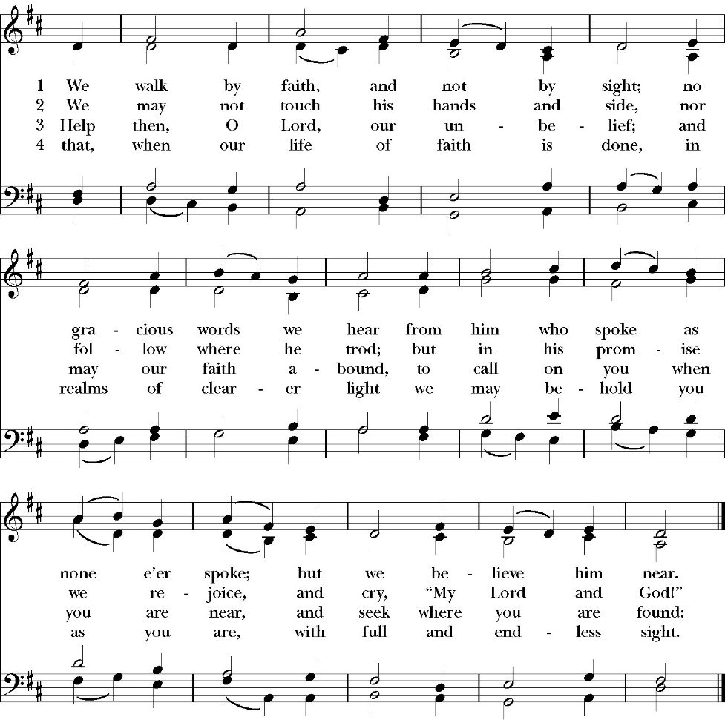

Clergy: The Gospel of the Lord, according to St. Luke
People: Glory to you, Lord God

Gospel: Luke 24:13-35

¹³ That very day two of them were going to a village named Emmaus, about seven miles from Jerusalem, ¹⁴ and they were talking with each other about all these things that had happened. ¹⁵ While they were talking and discussing together, Jesus himself drew near and went with them. ¹⁶ But their eyes were kept from recognizing him. ¹⁷ And he said to them, “What is this conversation that you are holding with each other as you walk?” And they stood still, looking sad. ¹⁸ Then one of them, named Cleopas, answered him, “Are you the only visitor to Jerusalem who does not know the things that have happened there in these days?” ¹⁹ And he said to them, “What things?” And they said to him, “Concerning Jesus of Nazareth, a man who was a prophet mighty in deed and word before God and all the people, ²⁰ and how our chief priests and rulers delivered him up to be condemned to death, and crucified him. ²¹ But we had hoped that he was the one to redeem Israel. Yes, and besides all this, it is now the third day since these things happened. ²² Moreover, some women of our company amazed us. They were at the tomb early in the morning, ²³ and when they did not find his body, they came back saying that they had even seen a vision of angels, who said that he was alive. ²⁴ Some of those who were with us went to the tomb and found it just as the women had said, but him they did not see.” ²⁵ And he said to them, “O foolish ones, and slow of heart to believe all that the prophets have spoken! ²⁶ Was it not necessary that the Christ should suffer these things and enter into his glory?” ²⁷ And beginning with Moses and all the Prophets, he interpreted to them in all the Scriptures the things concerning himself.

²⁸ So they drew near to the village to which they were going. He acted as if he were going farther, ²⁹ but they urged him strongly, saying, “Stay with us, for it is toward evening and the day is now far spent.” So he went in to stay with them. ³⁰ When he was at table with them, he took the bread and blessed and broke it and gave it to them. ³¹ And their eyes were opened, and they recognized him. And he vanished from their sight. ³² They said to each other, “Did not our hearts burn within us while he talked to us on the road, while he opened to us the Scriptures?” ³³ And they rose that same hour and returned to Jerusalem. And they found the eleven and those who were with them gathered together, ³⁴ saying, “The Lord has risen indeed, and has appeared to Simon!” ³⁵ Then they told what had happened on the road, and how he was known to them in the breaking of the bread.

Clergy: The Gospel of the Lord
People: Praise to you, Lord Christ

Sermon
The Rev. Robert Longbottom

The Nicene Creed

We believe in one God,
the Father, the Almighty,
maker of heaven and earth,
of all that is, visible and invisible.

We believe in one Lord, Jesus Christ,
the only-begotten Son of God,
eternally begotten of the Father,
God from God, Light from Light,
true God from true God,
begotten, not made,
of one Being with the Father.
through him all things were made.
For us and for our salvation he came down from heaven:
was incarnate from the Holy Spirit and the Virgin Mary,
and was made man.
For our sake he was crucified under Pontius Pilate;
he suffered death and was buried.
On the third day he rose again in accordance with the
Scriptures;
he ascended into heaven
and is seated at the right hand of the Father.
He will come again in glory to judge the living and the dead,
and his kingdom will have no end.

We believe in the Holy Spirit, the Lord, the giver of life,
who proceeds from the Father [and the Son],
who with the Father and the Son is worshiped and glorified.
who has spoken through the Prophets.
We believe in one holy catholic and apostolic Church.
We acknowledge one Baptism for the forgiveness of sins.
We look for the resurrection of the dead,
and the life of the world to come. Amen.

The Prayers of the People

Leader Let us pray for the Church and for the world, saying, “hear our prayer.”
For the peace of the whole world, and for the well-being and unity of the people of God.
Lord, in your mercy:
People Hear our prayer.

Leader For Stephen our archbishop, Julian the provincial dean and Eric, our bishop. For Fr. Rob, Deacon John, Deacon Kashy, and for all the clergy and people of our diocese and congregation and for the worldwide Anglican Communion.
Lord, in your mercy:
People Hear our prayer.

Leader For all those who proclaim the Gospel at home and abroad; and for all who teach and disciple others.
Lord, in your mercy:
People Hear our prayer.

Leader For our brothers and sisters in Christ who are persecuted for their faith.
Lord, in your mercy:
People Hear our prayer.

Leader For our nation, for those in authority, and for all in public service especially Donald our president and Gavin our governor.
Lord, in your mercy:
People Hear our prayer.

Leader: In the St. Paul’s cycle of prayer, we pray for all ministries of Christian education, discipleship and Bible study. We pray that through word and deed we might grow closer to the heart and life of Jesus through our study, prayer, fellowship and mission.
Lord, in your mercy:
People Hear our prayer.

Leader In the ACNA Cycle of Prayer, today we pray for the Anglican Convocation in Europe, Bishop Andy Lines and his wife, Mandy; Bishop Tim Davies and his wife, Tanya; Bishop Lee McMunn and his wife, Vicky; Bishop Ian Ferguson and his wife, Heather; and Bishop Stuart Bell and his wife, Pru.
Lord, in your mercy:
People Hear our prayer.

Leader For all those who are in trouble, sorrow, need, sickness, or
any other adversity [especially ____________]. We also
pray for all who are currently serving in our armed forces
and serving as first responders.
Lord, in your mercy:
People Hear our prayer.

Leader For all those who have departed this life in the certain hope
of the resurrection, (we pray especially for ____________),
in Thanksgiving let us pray.
Lord, in your mercy:
People Hear our prayer.

Celebrant will add a concluding prayer

The Confession and Absolution

Celebrant Let us humbly confess our sins to Almighty God.

Most merciful God,
we confess that we have sinned against you
in thought, word and deed,
by what we have done, and by what we have left undone.
We have not loved you with our whole heart;
we have not loved our neighbors as ourselves.
We are truly sorry and we humbly repent.
For the sake of your Son Jesus Christ,
have mercy on us and forgive us;
that we may delight in your will, and walk in your ways,
to the glory of your Name. Amen.
Almighty God, our heavenly Father, who in his great mercy has
promised forgiveness of sins to all those who sincerely repent and
with true faith turn to him, have mercy upon you, pardon and deliver
you from all your sins, confirm and strengthen you in all goodness,
and bring you to everlasting life; through Jesus Christ our Lord.
Amen.

God so loved the world, that he gave his only-begotten Son, that
whoever believes in him should not perish but have eternal life.
-John 3:16t

Celebrant The Peace of the Lord be always with you.
People And with your spirit.

offertory Solo
Be thou my vision – rose longbottom

The Doxology
(Verse 3 only)

Offertory

Celebrant All things come from you, O Lord,
People And of your own have we given you.

The Eucharistic Liturgy

Celebrant The Lord be with you.
People And with your spirit.
Celebrant Lift up your hearts.
People We lift them up to the Lord.
Celebrant Let us give thanks to the Lord our God.
People It is right to give him thanks and praise.

It is right, our duty and our joy, always and everywhere to give thanks to you, Father Almighty, Creator of heaven and earth.

But chiefly are we bound to praise you for the glorious resurrection of your Son Jesus Christ our Lord; for he is the true Paschal Lamb, who was offered for us, and has taken away the sin of the world; who by his death has destroyed death, and by his rising to life again has won for us everlasting life

Therefore we praise you, joining our voices with Angels and Archangels and with all the company of heaven, who for ever sing this hymn to proclaim the glory of your Name:

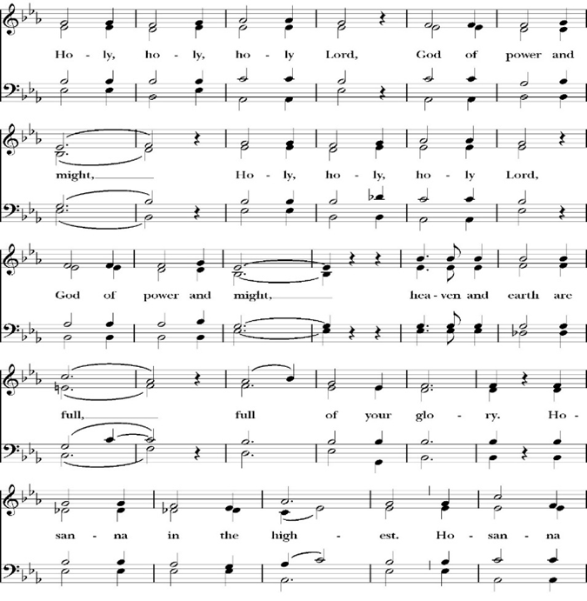
Sanctus

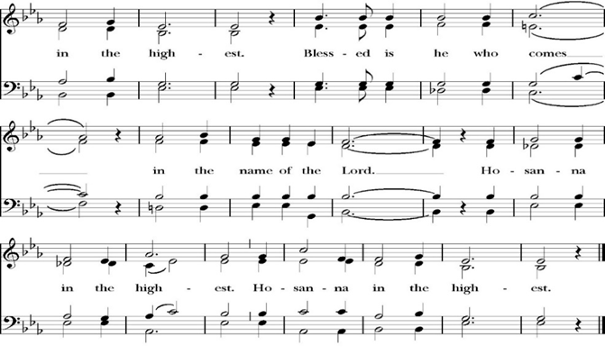
Holy and gracious Father: In your infinite love you made us for yourself; and when we had sinned against you and become subject to evil and death, you, in your mercy, sent your only Son Jesus Christ
into the world for our salvation. By the Holy Spirit and the Virgin Mary he became flesh and dwelt among us. In obedience to your will, he stretched out his arms upon the Cross and offered himself once for all, that by his suffering and death we might be saved. By his resurrection he broke the bonds of death, trampling Hell and Satan under his feet. As our great high priest, he ascended to your right hand in glory, that we might come with confidence before the throne of grace.

On the night that he was betrayed, our Lord Jesus Christ took bread; and when he had given thanks, he broke it,* and gave it to his disciples, saying, “Take, eat; this is my Body, which is given for you: Do this in remembrance of me.”

Likewise, after supper, Jesus took the cup, and when he had given thanks, he gave it to them, saying, “Drink this, all of you; for this is my Blood of the New Covenant, which is shed for you, and for many, for the forgiveness of sins: Whenever you drink it, do this in remembrance of me.”

Therefore we proclaim the mystery of faith:

Christ has died.
Christ is risen.
Christ will come again.

We celebrate the memorial of our redemption, O Father, in this sacrifice of praise and thanksgiving, and we offer you these gifts.

Sanctify them by your Word and Holy Spirit to be for your people the Body and Blood of your Son Jesus Christ. Sanctify us also, that we may worthily receive this holy Sacrament, and be made one body with him, that he may dwell in us and we in him. In the fullness of time, put all things in subjection under your Christ, and bring us with all your saints into the joy of your heavenly kingdom, where we shall see our Lord face to face.

All this we ask through your Son Jesus Christ: By him, and with him, and in him, in the unity of the Holy Spirit, all honor and glory is yours, Almighty Father, now and for ever. Amen.

And now, as our Savior Christ has taught us, we are bold to pray,

Our Father, who art in heaven,
hallowed be thy Name,
thy kingdom come,
thy will be done,
on earth as it is in heaven.
Give us this day our daily bread.
And forgive us our trespasses,
as we forgive those
who trespass against us.
And lead us not into temptation,
but deliver us from evil.
For thine is the kingdom,
and the power, and the glory,
for ever and ever. Amen.

Celebrant Alleluia! Christ our Passover is sacrificed for us.
People Therefore let us keep the feast. Alleluia!

We do not presume to come to this your table, O merciful Lord,
trusting in our own righteousness,
but in your abundant and great mercies.
We are not worthy so much as to gather up
the crumbs under your table;
but you are the same Lord
whose character is always to have mercy.
Grant us, therefore, gracious Lord,
so to eat the flesh of your dear Son Jesus Christ,
and to drink his blood,
that our sinful bodies may be made clean by his body,
and our souls washed through his most precious blood,
and that we may evermore dwell in him, and he in us.
Amen.

Agnus Dei

The Ministration of Communion

The gifts of God for the People of God. Take them in remembrance that Christ died for you and feed on him in your hearts by faith, with thanksgiving.

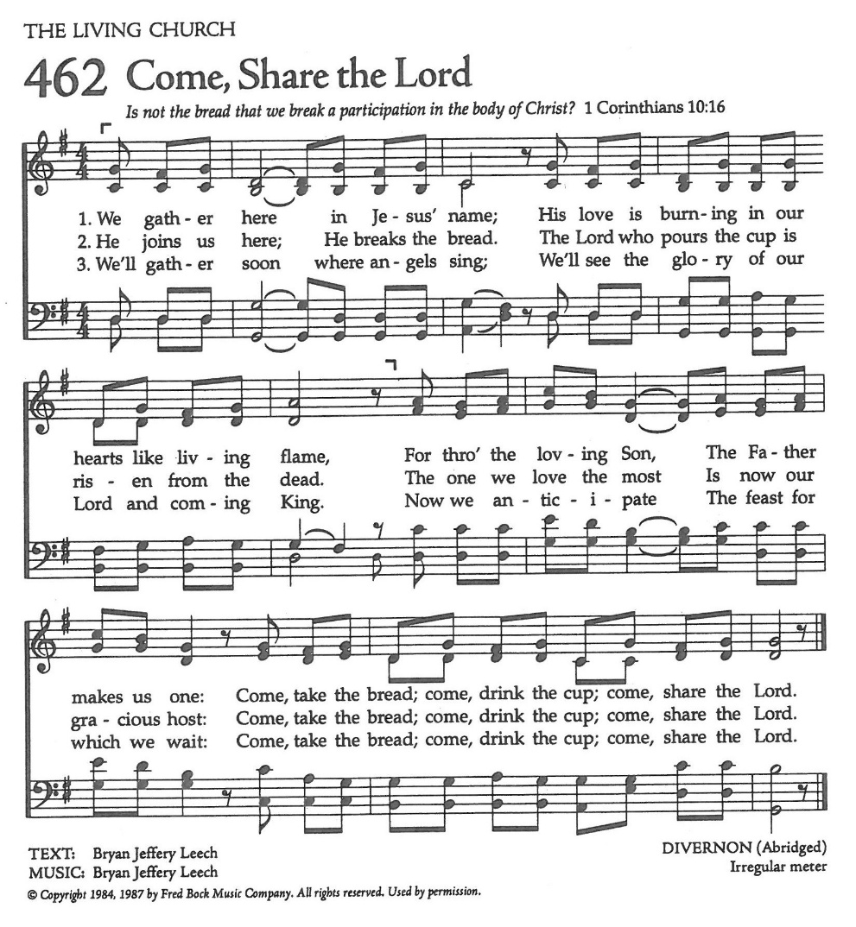
Communion Hymn: Come Share the Lord

The Post Communion Prayer

Let us pray.

Heavenly Father,
We thank you for feeding us with the spiritual food
of the most precious Body and Blood
of your Son our Savior Jesus Christ;
and for assuring us in these holy mysteries
that we are living members of the body of your Son,
and heirs of your eternal Kingdom.
And now, Father, send us out to do the work you have
given us to do,
to love and serve you as faithful witnesses of Christ our
Lord.
To him, to you, and to the Holy Spirit,
be honor and glory, now and for ever. Amen.

The Blessing

The blessing of God Almighty, the Father, the Son, and the Holy
Spirit, be among you, and remain with you always. Amen.

Closing Hymn: O For a Thousand Tongues to Sing

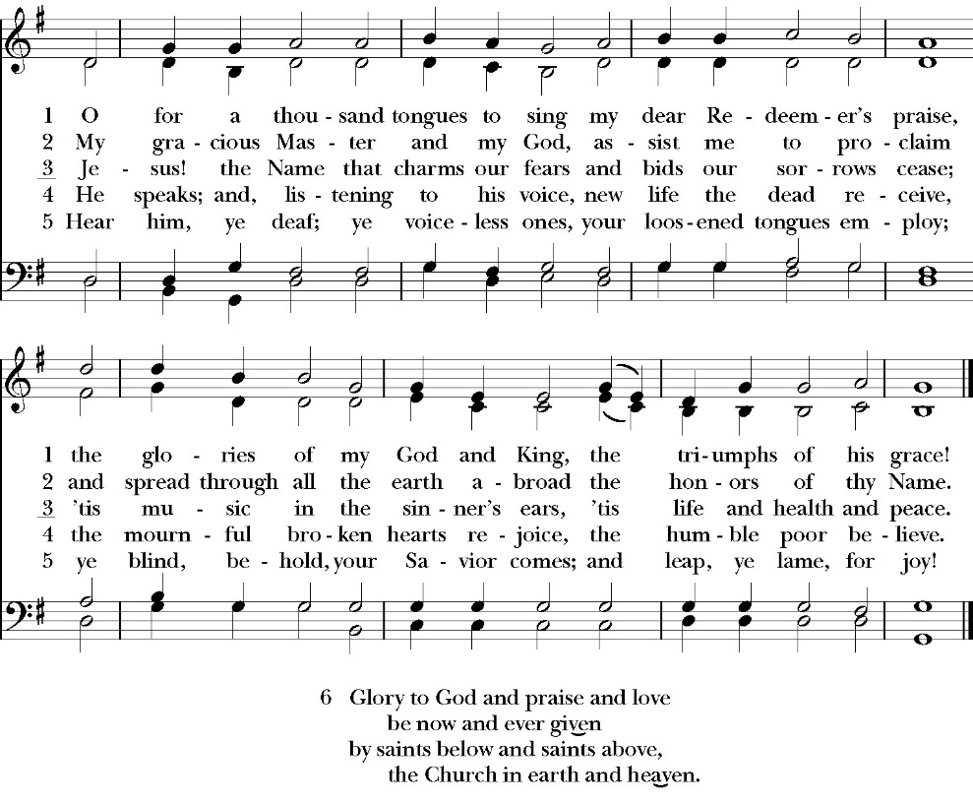

Celebrant Alleluia, Alleluia! Let us go forth in the name of Christ.
People Thanks be to God. Alleluia! Alleluia!

St. Paul’s Parish Calendar
Sunday April 19 – Sunday April 26

SUNDAY, April 19 – Third Sunday of Easter
9:15 AM Sunday Funday, Youth Room
9:15 AM Gospel of John Bible study, Conference Room
10:30 AM Children’s Sunday School, Chapel
Pre-K –2nd Grade, Sunday School Room
3rd -5th Grade, Youth Room
10:30 AM Holy Eucharist, Church

MONDAY, April 20
6:30 PM Women’s Bible Study, Conference Room

TUESDAY, April 21
6:00 PM Bell Choir Practice, Music Room

WEDNESDAY, April 22
9:30 AM Holy Eucharist with healing prayer, Chapel
10:15 AM Bible Study, Conference Room
7:00 PM Choir Practice, Chapel

THURSDAY, April 23

FRIDAY, April 24
6:30 AM Men’s Bible Study, Valhalla Restaurant

SATURDAY, April 25

SUNDAY, April 26 – Fourth Sunday of Easter
9:15 AM Sunday Funday, Youth Room
9:15 AM Gospel of John Bible study, Conference Room
9:30 AM Bell Choir Rehearsal, Church
10:30 AM Children’s Sunday School, Chapel
Pre-K –2nd Grade, Sunday School Room
3rd -5th Grade, Youth Room
10:30 AM Holy Eucharist, Church

Church Office Hours
Monday-Thursday 8:00 AM-4:00 PM

Sunday Morning Bible Study: The Gospel of John
St. Paul’s is embarking on a study of the Gospel of John that will span the next year. These classes will be on Sunday mornings from 9:15-10:00AM. We will take the better part of the next year to move slowly through John and savor the profound spiritual truths that it offers. We will be using a book called Be Alive by Warren Wiersbe as our guide. This book is essentially a study guide to the Gospel of John and will provide us with structure and insight as we move our way through the Gospel. Books will be available beginning the day of the first class.

Projected Class Timeline

April-May Chapters 4-8
June Chapter 9
July No Class
August Chapter 10

The class will progress based on how quickly or slowly is needed and our projected timelines may change as we move forward.

Wonderful Wednesday Dinner, May 6, 6:00PM
Theme: Cinco de Mayo Dinner.
Everyone is invited to join us for a Mexican food themed dinner in James Hall on Wednesday, May 6 at 6:00PM. Immediately after dinner there will be a pinata break in the courtyard for all the children.

Anglican Fourth Day Community Gathering
Wednesday, May 6, after Wonderful Wednesday Dinner.
The Anglican Fourth Day community is gathering together for what is called an Ultreya after the Wonderful Wednesday dinner on May 6. Ultreya’s are both a reunion for those who have attended the weekend and an opportunity for those exploring interest in the weekend retreat. This meeting will be about 30 minutes and include music, sharing from alumni of the weekend and encouragement for our walk with Jesus. This gathering will take place right in James Hall immediately following our dinner. All are welcome.
Car Show Hosted by St. Clement’s Anglican Church Day Care, Woodlake
Sunday, April 26, 9:00AM-2:00PM
St. Clement’s is inviting members of St. Paul’s to attend a car show that is a community outreach project and fundraiser for their daycare program. The car show will be combined with worship at 10:00AM. There will be worship, classic cars, food vendors and craft vendors. The event is located at St. Clement’s Anglican Church, Woodlake.
Location: 498 N. Valencia Blvd, Woodlake, CA.

St. Paul’s School Spring Auction, Saturday, May 9
“Stetsons and Starlight”
The St. Paul’s School spring auction is always a wonderful evening of fun and fundraising to support the work and ministry of the school. Tickets can be purchased beginning at $125 and up. Sponsorship opportunities are available at a variety of levels, and all members of St. Paul’s are invited to come out in your fanciest western wear! For more information, please talk with Fr. Rob, Deacon John, or call St. Paul’s School at 739-1619.

Friends and Fellowship, Saturday, May 30
Home of Blake and Madelyn Schneeman in Tulare
Our next Friends and Fellowship gathering for adults will be hosted by Blake and Madelyn Schneeman. As always, attendees are asked to bring an appetizer and their favorite drink to share. Please RSVP by calling the church office. The Schneeman’s address in Tulare will be provided when you call the church office.

Friends and Fellowship Always Looking for a Few Good Hosts
Friends and Fellowship is an important opportunity for our church community to gather together throughout the year to simply enjoy each other’s company and share in fellowship. We appreciate those who have volunteered and are still looking for more new hosts for this low-key fun event. Those who host simply open up their home while attendees bring food and refreshments for all to share. If you think you might have this gift of hospitality, please speak to Kim Robinson or Fr. Rob Longbottom and we would love to talk with you more about hosting.
Courtyard Gates Financial Campaign Update
We are very close to our financial goal for the courtyard gates. Thanks to the generosity of the people of St. Paul’s and the hard work of our rummage sale team we have raised $27,850 of our $32,5000 goal. It is likely our estimate will need to increase due to design changes which call for more metal and hooking in the gates to our security system. If you desire to give, but have yet to do so, there is still time. Thank you to everyone who has donated to date.

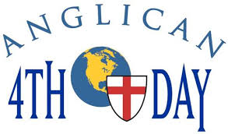
Anglican Fourth Day
QUESTION: What is the difference between Cursillo and Anglican 4th Day?
Absolutely nothing!

Anglican Fourth Day is the continuing ministry of Cursillo within the Anglican Church of North America.

More information on the Anglican 4th Day weekend:

PLACE: St Anthony's Retreat Center in Three Rivers
DATES: July 9-12, 2026
TIME: All day every day; some evenings
COST: $25.00
FOOD: 3 excellent meals a day plus snacks
ACCOMMODATIONS: Air-conditioned 2-person room with

bathroom, two twin beds; 24/7 use of chapel.
For any more information you may need to make a decision that will change your life, call Janet Robinson at 559-627-1783 or 559-786-9791.

St. Paul’s Anglican Church
Parish Office
6436 W. Hurley Ave
Visalia, California 93291
559-732-4821
Office Hours: 8:00 – 4:00
Monday – Thursday

Worship: Sundays at 10:30AM
Livestream: Link at spvisalia.com
and on our Facebook page
Please be advised that this service is being recorded for broadcast
and/or archival purposes. By attending, you consent
to the inclusion of your likeness in these recordings.

St. Paul’s Clergy and Staff
The Rev. Robert Longbottom, Rector
rector@spvisalia.com
(559)802-2928
The Rev. John Iseman, Pastoral Associate for Family Ministries
family@spvisalia.com
The Rev. Kashy Rowland-Smith, Deacon
kashyrs@aol.com
Antoinette Horsting, Parish Administrator
bookkeeper@spvisalia.com
Marguerite Crownover, Organist and Accompanist
Cynthia Culp, Choral Director
Jackie Iseman, Nursery Coordinator
Shane Motl, Sexton

St. Paul’s is a member church of the
Anglican Diocese of San Joaquin
The Rt. Rev. Eric V. Menees, Bishop

Next Week’s Lessons
Acts 6:1-9, 7:3a, 15-60
Psalm 23
1 Peter 2:13-25
Luke 10:1-10

