ST. PAUL’S ANGLICAN CHURCH
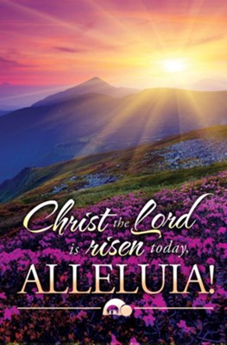
VISALIA, CALIFORNIA

EASTER SUNDAY
With Baptism and First Communion
April 5, 2026
10:30 A.M
Baptismal Candidate: Joseph Asman
First Communion: Abigail and Madelyn Asman
Children of Jason and Suzanne Asman

Welcome!

St. Paul’s Anglican Church extends a warm welcome to all visitors and newcomers, whether worshiping in person or at home via livestream.

Visitors’ Guide

St. Paul’s Church is a parish in the Diocese of San Joaquin of the Anglican Church in North America, which includes both Catholic and Protestant traditions. We accept Jesus Christ as Savior, and we promise to follow him as Lord. We believe in One God,

- the Father who created us and all things,
- the Son who redeems us from sin and death,
- the Holy Spirit who renews and sanctifies us.

We believe the Holy Scriptures to be the Word of God and to contain all things necessary for salvation, and we accept the Apostles’ and Nicene Creeds as essential beliefs of the Christian faith.

Holy Communion is open to all baptized Christians who have examined their lives, repented of their sins, and desire to live
in love and charity with all people.

Those not desiring to receive Holy Communion, and those who have not been baptized into the Christian faith, are invited to cross their arms across their chest, and a blessing will be given instead.

Visitors are invited to sign the guest book at the entrance table and introduce themselves to the clergy following the service.
The Holy Eucharist with Holy Baptism

Prelude: “Morning Has Broken” Wood
Opening Hymn: #175 - “Hail Thee, Festival Day” p. 4
Opening Acclamation p. 5
The Collect for Purity p. 5
Summary of the Law p. 5
Kyrie p. 5
Gloria p. 6
Collect of the Day p. 7
Lesson: Acts 10 :34-43 p. 7
Gradual: Psalm 118:14-17,22-24 p. 8
Epistle: Colossians 3:1-4 p. 8
Sequence Hymn: #182 - “Christ is Alive!” p. 9
Gospel: John 20:1-18 p. 9
Sermon: Rev. Robert Longbottom
The Exhortation p. 11
The Presentation p. 11
Profession of Faith p. 12
Litany for the Candidates p. 13
Thanksgiving Over the Water p. 14
The Peace p. 16
Choral Anthem: “He is Risen”
The Offertory p. 16
Sursum Corda p. 16
Proper Preface p. 16
Sanctus p. 17
The Lord’s Prayer p. 19
Fraction p. 19
Prayer for Humble Access p. 20
Agnus Dei p. 20
Communion Hymn: #209 - “We Walk by Faith” p. 21
Communion Praise Song “Above All” p. 22
Post Communion Prayer p. 24
Blessing p. 24
Closing Hymn: #207 - “Jesus Christ is Risen Today” p. 25
Dismissal p. 26
Postlude: “In Thee is Gladness” Bach
Opening Hymn: Hail Thee, Festival Day
Opening Acclamation

Celebrant Alleluia! Christ is risen!
People The Lord is risen indeed! Alleluia!
Celebrant There is one Body and one Spirit;
People There is one hope in God’s call to us;
Celebrant One Lord, one Faith, one Baptism;
People One God and Father of all.

Collect for Purity

Celebrant: Almighty God, to you all hearts are open, all desires
known, and from you no secrets are hid: Cleanse the thoughts
of our hearts by the inspiration of your Holy Spirit, that we
may perfectly love you, and worthily magnify your holy Name;
through Christ our Lord. Amen.

Summary of the law

Celebrant: Hear what our Lord Jesus Christ says: You shall love
the Lord your God with all your heart and with all your soul
and with all your mind. This is the first and great
commandment. And the second is like it: You shall love your
neighbor as yourself. On these two commandments depend all
the Law and the Prophets.

Kyrie
Gloria

Celebrant The Lord be with you.
People And with your spirit.
Celebrant Let us pray.

The Collect of the Day
Almighty God, who through your only-begotten Son Jesus Christ overcame death and opened to us the gate of everlasting life: Grant that we, who celebrate with joy the day of the Lord’s resurrection, may, by your life-giving Spirit, be delivered from sin and raised from death; through Jesus Christ our Lord, who lives and reigns with you and the Holy Spirit, one God, now and for ever. Amen.

Lesson: Acts 120:34-43
So Peter opened his mouth and said: “Truly I understand that God shows no partiality, 35 but in every nation anyone who
fears him and does what is right is acceptable to him. 36 As for the word that he sent to Israel, preaching good news of peace through Jesus Christ (he is Lord of all), 37 you yourselves know what happened throughout all Judea, beginning from Galilee after the baptism that John proclaimed: 38 how God anointed Jesus of Nazareth with the Holy Spirit and with power. He went about doing good and healing all who were oppressed by the devil, for God was with him. 39 And we are witnesses of all that he did both in the country of the Jews and in Jerusalem. They put him to death by hanging him on a tree, 40 but God raised him on the third day and made him to appear, 41 not to all the people but to us who had been chosen by God as witnesses, who ate and drank with him after he rose from the dead. 42 And he commanded us to preach to the people and to testify that he is the one appointed by God to be judge of the living and the dead. 43 To him all the prophets bear witness that everyone who believes in him receives forgiveness of sins through his name.”

Reader: The Word of the Lord
People: Thanks be to God

Gradual: Psalm 118:14-17,22-24
14 The LORD is my strength and my song, *
and has become my salvation.
15 The voice of joy and deliverance is in the dwellings of the
righteous; *
the right hand of the LORD brings mighty things to pass.
16 The right hand of the LORD is exalted; *
the right hand of the LORD brings mighty things to pass.
17 I shall not die, but live, *
and declare the works of the LORD.
22 The same stone which the builders refused *
has become the chief cornerstone.
23 This is the LORD’s doing, *
and it is marvelous in our eyes.
24 This is the day that the LORD has made; *
we will rejoice and be glad in it.

Glory be to the Father, and to the Son, and to the Holy Spirit;
as it was in the beginning, is now, and ever shall be, world without end. Amen
Epistle: Colossians 3:1-4
¹ If then you have been raised with Christ, seek the things that are above, where Christ is, seated at the right hand of God. ² Set your minds on things that are above, not on things that are on earth. ³ For you have died, and your life is hidden with Christ in God. ⁴ When Christ who is your life appears, then you also will appear with him in glory.
Reader: The Word of the Lord
People: Thanks be to God

Sequence Hymn: Christ is Alive!
(Verses 1-3 before Gospel, Verses 4-5 after

Clergy: The Gospel of the Lord, according to St. John
People: Glory to you, Lord God

Gospel: John 20:1-18

Now on the first day of the week Mary Magdalene came to the tomb early, while it was still dark, and saw that the stone had been taken away from the tomb. 2 So she ran and went to Simon Peter and the other disciple, the one whom Jesus loved, and said to them, “They have taken the Lord out of the tomb, and we do not know where they have laid him.” 3 So Peter went out with the other disciple, and they were going toward the tomb. 4 Both of them were running together, but the other disciple outran Peter and reached the tomb first. 5 And stooping to look in, he saw the linen cloths lying there, but he did not go in. 6 Then Simon Peter came, following him, and went into the tomb. He saw the linen cloths lying there, 7 and the face cloth, which had been on Jesus' head, not lying with the linen cloths but folded up in a place by itself. 8 Then the other disciple, who had reached the tomb first, also went in, and he saw and believed; 9 for as yet they did not understand the Scripture, that he must rise from the dead. 10 Then the disciples
went back to their homes.

11 But Mary stood weeping outside the tomb, and as she wept she stooped to look into the tomb. 12 And she saw two angels in white, sitting where the body of Jesus had lain, one at the head and one at the feet. 13 They said to her, “Woman, why are you weeping?” She said to them, “They have taken away my Lord, and I do not know where they have laid him.” 14 Having said this, she turned around and saw Jesus standing, but she did not know that it was Jesus. 15 Jesus said to her, “Woman, why are you weeping? Whom are you seeking?” Supposing him to be the gardener, she said to him, “Sir, if you have carried him away, tell me where you have laid him, and I will take him away.” 16 Jesus said to her, “Mary.” She turned and said to him in Aramaic, “Rabboni!” (which means Teacher). 17 Jesus said to her, “Do not cling to me, for I have not yet ascended to the Father; but go to my brothers and say to them, ‘I am ascending to my Father and your Father, to my God and your God.’”

18 Mary Magdalene went and announced to the disciples, “I have seen the Lord”—and that he had said these things to her.

Clergy: The Gospel of the Lord
People: Praise to you, Lord Christ

Sermon
The Rev. Robert Longbottom

THE BAPTISMAL LITURGY
THE EXHORTATION

Dearly beloved, Scripture teaches that we were all dead in our sins and trespasses, but by grace we may be saved through faith. Our Savior Jesus Christ said, “Unless one is born of water and the Spirit, he cannot enter the kingdom of God”; and he commissioned the Church to “make disciples of all nations, baptizing them in the Name of the Father, and of the Son, and of the Holy Spirit.” Here we ask our heavenly Father that this Candidate, being baptized with water, may be filled with the Holy Spirit, born again, and received into the Church as living members of Christ’s body. Therefore, I urge you to call upon God the Father, through our Lord Jesus Christ, that of his abundant mercy he will grant to this Candidate that which by nature he cannot have.

THE PRESENTATION

Celebrant: The Candidate for Holy Baptism will now be presented.

Sponsors: I present Joseph Robert Asman to receive the Sacrament of Baptism.

Celebrant:

Today, on behalf of this child, you shall make vows to renounce the devil and all his works, to trust God wholeheartedly, and to serve him faithfully. It is your task to see that child is taught, as soon as he is able to learn, the meaning of all these vows, and of the Faith that you will profess as revealed in the Holy Scriptures. He must come to put his faith in Jesus Christ, and learn the Creeds, the Lord’s Prayer, the Ten Commandments, and all other things that a Christian ought to know, believe, and do for the welfare of his soul. When he has embraced all these, he is to come to the Bishop to be confirmed, that he may publicly claim the Faith for his own and be further strengthened by the Holy Spirit to serve Christ and his kingdom.

Are you willing and ready to undertake this?

Sponsors: I am, the Lord being my helper.

PROFESSION OF FAITH

Question Do you renounce the devil and all the spiritual forces of
wickedness that rebel against God?
Answer I renounce them.

Question Do you renounce the empty promises and deadly deceits of this world that corrupt and destroy the creatures of God?
Answer I renounce them.

Question Do you renounce the sinful desires of the flesh that draw
you from the love of God?
Answer I renounce them.

The Celebrant prays over the Candidate and may anoint each Candidate with the Oil of Exorcism, saying

Almighty God, deliver you from the powers of darkness and evil, and lead you into the light and obedience of the kingdom of his Son Jesus Christ our Lord. Amen.

Question Do you turn to Jesus Christ and confess him as your Lord
and Savior?
Answer I do.

Question Do you joyfully receive the Christian Faith, as revealed in the Holy Scriptures of the Old and New Testaments?
Answer I do.

Question Will you obediently keep God’s holy will and commandments, and walk in them all the days of your life?
Answer I will, the Lord being my helper.

Will you who witness these vows do all in your power to support these persons in their life in Christ?

ALL: We will.

Let us join with this Candidate to proclaim our faith in the words of the ancient baptismal confession, the Apostles’ Creed.

Celebrant Do you believe and trust in God the Father?
People I do.
I believe in God, the Father almighty,
creator of heaven and earth.
Celebrant Do you believe and trust in Jesus Christ?
People I do.
I believe in Jesus Christ, his only Son, our Lord.
He was conceived by the Holy Spirit
and born of the Virgin Mary.
He suffered under Pontius Pilate,
was crucified, died, and was buried.
He descended to the dead.
On the third day he rose again.
He ascended into heaven,
and is seated at the right hand of the Father.

He will come again to judge the living and the dead.
Celebrant Do you believe and trust in the Holy Spirit?
People I do.
I believe in the Holy Spirit,
the holy catholic Church,
the communion of saints,
the forgiveness of sins,
the resurrection of the body,

and the life everlasting. Amen.

LITANY FOR THE CANDIDATES

Let us now pray for Joseph who is to receive the Sacrament of Baptism.

That Joseph may come to confess his faith in Jesus Christ as Lord and Savior,
We beseech you to hear us, Good Lord.

That Joseph may continue in the apostles’ teaching and the fellowship, in the breaking of bread, and in the prayers.
We beseech you to hear us, Good Lord.

That he may walk in a manner worthy of the calling to which he has been called, ever growing in faith and all heavenly virtues.
We beseech you to hear us, Good Lord.

That he may persevere in resisting evil, and, whenever he falls into sin, repent and return to the Lord.
We beseech you to hear us, Good Lord.

That he may proclaim by word and deed the Good News of God in Christ Jesus to a lost and broken world.
We beseech you to hear us, Good Lord.

That as living members of the Body of Christ, he grows up in every way into him who is the head.
We beseech you to hear us, Good Lord.

That, looking to Jesus, he may run with endurance the race set before him, and at the last receive the unfading crown of glory.
We beseech you to hear us, Good Lord.

Celebrant: Let us pray.

Almighty and everlasting Father, in your great mercy you saved Noah and his family in the Ark from the destruction of the flood, prefiguring the Sacrament of Holy Baptism. Look mercifully upon this, your servant Joseph. Wash and sanctify him through your Holy Spirit, that he may be delivered from destruction and received into the Ark of Christ’s Church; and being steadfast in faith, joyful through hope, and rooted in love, he may pass through the turbulent floods of this troublesome world and come into the land of everlasting life, through Jesus Christ our Lord. Amen.

THANKSGIVING OVER THE WATER

Celebrant The Lord be with you.
People And with your spirit.
Celebrant Lift up your hearts.
People We lift them up to the Lord.
Celebrant Let us give thanks to the Lord our God.
People It is right to give him thanks and praise.

We thank you, Almighty God, for the gift of water. Over it the Holy Spirit moved in the beginning of creation. Through it you led the children of Israel out of their bondage in Egypt into the land of promise. In it your Son Jesus received the baptism of John in the River Jordan when the Holy Spirit descended upon him as a dove.

We thank you, Father, for the water of Baptism. In it we are buried with Christ in his death. By it we share in his resurrection. Through it we are made regenerate by the Holy Spirit. Therefore, in joyful obedience to your Son, we bring into his fellowship those who come to him in faith, baptizing them in the Name of the Father, and of the Son, and of the Holy Spirit.

Now, Father, sanctify this water by the power of your Holy Spirit. May all who are baptized here be cleansed from sin, be born again, and continue for ever faithful in the risen life of Jesus Christ our Savior. To him, to you, and to the Holy Spirit, be all honor and glory, now and for ever. Amen.

The Celebrant says to the Sponsors:

Name this Child.

Joseph Robert Asman, I baptize you in the Name of the Father, and of the Son, and of the Holy Spirit. Amen.

Joseph receive the sign of the Cross as a token of your new life in Christ, in which you shall not be ashamed to confess the faith of Christ crucified, to fight bravely under his banner against the world, the flesh, and the devil, and to continue as his faithful soldier and servant to the end of your days. Amen.

Heavenly Father, we thank you that by water and the Holy Spirit you have bestowed upon your servant the forgiveness of sin, received him as your own child by adoption, made him a member of your holy Church, and raised him to the new life of grace. Sustain him, O Lord, in your Holy Spirit, that he may enjoy everlasting salvation through Jesus Christ our Lord. Amen.

Let us welcome the newly baptized.

We receive you into the fellowship of the Church. Confess the faith of Christ crucified, proclaim his resurrection, and share with us in the royal priesthood of all his people.

Celebrant The Peace of the Lord be always with you.
People And with your spirit.

Choral Anthem:
he is risen

Offertory

Celebrant All things come from you, O Lord,
People And of your own have we given you.

The Eucharistic Liturgy

Celebrant The Lord be with you.
People And with your spirit.
Celebrant Lift up your hearts.
People We lift them up to the Lord.
Celebrant Let us give thanks to the Lord our God.
People It is right to give him thanks and praise.

It is right, our duty and our joy, always and everywhere to give thanks to you, Father Almighty, Creator of heaven and earth.

But chiefly are we bound to praise you for the glorious resurrection of your Son Jesus Christ our Lord; for he is the true Paschal Lamb, who was offered for us, and has taken away the sin of the world; who by his death has destroyed death, and by his rising to life again has won for us everlasting life

Therefore we praise you, joining our voices with Angels and Archangels and with all the company of heaven, who for ever sing this hymn to proclaim the glory of your Name:

Sanctus

Holy and gracious Father: In your infinite love you made us for yourself; and when we had sinned against you and become subject to evil and death, you, in your mercy, sent your only Son Jesus Christ into the world for our salvation. By the Holy Spirit and the Virgin Mary he became flesh and dwelt among us. In obedience to your will, he stretched out his arms upon the Cross and offered himself once for all, that by his suffering and death we might be saved. By his resurrection he broke the bonds of death, trampling Hell and Satan under his feet. As our great high priest, he ascended to your right hand in glory, that we might come with confidence before the throne of grace.

On the night that he was betrayed, our Lord Jesus Christ took bread; and when he had given thanks, he broke it,* and gave it to his disciples, saying, “Take, eat; this is my Body, which is given for you: Do this in remembrance of me.”

Likewise, after supper, Jesus took the cup, and when he had given thanks, he gave it to them, saying, “Drink this, all of you; for this is my Blood of the New Covenant, which is shed for you, and for many, for the forgiveness of sins: Whenever you drink it, do this in remembrance of me.”

Therefore we proclaim the mystery of faith:

Christ has died.
Christ is risen.
Christ will come again.

We celebrate the memorial of our redemption, O Father, in this sacrifice of praise and thanksgiving, and we offer you these gifts.

Sanctify them by your Word and Holy Spirit to be for your people the Body and Blood of your Son Jesus Christ. Sanctify us also, that we may worthily receive this holy Sacrament, and be made one body with him, that he may dwell in us and we in him. In the fullness of time, put all things in subjection under your Christ, and bring us with all your saints into the joy of your heavenly kingdom, where we shall see our Lord face to face.

All this we ask through your Son Jesus Christ: By him, and with him, and in him, in the unity of the Holy Spirit, all honor and glory is yours, Almighty Father, now and for ever. Amen.

And now, as our Savior Christ has taught us, we are bold to pray,

Our Father, who art in heaven,
hallowed be thy Name,
thy kingdom come,
thy will be done,
on earth as it is in heaven.
Give us this day our daily bread.
And forgive us our trespasses,
as we forgive those
who trespass against us.
And lead us not into temptation,
but deliver us from evil.
For thine is the kingdom,
and the power, and the glory,
for ever and ever. Amen.

Celebrant Alleluia! Christ our Passover is sacrificed for us.
People Therefore let us keep the feast. Alleluia!

We do not presume to come to this your table, O merciful Lord,
trusting in our own righteousness,
but in your abundant and great mercies.
We are not worthy so much as to gather up
the crumbs under your table;
but you are the same Lord
whose character is always to have mercy.
Grant us, therefore, gracious Lord,
so to eat the flesh of your dear Son Jesus Christ,
and to drink his blood,
that our sinful bodies may be made clean by his body,
and our souls washed through his most precious blood,
and that we may evermore dwell in him, and he in us.
Amen.

Agnus Dei

The Ministration of Communion

The gifts of God for the People of God. Take them in remembrance that Christ died for you and feed on him in your hearts by faith, with thanksgiving.

Communion Hymn: We Walk by Faith

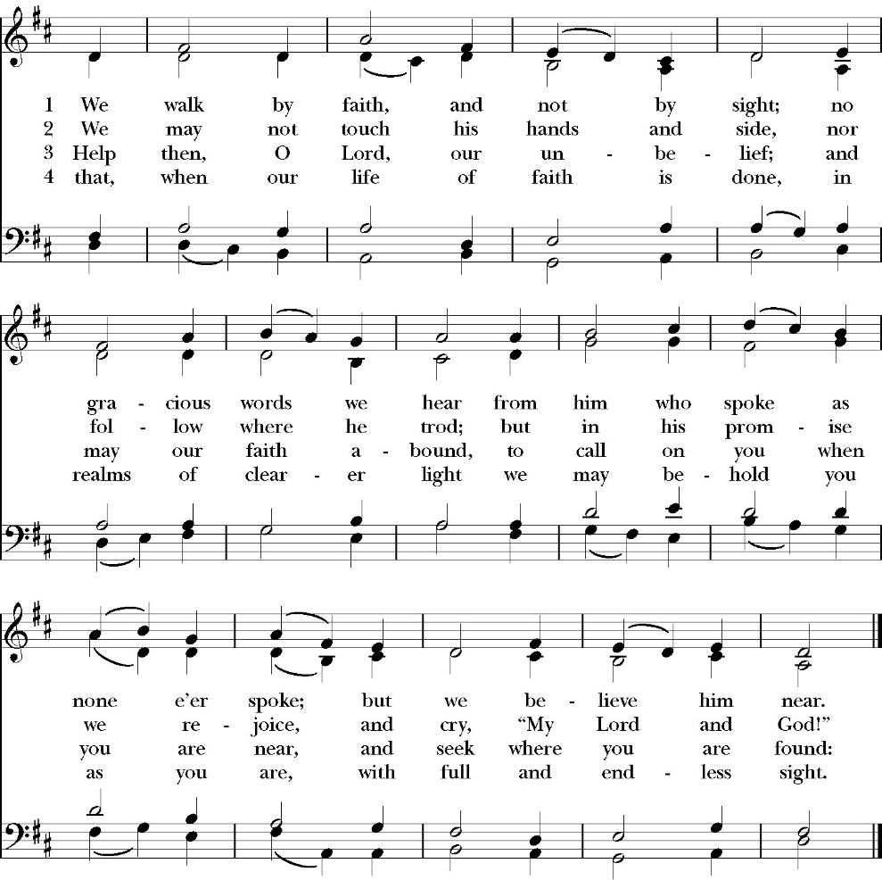

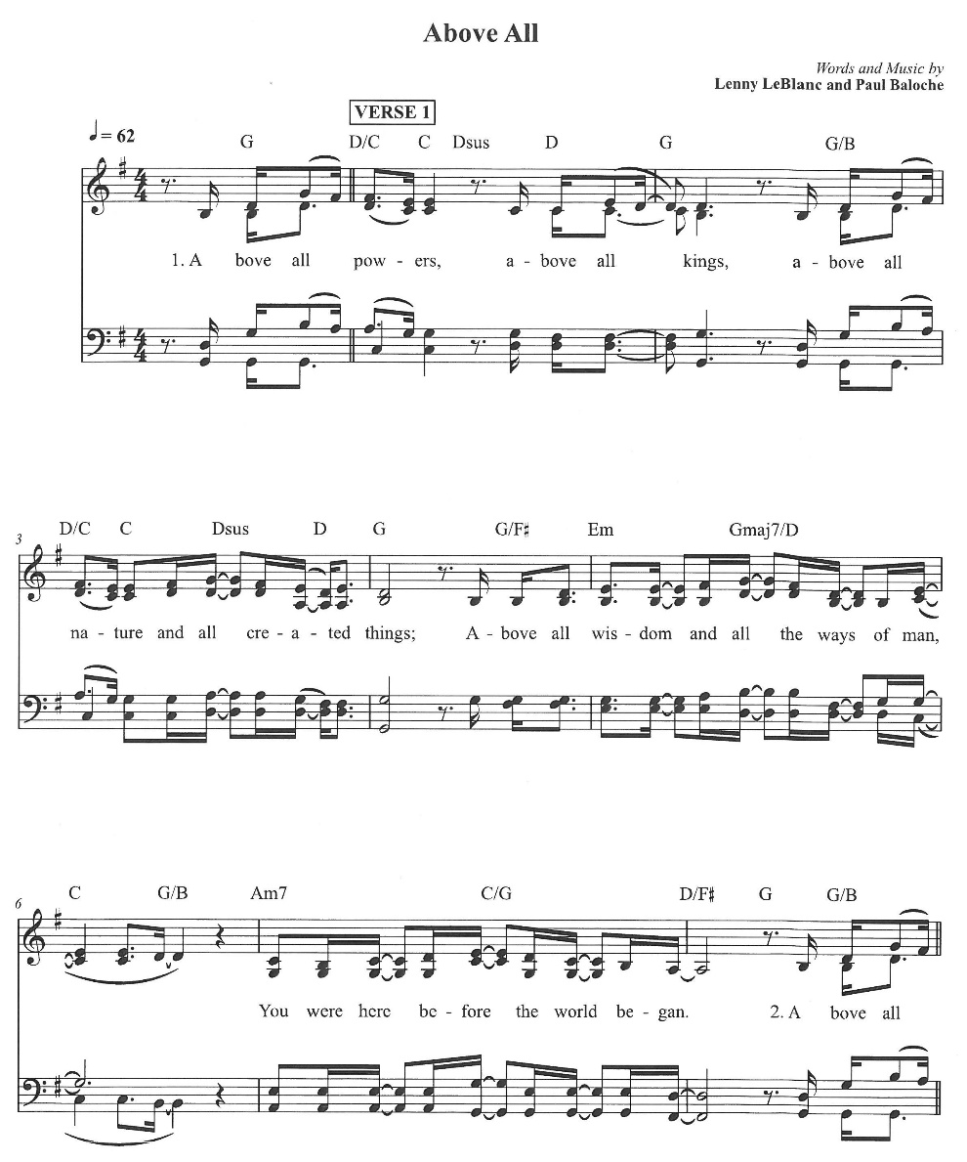
Communion Praise Song

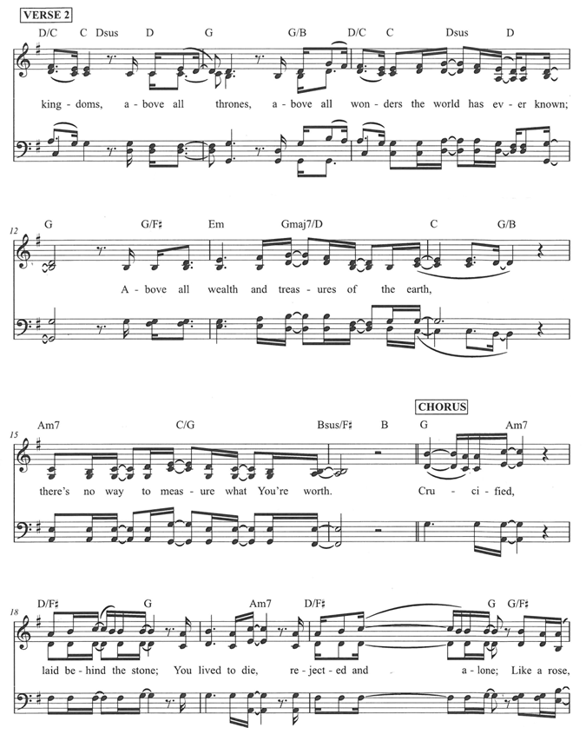

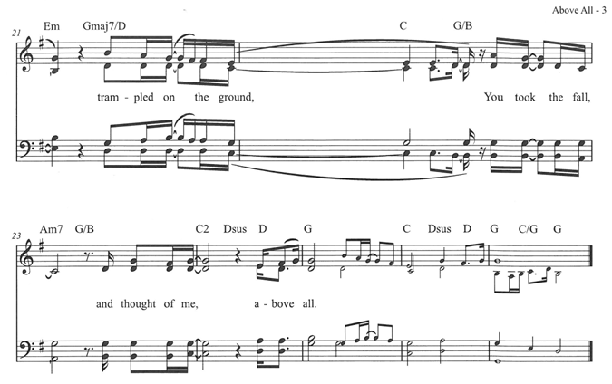
The Post Communion Prayer

Let us pray.

Heavenly Father,
We thank you for feeding us with the spiritual food
of the most precious Body and Blood
of your Son our Savior Jesus Christ;
and for assuring us in these holy mysteries
that we are living members of the body of your Son,
and heirs of your eternal Kingdom.
And now, Father, send us out to do the work you have
given us to do,
to love and serve you as faithful witnesses of Christ our
Lord.
To him, to you, and to the Holy Spirit,
be honor and glory, now and for ever. Amen.

The Blessing

The blessing of God Almighty, the Father, the Son, and the Holy
Spirit, be among you, and remain with you always. Amen.

Closing Hymn: Jesus Christ is Risen Today

Celebrant Alleluia, Alleluia! Let us go forth in the name of Christ.
People Thanks be to God. Alleluia! Alleluia!

The Congregation is invited to join with the Choir singing THE HALLELUJAH CHORUS by Handel immediately after the recessional hymn.
St. Paul’s Parish Calendar
Sunday April 5 – Sunday April 12

SUNDAY, April 5 – Easter Sunday
8:00AM Sunrise Service of scripture and the Great Litany. No Holy Eucharist
10:30 AM Festival Easter Holy Eucharist with Baptism
11:30 AM Easter Egg Hunt

MONDAY, April 6 – Office Closed

TUESDAY, April 7
6:00 PM Bell Choir Practice, Music Room
6:00 PM Assistance League, James Hall

WEDNESDAY, April 8
9:30 AM Holy Eucharist with healing prayer, Chapel
10:15 AM Bible Study, Conference Room

THURSDAY, April 9

FRIDAY, April 10
6:30 AM Men’s Bible Study, Valhalla Restaurant

SATURDAY, April 11

SUNDAY, April 12 – Second Sunday of Easter
9:15 AM Sunday Funday, Youth Room
9:15 AM Gospel of John Bible study, Conference Room
9:30 AM Vocal Choir rehearsal, Chapel
10:30 AM Children’s Sunday School, Chapel
Pre-K –2nd Grade, Sunday School Room
3rd -5th Grade, Youth Room
10:30 AM Holy Eucharist, Church

Monday April 6
Office will be closed

Church Office Hours
Monday-Thursday 8:00 AM-4:00 PM
Sunday Morning Bible Study: The Gospel of John
St. Paul’s is embarking on a study of the Gospel of John that will span the next year. These classes will be on Sunday mornings from 9:15-10:00AM. We will take the better part of the next year to move slowly through John and savor the profound spiritual truths that it offers. We will be using a book called Be Alive by Warren Wiersbe as our guide. This book is essentially a study guide to the Gospel of John and will provide us with structure and insight as we move our way through the Gospel. Books will be available beginning the day of the first class.

Projected Class Timeline

Easter Chapters 4-8
June Chapter 9
August Chapter 10
Fall Chapters 11-14
Advent Chapter 15
Epiphany Chapters 16-17
Lent 2027 Chapters 18-19
Easter season Chapters 20- 21

The class will progress based on how quickly or slowly is needed and our projected timelines may change as we move forward.

Coming Soon! An opportunity for you to investigate a new way to learn more about your own spirituality, the Anglican Church, and connect with old friends and meet new friends. Go on a 4 day "vacation" leaving Visalia for this educational and spirit-filled adventure from July 9-12, 2026. During the church service on Sunday, April 12, 2026, our very own Joey Haas and Amy Gunn will speak very briefly to the congregation about this valuable opportunity to inspire and infuse your own spiritual life. After Sunday service, please come to coffee hour to learn more about Anglican 4th Day. Parishioners who have taken advantage of this opportunity will be circulating around coffee hour to answer your questions.

New Cross Adorning Church Office Reception Area Designed and Crafted by David Daniels
Our own David Daniels was commissioned by the church to design and build a cross to adorn our office reception area. The cross matches the work David did for the processional cross designed for St. Paul’s School in honor of Fr. Richard James. All are invited to stop by the church office to view the beautiful cross and talk to David anytime about his studio and beautifully crafted woodwork.

Car Show Hosted by St. Clement’s Anglican Church Day Care, Woodlake
Sunday, April 26, 9:00AM-2:00PM
St. Clement’s is inviting members of St. Paul’s to attend a car show that is a community outreach project and fundraiser for their daycare program. The car show will be combined with worship at 10:00AM. There will be worship, classic cars, food vendors and craft vendors. The event is located at St. Clement’s Anglican church, Woodlake.
Location: 498 N. Valencia Blvd, Woodlake, CA.

A Food Bank for Hurley Families

The next Neighborhood Market to benefit students at Hurley School will be Wednesday April 15, 2:30 PM to 3:30 PM at St Paul’s Church parking lot. If you are interested in helping that day, please contact Sue Nyberg. My home phone number is 559-733-8244.

Due to the heat, we are in need of more volunteers for
the months of May, June, August and September.
This will allow volunteers to work in shifts during these hot months.

PROVIDED BY VISALIA EMERGENCY AID
AND ST. PAUL’S CHURCH
Wednesday, April 15, 2026
From 2:30 PM to 3:30 PM
LOCATION:
ST. PAUL'S CHURCH PARKING LOT
ACROSS THE STREET FROM HURLEY


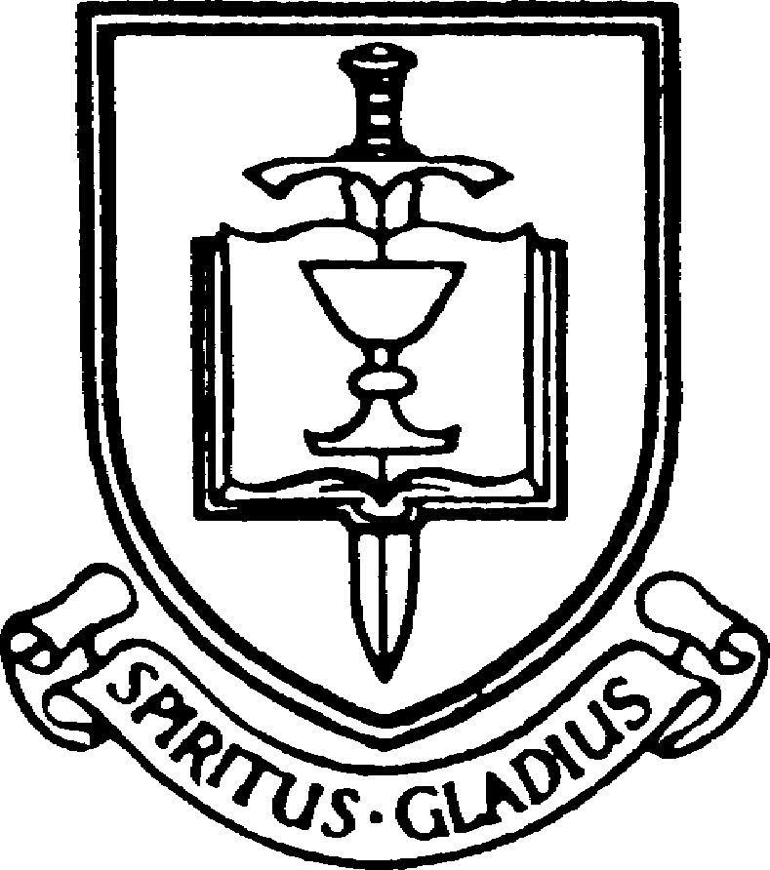



Easter Flowers

The flowers and decorations for Easter are given to the Glory of God by

Jack and Judy Adams, in thanksgiving for St. Paul’s and our many blessings.

The Bratton family, in thanksgiving for Ben.

Don and Peggy Buchanan, in memory of Bud Johnson and Patricia Buchanan.

Glen and Christine Catalina, in thanksgiving for St. Paul’s Church.

Mark and Amy Cave, in thanksgiving for our children, grandchildren and friends and in memory of Hugh and Librada Cave, Raymond Martin and Lena Burch and Raymond Anthony Burch.

Cliff and Diane Dunbar, in thanksgiving for the many blessings we have received and in memory of Barbara and Frank Dunbar.

Lynda Fillmore, in memory of Jim Fillmore and Ken and Gail Ross and Roger Ross.

Dave and Catherine Francis, in thanksgiving for Kim, Erik, Jake, Chloe and Ally and in memory of Durward and Fern Francis and Donald and Barbara Roper.

Margie Garcia, in memory of my husband Reuben Garcia.

Diane Garver, in memory of Leonard and Lois Wenn.

Elaine Hord, in thanksgiving for family and friends and in memory of Floyd Hord and Lee Duncan.

Rev. Robert and Amee Longbottom, in thanksgiving for the 90th and 91st birthday of Bob and Rose Marie Thompson and in memory of Matthew Longbottom.

Manny and Paula Lucero, in thanksgiving for Micoel, Eric, Mason, Sawyer and for St. Paul’s Church.

Tom and Monica Norton, in memory of Virginia L. Christensen.

Sue Nyberg, in thanksgiving for friends and family.

Kevin and Rosemary Reeder, in memory of Mercedes and Frank Borba and Linda Borba Luis

Ed and Kim Robinson, in memory of our parents Madeleine and
V. Craig Bull and Miriam and Ed Robinson Sr.

Kevin and Janet Robinson, in memory of Rev. Samuel T Gilliam and Maurine Gilliam Merritt.

Maria Round, in thanksgiving for family.

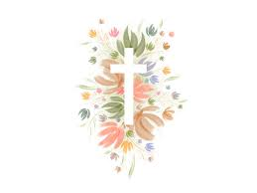

St. Paul’s Anglican Church
Parish Office
6436 W. Hurley Ave
Visalia, California 93291
559-732-4821
Office Hours: 8:00 – 4:00
Monday – Thursday

Worship: Sundays at 10:30AM
Livestream: Link at spvisalia.com
and on our Facebook page
Please be advised that this service is being recorded for broadcast
and/or archival purposes. By attending, you consent
to the inclusion of your likeness in these recordings.

St. Paul’s Clergy and Staff
The Rev. Robert Longbottom, Rector
rector@spvisalia.com
(559)802-2928
The Rev. John Iseman, Pastoral Associate for Family Ministries
family@spvisalia.com
The Rev. Kashy Rowland-Smith, Deacon
kashyrs@aol.com
Antoinette Horsting, Parish Administrator
bookkeeper@spvisalia.com
Marguerite Crownover, Organist and Accompanist
Cynthia Culp, Choral Director
Jackie Iseman, Nursery Coordinator
Shane Motl, Sexton

St. Paul’s is a member church of the
Anglican Diocese of San Joaquin
The Rt. Rev. Eric V. Menees, Bishop

Next Week’s Lessons
Acts 2:14a, 23-32
Psalm 111
Peter 1:3-9
John 20:19-31

