ST. PAUL’S
ANGLICAN CHURCH
VISALIA, CALIFORNIA

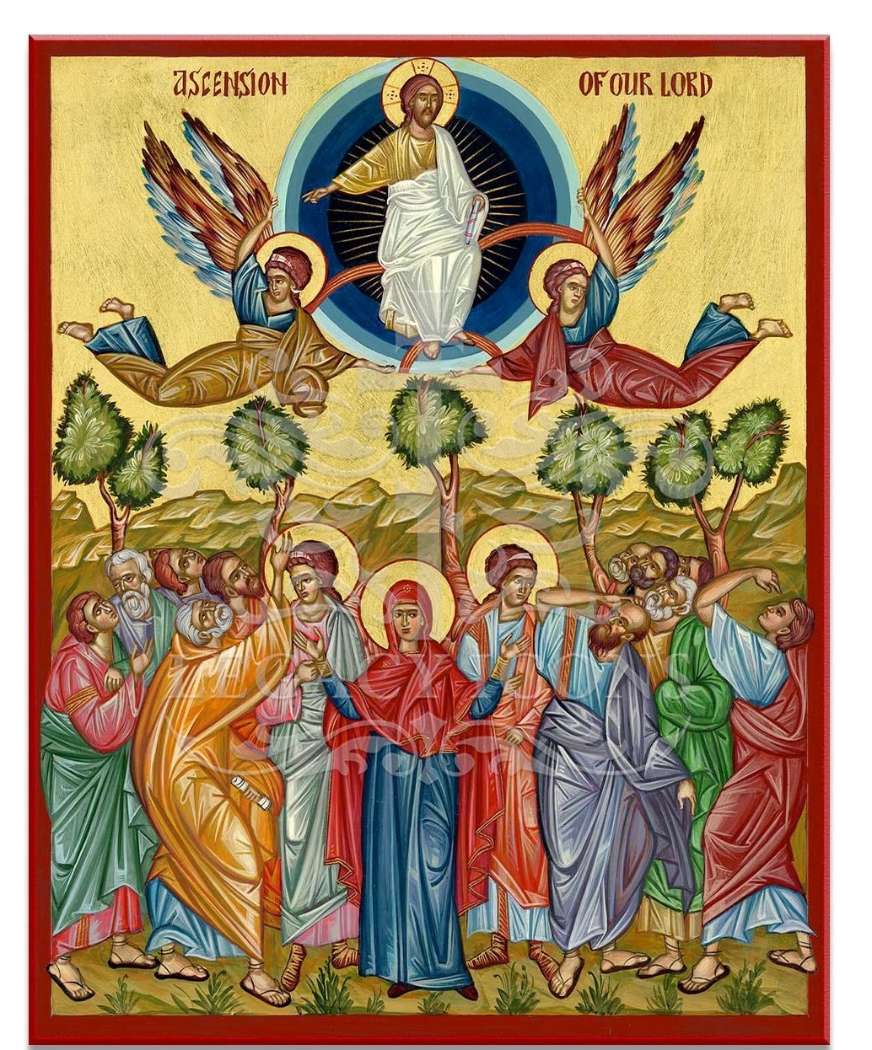

SUNDAY AFTER ASCENSION DAY
May 17, 2026
10:30 A.M.

Welcome!

St. Paul’s Anglican Church extends a warm welcome to all visitors and newcomers, whether worshiping in person or at home via livestream.

Visitors’ Guide

St. Paul’s Church is a parish in the Diocese of San Joaquin of the Anglican Church in North America, which includes both Catholic and Protestant traditions. We accept Jesus Christ as Savior, and we promise to follow him as Lord. We believe in One God,

- the Father who created us and all things,
- the Son who redeems us from sin and death,
- the Holy Spirit who renews and sanctifies us.

We believe the Holy Scriptures to be the Word of God and to contain all things necessary for salvation, and we accept the Apostles’ and Nicene Creeds as essential beliefs of the Christian faith.

Holy Communion is open to all baptized Christians who have examined their lives, repented of their sins, and desire to live
in love and charity with all people.

Those not desiring to receive Holy Communion, and those who have not been baptized into the Christian faith, are invited to cross their arms across their chest, and a blessing will be given instead.

Visitors are invited to sign the guest book at the entrance table and introduce themselves to the clergy following the service.

The Holy Eucharist

Prelude: “Prelude and Fugue in C Major” Bach
Opening Hymn: #460 - “Alleluia! Sing to Jesus” (All verses) p. 4
Opening Acclamation p. 6
The Collect for Purity p. 6
Summary of the Law p. 6
Kyrie p. 6
Gloria p. 7
Collect of the Day p. 8
Lesson: Acts 1:1-14 p. 8
Gradual: Psalm 47 p. 9
Epistle: 1 Peter 4:12-19 p. 10
Sequence Hymn: #603 – “When Christ was Lifted” p. 11
Gospel: John 17:1-11 p. 12
Sermon: The Rev. Robert Longbottom
Nicene Creed p. 13
Prayers of the People p. 14
Offertory Anthem: “Zip Zing Ring” Bell Choir
The Peace p. 16
The Offertory p. 17
Sursum Corda p. 17
Sanctus p. 18
The Lord’s Prayer p. 20
Fraction p. 20
Prayer for Humble Access p. 21
Agnus Dei p. 21
Communion Hymn: #333 – “Now the Silence, Now the Peace” p. 22
Post Communion Prayer p. 23
Blessing p. 23
Closing Hymn: #473 – “Lift High the Cross” p. 24
Dismissal p. 24
Postlude: “Praise to the Lord, the Almighty” Blanchard

Opening Hymn: Alleluia! Sing to Jesus
(All Verses)
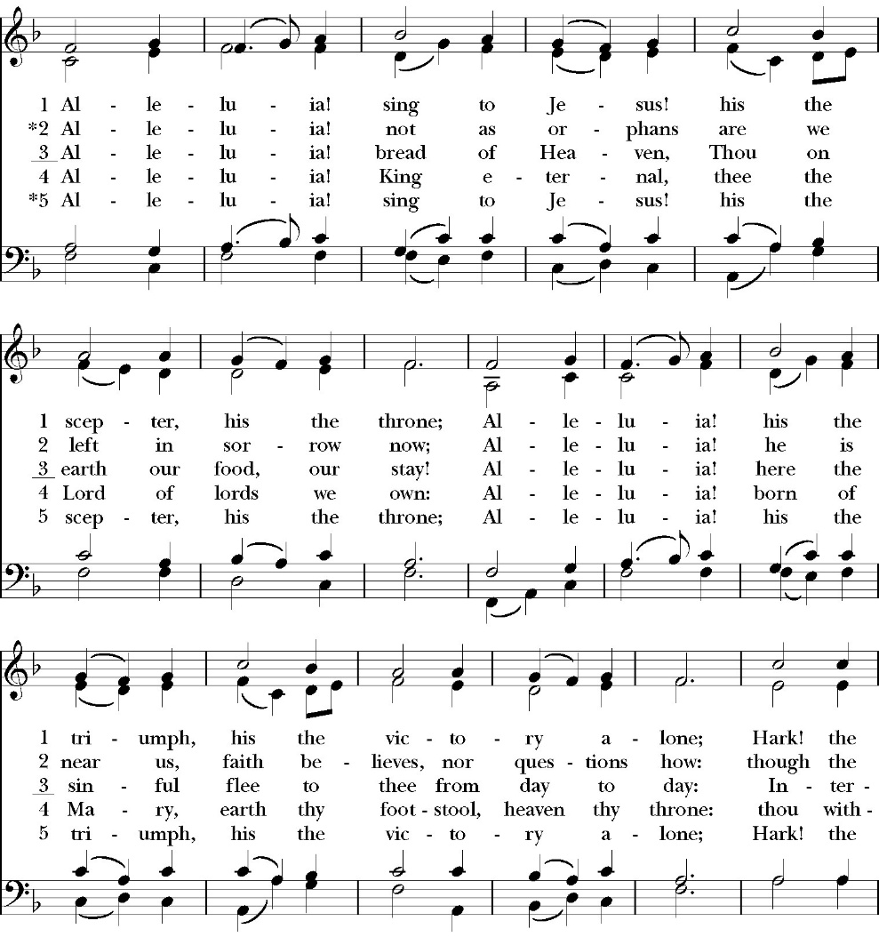

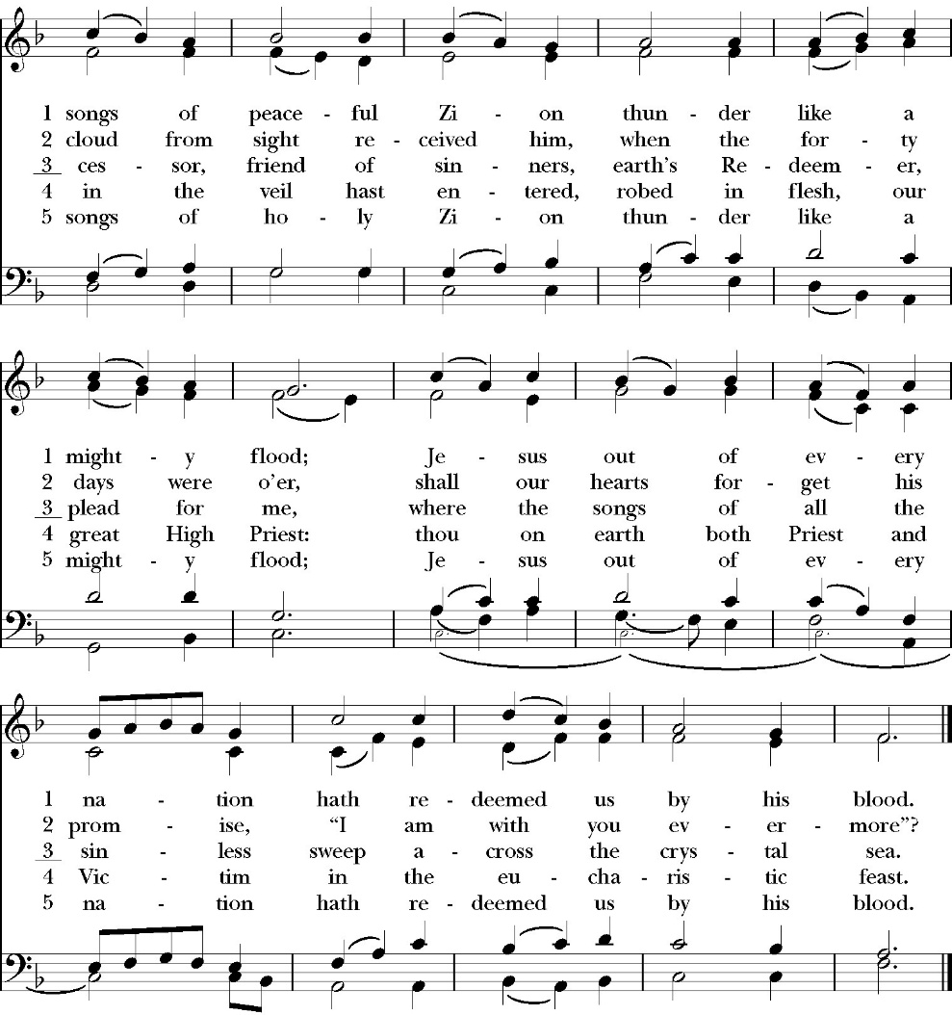

Opening Acclamation

Celebrant Alleluia! Christ is risen!
People The Lord is risen indeed! Alleluia!

Collect for Purity

Celebrant: Almighty God, to you all hearts are open, all desires
known, and from you no secrets are hid: Cleanse the thoughts
of our hearts by the inspiration of your Holy Spirit, that we
may perfectly love you, and worthily magnify your holy Name;
through Christ our Lord. Amen.

Summary of the law

Celebrant: Hear what our Lord Jesus Christ says: You shall love
the Lord your God with all your heart and with all your soul
and with all your mind. This is the first and great
commandment. And the second is like it: You shall love your
neighbor as yourself. On these two commandments depend all
the Law and the Prophets.

Kyrie
Gloria

Celebrant The Lord be with you.
People And with your spirit.
Celebrant Let us pray.

The Collect of the Day

O God, the King of glory, you have exalted your only Son Jesus Christ with great triumph to your kingdom in heaven: Do not leave us comfortless, but send us your Holy Spirit to strengthen us, and exalt us to that place where our Savior Christ has gone before; who lives and reigns with you and the Holy Spirit, one God, in glory everlasting. Amen.

Lesson: Acts 1:1-14
In the first book, O Theophilus, I have dealt with all that Jesus began to do and teach, ² until the day when he was taken up, after he had given commands through the Holy Spirit to the apostles whom he had chosen. ³ He presented himself alive to them after his suffering by many proofs, appearing to them during forty days and speaking about the kingdom of God.

⁴ And while staying with them he ordered them not to depart from Jerusalem, but to wait for the promise of the Father, which, he said, “you heard from me; ⁵ for John baptized with water, but you will be baptized with the Holy Spirit not many days from now.”

⁶ So when they had come together, they asked him, “Lord, will you at this time restore the kingdom to Israel?” ⁷ He said to them, “It is not for you to know times or seasons that the Father has fixed by his own authority. ⁸ But you will receive power when the Holy Spirit has come upon you, and you will be my witnesses in Jerusalem and in all Judea and Samaria, and to the end of the earth.” ⁹ And when he had said these things, as they were looking on, he was lifted up, and a cloud took him out of their sight. ¹⁰ And while they were gazing into heaven as he went, behold, two men stood by them in white robes, ¹¹ and said, “Men of Galilee, why do you stand looking into heaven? This Jesus, who was taken up from you into heaven, will come in the same way as you saw him go into heaven”

¹² Then they returned to Jerusalem from the mount called Olivet, which is near Jerusalem, a Sabbath day's journey away. ¹³ And when they had entered, they went up to the upper room, where they were staying, Peter and John and James and Andrew, Philip and Thomas, Bartholomew and Matthew, James the son of Alphaeus and Simon the Zealot and Judas the son of James. ¹⁴ All these with one accord were devoting themselves to prayer, together with the women and Mary the mother of Jesus, and his brothers.

Reader: The Word of the Lord
People: Thanks be to God

Gradual: Psalm 47
1 O clap your hands together, all you peoples; *
O cry aloud unto God with shouts of joy.
2 For the LORD Most High is to be feared; *
he is the great King over all the earth.
3 He shall subdue the peoples under us, *
and the nations under our feet.
4 He shall choose our inheritance for us, *
the pride of Jacob whom he loved.
5 God has gone up with a shout of triumph, *
the LORD with the sound of the trumpet.
6 O sing praises, sing praises unto our God; *
O sing praises, sing praises unto our King.
7 For God is the King of all the earth; *
think upon his mighty acts and praise him with a song. 8God reigns over the nations; * God sits on his holy throne.
9 The princes of the peoples are gathered with the people of the God of Abraham; *
for the mighty upon earth have become the servants of the Lord, and he is very highly exalted.

Glory be to the Father, and to the Son, and to the Holy Spirit;
as it was in the beginning, is now, and ever shall be, world
without end. Amen

Epistle: 1 Peter 4:12-19
Beloved, do not be surprised at the fiery trial when it comes upon you to test you, as though something strange were happening to you. ¹³ But rejoice insofar as you share Christ's sufferings, that you may also rejoice and be glad when his glory is revealed. ¹⁴ If you are insulted for the name of Christ, you are blessed, because the Spirit of glory and of God rests upon you. ¹⁵ But let none of you suffer as a murderer or a thief or an evildoer or as a meddler. ¹⁶ Yet if anyone suffers as a Christian, let him not be ashamed, but let him glorify God in that name. ¹⁷ For it is time for judgment to begin at the household of God; and if it begins with us, what will be the outcome for those who do not obey the gospel of God?

18 And

“If the righteous is scarcely saved, what will become of the ungodly and the sinner?”

¹⁹ Therefore let those who suffer according to God's will entrust their souls to a faithful Creator while doing good.

Reader: The word of the Lord.
People: Thanks be to God.

Sequence Hymn: When Christ Was Lifted
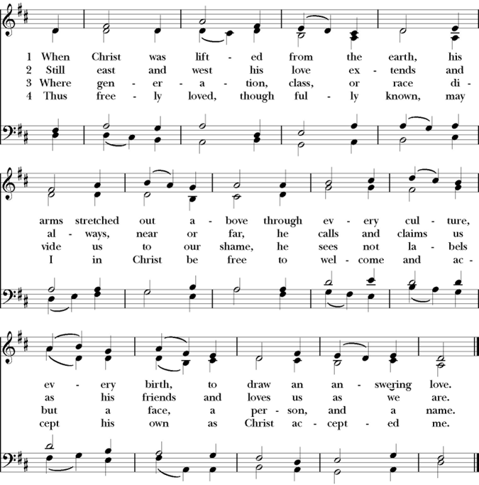
(Verse 1-2 before the Gospel, verse 3-4 after)

Clergy: The Holy Gospel of Our Lord Jesus Christ,
according to St. John.
People: Glory to you, Lord God

Gospel: John 17:1-11
When Jesus had spoken these words, he lifted up his eyes to heaven, and said, “Father, the hour has come; glorify your Son that the Son may glorify you, ² since you have given him authority over all flesh, to give eternal life to all whom you have given him. ³ And this is eternal life, that they know you, the only true God, and Jesus Christ whom you have sent. ⁴ I glorified you on earth, having accomplished the work that you gave me to do. ⁵ And now, Father, glorify me in your own presence with the glory that I had with you before the world existed.
⁶ “I have manifested your name to the people whom you gave me out of the world. Yours they were, and you gave them to me, and they have kept your word. ⁷ Now they know that everything that you have given me is from you. ⁸ For I have given them the words that you gave me, and they have received them and have come to know in truth that I came from you; and they have believed that you sent me. ⁹ I am praying for them. I am not praying for the world but for those whom you have given me, for they are yours. ¹⁰ All mine are yours, and yours are mine, and I am glorified in them. ¹¹ And I am no longer in the world, but they are in the world, and I am coming to you. Holy Father, keep them in your name, which you have given me, that they may be one, even as we are one.

Clergy: The Gospel of the Lord
People: Praise to you, Lord Christ

Sermon
The Rev. Robert Longbottom

The Nicene Creed

We believe in one God,
the Father, the Almighty,
maker of heaven and earth,
of all that is, visible and invisible.

We believe in one Lord, Jesus Christ,
the only-begotten Son of God,
eternally begotten of the Father,
God from God, Light from Light,
true God from true God,
begotten, not made,
of one Being with the Father.
through him all things were made.
For us and for our salvation he came down from heaven:
was incarnate from the Holy Spirit and the Virgin Mary,
and was made man.
For our sake he was crucified under Pontius Pilate;
he suffered death and was buried.
On the third day he rose again in accordance with the
Scriptures;
he ascended into heaven
and is seated at the right hand of the Father.
He will come again in glory to judge the living and the dead,
and his kingdom will have no end.

We believe in the Holy Spirit, the Lord, the giver of life,
who proceeds from the Father [and the Son],
who with the Father and the Son is worshiped and glorified.
who has spoken through the Prophets.
We believe in one holy catholic and apostolic Church.
We acknowledge one Baptism for the forgiveness of sins.
We look for the resurrection of the dead,
and the life of the world to come. Amen.

The Prayers of the People

Leader Let us pray for the Church and for the world, saying, “hear our prayer.”
For the peace of the whole world, and for the well-being and unity of the people of God.
Lord, in your mercy:
People Hear our prayer.

Leader For Stephen our archbishop, Julian our provincial dean and Eric, our bishop. For Fr. Rob, Deacon John, Deacon Kashy, and for all the clergy and people of our diocese and congregation and for the worldwide Anglican Communion.
Lord, in your mercy:
People Hear our prayer.

Leader For all those who proclaim the Gospel at home and abroad; and for all who teach and disciple others.
Lord, in your mercy:
People Hear our prayer.

Leader For our brothers and sisters in Christ who are persecuted for their faith.
Lord, in your mercy:
People Hear our prayer.

Leader For our nation, for those in authority, and for all in public service especially Donald our president and Gavin our governor.
Lord, in your mercy:
People Hear our prayer.

Leader: In the St. Paul’s cycle of prayer, we pray for all ministries to children, youth and families both in our church and through our church into the community around us. We pray for Sunday Funday, Sunday School, Youth Group and the Nursery program. We pray for all our family ministry volunteers. We pray for the children and youth you have given to our care and for their formation in the Christian faith. We pray for all children and youth to whom we are reaching out with the Good News of Jesus Christ.
Lord, in your mercy:
People Hear our prayer.

Leader In the ACNA Cycle of Prayer, today we pray for GAFCON Australia, The Rev. Peter Smith, Chair, and his wife, Shelley.
Lord, in your mercy:
People Hear our prayer.

Leader For all those who are in trouble, sorrow, need, sickness, or
any other adversity [especially ____________]. We also
pray for all who are currently serving in our armed forces
and serving as first responders.
Lord, in your mercy:
People Hear our prayer.

Leader For all those who have departed this life in the certain hope
of the resurrection, (we pray especially for ____________),
in Thanksgiving let us pray.
Lord, in your mercy:
People Hear our prayer.

Celebrant will add a concluding prayer

Heavenly Father, grant these our prayers for the sake of Jesus Christ,
our only Mediator and Advocate, who lives and reigns with you in
the unity of the Holy Spirit, one God, now and for ever. Amen.

The Confession and Absolution

Celebrant Let us humbly confess our sins to Almighty God.

Most merciful God,
we confess that we have sinned against you
in thought, word and deed,
by what we have done, and by what we have left undone.
We have not loved you with our whole heart;
we have not loved our neighbors as ourselves.
We are truly sorry and we humbly repent.
For the sake of your Son Jesus Christ,
have mercy on us and forgive us;
that we may delight in your will, and walk in your ways,
to the glory of your Name. Amen.

Almighty God, our heavenly Father, who in his great mercy has
promised forgiveness of sins to all those who sincerely repent and
with true faith turn to him, have mercy upon you, pardon and deliver
you from all your sins, confirm and strengthen you in all goodness,
and bring you to everlasting life; through Jesus Christ our Lord.
Amen.

Hear the Word of God to all who truly turn to him.

God so loved the world, that he gave his only-begotten Son, that
whoever believes in him should not perish but have eternal life.
-John 3:16t

Celebrant The Peace of the Lord be always with you.
People And with your spirit.

offertory anthem
Zip, Zing, Ring! Bell Choir
by brenda austing

The Doxology
(Verse 3 only)

Offertory
Celebrant All things come from you, O Lord,
People And of your own have we given you.

The Eucharistic Liturgy

Celebrant The Lord be with you.
People And with your spirit.
Celebrant Lift up your hearts.
People We lift them up to the Lord.
Celebrant Let us give thanks to the Lord our God.
People It is right to give him thanks and praise.

It is right, our duty and our joy, always and everywhere to give thanks to you, Father Almighty, Creator of heaven and earth.

But chiefly are we bound to praise you for the glorious resurrection of your Son Jesus Christ our Lord; for he is the true Paschal Lamb, who was offered for us, and has taken away the sin of the world; who by his death has destroyed death, and by his rising to life again has won for us everlasting life

Therefore we praise you, joining our voices with Angels and Archangels and with all the company of heaven, who for ever sing this hymn to proclaim the glory of your Name:

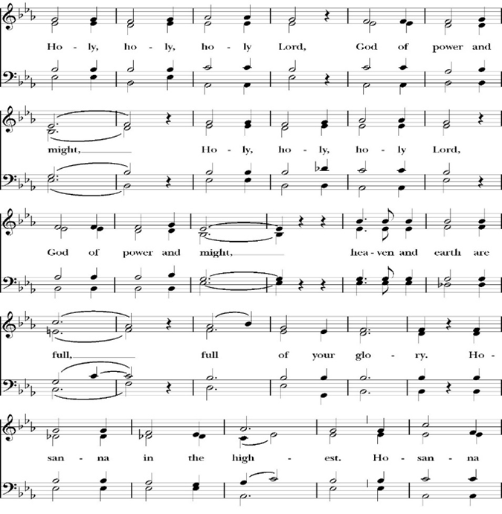
Sanctus

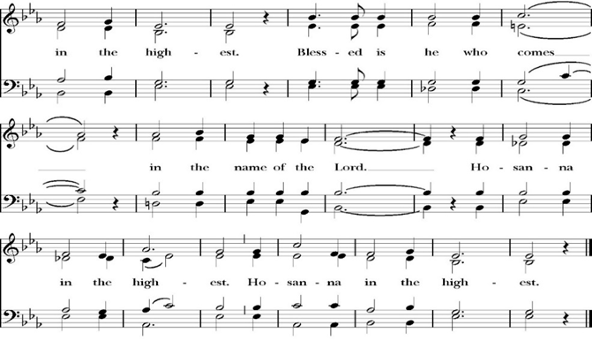
Holy and gracious Father: In your infinite love you made us for yourself; and when we had sinned against you and become subject to evil and death, you, in your mercy, sent your only Son Jesus Christ into the world for our salvation. By the Holy Spirit and the Virgin Mary he became flesh and dwelt among us. In obedience to your will, he stretched out his arms upon the Cross and offered himself once for all, that by his suffering and death we might be saved. By his resurrection he broke the bonds of death, trampling Hell and Satan under his feet. As our great high priest, he ascended to your right hand in glory, that we might come with confidence before the throne of grace.

On the night that he was betrayed, our Lord Jesus Christ took bread; and when he had given thanks, he broke it,* and gave it to his disciples, saying, “Take, eat; this is my Body, which is given for you: Do this in remembrance of me.”

Likewise, after supper, Jesus took the cup, and when he had given thanks, he gave it to them, saying, “Drink this, all of you; for this is my Blood of the New Covenant, which is shed for you, and for many, for the forgiveness of sins: Whenever you drink it, do this in remembrance of me.”

Therefore we proclaim the mystery of faith:

Christ has died.
Christ is risen.
Christ will come again.

We celebrate the memorial of our redemption, O Father, in this sacrifice of praise and thanksgiving, and we offer you these gifts.

Sanctify them by your Word and Holy Spirit to be for your people the Body and Blood of your Son Jesus Christ. Sanctify us also, that we may worthily receive this holy Sacrament, and be made one body with him, that he may dwell in us and we in him. In the fullness of time, put all things in subjection under your Christ, and bring us with all your saints into the joy of your heavenly kingdom, where we shall see our Lord face to face.

All this we ask through your Son Jesus Christ: By him, and with him, and in him, in the unity of the Holy Spirit, all honor and glory is yours, Almighty Father, now and for ever. Amen.

And now, as our Savior Christ has taught us, we are bold to pray,

Our Father, who art in heaven,
hallowed be thy Name,
thy kingdom come,
thy will be done,
on earth as it is in heaven.
Give us this day our daily bread.
And forgive us our trespasses,
as we forgive those
who trespass against us.
And lead us not into temptation,
but deliver us from evil.
For thine is the kingdom,
and the power, and the glory,
for ever and ever. Amen.

Celebrant Alleluia! Christ our Passover is sacrificed for us.
People Therefore let us keep the feast. Alleluia!

We do not presume to come to this your table, O merciful Lord,
trusting in our own righteousness,
but in your abundant and great mercies.
We are not worthy so much as to gather up
the crumbs under your table;
but you are the same Lord
whose character is always to have mercy.
Grant us, therefore, gracious Lord,
so to eat the flesh of your dear Son Jesus Christ,
and to drink his blood,
that our sinful bodies may be made clean by his body,
and our souls washed through his most precious blood,
and that we may evermore dwell in him, and he in us.
Amen.

Agnus Dei

The Ministration of Communion

The gifts of God for the People of God. Take them in remembrance that Christ died for you and feed on him in your hearts by faith, with thanksgiving.

Communion Hymn: Now the Silence, Now the Peace
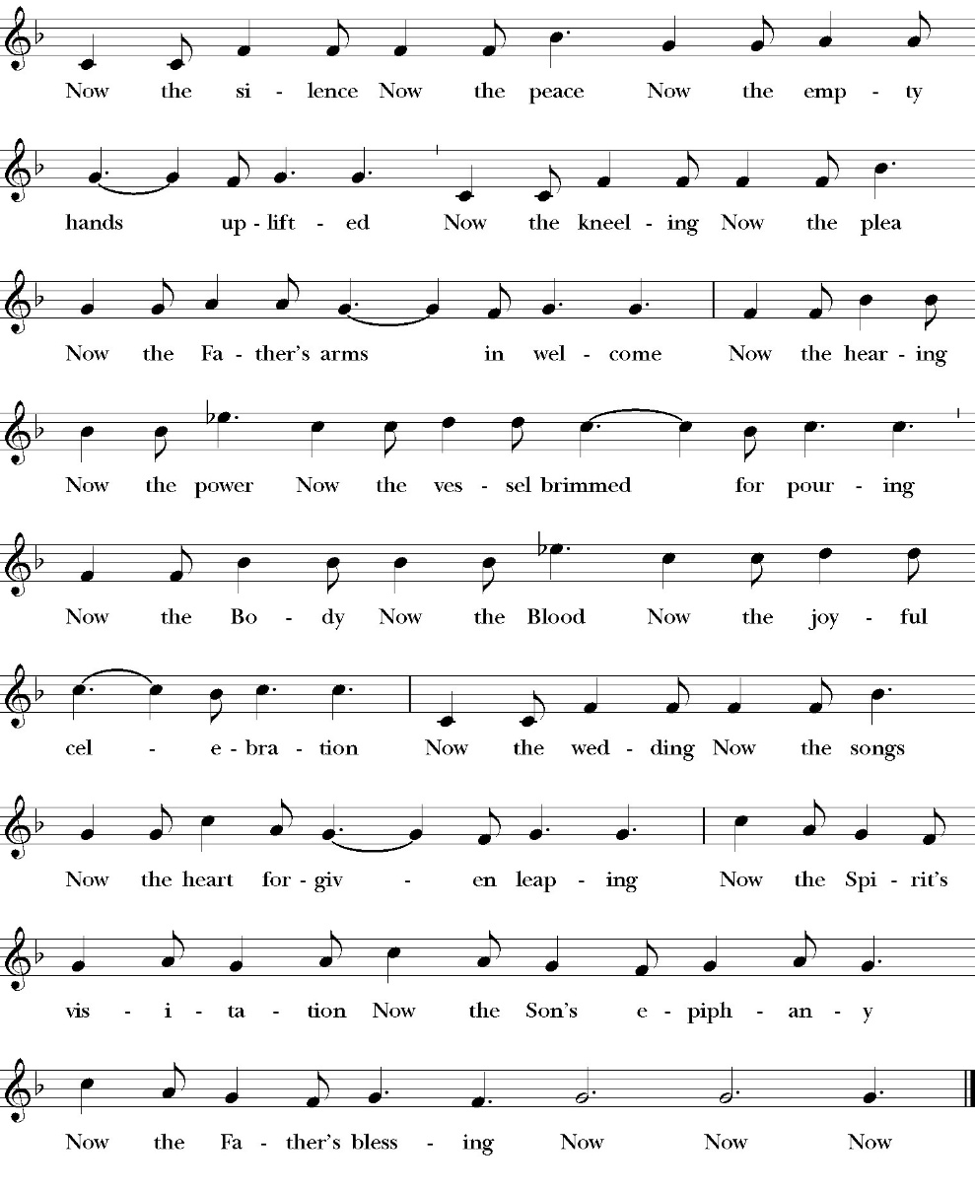

The post communion Prayer

Let us pray.

Heavenly Father,
We thank you for feeding us with the spiritual food
of the most precious Body and Blood
of your Son our Savior Jesus Christ;
and for assuring us in these holy mysteries
that we are living members of the body of your Son,
and heirs of your eternal Kingdom.
And now, Father, send us out to do the work you have
given us to do,
to love and serve you as faithful witnesses of Christ our
Lord.
To him, to you, and to the Holy Spirit,
be honor and glory, now and for ever. Amen.

The Blessing

The blessing of God Almighty, the Father, the Son, and the Holy
Spirit, be among you, and remain with you always. Amen.

Closing Hymn: Lift High, the Cross
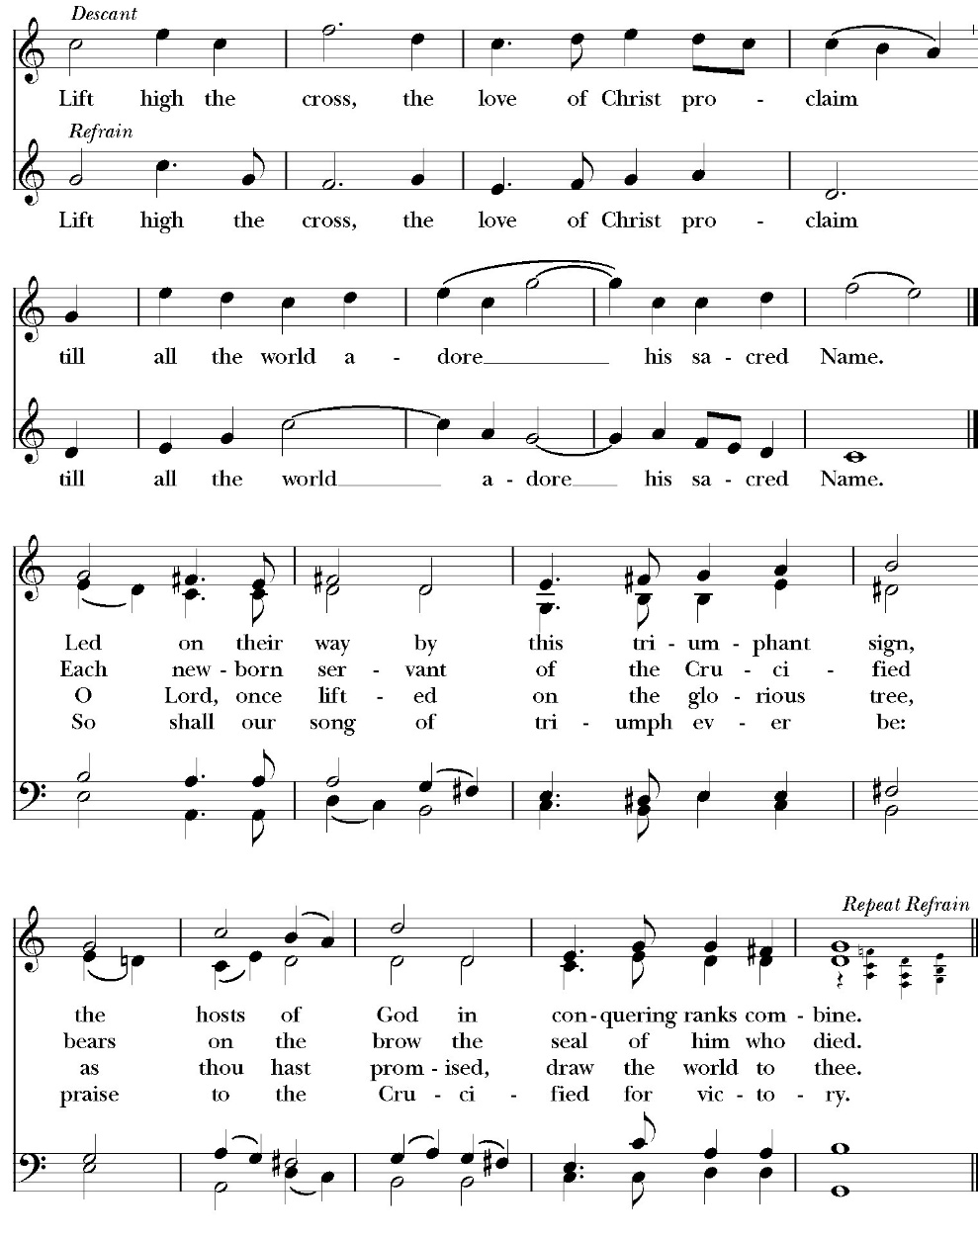

Celebrant Alleluia, Alleluia! Let us go forth in the name of Christ.
People Thanks be to God. Alleluia! Alleluia!
St. Paul’s Parish Calendar
Sunday May 17– Sunday May 24

SUNDAY, May 17 – Sunday after Ascension Day
9:15 AM Sunday Funday, Youth Room
9:15 AM Gospel of John Bible Study, Conference Room
9:30 AM Bell Choir Rehearsal, Church
10:30 AM Children’s Sunday School, Chapel
Pre-K –2nd Grade, Sunday School Room
3rd -5th Grade, Youth Room
10:30 AM Holy Eucharist, Church

MONDAY, May 18

TUESDAY, May 19

WEDNESDAY, May 20
9:30 AM Holy Eucharist with healing prayer, Chapel
10:15 AM Bible Study, Conference Room
2:30 – 3:30 PM Neighborhood Market, Church Parking Lot
7:00 PM Choir Practice, Chapel

THURSDAY, May 21

FRIDAY, May 22
6:30 AM Men’s Bible Study, Valhalla Restaurant

SATURDAY, May 23

SUNDAY, May 24 – Pentecost Sunday
9:15 AM Sunday Funday, Youth Room
9:15 AM No Gospel of John Bible Study, Conference Room
9:30 AM Choir Rehearsal, Church
10:30 AM Children’s Sunday School, Chapel
Pre-K –2nd Grade, Sunday School Room
3rd -5th Grade, Youth Room
10:30 AM Holy Eucharist, Church

Church Office Hours
Monday-Thursday 8:00 AM-4:00 PM

Office will be closed for Memorial Day, Monday, May 25

Sunday Morning Bible Study: The Gospel of John
St. Paul’s is embarking on a study of the Gospel of John that will span the next year. These classes will be on Sunday mornings from 9:15-10:00AM. We will take the better part of the next year to move slowly through John and savor the profound spiritual truths that it offers. We will be using a book called Be Alive by Warren Wiersbe as our guide. This book is essentially a study guide to the Gospel of John and will provide us with structure and insight as we move our way through the Gospel. Books will be available beginning the day of the first class.

Projected Class Timeline

April-May Chapters 4-6
June Chapter 7-8
July No Class
August Chapter 9-10

The class will progress based on how quickly or slowly is needed and our projected timelines may change as we move forward.

Graduations and Educational Milestones
Do you have a child, grandchild, member of your family graduating or reaching a significant educational milestone in May or June? We want to celebrate the educational achievements of our congregation and their families in our June bulletins and newsletter. Please reach out to our church office with information so that we can recognize these students.

End-of-School-Year After-Church Picnic with Water Fun, Sunday, June 7
St. Paul’s will celebrate the end of the school year with a picnic celebration with water fun after church and a thank you to our children’s and youth ministry leaders and volunteers during church.
All families are invited to join us for church followed by a picnic lunch and water fun. St. Paul’s will provide a large water fun area and splash pad for children ages 10 and under. Older youth will have slip- and-slides.

Visalia Emergency Aid Food Barrel
For many years, St. Paul’s supported the ministry of Visalia Emergency Aid by housing a food barrel. We are renewing this ministry and invite members to bring food on Sunday mornings to place into the food barrel and support the VEA feeding ministries.

A Food Bank for Hurley Families
The next Neighborhood Market to benefit students at Hurley School will be Wednesday, May 20, 2:30 PM to 3:30 PM at St Paul’s Church parking lot. If you are interested in helping that day, please contact Sue Nyberg. My home phone number is 559-733-8244.

Due to the heat, we are in need of more volunteers for
the months of May, June, August, and September.
This will allow volunteers to work in shifts during these hot months.

PROVIDED BY VISALIA EMERGENCY AID
AND ST. PAUL’S CHURCH
Wednesday, May 20, 2026
From 2:30 PM to 3:30 PM
LOCATION:
ST. PAUL'S CHURCH PARKING LOT
ACROSS THE STREET FROM HURLEY


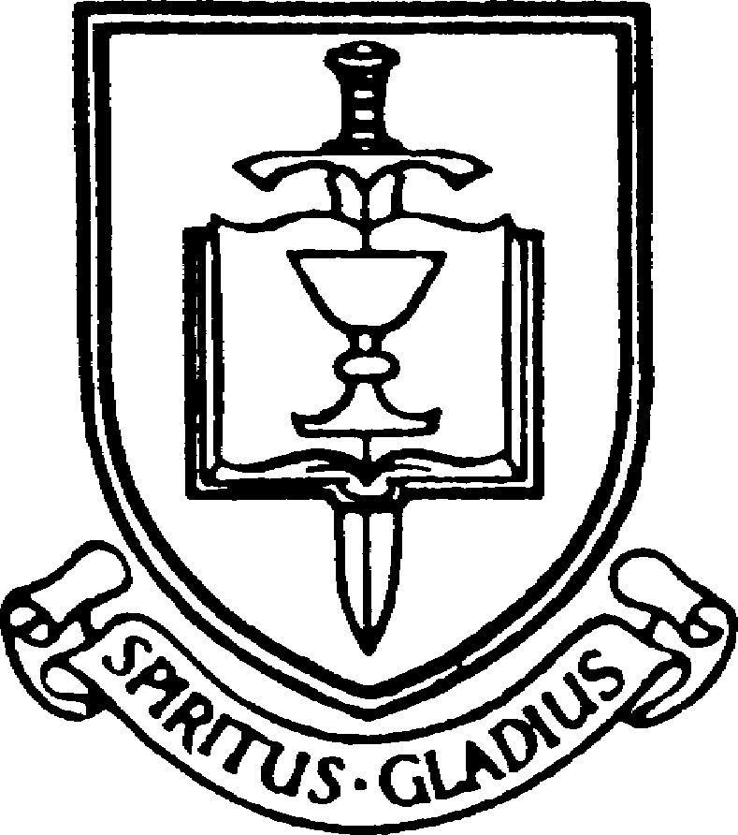


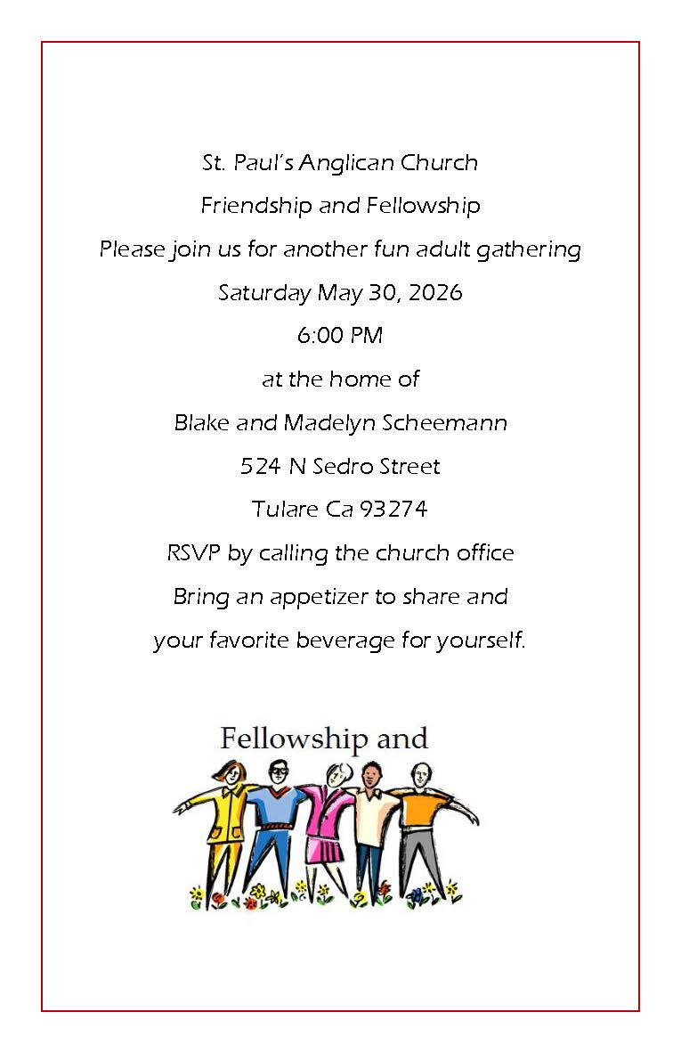

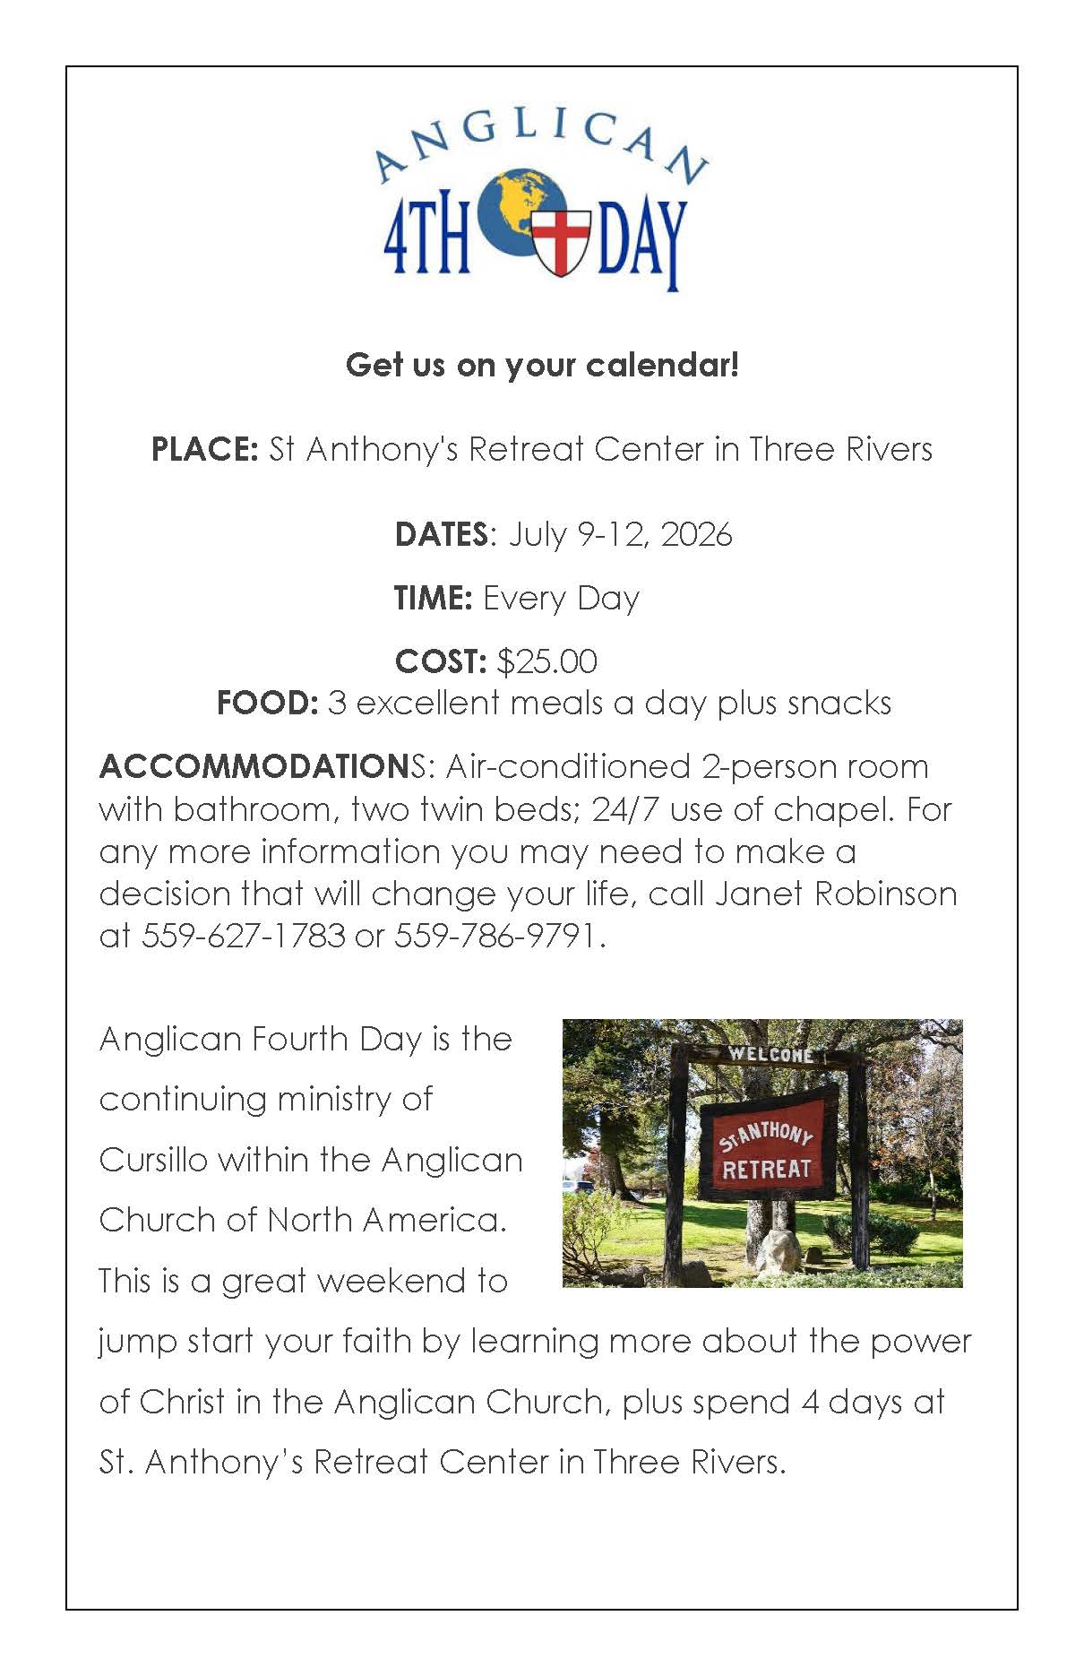

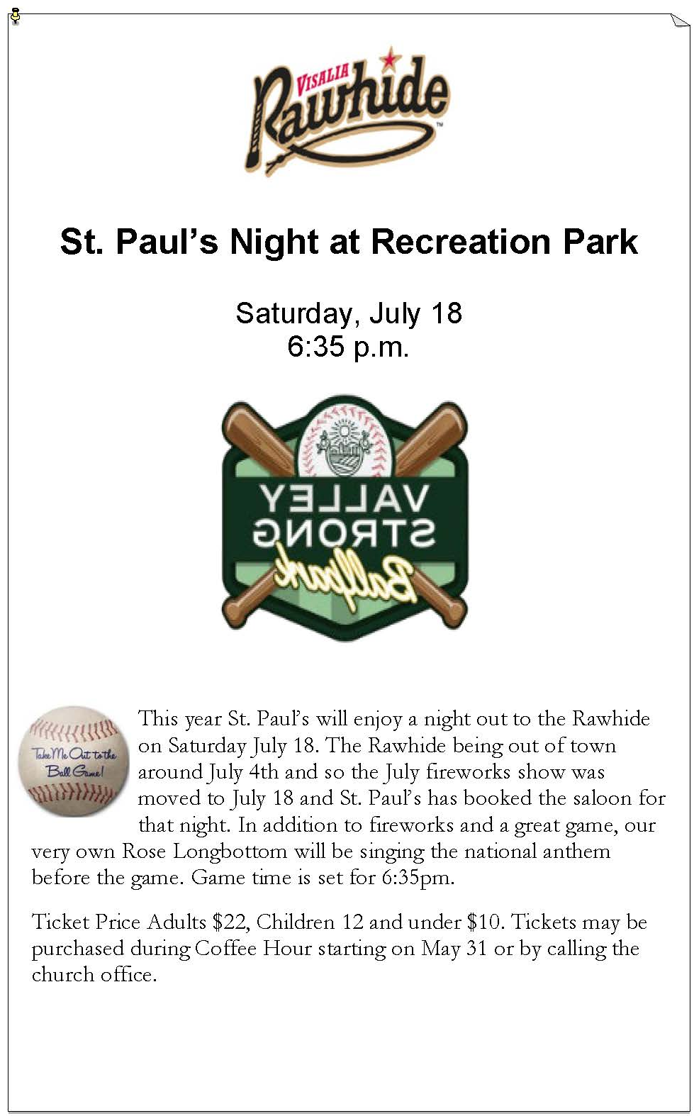

St. Paul’s Anglican Church
Parish Office
6436 W. Hurley Ave
Visalia, California 93291
559-732-4821
Office Hours: 8:00 – 4:00
Monday – Thursday

Worship: Sundays at 10:30AM
Livestream: Link at spvisalia.com
and on our Facebook page
Please be advised that this service is being recorded for broadcast
and/or archival purposes. By attending, you consent
to the inclusion of your likeness in these recordings.

St. Paul’s Clergy and Staff
The Rev. Robert Longbottom, Rector
rector@spvisalia.com
(559)802-2928
The Rev. John Iseman, Pastoral Associate for Family Ministries
family@spvisalia.com
The Rev. Kashy Rowland-Smith, Deacon
kashyrs@aol.com
Antoinette Horsting, Parish Administrator
bookkeeper@spvisalia.com
Marguerite Crownover, Organist and Accompanist
Cynthia Culp, Choral Director
Jackie Iseman, Nursery Coordinator
Shane Motl, Sexton

St. Paul’s is a member church of the
Anglican Diocese of San Joaquin
The Rt. Rev. Eric V. Menees, Bishop

Next Week’s Lessons
Genesis 11:1-9
Psalm 104:24-35
Acts 2:1-21
John 14:8-17

