ST. PAUL’S
ANGLICAN CHURCH
VISALIA, CALIFORNIA

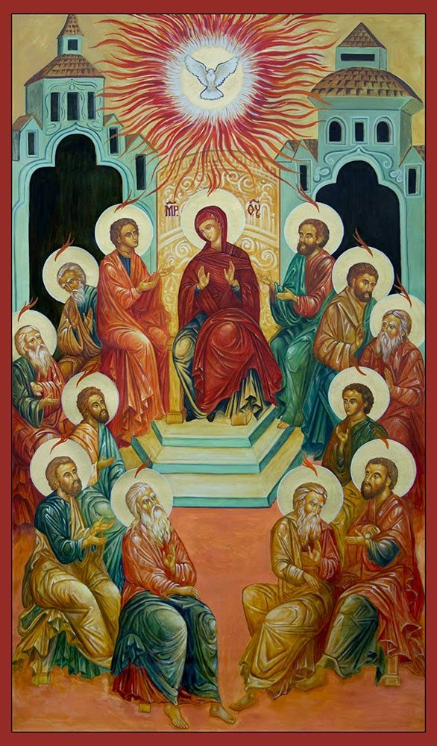

Pentecost Sunday
May 24, 2026
10:30 A.M

Welcome!

St. Paul’s Anglican Church extends a warm welcome to all visitors and newcomers, whether worshiping in person or at home via livestream.

Visitors’ Guide

St. Paul’s Church is a parish in the Diocese of San Joaquin of the Anglican Church in North America, which includes both Catholic and Protestant traditions. We accept Jesus Christ as Savior, and we promise to follow him as Lord. We believe in One God,

- the Father who created us and all things,
- the Son who redeems us from sin and death,
- the Holy Spirit who renews and sanctifies us.

We believe the Holy Scriptures to be the Word of God and to contain all things necessary for salvation, and we accept the Apostles’ and Nicene Creeds as essential beliefs of the Christian faith.

Holy Communion is open to all baptized Christians who have examined their lives, repented of their sins, and desire to live
in love and charity with all people.

Those not desiring to receive Holy Communion, and those who have not been baptized into the Christian faith, are invited to cross their arms across their chest, and a blessing will be given instead.

Visitors are invited to sign the guest book at the entrance table and introduce themselves to the clergy following the service.

The Holy Eucharist

Prelude: “Pentecost Dance” Fedak
Opening Hymn: #522 – “Glorious Things of Thee are Spoken” p. 4
Opening Acclamation p. 6
The Collect for Purity p. 6
Summary of the Law p. 6
Kyrie p. 7
Gloria p. 8
Collect of the Day p. 9
Lesson: Genesis 11:1-9 p. 9
Gradual: Psalm 104:24-35 p. 10
Epistle: Acts 2:1-21 p. 11
Sequence Hymn: #516 – “Come Down, O Love Divine” p. 12
Gospel: John 14:8-17 p. 13
Sermon: Rev. Rob Longbottom
Nicene Creed p. 14
Prayers of the People p. 15
The Peace p. 18
Offertory Anthem: “Pentecost” Choir
The Offertory p. 19
Sursum Corda p. 19
Sanctus p. 20
The Lord’s Prayer p. 22
Fraction p. 22
Prayer for Humble Access p. 22
Agnus Dei p. 23
Communion Hymn: #508 - “Breathe On, Me Breath of God” p. 24
Post Communion Prayer p. 24
Blessing p. 24
Closing Hymn: #719 – “O Beautiful for Spacious Skies” p. 25
Dismissal p. 25
Postlude: “Spirit Divine, Attend Our Prayers” Fedak

Opening Hymn: Glorious Things of Thee Are Spoken
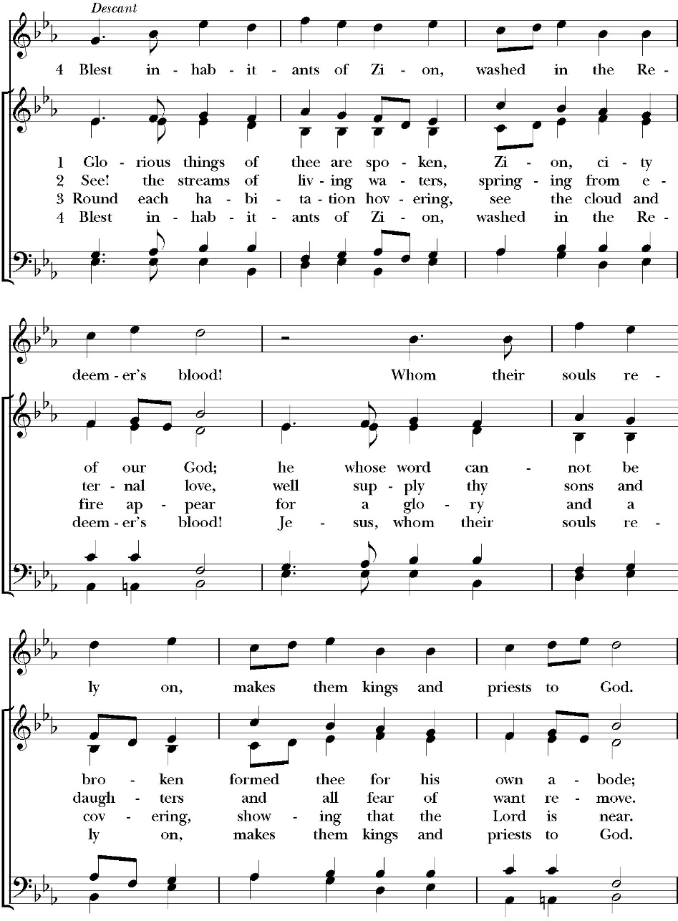

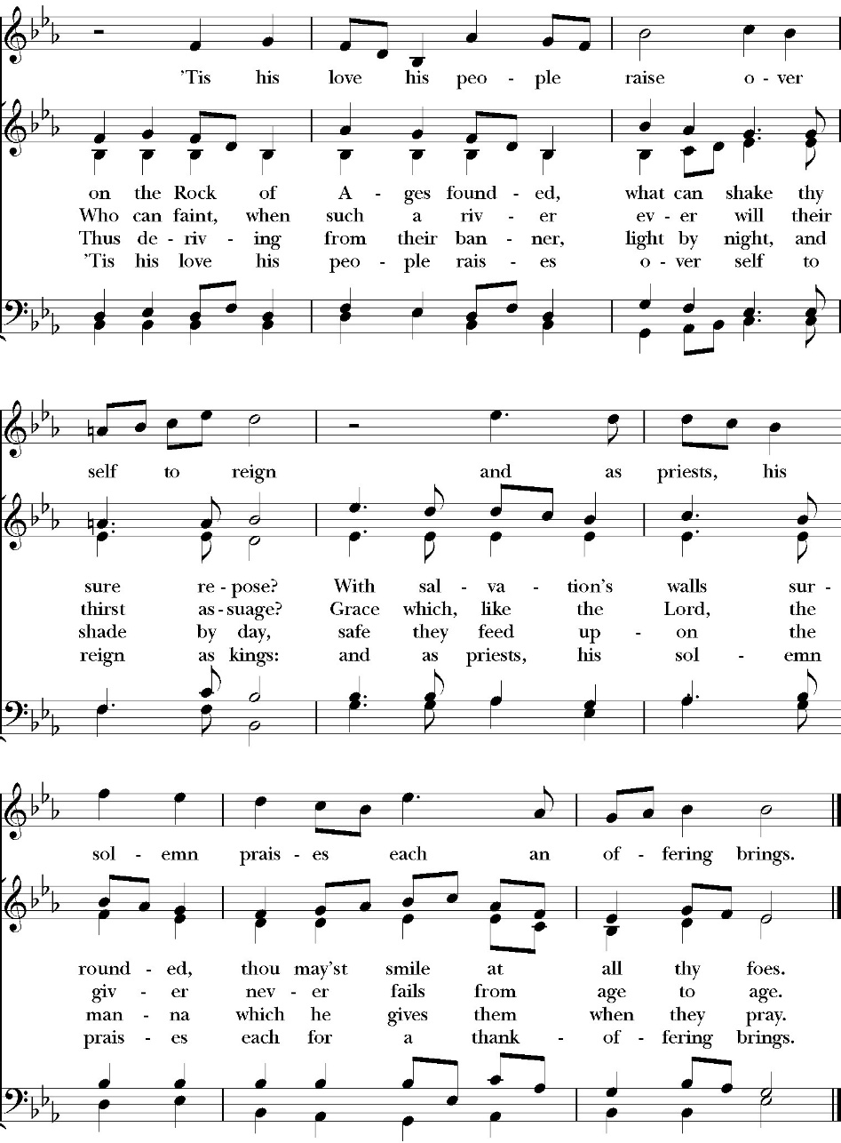

The Pentecost Acclamation

Celebrant The Lord will pour out his Spirit upon all flesh,
People And your sons and daughters shall prophesy.
Celebrant Your old men shall dream dreams,
People And your young men shall see visions.
Celebrant You shall know that the Lord is in the midst of his
people,
People That he is the Lord and there is none else.
Celebrant And it shall come to pass
People That everyone who calls on the Name of the Lord
shall be saved.

The Collect for Purity

Almighty God, to you all hearts are open, all desires known, and from you no secrets are hid: Cleanse the thoughts of our hearts by the inspiration of your Holy Spirit, that we may perfectly love you, and worthily magnify your holy Name through Christ our Lord. Amen.

The Summary of the law

Hear what our Lord Jesus Christ says: You shall love the Lord your God with all your heart and with all your soul and with all your mind. This is the first and great commandment. And the second is like it: You shall love your neighbor as yourself. On these two commandments depend all the Law and the Prophets.

The Kyrie

Gloria

Celebrant The Lord be with you.
People And with your spirit.
Celebrant Let us pray.

The Collect of the Day

Almighty God, on this day, through the outpouring of the Holy Spirit, you revealed the way of eternal life to every race and nation: Pour out this gift anew, that by the preaching of the Gospel your salvation may reach to the ends of the earth; through Jesus Christ our Lord, who lives and reigns with you, in the unity of the Holy Spirit, one God, for ever and ever. Amen.

Lesson Genesis 11:1-9
Now the whole earth had one language and the same words. 2 And as people migrated from the east, they found a plain in the land of Shinar and settled there. 3 And they said to one another, “Come, let us make bricks, and burn them thoroughly.” And they had brick for stone, and bitumen for mortar. 4 Then they said, “Come, let us build ourselves a city and a tower with its top in the heavens, and let us make a name for ourselves, lest we be dispersed over the face of the whole earth.” 5 And the LORD came down to see the city and the tower, which the children of man had built. 6 And the LORD said, “Behold, they are one people, and they have all one language, and this is only the beginning of what they will do. And nothing that they propose to do will now be impossible for them. 7 Come, let us go down and there confuse their language, so that they may not understand one another's speech.” 8 So the LORD dispersed them from there over the face of all the earth, and they left off building the city. 9 Therefore its name was called Babel, because there the LORD confused the language of all the earth. And from there the LORD dispersed them over the face of all the earth.

Reader: The Word of the Lord
People: Thanks be to God

Gradual: Psalm 104:24-35

24 O LORD, how manifold are your works; *
in wisdom you made them all; the earth is full of your creatures.
25 So is the great and wide sea also, *
in which are things creeping innumerable, creatures both small and great.
26 There go the ships, and there is that Leviathan, *
whom you made to take its pleasure therein.
27 These all wait upon you, *
that you may give them food in due season.
28 When you give it to them, they gather it, *
and when you open your hand, they are filled with good things.
29 When you hide your face, they are troubled; *
when you take away their breath, they die, and are turned again to their dust.
30 When you let your breath go forth, they shall be made, *
and you shall renew the face of the earth.
31 The glorious majesty of the LORD shall endure for ever; * the LORD shall rejoice in his works.
32 He looks at the earth and it trembles; *
if he even touches the hills, they shall smoke.
33 I will sing unto the LORD as long as I live; *
I will praise my God while I have my being,
34 And so shall my words please him; *
my joy shall be in the LORD.
35 As for sinners, they shall perish from the earth, and the ungodly shall come to an end. *
Praise the LORD, O my soul. Praise the LORD.

Glory be to the Father, and to the Son, and to the Holy Spirit;
as it was in the beginning, is now, and ever shall be, world
without end. Amen

Epistle: Acts 2:1-21
When the day of Pentecost arrived, they were all together in one place. 2 And suddenly there came from heaven a sound like a mighty rushing wind, and it filled the entire house where they were sitting. 3 And divided tongues as of fire appeared to them and rested on each one of them. 4 And they were all filled with the Holy Spirit and began to speak in other tongues as the Spirit gave them utterance.

5 Now there were dwelling in Jerusalem Jews, devout men from every nation under heaven. 6 And at this sound the multitude came together, and they were bewildered, because each one was hearing them speak in his own language. 7 And they were amazed and astonished, saying, “Are not all these who are speaking Galileans?
8 And how is it that we hear, each of us in his own native language?
9 Parthians and Medes and Elamites and residents of Mesopotamia, Judea and Cappadocia, Pontus and Asia, 10 Phrygia and Pamphylia, Egypt and the parts of Libya belonging to Cyrene, and visitors from Rome, 11 both Jews and proselytes, Cretans and Arabians—we hear them telling in our own tongues the mighty works of God.” 12 And all were amazed and perplexed, saying to one another, “What does this mean?” 13 But others mocking said, “They are filled with new wine.”

14 But Peter, standing with the eleven, lifted up his voice and addressed them: “Men of Judea and all who dwell in Jerusalem, let this be known to you, and give ear to my words. 15 For these people are not drunk, as you suppose, since it is only the third hour of the day. 16 But this is what was uttered through the prophet Joel:

17 “‘And in the last days it shall be, God declares, that I will pour out my Spirit on all flesh, and your sons and your daughters shall prophesy, and your young men shall see visions, and your old men shall dream dreams; 18 even on my male servants and female servants in those days I will pour out my Spirit, and they shall prophesy. 19 And I will show wonders in the heavens above and signs on the earth below, blood, and fire, and vapor of smoke; 20 the sun shall be turned to darkness and the moon to blood, before the day of the Lord comes, the great and magnificent day. 21 And it shall come to pass that everyone who calls upon the name of the Lord shall be saved.’

Reader: The Word of the Lord.
People: Thanks be to God.
Sequence Hymn: Come Down, O Love Divine
(Verse 1-2 before the Gospel, verse 3 after)
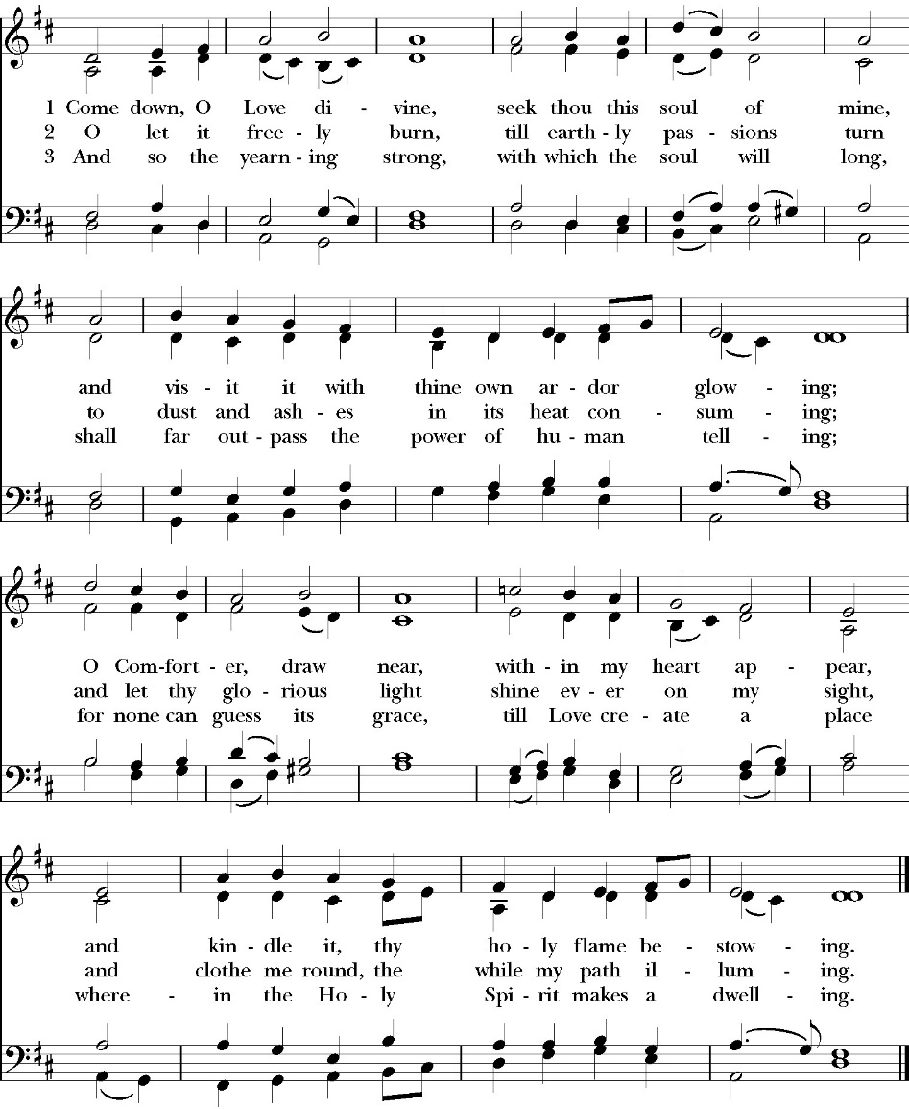

Celebrant: The Holy Gospel of Our Lord Jesus Christ,
according to St. John.
People: Glory to you, Lord God

Gospel: John 14:8-17
Philip said to him, “Lord, show us the Father, and it is enough for us.”
9 Jesus said to him, “Have I been with you so long, and you still do not know me, Philip? Whoever has seen me has seen the Father. How can you say, ‘Show us the Father’? 10 Do you not believe that I am in the Father and the Father is in me? The words that I say to you I do not speak on my own authority, but the Father who dwells in me does his works.

11 Believe me that I am in the Father and the Father is in me, or else believe on account of the works themselves.

12 “Truly, truly, I say to you, whoever believes in me will also do the works that I do; and greater works than these will he do, because I am going to the Father. 13 Whatever you ask in my name, this I will do, that the Father may be glorified in the Son. 14 If you ask me anything in my name, I will do it.

15 “If you love me, you will keep my commandments. 16 And I will ask the Father, and he will give you another Helper, to be with you forever, 17 even the Spirit of truth, whom the world cannot receive, because it neither sees him nor knows him. You know him, for he dwells with you and will be in you.

Clergy: The Gospel of the Lord
People: Praise to you Lord Christ

Sermon
rev. Rob Longbottom

The Nicene Creed

We believe in one God,
the Father, the Almighty,
maker of heaven and earth,
of all that is, visible and invisible.
We believe in one Lord, Jesus Christ,
the only-begotten Son of God,
eternally begotten of the Father,
God from God, Light from Light,
true God from true God,
begotten, not made,
of one Being with the Father.
through him all things were made.
For us and for our salvation he came down from heaven:
was incarnate from the Holy Spirit and the Virgin Mary,
and was made man.
For our sake he was crucified under Pontius Pilate;
he suffered death and was buried.
On the third day he rose again in accordance with the
Scriptures;
he ascended into heaven
and is seated at the right hand of the Father.
He will come again in glory to judge the living and the dead,
and his kingdom will have no end.
We believe in the Holy Spirit, the Lord, the giver of life,
who proceeds from the Father and the Son,
who with the Father and the Son is worshiped and glorified.
who has spoken through the Prophets.
We believe in one holy catholic and apostolic Church.
We acknowledge one Baptism for the forgiveness of sins.
We look for the resurrection of the dead,
and the life of the world to come. Amen.

The Prayers of the People

Leader Let us pray for the Church and for the world, saying, “hear our prayer.”
For the peace of the whole world, and for the well-being and unity of the people of God.
Lord, in your mercy:
People Hear our prayer.

Leader For Stephen our archbishop, Julian our provincial dean and Eric, our bishop. For Fr. Rob, Deacon John, Deacon Kashy, and for all the clergy and people of our diocese and congregation and for the worldwide Anglican Communion.
Lord, in your mercy:
People Hear our prayer.

Leader For all those who proclaim the Gospel at home and abroad; and for all who teach and disciple others.
Lord, in your mercy:
People Hear our prayer.

Leader For our brothers and sisters in Christ who are persecuted for their faith.
Lord, in your mercy:
People Hear our prayer.

Leader For our nation, for those in authority, and for all in public service especially Donald our president and Gavin our governor.
Lord, in your mercy:
People Hear our prayer.

Leader: In the St. Paul’s cycle of prayer, we lift up the ministries of pastoral care, all our members who are in the hospital, care facilities or who are shut into their own homes. We pray for those who are recovering from recent surgeries and for those who are in crisis.
Lord, in your mercy:
People Hear our prayer.

Leader In the ACNA Cycle of Prayer, today we pray for the Diocese of the Southwest, Bishop Steven Tighe and his wife, Patricia and Bishop Bill Atwood, Provincial Dean for International Affairs, and his wife Susan.
Lord, in your mercy:
People Hear our prayer.

Leader For all those who are in trouble, sorrow, need, sickness, or
any other adversity [especially ____________]. We also
pray for all who are currently serving in our armed forces
and serving as first responders.
Lord, in your mercy:
People Hear our prayer.

Leader For all those who have departed this life in the certain hope
of the resurrection, (we pray especially for ____________),
in Thanksgiving let us pray.
Lord, in your mercy:
People Hear our prayer.

Prayer for those in the armed forces as we observe Memorial Day

Almighty God, we commend to your gracious care and keeping all
the men and women of our armed forces at home and abroad.
Defend them day by day with your heavenly grace; strengthen them
in their trials and temptations; give them courage to face the perils
which beset them; and grant them a sense of your abiding presence
wherever they may be; through Jesus Christ our Lord. Amen.

A Prayer for military veterans as we observe Memorial Day

O Judge of the nations, we thank you with grateful hearts for the
men and women of our country who in the day of decision ventured
much for the liberties we now enjoy. Grant that we may not rest until
all the people of this land share the benefits of true freedom and
gladly accept its disciplines. This we ask in the Name of Jesus Christ
our Lord. Amen.

Celebrant will add a concluding prayer

Heavenly Father, grant these our prayers for the sake of Jesus Christ,
our only Mediator and Advocate, who lives and reigns with you in
the unity of the Holy Spirit, one God, now and for ever. Amen.

The Confession and Absolution

Celebrant Let us humbly confess our sins to Almighty God.

Most merciful God,
we confess that we have sinned against you
in thought, word and deed,
by what we have done, and by what we have left undone.
We have not loved you with our whole heart;
we have not loved our neighbors as ourselves.
We are truly sorry and we humbly repent.
For the sake of your Son Jesus Christ,
have mercy on us and forgive us;
that we may delight in your will, and walk in your ways,
to the glory of your Name. Amen.

The Priest stands and says

Almighty God, our heavenly Father, who in his great mercy has
promised forgiveness of sins to all those who sincerely repent
and with true faith turn to him, have mercy upon you, pardon
and deliver you from all your sins, confirm and strengthen you in
all goodness, and bring you to everlasting life; through Jesus
Christ our Lord. Amen.

the Comfortable Words

Hear the Word of God to all who truly turn to him.

The saying is trustworthy and deserving of full acceptance, that Christ Jesus came into the world to save sinners.

-1 Timothy 1:15

If anyone sins, we have an advocate with the Father, Jesus Christ the righteous. He is the propitiation for our sins, and not for ours only, but also for the sins of the whole world.

-1 John 2:1-2

The Peace

Celebrant The Peace of the Lord be always with you.
People And with your spirit.

offertory anthem
Pentecost - choir

The Doxology
(Verse 3 only)

Offertory
Celebrant All things come from you, O Lord,
People And of your own have we given you.

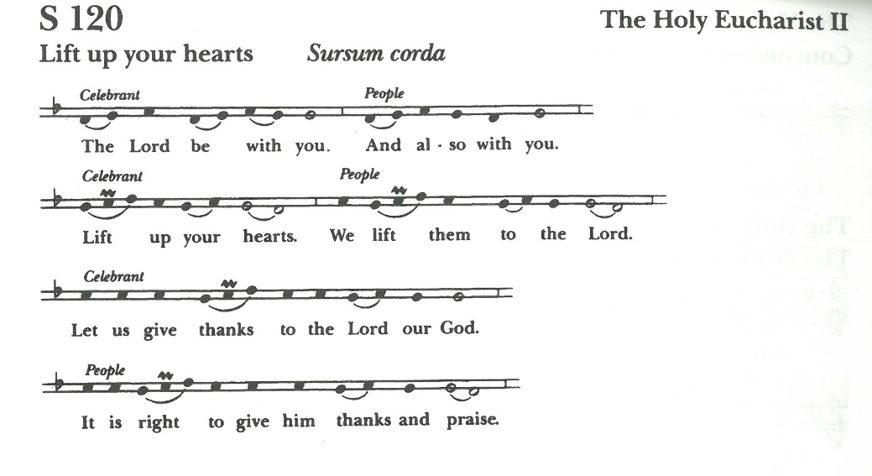
The Eucharistic Liturgy

It is right, our duty and our joy, always and everywhere to give thanks to you, Father Almighty, Creator of heaven and earth.

Through Jesus Christ our Lord; according to whose most true promise, the Holy Spirit came down from heaven, lighting upon the disciples, to teach them and to lead them into all truth, giving them boldness and fervent zeal constantly to preach the Gospel to all nations; by which we have been brought out of darkness and error into the clear light and true knowledge of you, and of your Son Jesus Christ.

Therefore we praise you, joining our voices with Angels and Archangels and with all the company of heaven, who for ever sing this hymn to proclaim the glory of your Name:

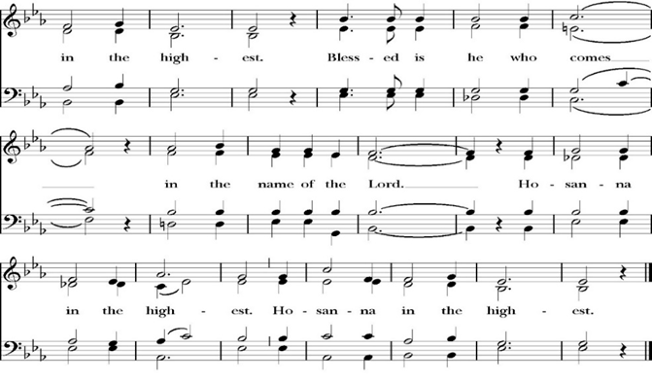
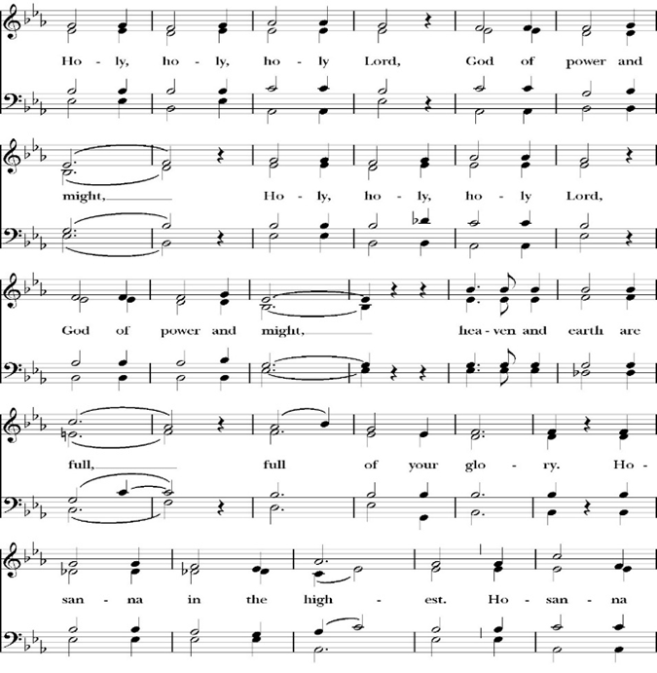
Sanctus

Holy and gracious Father: In your infinite love you made us for yourself; and when we had sinned against you and become subject to evil and death, you, in your mercy, sent your only Son Jesus Christ into the world for our salvation. By the Holy Spirit and the Virgin Mary he became flesh and dwelt among us. In obedience to your will, he stretched out his arms upon the Cross and offered himself once for all, that by his suffering and death we might be saved. By his resurrection he broke the bonds of death, trampling Hell and Satan under his feet. As our great high priest, he ascended to your right hand in glory, that we might come with confidence before the throne of grace.

On the night that he was betrayed, our Lord Jesus Christ took bread; and when he had given thanks, he broke it, * and gave it to his disciples, saying, “Take, eat; this is my Body, which is given for you: Do this in remembrance of me.”
Likewise, after supper, Jesus took the cup, and when he had given thanks, he gave it to them, saying, “Drink this, all of you; for this is my Blood of the New Covenant, which is shed for you, and for many, for the forgiveness of sins: Whenever you drink it, do this in remembrance of me.”
Therefore we proclaim the mystery of faith:

Christ has died.
Christ is risen.
Christ will come again.

We celebrate the memorial of our redemption, O Father, in this sacrifice of praise and thanksgiving, and we offer you these gifts.

Sanctify them by your Word and Holy Spirit to be for your people the Body and Blood of your Son Jesus Christ. Sanctify us also, that we may worthily receive this holy Sacrament, and be made one body with him, that he may dwell in us and we in him. In the fullness of time, put all things in subjection under your Christ, and bring us with all your saints into the joy of your heavenly kingdom, where we shall see our Lord face to face.

And now, as our Savior Christ has taught us, we are bold to pray,

Our Father, who art in heaven,
hallowed be thy Name,
thy kingdom come,
thy will be done,
on earth as it is in heaven.
Give us this day our daily bread.
And forgive us our trespasses,
as we forgive those
who trespass against us.
And lead us not into temptation,
but deliver us from evil.
For thine is the kingdom,
and the power, and the glory,
for ever and ever. Amen.

Fraction
Celebrant Alleluia! Christ our Passover is sacrificed for us.
People Therefore let us keep the feast. Alleluia!

The Prayer of Humble Access

We do not presume to come to this your table, O merciful Lord,
trusting in our own righteousness,
but in your abundant and great mercies.
We are not worthy so much as to gather up
the crumbs under your table;
but you are the same Lord
whose character is always to have mercy.
Grant us, therefore, gracious Lord,
so to eat the flesh of your dear Son Jesus Christ,
and to drink his blood,
that our sinful bodies may be made clean by his body,
and our souls washed through his most precious blood,
and that we may evermore dwell in him, and he in us.
Amen.

Agnus Dei

Ministration of Communion
The gifts of God for the People of God. Take them in remembrance that Christ died for you and feed on him in your hearts by faith, with thanksgiving.

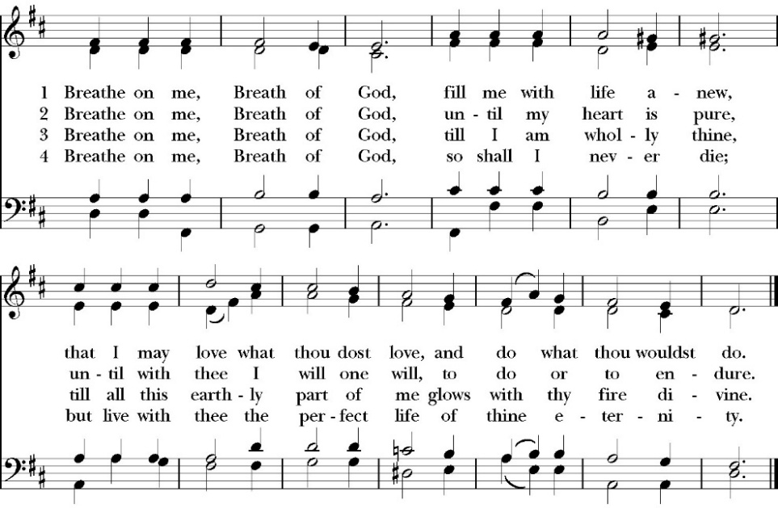
Communion Hymn: Breathe On Me, Breath of God

The Post Communion Prayer

Let us pray.

Heavenly Father,
We thank you for feeding us with the spiritual food
of the most precious Body and Blood
of your Son our Savior Jesus Christ;
and for assuring us in these holy mysteries
that we are living members of the body of your Son,
and heirs of your eternal Kingdom.
And now, Father, send us out to do the work you have
given us to do,
to love and serve you as faithful witnesses of Christ our
Lord.
To him, to you, and to the Holy Spirit,
be honor and glory, now and for ever. Amen.

Blessing

The peace of God, which passes all understanding,
keep your hearts and minds in the knowledge and love of God, and of his Son Jesus Christ our Lord; and the blessing of God Almighty, the Father, the Son, and the Holy Spirit, be among you, and remain with you always. Amen.
Closing Hymn: O Beautiful for Spacious Skies
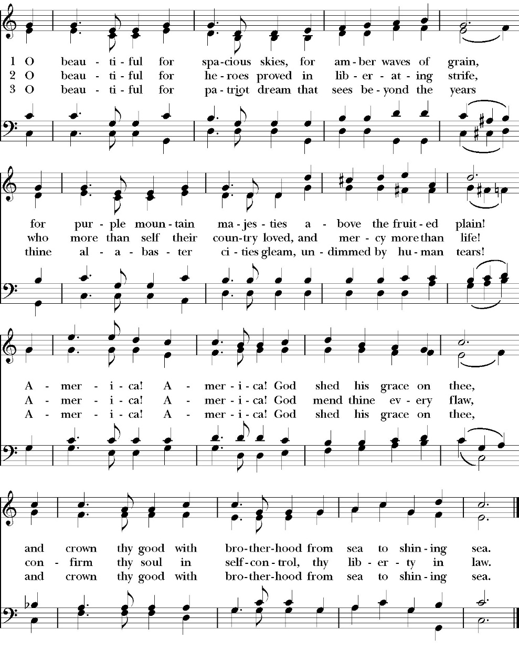

Celebrant Alleluia! Go in peace to love and serve the Lord.
People Thanks be to God. Alleluia! Alleluia!

St. Paul’s Parish Calendar
Sunday May 24– Sunday May 31

SUNDAY, May 24 – Pentecost Sunday
9:15 AM Sunday Funday, Youth Room
9:15 AM No Gospel of John Bible Study, Conference Room
9:30 AM Choir Rehearsal, Church
10:30 AM Children’s Sunday School, Chapel
Pre-K –2nd Grade, Sunday School Room
3rd -5th Grade, Youth Room
10:30 AM Holy Eucharist, Church

MONDAY, May 25 – Office Closed Memorial Day

TUESDAY, May 26

WEDNESDAY, May 27
9:30 AM Holy Eucharist with healing prayer, Chapel
10:15 AM Bible Study, Conference Room
7:00 PM Choir Practice, Chapel

THURSDAY, May 28

FRIDAY, May 29
6:30 AM Men’s Bible Study, Valhalla Restaurant

SATURDAY, May 30
6:00 PM Friendship and Fellowship,
Home of Blake and Madelyn Scheemann

SUNDAY, May 31 – Pentecost Sunday
9:15 AM Sunday Funday, Youth Room
9:15 AM Gospel of John Bible Study, Conference Room
9:30 AM Choir Rehearsal, Church
10:30 AM Children’s Sunday School, Chapel
Pre-K –2nd Grade, Sunday School Room
3rd -5th Grade, Youth Room
10:30 AM Holy Eucharist, Church

Church Office Hours
Monday-Thursday 8:00 AM-4:00 PM

Office will be closed for Memorial Day, Monday, May 25

Sunday Morning Bible Study: The Gospel of John
St. Paul’s is embarking on a study of the Gospel of John that will span the next year. These classes will be on Sunday mornings from 9:15-10:00AM. We will take the better part of the next year to move slowly through John and savor the profound spiritual truths that it offers. We will be using a book called Be Alive by Warren Wiersbe as our guide. This book is essentially a study guide to the Gospel of John and will provide us with structure and insight as we move our way through the Gospel. Books will be available beginning the day of the first class.

Projected Class Timeline

June Chapter 7-8
July No Class
August Chapter 9-10

The class will progress based on how quickly or slowly is needed and our projected timelines may change as we move forward.

Graduations and Educational Milestones
Do you have a child, grandchild, member of your family graduating or reaching a significant educational milestone in May or June? We want to celebrate the educational achievements of our congregation and their families in our June bulletins and newsletter. Please reach out to our church office with information so that we can recognize these students.

End-of-Schoolyear Thank You to Our Children and Youth Volunteers at an After-Church Picnic with Water Fun, Sunday, June 7
St. Paul’s will celebrate the end of the school year with a picnic celebration with water fun after church and a thank you to our children’s and youth ministry leaders and volunteers during church.
All families are invited to join us for church followed by a picnic lunch and water fun. St. Paul’s will provide a large water fun area and splash pad for children ages 10 and under. Older youth will have slip- and-slides.

Visalia Emergency Aid Food Barrel
For many years, St. Paul’s supported the ministry of Visalia Emergency Aid by housing a food barrel. We are renewing this ministry and invite members to bring food on Sunday mornings to place into the food barrel and support the VEA feeding ministries.

A Food Bank for Hurley Families
The next Neighborhood Market to benefit students at Hurley School will be Tuesday June 2, 2:30 PM to 3:30 PM at St Paul’s Church parking lot. If you are interested in helping that day, please contact Sue Nyberg. My home phone number is 559-733-8244.

Due to the heat, we are in need of more volunteers for
the months of May, June, August, and September.
This will allow volunteers to work in shifts during these hot months.

PROVIDED BY VISALIA EMERGENCY AID
AND ST. PAUL’S CHURCH
Tuesday, June 2, 2026
From 2:30 PM to 3:30 PM
LOCATION:
ST. PAUL'S CHURCH PARKING LOT
ACROSS THE STREET FROM HURLEY


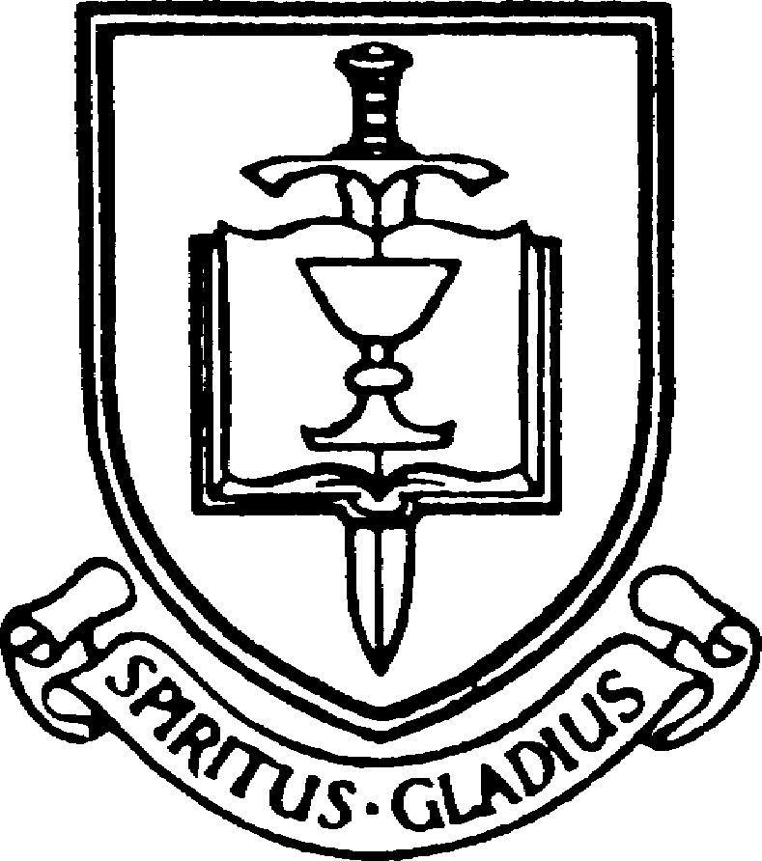


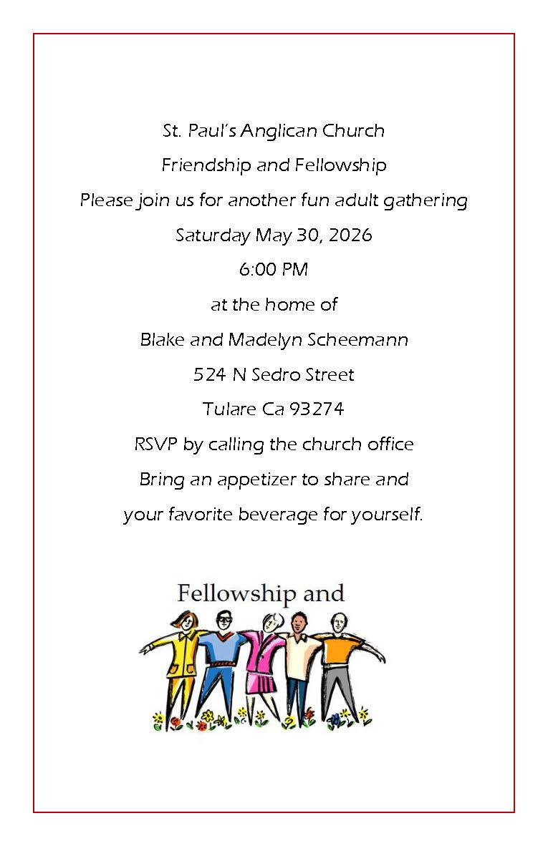

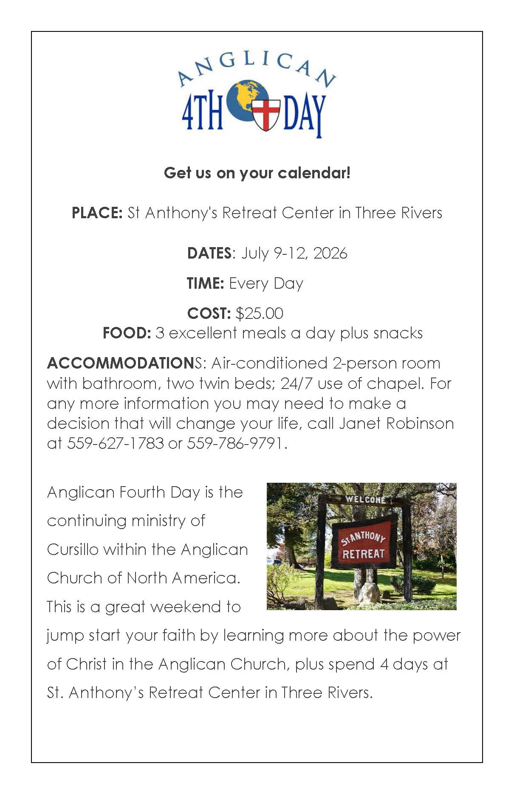
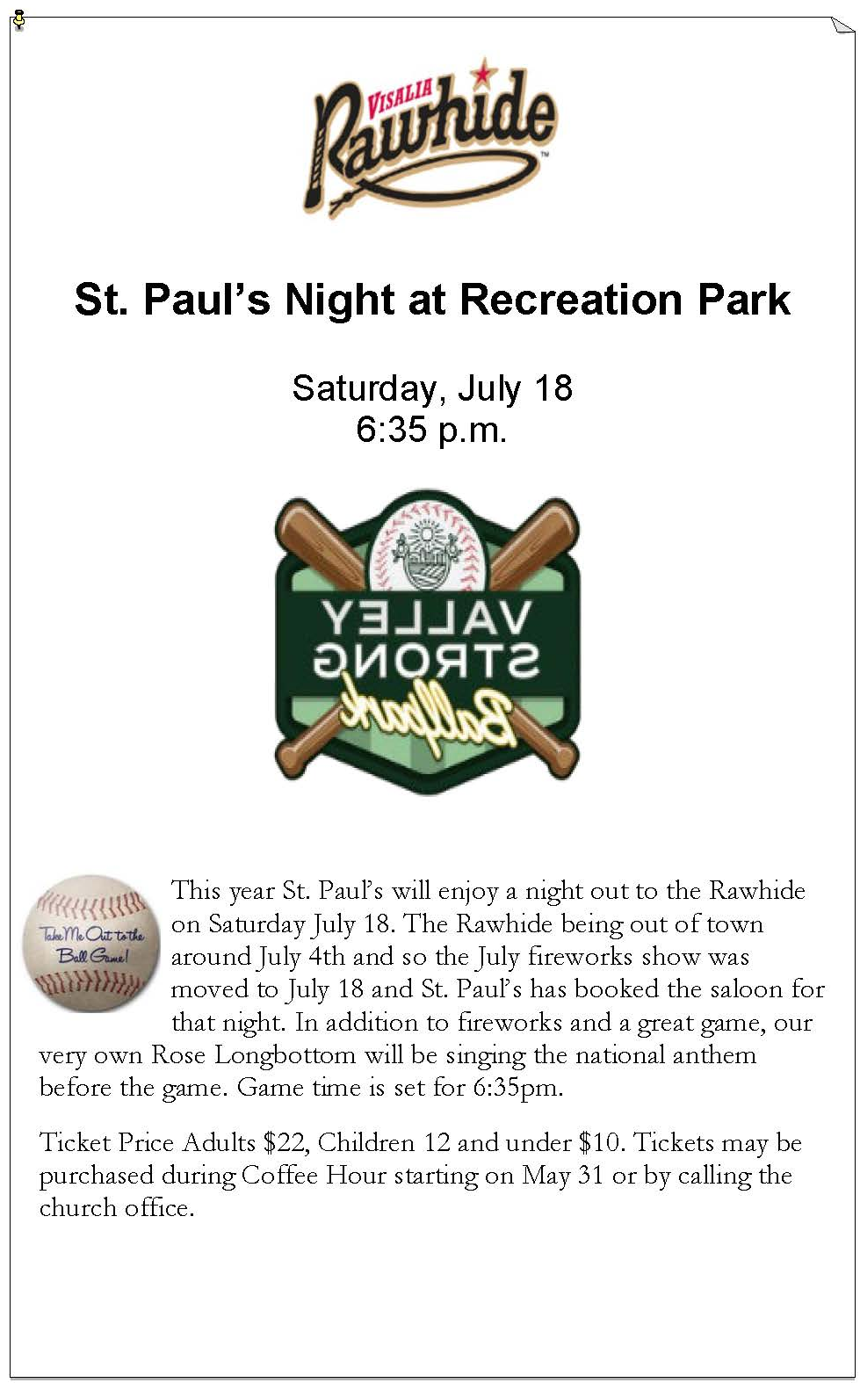
St. Paul’s Anglican Church
Parish Office
6436 W. Hurley Ave
Visalia, California 93291
559-732-4821
Office Hours: 8:00 – 4:00
Monday – Thursday

Worship: Sundays at 10:30AM
Livestream: Link at spvisalia.com
and on our Facebook page
Please be advised that this service is being recorded for broadcast
and/or archival purposes. By attending, you consent
to the inclusion of your likeness in these recordings.

St. Paul’s Clergy and Staff
The Rev. Robert Longbottom, Rector
rector@spvisalia.com
(559)802-2928
The Rev. John Iseman, Pastoral Associate for Family Ministries
family@spvisalia.com
The Rev. Kashy Rowland-Smith, Deacon
kashyrs@aol.com
Antoinette Horsting, Parish Administrator
bookkeeper@spvisalia.com
Marguerite Crownover, Organist and Accompanist
Cynthia Culp, Choral Director
Jackie Iseman, Nursery Coordinator
Shane Motl, Sexton

St. Paul’s is a member church of the
Anglican Diocese of San Joaquin
The Rt. Rev. Eric V. Menees, Bishop

Next Week’s Lessons
Genesis 1:1-2:3
Psalm 150
2 Corinthians 13:5-14
Matthews 28:16-20

The Altar Flowers
The flowers at the altar are given to the Glory of God,
by Mark and Kris Bratton, in celebration
for their forty-fourth anniversary.

