ST. PAUL’S
ANGLICAN CHURCH
VISALIA, CALIFORNIA

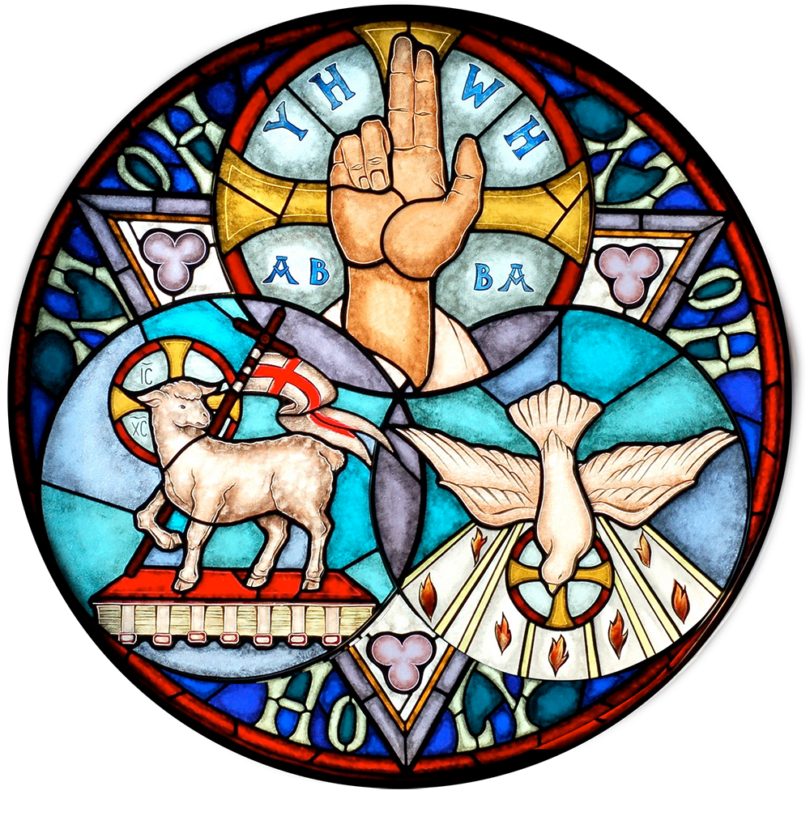

Trinity Sunday
May 31, 2026
10:30 A.M


Welcome!

St. Paul’s Anglican Church extends a warm welcome to all visitors and newcomers, whether worshiping in person or at home via livestream.

Visitors’ Guide

St. Paul’s Church is a parish in the Diocese of San Joaquin of the Anglican Church in North America, which includes both Catholic and Protestant traditions. We accept Jesus Christ as Savior, and we promise to follow him as Lord. We believe in One God,

- the Father who created us and all things,
- the Son who redeems us from sin and death,
- the Holy Spirit who renews and sanctifies us.

We believe the Holy Scriptures to be the Word of God and to contain all things necessary for salvation, and we accept the Apostles’ and Nicene Creeds as essential beliefs of the Christian faith.

All followers of Jesus who are baptized in the name of the Trinity are invited to receive Holy Communion. If for whatever reason you feel you cannot receive communion, we invite you to come forward to receive a blessing. Please indicate you’d like a blessing by crossing your arms. All people are welcome at the Altar of the Lord.

Visitors are invited to sign the guest book at the entrance table and introduce themselves to the clergy following the service.

Holy Eucharist

Prelude: “Prelude in G Major” Bach
Opening Hymn: #362 – “Holy, Holy, Holy Lord God Almighty p. 4
Acclamation p. 5
The Collect for Purity p. 5
Summary of the Law p. 5
Kyrie p. 5
Gloria p. 6
The Collect of the Day p. 7
Lesson: Genesis 1:1-2:3 p. 7
Gradual: Psalm 150 p. 9
Epistle 2 Corinthians 13:5-14 p. 9
Sequence Hymn: #488 – “Be Thou My Vision” p. 10
Gospel: Matthew 28:16-20 p. 11
Sermon: Rev. John Iseman
Nicene Creed p. 11
Prayers of the People p. 12
Confession and Absolution p. 14
The Comfortable Words p. 14
The Peace p. 15
Offertory Hymn: “Fly Away Medley” Choir
Doxology p. 15
The Offertory p. 16
Sursum Corda p. 16
Sanctus p. 17
The Lord’s Prayer p. 19
Prayer of Humble Access p. 20
Agnus Dei p. 20
Communion: (Praise Band) “The Commission” p. 21
Post Communion Prayer p. 22
Blessing p. 22
Closing Hymn: #589 – “Here I am Lord” p. 23
Dismissal p. 24
Postlude: “St Anne’s Recessional” Young

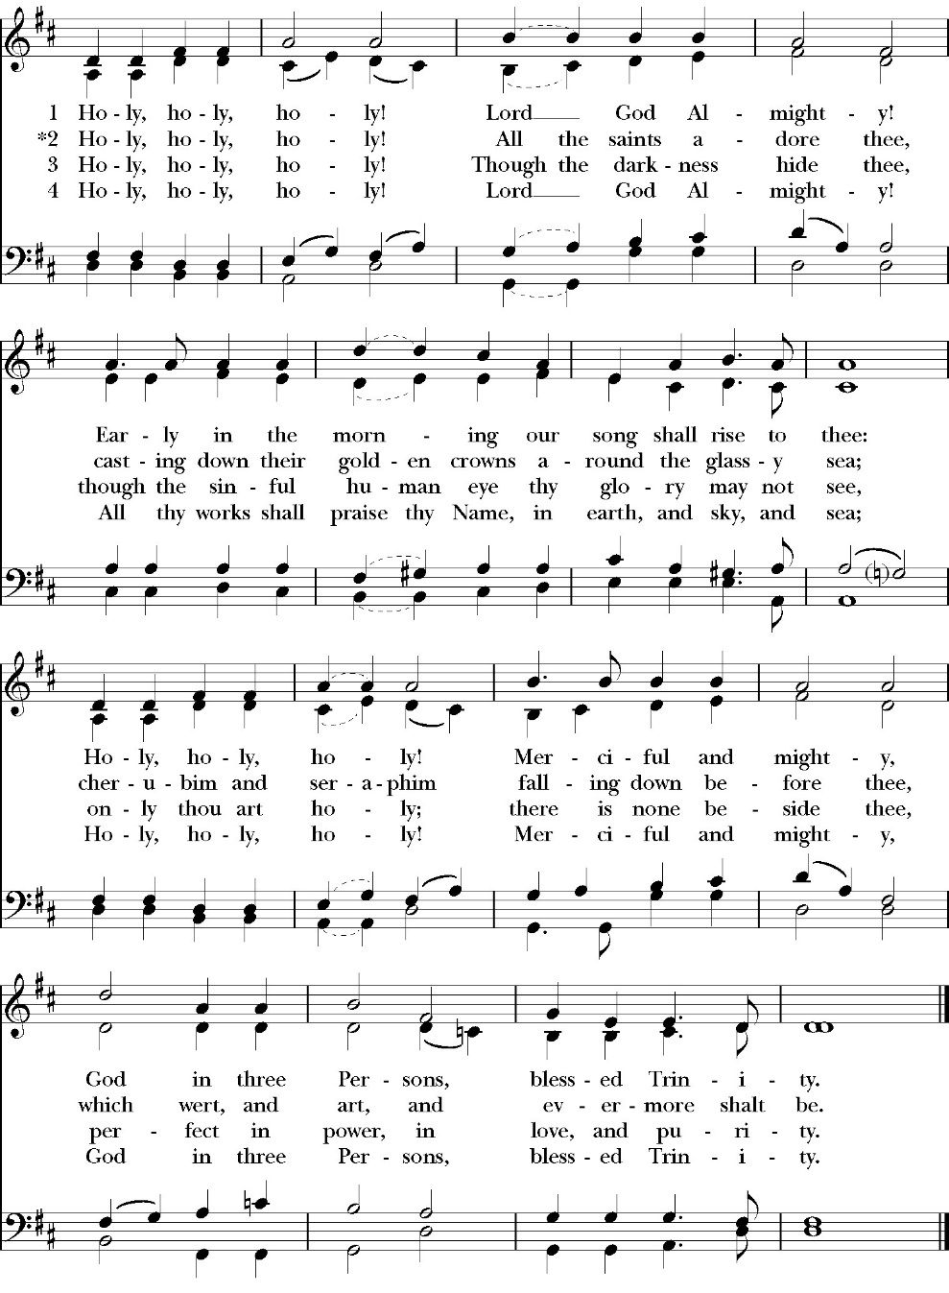
Opening Hymn: Holy, Holy, Holy Lord God Almighty

The Acclamation
Celebrant Blessed be God, the Father, the Son, and the Holy Spirit.
People And blessed be his kingdom, now and forever.
Amen.

The Collect for Purity

Almighty God, to you all hearts are open, all desires known, and from you no secrets are hid: Cleanse the thoughts of our hearts by the inspiration of your Holy Spirit, that we may perfectly love you, and worthily magnify your holy Name through Christ our Lord. Amen.

The Summary of the law

Hear what our Lord Jesus Christ says: You shall love the Lord your God with all your heart and with all your soul and with all your mind. This is the first and great commandment. And the second is like it: You shall love your neighbor as yourself. On these two commandments depend all the Law and the Prophets.

Kyrie
Gloria

Celebrant The Lord be with you.
People And with your spirit.
Celebrant Let us pray.

The Collect of the Day

Almighty and everlasting God, you have given to us your servants grace, by the confession of a true faith, to acknowledge the glory of the eternal Trinity, and in the power of your divine Majesty to worship the Unity: Keep us steadfast in this faith and worship, and bring us at last to see you in your one and eternal glory, O Father; who with the Son and the Holy Spirit live and reign, one God, for ever and ever. Amen.

Lesson: Genesis 1:1-2:3
In the beginning, God created the heavens and the earth. 2 The earth was without form and void, and darkness was over the face of the deep. And the Spirit of God was hovering over the face of the waters.

3 And God said, “Let there be light,” and there was light. 4 And God saw that the light was good. And God separated the light from the darkness. 5 God called the light Day, and the darkness he called Night. And there was evening and there was morning, the first day.

6 And God said, “Let there be an expanse in the midst of the waters, and let it separate the waters from the waters.” 7 And God made the expanse and separated the waters that were under the expanse from the waters that were above the expanse. And it was so. 8 And God called the expanse Heaven. And there was evening and there was morning, the second day.

9 And God said, “Let the waters under the heavens be gathered together into one place, and let the dry land appear.” And it was so. 10 God called the dry land Earth, and the waters that were gathered together he called Seas. And God saw that it was good.

11 And God said, “Let the earth sprout vegetation, plants yielding seed, and fruit trees bearing fruit in which is their seed, each according to its kind, on the earth.” And it was so. 12 The earth brought forth vegetation, plants yielding seed according to their own kinds, and trees bearing fruit in which is their seed, each according to its kind. And God saw that it was good. 13 And there was evening and there was morning, the third day.

14 And God said, “Let there be lights in the expanse of the heavens to separate the day from the night. And let them be for signs and for seasons, and for days and years, 15 and let them be lights in the expanse of the heavens to give light upon the earth.” And it was so. 16 And God made the two great lights—the greater light to rule the day and the lesser light to rule the night—and the stars. 17 And God set them in the expanse of the heavens to give light on the earth, 18 to rule over the day and over the night, and to separate the light from the darkness. And God saw that it was good. 19 And there was evening and there was morning, the fourth day.

20 And God said, “Let the waters swarm with swarms of living creatures, and let birds fly above the earth across the expanse of the heavens.” 21 So God created the great sea creatures and every living creature that moves, with which the waters swarm, according to their kinds, and every winged bird according to its kind. And God saw that it was good. 22 And God blessed them, saying, “Be fruitful and multiply and fill the waters in the seas, and let birds multiply on the earth.” 23 And there was evening and there was morning, the fifth day.

24 And God said, “Let the earth bring forth living creatures according to their kinds—livestock and creeping things and beasts of the earth according to their kinds.” And it was so. 25 And God made the beasts of the earth according to their kinds and the livestock according to their kinds, and everything that creeps on the ground according to its kind. And God saw that it was good.

26 Then God said, “Let us make man in our image, after our likeness. And let them have dominion over the fish of the sea and over the birds of the heavens and over the livestock and over all the earth and over every creeping thing that creeps on the earth.”

27 So God created man in his own image, in the image of God he created him; male and female he created them.
28 And God blessed them. And God said to them, “Be fruitful and multiply and fill the earth and subdue it, and have dominion over the fish of the sea and over the birds of the heavens and over every living thing that moves on the earth.” 29 And God said, “Behold, I have given you every plant yielding seed that is on the face of all the earth, and every tree with seed in its fruit. You shall have them for food. 30 And to every beast of the earth and to every bird of the heavens and to everything that creeps on the earth, everything that has the breath of life, I have given every green plant for food.” And it was so. 31 And God saw everything that he had made, and behold, it was very good. And there was evening and there was morning, the sixth day.

2 Thus the heavens and the earth were finished, and all the host of them. 2 And on the seventh day God finished his work that he had done, and he rested on the seventh day from all his work that he had done. 3 So God blessed the seventh day and made it holy, because on it God rested from all his work that he had done in creation.

Reader: The Word of the Lord
People: Thanks be to God

Gradual: Psalm 150
1 Praise the LORD. Praise God in his holiness; *
praise him in the firmament of his power.
2 Praise him for his mighty acts; *
praise him for his excellent greatness.
3 Praise him with the sound of the trumpet; *
praise him upon the lute and harp.
4 Praise him with the timbrels and dances; *
praise him upon the strings and pipe.
5 Praise him with the resounding cymbals; *
praise him with the loud cymbals.
6 Let everything that has breath praise the LORD. *
O praise the LORD.

Glory be to the Father, and to the Son, and to the Holy Spirit;
as it was in the beginning, is now, and ever shall be, world
without end. Amen

Epistle: 2 Corinthians 13:5-14
Examine yourselves, to see whether you are in the faith. Test yourselves. Or do you not realize this about yourselves, that Jesus Christ is in you? —unless indeed you fail to meet the test! 6 I hope you will find out that we have not failed the test. 7 But we pray to God that you may not do wrong—not that we may appear to have met the test, but that you may do what is right, though we may seem to have failed. 8 For we cannot do anything against the truth, but only for the truth. 9 For we are glad when we are weak and you are strong. Your restoration is what we pray for. 10 For this reason I write these things while I am away from you, that when I come I may not have to be severe in my use of the authority that the Lord has given me for building up and not for tearing down.

11 Finally, brothers, rejoice. Aim for restoration, comfort one another, agree with one another, live in peace; and the God of love and peace will be with you. 12 Greet one another with a holy kiss. 13 All the saints greet you.

14 The grace of the Lord Jesus Christ and the love of God and the fellowship of the Holy Spirit be with you all.

Reader: The Word of the Lord
People: Thanks be to God

Sequence Hymn: Be Thou My Vision
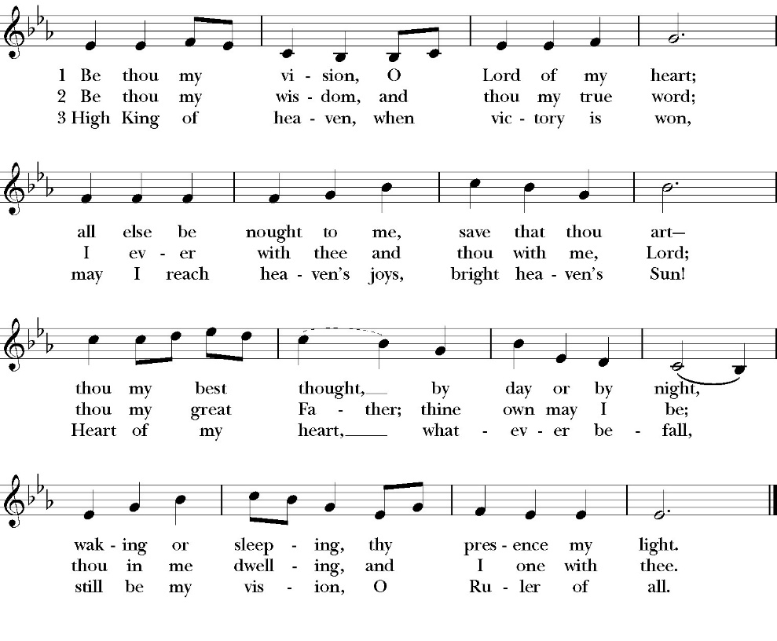
(Verses 1-2 before Gospel, verse 3 after)
Clergy: The Holy Gospel of Our Lord Jesus Christ, according to
Matthew
People: Glory to you, Lord Christ.

Gospel Matthew 28:16-20
Now the eleven disciples went to Galilee, to the mountain to which Jesus had directed them. 17 And when they saw him they worshiped him, but some doubted. 18 And Jesus came and said to them, “All authority in heaven and on earth has been given to me. 19 Go therefore and make disciples of all nations, baptizing them in the name of the Father and of the Son and of the Holy Spirit, 20 teaching them to observe all that I have commanded you. And behold, I am with you always, to the end of the age.”

Clergy: The Gospel of the Lord
People: Praise to you Lord Christ

Sermon
rev. john iseman

The Nicene Creed

We believe in one God,
the Father, the Almighty,
maker of heaven and earth,
of all that is, visible and invisible.
We believe in one Lord, Jesus Christ,
the only-begotten Son of God,
eternally begotten of the Father,
God from God, Light from Light,
true God from true God,
begotten, not made,
of one Being with the Father.
through him all things were made.
For us and for our salvation he came down from heaven:
was incarnate from the Holy Spirit and the Virgin Mary,
and was made man.
For our sake he was crucified under Pontius Pilate;
he suffered death and was buried.
On the third day he rose again in accordance with the
Scriptures;
he ascended into heaven
and is seated at the right hand of the Father.
He will come again in glory to judge the living and the dead,
and his kingdom will have no end.
We believe in the Holy Spirit, the Lord, the giver of life,
who proceeds from the Father and the Son,
who with the Father and the Son is worshiped and glorified.
who has spoken through the Prophets.
We believe in one holy catholic and apostolic Church.
We acknowledge one Baptism for the forgiveness of sins.
We look for the resurrection of the dead,
and the life of the world to come. Amen.

The Prayers of the People

Leader Let us pray for the Church and for the world, saying, “hear our prayer.”
For the peace of the whole world, and for the well-being and unity of the people of God.
Lord, in your mercy:
People Hear our prayer.

Leader For Stephen our archbishop, Julian our provincial dean and Eric, our bishop. For Fr. Rob, Deacon John, Deacon Kashy, and for all the clergy and people of our diocese and congregation and for the worldwide Anglican Communion.
Lord, in your mercy:
People Hear our prayer.

Leader For all those who proclaim the Gospel at home and abroad; and for all who teach and disciple others.
Lord, in your mercy:
People Hear our prayer.

Leader For our brothers and sisters in Christ who are persecuted for their faith.
Lord, in your mercy:
People Hear our prayer.

Leader For our nation, for those in authority, and for all in public service especially Donald our president and Gavin our governor.
Lord, in your mercy:
People Hear our prayer.

Leader: In the St. Paul’s cycle of prayer, we pray for all ministries of Christian education, discipleship and bible study. We pray that through word and deed we might grow closer to the heart and life of Jesus through our study, prayer, fellowship and mission.
Lord, in your mercy:
People Hear our prayer.

Leader In the ACNA Cycle of Prayer, today we pray for the Diocese of Mid-America (REC), Bishop Ray Sutton, his wife, Susan; Bishop Charles Camlin and his wife, Brett; Bishop Walter Banek, his wife, Nelda; and Bishop Charles Dorrington and his wife, Claudia Jean.
Lord, in your mercy:
People Hear our prayer.

Leader For all those who are in trouble, sorrow, need, sickness, or
any other adversity [especially ____________]. We also
pray for all who are currently serving in our armed forces
and serving as first responders.
Lord, in your mercy:
People Hear our prayer.

Leader For all those who have departed this life in the certain hope
of the resurrection, (we pray especially for ____________),
in Thanksgiving let us pray.
Lord, in your mercy:
People Hear our prayer.

Celebrant will add a concluding prayer
O God, our heavenly Father, you manifested your love by sending your only-begotten Son into the world, that all might live through him: Pour out your Spirit on your Church, that we may fulfill his command to preach the Gospel to all people. Send forth laborers into your harvest; defend them in all dangers and temptations; and hasten the time when the fullness of the Gentiles shall be gathered in, and faithful Israel shall be saved; through your Son Jesus Christ our Lord. Amen.

The Confession and Absolution

Celebrant Let us humbly confess our sins to Almighty God.

Most merciful God,
we confess that we have sinned against you
in thought, word and deed,
by what we have done, and by what we have left undone.
We have not loved you with our whole heart;
we have not loved our neighbors as ourselves.
We are truly sorry and we humbly repent.
For the sake of your Son Jesus Christ,
have mercy on us and forgive us;
that we may delight in your will, and walk in your ways,
to the glory of your Name. Amen.

the Comfortable Words

Hear the Word of God to all who truly turn to him.

The saying is trustworthy and deserving of full acceptance, that Christ Jesus came into the world to save sinners.

-1 Timothy 1:15

If anyone sins, we have an advocate with the Father, Jesus Christ the righteous. He is the propitiation for our sins, and not for ours only, but also for the sins of the whole world.

-1 John 2:1-2

The Peace

Celebrant The Peace of the Lord be always with you.
People And with your spirit.

offertory anthem

Fly Away Medley -Choir

The Doxology
(Verse 3 only)

Offertory
Celebrant All things come from you, O Lord,
People And of your own have we given you.

The Eucharistic Liturgy

Celebrant The Lord be with you.
People And with your spirit.
Celebrant Lift up your hearts.
People We lift them up to the Lord.
Celebrant Let us give thanks to the Lord our God.
People It is right to give him thanks and praise.

It is right, our duty and our joy, always and everywhere to give thanks to you, Father Almighty, Creator of heaven and earth.

But chiefly are we bound to praise you for the glorious resurrection of your Son Jesus Christ our Lord; for he is the true Paschal Lamb, who was offered for us, and has taken away the sin of the world; who by his death has destroyed death, and by his rising to life again has won for us everlasting life

Therefore we praise you, joining our voices with Angels and Archangels and with all the company of heaven, who for ever sing this hymn to proclaim the glory of your Name:
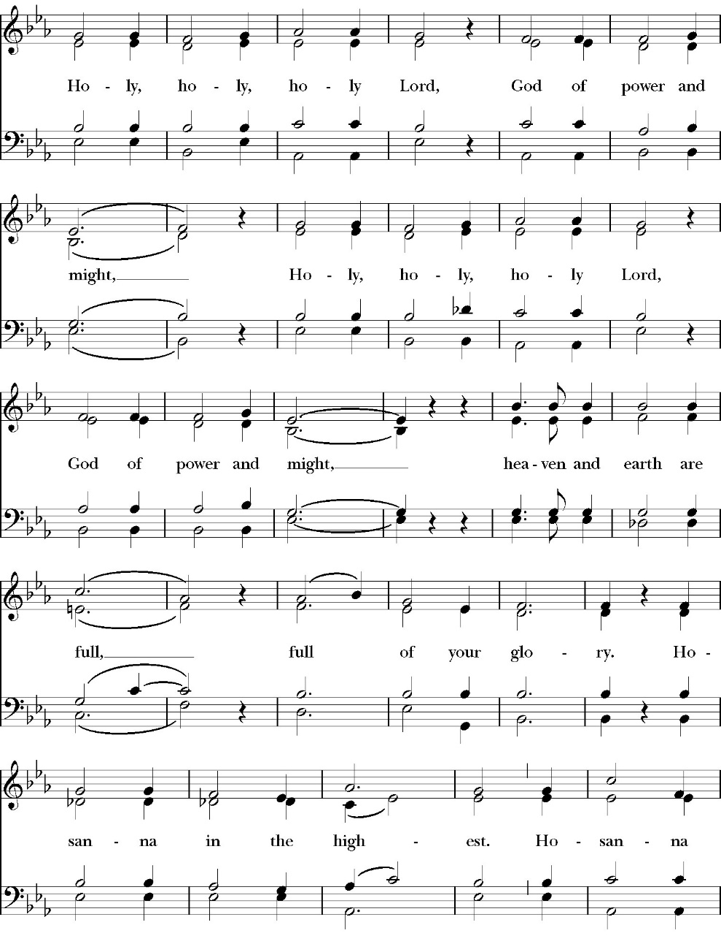
Sanctus

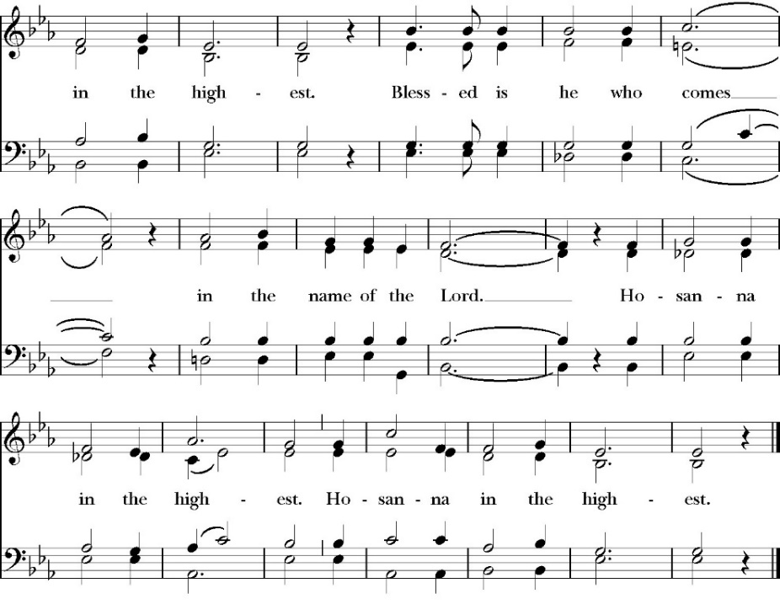
Holy and gracious Father: In your infinite love you made us for yourself; and when we had sinned against you and become subject to evil and death, you, in your mercy, sent your only Son Jesus Christ into the world for our salvation. By the Holy Spirit and the Virgin Mary he became flesh and dwelt among us. In obedience to your will, he stretched out his arms upon the Cross and offered himself once for all, that by his suffering and death we might be saved. By his resurrection he broke the bonds of death, trampling Hell and Satan under his feet. As our great high priest, he ascended to your right hand in glory, that we might come with confidence before the throne of grace.

On the night that he was betrayed, our Lord Jesus Christ took bread; and when he had given thanks, he broke it, * and gave it to his disciples, saying, “Take, eat; this is my Body, which is given for you: Do this in remembrance of me.”
Likewise, after supper, Jesus took the cup, and when he had given thanks, he gave it to them, saying, “Drink this, all of you; for this is my Blood of the New Covenant, which is shed for you, and for many, for the forgiveness of sins: Whenever you drink it, do this in remembrance of me.”

Therefore we proclaim the mystery of faith:

Christ has died.
Christ is risen.
Christ will come again.

We celebrate the memorial of our redemption, O Father, in this sacrifice of praise and thanksgiving, and we offer you these gifts.

Sanctify them by your Word and Holy Spirit to be for your people the Body and Blood of your Son Jesus Christ. Sanctify us also, that we may worthily receive this holy Sacrament, and be made one body with him, that he may dwell in us and we in him. In the fullness of time, put all things in subjection under your Christ, and bring us with all your saints into the joy of your heavenly kingdom, where we shall see our Lord face to face.

And now, as our Savior Christ has taught us, we are bold to pray,

Our Father, who art in heaven,
hallowed be thy Name,
thy kingdom come,
thy will be done,
on earth as it is in heaven.
Give us this day our daily bread.
And forgive us our trespasses,
as we forgive those
who trespass against us.
And lead us not into temptation,
but deliver us from evil.
For thine is the kingdom,
and the power, and the glory,
for ever and ever. Amen.

Fraction

Celebrant Alleluia! Christ our Passover is sacrificed for us.
People Therefore let us keep the feast. Alleluia!

The Prayer of Humble Access

We do not presume to come to this your table, O merciful Lord,
trusting in our own righteousness,
but in your abundant and great mercies.
We are not worthy so much as to gather up
the crumbs under your table;
but you are the same Lord
whose character is always to have mercy.
Grant us, therefore, gracious Lord,
so to eat the flesh of your dear Son Jesus Christ,
and to drink his blood,
that our sinful bodies may be made clean by his body,
and our souls washed through his most precious blood,
and that we may evermore dwell in him, and he in us.
Amen.

Agnus Dei

Ministration of Communion

The gifts of God for the People of God. Take them in remembrance that Christ died for you and feed on him in your hearts by faith, with thanksgiving.

Communion (Praise Band) The Commission

See my hands look at my feet
It’s okay if it’s hard to believe
I have faith you will do greater things
It’s my time to go but before I leave

Go tell the world about me
I was dead but now I live
I’ve gotta go now for a little while
But goodbye is not the (end)

Don’t forget the things that I taught you
I conquered death and I hold the keys
Where I go you will go too someday
But there’s much to do here before you leave

Go tell the world about me
I was dead but now I live
I’ve gotta go now for a little while
But goodbye is not the

End of the journey the end of the road
My spirit is with you wherever you go
You have a purpose and I have a plan
I’ll make you this promise
I’ll come back again but until then

Go tell the world about me
For I was dead but now I live
Oh I’ve gotta go now for a little while aye
But goodbye is not the end

(Go tell the world) Go tell them about me
(Go tell the world) I’ve gotta go
Go tell the world) For a little while
But goodbye is not the end
The Post Communion Prayer
Let us pray.

Heavenly Father,
We thank you for feeding us with the spiritual food
of the most precious Body and Blood
of your Son our Savior Jesus Christ;
and for assuring us in these holy mysteries
that we are living members of the body of your Son,
and heirs of your eternal Kingdom.
And now, Father, send us out to do the work you have
given us to do,
to love and serve you as faithful witnesses of Christ our
Lord.
To him, to you, and to the Holy Spirit,
be honor and glory, now and for ever. Amen.

Blessing

The peace of God, which passes all understanding,
keep your hearts and minds in the knowledge and love of God, and of his Son Jesus Christ our Lord; and the blessing of God Almighty, the Father, the Son, and the Holy Spirit, be among you, and remain with you always. Amen.

Closing Hymn: Here I am Lord
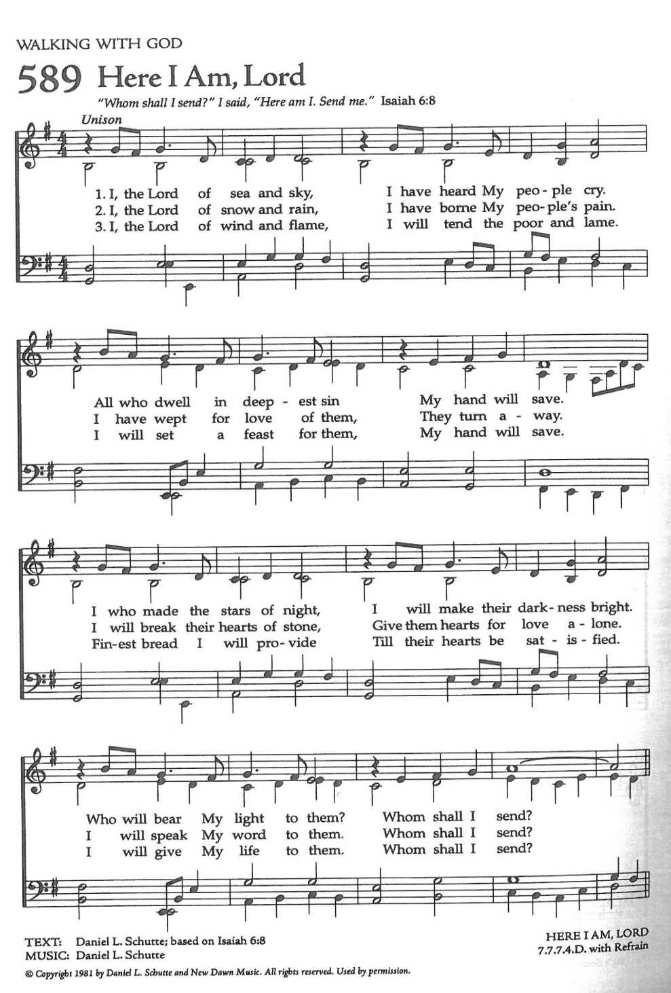

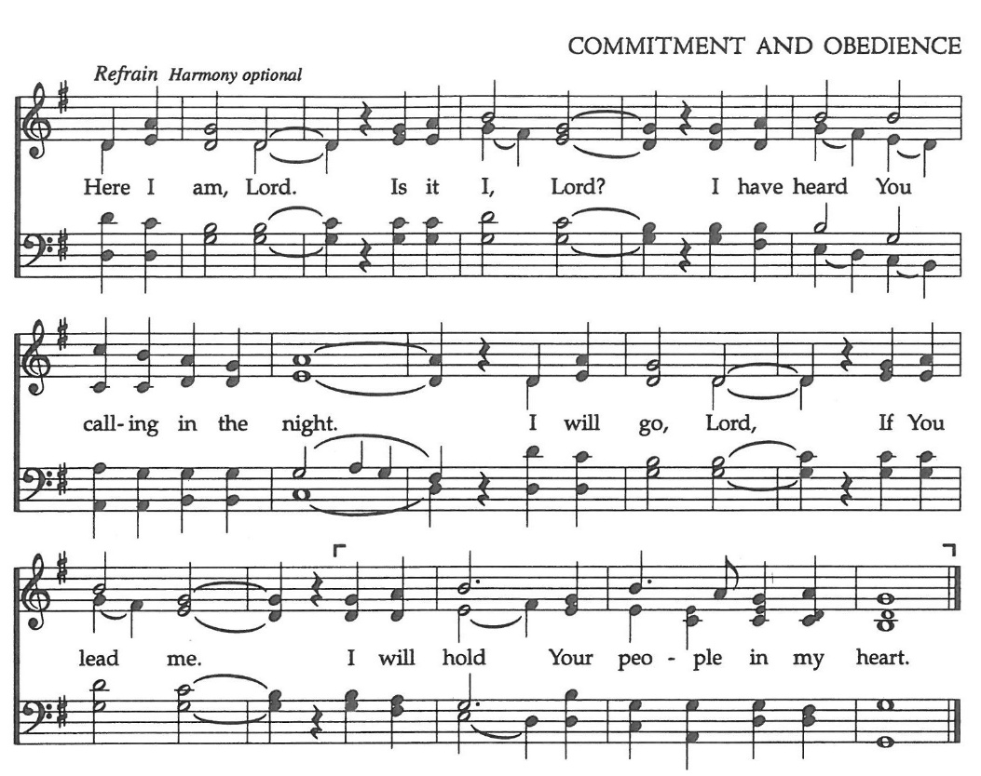

Celebrant Alleluia! Go in peace to love and serve the Lord.
People Thanks be to God. Alleluia! Alleluia!

St. Paul’s Parish Calendar
Sunday May 31– Sunday June 7

SUNDAY, May 31 – Trinity Sunday
9:15 AM Sunday Funday, Youth Room
9:15 AM Gospel of John Bible Study, Conference Room
9:30 AM Choir Rehearsal, Church
10:30 AM Children’s Sunday School, Chapel
Pre-K –2nd Grade, Sunday School Room
3rd -5th Grade, Youth Room
10:30 AM Holy Eucharist, Church

MONDAY, June 1

TUESDAY, June 2
2:30 – 3:30 Neighborhood Market for Hurley School
Church Parking Lot

WEDNESDAY, June 3
9:30 AM Holy Eucharist with healing prayer, Chapel
10:15 AM Bible Study, Conference Room

THURSDAY, June 4

FRIDAY, June 5
6:30 AM Men’s Bible Study, Valhalla Restaurant

SATURDAY, June 6

SUNDAY, June 7 – Second Sunday after Pentecost
9:15 AM Sunday Funday, Youth Room
9:15 AM Gospel of John Bible Study, Conference Room
10:30 AM Children’s Sunday School, Chapel
Pre-K –2nd Grade, Sunday School Room
3rd -5th Grade, Youth Room
10:30 AM Holy Eucharist, Church
12:00 PM Church Picnic

Church Office Hours
Monday-Thursday 8:00 AM-4:00 PM

Sunday Morning Bible Study: The Gospel of John
St. Paul’s is embarking on a study of the Gospel of John that will span the next year. These classes will be on Sunday mornings from 9:15-10:00AM. We will take the better part of the next year to move slowly through John and savor the profound spiritual truths that it offers. We will be using a book called Be Alive by Warren Wiersbe as our guide. This book is essentially a study guide to the Gospel of John and will provide us with structure and insight as we move our way through the Gospel. Books will be available beginning the day of the first class.

Projected Class Timeline

June Chapter 7
July No Class
August Chapter 8-9

The class will progress based on how quickly or slowly is needed and our projected timelines may change as we move forward.

Graduations and Educational Milestones
Do you have a child, grandchild, member of your family graduating or reaching a significant educational milestone in May or June? We want to celebrate the educational achievements of our congregation and their families in our June bulletins and newsletter. Please reach out to our church office with information so that we can recognize these students.

End of School Year After-Church Picnic with Water Fun,
And Thank You to our children and youth volunteers
Sunday, June 7
St. Paul’s will celebrate the end of the school year with a picnic celebration with water fun after church and a thank you to our children’s and youth ministry leaders and volunteers during church.
All families are invited to join us for church followed by a picnic lunch and water fun. St. Paul’s will provide a large water fun area and splash pad for children ages 10 and under. Older youth will have slip- and-slides.

Visalia Emergency Aid Food Barrel
For many years, St. Paul’s supported the ministry of Visalia Emergency Aid by housing a food barrel. We are renewing this ministry and invite members to bring food on Sunday mornings to place into the food barrel and support the VEA feeding ministries.

A Food Bank for Hurley Families
The next Neighborhood Market to benefit students at Hurley School will be Tuesday June 2, 2:30 PM to 3:30 PM at St Paul’s Church parking lot. If you are interested in helping that day, please contact Sue Nyberg. My home phone number is 559-733-8244.

Due to the heat, we are in need of more volunteers for
the months of May, June, August, and September.
This will allow volunteers to work in shifts during these hot months.

PROVIDED BY VISALIA EMERGENCY AID
AND ST. PAUL’S CHURCH
Tuesday, June 2, 2026
From 2:30 PM to 3:30 PM
LOCATION:
ST. PAUL'S CHURCH PARKING LOT
ACROSS THE STREET FROM HURLEY






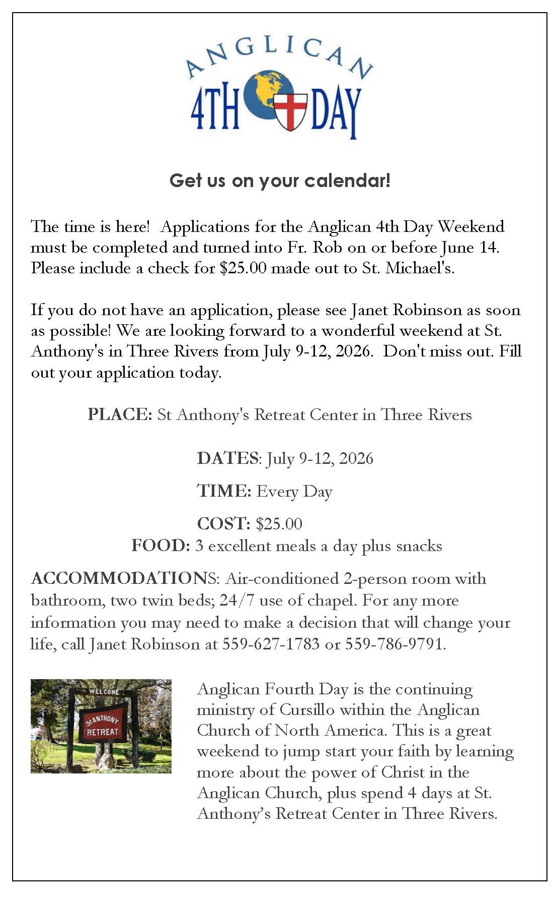
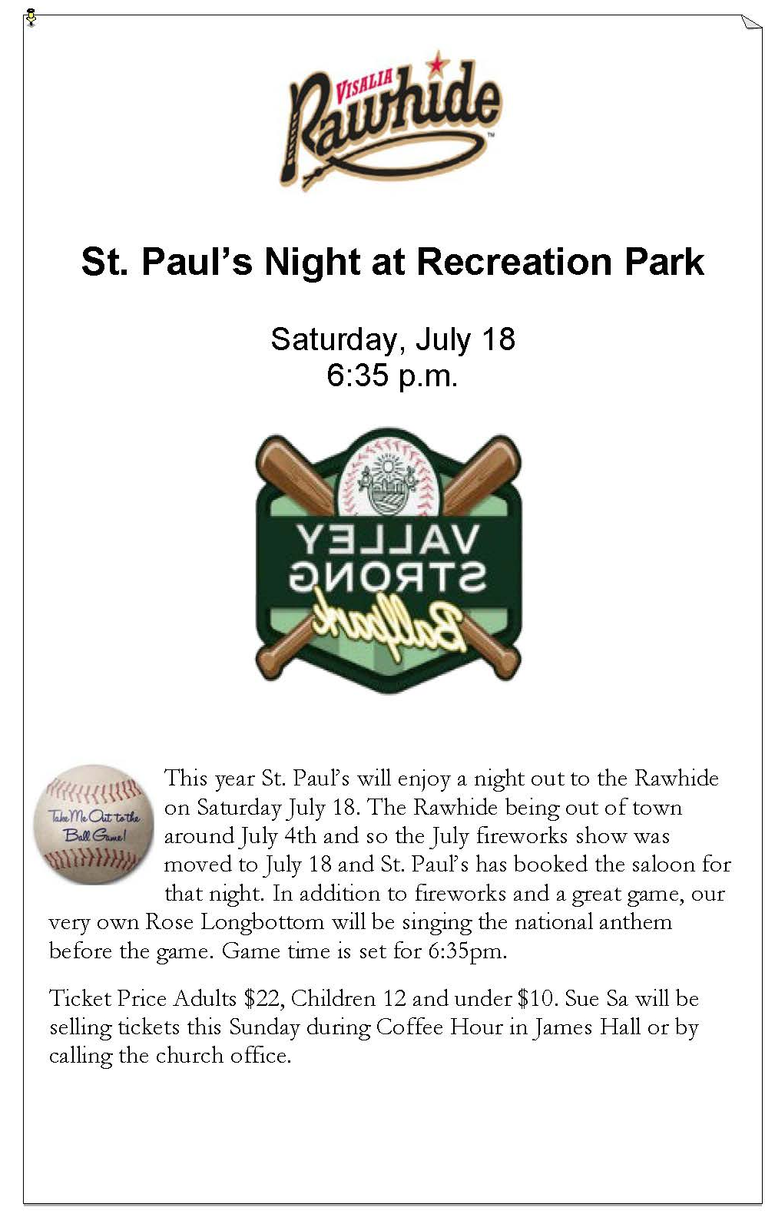

St. Paul’s Anglican Church
Parish Office
6436 W. Hurley Ave
Visalia, California 93291
559-732-4821
Office Hours: 8:00 – 4:00
Monday – Thursday

Worship: Sundays at 10:30AM
Livestream: Link at spvisalia.com
and on our Facebook page
Please be advised that this service is being recorded for broadcast
and/or archival purposes. By attending, you consent
to the inclusion of your likeness in these recordings.

St. Paul’s Clergy and Staff
The Rev. Robert Longbottom, Rector
rector@spvisalia.com
(559)802-2928
The Rev. John Iseman, Pastoral Associate for Family Ministries
family@spvisalia.com
The Rev. Kashy Rowland-Smith, Deacon
kashyrs@aol.com
Antoinette Horsting, Parish Administrator
bookkeeper@spvisalia.com
Marguerite Crownover, Organist and Accompanist
Cynthia Culp, Choral Director
Jackie Iseman, Nursery Coordinator
Shane Motl, Sexton

St. Paul’s is a member church of the
Anglican Diocese of San Joaquin
The Rt. Rev. Eric V. Menees, Bishop

Next Week’s Lessons
Hosea 5:15-6:6
Psalm 50
Romans 4:13-18
Matthew 9:9-13

