ST. PAUL’S
ANGLICAN CHURCH
VISALIA, CALIFORNIA

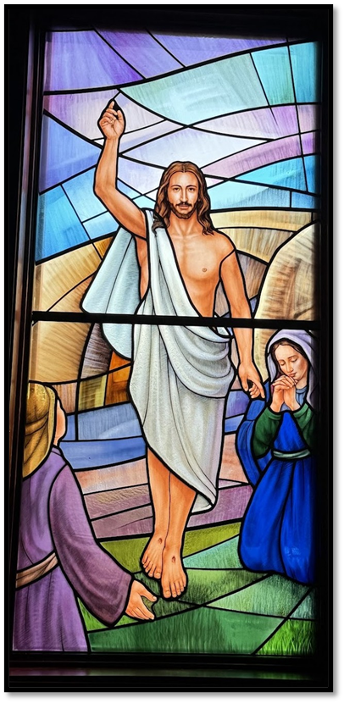

FIFTH SUNDAY OF EASTER
May 3, 2026
10:30 A.M

Welcome!

St. Paul’s Anglican Church extends a warm welcome to all visitors and newcomers, whether worshiping in person or at home via livestream.

Visitors’ Guide

St. Paul’s Church is a parish in the Diocese of San Joaquin of the Anglican Church in North America, which includes both Catholic and Protestant traditions. We accept Jesus Christ as Savior, and we promise to follow him as Lord. We believe in One God,

- the Father who created us and all things,
- the Son who redeems us from sin and death,
- the Holy Spirit who renews and sanctifies us.

We believe the Holy Scriptures to be the Word of God and to contain all things necessary for salvation, and we accept the Apostles’ and Nicene Creeds as essential beliefs of the Christian faith.

Holy Communion is open to all baptized Christians who have examined their lives, repented of their sins, and desire to live
in love and charity with all people.

Those not desiring to receive Holy Communion, and those who have not been baptized into the Christian faith, are invited to cross their arms across their chest, and a blessing will be given instead.

Visitors are invited to sign the guest book at the entrance table and introduce themselves to the clergy following the service.

The Holy Eucharist

Prelude: “Earth and All Stars” Burkhardt
Opening Hymn: #47 – “On This Day, the First of Days” p. 4
Opening Acclamation p. 4
The Collect for Purity p. 4
Summary of the Law p. 5
Kyrie p. 5
Gloria p. 6
Collect of the Day p. 7
Lesson: Acts 17:1-15 p. 7
Gradual: Psalm 66:1-11 p. 8
Epistle: 1 Peter 2:1-12 p. 9
Sequence Hymn: #487 – “Come, My Way, My Truth, My Life” p. 10
Gospel: John 14:1-14 p. 10
Sermon: Rev. John Iseman
Nicene Creed p. 11
Prayers of the People p. 12
The Peace p. 14
Offertory Anthem: “Oh, How He Loves You and Me” Women’s Quartet
The Offertory p. 16
Sursum Corda p. 16
Sanctus p. 17
The Lord’s Prayer p. 19
Fraction p. 19
Prayer for Humble Access p. 19
Agnus Dei p. 20
Communion: (Celebration Hymn) “In Remembrance of Me” p. 21
Post Communion Prayer p. 23
Blessing p. 23
Closing Hymn: #518 – “Christ is Made the Sure Foundation” p. 24
Dismissal p. 25
Postlude: “Allegro Maestoso” Handel

Opening Hymn: On This Day, the First of Days

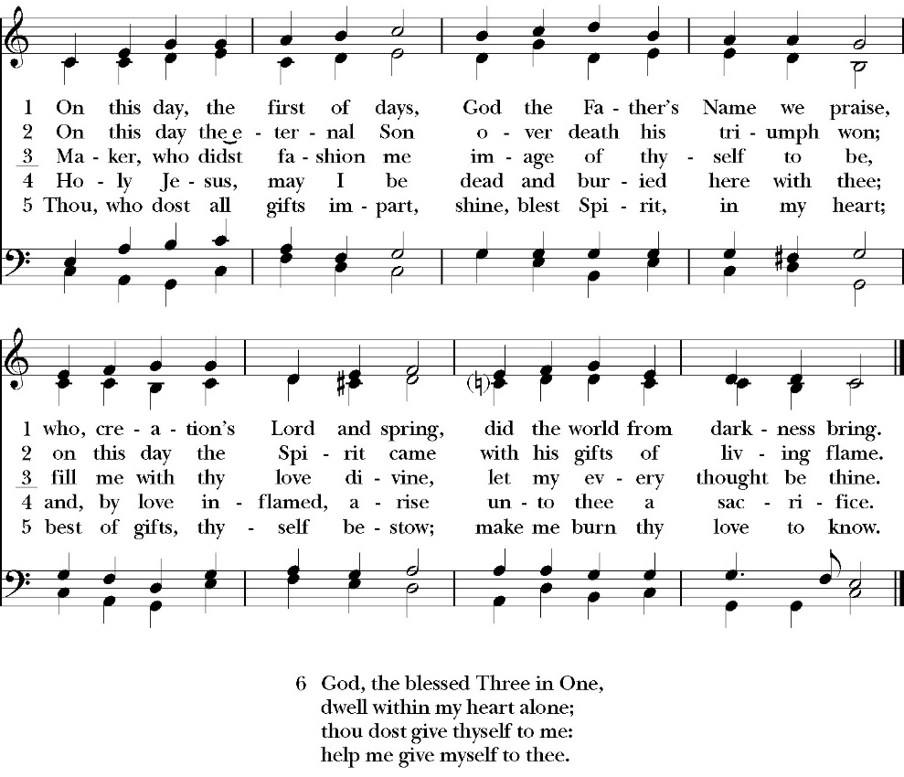

Opening Acclamation

Celebrant Alleluia! Christ is risen!
People The Lord is risen indeed! Alleluia!

Collect for Purity

Celebrant: Almighty God, to you all hearts are open, all desires
known, and from you no secrets are hid: Cleanse the thoughts
of our hearts by the inspiration of your Holy Spirit, that we
may perfectly love you, and worthily magnify your holy Name;
through Christ our Lord. Amen.

Summary of the law

Celebrant: Hear what our Lord Jesus Christ says: You shall love
the Lord your God with all your heart and with all your soul
and with all your mind. This is the first and great
commandment. And the second is like it: You shall love your
neighbor as yourself. On these two commandments depend all
the Law and the Prophets.

Kyrie

Gloria

The Collect of the Day

Celebrant The Lord be with you.
People And with your spirit.
Celebrant Let us pray.

Almighty God, whom truly to know is everlasting life: Grant us so perfectly to know your Son Jesus Christ to be the way, the truth, and the life, that we may steadfastly follow his steps in the way that leads to eternal glory; through Jesus Christ your Son our Lord, who lives and reigns with you, in the unity of the Holy Spirit, one God, for ever and ever. Amen.

Lesson: Lesson: Acts 17:1-15
17 Now when they had passed through Amphipolis and Apollonia, they came to Thessalonica, where there was a synagogue of the Jews. 2 And Paul went in, as was his custom, and on three Sabbath days he reasoned with them from the Scriptures, 3 explaining and proving that it was necessary for the Christ to suffer and to rise from the dead, and saying, “This Jesus, whom I proclaim to you, is the Christ.” 4 And some of them were persuaded and joined Paul and Silas, as did a great many of the devout Greeks and not a few of the leading women. 5 But the Jews were jealous, and taking some wicked men of the rabble, they formed a mob, set the city in an uproar, and attacked the house of Jason, seeking to bring them out to the crowd. 6 And when they could not find them, they dragged Jason and some of the brothers before the city authorities, shouting, “These men who have turned the world upside down have come here also, 7 and Jason has received them, and they are all acting against the decrees of Caesar, saying that there is another king, Jesus.” 8 And the people and the city authorities were disturbed when they heard these things. 9 And when they had taken money as security from Jason and the rest, they let them go.
10 The brothers immediately sent Paul and Silas away by night to Berea, and when they arrived they went into the Jewish synagogue. 11 Now these Jews were more noble than those in Thessalonica; they received the word with all eagerness, examining the Scriptures daily to see if these things were so. 12 Many of them therefore believed, with not a few Greek women of high standing as well as men. 13 But
when the Jews from Thessalonica learned that the word of God was proclaimed by Paul at Berea also, they came there too, agitating and stirring up the crowds. 14 Then the brothers immediately sent Paul off on his way to the sea, but Silas and Timothy remained there. 15 Those who conducted Paul brought him as far as Athens, and after receiving a command for Silas and Timothy to come to him as soon as possible, they departed.

Reader: The Word of the Lord
People: Thanks be to God

Gradual: Psalm 66:1-11
1 Be joyful in God, all you lands; *
sing praises to the honor of his Name; make his praise to be glorious.
2 Say to God, “How wonderful are your works; *
through the greatness of your power shall your enemies cower before you.
3 For all the world shall worship you, *
sing to you, and praise your Name.”
4 O come and see the works of God, *
how wonderful he is in his doing toward all people.
5 He turned the sea into dry land, so that they went through the water on foot; *
therefore in him let us rejoice.
6 He rules with his power for ever; his eyes keep watch over the nations; *
let not the rebellious exalt themselves.
7 Bless our God, you peoples, *
and make the voice of his praise to be heard,
8 Who holds our soul in life, *
and does not allow our feet to slip.
9 For you, O God, have proved us; *
you have tried us, as silver is tried.
10 You brought us into the snare *
and laid trouble upon our backs.
11 You allowed men to ride over our heads; we went through fire and water; *
but you brought us out into a place of plenty.

Glory be to the Father, and to the Son, and to the Holy Spirit;
as it was in the beginning, is now, and ever shall be, world
without end. Amen

Epistle: 1 Peter 2:1-12
2 So put away all malice and all deceit and hypocrisy and envy and all slander. ² Like newborn infants, long for the pure spiritual milk, that by it you may grow up into salvation— ³ if indeed you have tasted that the Lord is good.
⁴ As you come to him, a living stone rejected by men but in the sight of God chosen and precious, ⁵ you yourselves like living stones are being built up as a spiritual house, to be a holy priesthood, to offer spiritual sacrifices acceptable to God through Jesus Christ. ⁶ For it stands in Scripture:
“Behold, I am laying in Zion a stone, a cornerstone chosen and precious, and whoever believes in him will not be put to shame.”
⁷ So the honor is for you who believe, but for those who do not believe, “The stone that the builders rejected has become the cornerstone,”^{[a]}and “A stone of stumbling, and a rock of offense.”
They stumble because they disobey the word, as they were destined to do.
⁹ But you are a chosen race, a royal priesthood, a holy nation, a people for his own possession, that you may proclaim the excellencies of him who called you out of darkness into his marvelous light. ¹⁰ Once you were not a people, but now you are God's people; once you had not received mercy, but now you have received mercy.
¹¹ Beloved, I urge you as sojourners and exiles to abstain from the passions of the flesh, which wage war against your soul. ¹² Keep your conduct among the Gentiles honorable, so that when they speak against you as evildoers, they may see your good deeds and glorify God on the day of visitation.

Reader: The Word of the Lord
People: Thanks be to God

Sequence Hymn: Come My Way, My Truth, My Life
(Verse 1-2 before the Gospel, verse 3 after)

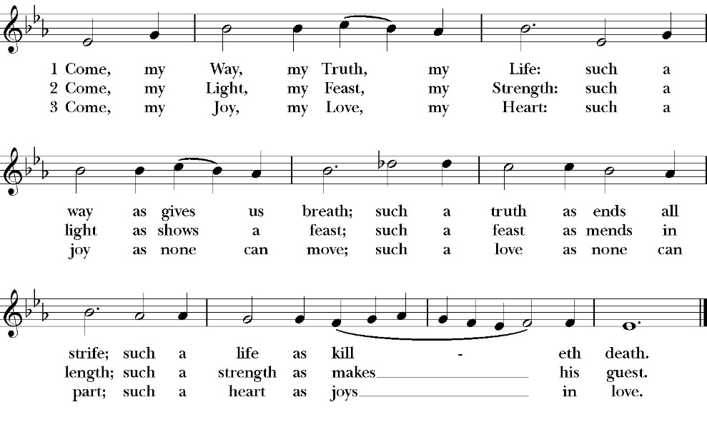

Clergy: The Holy Gospel of Our Lord Jesus Christ, according to St. John
People: Glory to you, Lord God

Gospel: John 14:1-14

“Let not your hearts be troubled. Believe in God; believe also in me. ² In my Father's house are many rooms. If it were not so, would I have told you that I go to prepare a place for you? ³ And if I go and prepare a place for you, I will come again and will take you to myself, that where I am you may be also. ⁴ And you know the way to where I am going.” ⁵ Thomas said to him, “Lord, we do not know where you are going. How can we know the way?” ⁶ Jesus said to him, “I am the way, and the truth, and the life. No one comes to the Father except through me. ⁷ If you had known me, you would have known my Father also. From now on you do know him and have seen him.”

⁸ Philip said to him, “Lord, show us the Father, and it is enough for us.” ⁹ Jesus said to him, “Have I been with you so long, and you still do not know me, Philip? Whoever has seen me has seen the Father. How can you say, ‘Show us the Father’? ¹⁰ Do you not believe that I am in the Father and the Father is in me? The words that I say to you I do not speak on my own authority, but the Father who dwells in me does his works. ¹¹ Believe me that I am in the Father and the Father is in me, or else believe on account of the works themselves.

¹² “Truly, truly, I say to you, whoever believes in me will also do the works that I do; and greater works than these will he do, because I am going to the Father. ¹³ Whatever you ask in my name, this I will do, that the Father may be glorified in the Son. ¹⁴ If you ask me^{[e]} anything in my name, I will do it.

Clergy: The Gospel of the Lord
People: Praise to you, Lord Christ

Sermon
Rev. John Isman

The Nicene Creed

We believe in one God,
the Father, the Almighty,
maker of heaven and earth,
of all that is, visible and invisible.

We believe in one Lord, Jesus Christ,
the only-begotten Son of God,
eternally begotten of the Father,
God from God, Light from Light,
true God from true God,
begotten, not made,
of one Being with the Father.
through him all things were made.
For us and for our salvation he came down from heaven:
was incarnate from the Holy Spirit and the Virgin Mary,
and was made man.
For our sake he was crucified under Pontius Pilate;
he suffered death and was buried.
On the third day he rose again in accordance with the
Scriptures;
he ascended into heaven
and is seated at the right hand of the Father.
He will come again in glory to judge the living and the dead,
and his kingdom will have no end.

We believe in the Holy Spirit, the Lord, the giver of life,
who proceeds from the Father [and the Son],
who with the Father and the Son is worshiped and glorified.
who has spoken through the Prophets.
We believe in one holy catholic and apostolic Church.
We acknowledge one Baptism for the forgiveness of sins.
We look for the resurrection of the dead,
and the life of the world to come. Amen.

The Prayers of the People

Leader Let us pray for the Church and for the world, saying, “hear our prayer.”
For the peace of the whole world, and for the well-being and unity of the people of God.
Lord, in your mercy:
People Hear our prayer.

Leader For Stephen our archbishop, Julian our Provincial Dean and Eric, our bishop. For Fr. Rob, Deacon John, Deacon Kashy, and for all the clergy and people of our diocese and congregation and for the worldwide Anglican Communion.
Lord, in your mercy:
People Hear our prayer.

Leader For all those who proclaim the Gospel at home and abroad; and for all who teach and disciple others.
Lord, in your mercy:
People Hear our prayer.

Leader For our brothers and sisters in Christ who are persecuted for their faith.
Lord, in your mercy:
People Hear our prayer.

Leader For our nation, for those in authority, and for all in public service especially Donald our president and Gavin our governor.
Lord, in your mercy:
People Hear our prayer.

Leader: In the St. Paul’s cycle of prayer we pray for all ministries of mission and outreach to our community and in the world. We pray specifically for St. Paul’s School, Visalia Senior Housing, Turning Point ministries, Visalia Emergency Aid Neighborhood Market and all ministries which we support as a parish. We pray for missionaries Fr. Frank and Ann Bernardi and Millagro Menees.
Lord, in your mercy:
People Hear our prayer.

Leader In the ACNA Cycle of Prayer, today we pray for the Diocese of the Upper Midwest, Bishop Stewart Ruch and his wife, Katherine.
Lord, in your mercy:
People Hear our prayer.

Leader For all those who are in trouble, sorrow, need, sickness, or
any other adversity [especially ____________]. We also
pray for all who are currently serving in our armed forces
and serving as first responders.
Lord, in your mercy:
People Hear our prayer.

Leader For all those who have departed this life in the certain hope
of the resurrection, (we pray especially for ____________),
in Thanksgiving let us pray.
Lord, in your mercy:
People Hear our prayer.

Celebrant will add a concluding prayer
The Confession and Absolution

Celebrant Let us humbly confess our sins to Almighty God.

Most merciful God,
we confess that we have sinned against you
in thought, word and deed,
by what we have done, and by what we have left undone.
We have not loved you with our whole heart;
we have not loved our neighbors as ourselves.
We are truly sorry and we humbly repent.
For the sake of your Son Jesus Christ,
have mercy on us and forgive us;
that we may delight in your will, and walk in your ways,
to the glory of your Name. Amen.

Almighty God, our heavenly Father, who in his great mercy has
promised forgiveness of sins to all those who sincerely repent and
with true faith turn to him, have mercy upon you, pardon and deliver
you from all your sins, confirm and strengthen you in all goodness,
and bring you to everlasting life; through Jesus Christ our Lord.
Amen.

God so loved the world, that he gave his only-begotten Son, that
whoever believes in him should not perish but have eternal life.
-John 3:16t

Celebrant The Peace of the Lord be always with you.
People And with your spirit.

Offertory Anthem
women’s quartet
cyndi culp, ellen daniels,
jennifer proch, elaine hord

OH, How He Loves You and Me
Kurt Kaiser /arr. John Purifoy

The Doxology
(Verse 3 only)

Offertory

Celebrant All things come from you, O Lord,
People And of your own have we given you.

The Eucharistic Liturgy

Celebrant The Lord be with you.
People And with your spirit.
Celebrant Lift up your hearts.
People We lift them up to the Lord.
Celebrant Let us give thanks to the Lord our God.
People It is right to give him thanks and praise.

It is right, our duty and our joy, always and everywhere to give thanks to you, Father Almighty, Creator of heaven and earth.

But chiefly are we bound to praise you for the glorious resurrection of your Son Jesus Christ our Lord; for he is the true Paschal Lamb, who was offered for us, and has taken away the sin of the world; who by his death has destroyed death, and by his rising to life again has won for us everlasting life

Therefore we praise you, joining our voices with Angels and Archangels and with all the company of heaven, who for ever sing this hymn to proclaim the glory of your Name:

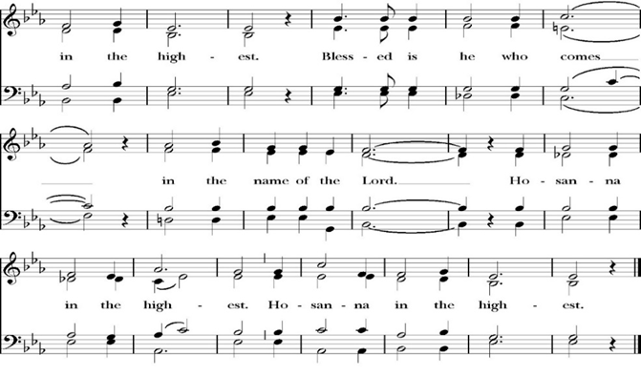
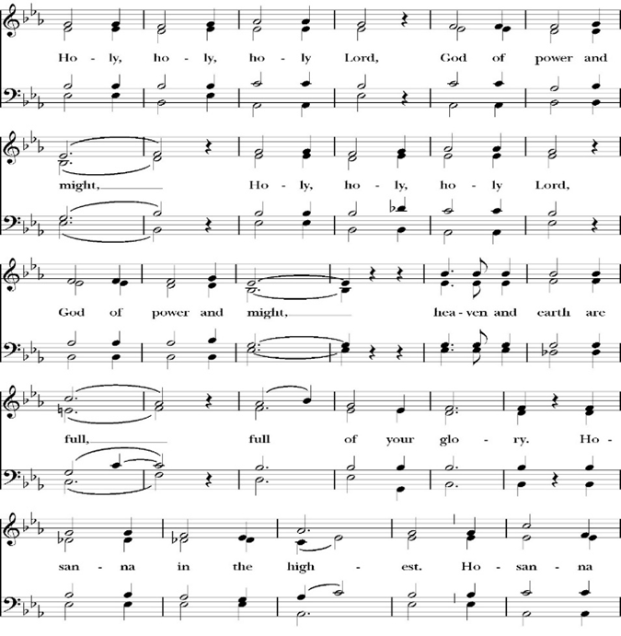
Sanctus
Holy and gracious Father: In your infinite love you made us for yourself; and when we had sinned against you and become subject to evil and death, you, in your mercy, sent your only Son Jesus Christ into the world for our salvation. By the Holy Spirit and the Virgin Mary he became flesh and dwelt among us. In obedience to your will, he stretched out his arms upon the Cross and offered himself once for all, that by his suffering and death we might be saved. By his resurrection he broke the bonds of death, trampling Hell and Satan under his feet. As our great high priest, he ascended to your right hand in glory, that we might come with confidence before the throne of grace.

On the night that he was betrayed, our Lord Jesus Christ took bread; and when he had given thanks, he broke it,* and gave it to his disciples, saying, “Take, eat; this is my Body, which is given for you: Do this in remembrance of me.”

Likewise, after supper, Jesus took the cup, and when he had given thanks, he gave it to them, saying, “Drink this, all of you; for this is my Blood of the New Covenant, which is shed for you, and for many, for the forgiveness of sins: Whenever you drink it, do this in remembrance of me.”

Therefore we proclaim the mystery of faith:

Christ has died.
Christ is risen.
Christ will come again.

We celebrate the memorial of our redemption, O Father, in this sacrifice of praise and thanksgiving, and we offer you these gifts.

Sanctify them by your Word and Holy Spirit to be for your people the Body and Blood of your Son Jesus Christ. Sanctify us also, that we may worthily receive this holy Sacrament, and be made one body with him, that he may dwell in us and we in him. In the fullness of time, put all things in subjection under your Christ, and bring us with all your saints into the joy of your heavenly kingdom, where we shall see our Lord face to face. All this we ask through your Son Jesus Christ: By him, and with him, and in him, in the unity of the Holy Spirit, all honor and glory is yours, Almighty Father, now and for ever. Amen.
And now, as our Savior Christ has taught us, we are bold to pray,

Our Father, who art in heaven,
hallowed be thy Name,
thy kingdom come,
thy will be done,
on earth as it is in heaven.
Give us this day our daily bread.
And forgive us our trespasses,
as we forgive those
who trespass against us.
And lead us not into temptation,
but deliver us from evil.
For thine is the kingdom,
and the power, and the glory,
for ever and ever. Amen.

Celebrant Alleluia! Christ our Passover is sacrificed for us.
People Therefore let us keep the feast. Alleluia!

We do not presume to come to this your table, O merciful Lord,
trusting in our own righteousness,
but in your abundant and great mercies.
We are not worthy so much as to gather up
the crumbs under your table;
but you are the same Lord
whose character is always to have mercy.
Grant us, therefore, gracious Lord,
so to eat the flesh of your dear Son Jesus Christ,
and to drink his blood,
that our sinful bodies may be made clean by his body,
and our souls washed through his most precious blood,
and that we may evermore dwell in him, and he in us.
Amen.
Agnus Dei

The Ministration of Communion

The gifts of God for the People of God. Take them in remembrance that Christ died for you and feed on him in your hearts by faith, with thanksgiving.

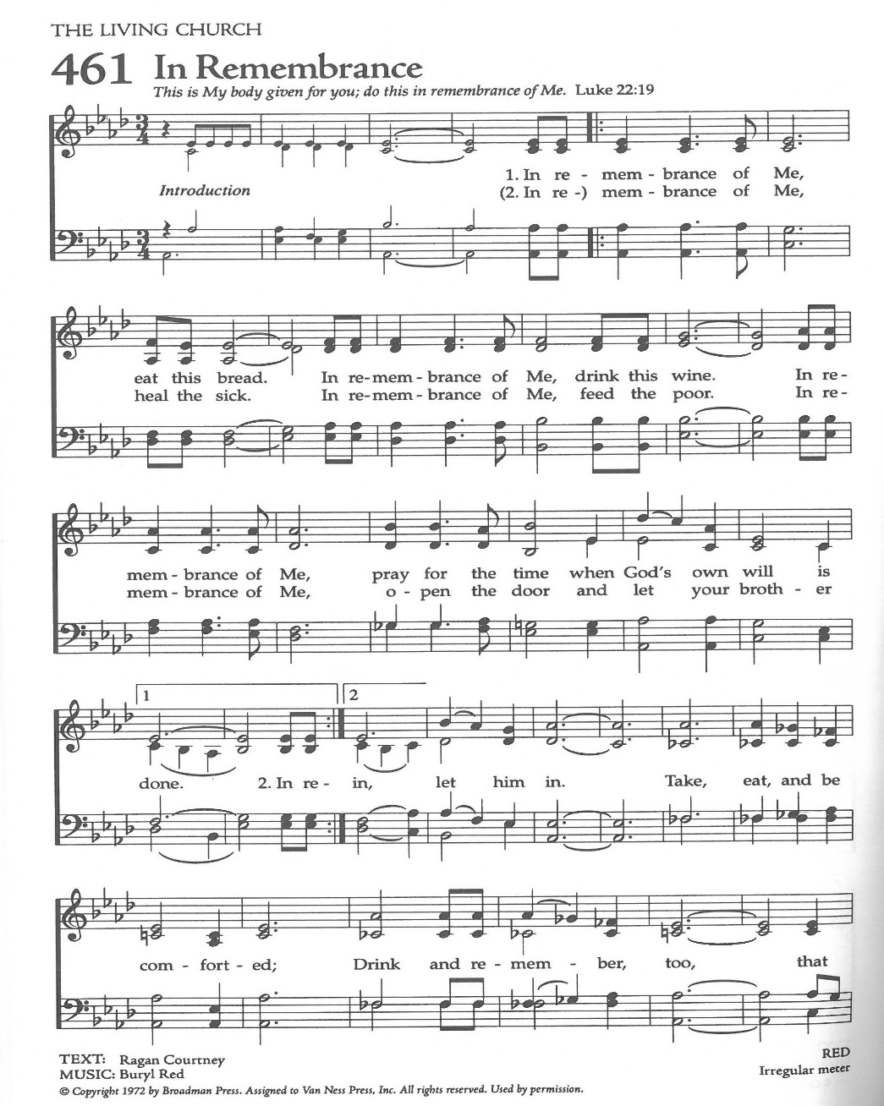
Communion Hymn: In Remembrance of Me

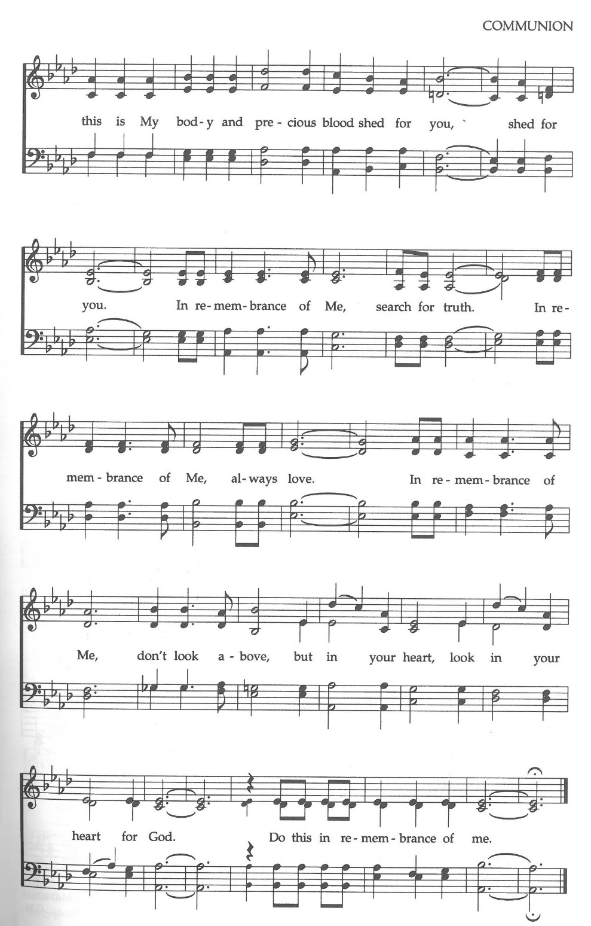

The Post Communion Prayer

Let us pray.

Heavenly Father,
We thank you for feeding us with the spiritual food
of the most precious Body and Blood
of your Son our Savior Jesus Christ;
and for assuring us in these holy mysteries
that we are living members of the body of your Son,
and heirs of your eternal Kingdom.
And now, Father, send us out to do the work you have
given us to do,
to love and serve you as faithful witnesses of Christ our
Lord.
To him, to you, and to the Holy Spirit,
be honor and glory, now and for ever. Amen.

The Blessing

The blessing of God Almighty, the Father, the Son, and the Holy
Spirit, be among you, and remain with you always. Amen.

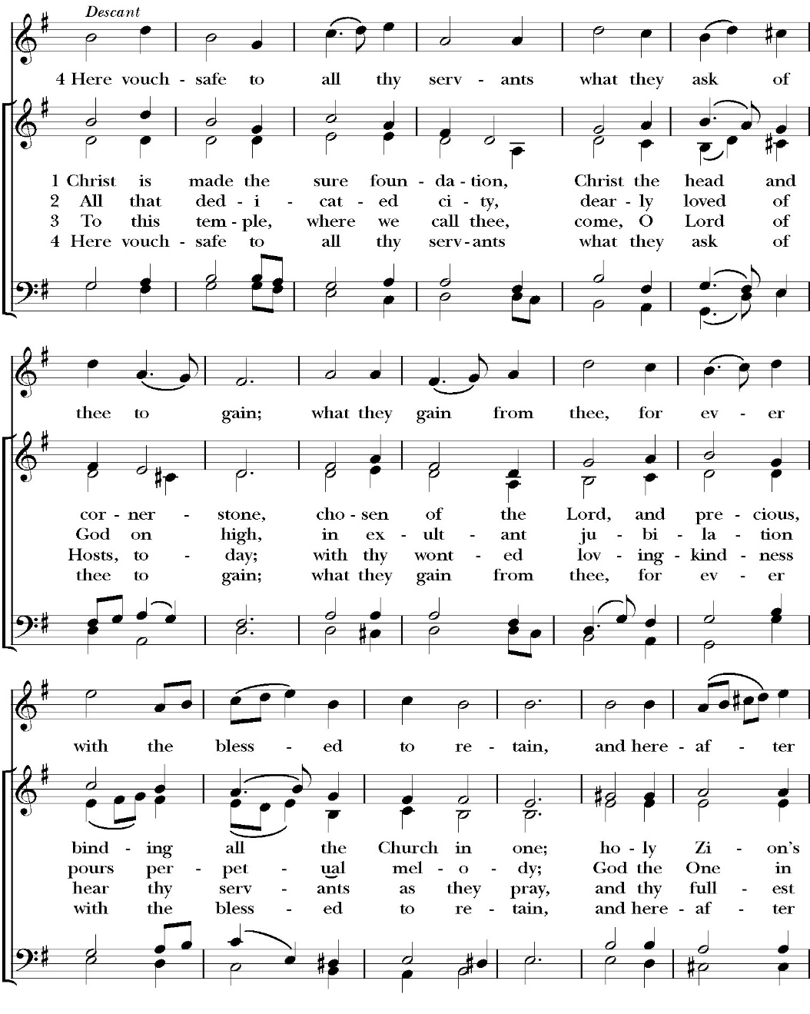
Closing Hymn: Christ is Made the Sure Foundation

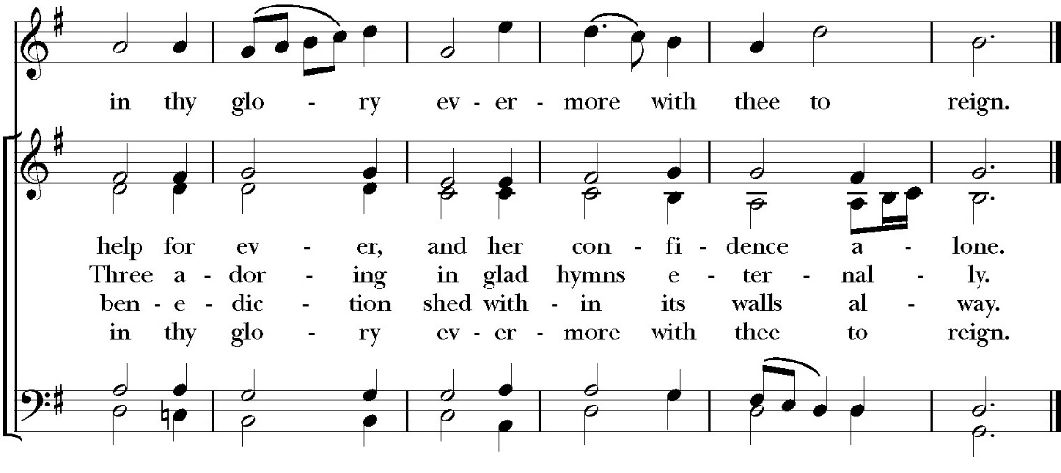

Celebrant Alleluia, Alleluia! Let us go forth in the name of Christ.
People Thanks be to God. Alleluia! Alleluia!

St. Paul’s Parish Calendar
Sunday May 3 – Sunday May 10

SUNDAY, May 3 – Fifth Sunday of Easter
9:15 AM Sunday Funday, Youth Room
9:15 AM Gospel of John Bible Study, Conference Room
9:30 AM Bell Choir Rehearsal, Church
10:30 AM Children’s Sunday School, Chapel
Pre-K –2nd Grade, Sunday School Room
3rd -5th Grade, Youth Room
10:30 AM Holy Eucharist, Church

MONDAY, May 4

TUESDAY, May 5
6:00 PM Bell Choir Practice, Music Room

WEDNESDAY, May 6
9:30 AM Holy Eucharist with healing prayer, Chapel
10:15 AM Bible Study, Conference Room
6:00 PM Wonderful Wednesday Dinner, James Hall
7:00 PM Choir Practice, Chapel

THURSDAY, May 7

FRIDAY, May 8
6:30 AM Men’s Bible Study, Valhalla Restaurant

SATURDAY, May 9

SUNDAY, May 10 – Sixth Sunday of Easter
9:15 AM Sunday Funday, Youth Room
9:15 AM Gospel of John Bible Study, Conference Room
9:30 AM Bell Choir Rehearsal, Church
10:30 AM Children’s Sunday School, Chapel
Pre-K –2nd Grade, Sunday School Room
3rd -5th Grade, Youth Room
10:30 AM Holy Eucharist, Church

Church Office Hours
Monday-Thursday 8:00 AM-4:00 PM

Sunday Morning Bible Study: The Gospel of John
St. Paul’s is embarking on a study of the Gospel of John that will span the next year. These classes will be on Sunday mornings from 9:15-10:00AM. We will take the better part of the next year to move slowly through John and savor the profound spiritual truths that it offers. We will be using a book called Be Alive by Warren Wiersbe as our guide. This book is essentially a study guide to the Gospel of John and will provide us with structure and insight as we move our way through the Gospel. Books will be available beginning the day of the first class.

Projected Class Timeline

April-May Chapters 4-8
June Chapter 9
July No Class
August Chapter 10

The class will progress based on how quickly or slowly is needed and our projected timelines may change as we move forward.

Wonderful Wednesday Dinner, May 6, 6:00PM
Theme: Cinco de Mayo Dinner
Everyone is invited to join us for a Mexican-food-themed dinner in James Hall on Wednesday, May 6, at 6:00PM. Immediately after dinner, there will be a pinata break in the courtyard for all the children.

Wonderful Wednesday
Cinco de Mayo Dinner Menu
Please RSVP by Monday May 4 by 3:30 PM

Cheese Enchiladas (Manny’s Red Chili Sauce)
Spanish Rice, Pinto Beans and Sour Cream for Enchiladas


Kids Menu
Salsa and Chips Cheese Quesadillas


Dessert: Sopapilla Cream Cheese Bars

Anglican Fourth Day Community Gathering
Wednesday, May 6, after Wonderful Wednesday Dinner
The Anglican Fourth Day community is gathering together for what is called an Ultreya after the Wonderful Wednesday dinner on May 6. Ultreyas are both a reunion for those who have attended the weekend and an opportunity for those exploring interest in the weekend retreat. This meeting will be about 30 minutes and include music, sharing from alumni of the weekend, and encouragement for our walk with Jesus. This gathering will take place right in James Hall immediately following our dinner. All are welcome.

St. Paul’s School Spring Auction, Saturday, May 9
“Stetsons and Starlight”
The St. Paul’s School spring auction is always a wonderful evening of fun and fundraising to support the work and ministry of the school. Tickets can be purchased beginning at $125 and up. Sponsorship opportunities are available at a variety of levels, and all members of St. Paul’s are invited to come out in your fanciest western wear! For more information, please talk with Fr. Rob, Deacon John, or call St. Paul’s School at 739-1619.

Friends and Fellowship, Saturday, May 30
Home of Blake and Madelyn Schneeman in Tulare
Our next Friends and Fellowship gathering for adults will be hosted by Blake and Madelyn Schneeman. As always, attendees are asked to bring an appetizer and their favorite drink to share. Please RSVP by calling the church office. The Schneeman’s address is 524 N. Sedro in Tulare, 93274

Courtyard Gates Financial Campaign Update
We are very close to our financial goal for the courtyard gates. Thanks to the generosity of the people of St. Paul’s and the hard work of our rummage sale team we have raised $32,850 of our initial $32,500 goal. However, our estimate has increased due to design changes which call for more metal and hooking in the gate locks for our security system. We now expect our costs to be closer to $35,000. If you desire to give, but have yet to do so, there is still time. Thank you to everyone who has donated to date.

Graduations and Educational Milestones
Do you have a child, grandchild, member of your family graduating or reaching a significant educational milestone in May or June? We want to celebrate the educational achievements of our congregation and their families in our June bulletins and newsletter. Please reach out to our church office with information so that we can recognize these students.


Anglican Fourth Day
QUESTION: What is the difference between Cursillo and Anglican 4th Day?
Absolutely nothing!

Anglican Fourth Day is the continuing ministry of Cursillo within the Anglican Church of North America.

More information on the Anglican 4th Day weekend:

PLACE: St Anthony's Retreat Center in Three Rivers
DATES: July 9-12, 2026
TIME: All day every day; some evenings
COST: $25.00
FOOD: 3 excellent meals a day plus snacks
ACCOMMODATIONS: Air-conditioned 2-person room with bathroom, two twin beds; 24/7 use of chapel.

For any more information you may need to make a decision that will change your life, call Janet Robinson at 559-627-1783 or 559-786-9791.

Visalia Emergency Aid Food Barrel
For many years, St. Paul’s supported the ministry of Visalia Emergency Aid by housing a food barrel. We are renewing this ministry and invite members to bring food on Sunday mornings to place into the food barrel and support the VEA feeding ministries.

A Food Bank for Hurley Families

The next Neighborhood Market to benefit students at Hurley School will be Wednesday May 20, 2:30 PM to 3:30 PM at St Paul’s Church parking lot. If you are interested in helping that day, please contact Sue Nyberg. My home phone number is 559-733-8244.

Due to the heat, we are in need of more volunteers for
the months of May, June, August and September.
This will allow volunteers to work in shifts during these hot months.

PROVIDED BY VISALIA EMERGENCY AID
AND ST. PAUL’S CHURCH
Wednesday, May 20, 2026
From 2:30 PM to 3:30 PM
LOCATION:
ST. PAUL'S CHURCH PARKING LOT
ACROSS THE STREET FROM HURLEY


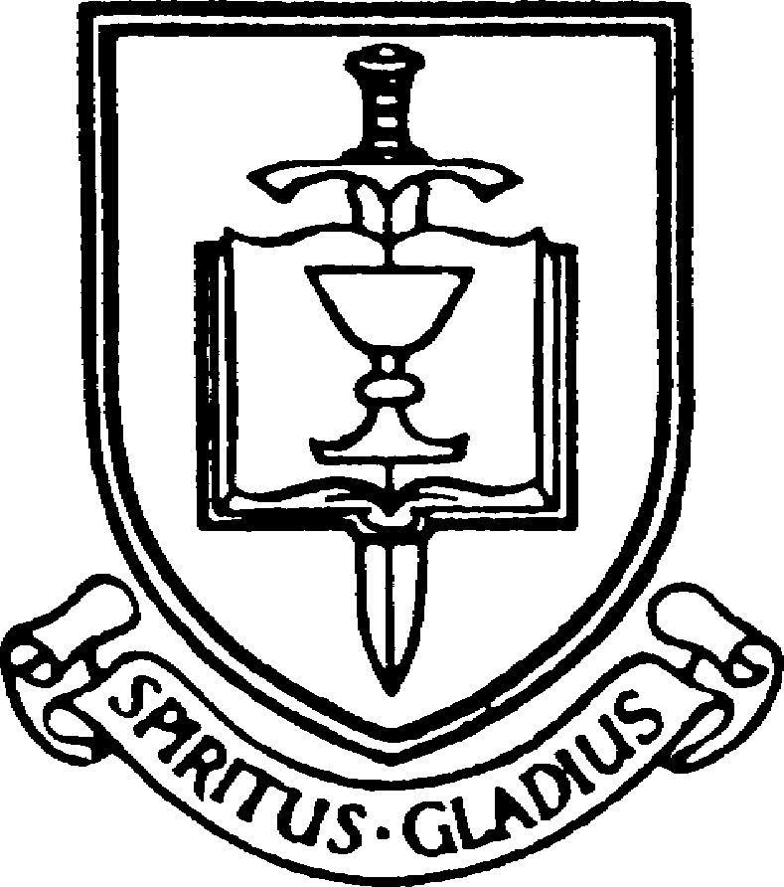


St. Paul’s Anglican Church
Parish Office
6436 W. Hurley Ave
Visalia, California 93291
559-732-4821
Office Hours: 8:00 – 4:00
Monday – Thursday

Worship: Sundays at 10:30AM
Livestream: Link at spvisalia.com
and on our Facebook page
Please be advised that this service is being recorded for broadcast
and/or archival purposes. By attending, you consent
to the inclusion of your likeness in these recordings.

St. Paul’s Clergy and Staff
The Rev. Robert Longbottom, Rector
rector@spvisalia.com
(559)802-2928
The Rev. John Iseman, Pastoral Associate for Family Ministries
family@spvisalia.com
The Rev. Kashy Rowland-Smith, Deacon
kashyrs@aol.com
Antoinette Horsting, Parish Administrator
bookkeeper@spvisalia.com
Marguerite Crownover, Organist and Accompanist
Cynthia Culp, Choral Director
Jackie Iseman, Nursery Coordinator
Shane Motl, Sexton

St. Paul’s is a member church of the
Anglican Diocese of San Joaquin
The Rt. Rev. Eric V. Menees, Bishop

Next Week’s Lessons
Acts 17:16-34
Psalm 148
1 Peter 3:8-18
John 15:1-11

