ST. PAUL’S
ANGLICAN CHURCH
VISALIA, CALIFORNIA

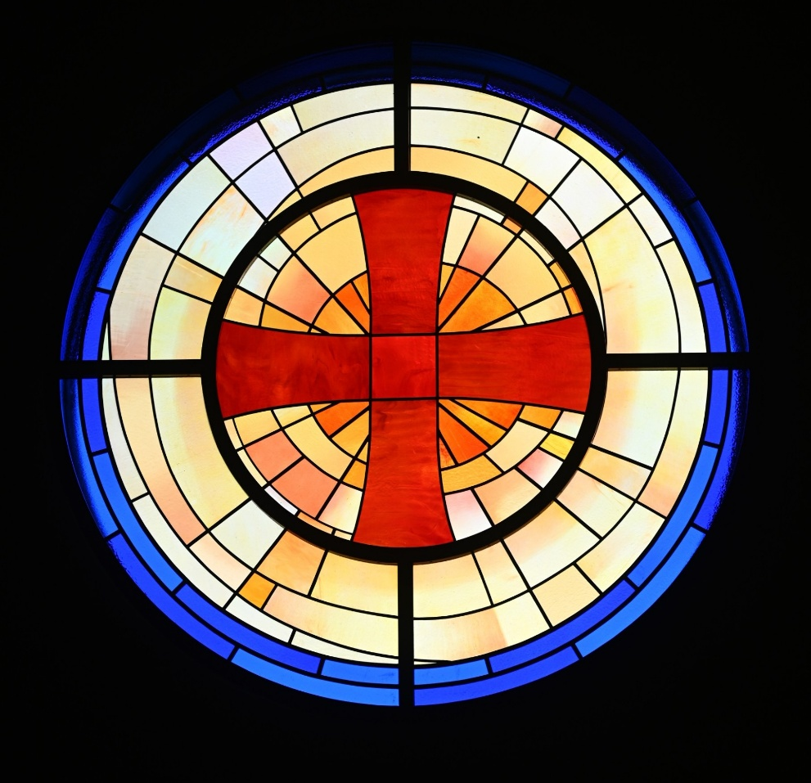

Fourth Sunday after Pentecost
June 21, 2026
10:30 A.M

Welcome!

St. Paul’s Anglican Church extends a warm welcome to all visitors and newcomers, whether worshiping in person or at home via livestream.

Visitors’ Guide

St. Paul’s Church is a parish in the Diocese of San Joaquin of the Anglican Church in North America, which includes both Catholic and Protestant traditions. We accept Jesus Christ as Savior, and we promise to follow him as Lord. We believe in One God,

- the Father who created us and all things,
- the Son who redeems us from sin and death,
- the Holy Spirit who renews and sanctifies us.

We believe the Holy Scriptures to be the Word of God and to contain all things necessary for salvation, and we accept the Apostles’ and Nicene Creeds as essential beliefs of the Christian faith.

Those not desiring to receive Holy Communion, and those who have not been baptized into the Christian faith, are invited to cross their arms across their chest, and a blessing will be given instead.

Visitors are invited to sign the guest book at the entrance table and introduce themselves to the clergy following the service.

The Holy Eucharist

Prelude: “Prelude on Slane” Young
Opening Hymn: #535 – “Praise to the Living God” p. 4
Opening Acclamation p. 5
The Collect for Purity p. 5
Summary of the Law p. 5
Kyrie p. 5
Gloria p. 6
Collect of the Day p. 7
Lesson: Jeremiah 20:7-13 p. 7
Gradual: Psalm 69:1-18 p. 8
Epistle: Romans 5:15b-19 p. 9
Sequence Hymn: #593 – “Lord, Make Us Servants of Your Peace” p. 10
Gospel: Matthew 10:16-33 p. 11
Sermon: Rev. John Iseman
Nicene Creed p. 12
Prayers of the People p. 13
The Peace p. 15
Anthem: “Sanctuary” Praise Band
The Offertory p. 16
Sursum Corda p. 16
Sanctus p. 17
The Lord’s Prayer p. 19
Fraction p. 19
Prayer for Humble Access p. 20
Agnus Dei p. 20
Communion Hymn: #679 “Surely It Is God Who Saves Me” p. 21
Post Communion Prayer p. 22
Blessing p. 22
Closing Hymn: #537 – “Christ for the World We Sing” p. 23
Dismissal p. 23
Postlude: Fanfare on “St. Gertrude” Young

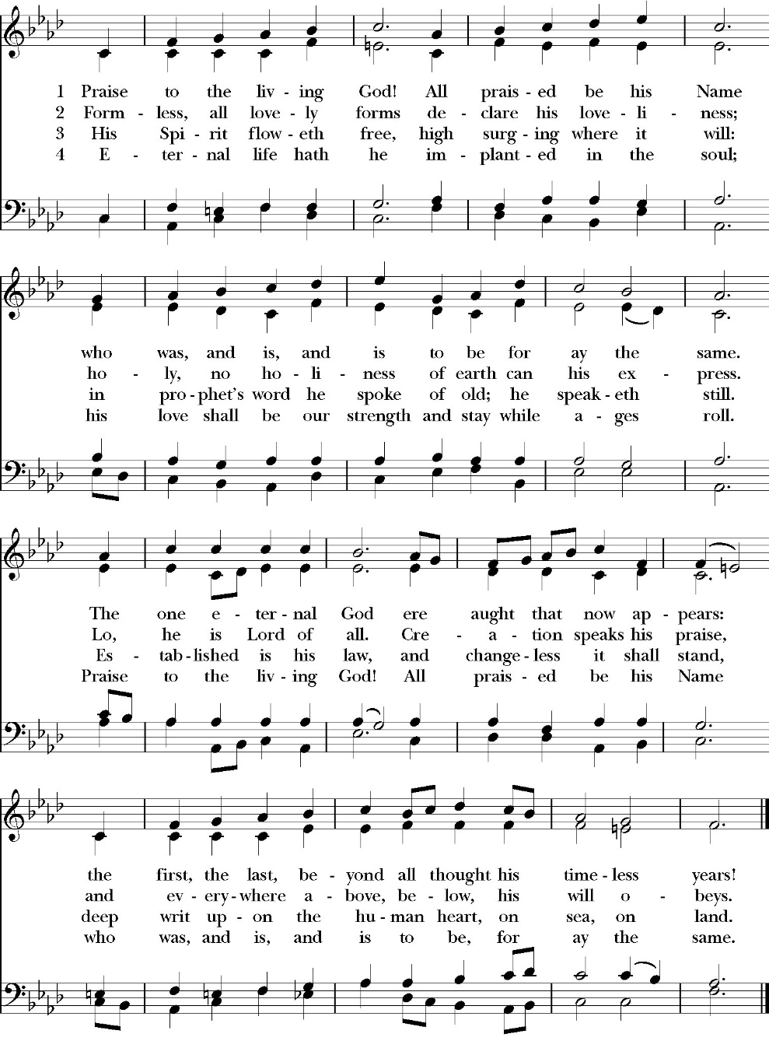
Opening Hymn: Praise to the Living God

Opening Acclamation

Celebrant Blessed be God, the Father, the Son and the Holy Spirit. People And blessed be his kingdom, now and forever. Amen.

Collect for Purity

Almighty God, to you all hearts are open, all desires
known, and from you no secrets are hid: Cleanse the thoughts
of our hearts by the inspiration of your Holy Spirit, that we
may perfectly love you, and worthily magnify your holy Name;
through Christ our Lord. Amen.

Summary of the law

Hear what our Lord Jesus Christ says: You shall love
the Lord your God with all your heart and with all your soul
and with all your mind. This is the first and great
commandment. And the second is like it: You shall love your
neighbor as yourself. On these two commandments depend all
the Law and the Prophets.

Kyrie
Gloria

Celebrant The Lord be with you.
People And with your spirit.
Celebrant Let us pray.

The Collect of the Day

Lord of all power and might, the author and giver of all good things: Graft in our hearts the love of your Name, increase in us true religion, nourish us with all goodness, and bring forth in us the fruit of good works; through Jesus Christ our Lord, who lives and reigns with you and the Holy Spirit, one God, for ever and ever. Amen.

Lesson: Jeremiah 20:7-13
O LORD, you have deceived me, and I was deceived; you are stronger than I, and you have prevailed. I have become a laughingstock all the day; everyone mocks me. 8 For whenever I speak, I cry out, I shout, “Violence and destruction!” For the word of the LORD has become for me a reproach and derision all day long. 9 If I say, “I will not mention him, or speak any more in his name, there is in my heart as it were a burning fire shut up in my bones, and I am weary with holding it in, and I cannot. 10 For I hear many whispering. Terror is on every side! “Denounce him! Let us denounce him!” say all my close friends, watching for my fall. “Perhaps he will be deceived; then we can overcome him and take our revenge on him.” 11 But the LORD is with me as a dread warrior; therefore my persecutors will stumble; they will not overcome me. They will be greatly shamed, for they will not succeed. Their eternal dishonor will never be forgotten. 12 O LORD of hosts, who tests the righteous, who sees the heart and the mind, let me see your vengeance upon them, for to you have I committed my cause.
13 Sing to the LORD; praise the LORD! For he has delivered the life of the needy from the hand of evildoers

Reader: The Word of the Lord
People: Thanks be to God

Gradual: Psalm 69:1-18
1 Save me, O God, *
for the waters have come up even to my neck.
2 I sink down in the deep mire, where there is no ground; *
I have come into deep waters, so that the floods run over me. 3 I am weary of crying; my throat is dry; *
my sight fails me from waiting so long for my God.
4 Those who hate me without a cause are more than the hairs of my head; *
those who are my enemies, and would destroy me wrongfully, are mighty.
5 They bid me restore things I never took. *
O God, you know my foolishness, and my faults are not hidden from you
6 Let not those who trust in you, O Lord God of hosts, be ashamed because of me; *
let not those who seek you be confounded through me, O God of Israel.
7 Surely for your sake have I suffered reproach; *
shame has covered my face.
8 I have become a stranger to my brethren, *
unknown to my mother’s children,
9 Because zeal for your house has consumed me, *
and the reproaches of those who reproached you have fallen upon me.
10 I wept, and humbled myself with fasting, *
but that was turned to my reproach.
11 I put on sackcloth also, *
and I became a byword among them.
12 Those who sit in the gate speak against me, *
and the drunkards make songs about me.
13 But, LORD, I make my prayer to you *
in an acceptable time.
14 Hear me, O God, in the multitude of your mercy, *
even in the truth of your salvation.
15 Take me out of the mire, lest I sink; *
O let me be delivered from those who hate me, and out of the deep waters.
16 Let not the floodwaters drown me, neither let the deep swallow me up, *
and let not the pit shut its mouth upon me.
17 Hear me, O LORD, for your loving-kindness is good; *
turn to me according to the multitude of your mercies;
18 And hide not your face from your servant, for I am in trouble; * O hasten and hear me.

Glory be to the Father, and to the Son, and to the Holy Spirit;
as it was in the beginning, is now, and ever shall be, world
without end. Amen

Epistle Romans 5:15b-19
For if many died through one man's trespass, much more have the grace of God and the free gift by the grace of that one man Jesus Christ abounded for many. 16 And the free gift is not like the result of that one man's sin. For the judgment following one trespass brought condemnation, but the free gift following many trespasses brought justification. 17 For if, because of one man's trespass, death reigned through that one man, much more will those who receive the abundance of grace and the free gift of righteousness reign in life through the one man Jesus Christ. 18 Therefore, as one trespass led to condemnation for all men, so one act of righteousness leads to justification and life for all men. 19 For as by the one man's disobedience the many were made sinners, so by the one man's obedience the many will be made righteous.

Reader: The Word of the Lord
People: Thanks be to God

Sequence Hymn: Lord, Make Us Servants of Your Peace
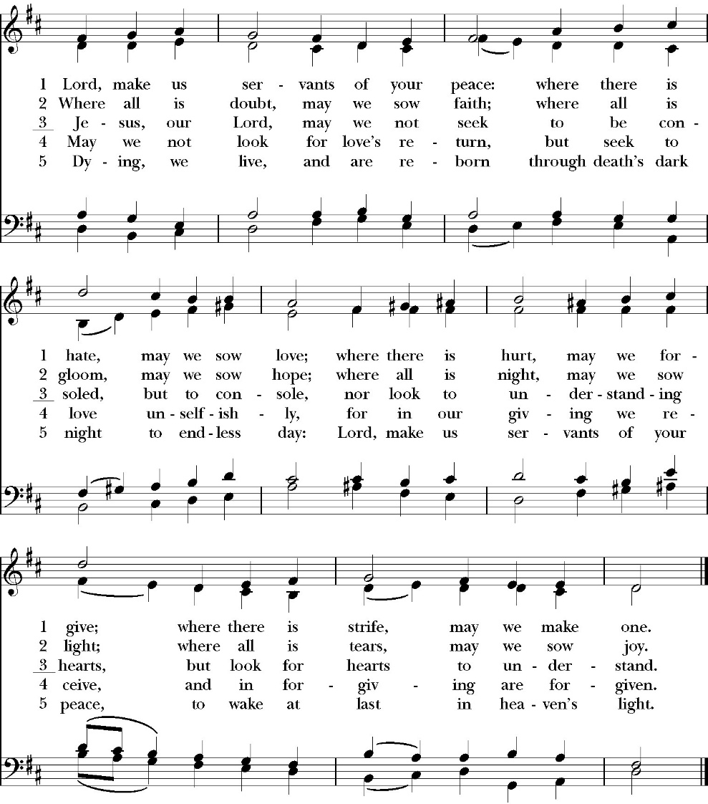
(Verses 1-2 before gospel verse 3 after gospel)

Clergy: The Holy Gospel of Our Lord Jesus Christ,
according to St. Matthew
People: Glory to you, Lord God

Gospel: Matthew 10:16-33
Behold, I am sending you out as sheep in the midst of wolves, so be wise as serpents and innocent as doves. 17 Beware of men, for they will deliver you over to courts and flog you in their synagogues, 18 and you will be dragged before governors and kings for my sake, to bear witness before them and the Gentiles. 19 When they deliver you over, do not be anxious how you are to speak or what you are to say, for what you are to say will be given to you in that hour. 20 For it is not you who speak, but the Spirit of your Father speaking through
you. 21 Brother will deliver brother over to death, and the father his child, and children will rise against parents and have them put to death, 22 and you will be hated by all for my name's sake. But the one who endures to the end will be saved. 23 When they persecute you in one town, flee to the next, for truly, I say to you, you will not have gone through all the towns of Israel before the Son of Man comes.
24 “A disciple is not above his teacher, nor a servant above his master. 25 It is enough for the disciple to be like his teacher, and the servant like his master. If they have called the master of the house Beelzebul, how much more will they malign those of his household.
26 “So have no fear of them, for nothing is covered that will not be revealed, or hidden that will not be known. 27 What I tell you in the dark, say in the light, and what you hear whispered, proclaim on the housetops. 28 And do not fear those who kill the body but cannot kill the soul. Rather fear him who can destroy both soul and body in hell. 29 Are not two sparrows sold for a penny? And not one of them will fall to the ground apart from your Father. 30 But even the hairs of your head are all numbered. 31 Fear not, therefore; you are of more value than many sparrows. 32 So everyone who acknowledges me before men, I also will acknowledge before my Father who is in heaven, 33 but whoever denies me before men, I also will deny before my Father who is in heaven.

Clergy: The Gospel of the Lord
People: Praise to you, Lord Christ

Sermon
Rev. John Iseman

The Nicene Creed

We believe in one God,
the Father, the Almighty,
maker of heaven and earth,
of all that is, visible and invisible.

We believe in one Lord, Jesus Christ,
the only-begotten Son of God,
eternally begotten of the Father,
God from God, Light from Light,
true God from true God,
begotten, not made,
of one Being with the Father.
through him all things were made.

For us and for our salvation he came down from heaven:
was incarnate from the Holy Spirit and the Virgin Mary,
and was made man.
For our sake he was crucified under Pontius Pilate;
he suffered death and was buried.
On the third day he rose again in accordance with the
Scriptures;

he ascended into heaven
and is seated at the right hand of the Father.
He will come again in glory to judge the living and the dead,
and his kingdom will have no end.
We believe in the Holy Spirit, the Lord, the giver of life,
who proceeds from the Father and the Son,
who with the Father and the Son is worshiped and glorified.
who has spoken through the Prophets.
We believe in one holy catholic and apostolic Church.
We acknowledge one Baptism for the forgiveness of sins.
We look for the resurrection of the dead,
and the life of the world to come. Amen.

The Prayers of the People

Leader Let us pray for the Church and for the world, saying, “hear our prayer.”
For the peace of the whole world, and for the well-being and unity of the people of God.
Lord, in your mercy:
People Hear our prayer.

Leader For Stephen our archbishop, Julian our provincial dean, and Eric our bishop. For Fr. Rob, Deacon John, Deacon Kashy, and for all the clergy and people of our diocese and congregation and for the worldwide Anglican Communion.
Lord, in your mercy:
People Hear our prayer.

Leader For all those who proclaim the Gospel at home and abroad; and for all who teach and disciple others.
Lord, in your mercy:
People Hear our prayer.

Leader For our brothers and sisters in Christ who are persecuted for their faith.
Lord, in your mercy:
People Hear our prayer.

Leader For our nation, for those in authority, and for all in public service especially Donald our president and Gavin our governor.
Lord, in your mercy:
People Hear our prayer.

Leader: In the St. Paul’s cycle of prayer, we pray for our Sunday morning worship and welcoming ministries. We pray for the Altar Guild, our Lay Eucharistic Ministers, our Lectors, and our Acolytes. We pray for our music ministry and the musicians and vocalists. We pray for our ushers, greeters, and prayer table ministries.
Lord, in your mercy:
People Hear our prayer.

Leader In the ACNA Cycle of Prayer, today we pray for the Anglican Province of Bangladesh and The Most Rev. Samuel Mankhin, Moderator.
Lord, in your mercy:
People Hear our prayer.

Leader For all those who are in trouble, sorrow, need, sickness, or
any other adversity [especially ____________]. We also
pray for all who are currently serving in our armed forces
and serving as first responders.
Lord, in your mercy:
People Hear our prayer.

Leader For all those who have departed this life in the certain hope
of the resurrection, (we pray especially for ____________),
in Thanksgiving let us pray.
Lord, in your mercy:
People Hear our prayer.

Celebrant will add a concluding prayer

Heavenly Father, grant these our prayers for the sake of Jesus Christ,
our only Mediator and Advocate, who lives and reigns with you in
the unity of the Holy Spirit, one God, now and for ever. Amen.

The Confession and Absolution

Celebrant Let us humbly confess our sins to Almighty God.

Most merciful God,
we confess that we have sinned against you
in thought, word and deed,
by what we have done, and by what we have left undone.
We have not loved you with our whole heart;
we have not loved our neighbors as ourselves.
We are truly sorry and we humbly repent.
For the sake of your Son Jesus Christ,
have mercy on us and forgive us;
that we may delight in your will, and walk in your ways,
to the glory of your Name. Amen.

Almighty God, our heavenly Father, who in his great mercy has
promised forgiveness of sins to all those who sincerely repent and
with true faith turn to him, have mercy upon you, pardon and deliver
you from all your sins, confirm and strengthen you in all goodness,
and bring you to everlasting life; through Jesus Christ our Lord.
Amen.

Hear the Word of God to all who truly turn to him.

God so loved the world, that he gave his only-begotten Son, that
whoever believes in him should not perish but have eternal life.
John 3:16
Celebrant The Peace of the Lord be always with you.
People And with your spirit.

Offertory
Congregational Song: Sanctuary
CCLI Song # 24140
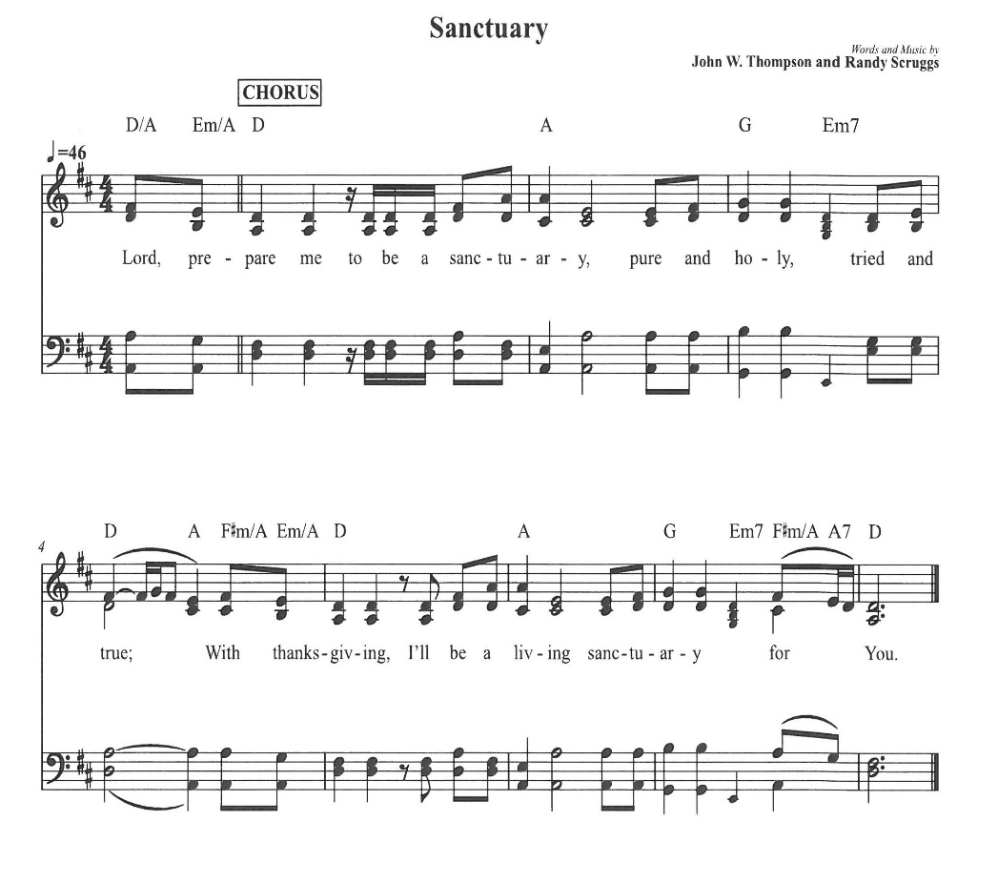
CCLI License # 20413513
The Doxology
(Verse 3 only)

Offertory

Celebrant All things come from you, O Lord,
People And of your own have we given you.

The Eucharistic Liturgy

Celebrant The Lord be with you.
People And with your spirit.
Celebrant Lift up your hearts.
People We lift them up to the Lord.
Celebrant Let us give thanks to the Lord our God.
People It is right to give him thanks and praise.

It is right, our duty and our joy, always and everywhere to give thanks to you, Father Almighty, Creator of heaven and earth.
Through Jesus Christ our Lord, who on the first day of the week overcame death and the grave, and by his glorious resurrection opened to us the way of everlasting life.

Therefore we praise you, joining our voices with Angels and Archangels and with all the company of heaven, who for ever sing this hymn to proclaim the glory of your Name:

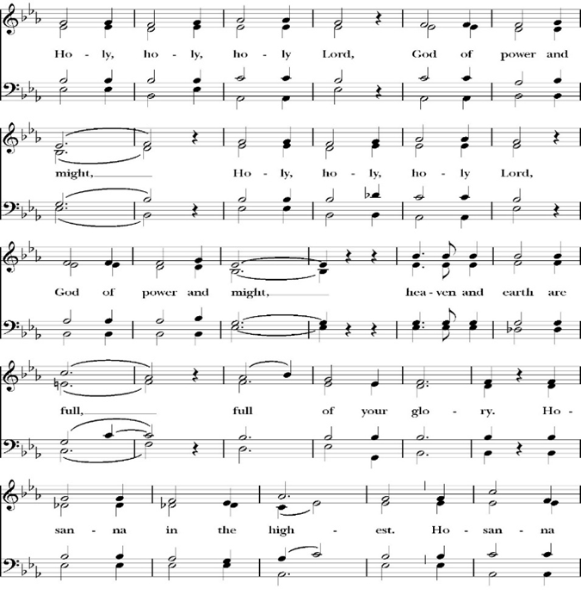
Sanctus

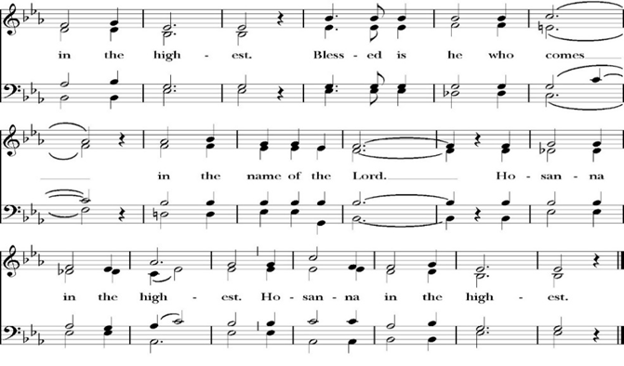
Holy and gracious Father: In your infinite love you made us for yourself; and when we had sinned against you and become subject to evil and death, you, in your mercy, sent your only Son Jesus Christ into the world for our salvation. By the Holy Spirit and the Virgin Mary he became flesh and dwelt among us. In obedience to your will, he stretched out his arms upon the Cross and offered himself once for all, that by his suffering and death we might be saved. By his resurrection he broke the bonds of death, trampling Hell and Satan under his feet. As our great high priest, he ascended to your right hand in glory, that we might come with confidence before the throne of grace.

On the night that he was betrayed, our Lord Jesus Christ took bread; and when he had given thanks, he broke it,* and gave it to his disciples, saying, “Take, eat; this is my Body, which is given for you: Do this in remembrance of me.”

Likewise, after supper, Jesus took the cup, and when he had given thanks, he gave it to them, saying, “Drink this, all of you; for this is my Blood of the New Covenant, which is shed for you, and for many, for the forgiveness of sins: Whenever you drink it, do this in remembrance of me.”

Therefore we proclaim the mystery of faith:

Christ has died.
Christ is risen.
Christ will come again.

We celebrate the memorial of our redemption, O Father, in this sacrifice of praise and thanksgiving, and we offer you these gifts.

Sanctify them by your Word and Holy Spirit to be for your people the Body and Blood of your Son Jesus Christ. Sanctify us also, that we may worthily receive this holy Sacrament, and be made one body with him, that he may dwell in us and we in him. In the fullness of time, put all things in subjection under your Christ, and bring us with all your saints into the joy of your heavenly kingdom, where we shall see our Lord face to face. All this we ask through your Son Jesus Christ: By him, and with him, and in him, in the unity of the Holy Spirit, all honor and glory is yours, Almighty Father, now and for ever. Amen.

And now, as our Savior Christ has taught us, we are bold to pray,

Our Father, who art in heaven,
hallowed be thy Name,
thy kingdom come,
thy will be done,
on earth as it is in heaven.
Give us this day our daily bread.
And forgive us our trespasses,
as we forgive those
who trespass against us.
And lead us not into temptation,
but deliver us from evil.
For thine is the kingdom,
and the power, and the glory,
for ever and ever. Amen.

Fraction

Celebrant Alleluia! Christ our Passover is sacrificed for us.
People Therefore let us keep the feast. Alleluia!
The Prayer for Humble Access

We do not presume to come to this your table, O merciful Lord,
trusting in our own righteousness,
but in your abundant and great mercies.
We are not worthy so much as to gather up
the crumbs under your table;
but you are the same Lord
whose character is always to have mercy.
Grant us, therefore, gracious Lord,
so to eat the flesh of your dear Son Jesus Christ,
and to drink his blood,
that our sinful bodies may be made clean by his body,
and our souls washed through his most precious blood,
and that we may evermore dwell in him, and he in us.
Amen.
Agnus Dei

The Ministration of Communion

The gifts of God for the People of God. Take them in remembrance that Christ died for you and feed on him in your hearts by faith, with thanksgiving.

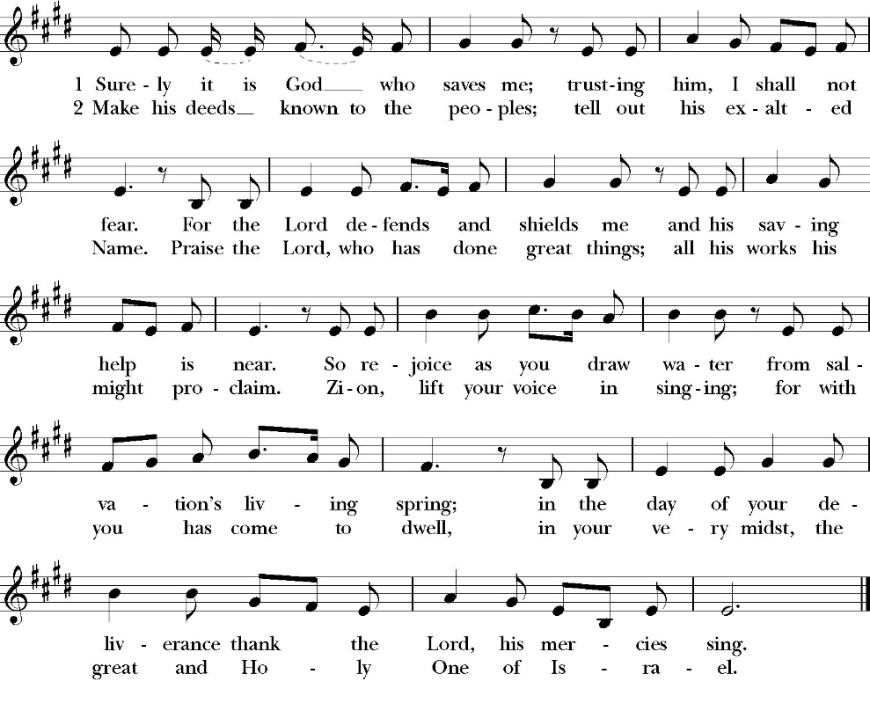
Communion Hymn: Surely It Is God Who Saves Me

The Post Communion Prayer

Let us pray.

Heavenly Father,
We thank you for feeding us with the spiritual food
of the most precious Body and Blood
of your Son our Savior Jesus Christ;
and for assuring us in these holy mysteries
that we are living members of the body of your Son,
and heirs of your eternal Kingdom.
And now, Father, send us out to do the work you have
given us to do,
to love and serve you as faithful witnesses of Christ our
Lord.
To him, to you, and to the Holy Spirit,
be honor and glory, now and for ever. Amen.

The Blessing

The blessing of God Almighty, the Father, the Son, and the Holy
Spirit, be among you, and remain with you always. Amen.

Closing Hymn: Christ for the World We Sing
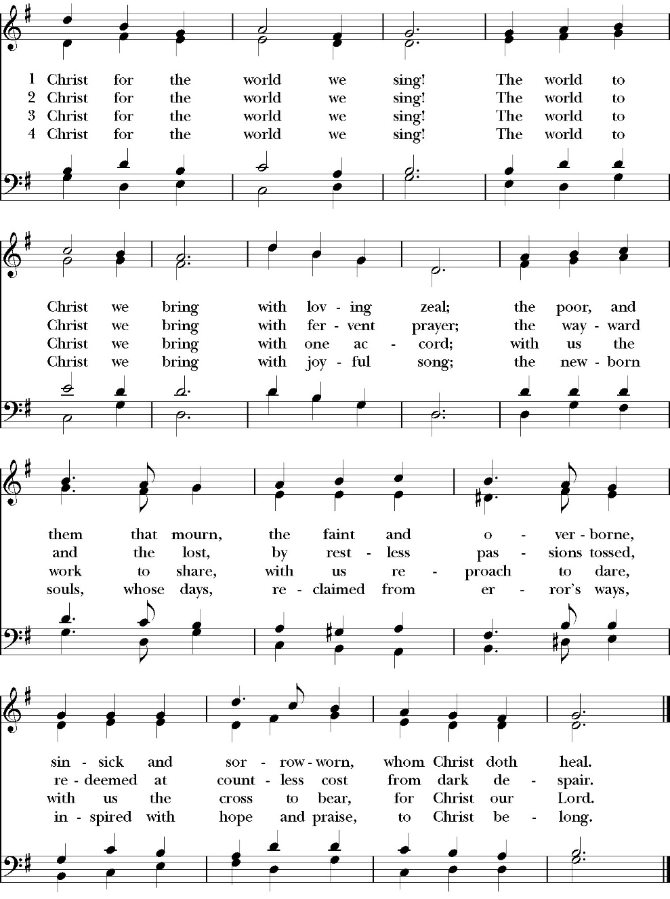

Dismissal

Deacon Alleluia, Alleluia. Let us go forth into the world, rejoicing
in the power of the Holy Spirit.
People Thanks be to God. Alleluia, alleluia.
St. Paul’s Parish Calendar
Sunday June 21– Sunday June 28

SUNDAY, June 21 – Fourth Sunday after Pentecost
9:15 AM Sunday Funday, Youth Room
9:15 AM Gospel of John Bible Study, Conference Room
10:30 AM Children’s Sunday School, Chapel
Pre-K –2nd Grade, Sunday School Room
3rd -5th Grade, Youth Room
10:30 AM Holy Eucharist, Church

MONDAY, June 22
10:00 AM Dr. Bill Winn’s Memorial Service, Church

TUESDAY, June 23

WEDNESDAY, June 24
9:30 AM Holy Eucharist with healing prayer, Chapel
10:15 AM Bible Study, Conference Room

THURSDAY, June 25

FRIDAY, June 26
6:30 AM Men’s Bible Study, Valhalla Restaurant

SATURDAY, June 27

SUNDAY, June 28 – Fifth Sunday after Pentecost
9:15 AM Sunday Funday, Youth Room
9:15 AM Gospel of John Bible Study, Conference Room
10:30 AM Children’s Sunday School, Chapel
Pre-K –2nd Grade, Sunday School Room
3rd -5th Grade, Youth Room
10:30 AM Holy Eucharist, Church

Church Office Hours
Monday-Thursday 8:00 AM-4:00 PM

Dr. Bill Winn’s Memorial Service: Monday, June 22, 10AM
Dr. Bill Winn has been a longtime member and friend to so many in our church. He passed away Saturday, June 6. Dr. Winn’s memorial service will be here at St. Paul’s Anglican Church on Monday, June 22, 10AM, with a reception to follow in James Hall. Dr. Winn’s wife Wilma and his family invite all of his friends at St. Paul’s to join them at the memorial service.

Sunday Morning Bible Study: The Gospel of John
St. Paul’s is embarking on a study of the Gospel of John that will span the next year. These classes will be on Sunday mornings from 9:15-10:00AM. We will take the better part of the next year to move slowly through John and savor the profound spiritual truths that it offers. We will be using a book called Be Alive by Warren Wiersbe as our guide. This book is essentially a study guide to the Gospel of John and will provide us with structure and insight as we move our way through the Gospel. Books will be available if you would like one.

Projected Class Timeline

June Chapter 7
July No Class
August Chapter 8-9

The class will progress based on how quickly or slowly is needed and our projected timelines may change as we move forward.

Upcoming Staff Vacations and Continuing Education
Fr. Rob Longbottom June 23-27 Vacation
Antoinette Horsting July 2, 6-9

In case of pastoral emergencies during Fr. Rob’s vacation, please call the church office or Deacon John Iseman at (518)222-6722 or Deacon Kashy Rowland-Smith at (559)909-3305.

“Changing Babies” Baby Bottle Fundraiser Ends Today on June 21, 2026, Father’s Day
Please bring your baby bottles to church on Sunday, June 21, and place them in the basket in the Narthex. If you forget to bring it today, please bring the baby bottles to the church office.


St. Paul’s Anglican Church
Friends and Fellowship

Please join us for another fun gathering

Saturday July 4

4:00 Pm to 8:00 Pm

at the home of
David and Ellen Daniels
27398B Road 108,
Visalia, CA 93277

the Daniels will provide pulled pork
and Guests can bring their favorite
appetizers and drinks to share.

RSVP by calling the church office.

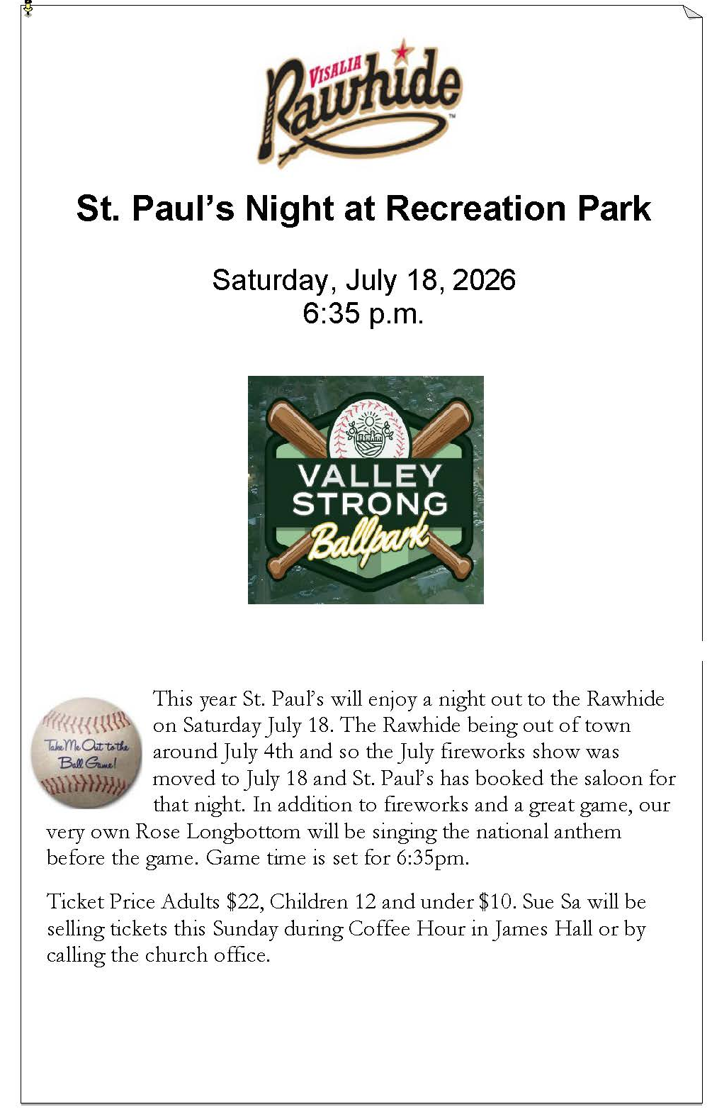
St. Paul’s Anglican Church
Parish Office
6436 W. Hurley Ave
Visalia, California 93291
559-732-4821
Office Hours: 8:00 – 4:00
Monday – Thursday

Worship: Sundays at 10:30AM
Livestream: Link at spvisalia.com
and on our Facebook page
Please be advised that this service is being recorded for broadcast
and/or archival purposes. By attending, you consent
to the inclusion of your likeness in these recordings.

St. Paul’s Clergy and Staff
The Rev. Robert Longbottom, Rector
rector@spvisalia.com
(559)802-2928
The Rev. John Iseman, Pastoral Associate for Family Ministries
family@spvisalia.com
The Rev. Kashy Rowland-Smith, Deacon
kashyrs@aol.com
Antoinette Horsting, Parish Administrator
bookkeeper@spvisalia.com
Marguerite Crownover, Organist and Accompanist
Cynthia Culp, Choral Director
Jackie Iseman, Nursery Coordinator
Shane Motl, Sexton

St. Paul’s is a member church of the
Anglican Diocese of San Joaquin
The Rt. Rev. Eric V. Menees, Bishop

Next Week’s Lessons
Isaiah 2:10-17
Psalm 89:1-18
Romans 6:1-11
Matthew 10:34-42

