ST. PAUL’S
ANGLICAN CHURCH
VISALIA, CALIFORNIA

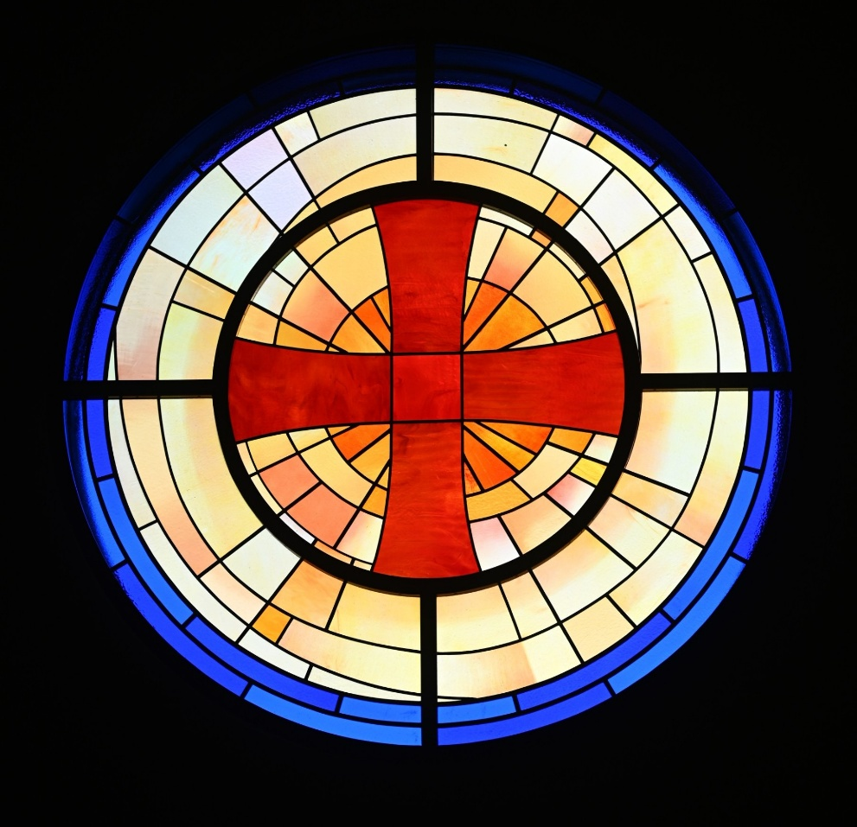

Fifth Sunday after Pentecost
June 28, 2026
10:30 A.M

Welcome!

St. Paul’s Anglican Church extends a warm welcome to all visitors and newcomers, whether worshiping in person or at home via livestream.

Visitors’ Guide

St. Paul’s Church is a parish in the Diocese of San Joaquin of the Anglican Church in North America, which includes both Catholic and Protestant traditions. We accept Jesus Christ as Savior, and we promise to follow him as Lord. We believe in One God,

- the Father who created us and all things,
- the Son who redeems us from sin and death,
- the Holy Spirit who renews and sanctifies us.

We believe the Holy Scriptures to be the Word of God and to contain all things necessary for salvation, and we accept the Apostles’ and Nicene Creeds as essential beliefs of the Christian faith.

Those not desiring to receive Holy Communion, and those who have not been baptized into the Christian faith, are invited to cross their arms across their chest, and a blessing will be given instead.

Visitors are invited to sign the guest book at the entrance table and introduce themselves to the clergy following the service.

The Holy Eucharist

Opening Hymn: #525 – “The Church’s One Foundation” p. 4
Opening Acclamation p. 5
The Collect for Purity p. 5
Summary of the Law p. 5
Kyrie p. 5
Gloria p. 5
Collect of the Day p. 6
Lesson: Isaiah 2:10-17 p. 6
Gradual: Psalm 89:1-18 p. 7
Epistle: Romans 6:1-11 p. 8
Sequence Hymn: #685 – “Rock of Ages” p. 9
Gospel: Matthew 10:34-42 p. 9
Sermon: The Rev. Kashy Rowland-Smith
Nicene Creed p. 10
Prayers of the People p. 11
The Peace p. 13
Anthem: “I Surrender All” Praise Band
The Offertory p. 15
Sursum Corda p. 15
Sanctus p. 16
The Lord’s Prayer p. 17
Fraction p. 18
Prayer for Humble Access p. 18
Agnus Dei p. 18
Communion Hymn: Celebration Hymn – “Come, Share the Lord” p. 19
Post Communion Prayer p. 20
Blessing p. 20
Closing Hymn: #718 – “God of Our Fathers” p. 21
Dismissal p. 21

Today we welcome our guest accompanist
Gabriel Hatcher

Opening Hymn: The Church’s One Foundation
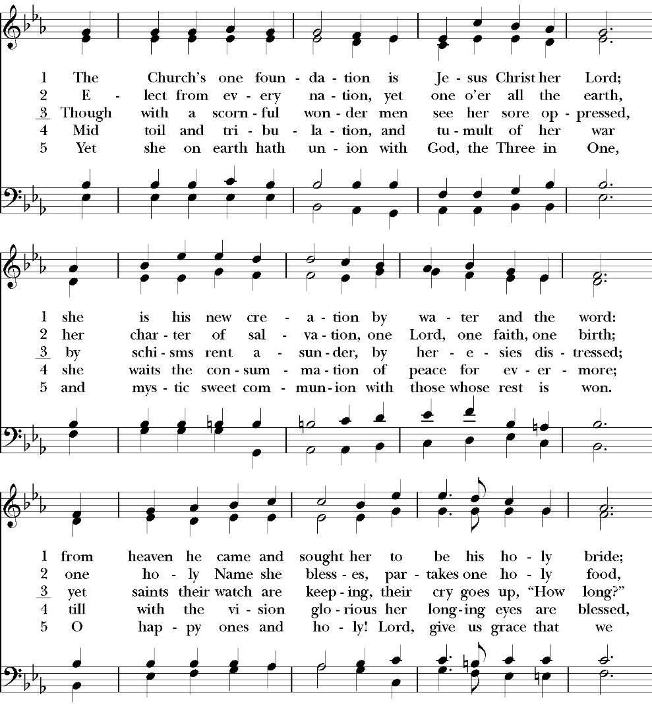
(Verses 1-3 only)
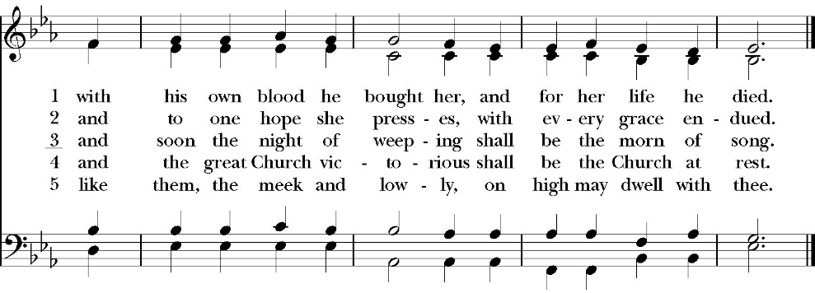

Opening Acclamation

Celebrant Blessed be God, the Father, the Son and the Holy Spirit. People And blessed be his kingdom, now and forever. Amen.

Collect for Purity

Almighty God, to you all hearts are open, all desires
known, and from you no secrets are hid: Cleanse the thoughts
of our hearts by the inspiration of your Holy Spirit, that we
may perfectly love you, and worthily magnify your holy Name;
through Christ our Lord. Amen.

Summary of the law

Hear what our Lord Jesus Christ says: You shall love
the Lord your God with all your heart and with all your soul
and with all your mind. This is the first and great
commandment. And the second is like it: You shall love your
neighbor as yourself. On these two commandments depend all
the Law and the Prophets.

Kyrie

Lord, have mercy upon us.
Christ, have mercy upon us.
Lord, have mercy upon us.

Gloria
Glory to God in the highest,
and peace to his people on earth.
Lord God, heavenly King,
almighty God and Father,
we worship you, we give you thanks,
we praise you for your glory.
Lord Jesus Christ, only Son of the Father,
Lord God, Lamb of God,
you take away the sin of the world:
have mercy on us;
you are seated at the right hand of the Father:
receive our prayer.
For you alone are the Holy One,
you alone are the Lord,
you alone are the Most High,
Jesus Christ,
with the Holy Spirit,
in the glory of God the Father. Amen

Celebrant The Lord be with you.
People And with your spirit.
Celebrant Let us pray.

The Collect of the Day
O God, your never-failing providence sets in order all things both in heaven and on earth: Put away from us all hurtful things, and give us those things that are profitable for us; through Jesus Christ our Lord, who lives and reigns with you and the Holy Spirit, one God, for ever and ever. Amen.

Lesson: Isaiah 2:10-17
Enter into the rock and hide in the dust from before the terror of the LORD, and from the splendor of his majesty. 11 The haughty looks of man shall be brought low, and the lofty pride of men shall be humbled, and the LORD alone will be exalted in that day.

12 For the LORD of hosts has a day against all that is proud and lofty, against all that is lifted up—and it shall be brought low; 13 against all the cedars of Lebanon, lofty and lifted up; and against all the oaks of Bashan; 14 against all the lofty mountains, and against all the uplifted hills; 15 against every high tower, and against every fortified wall;

16 against all the ships of Tarshish, and against all the beautiful craft.

17 And the haughtiness of man shall be humbled, and the lofty pride of men shall be brought low, and the LORD alone will be exalted in that day.

Reader: The Word of the Lord
People: Thanks be to God

Gradual: Psalm 89:1-18
1 My song shall be always of the loving-kindness of the LORD; * with my mouth will I ever be proclaiming your faithfulness, from one generation to another.
2 For I have said, “Mercy shall be built up for ever; *
your faithfulness shall be established in the heavens.”
3 I have made a covenant with my chosen one; *
I have sworn to David my servant:
4 “Your seed will I establish for ever, *
and set up your throne from one generation to another.”
5 O LORD, the heavens will praise your wondrous works *
and your faithfulness in the assembly of the saints.
6 For who in the clouds can be compared unto the LORD? *
And who among the gods is like unto the LORD?
7 God is greatly to be feared in the council of the saints, *
and to be held in reverence by all those who are round about him.
8 O LORD God of hosts, who is like you? *
Your faithfulness, most mighty LORD, is round about you.
9 You rule the raging of the sea; *
you still the waves when they arise.
10 You have subdued Rahab of the deep, and destroyed her; *
you have scattered your enemies with your mighty arm.
11 The heavens are yours; the earth also is yours; * you laid the foundation of the world, and all that is in it.
12 You have made the north and the south; *
Tabor and Hermon shall rejoice in your Name.
13 You have a mighty arm; *
strong is your hand, and high is your right hand.
14 Righteousness and justice are the foundation of your throne; * mercy and truth shall go before your face.
15 Blessed are the people, O LORD, who rejoice in you; *
they shall walk in the light of your countenance.
16 Their delight shall be in your Name all the day long, *
and in your righteousness shall they make their boast.
17 For you are the glory of their strength, *
and by your favor you shall lift up our might.
18 For the LORD is our defense; *
the Holy One of Israel is our King.

Glory be to the Father, and to the Son, and to the Holy Spirit;
as it was in the beginning, is now, and ever shall be, world
without end. Amen

Epistle Romans 6:1-11
What shall we say then? Are we to continue in sin that grace may abound? 2 By no means! How can we who died to sin still live in it?

3 Do you not know that all of us who have been baptized into Christ Jesus were baptized into his death? 4 We were buried therefore with him by baptism into death, in order that, just as Christ was raised from the dead by the glory of the Father, we too might walk in newness of life.

5 For if we have been united with him in a death like his, we shall certainly be united with him in a resurrection like his. 6 We know that our old self was crucified with him in order that the body of sin might be brought to nothing, so that we would no longer be enslaved to sin. 7 For one who has died has been set free from sin. 8 Now if we have died with Christ, we believe that we will also live with him. 9 We know that Christ, being raised from the dead, will never die again; death no longer has dominion over him. 10 For the death he died he died to sin, once for all, but the life he lives he lives to God. 11 So you also must consider yourselves dead to sin and alive to God in Christ Jesus.

Reader: The Word of the Lord
People: Thanks be to God

Sequence Hymn: Rock of Ages
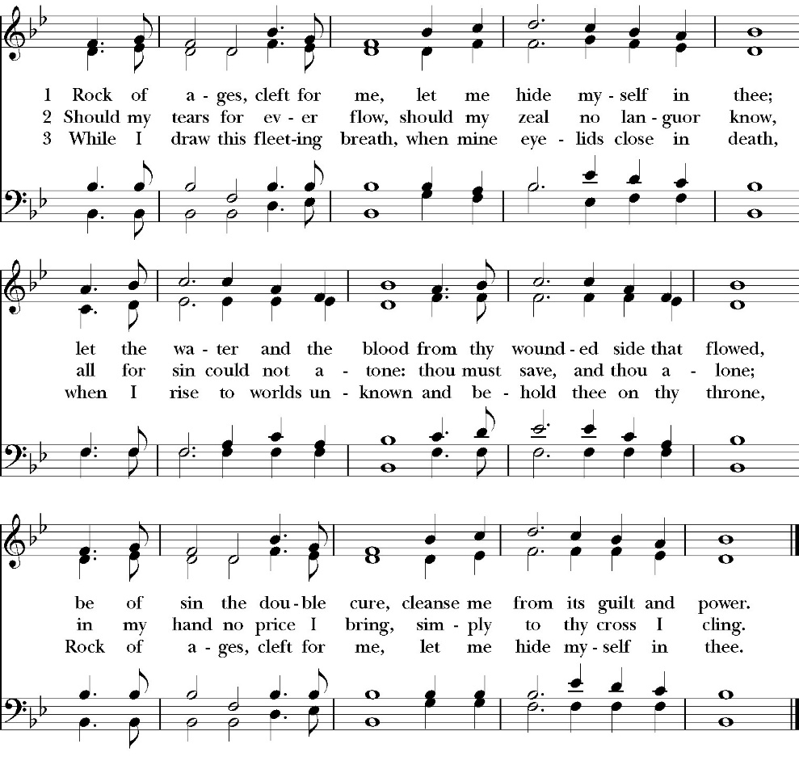
(Verses 1-2 before gospel, verse 3 after gospel)

Clergy: The Holy Gospel of Our Lord Jesus Christ,
according to St. Matthew
People: Glory to you, Lord God

Gospel: Matthew 10:34-42
“Do not think that I have come to bring peace to the earth. I have not come to bring peace, but a sword. 35 For I have come to set a man against his father, and a daughter against her mother, and a daughterin-law against her mother-in-law. 36 And a person's enemies will be those of his own household. 37 Whoever loves father or mother more than me is not worthy of me, and whoever loves son or daughter more than me is not worthy of me. 38 And whoever does not take his cross and follow me is not worthy of me. 39 Whoever finds his life will lose it, and whoever loses his life for my sake will find it.

40 “Whoever receives you receives me, and whoever receives me receives him who sent me. 41 The one who receives a prophet because he is a prophet will receive a prophet's reward, and the one who receives a righteous person because he is a righteous person will receive a righteous person's reward. 42 And whoever gives one of these little ones even a cup of cold water because he is a disciple, truly, I say to you, he will by no means lose his reward.”

Clergy: The Gospel of the Lord
People: Praise to you, Lord Christ

Sermon
The Rev. Kashy Rowland-Smith

The Nicene Creed

We believe in one God,
the Father, the Almighty,
maker of heaven and earth,
of all that is, visible and invisible.

We believe in one Lord, Jesus Christ,
the only-begotten Son of God,
eternally begotten of the Father,
God from God, Light from Light,
true God from true God,
begotten, not made,
of one Being with the Father.
through him all things were made.

For us and for our salvation he came down from heaven:
was incarnate from the Holy Spirit and the Virgin Mary,
and was made man.
For our sake he was crucified under Pontius Pilate;
he suffered death and was buried.
On the third day he rose again in accordance with the
Scriptures;
he ascended into heaven
and is seated at the right hand of the Father.
He will come again in glory to judge the living and the dead,
and his kingdom will have no end.
We believe in the Holy Spirit, the Lord, the giver of life,
who proceeds from the Father and the Son,
who with the Father and the Son is worshiped and glorified.
who has spoken through the Prophets.
We believe in one holy catholic and apostolic Church.
We acknowledge one Baptism for the forgiveness of sins.
We look for the resurrection of the dead,
and the life of the world to come. Amen.

The Prayers of the People

Leader Let us pray for the Church and for the world, saying, “hear our prayer.”
For the peace of the whole world, and for the well-being and unity of the people of God.
Lord, in your mercy:
People Hear our prayer.

Leader For Stephen our archbishop, Julian our provincial dean, and Eric our bishop. For Fr. Rob, Deacon John, Deacon Kashy, and for all the clergy and people of our diocese and congregation and for the worldwide Anglican Communion.
Lord, in your mercy:
People Hear our prayer.

Leader For all those who proclaim the Gospel at home and abroad; and for all who teach and disciple others.
Lord, in your mercy:
People Hear our prayer.

Leader For our brothers and sisters in Christ who are persecuted for their faith.
Lord, in your mercy:
People Hear our prayer.

Leader For our nation, for those in authority, and for all in public service especially Donald our president and Gavin our governor.
Lord, in your mercy:
People Hear our prayer.

Leader: In the St. Paul’s cycle of prayer, we lift up the ministries of pastoral care, all our members who are in the hospital, care facilities or who are shut into their own homes. We pray for those who are recovering from recent surgeries and for those who are in crisis.
Lord, in your mercy:
People Hear our prayer.

Leader In the ACNA Cycle of Prayer, today we pray for the Anglican Province of Bangladesh and The Most Rev. Samuel Mankhin, Moderator.
Lord, in your mercy:
People Hear our prayer.

Leader For all those who are in trouble, sorrow, need, sickness, or
any other adversity [especially ____________]. We also
pray for all who are currently serving in our armed forces
and serving as first responders.
Lord, in your mercy:
People Hear our prayer.

Leader For all those who have departed this life in the certain hope
of the resurrection, (we pray especially for ____________),
in Thanksgiving let us pray.
Lord, in your mercy:
People Hear our prayer.

Celebrant will add a concluding prayer

Heavenly Father, grant these our prayers for the sake of Jesus Christ,
our only Mediator and Advocate, who lives and reigns with you in
the unity of the Holy Spirit, one God, now and for ever. Amen.

The Confession and Absolution

Celebrant Let us humbly confess our sins to Almighty God.

Most merciful God,
we confess that we have sinned against you
in thought, word and deed,
by what we have done, and by what we have left undone.
We have not loved you with our whole heart;
we have not loved our neighbors as ourselves.
We are truly sorry and we humbly repent.
For the sake of your Son Jesus Christ,
have mercy on us and forgive us;
that we may delight in your will, and walk in your ways,
to the glory of your Name. Amen.

Almighty God, our heavenly Father, who in his great mercy has
promised forgiveness of sins to all those who sincerely repent and
with true faith turn to him, have mercy upon you, pardon and deliver
you from all your sins, confirm and strengthen you in all goodness,
and bring you to everlasting life; through Jesus Christ our Lord.
Amen.

Hear the Word of God to all who truly turn to him.

God so loved the world, that he gave his only-begotten Son, that
whoever believes in him should not perish but have eternal life.
John 3:16
Celebrant The Peace of the Lord be always with you.
People And with your spirit.

Offertory
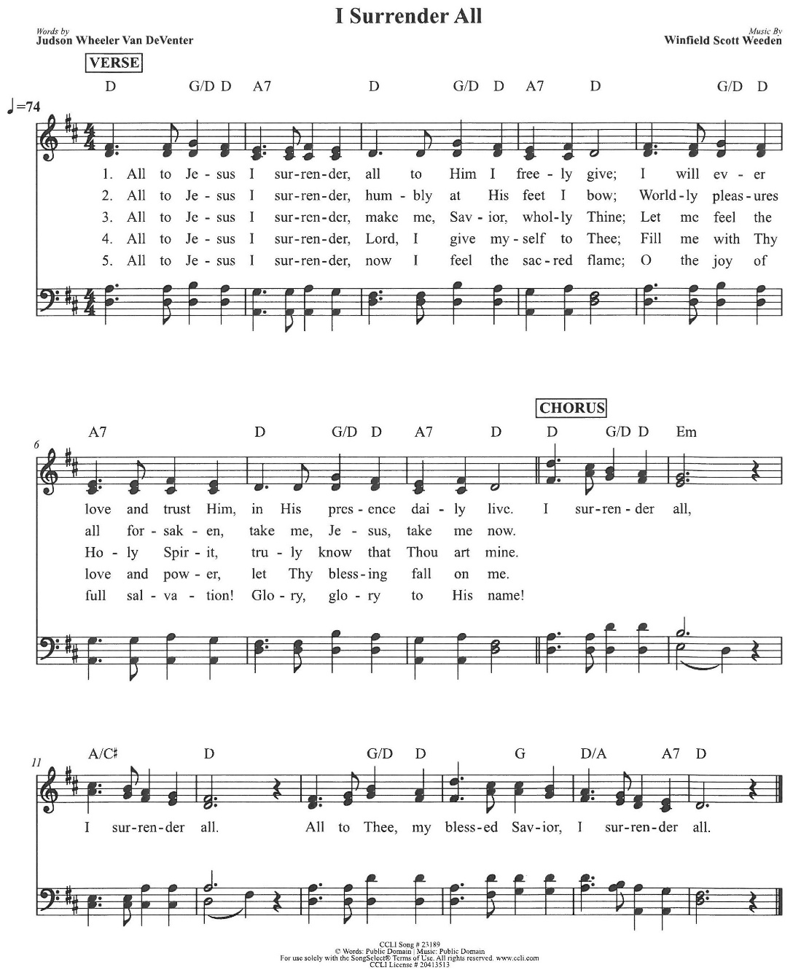
Praise Band

The Doxology
(Verse 3 only)

Offertory

Celebrant All things come from you, O Lord,
People And of your own have we given you.

The Eucharistic Liturgy

Celebrant The Lord be with you.
People And with your spirit.
Celebrant Lift up your hearts.
People We lift them up to the Lord.
Celebrant Let us give thanks to the Lord our God.
People It is right to give him thanks and praise.

It is right, our duty and our joy, always and everywhere to give thanks to you, Father Almighty, Creator of heaven and earth.

Through Jesus Christ our Lord, who on the first day of the week overcame death and the grave, and by his glorious resurrection opened to us the way of everlasting life.

Therefore we praise you, joining our voices with Angels and Archangels and with all the company of heaven, who for ever sing this hymn to proclaim the glory of your Name:

Sanctus

Holy, Holy, Holy, Lord God of power and might, heaven and
earth are full of your glory.
Hosanna in the highest.
Blessed is he who comes in the Name of the Lord.
Hosanna in the highest.

Holy and gracious Father: In your infinite love you made us for yourself; and when we had sinned against you and become subject to evil and death, you, in your mercy, sent your only Son Jesus Christ into the world for our salvation. By the Holy Spirit and the Virgin Mary he became flesh and dwelt among us. In obedience to your will, he stretched out his arms upon the Cross and offered himself once for all, that by his suffering and death we might be saved. By his resurrection he broke the bonds of death, trampling Hell and Satan under his feet. As our great high priest, he ascended to your right hand in glory, that we might come with confidence before the throne of grace.

On the night that he was betrayed, our Lord Jesus Christ took bread; and when he had given thanks, he broke it,* and gave it to his disciples, saying, “Take, eat; this is my Body, which is given for you: Do this in remembrance of me.”

Likewise, after supper, Jesus took the cup, and when he had given thanks, he gave it to them, saying, “Drink this, all of you; for this is my Blood of the New Covenant, which is shed for you, and for many, for the forgiveness of sins: Whenever you drink it, do this in remembrance of me.”

Therefore we proclaim the mystery of faith:

Christ has died.
Christ is risen.
Christ will come again.

We celebrate the memorial of our redemption, O Father, in this sacrifice of praise and thanksgiving, and we offer you these gifts.

Sanctify them by your Word and Holy Spirit to be for your people the Body and Blood of your Son Jesus Christ. Sanctify us also, that we may worthily receive this holy Sacrament, and be made one body with him, that he may dwell in us and we in him. In the fullness of time, put all things in subjection under your Christ, and bring us with all your saints into the joy of your heavenly kingdom, where we shall see our Lord face to face.

All this we ask through your Son Jesus Christ: By him, and with him, and in him, in the unity of the Holy Spirit, all honor and glory is yours, Almighty Father, now and for ever. Amen.

And now, as our Savior Christ has taught us, we are bold to pray,

Our Father, who art in heaven,
hallowed be thy Name,
thy kingdom come,
thy will be done,
on earth as it is in heaven.
Give us this day our daily bread.
And forgive us our trespasses,
as we forgive those
who trespass against us.
And lead us not into temptation,
but deliver us from evil.
For thine is the kingdom,
and the power, and the glory,
for ever and ever. Amen.

Fraction

Celebrant Alleluia! Christ our Passover is sacrificed for us.
People Therefore let us keep the feast. Alleluia!

The Prayer for Humble Access

We do not presume to come to this your table, O merciful Lord,
trusting in our own righteousness,
but in your abundant and great mercies.
We are not worthy so much as to gather up
the crumbs under your table;
but you are the same Lord
whose character is always to have mercy.
Grant us, therefore, gracious Lord,
so to eat the flesh of your dear Son Jesus Christ,
and to drink his blood,
that our sinful bodies may be made clean by his body,
and our souls washed through his most precious blood,
and that we may evermore dwell in him, and he in us.
Amen.

Agnus Dei

Lamb of God, you take away the sin of the world;
have mercy on us.
Lamb of God, you take away the sin of the world;
have mercy on us.
Lamb of God, you take away the sin of the world;
grant us your peace.

The Ministration of Communion

The gifts of God for the People of God. Take them in remembrance that Christ died for you and feed on him in your hearts by faith, with thanksgiving.

Communion Hymn: Come Share the Lord
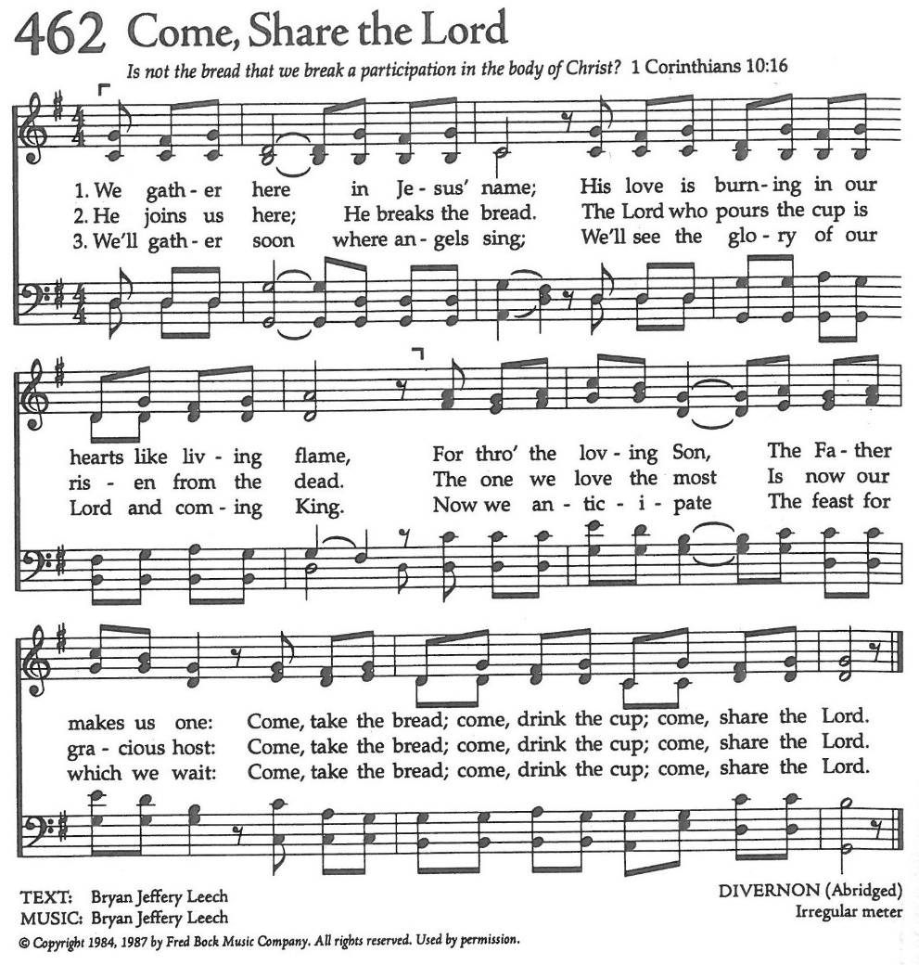

The Post Communion Prayer

Let us pray.

Heavenly Father,
We thank you for feeding us with the spiritual food
of the most precious Body and Blood
of your Son our Savior Jesus Christ;
and for assuring us in these holy mysteries
that we are living members of the body of your Son,
and heirs of your eternal Kingdom.
And now, Father, send us out to do the work you have
given us to do,
to love and serve you as faithful witnesses of Christ our
Lord.
To him, to you, and to the Holy Spirit,
be honor and glory, now and for ever. Amen.

The Blessing

The blessing of God Almighty, the Father, the Son, and the Holy
Spirit, be among you, and remain with you always. Amen.

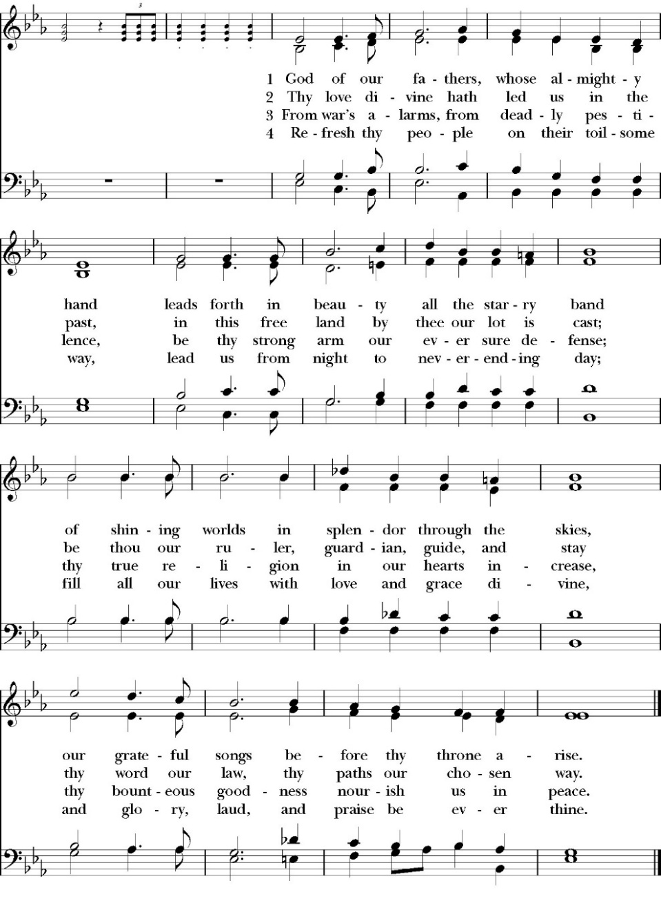
Closing Hymn: God of Our Fathers

Dismissal

Deacon Alleluia, Alleluia. Let us go forth into the world, rejoicing
in the power of the Holy Spirit.
People Thanks be to God. Alleluia, alleluia.
St. Paul’s Parish Calendar
Sunday June 28– Sunday July 5

SUNDAY, June 28 – Fifth Sunday after Pentecost
9:15 AM Sunday Funday, Youth Room
9:15 AM Gospel of John Bible Study, Conference Room
10:30 AM Children’s Sunday School, Chapel
Pre-K –2nd Grade, Sunday School Room
3rd -5th Grade, Youth Room
10:30 AM Holy Eucharist, Church

MONDAY, June 29

TUESDAY, June 30

WEDNESDAY, July 1
9:30 AM Holy Eucharist with healing prayer, Chapel
10:15 AM Bible Study, Conference Room

THURSDAY, July 2

FRIDAY, July 3
6:30 AM Men’s Bible Study, Valhalla Restaurant

SATURDAY, July 4
4:00 PM Friendship and Fellowship, home of David and Ellen Daniels

SUNDAY, July 5 – Sixth Sunday after Pentecost
10:30 AM Children’s Sunday School, Chapel
Pre-K –2nd Grade, Sunday School Room
3rd -5th Grade, Youth Room
10:30 AM Holy Eucharist, Church

Church Office Hours
Monday-Thursday 8:00 AM-4:00 PM

Sunday Morning Bible Study: The Gospel of John
St. Paul’s is embarking on a study of the Gospel of John that will span the next year. These classes will be on Sunday mornings from 9:15-10:00AM. We will take the better part of the next year to move slowly through John and savor the profound spiritual truths that it offers. We will be using a book called Be Alive by Warren Wiersbe as our guide. This book is essentially a study guide to the Gospel of John and will provide us with structure and insight as we move our way through the Gospel. Books will be available if you would like one.

Projected Class Timeline

June Chapter 7
July No Class
August Chapter 8-9

The class will progress based on how quickly or slowly is needed and our projected timelines may change as we move forward.

Upcoming staff Vacations and Continuing Education
Antoinette Horsting July 2, 6-9



st. Paul’s Anglican Church
Friends and Fellowship

Please join us for another fun gathering

Saturday July 4

4:00 Pm to 8:00 Pm

at the home of
David and Ellen Daniels
27398B Road 108,
Visalia, CA 93277

direction to the Daniels home
Driveway is on the East side of Demaree between Visalia Park Way and Ave 272.
just follow the flags.

the Daniels will provide pulled pork
and Guests can bring their favorite
appetizers, side dish or dessert
and drinks to share.

RSVP by calling the
Ellen Daniels 559-303-4812
or the church office.

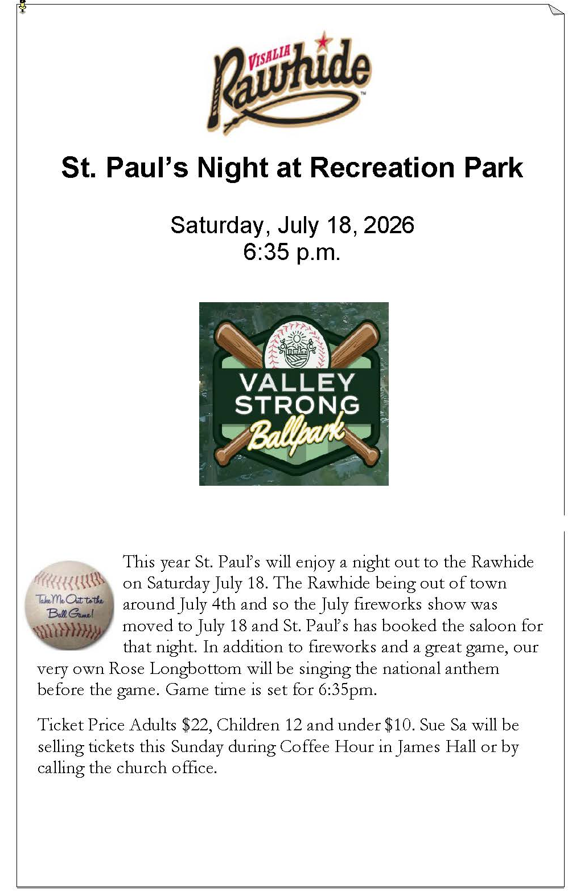

St. Paul’s Anglican Church
Parish Office
6436 W. Hurley Ave
Visalia, California 93291
559-732-4821
Office Hours: 8:00 – 4:00
Monday – Thursday

Worship: Sundays at 10:30AM
Livestream: Link at spvisalia.com
and on our Facebook page
Please be advised that this service is being recorded for broadcast
and/or archival purposes. By attending, you consent
to the inclusion of your likeness in these recordings.

St. Paul’s Clergy and Staff
The Rev. Robert Longbottom, Rector
rector@spvisalia.com
(559)802-2928
The Rev. John Iseman, Pastoral Associate for Family Ministries
family@spvisalia.com
The Rev. Kashy Rowland-Smith, Deacon
kashyrs@aol.com
Antoinette Horsting, Parish Administrator
bookkeeper@spvisalia.com
Marguerite Crownover, Organist and Accompanist
Cynthia Culp, Choral Director
Jackie Iseman, Nursery Coordinator
Shane Motl, Sexton

St. Paul’s is a member church of the
Anglican Diocese of San Joaquin
The Rt. Rev. Eric V. Menees, Bishop

Next Week’s Lessons
Zechariah 9:9-12
Psalm 145
Romans 7:21-8:6
Matthew 11:25-30

