ST. PAUL’S
ANGLICAN CHURCH
VISALIA, CALIFORNIA

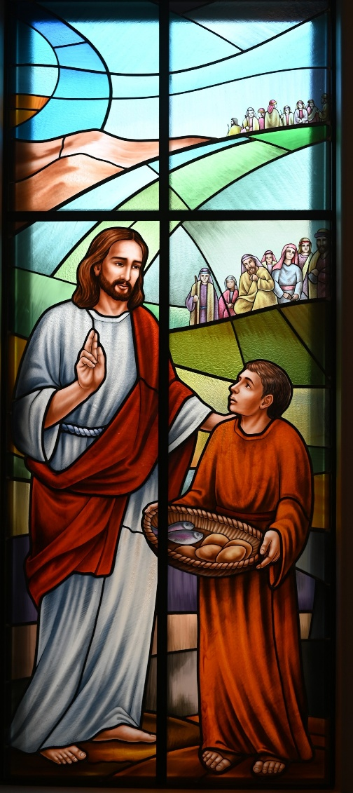

Second Sunday after Pentecost
June 7, 2026
10:30 A.M

Welcome!

St. Paul’s Anglican Church extends a warm welcome to all visitors and newcomers, whether worshiping in person or at home via livestream.

Visitors’ Guide

St. Paul’s Church is a parish in the Diocese of San Joaquin of the Anglican Church in North America, which includes both Catholic and Protestant traditions. We accept Jesus Christ as Savior, and we promise to follow him as Lord. We believe in One God,

- the Father who created us and all things,
- the Son who redeems us from sin and death,
- the Holy Spirit who renews and sanctifies us.

We believe the Holy Scriptures to be the Word of God and to contain all things necessary for salvation, and we accept the Apostles’ and Nicene Creeds as essential beliefs of the Christian faith.

Those not desiring to receive Holy Communion, and those who have not been baptized into the Christian faith, are invited to cross their arms across their chest, and a blessing will be given instead.

Visitors are invited to sign the guest book at the entrance table and introduce themselves to the clergy following the service.

The Holy Eucharist

Opening Hymn: #686 - “Come, Thou Font of Every Blessing” p. 4
Opening Acclamation p. 5
The Collect for Purity p. 5
Summary of the Law p. 5
Kyrie p. 5
Gloria p. 5
Collect of the Day p. 6
Lesson: Hosea 5:15-6:6 p. 6
Gradual: Psalm 50 p. 7
Epistle: Romans 4:13-18 p. 8
Sequence Hymn: 707 – “Take My Life and Let Be” p. 9
Gospel: Matthew 9:9-13 p. 9
Sermon: The Rev Robert Longbottom
Nicene Creed p. 10
Prayers of the People p. 11
The Peace p. 13
Anthem: “Every Move I Make” Sunday School Children
The Offertory p. 15
Sursum Corda p. 15
Sanctus p. 15
The Lord’s Prayer p. 17
Fraction p. 17
Prayer for Humble Access p. 17
Agnus Dei p. 18
Communion Hymn: #304 - “I Come with Joy” p. 18
Post Communion Prayer p. 19
Blessing p. 19
Closing Hymn: #602 - “I Have Decided to Follow Jesus” p. 20
Dismissal p. 20

Today we welcome our guest accompanist
Gabriel Hatcher

Opening Hymn: Come, Thou Font of Every Blessing

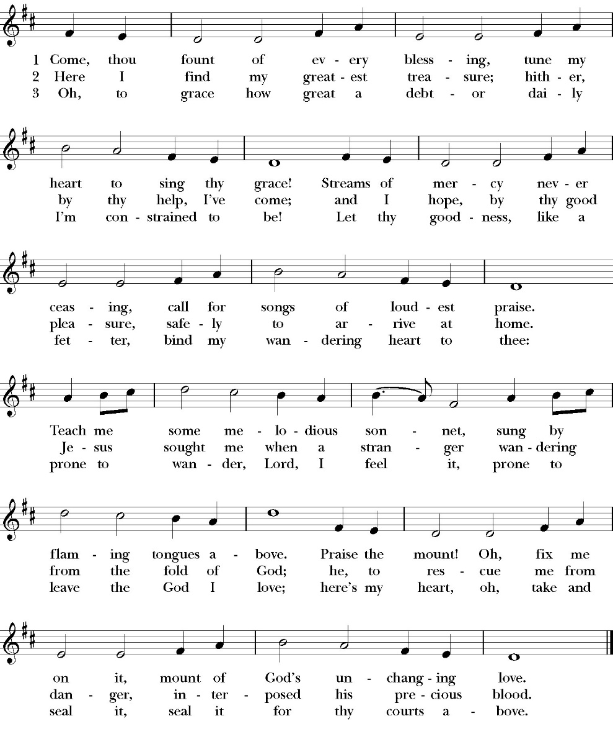

Opening Acclamation

Celebrant Blessed be God, the Father, the Son and the Holy Spirit. People And blessed be his kingdom, now and forever. Amen.

Collect for Purity
Almighty God, to you all hearts are open, all desires
known, and from you no secrets are hid: Cleanse the thoughts
of our hearts by the inspiration of your Holy Spirit, that we
may perfectly love you, and worthily magnify your holy Name;
through Christ our Lord. Amen.

Summary of the law

Hear what our Lord Jesus Christ says: You shall love
the Lord your God with all your heart and with all your soul
and with all your mind. This is the first and great
commandment. And the second is like it: You shall love your
neighbor as yourself. On these two commandments depend all
the Law and the Prophets.

Kyrie

Lord, have mercy upon us.
Christ, have mercy upon us.
Lord, have mercy upon us.

Gloria

Glory to God in the highest,
and peace to his people on earth.
Lord God, heavenly King,
almighty God and Father,
we worship you, we give you thanks,
we praise you for your glory.
Lord Jesus Christ, only Son of the Father,
Lord God, Lamb of God,
you take away the sin of the world:
have mercy on us;
you are seated at the right hand of the Father:
receive our prayer.
For you alone are the Holy One,
you alone are the Lord,
you alone are the Most High,
Jesus Christ,
with the Holy Spirit,
in the glory of God the Father. Amen

Celebrant The Lord be with you.
People And with your spirit.
Celebrant Let us pray.

The Collect of the Day

Grant, O Lord, that the course of this world may be so peaceably ordered by your providence, that your Church may joyfully serve you in quiet confidence and godly peace; through Jesus Christ our Lord, who lives and reigns with you and the Holy Spirit, one God, for ever and ever. Amen.

Lesson: Hosea 5:15-6:6

I will return again to my place, until they acknowledge their guilt and seek my face, and in their distress earnestly seek me.

6 “Come, let us return to the LORD; for he has torn us, that he may heal us; he has struck us down, and he will bind us up. 2 After two days he will revive us; on the third day he will raise us up, that we may live before him. 3 Let us know; let us press on to know the LORD; his going out is sure as the dawn; he will come to us as the showers, as the spring rains that water the earth.”
4 What shall I do with you, O Ephraim? What shall I do with you, O Judah? Your love is like a morning cloud, like the dew that goes early away. 5 Therefore I have hewn them by the prophets; I have slain them by the words of my mouth, and my judgment goes forth as the light. 6 For I desire steadfast love and not sacrifice, the knowledge of God rather than burnt offerings.

Reader: The Word of the Lord
People: Thanks be to God

Gradual: Psalm 50
1 The LORD, even the most mighty God, has spoken *
and called the world, from the rising of the sun to the going down thereof.
2 Out of Zion, perfect in her beauty, *
has God shone forth in glory.
3 Our God shall come and shall not keep silence; *
there shall go before him a consuming fire, and a mighty tempest shall be stirred up round about him.
4 He shall call to the heavens above, *
and to the earth beneath, that he may judge his people:
5 “Gather my faithful together unto me, *
those who have made a covenant with me by sacrifice.”
6 And the heavens shall declare his righteousness, *
for God himself is Judge.
7 “Hear, O my people, and I will speak; *
I myself will testify against you, O Israel, for I am God, even your God.
8 I will not rebuke you because of your sacrifices, or for your burnt offerings, *
because they are always before me.
9 I will take no bull calf out of your house, *
nor he-goat out of your folds.
10 For all the beasts of the forest are mine, *
and so are the cattle upon a thousand hills.
11 I know all the birds of the air, *
and the wild beasts of the field are in my sight.
12 If I were hungry, I would not tell you, *
for the whole world is mine, and all that is therein.
13 Do you think that I will eat the flesh of bulls *
and drink the blood of goats?
14 Offer unto God a sacrifice of thanksgiving, *
and pay your vows unto the Most High,
15 And call upon me in the time of trouble; *
so will I hear you, and you shall praise me.”
16 But to the ungodly God says: *
“Why do you recite my laws, and take my covenant in your mouth,

17 Though you hate to be disciplined, *
and have cast my words behind you?
18 When you saw a thief, you agreed with him, *
and you have taken part with adulterers.
19 You have let your mouth speak wickedness, *
and with your tongue you have set forth deceit.
20 You sat and spoke against your brother; *
yes, and have slandered your own mother’s son.
21 These things you have done, and I held my tongue, *
and you thought wickedly that I am such a one as yourself.
22 But I will reprove you, *
and set before you the things that you have done.
23 O consider this, you who forget God, *
lest I tear you in pieces, and there be none to deliver you.
24 Whoever offers me a sacrifice of thanksgiving honors me, *
and to him who orders his way aright will I show the salvation of God.”

Glory be to the Father, and to the Son, and to the Holy Spirit;
as it was in the beginning, is now, and ever shall be, world
without end. Amen

Epistle: Romans 4:13-18
For the promise to Abraham and his offspring that he would be heir of the world did not come through the law but through the righteousness of faith. 14 For if it is the adherents of the law who are to be the heirs, faith is null and the promise is void. 15 For the law brings wrath, but where there is no law there is no transgression.

16 That is why it depends on faith, in order that the promise may rest on grace and be guaranteed to all his offspring—not only to the adherent of the law but also to the one who shares the faith of Abraham, who is the father of us all, 17 as it is written, “I have made you the father of many nations”—in the presence of the God in whom he believed, who gives not exist. 18 In hope he believed against hope, that he should become the father of many nations, as he had been told, “So shall your offspring be.”

Reader: The Word of the Lord
People: Thanks be to God

Sequence Hymn: Take My Life and Let Be
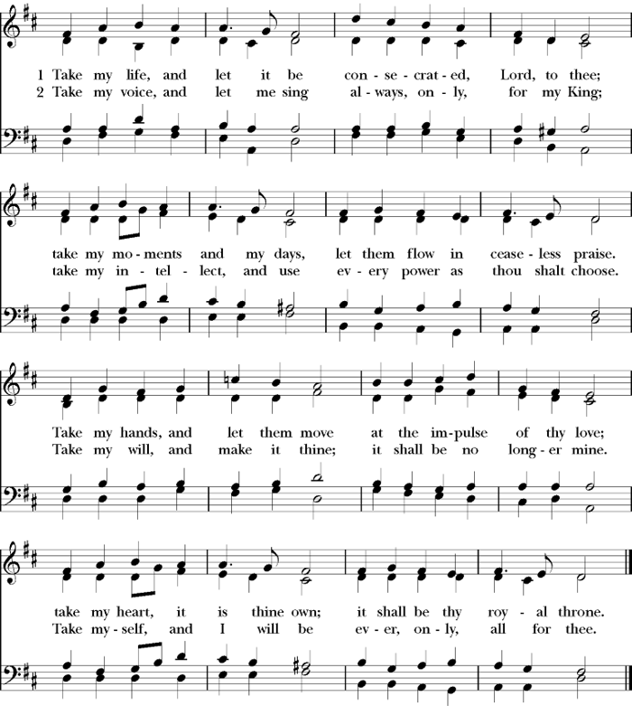
(Verses 1 before gospel verse 2 after gospel)

Clergy: The Holy Gospel of Our Lord Jesus Christ,
according to St. Matthew
People: Glory to you, Lord God

Gospel: Matthew 9:9-13
As Jesus passed on from there, he saw a man called Matthew sitting at the tax booth, and he said to him, “Follow me.” And he rose and followed him.
10 And as Jesus reclined at table in the house, behold, many tax collectors and sinners came and were reclining with Jesus and his disciples. 11 And when the Pharisees saw this, they said to his disciples, “Why does your teacher eat with tax collectors and sinners?” 12 But when he heard it, he said, “Those who are well have no need of a physician, but those who are sick. 13 Go and learn what this means: ‘I desire mercy, and not sacrifice.’ For I came not to call the righteous, but sinners.”

Clergy: The Gospel of the Lord
People: Praise to you Lord Christ

Sermon
The Rev. Robert Longbottom

The Nicene Creed

We believe in one God,
the Father, the Almighty,
maker of heaven and earth,
of all that is, visible and invisible.

We believe in one Lord, Jesus Christ,
the only-begotten Son of God,
eternally begotten of the Father,
God from God, Light from Light,
true God from true God,
begotten, not made,
of one Being with the Father.
through him all things were made.

For us and for our salvation he came down from heaven:
was incarnate from the Holy Spirit and the Virgin Mary,
and was made man.
For our sake he was crucified under Pontius Pilate;
he suffered death and was buried.
On the third day he rose again in accordance with the
Scriptures;

he ascended into heaven
and is seated at the right hand of the Father.
He will come again in glory to judge the living and the dead,
and his kingdom will have no end.
We believe in the Holy Spirit, the Lord, the giver of life,
who proceeds from the Father and the Son,
who with the Father and the Son is worshiped and glorified.
who has spoken through the Prophets.
We believe in one holy catholic and apostolic Church.
We acknowledge one Baptism for the forgiveness of sins.
We look for the resurrection of the dead,
and the life of the world to come. Amen.

The Prayers of the People

Leader Let us pray for the Church and for the world, saying, “hear our prayer.”
For the peace of the whole world, and for the well-being and unity of the people of God.
Lord, in your mercy:
People Hear our prayer.

Leader For Stephen our archbishop, Julian our provincial dean, and Eric our bishop. For Fr. Rob, Deacon John, Deacon Kashy, and for all the clergy and people of our diocese and congregation and for the worldwide Anglican Communion.
Lord, in your mercy:
People Hear our prayer.

Leader For all those who proclaim the Gospel at home and abroad; and for all who teach and disciple others.
Lord, in your mercy:
People Hear our prayer.

Leader For our brothers and sisters in Christ who are persecuted for their faith.
Lord, in your mercy:
People Hear our prayer.
Leader For our nation, for those in authority, and for all in public service especially Donald our president and Gavin our governor.
Lord, in your mercy:
People Hear our prayer.

Leader: In the St. Paul’s cycle of prayer, we pray for our Bishop Eric Menees, the Ministries of the Anglican Diocese of San Joaquin and its churches, for the Anglican Church in North America and its dioceses, for the Global Anglican Futures Conference, for the Global Anglican Communion and worldwide Anglican Communion and all their provinces, diocese and churches.
Lord, in your mercy:
People Hear our prayer.

Leader In the ACNA Cycle of Prayer, today we pray for the Anglican Diocese of South Carolina, Bishop Chip Edgar, his wife, Beth; and Bishop Mark Lawrence and his wife, Allison.
Lord, in your mercy:
People Hear our prayer.

Leader For all those who are in trouble, sorrow, need, sickness, or
any other adversity [especially ____________]. We also
pray for all who are currently serving in our armed forces
and serving as first responders.
Lord, in your mercy:
People Hear our prayer.

Leader For all those who have departed this life in the certain hope
of the resurrection, (we pray especially for ____________),
in Thanksgiving let us pray.
Lord, in your mercy:
People Hear our prayer.
Celebrant will add a concluding prayer

Heavenly Father, grant these our prayers for the sake of Jesus Christ,
our only Mediator and Advocate, who lives and reigns with you in
the unity of the Holy Spirit, one God, now and for ever. Amen.
The Confession and Absolution

Celebrant Let us humbly confess our sins to Almighty God.

Most merciful God,
we confess that we have sinned against you
in thought, word and deed,
by what we have done, and by what we have left undone.
We have not loved you with our whole heart;
we have not loved our neighbors as ourselves.
We are truly sorry and we humbly repent.
For the sake of your Son Jesus Christ,
have mercy on us and forgive us;
that we may delight in your will, and walk in your ways,
to the glory of your Name. Amen.

Almighty God, our heavenly Father, who in his great mercy has
promised forgiveness of sins to all those who sincerely repent and
with true faith turn to him, have mercy upon you, pardon and deliver
you from all your sins, confirm and strengthen you in all goodness,
and bring you to everlasting life; through Jesus Christ our Lord.
Amen.

Hear the Word of God to all who truly turn to him.

God so loved the world, that he gave his only-begotten Son, that
whoever believes in him should not perish but have eternal life.
John 3:16
Celebrant The Peace of the Lord be always with you.
People And with your spirit.

Anthem
Every Move I Make (Sunday School Children)

Every move I make I make in You. You make me move Jesus
Every breath I take I breathe in You
Every step I take I take in You. You are my way Jesus
Every breath I take I breathe in You

Chorus
Waves of mercy waves of grace. Everywhere I look I see Your face
Your love has captured me. Oh my God this love how can it be

Bridge
La la la la la la la
La la la la la la la la la

The Doxology
(Verse 3 only)

Offertory

Celebrant All things come from you, O Lord,
People And of your own have we given you.

The Eucharistic Liturgy

Celebrant The Lord be with you.
People And with your spirit.
Celebrant Lift up your hearts.
People We lift them up to the Lord.
Celebrant Let us give thanks to the Lord our God.
People It is right to give him thanks and praise.

It is right, our duty and our joy, always and everywhere to give thanks to you, Father Almighty, Creator of heaven and earth.
Through Jesus Christ our Lord, who on the first day of the week overcame death and the grave, and by his glorious resurrection opened to us the way of everlasting life.

Therefore we praise you, joining our voices with Angels and Archangels and with all the company of heaven, who for ever sing this hymn to proclaim the glory of your Name:

Sanctus

Holy, Holy, Holy, Lord God of power and might, heaven and
earth are full of your glory.
Hosanna in the highest.
Blessed is he who comes in the Name of the Lord.
Hosanna in the highest.

Holy and gracious Father: In your infinite love you made us for yourself; and when we had sinned against you and become subject to evil and death, you, in your mercy, sent your only Son Jesus Christ into the world for our salvation. By the Holy Spirit and the Virgin Mary he became flesh and dwelt among us. In obedience to your will, he stretched out his arms upon the Cross and offered himself once for all, that by his suffering and death we might be saved. By his resurrection he broke the bonds of death, trampling Hell and Satan under his feet. As our great high priest, he ascended to your right hand in glory, that we might come with confidence before the throne of grace.

On the night that he was betrayed, our Lord Jesus Christ took bread; and when he had given thanks, he broke it,* and gave it to his disciples, saying, “Take, eat; this is my Body, which is given for you: Do this in remembrance of me.”

Likewise, after supper, Jesus took the cup, and when he had given thanks, he gave it to them, saying, “Drink this, all of you; for this is my Blood of the New Covenant, which is shed for you, and for many, for the forgiveness of sins: Whenever you drink it, do this in remembrance of me.”

Therefore we proclaim the mystery of faith:

Christ has died.
Christ is risen.
Christ will come again.

We celebrate the memorial of our redemption, O Father, in this sacrifice of praise and thanksgiving, and we offer you these gifts.

Sanctify them by your Word and Holy Spirit to be for your people the Body and Blood of your Son Jesus Christ. Sanctify us also, that we may worthily receive this holy Sacrament, and be made one body with him, that he may dwell in us and we in him. In the fullness of time, put all things in subjection under your Christ, and bring us with all your saints into the joy of your heavenly kingdom, where we shall see our Lord face to face.

All this we ask through your Son Jesus Christ: By him, and with him, and in him, in the unity of the Holy Spirit, all honor and glory is yours, Almighty Father, now and for ever. Amen.

And now, as our Savior Christ has taught us, we are bold to pray,

Our Father, who art in heaven,
hallowed be thy Name,
thy kingdom come,
thy will be done,
on earth as it is in heaven.
Give us this day our daily bread.
And forgive us our trespasses,
as we forgive those
who trespass against us.
And lead us not into temptation,
but deliver us from evil.
For thine is the kingdom,
and the power, and the glory,
for ever and ever. Amen.

Fraction

Celebrant Alleluia! Christ our Passover is sacrificed for us.
People Therefore let us keep the feast. Alleluia!

The Prayer for Humble Access

We do not presume to come to this your table, O merciful Lord,
trusting in our own righteousness,
but in your abundant and great mercies.
We are not worthy so much as to gather up
the crumbs under your table;
but you are the same Lord
whose character is always to have mercy.
Grant us, therefore, gracious Lord,
so to eat the flesh of your dear Son Jesus Christ,
and to drink his blood,
that our sinful bodies may be made clean by his body,
and our souls washed through his most precious blood,
and that we may evermore dwell in him, and he in us.
Amen.

Agnus Dei
Lamb of God, you take away the sin of the world;
have mercy on us.
Lamb of God, you take away the sin of the world;
have mercy on us.
Lamb of God, you take away the sin of the world;
grant us your peace.

The Ministration of Communion

The gifts of God for the People of God. Take them in remembrance that Christ died for you and feed on him in your hearts by faith, with thanksgiving.

Communion Hymn: I Come With Joy
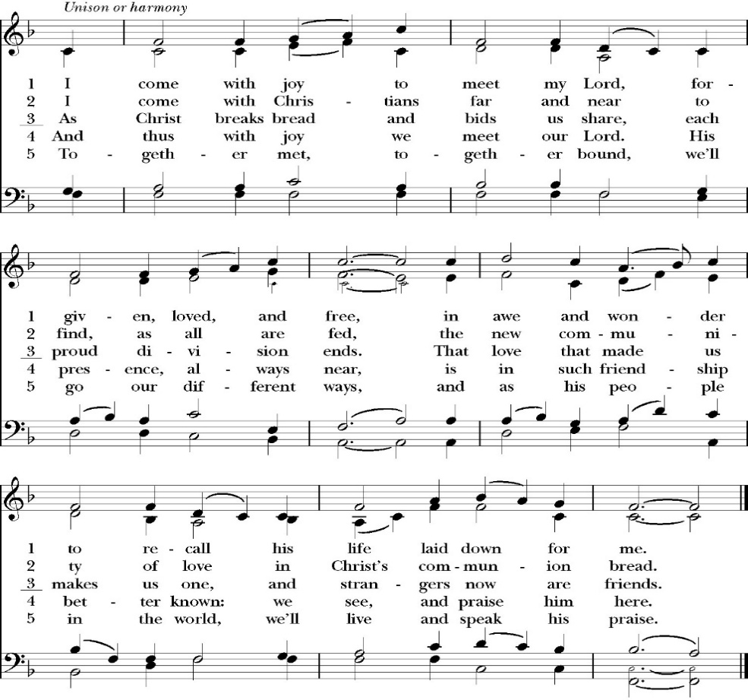
(verses 1-3 only)

The Post Communion Prayer

Let us pray.

Heavenly Father,
We thank you for feeding us with the spiritual food
of the most precious Body and Blood
of your Son our Savior Jesus Christ;
and for assuring us in these holy mysteries
that we are living members of the body of your Son,
and heirs of your eternal Kingdom.
And now, Father, send us out to do the work you have
given us to do,
to love and serve you as faithful witnesses of Christ our
Lord.
To him, to you, and to the Holy Spirit,
be honor and glory, now and for ever. Amen.

The Blessing

The blessing of God Almighty, the Father, the Son, and the Holy
Spirit, be among you, and remain with you always. Amen.

Closing Hymn: I Have Decided to Follow Jesus
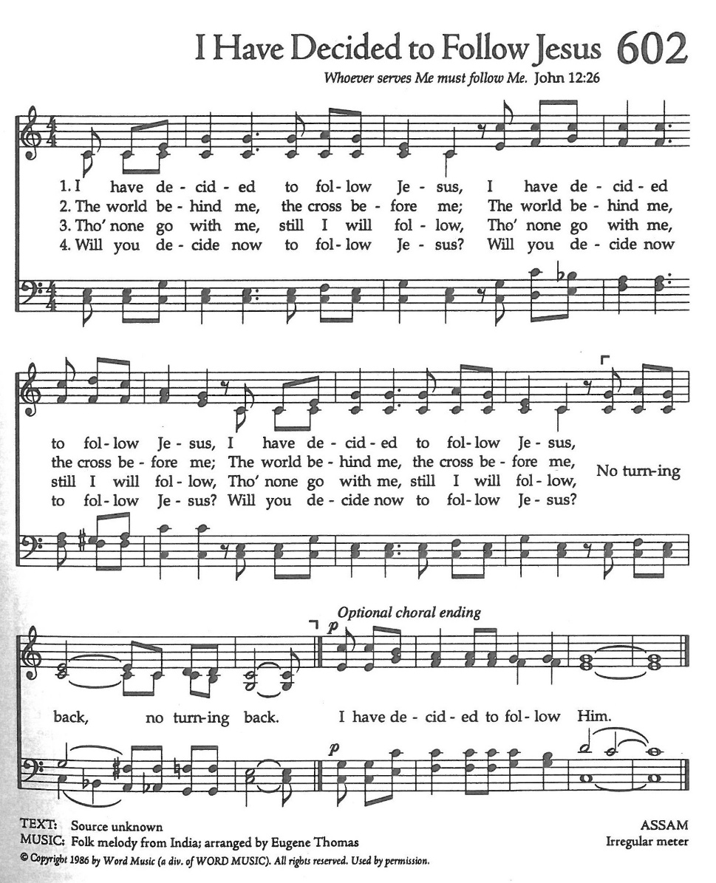

Deacon Alleluia, Alleluia, Let us go forth into the world, rejoicing
in the power of the Holy Spirit.
People Thanks be to God. Alleluia, alleluia.
St. Paul’s Parish Calendar
Sunday June 7– Sunday June 14

SUNDAY, June 7 – Second Sunday after Pentecost
9:15 AM Sunday Funday, Youth Room
9:15 AM Gospel of John Bible Study, Conference Room
10:30 AM Children’s Sunday School, Chapel
Pre-K –2nd Grade, Sunday School Room
3rd -5th Grade, Youth Room
10:30 AM Holy Eucharist, Church
12:00 PM Church Picnic

MONDAY, June 8

TUESDAY, June 9

WEDNESDAY, June 10
9:30 AM Holy Eucharist with healing prayer, Chapel
10:15 AM Bible Study, Conference Room

THURSDAY, June 11

FRIDAY, June 12
6:30 AM Men’s Bible Study, Valhalla Restaurant

SATURDAY, June 13

SUNDAY, June 14 – Second Sunday after Pentecost
9:15 AM Sunday Funday, Youth Room
9:15 AM Gospel of John Bible Study, Conference Room
10:30 AM Children’s Sunday School, Chapel
Pre-K –2nd Grade, Sunday School Room
3rd -5th Grade, Youth Room
10:30 AM Holy Eucharist, Church

Church Office Hours
Monday-Thursday 8:00 AM-4:00 PM

Sunday Morning Bible Study: The Gospel of John
St. Paul’s is embarking on a study of the Gospel of John that will span the next year. These classes will be on Sunday mornings from 9:15-10:00AM. We will take the better part of the next year to move slowly through John and savor the profound spiritual truths that it offers. We will be using a book called Be Alive by Warren Wiersbe as our guide. This book is essentially a study guide to the Gospel of John and will provide us with structure and insight as we move our way through the Gospel. Books will be available beginning the day of the first class.

Projected Class Timeline

June Chapter 7
July No Class
August Chapter 8-9

The class will progress based on how quickly or slowly is needed and our projected timelines may change as we move forward.

End of School Year After-Church Picnic with Water Fun,
and Thank-You to our Children and Youth Volunteers
Sunday, June 7
St. Paul’s will celebrate the end of the school year with a picnic celebration with water fun after church and a thank you to our children’s and youth ministry leaders and volunteers during church.
All families are invited to join us for church followed by a picnic lunch and water fun. St. Paul’s will provide a large water-fun area and splash pad for children ages 10 and under. Older youth will have slip- and-slides.

Upcoming staff Vacations and Continuing Education
Deacon John Iseman June 8-15 Vacation
Fr. Rob Longbottom June 15-19 Continuing Education
June 22-27 Vacation
Antoinette Horsting July 2, 6-9

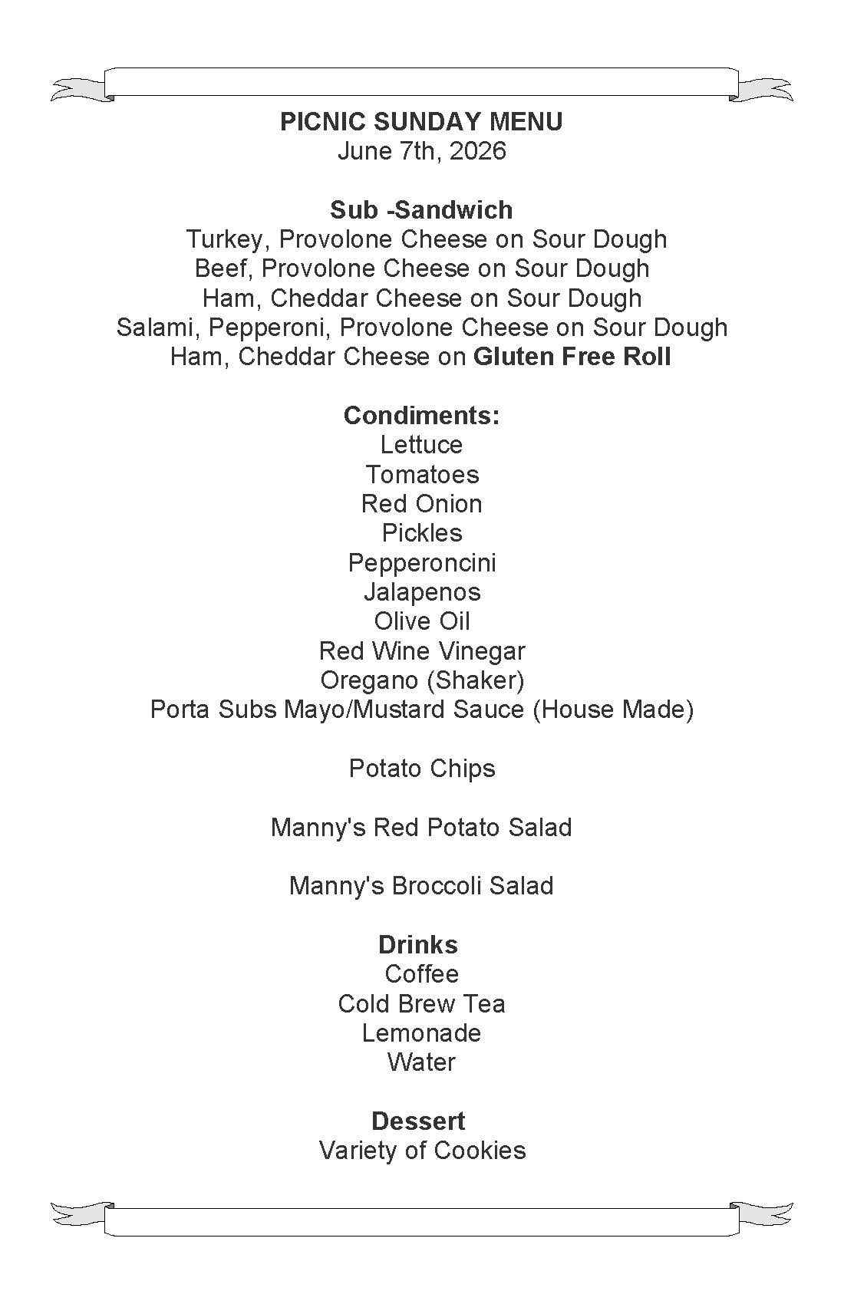

St. Paul’s Anglican Church
Visalia, California


This Photo by Unknown Author is licensed under CC BY

St. Paul’s offers congratulations to those in the church family who are graduating this year, and to their parents and grandparents who have helped them throughout their education!

Middle School

Luke Iverson, Grandson of Dennis and Laurie Buhler
St. Paul’s School Visalia, California

High School

Alyssa Blackmon, Granddaughter of Betty Lee Blackmon
El Diamante High School Visalia, California

Aria Atkisson, Granddaughter of Gene and Linda Atkisson
Wache High School Watauga, TX

Olivia Lucio, Granddaughter of Joe and Marilyn Macedo
Golden West High School Visalia, California

Jason MacDonald, Grandson of Anne MacDonald
Redwood High School Visalia, California

Elijah Nyberg, Grandson of Sue Nyberg
Clovis North High School Clovis, California

Emery Kuhnel, who worked in the Nursery for the church, and is also a friend of Amy Gunn
Redwood High School Visalia, California

College and Graduate School

Samuel Louis Fleischer, Grandson of Franco and Kathy Bernardi
Ancient Linguistics and Minor in Christian Ministry.
Wheaton College Wheaton, IL

Conner Jensen, Grandson of Dwight and Jennifer Walthall
B.A. in Anthropology
University of California, Riverside Riverside, California

William Liu, Grandson of Russell and Sally Williams
Bachelor of Science in Electrical Engineering
University of California, Davis Davis, California

A Prayer for Graduates
Almighty God, we offer our thanks for the guidance, help, and care you have given to the students at schools everywhere throughout the world which you have made. We commend to you all that has been attempted and accomplished, and we ask you to forgive what has been unworthy or left undone. We pray your special blessing upon this year’s graduates that they may grow in hope and love, in faith and knowledge, and in service to you wherever they may be, through Jesus Christ, our Lord. Amen.

This Photo by Unknown Author is licensed under CC BY-NC

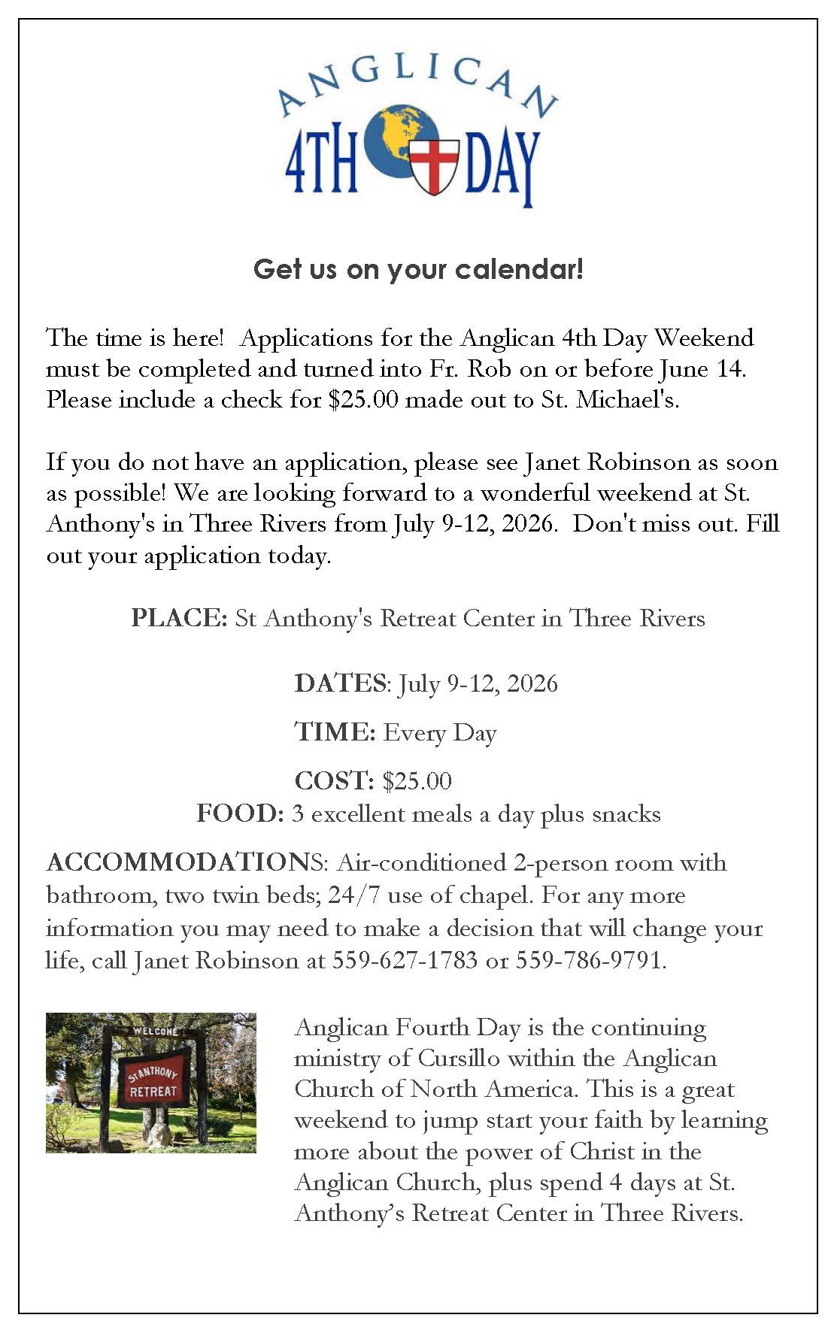
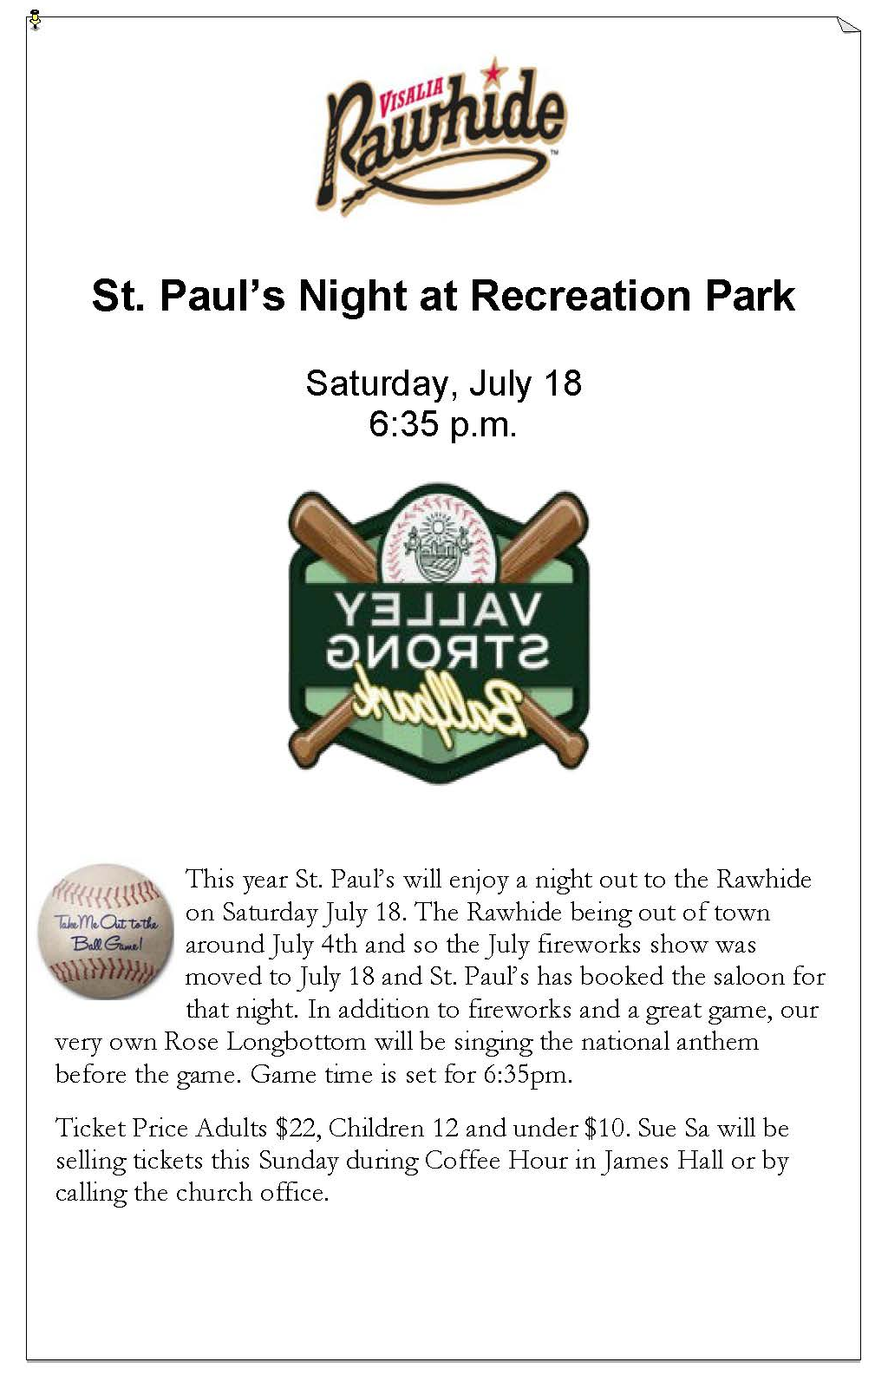
St. Paul’s Anglican Church
Parish Office
6436 W. Hurley Ave
Visalia, California 93291
559-732-4821
Office Hours: 8:00 – 4:00
Monday – Thursday

Worship: Sundays at 10:30AM
Livestream: Link at spvisalia.com
and on our Facebook page
Please be advised that this service is being recorded for broadcast
and/or archival purposes. By attending, you consent
to the inclusion of your likeness in these recordings.

St. Paul’s Clergy and Staff
The Rev. Robert Longbottom, Rector
rector@spvisalia.com
(559)802-2928
The Rev. John Iseman, Pastoral Associate for Family Ministries
family@spvisalia.com
The Rev. Kashy Rowland-Smith, Deacon
kashyrs@aol.com
Antoinette Horsting, Parish Administrator
bookkeeper@spvisalia.com
Marguerite Crownover, Organist and Accompanist
Cynthia Culp, Choral Director
Jackie Iseman, Nursery Coordinator
Shane Motl, Sexton

St. Paul’s is a member church of the
Anglican Diocese of San Joaquin
The Rt. Rev. Eric V. Menees, Bishop

Next Week’s Lessons
Exodus 19:1-8
Psalm 100
Romans 5:1-11
Matthew 9:35-10:15

The Altar Flowers
The flowers at the altar are given to the Glory of God,
by Chris and Melinda Audino, in celebration
for their fiftieth wedding anniversary.

