ST. PAUL’S
ANGLICAN CHURCH
VISALIA, CALIFORNIA

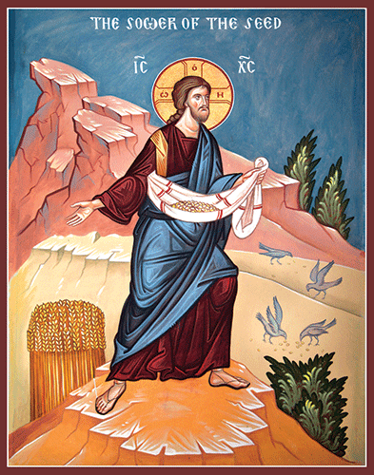

Seventh Sunday after Pentecost
July 12, 2026
10:30 A.M

Welcome!

St. Paul’s Anglican Church extends a warm welcome to all visitors and newcomers, whether worshiping in person or at home via livestream.

Visitors’ Guide

St. Paul’s Church is a parish in the Diocese of San Joaquin of the Anglican Church in North America, which includes both Catholic and Protestant traditions. We accept Jesus Christ as Savior, and we promise to follow him as Lord. We believe in One God,

- the Father who created us and all things,
- the Son who redeems us from sin and death,
- the Holy Spirit who renews and sanctifies us.

We believe the Holy Scriptures to be the Word of God and to contain all things necessary for salvation, and we accept the Apostles’ and Nicene Creeds as essential beliefs of the Christian faith.

Those not desiring to receive Holy Communion, and those who have not been baptized into the Christian faith, are invited to cross their arms across their chest, and a blessing will be given instead.

Visitors are invited to sign the guest book at the entrance table and introduce themselves to the clergy following the service.

The Holy Eucharist

Prelude: “Jesus Loves Me” (Claire de lune) Debussy
Opening Hymn: # 530 – “Spread, O Spread Thou Mighty Word” p. 4
Opening Acclamation p. 4
The Collect for Purity p. 4
Summary of the Law p. 5
Kyrie p. 5
Gloria p. 6
Collect of the Day p. 7
Lesson: Isaiah 55 p. 7
Gradual: Psalm 65 p. 8
Epistle: Romans 8:7-17 p. 9
Sequence Hymn: (Celebration Hymn) – “As the Deer” p. 10
Gospel: Matthew 13:1-9, 18-23 p. 10
Sermon: The Rev Robert Longbottom
Nicene Creed p. 11
Prayers of the People p. 12
The Peace p. 14
Offertory Praise Song – “All Who Are Thirsty”
The Offertory p. 17
Sursum Corda p. 17
Sanctus p. 18
The Lord’s Prayer p. 20
Fraction p. 20
Prayer for Humble Access p. 20
Agnus Dei p. 21
Communion Hymn: #325 – Let Us Break Bread together on Our Knees” p. 22
Post Communion Prayer p. 23
Blessing p. 23
Closing Hymn: #48 – “O Day of Radiant Gladness” p. 24
Dismissal p. 24
Postlude: “Jerusalem” Welch

Opening Hymn: Spread, O Spread Thou Mighty Word

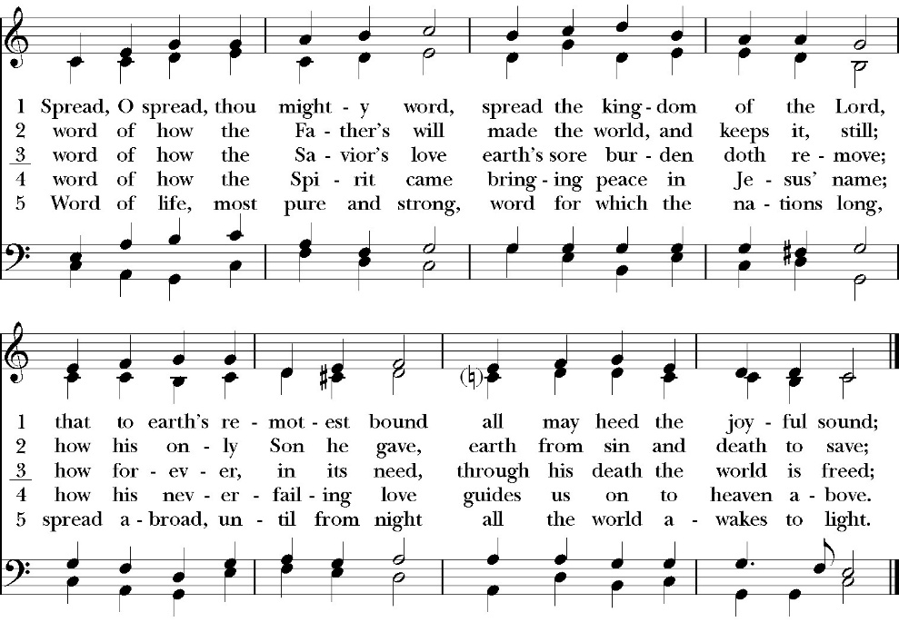

Opening Acclamation

Celebrant Blessed be God, the Father, the Son and the Holy Spirit. People And blessed be his kingdom, now and forever. Amen.

Collect for Purity

Almighty God, to you all hearts are open, all desires
known, and from you no secrets are hid: Cleanse the thoughts
of our hearts by the inspiration of your Holy Spirit, that we
may perfectly love you, and worthily magnify your holy Name;
through Christ our Lord. Amen.

Summary of the law

Hear what our Lord Jesus Christ says: You shall love
the Lord your God with all your heart and with all your soul
and with all your mind. This is the first and great
commandment. And the second is like it: You shall love your
neighbor as yourself. On these two commandments depend all
the Law and the Prophets.

Kyrie

Gloria

Celebrant The Lord be with you.
People And with your spirit.
Celebrant Let us pray.

The Collect of the Day

Let your merciful ears, O Lord, be open to the prayers of your humble servants; and, that we may receive what we ask, teach us by your Holy Spirit to ask only those things that are pleasing to you; through Jesus Christ our Lord, who with you and the same Spirit lives and reigns for ever and ever. Amen.

Lesson: Isaiah 55

“Come, everyone who thirsts, come to the waters; and he who has no money, come, buy and eat! Come, buy wine and milk without money and without price. 2 Why do you spend your money for that which is not bread, and your labor for that which does not satisfy? Listen diligently to me, and eat what is good, and delight yourselves in rich food. 3 Incline your ear, and come to me; hear, that your soul may live; and I will make with you an everlasting covenant, my steadfast, sure love for David. 4 Behold, I made him a witness to the peoples, a leader and commander for the peoples. 5 Behold, you shall call a nation that you do not know, and a nation that did not know you shall run to you, because of the LORD your God, and of the Holy One of Israel, for he has glorified you.
6“Seek the LORD while he may be found; call upon him while he is near;
7 let the wicked forsake his way, and the unrighteous man his thoughts; let him return to the LORD, that he may have compassion on him, and to our God, for he will abundantly pardon. 8 For my thoughts are not your thoughts, neither are your ways my ways, declares the LORD. 9 For as the heavens are higher than the earth, so are my ways higher than your ways and my thoughts than your thoughts.
10 “For as the rain and the snow come down from heaven and do not return there but water the earth, making it bring forth and sprout, giving seed to the sower and bread to the eater, 11 so shall my word be that goes out from my mouth; it shall not return to me empty, but it shall accomplish that which I purpose, and shall succeed in the thing for which I sent it.
12 “For you shall go out in joy and be led forth in peace; the mountains and the hills before you shall break forth into singing, and all the trees of the field shall clap their hands. 13 Instead of the thorn shall come up the cypress; instead of the brier shall come up the myrtle; and it shall make a name for the LORD, an everlasting sign that shall not be cut off.”

Reader: The Word of the Lord
People: Thanks be to God

Gradual: Psalm 65

1 You, O God, are to be praised in Zion, *
and unto you shall vows be performed in Jerusalem.
2 You who hear our prayer, *
unto you shall all flesh come.
3 My misdeeds prevail against me; *
O be merciful and blot out our sins.
4 Blessed is the man whom you choose and receive unto yourself; *
he shall dwell in your courts, and shall be satisfied with the pleasures of your house, even of your holy temple.
5 You shall show us wonderful things in your righteousness, O God of our salvation, *
for you are the hope of all the ends of the earth and of the isles that are far away.
6 You in your strength set firm the mountains, *
and are girded about with power.
7 You still the raging of the seas, *
the noise of their waves, and the tumult of the peoples.
8 Those who dwell in the uttermost parts of the earth shall be in fear of your wonders; *
you make the morning and evening to shout with joy.
9 You visit the earth and bless it; *
you make it very plenteous.
10 The river of God is full of water; *
you prepare the grain, for so you provide for the earth.

11 You water its furrows; you send rain into the little valleys; *
you make it soft with the drops of rain and bless the increase of it.
12 You crown the year with your goodness, *
and your paths overflow with plenty.
13 The fields of the wilderness are rich in pasture, *
and the little hills rejoice on every side.
14 The folds shall be full of sheep; *
the valleys also shall stand so thick with grain that they shall laugh and sing.

Glory be to the Father, and to the Son, and to the Holy Spirit;
as it was in the beginning, is now, and ever shall be, world
without end. Amen

Epistle: Romans 8:7-17

For the mind that is set on the flesh is hostile to God, for it does not submit to God's law; indeed, it cannot. 8 Those, who are in the flesh, cannot please God.
9 You, however, are not in the flesh but in the Spirit, if in fact the Spirit of God dwells in you. Anyone who does not have the Spirit of Christ does not belong to him. 10 But if Christ is in you, although the body is dead because of sin, the Spirit is life because of righteousness. 11 If the Spirit of him who raised Jesus from the dead dwells in you, he who raised Christ Jesus from the dead will also give life to your mortal bodies through his Spirit who dwells in you.
12 So then, brothers, we are debtors, not to the flesh, to live according to the flesh. 13 For if you live according to the flesh you will die, but if by the Spirit you put to death the deeds of the body, you will live. 14 For all who are led by the Spirit of God are sons of God. 15 For you did not receive the spirit of slavery to fall back into fear, but you have received the Spirit of adoption as sons, by whom we cry, “Abba! Father!” 16 The Spirit himself bears witness with our spirit that we are children of God, 17 and if children, then heirs—heirs of God and fellow heirs with Christ, provided we suffer with him in order that we may also be glorified with him.

Reader: The Word of the Lord
People: Thanks be to God
Sequence Hymn: As the Deer
(Verses 1-2 before gospel verse 3 after gospel)

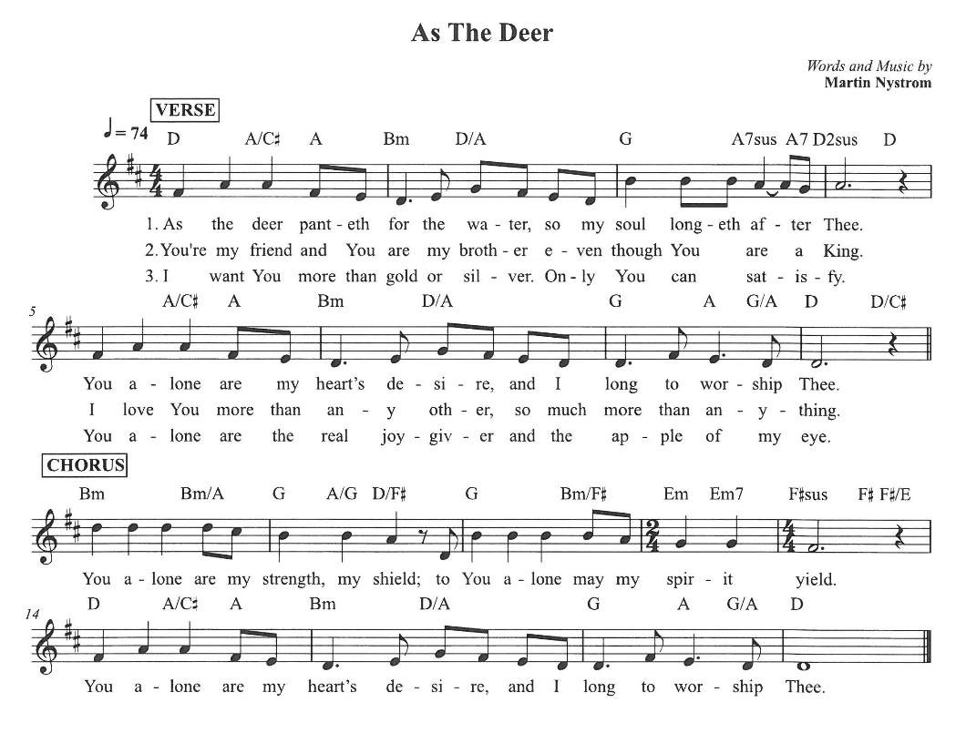

Clergy: The Holy Gospel of Our Lord Jesus Christ,
according to St. Matthew
People: Glory to you, Lord Christ.

Gospel: Matthew 13:1-9, 18-23

That same day Jesus went out of the house and sat beside the sea. 2 And great crowds gathered about him, so that he got into a boat and sat down. And the whole crowd stood on the beach. 3 And he told them many things in parables, saying: “A sower went out to sow. 4 And as he sowed, some seeds fell along the path, and the birds came and devoured them. 5 Other seeds fell on rocky ground, where they did not have much soil, and immediately they sprang up, since they had no depth of soil, 6 but when the sun rose they were scorched. And since they had no root, they withered away. 7 Other seeds fell among thorns, and the thorns grew up and choked them. 8 Other seeds fell on good soil and produced grain, some a hundredfold, some sixty, some thirty. 9 He who has ears, let him hear.”

18 “Hear then the parable of the sower: 19 When anyone hears the word of the kingdom and does not understand it, the evil one comes and snatches away what has been sown in his heart. This is what was sown along the path. 20 As for what was sown on rocky ground, this is the one who hears the word and immediately receives it with joy, 21 yet he has no root in himself, but endures for a while, and when tribulation or persecution arises on account of the word, immediately he falls away. 22 As for what was sown among thorns, this is the one who hears the word, but the cares of the world and the deceitfulness of riches choke the word, and it proves unfruitful. 23 As for what was sown on good soil, this is the one who hears the word and understands it. He indeed bears fruit and yields, in one case a hundredfold, in another sixty, and in another thirty.”

Clergy: The Gospel of the Lord
People: Praise to you, Lord Christ

Sermon
The Rev. Robert Longbottom

The Nicene Creed

We believe in one God,
the Father, the Almighty,
maker of heaven and earth,
of all that is, visible and invisible.

We believe in one Lord, Jesus Christ,
the only-begotten Son of God,
eternally begotten of the Father,
God from God, Light from Light,
true God from true God,
begotten, not made,
of one Being with the Father.
through him all things were made.

For us and for our salvation he came down from heaven:
was incarnate from the Holy Spirit and the Virgin Mary,
and was made man.
For our sake he was crucified under Pontius Pilate;
he suffered death and was buried.
On the third day he rose again in accordance with the
Scriptures;

he ascended into heaven
and is seated at the right hand of the Father.
He will come again in glory to judge the living and the dead,
and his kingdom will have no end.
We believe in the Holy Spirit, the Lord, the giver of life,
who proceeds from the Father and the Son,
who with the Father and the Son is worshiped and glorified.
who has spoken through the Prophets.
We believe in one holy catholic and apostolic Church.
We acknowledge one Baptism for the forgiveness of sins.
We look for the resurrection of the dead,
and the life of the world to come. Amen.

The Prayers of the People

Leader Let us pray for the Church and for the world, saying, “hear our prayer.”
For the peace of the whole world, and for the well-being and unity of the people of God.
Lord, in your mercy:
People Hear our prayer.

Leader For Stephen our archbishop, Julian our provincial dean, and Eric our bishop. For Fr. Rob, Deacon John, Deacon Kashy, and for all the clergy and people of our diocese and congregation and for the worldwide Anglican Communion.
Lord, in your mercy:
People Hear our prayer.

Leader For all those who proclaim the Gospel at home and abroad; and for all who teach and disciple others.
Lord, in your mercy:
People Hear our prayer.

Leader For our brothers and sisters in Christ who are persecuted for their faith.
Lord, in your mercy:
People Hear our prayer.

Leader For our nation, for those in authority, and for all in public service especially Donald our president and Gavin our governor.
Lord, in your mercy:
People Hear our prayer.

Leader: In the St. Paul’s cycle of prayer, we lift up the ministries of pastoral care, all our members who are in the hospital, care facilities or who are shut into their own homes. We pray for those who are recovering from recent surgeries and for those who are in crisis.
Lord, in your mercy:
People Hear our prayer.

Leader In the ACNA Cycle of Prayer today we pray for the Province of Alexandria; the Rt. Rev. Samy Fawzy, Archbishop, and his wife, Madeleine.
Lord, in your mercy:
People Hear our prayer.

Leader For all those who are in trouble, sorrow, need, sickness, or
any other adversity [especially ____________]. We also
pray for all who are currently serving in our armed forces
and serving as first responders.
Lord, in your mercy:
People Hear our prayer.

Leader For all those who have departed this life in the certain hope
of the resurrection, (we pray especially for ____________),
in Thanksgiving let us pray.
Lord, in your mercy:
People Hear our prayer.
Celebrant will add a concluding prayer

Heavenly Father, grant these our prayers for the sake of Jesus Christ,
our only Mediator and Advocate, who lives and reigns with you in
the unity of the Holy Spirit, one God, now and for ever. Amen.

The Confession and Absolution

Celebrant Let us humbly confess our sins to Almighty God.

Most merciful God,
we confess that we have sinned against you
in thought, word and deed,
by what we have done, and by what we have left undone.
We have not loved you with our whole heart;
we have not loved our neighbors as ourselves.
We are truly sorry and we humbly repent.
For the sake of your Son Jesus Christ,
have mercy on us and forgive us;
that we may delight in your will, and walk in your ways,
to the glory of your Name. Amen.

Almighty God, our heavenly Father, who in his great mercy has
promised forgiveness of sins to all those who sincerely repent and
with true faith turn to him, have mercy upon you, pardon and deliver
you from all your sins, confirm and strengthen you in all goodness,
and bring you to everlasting life; through Jesus Christ our Lord.
Amen.

Hear the Word of God to all who truly turn to him.

God so loved the world, that he gave his only-begotten Son, that
whoever believes in him should not perish but have eternal life.
John 3:16

Celebrant The Peace of the Lord be always with you.
People And with your spirit.

offertory

Praise Song: All Who Thirsty
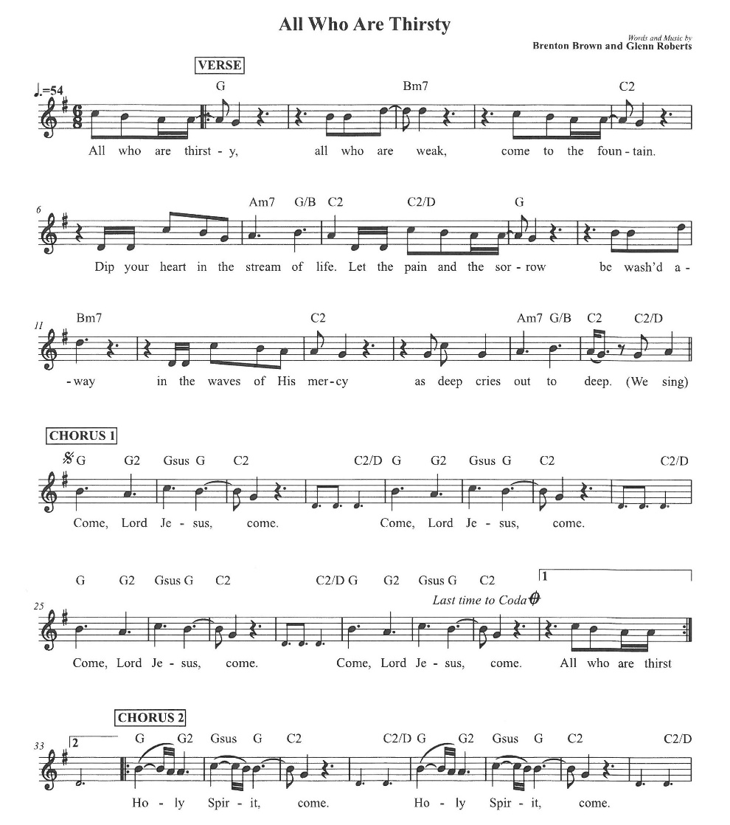

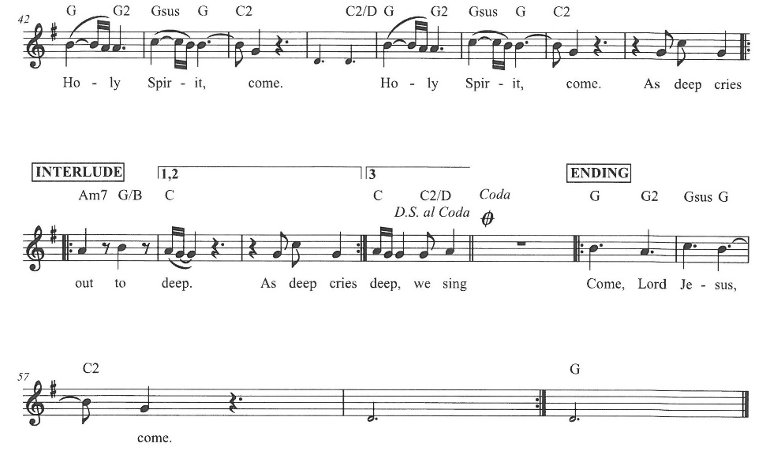

The Doxology
(Verse 3 only)

Offertory

Celebrant All things come from you, O Lord,
People And of your own have we given you.

The Eucharistic Liturgy

Celebrant The Lord be with you.
People And with your spirit.
Celebrant Lift up your hearts.
People We lift them up to the Lord.
Celebrant Let us give thanks to the Lord our God.
People It is right to give him thanks and praise.

It is right, our duty and our joy, always and everywhere to give thanks to you, Father Almighty, Creator of heaven and earth.

Through Jesus Christ our Lord, who on the first day of the week overcame death and the grave, and by his glorious resurrection opened to us the way of everlasting life.

Therefore we praise you, joining our voices with Angels and Archangels and with all the company of heaven, who for ever sing this hymn to proclaim the glory of your Name:

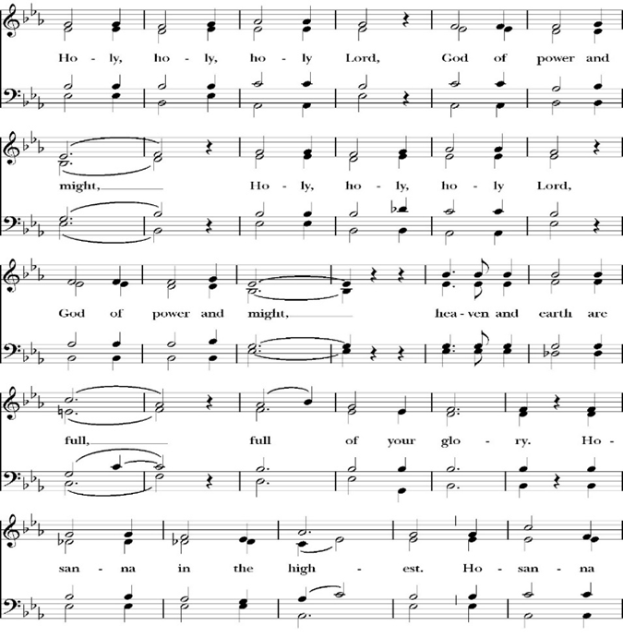
Sanctus

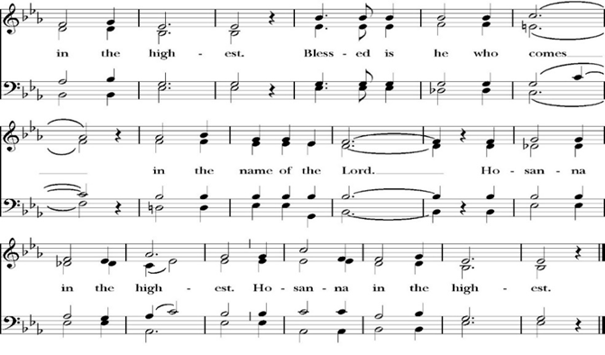
Holy and gracious Father: In your infinite love you made us for yourself; and when we had sinned against you and become subject to evil and death, you, in your mercy, sent your only Son Jesus Christ into the world for our salvation. By the Holy Spirit and the Virgin Mary he became flesh and dwelt among us. In obedience to your will, he stretched out his arms upon the Cross and offered himself once for all, that by his suffering and death we might be saved. By his resurrection he broke the bonds of death, trampling Hell and Satan under his feet. As our great high priest, he ascended to your right hand in glory, that we might come with confidence before the throne of grace.

On the night that he was betrayed, our Lord Jesus Christ took bread; and when he had given thanks, he broke it,* and gave it to his disciples, saying, “Take, eat; this is my Body, which is given for you: Do this in remembrance of me.”

Likewise, after supper, Jesus took the cup, and when he had given thanks, he gave it to them, saying, “Drink this, all of you; for this is my Blood of the New Covenant, which is shed for you, and for many, for the forgiveness of sins: Whenever you drink it, do this in remembrance of me.”

Therefore we proclaim the mystery of faith:

Christ has died.
Christ is risen.
Christ will come again.

We celebrate the memorial of our redemption, O Father, in this sacrifice of praise and thanksgiving, and we offer you these gifts.

Sanctify them by your Word and Holy Spirit to be for your people the Body and Blood of your Son Jesus Christ. Sanctify us also, that we may worthily receive this holy Sacrament, and be made one body with him, that he may dwell in us and we in him. In the fullness of time, put all things in subjection under your Christ, and bring us with all your saints into the joy of your heavenly kingdom, where we shall see our Lord face to face.

All this we ask through your Son Jesus Christ: By him, and with him, and in him, in the unity of the Holy Spirit, all honor and glory is yours, Almighty Father, now and for ever. Amen.

And now, as our Savior Christ has taught us, we are bold to pray,

Our Father, who art in heaven,
hallowed be thy Name,
thy kingdom come,
thy will be done,
on earth as it is in heaven.
Give us this day our daily bread.
And forgive us our trespasses,
as we forgive those
who trespass against us.
And lead us not into temptation,
but deliver us from evil.
For thine is the kingdom,
and the power, and the glory,
for ever and ever. Amen.

Fraction

Celebrant Alleluia! Christ our Passover is sacrificed for us.
People Therefore let us keep the feast. Alleluia!

The Prayer for Humble Access

We do not presume to come to this your table, O merciful Lord,
trusting in our own righteousness,
but in your abundant and great mercies.
We are not worthy so much as to gather up
the crumbs under your table;
but you are the same Lord
whose character is always to have mercy.
Grant us, therefore, gracious Lord,
so to eat the flesh of your dear Son Jesus Christ,
and to drink his blood,
that our sinful bodies may be made clean by his body,
and our souls washed through his most precious blood,
and that we may evermore dwell in him, and he in us.
Amen.
Agnus Dei

The Ministration of Communion

The gifts of God for the People of God. Take them in remembrance that Christ died for you and feed on him in your hearts by faith, with thanksgiving.

Communion Hymn:
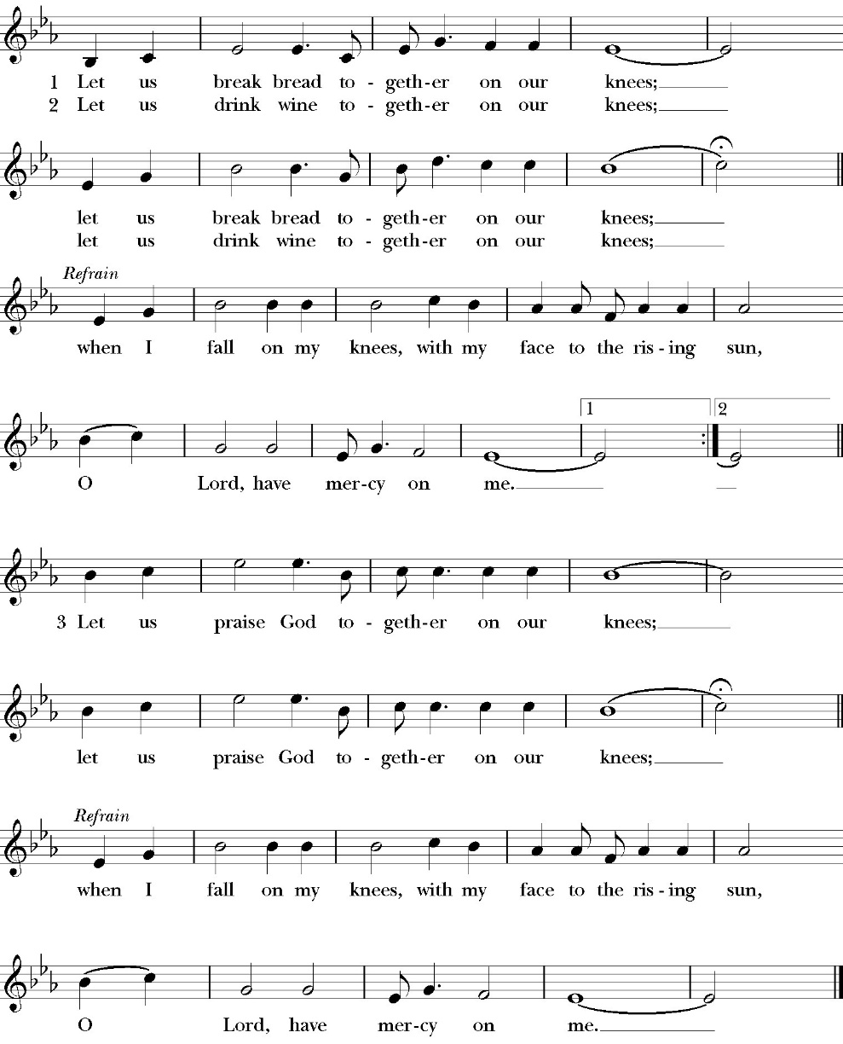
Let Us Break Bread Together on our Knees

The Post Communion Prayer

Let us pray.

Heavenly Father,
We thank you for feeding us with the spiritual food
of the most precious Body and Blood
of your Son our Savior Jesus Christ;
and for assuring us in these holy mysteries
that we are living members of the body of your Son,
and heirs of your eternal Kingdom.
And now, Father, send us out to do the work you have
given us to do,
to love and serve you as faithful witnesses of Christ our
Lord.
To him, to you, and to the Holy Spirit,
be honor and glory, now and for ever. Amen.

The Blessing

The blessing of God Almighty, the Father, the Son, and the Holy
Spirit, be among you, and remain with you always. Amen.

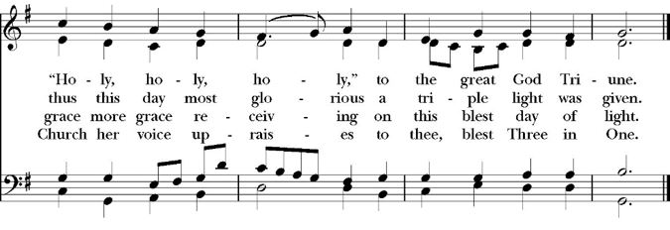
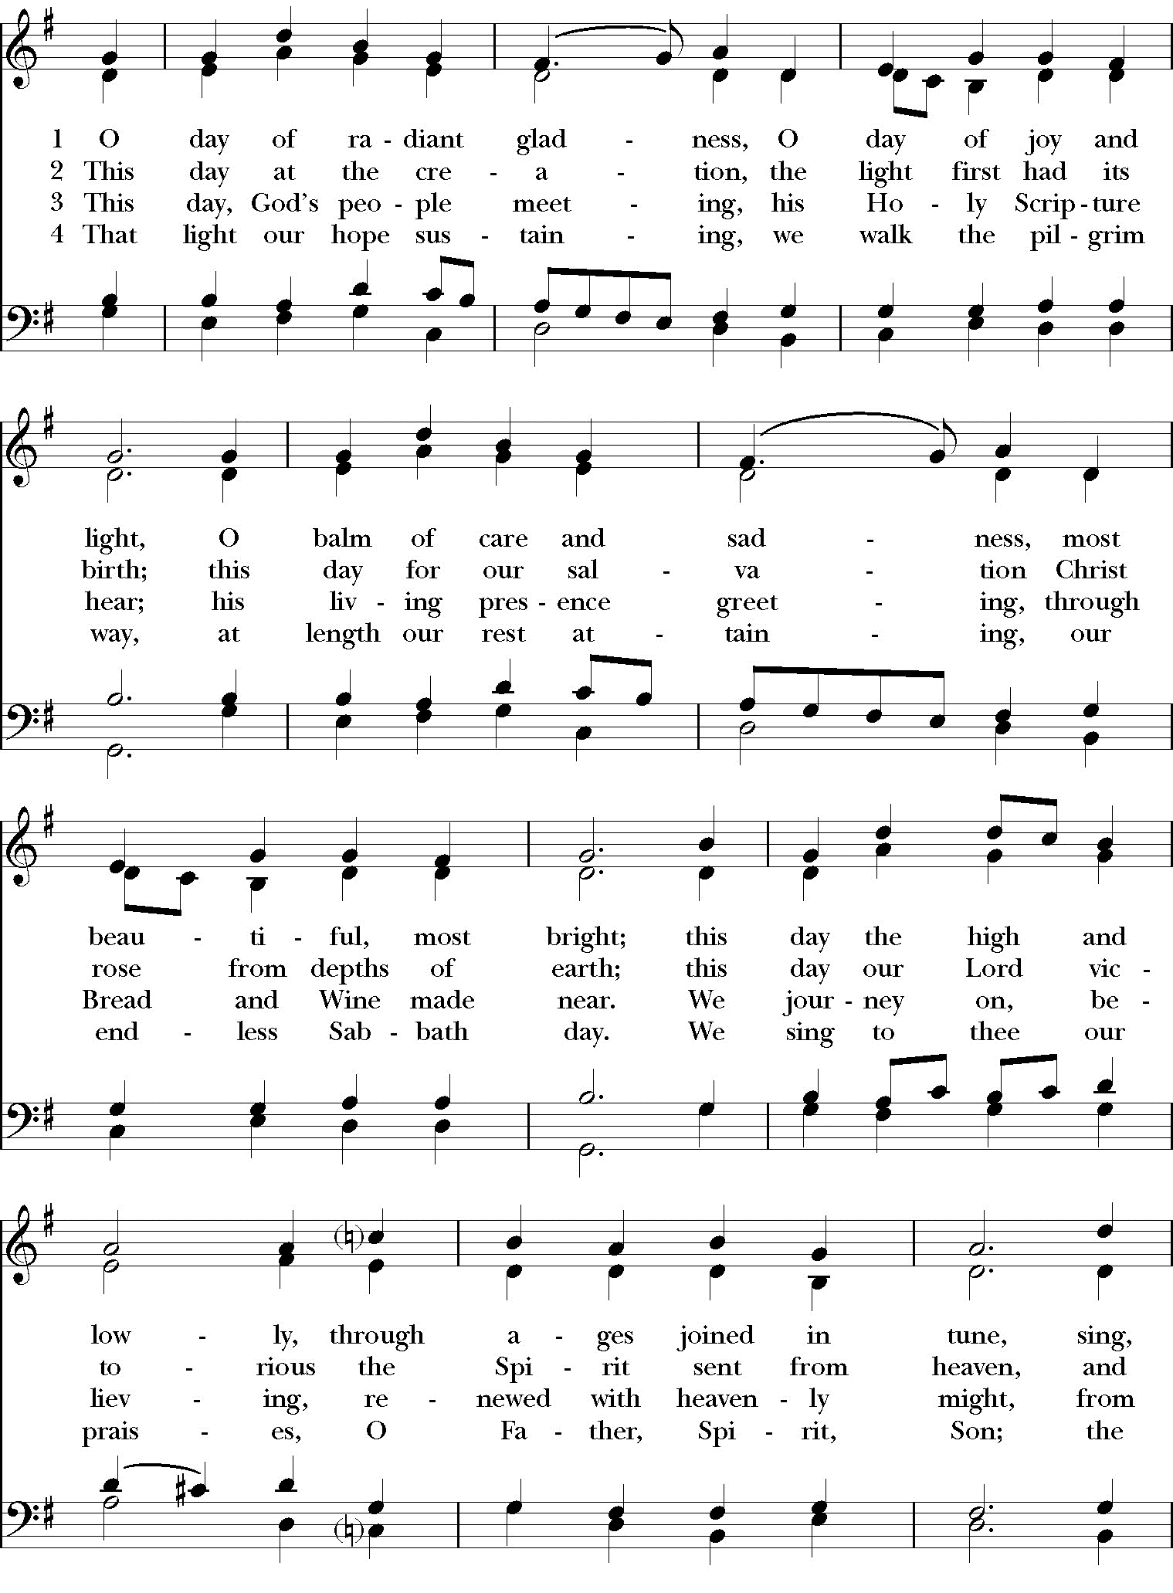
Closing Hymn: O Day of Radiant Gladness
Dismissal
Deacon Alleluia, Alleluia. Let us go forth into the world, rejoicing
in the power of the Holy Spirit.
People Thanks be to God. Alleluia, alleluia.

St. Paul’s Parish Calendar
Sunday July 12– Sunday July 19

SUNDAY, July 12 – Seventh Sunday after Pentecost
10:30 AM Children’s Sunday School, Chapel
Pre-K –2nd Grade, Sunday School Room
3rd -5th Grade, Youth Room
10:30 AM Holy Eucharist, Church

MONDAY, July 13

TUESDAY, July 14

WEDNESDAY, July 15
9:30 AM Holy Eucharist with healing prayer, Chapel
10:15 AM Bible Study, Conference Room

THURSDAY, July 16

FRIDAY, July 17
6:30 AM Men’s Bible Study, Valhalla Restaurant

SATURDAY, July 18
6:35 PM Night at the Recreation Park, Visalia Rawhide

SUNDAY, July 19 – Eighth Seventh Sunday after Pentecost
10:30 AM Children’s Sunday School, Chapel
Pre-K –2nd Grade, Sunday School Room
3rd -5th Grade, Youth Room
10:30 AM Holy Eucharist, Church

Church Office Hours
Monday-Thursday 8:00 AM-4:00 PM

Upcoming staff Vacations and church ministry time away
Dcn. John Iseman July 23-26 (Youth Camp)
Fr. Rob Longbottom July 9-11 (Anglican 4th Day)
July 13-14 (Vacation)
July 23-26 (Youth Camp)
August 6-10 (Vacation)
Dcn. Kashy Rowland-Smith July 9-12 (Anglican 4th Day)
July 23-26 (Youth Camp)

In Case of Pastoral emergencies here are the cell phone numbers of our pastors:
Fr. Rob Longbottom (559)802-2928
Dcn. John Iseman (518)222-6722
Dcn. Kashy Rosland-Smith (559)733-1229

Explore Bells in James Hall, July 19
Come and ring bells with us after church on July 19. The Bell Choir will be showcasing their bells and their ministry after Church in James Hall on July 19 for all. This opportunity invites members of the church to get to know the bell choir more and learn that even with no experience you can be a part of this wonderful ministry.

Bell Skill Day Saturday, August 1, 9-11AM
The Bell choir is inviting its members and all those interested in learning more about the ministry of bell choir to join them for an introductory skills day. This will be a day for beginners and current members alike to learn and hone their bell playing skills. If you have any questions, feel free to come to the Exploring Bells program after church in James Hall in July, our bell choir director Brenda or talk to our bell choir members.

The Gospel of John Sunday morning Bible study, 9:15-10:00AM Resumes Sunday August 2
The Sunday morning Gospel of John bible study resumes Sunday, August 2 from 9:15am-10:00am. The Class finished through chapter 7 in June and is currently working through chapter 8.

School Supply drive for Hurley Elementary
Begins now and runs through Sunday, August 9
Did you know that 1/3 of all students at Hurley elementary are from low-income households? Help us serve these students with a school supply drive to help teachers make sure all their students have the supplies they need for a great school year. School supplies can be brought to Church on Sundays or to the church office Monday-Thursday 8am-4pm.

List of School Supplies needed are:

Backpacks, Crayons, Pencils Erasers, Glue Sticks, Scissors, Composition books, 1-inch binders, Expo markers, Lined paper, Pencil pouch.

Anglican Diocese of San Joaquin Family Camp,
Out Of the Noise and Into the Wonder
September 27-29, Calvin Crest Sherwood Forrest, Oakhurst, CA
Join your friends from St. Paul’s for an unhurried retreat for families and individuals, shaped by the beauty of our Anglican tradition. Calvin Crest Sherwood Forrest is outside Oakhurst, CA near Yosemite. Each day flows from Morning Prayer to Compline. The family camp will feature tent and rustic cabin accommodations and will feel very much like the old Camp San Joaquin. The Camp will be led by our friend Rev. Paul Gibbons so we know that it will be a wonderful time.

The Cost cannot be beat:
Bring your own Tent or RV: $75 for the whole family
Rustic Cabin Accommodations: $150 for the whole family

Accommodation and bathroom facilities

Tent & RV Sites: Pitch a tent or park your rig in the scenic Sherwood Forest area.
Rustic Cabins: Each cabin features 10 bunks with mattresses. Cabins are non-electric.
Bathrooms and Showers: Clean, private bathrooms and hot showers are available throughout camp.

What is included for this price:

The flat rate covers lodging, firewood, a sub sandwich dinner on Friday evening, breakfast on Saturday morning and a BBQ on Saturday evening.
How do I sign up or find out more?
Talk with Fr. Rob Longbottom or go to the Family Camp website at:
dsjfamilycamp.com

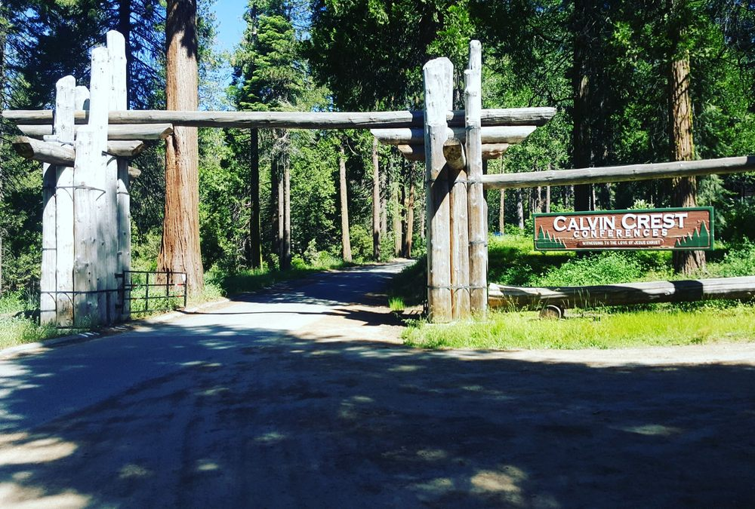

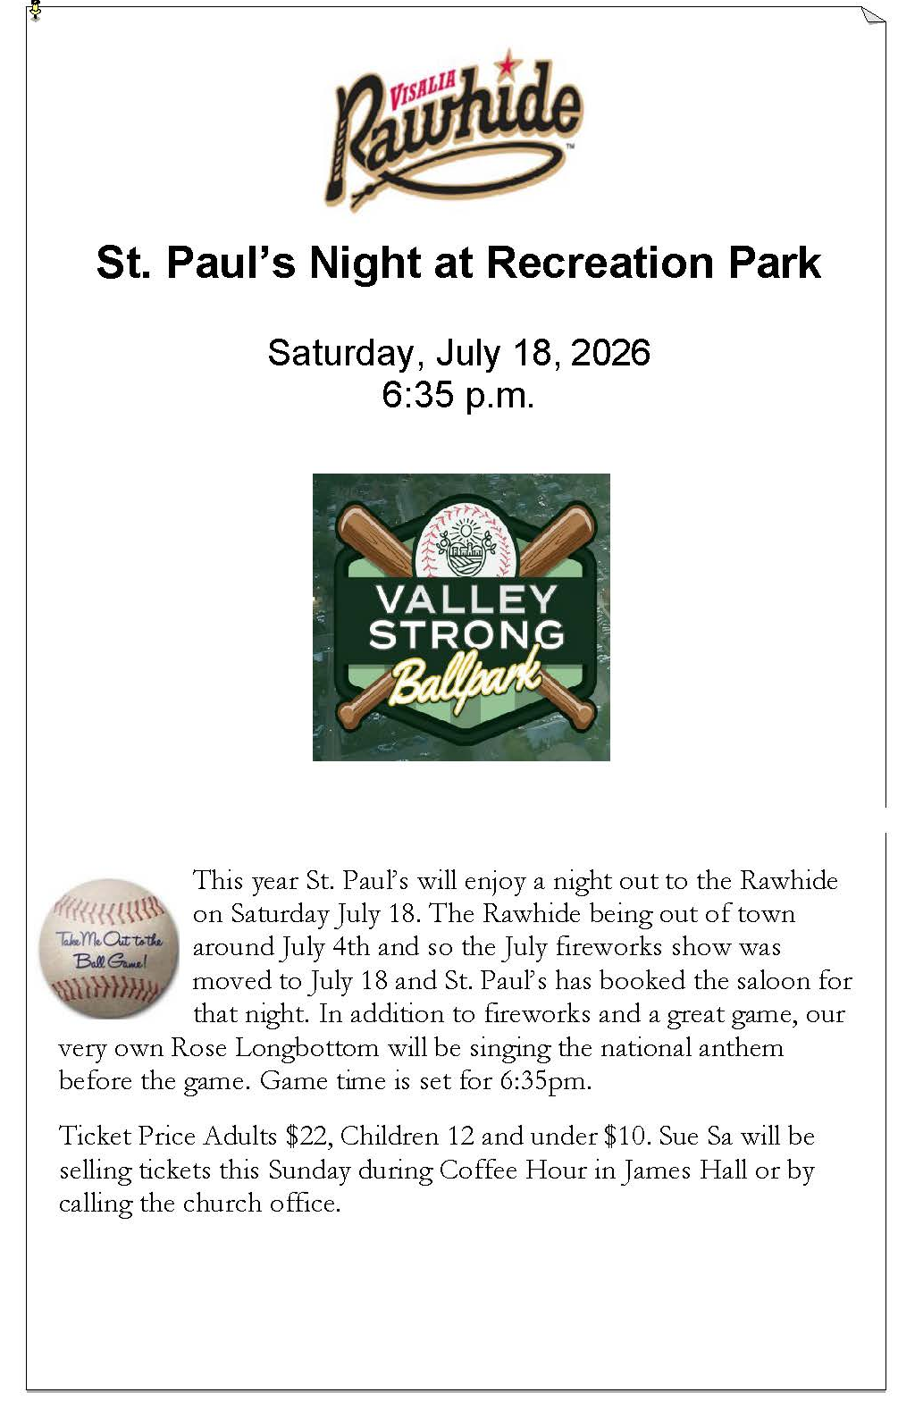

St. Paul’s Anglican Church
Parish Office
6436 W. Hurley Ave
Visalia, California 93291
559-732-4821
Office Hours: 8:00 – 4:00
Monday – Thursday

Worship: Sundays at 10:30AM
Livestream: Link at spvisalia.com
and on our Facebook page
Please be advised that this service is being recorded for broadcast
and/or archival purposes. By attending, you consent
to the inclusion of your likeness in these recordings.

St. Paul’s Clergy and Staff
The Rev. Robert Longbottom, Rector
rector@spvisalia.com
(559)802-2928
The Rev. John Iseman, Pastoral Associate for Family Ministries
family@spvisalia.com
The Rev. Kashy Rowland-Smith, Deacon
kashyrs@aol.com
Antoinette Horsting, Parish Administrator
bookkeeper@spvisalia.com
Marguerite Crownover, Organist and Accompanist
Cynthia Culp, Choral Director
Jackie Iseman, Nursery Coordinator
Shane Motl, Sexton

St. Paul’s is a member church of the
Anglican Diocese of San Joaquin
The Rt. Rev. Eric V. Menees, Bishop

Next Week’s Lessons
Wisdom 12:13, 16-19
Psalm 86
Romans 8:18-25
Matthew 13:24-30, 34-43

