ST. PAUL’S
ANGLICAN CHURCH
VISALIA, CALIFORNIA

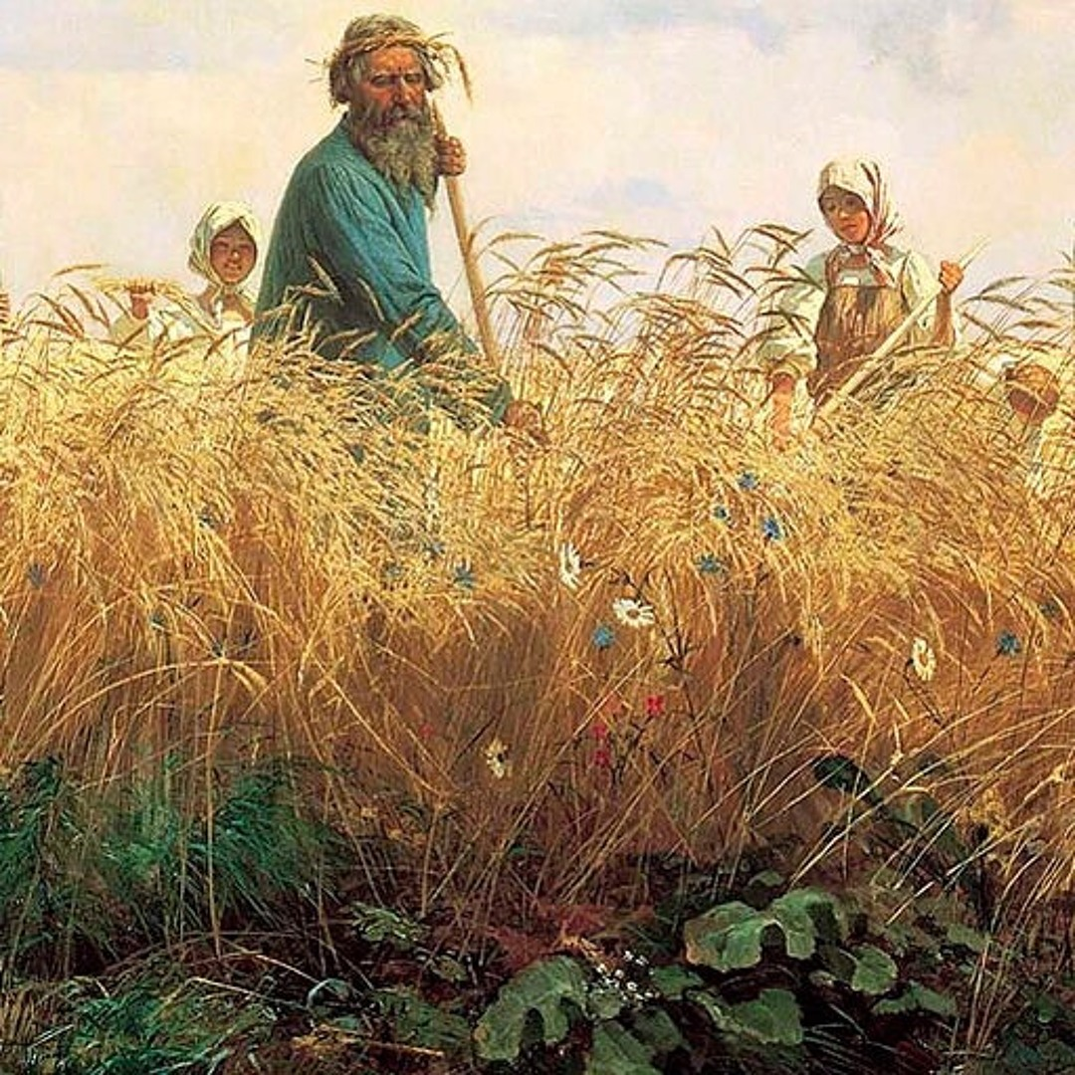

Eighth Sunday after Pentecost
July 19, 2026
10:30 A.M

Welcome!

St. Paul’s Anglican Church extends a warm welcome to all visitors and newcomers, whether worshiping in person or at home via livestream.

Visitors’ Guide

St. Paul’s Church is a parish in the Diocese of San Joaquin of the Anglican Church in North America, which includes both Catholic and Protestant traditions. We accept Jesus Christ as Savior, and we promise to follow him as Lord. We believe in One God,

- the Father who created us and all things,
- the Son who redeems us from sin and death,
- the Holy Spirit who renews and sanctifies us.

We believe the Holy Scriptures to be the Word of God and to contain all things necessary for salvation, and we accept the Apostles’ and Nicene Creeds as essential beliefs of the Christian faith.

Those not desiring to receive Holy Communion, and those who have not been baptized into the Christian faith, are invited to cross their arms across their chest, and a blessing will be given instead.

Visitors are invited to sign the guest book at the entrance table and introduce themselves to the clergy following the service.

The Holy Eucharist

Prelude: Karli Leal (Viola)
Opening Hymn: #372 – “Praise to the Living Lord” p. 4
Opening Acclamation p. 5
The Collect for Purity p. 5
Summary of the Law p. 5
Kyrie p. 5
Gloria p. 5
Collect of the Day p. 6
Lesson: Wisdom 12:13, 16-19 p. 6
Gradual: Psalm 86 p. 7
Epistle: Romans 8:18-25 p. 8
Sequence Hymn: #302 – Father, We Thank Thee Who Hast Planted” p. 9
Gospel: Matthew 13:24-30, 34-43 p. 10
Sermon: The Rev Robert Longbottom
Nicene Creed p. 11
Prayers of the People p. 12
The Peace p. 14
Offertory: Karli Leal (Viola)
The Offertory p. 15
Sursum Corda p. 15
Sanctus p. 16
The Lord’s Prayer p. 17
Fraction p. 17
Prayer for Humble Access p. 18
Agnus Dei p. 18
Communion Hymn: #654 – “Day by Day p. 19
Post Communion Prayer p. 20
Blessing p. 20
Closing Hymn: #657 “Love Divine All Love Excelling” p. 21
Dismissal p. 21

Today we welcome guest musicians
Gabriel Hatcher: Piano
Karli Leal: Viola
Opening Hymn: Praise to the Living King
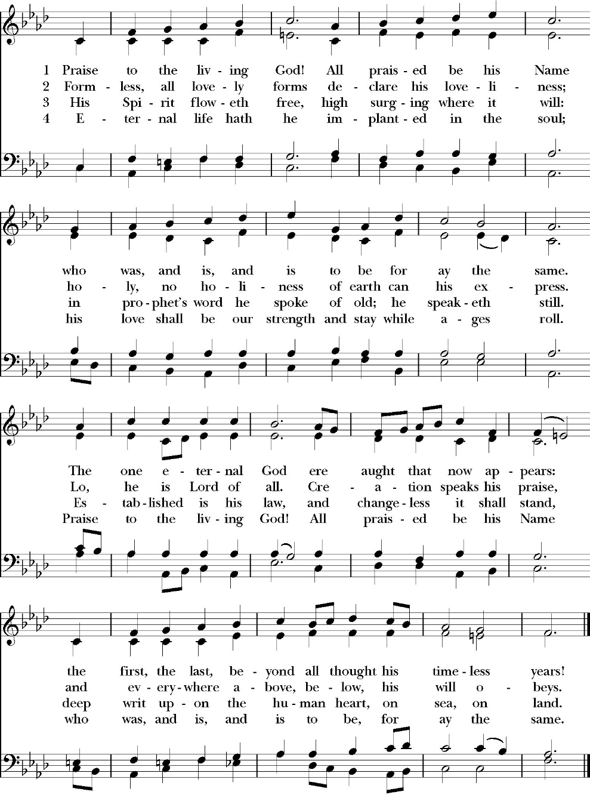

Opening Acclamation

Celebrant Blessed be God, the Father, the Son and the Holy Spirit. People And blessed be his kingdom, now and forever. Amen.

Collect for Purity

Almighty God, to you all hearts are open, all desires
known, and from you no secrets are hid: Cleanse the thoughts
of our hearts by the inspiration of your Holy Spirit, that we
may perfectly love you, and worthily magnify your holy Name;
through Christ our Lord. Amen.

Summary of the law

Hear what our Lord Jesus Christ says: You shall love
the Lord your God with all your heart and with all your soul
and with all your mind. This is the first and great
commandment. And the second is like it: You shall love your
neighbor as yourself. On these two commandments depend all
the Law and the Prophets.

Kyrie

Lord, have mercy upon us.
Christ, have mercy upon us.
Lord, have mercy upon us.

Gloria
Glory to God in the highest,
and peace to his people on earth.
Lord God, heavenly King,
almighty God and Father,
we worship you, we give you thanks,
we praise you for your glory.
Lord Jesus Christ, only Son of the Father,
Lord God, Lamb of God,
you take away the sin of the world:
have mercy on us;
you are seated at the right hand of the Father:
receive our prayer.
For you alone are the Holy One,
you alone are the Lord,
you alone are the Most High,
Jesus Christ,
with the Holy Spirit,
in the glory of God the Father. Amen

Celebrant The Lord be with you.
People And with your spirit.
Celebrant Let us pray.

The Collect of the Day

O God, you declare your almighty power chiefly in showing mercy and pity: Grant us the fullness of your grace, that we, running to obtain your promises, may become partakers of your heavenly treasure; through Jesus Christ our Lord, who lives and reigns with you and the Holy Spirit, one God, for ever and ever. Amen.

Lesson: Wisdom 12:13, 16-19
For neither is there any God besides you, whose care is for all,
16 For your strength is the source of righteousness, and your sovereignty over all causes you to spare all. 17 For you show your strength when men doubt the completeness of your power, and you rebuke any insolence among those who know it. 18 You are sovereign in strength but you judge with mildness, and with great forbearance you govern us; for you have power to act whenever you choose.
19 Through such works you have taught your people that the one who is righteous must be kind, and you have filled your sons with good hope, because you give repentance for sins.

Reader: The Word of the Lord
People: Thanks be to God

Gradual: Psalm 86
1 Bow down your ear, O LORD, and hear me, *
for I am poor and in misery.
2 Preserve my life, for I am faithful; *
my God, save your servant who puts his trust in you.
3 Be merciful unto me, O Lord, *
for I will call daily upon you.
4 Comfort the soul of your servant, *
for to you, O Lord, do I lift up my soul.
5 For you, Lord, are good and gracious, *
and of great mercy to all those who call upon you.
6 Give ear, LORD, unto my prayer, *
and attend to the voice of my humble supplications.
7 In the time of my trouble I will call upon you, *
for you answer me when I call.
8 Among the gods there is none like you, O Lord, *
nor are there any deeds like yours.
9 All nations that you have made shall come and worship you, O Lord, *
and shall glorify your Name.
10 For you are great and do wondrous things; *
indeed, you are God alone.
11 Teach me your way, O LORD, and I will walk in your truth; *
O knit my heart to you, that I may fear your Name.
12 I will thank you, O Lord my God, with all my heart, *
and will praise your Name for evermore.
13 For great is your mercy toward me; *
you have delivered my life from the nethermost Pit.
14 O God, the proud have risen up against me, *
and the company of violent men have sought after my life, and have not set you before their eyes.
15 But you, O Lord God, are full of compassion and mercy, *
long-suffering, plenteous in goodness and truth.
16 O turn then unto me, and have mercy upon me; *
give your strength unto your servant, and help the son of your handmaid
17 Show me some token of your favor, that those who hate me may see it and be ashamed, *
because you, LORD, have been my helper and comforter.

Glory be to the Father, and to the Son, and to the Holy Spirit;
as it was in the beginning, is now, and ever shall be, world
without end. Amen

Epistle: Romans 8:18-25

For I consider that the sufferings of this present time are not worth comparing with the glory that is to be revealed to us. 19 For the creation waits with eager longing for the revealing of the sons of God. 20 For the creation was subjected to futility, not willingly, but because of him who subjected it, in hope 21 that the creation itself will be set free from its bondage to corruption and obtain the freedom of the glory of the children of God. 22 For we know that the whole creation has been groaning together in the pains of childbirth until now. 23 And not only the creation, but we ourselves, who have the firstfruits of the Spirit, groan inwardly as we wait eagerly for adoption as sons, the redemption of our bodies. 24 For in this hope we were saved. Now hope that is seen is not hope. For who hopes for what he sees? 25 But if we hope for what we do not see, we wait for it with patience.

Reader: The Word of the Lord
People: Thanks be to God

Sequence Hymn: Father, We Thank Thee Who Host Planted
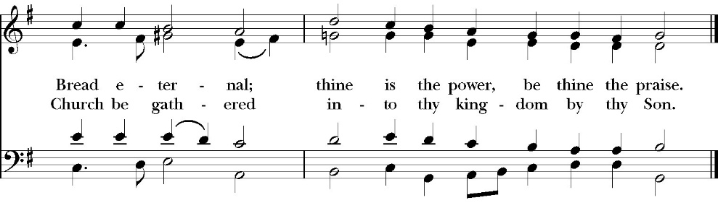
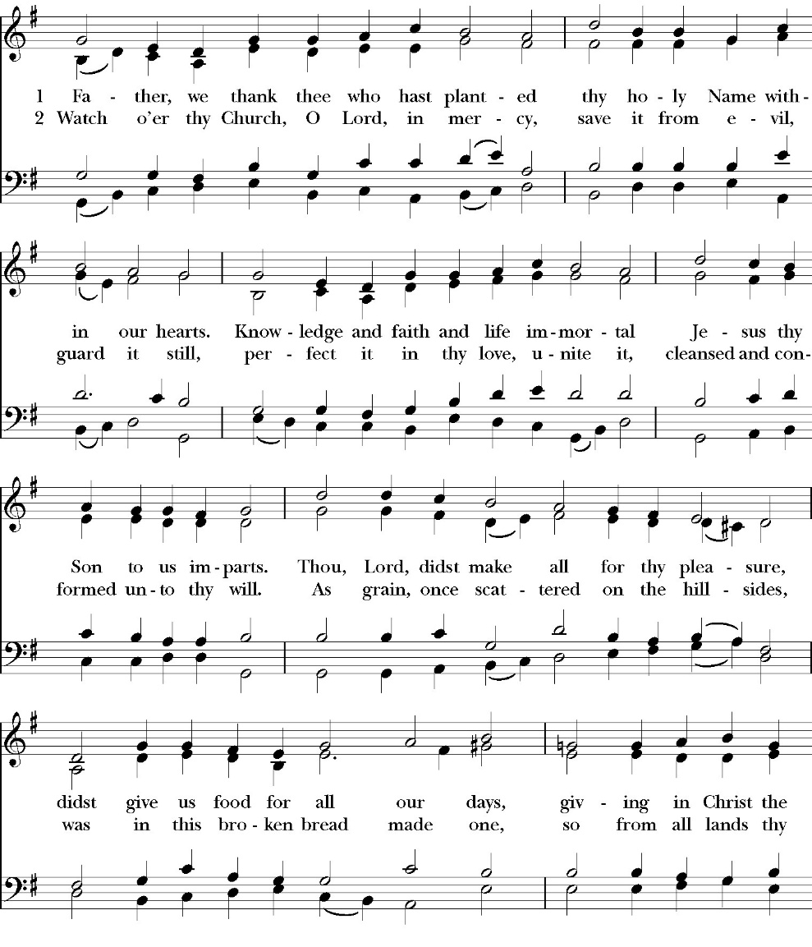
(Verses 1 before gospel verse 2 after gospel)

Clergy: The Holy Gospel of Our Lord Jesus Christ,
according to St. Matthew
People: Glory to you, Lord Christ.

Gospel: Matthew 13:24-30, 34-43
He put another parable before them, saying, “The kingdom of heaven may be compared to a man who sowed good seed in his field, 25 but while his men were sleeping, his enemy came and sowed weeds among the wheat and went away. 26 So when the plants came up and bore grain, then the weeds appeared also. 27 And the servants of the master of the house came and said to him, ‘Master, did you not sow good seed in your field? How then does it have weeds?’ 28 He said to them, ‘An enemy has done this.’ So the servants said to him, ‘Then do you want us to go and gather them?’ 29 But he said, ‘No, lest in gathering the weeds you root up the wheat along with them. 30 Let both grow together until the harvest, and at harvest time I will tell the reapers, “Gather the weeds first and bind them in bundles to be burned, but gather the wheat into my barn.” 34 All these things Jesus said to the crowds in parables; indeed, he said nothing to them without a parable. 35 This was to fulfill what was spoken by the prophet:
“I will open my mouth in parables; I will utter what has been hidden since the foundation of the world.”
36 Then he left the crowds and went into the house. And his disciples came to him, saying, “Explain to us the parable of the weeds of the field.” 37 He answered, “The one who sows the good seed is the Son of Man. 38 The field is the world, and the good seed is the sons of the kingdom. The weeds are the sons of the evil one, 39 and the enemy who sowed them is the devil. The harvest is the end of the age, and the reapers are angels. 40 Just as the weeds are gathered and burned with fire, so will it be at the end of the age. 41 The Son of Man will send his angels, and they will gather out of his kingdom all causes of sin and all law-breakers, 42and throw them into the fiery furnace. In that place there will be weeping and gnashing of teeth.
43 Then the righteous will shine like the sun in the kingdom of their Father. He who has ears, let him hear.

Clergy: The Gospel of the Lord
People: Praise to you, Lord Christ
Sermon
The Rev. Robert Longbottom

The Nicene Creed

We believe in one God,
the Father, the Almighty,
maker of heaven and earth,
of all that is, visible and invisible.

We believe in one Lord, Jesus Christ,
the only-begotten Son of God,
eternally begotten of the Father,
God from God, Light from Light,
true God from true God,
begotten, not made,
of one Being with the Father.
through him all things were made.

For us and for our salvation he came down from heaven:
was incarnate from the Holy Spirit and the Virgin Mary,
and was made man.
For our sake he was crucified under Pontius Pilate;
he suffered death and was buried.
On the third day he rose again in accordance with the
Scriptures;

he ascended into heaven
and is seated at the right hand of the Father.
He will come again in glory to judge the living and the dead,
and his kingdom will have no end.
We believe in the Holy Spirit, the Lord, the giver of life,
who proceeds from the Father and the Son,
who with the Father and the Son is worshiped and glorified.
who has spoken through the Prophets.
We believe in one holy catholic and apostolic Church.
We acknowledge one Baptism for the forgiveness of sins.
We look for the resurrection of the dead,
and the life of the world to come. Amen.

The Prayers of the People

Leader Let us pray for the Church and for the world, saying, “hear our prayer.”
For the peace of the whole world, and for the well-being and unity of the people of God.
Lord, in your mercy:
People Hear our prayer.

Leader For Stephen our archbishop, Julian our provincial dean, and Eric our bishop. For Fr. Rob, Deacon John, Deacon Kashy, and for all the clergy and people of our diocese and congregation and for the worldwide Anglican Communion.
Lord, in your mercy:
People Hear our prayer.

Leader For all those who proclaim the Gospel at home and abroad; and for all who teach and disciple others.
Lord, in your mercy:
People Hear our prayer.

Leader For our brothers and sisters in Christ who are persecuted for their faith.
Lord, in your mercy:
People Hear our prayer.

Leader For our nation, for those in authority, and for all in public service especially Donald our president and Gavin our governor.
Lord, in your mercy:
People Hear our prayer.

Leader: In the St. Paul’s cycle of prayer, we pray for all ministries of Christian education, discipleship and bible study. We pray that through word and deed we might grow closer to the heart and life of Jesus through our study, prayer, fellowship and mission.
Lord, in your mercy:
People Hear our prayer.

Leader In the ACNA Cycle of Prayer, today we pray for the Diocese of Western Anglicans and Bishop Keith Andrews and his wife, Gail.
Lord, in your mercy:
People Hear our prayer.

Leader For all those who are in trouble, sorrow, need, sickness, or
any other adversity [especially ____________]. We also
pray for all who are currently serving in our armed forces
and serving as first responders.
Lord, in your mercy:
People Hear our prayer.

Leader For all those who have departed this life in the certain hope
of the resurrection, (we pray especially for ____________),
in Thanksgiving let us pray.
Lord, in your mercy:
People Hear our prayer.

Celebrant will add a concluding prayer

Celebrant: A Prayer for a spirit of evangelism (BCP page 652)

Almighty God our Savior, you desire that none should perish, and
you have taught us through your Son that there is great joy in heaven
over every sinner who repents: Grant that our hearts may ache for a
lost and broken world. May your Holy Spirit work through our
words, deeds, and prayers, that the lost may be found and the dead
made alive, and that all your redeemed may rejoice around your
throne; through Jesus Christ our Lord. Amen.

Heavenly Father, grant these our prayers for the sake of Jesus Christ,
our only Mediator and Advocate, who lives and reigns with you in
the unity of the Holy Spirit, one God, now and for ever. Amen.

The Confession and Absolution

Celebrant Let us humbly confess our sins to Almighty God.

Most merciful God,
we confess that we have sinned against you
in thought, word and deed,
by what we have done, and by what we have left undone.
We have not loved you with our whole heart;
we have not loved our neighbors as ourselves.
We are truly sorry and we humbly repent.
For the sake of your Son Jesus Christ,
have mercy on us and forgive us;
that we may delight in your will, and walk in your ways,
to the glory of your Name. Amen.

Almighty God, our heavenly Father, who in his great mercy has
promised forgiveness of sins to all those who sincerely repent and
with true faith turn to him, have mercy upon you, pardon and deliver
you from all your sins, confirm and strengthen you in all goodness,
and bring you to everlasting life; through Jesus Christ our Lord.
Amen.

Hear the Word of God to all who truly turn to him.

God so loved the world, that he gave his only-begotten Son, that
whoever believes in him should not perish but have eternal life.
John 3:16
Celebrant The Peace of the Lord be always with you.
People And with your spirit.

offertory

Karli Leal (Viola)

The Doxology
(Verse 3 only)

Offertory
Celebrant All things come from you, O Lord,
People And of your own have we given you.

The Eucharistic Liturgy

Celebrant The Lord be with you.
People And with your spirit.
Celebrant Lift up your hearts.
People We lift them up to the Lord.
Celebrant Let us give thanks to the Lord our God.
People It is right to give him thanks and praise.

It is right, our duty and our joy, always and everywhere to give thanks to you, Father Almighty, Creator of heaven and earth.

Through Jesus Christ our Lord, who on the first day of the week overcame death and the grave, and by his glorious resurrection opened to us the way of everlasting life.

Therefore we praise you, joining our voices with Angels and Archangels and with all the company of heaven, who for ever sing this hymn to proclaim the glory of your Name:

Sanctus

Holy, Holy, Holy, Lord God of power and might, heaven and
earth are full of your glory.
Hosanna in the highest.
Blessed is he who comes in the Name of the Lord.
Hosanna in the highest.

Holy and gracious Father: In your infinite love you made us for yourself; and when we had sinned against you and become subject to evil and death, you, in your mercy, sent your only Son Jesus Christ into the world for our salvation. By the Holy Spirit and the Virgin Mary he became flesh and dwelt among us. In obedience to your will, he stretched out his arms upon the Cross and offered himself once for all, that by his suffering and death we might be saved. By his resurrection he broke the bonds of death, trampling Hell and Satan under his feet. As our great high priest, he ascended to your right hand in glory, that we might come with confidence before the throne of grace.

On the night that he was betrayed, our Lord Jesus Christ took bread; and when he had given thanks, he broke it,* and gave it to his disciples, saying, “Take, eat; this is my Body, which is given for you: Do this in remembrance of me.”

Likewise, after supper, Jesus took the cup, and when he had given thanks, he gave it to them, saying, “Drink this, all of you; for this is my Blood of the New Covenant, which is shed for you, and for many, for the forgiveness of sins: Whenever you drink it, do this in remembrance of me.”

Therefore we proclaim the mystery of faith:

Christ has died.
Christ is risen.
Christ will come again.

We celebrate the memorial of our redemption, O Father, in this sacrifice of praise and thanksgiving, and we offer you these gifts.

Sanctify them by your Word and Holy Spirit to be for your people the Body and Blood of your Son Jesus Christ. Sanctify us also, that we may worthily receive this holy Sacrament, and be made one body with him, that he may dwell in us and we in him. In the fullness of time, put all things in subjection under your Christ, and bring us with all your saints into the joy of your heavenly kingdom, where we shall see our Lord face to face.

All this we ask through your Son Jesus Christ: By him, and with him, and in him, in the unity of the Holy Spirit, all honor and glory is yours, Almighty Father, now and for ever. Amen.

And now, as our Savior Christ has taught us, we are bold to pray,

Our Father, who art in heaven,
hallowed be thy Name,
thy kingdom come,
thy will be done,
on earth as it is in heaven.
Give us this day our daily bread.
And forgive us our trespasses,
as we
forgive those
who trespass against us.
And lead us not into temptation,
but deliver us from evil.
For thine is the kingdom,
and the power, and the glory,
for ever and ever. Amen.

Fraction

Celebrant Alleluia! Christ our Passover is sacrificed for us.
People Therefore let us keep the feast. Alleluia!

The Prayer for Humble Access

We do not presume to come to this your table, O merciful Lord,
trusting in our own righteousness,
but in your abundant and great mercies.
We are not worthy so much as to gather up
the crumbs under your table;
but you are the same Lord
whose character is always to have mercy.
Grant us, therefore, gracious Lord,
so to eat the flesh of your dear Son Jesus Christ,
and to drink his blood,
that our sinful bodies may be made clean by his body,
and our souls washed through his most precious blood,
and that we may evermore dwell in him, and he in us.
Amen.

Agnus Dei

Lamb of God, you take away the sin of the world;
have mercy on us.
Lamb of God, you take away the sin of the world;
have mercy on us.
Lamb of God, you take away the sin of the world;
grant us your peace.

The Ministration of Communion

The gifts of God for the People of God. Take them in remembrance that Christ died for you and feed on him in your hearts by faith, with thanksgiving.

Communion Hymn: Day by Day
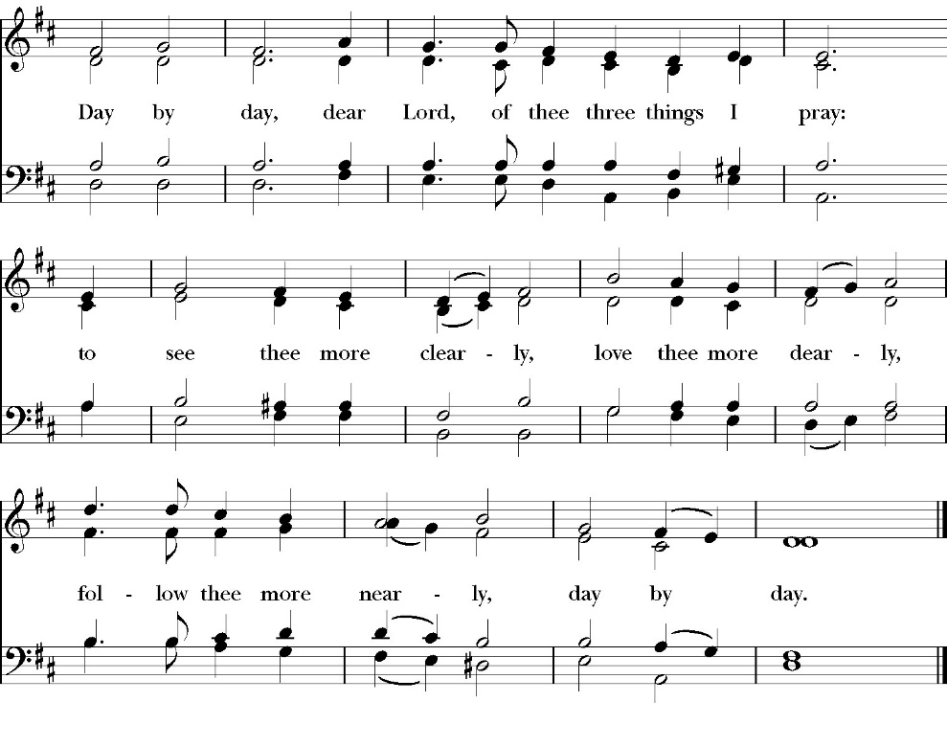
(Sing Twice)

The Post Communion Prayer
Let us pray.

Heavenly Father,
We thank you for feeding us with the spiritual food
of the most precious Body and Blood
of your Son our Savior Jesus Christ;
and for assuring us in these holy mysteries
that we are living members of the body of your Son,
and heirs of your eternal Kingdom.
And now, Father, send us out to do the work you have
given us to do,
to love and serve you as faithful witnesses of Christ our
Lord.
To him, to you, and to the Holy Spirit,
be honor and glory, now and for ever. Amen.

The Blessing

The peace of God, which passes all understanding, keep your hearts and minds in the knowledge and love of God, and of his Son Jesus Christ our Lord; and the blessing of God Almighty, the Father, the Son, and the Holy Spirit, be among you, and remain with you always. Amen.

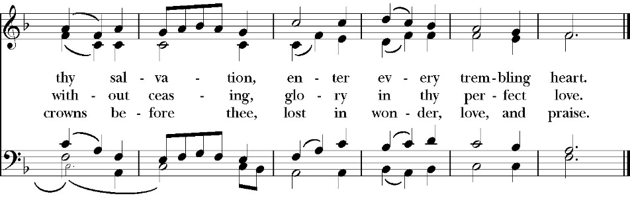
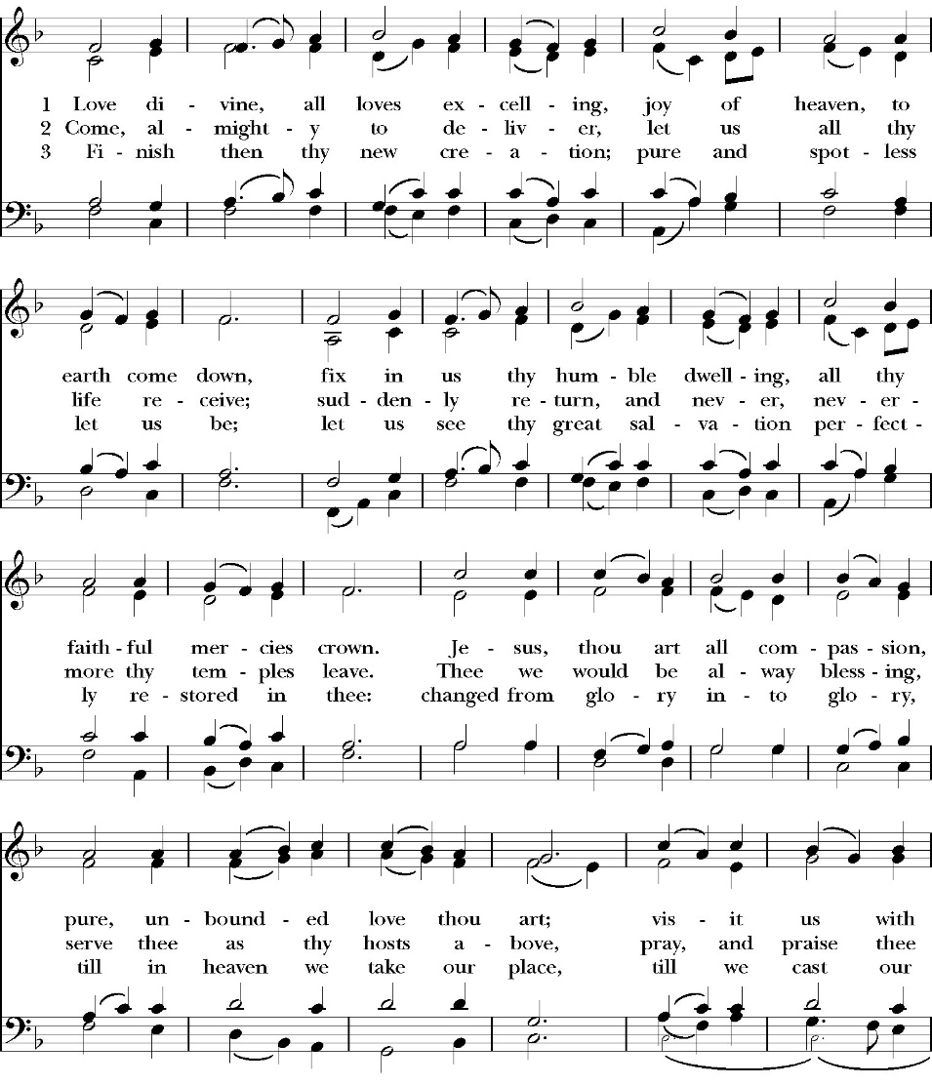
Closing Hymn: Love Divine All Love Excelling
Dismissal
Deacon Alleluia, Alleluia. Let us go forth into the world, rejoicing
in the power of the Holy Spirit.
People Thanks be to God. Alleluia, alleluia.

St. Paul’s Parish Calendar
Sunday July 19 – Sunday July 26

SUNDAY, July 19 – Eighth Sunday after Pentecost
10:30 AM Children’s Sunday School, Chapel
Pre-K –2nd Grade, Sunday School Room
3rd -5th Grade, Youth Room
10:30 AM Holy Eucharist, Church

MONDAY, July 20

TUESDAY, July 21

WEDNESDAY, July 22
9:30 AM Holy Eucharist with healing prayer, Chapel
10:15 AM Bible Study, Conference Room

THURSDAY, July 23

FRIDAY, July 24
6:30 AM Men’s Bible Study, Valhalla Restaurant

SATURDAY, July 25

SUNDAY, July 26 – Ninth Sunday after Pentecost
10:30 AM Children’s Sunday School, Chapel
Pre-K –2nd Grade, Sunday School Room
3rd -5th Grade, Youth Room
10:30 AM Holy Eucharist, Church

Church Office Hours
Monday-Thursday 8:00 AM-4:00 PM

Our clergy Fr. Rob, Dcn. John and Dcn. Kashy will be away on the youth camping trip from Thursday, July 23-25. Incase of a pastoral emergency, Fr. Rob can be contacted at (559)802-2928. Dcn. John at (518)222-6722.

Upcoming staff Vacations and church ministry time away
Dcn. John Iseman July 23-26 (Youth Camp)
Fr. Rob Longbottom July 23-26 (Youth Camp)
August 6-10 (Vacation)
Dcn. Kashy Rowland-Smith July 23-25 (Youth Camp)

In Case of Pastoral emergencies here are the cell phone numbers of our pastors:
Fr. Rob Longbottom (559)802-2928
Dcn. John Iseman (518)222-6722
Dcn. Kashy Rosland-Smith (559)733-1229

Explore Bells in James Hall, July 19
Come and ring bells with us after church on July 19. The Bell Choir will be showcasing their bells and their ministry after Church in James Hall on July 19 for all. This opportunity invites members of the church to get to know the bell choir more and learn that even with no experience you can be a part of this wonderful ministry.

Bell Skill Day Saturday, August 1, 9-11AM
The Bell choir is inviting its members and all those interested in learning more about the ministry of bell choir to join them for an introductory skills day. This will be a day for beginners and current members alike to learn and hone their bell playing skills. If you have any questions, feel free to come to the Exploring Bells program after church in James Hall in July, our bell choir director Brenda or talk to our bell choir members.

The Gospel of John Sunday morning Bible study, 9:15-10:00AM Resumes Sunday August 2
The Sunday morning Gospel of John bible study resumes Sunday, August 2 from 9:15am-10:00am. The Class finished through chapter 7 in June and is currently working through chapter 8.

School Supply drive for Hurley Elementary
Begins now and runs through Sunday, August 9
Did you know that 1/3 of all students at Hurley elementary are from low-income households? Help us serve these students with a school supply drive to help teachers make sure all their students have the supplies they need for a great school year. School supplies can be brought to Church on Sundays or to the church office Monday-Thursday 8am-4pm.
List of School Supplies needed are:

Backpacks, Crayons, Pencils Erasers, Glue Sticks, Scissors, Composition books, 1-inch binders, Expo markers, Lined paper, Pencil pouch.


A Food Bank for Hurley Families
The next Neighborhood Market to benefit students at Hurley School will be Tuesday August 11, 2:30 PM to 3:30 PM at St Paul’s Church parking lot. If you are interested in helping that day, please contact Sue Nyberg. My home phone number is 559-733-8244.

Due to the heat, we are in need of more volunteers for
the months of August and September. This will allow volunteers to work in shifts during these hot months.

PROVIDED BY VISALIA EMERGENCY AID
AND ST. PAUL’S CHURCH
Tuesday, August 11, 2026
From 2:30 PM to 3:30 PM
LOCATION:
ST. PAUL'S CHURCH PARKING LOT
ACROSS THE STREET FROM HURLEY





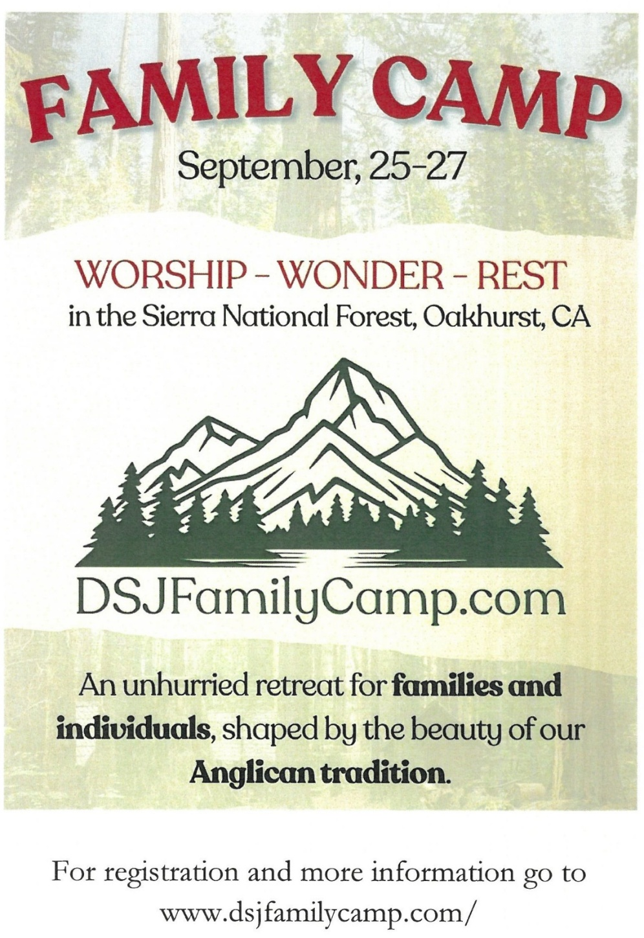

Anglican Diocese of San Joaquin Family Camp,
Out Of the Noise and Into the Wonder
September 25-27, Calvin Crest Sherwood Forrest, Oakhurst, CA
Join your friends from St. Paul’s for an unhurried retreat for families and individuals, shaped by the beauty of our Anglican tradition. Calvin Crest Sherwood Forrest is outside Oakhurst, CA near Yosemite. Each day flows from Morning Prayer to Compline. The family camp will feature tent and rustic cabin accommodations and will feel very much like the old Camp San Joaquin. The Camp will be led by our friend Rev. Paul Gibbons so we know that it will be a wonderful time.

The Cost cannot be beat:
Bring your own Tent or RV: $75 for the whole family
Rustic Cabin Accommodations: $150 for the whole family

Accommodation and bathroom facilities

Tent & RV Sites: Pitch a tent or park your rig in the scenic Sherwood Forest area.
Rustic Cabins: Each cabin features 10 bunks with mattresses. Cabins are non-electric.
Bathrooms and Showers: Clean, private bathrooms and hot showers are available throughout camp.

What is included for this price:

The flat rate covers lodging, firewood, a sub sandwich dinner on Friday evening, breakfast on Saturday morning and a BBQ on Saturday evening.
How do I sign up or find out more?
Talk with Fr. Rob Longbottom or go to the Family Camp website at:
dsjfamilycamp.com

St. Paul’s Anglican Church
Parish Office
6436 W. Hurley Ave
Visalia, California 93291
559-732-4821
Office Hours: 8:00 – 4:00
Monday – Thursday

Worship: Sundays at 10:30AM
Livestream: Link at spvisalia.com
and on our Facebook page
Please be advised that this service is being recorded for broadcast
and/or archival purposes. By attending, you consent
to the inclusion of your likeness in these recordings.

St. Paul’s Clergy and Staff
The Rev. Robert Longbottom, Rector
rector@spvisalia.com
(559)802-2928
The Rev. John Iseman, Pastoral Associate for Family Ministries
family@spvisalia.com
The Rev. Kashy Rowland-Smith, Deacon
kashyrs@aol.com
Antoinette Horsting, Parish Administrator
bookkeeper@spvisalia.com
Marguerite Crownover, Organist and Accompanist
Ellen Daniels, Choral Director
Jackie Iseman, Nursery Coordinator
Shane Motl, Sexton

St. Paul’s is a member church of the
Anglican Diocese of San Joaquin
The Rt. Rev. Eric V. Menees, Bishop

Next Week’s Lessons
1 King 3:3-14
Psalm 119:121-136
Romans 8:26-34
Matthew 13:31-33, 44-50

