ST. PAUL’S
ANGLICAN CHURCH
VISALIA, CALIFORNIA

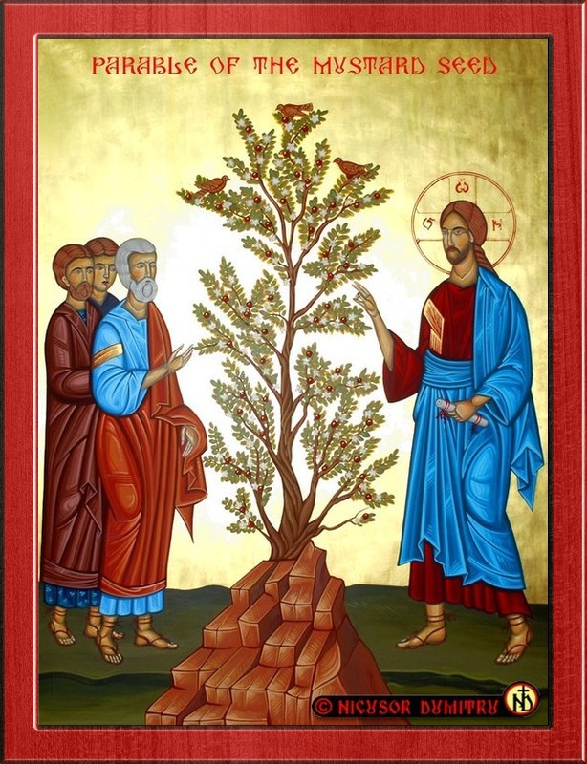

Ninth Sunday after Pentecost
July 26, 2026
10:30 A.M

Welcome!

St. Paul’s Anglican Church extends a warm welcome to all visitors and newcomers, whether worshiping in person or at home via livestream.

Visitors’ Guide

St. Paul’s Church is a parish in the Diocese of San Joaquin of the Anglican Church in North America, which includes both Catholic and Protestant traditions. We accept Jesus Christ as Savior, and we promise to follow him as Lord. We believe in One God,

- the Father who created us and all things,
- the Son who redeems us from sin and death,
- the Holy Spirit who renews and sanctifies us.

We believe the Holy Scriptures to be the Word of God and to contain all things necessary for salvation, and we accept the Apostles’ and Nicene Creeds as essential beliefs of the Christian faith.

Those not desiring to receive Holy Communion, and those who have not been baptized into the Christian faith, are invited to cross their arms across their chest, and a blessing will be given instead.

Visitors are invited to sign the guest book at the entrance table and introduce themselves to the clergy following the service.

The Holy Eucharist

Prelude: Karli Leal (Viola)
Opening Hymn: #8 – “Morning Has Broken” p. 4
Opening Acclamation p. 5
The Collect for Purity p. 5
Summary of the Law p. 5
Kyrie p. 5
Gloria p. 5
Collect of the Day p. 6
Lesson: 1 Kings 3:3-14 p. 6
Gradual: Psalm 119:121-136 p. 7
Epistle: Romans 8:26-34 p. 8
Sequence Hymn: #635 – “If Thou but Trust in God to Guide Thee” p. 9
Gospel: Matthew 13:31-33, 44-50 p. 10
Sermon: Rev Kashy Rowland-Smith
Nicene Creed p. 11
Prayers of the People p. 12
The Peace p. 14
Offertory: Karli Leal (Viola)
The Offertory p. 15
Sursum Corda p. 15
Sanctus p. 16
The Lord’s Prayer p. 16
Fraction p. 16
Prayer for Humble Access p. 17
Agnus Dei p. 17
Communion Hymn: Celebration Hymn “Come to the Table p. 18
Post Communion Prayer p. 19
Blessing p. 19
Closing Hymn: #388 – ‘O Worship the King” p. 20
Dismissal p. 20

St. Paul’s welcome our guest musicians
Gabriel Hatcher-Piano
Karli Leal-Viola

Opening Hymn: Morning Has Broken
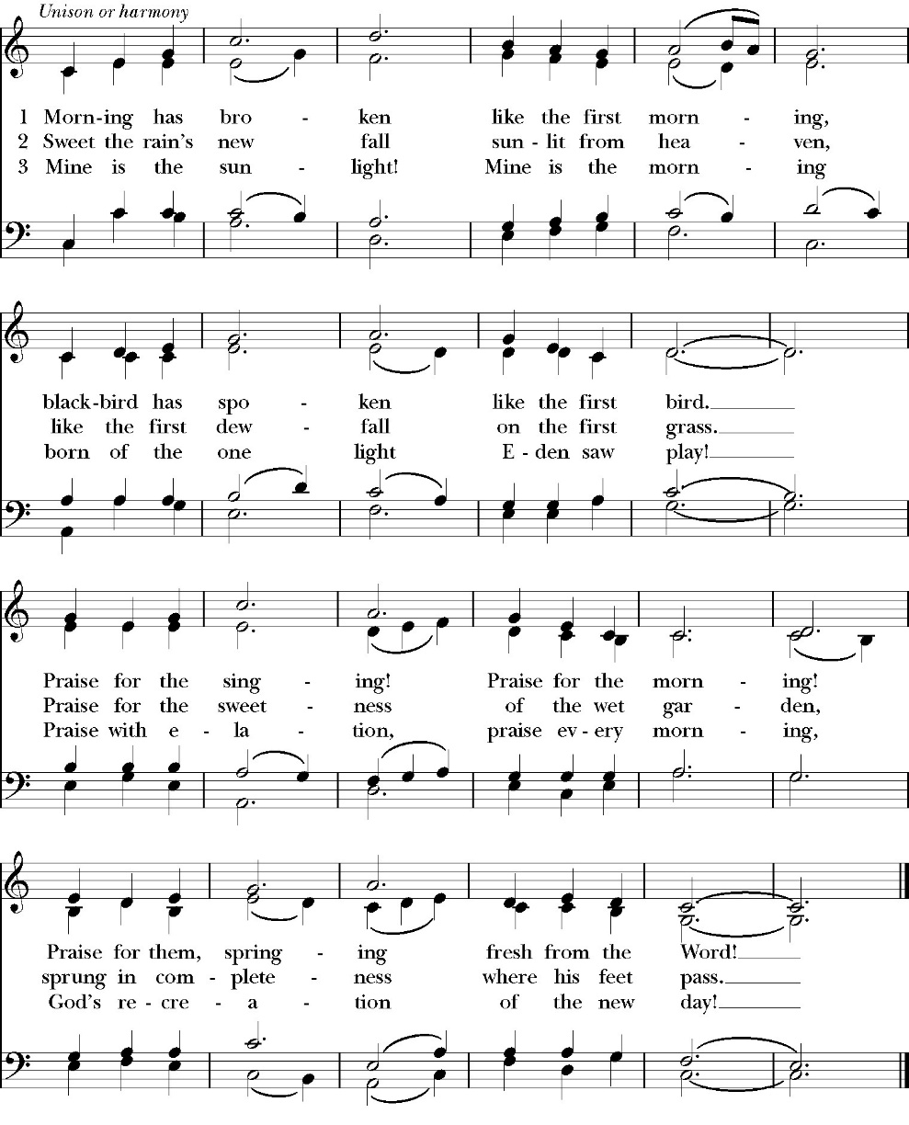

Opening Acclamation

Celebrant Blessed be God, the Father, the Son and the Holy Spirit. People And blessed be his kingdom, now and forever. Amen.

Collect for Purity

Almighty God, to you all hearts are open, all desires
known, and from you no secrets are hid: Cleanse the thoughts
of our hearts by the inspiration of your Holy Spirit, that we
may perfectly love you, and worthily magnify your holy Name;
through Christ our Lord. Amen.

Summary of the law

Hear what our Lord Jesus Christ says: You shall love
the Lord your God with all your heart and with all your soul
and with all your mind. This is the first and great
commandment. And the second is like it: You shall love your
neighbor as yourself. On these two commandments depend all
the Law and the Prophets.

Kyrie

Lord, have mercy upon us.
Christ, have mercy upon us.
Lord, have mercy upon us.

Gloria
Glory to God in the highest,
and peace to his people on earth.
Lord God, heavenly King,
almighty God and Father,
we worship you, we give you thanks,
we praise you for your glory.
Lord Jesus Christ, only Son of the Father,
Lord God, Lamb of God,
you take away the sin of the world:
have mercy on us;
you are seated at the right hand of the Father:
receive our prayer.
For you alone are the Holy One,
you alone are the Lord,
you alone are the Most High,
Jesus Christ,
with the Holy Spirit,
in the glory of God the Father. Amen

Celebrant The Lord be with you.
People And with your spirit.
Celebrant Let us pray.

The Collect of the Day

Almighty and everlasting God, you are always more ready to hear than we to pray, and to give more than we either desire or deserve: Pour down upon us the abundance of your mercy, forgiving us those things of which our conscience is afraid, and giving us those good things for which we are not worthy to ask,except through the merits and mediation of Jesus Christ our Savior; who lives and reigns with you and the Holy Spirit, one God, for ever and ever. Amen.

Lesson: 1 King 3:3-14
Solomon loved the LORD, walking in the statutes of David his father, only he sacrificed and made offerings at the high places. 4 And the king went to Gibeon to sacrifice there, for that was the great high place. Solomon used to offer a thousand burnt offerings on that altar. 5 At Gibeon the LORD appeared to Solomon in a dream by night, and God said, “Ask what I shall give you.” 6 And Solomon said, “You have shown great and steadfast love to your servant David my father, because he walked before you in faithfulness, in righteousness, and in uprightness of heart toward you. And you have kept for him this great and steadfast love and have given him a son to sit on his throne this day. 7 And now, O LORD my God, you have made your servant king in place of David my father, although I am but a little child. I do not know how to go out or come in. 8 And your servant is in the midst of your people whom you have chosen, a great people, too many to be numbered or counted for multitude. 9 Give your servant therefore an understanding mind to govern your people, that I may discern between good and evil, for who is able to govern this your great people?”
10 It pleased the Lord that Solomon had asked this. 11 And God said to him, “Because you have asked this, and have not asked for yourself long life or riches or the life of your enemies, but have asked for yourself understanding to discern what is right, 12 behold, I now do according to your word. Behold, I give you a wise and discerning

Reader: The Word of the Lord
People: Thanks be to God

Gradual: Psalm 119:121-136
121 I have done that which is lawful and right; *
O give me not over to my oppressors.
122 Be surety for your servant’s good; *
O let not the arrogant oppress me.
123 My eyes have wasted away with looking for your salvation, *
and for the word of your righteousness.
124 O deal with your servant according to your loving mercy, *
and teach me your statutes.
125 I am your servant; O grant me understanding, *
that I may know your testimonies.
126 It is time for you, O LORD, to act, *
for they have broken your law.
127 For I love your commandments above all things, *
more than gold and precious stones.
128 Therefore I hold all your commandments to be right, *
and all false ways I utterly abhor.
129 Your testimonies are wonderful; *
therefore does my soul keep them.
130 When your word goes forth it gives light *
and understanding to the simple.
131 I opened my mouth, and drew in my breath, *
for my delight was in your commandments.
132 O look upon me, and be merciful unto me, *
as you always do for those who love your Name.
133 Order my steps according to your word, *
and so shall no wickedness have dominion over me.

134 O deliver me from those who deal wrongfully, *
and so shall I keep your commandments.
135 Show the light of your countenance upon your servant, *
and teach me your statutes.
136 My eyes gush out water *
because of those who do not keep your law.

Glory be to the Father, and to the Son, and to the Holy Spirit;
as it was in the beginning, is now, and ever shall be, world
without end. Amen

Epistle: Romans 8:26-34
Likewise the Spirit helps us in our weakness. For we do not know what to pray for as we ought, but the Spirit himself intercedes for us with groanings too deep for words. 27 And he who searches hearts knows what is the mind of the Spirit, because the Spirit intercedes for the saints according to the will of God. 28 And we know that for those who love God all things work together for good, for those who are called according to his purpose. 29 For those whom he foreknew he also predestined to be conformed to the image of his Son, in order that he might be the firstborn among many brothers. 30And those whom he predestined he also called, and those whom he called he also justified, and those whom he justified he also glorified.
31 What then shall we say to these things? If God is for us, who can be against us? 32 He who did not spare his own Son but gave him up for us all, how will he not also with him graciously give us all things? 33 Who shall bring any charge against God's elect? It is God who justifies. 34 Who is to condemn? Christ Jesus is the one who died—more than that, who was raised—who is at the right hand of God, who indeed is interceding for us.

Reader: The Word of the Lord
People: Thanks be to God

Sequence Hymn: If Thou but Trust in God to Gude Thee
(Verses 1 before gospel verse 2 after gospel)
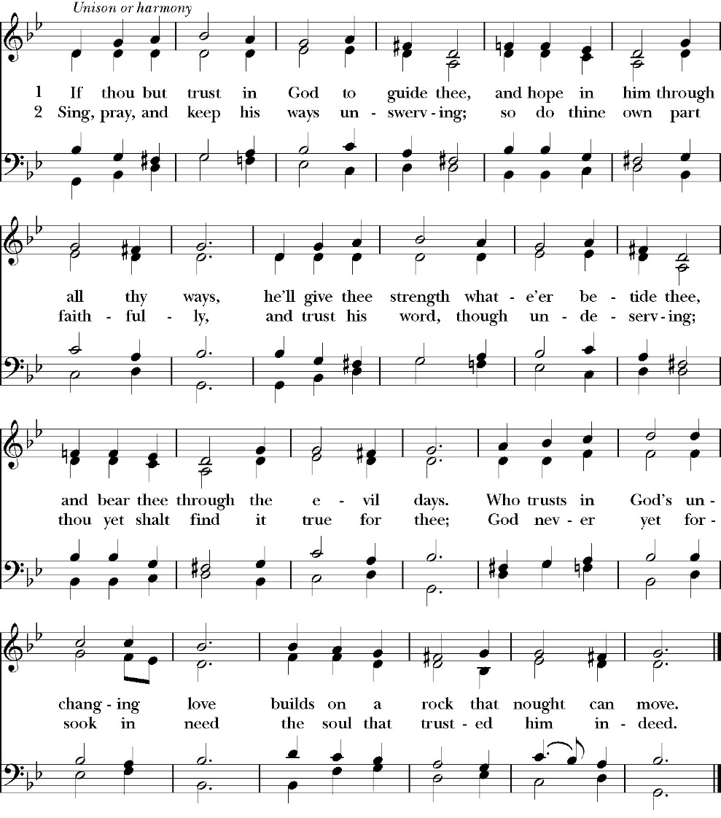

Clergy: The Holy Gospel of Our Lord Jesus Christ,
according to St. Matthew
People: Glory to you, Lord Christ.

Gospel: Matthew 13:31-33, 44-50

He put another parable before them, saying, “The kingdom of heaven is like a grain of mustard seed that a man took and sowed in his field. 32 It is the smallest of all seeds, but when it has grown it is larger than all the garden plants and becomes a tree, so that the birds of the air come and make nests in its branches.”
33 He told them another parable. “The kingdom of heaven is like leaven that a woman took and hid in three measures of flour, till it was all leavened.” 44 “The kingdom of heaven is like treasure hidden in a field, which a man found and covered up. Then in his joy he goes and sells all that he has and buys that field.
45 “Again, the kingdom of heaven is like a merchant in search of fine pearls, 46 who, on finding one pearl of great value, went and sold all that he had and bought it.
47 “Again, the kingdom of heaven is like a net that was thrown into the sea and gathered fish of every kind. 48 When it was full, men drew it ashore and sat down and sorted the good into containers but threw away the bad. 49 So it will be at the end of the age. The angels will come out and separate the evil from the righteous 50 and throw them into the fiery furnace. In that place there will be weeping and gnashing of teeth.

Clergy: The Gospel of the Lord
People: Praise to you, Lord Christ

Sermon

Rev. Kashy Rowland-Smith

The Nicene Creed

We believe in one God,
the Father, the Almighty,
maker of heaven and earth,
of all that is, visible and invisible.

We believe in one Lord, Jesus Christ,
the only-begotten Son of God,
eternally begotten of the Father,
God from God, Light from Light,
true God from true God,
begotten, not made,
of one Being with the Father.
through him all things were made.

For us and for our salvation he came down from heaven:
was incarnate from the Holy Spirit and the Virgin Mary,
and was made man.
For our sake he was crucified under Pontius Pilate;
he suffered death and was buried.
On the third day he rose again in accordance with the
Scriptures;

he ascended into heaven
and is seated at the right hand of the Father.
He will come again in glory to judge the living and the dead,
and his kingdom will have no end.
We believe in the Holy Spirit, the Lord, the giver of life,
who proceeds from the Father and the Son,
who with the Father and the Son is worshiped and glorified.
who has spoken through the Prophets.
We believe in one holy catholic and apostolic Church.
We acknowledge one Baptism for the forgiveness of sins.
We look for the resurrection of the dead,
and the life of the world to come. Amen.

The Prayers of the People

Leader Let us pray for the Church and for the world, saying, “hear our prayer.”
For the peace of the whole world, and for the well-being and unity of the people of God.
Lord, in your mercy:
People Hear our prayer.

Leader For Stephen our archbishop, Julian our provincial dean, and Eric our bishop. For Fr. Rob, Deacon John, Deacon Kashy, and for all the clergy and people of our diocese and congregation and for the worldwide Anglican Communion.
Lord, in your mercy:
People Hear our prayer.

Leader For all those who proclaim the Gospel at home and abroad; and for all who teach and disciple others.
Lord, in your mercy:
People Hear our prayer.

Leader For our brothers and sisters in Christ who are persecuted for their faith.
Lord, in your mercy:
People Hear our prayer.

Leader For our nation, for those in authority, and for all in public service especially Donald our president and Gavin our governor.
Lord, in your mercy:
People Hear our prayer.

Leader: In the St. Paul’s cycle of prayer, we pray for our Bishop Eric Menees, the Ministries of the Anglican Diocese of San Joaquin and its churches, for the Anglican Church in North America and its dioceses, for the Global Anglican Futures Conference, for the Worldwide Anglican Communion and all their provinces, diocese and churches.
Lord, in your mercy:
People Hear our prayer.

Leader In the ACNA Cycle of Prayer, today we pray for the Diocese of Cascadia and Bishop Jake Worley and his wife, Kelly; Bishop Kevin Bond Allen and his wife, Stefanie.
Lord, in your mercy:
People Hear our prayer.

Leader For all those who are in trouble, sorrow, need, sickness, or
any other adversity [especially ____________]. We also
pray for all who are currently serving in our armed forces
and serving as first responders.
Lord, in your mercy:
People Hear our prayer.

Leader For all those who have departed this life in the certain hope
of the resurrection, (we pray especially for ____________),
in Thanksgiving let us pray.
Lord, in your mercy:
People Hear our prayer.

Celebrant will add a concluding prayer

Heavenly Father, grant these our prayers for the sake of Jesus Christ,
our only Mediator and Advocate, who lives and reigns with you in
the unity of the Holy Spirit, one God, now and for ever. Amen.

The Confession and Absolution

Celebrant Let us humbly confess our sins to Almighty God.

Most merciful God,
we confess that we have sinned against you
in thought, word and deed,
by what we have done, and by what we have left undone.
We have not loved you with our whole heart;
we have not loved our neighbors as ourselves.
We are truly sorry and we humbly repent.
For the sake of your Son Jesus Christ,
have mercy on us and forgive us;
that we may delight in your will, and walk in your ways,
to the glory of your Name. Amen.
The Deacon leads the congregation is saying together a prayer to receive
God’s forgiveness.

Almighty God, our heavenly Father, who in his great mercy has
promised forgiveness of sins to all those who sincerely repent
and with true faith turn to him, have mercy upon us, pardon
and deliver us from all our sins, confirm and strengthen us in
all goodness, and bring us to everlasting life; through Jesus
Christ our Lord. Amen.

The comfortable words

The Deacon may then say one or more of the following sentences,

Come to me, all who labor and are heavy laden, and I will give you
rest.
-Matthew 11:28

God so loved the world, that he gave his only-begotten Son, that
whoever believes in him should not perish but have eternal life.
-John 3:16

The saying is trustworthy and deserving of full acceptance, that
Christ Jesus came into the world to save sinners.
-1 Timothy 1:15

If anyone sins, we have an advocate with the Father, Jesus Christ the
righteous. He is the propitiation for our sins, and not for ours only,
but also for the sins of the whole world.
-1 John 2:1-2t

Celebrant The Peace of the Lord be always with you.
People And with your spirit.

offertory
Karli Leal (viola)

The Doxology
(Verse 3 only)

Offertory
Celebrant All things come from you, O Lord,
People And of your own have we given you.

The Eucharistic Liturgy

Celebrant The Lord be with you.
People And with your spirit.
Celebrant Lift up your hearts.
People We lift them up to the Lord.
Celebrant Let us give thanks to the Lord our God.
People It is right to give him thanks and praise.

It is right, our duty and our joy, always and everywhere to give thanks to you, Father Almighty, Creator of heaven and earth.

Through Jesus Christ our Lord, who on the first day of the week overcame death and the grave, and by his glorious resurrection opened to us the way of everlasting life.

Therefore we praise you, joining our voices with Angels and Archangels and with all the company of heaven, who for ever sing this hymn to proclaim the glory of your Name:

Sanctus

Holy, Holy, Holy, Lord God of power and might, heaven and
earth are full of your glory.
Hosanna in the highest.
Blessed is he who comes in the Name of the Lord.
Hosanna in the highest.

And now, as our Savior Christ has taught us, we are bold to pray,

Our Father, who art in heaven,
hallowed be thy Name,
thy kingdom come,
thy will be done,
on earth as it is in heaven.
Give us this day our daily bread.
And forgive us our trespasses,
as we
forgive those
who trespass against us.
And lead us not into temptation,
but deliver us from evil.
For thine is the kingdom,
and the power, and the glory,
for ever and ever. Amen.

Fraction

Celebrant Alleluia! Christ our Passover is sacrificed for us.
People Therefore let us keep the feast. Alleluia!

The Prayer for Humble Access

We do not presume to come to this your table, O merciful Lord,
trusting in our own righteousness,
but in your abundant and great mercies.
We are not worthy so much as to gather up
the crumbs under your table;
but you are the same Lord
whose character is always to have mercy.
Grant us, therefore, gracious Lord,
so to eat the flesh of your dear Son Jesus Christ,
and to drink his blood,
that our sinful bodies may be made clean by his body,
and our souls washed through his most precious blood,
and that we may evermore dwell in him, and he in us.
Amen.

Agnus Dei
Lamb of God, you take away the sin of the world;
have mercy on us.
Lamb of God, you take away the sin of the world;
have mercy on us.
Lamb of God, you take away the sin of the world;
grant us your peace.

The Ministration of Communion

The gifts of God for the People of God. Take them in remembrance that Christ died for you and feed on him in your hearts by faith, with thanksgiving.

Communion Hymn: Come to the Table
(Sing Twice)
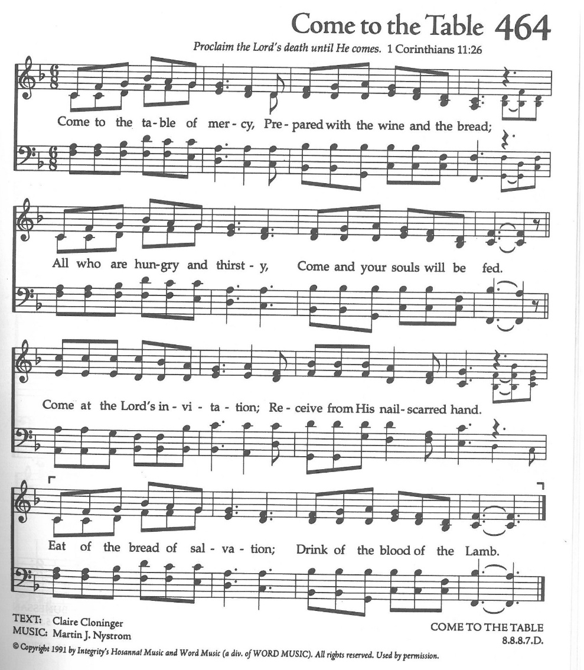

The Post Communion Prayer
Let us pray.

Heavenly Father,
We thank you for feeding us with the spiritual food
of the most precious Body and Blood
of your Son our Savior Jesus Christ;
and for assuring us in these holy mysteries
that we are living members of the body of your Son,
and heirs of your eternal Kingdom.
And now, Father, send us out to do the work you have
given us to do,
to love and serve you as faithful witnesses of Christ our
Lord.
To him, to you, and to the Holy Spirit,
be honor and glory, now and for ever. Amen.

The Blessing

The blessing of God Almighty, the Father, the Son, and the Holy
Spirit, be upon us, and remain with us always. Amen.
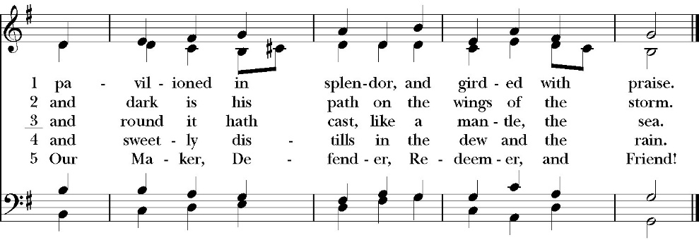
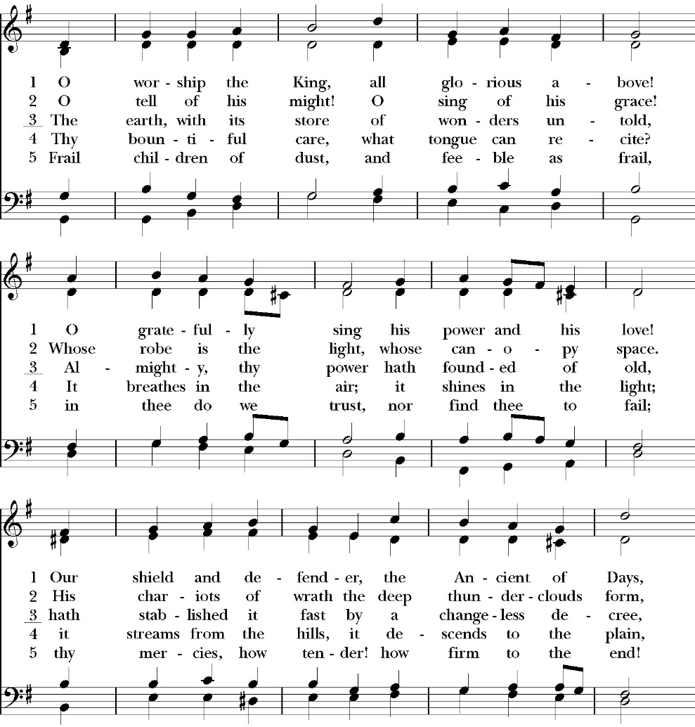
Closing Hymn: O Worship the King

Dismissal
Deacon Alleluia, Alleluia. Let us go forth into the world, rejoicing
in the power of the Holy Spirit.
People Thanks be to God. Alleluia, alleluia.
St. Paul’s Parish Calendar
Sunday July 26 – Sunday August 2

SUNDAY, July 26 – Ninth Sunday after Pentecost
10:30 AM Children’s Sunday School, Chapel
Pre-K –2nd Grade, Sunday School Room
3rd -5th Grade, Youth Room
10:30 AM Holy Eucharist, Church

MONDAY, July 27

TUESDAY, July 28

WEDNESDAY, July 29
9:30 AM Holy Eucharist with healing prayer, Chapel
10:15 AM Bible Study, Conference Room

THURSDAY, July 30

FRIDAY, July 30
6:30 AM Men’s Bible Study, Valhalla Restaurant

SATURDAY, August 1
9:00 AM – 11:00 AM Bell Skill Day, James Hall

SUNDAY, August 2 – Tenth Sunday after Pentecost
9:15 AM Sunday Funday, Youth Room
9:15 AM Gospel of John Bible Study, Conference Room
10:30 AM Children’s Sunday School, Chapel
Pre-K –2nd Grade, Sunday School Room
3rd -5th Grade, Youth Room
10:30 AM Holy Eucharist, Church

Church Office Hours
Monday-Thursday 8:00 AM-4:00 PM

Upcoming staff Vacations and church ministry time away
Fr. Rob Longbottom August 6-10 (Vacation)

In Case of Pastoral emergencies here are the cell phone numbers of our pastors:
Fr. Rob Longbottom (559)802-2928
Dcn. John Iseman (518)222-6722
Dcn. Kashy Rosland-Smith (559)733-1229

Bell Skill Day Saturday, August 1, 9-11AM
The Bell choir is inviting its members and all those interested in learning more about the ministry of bell choir to join them for an introductory skills day. This will be a day for beginners and current members alike to learn and hone their bell playing skills. If you have any questions, feel free to come to the Exploring Bells program after church in James Hall in July, our bell choir director Brenda or talk to our bell choir members.

The Gospel of John Sunday morning Bible study, 9:15-10:00AM Resumes Sunday August 2
The Sunday morning Gospel of John bible study resumes Sunday, August 2 from 9:15am-10:00am. The Class finished through chapter 7 in June and is currently working through chapter 8.

School Supply drive for Hurley Elementary
Begins now and runs through Sunday, August 9
Did you know that 1/3 of all students at Hurley elementary are from low-income households? Help us serve these students with a school supply drive to help teachers make sure all their students have the supplies they need for a great school year. School supplies can be brought to Church on Sundays or to the church office Monday-Thursday 8am-4pm.
List of School Supplies needed are:

Backpacks, Crayons, Pencils Erasers, Glue Sticks, Scissors, Composition books, 1-inch binders, Expo markers, Lined paper, Pencil pouch.

A Food Bank for Hurley Families
The next Neighborhood Market to benefit students at Hurley School will be Tuesday August 11, 2:30 PM to 3:30 PM at St Paul’s Church parking lot. If you are interested in helping that day, please contact Sue Nyberg. My home phone number is 559-733-8244.

Due to the heat, we are in need of more volunteers for
the months of August and September. This will allow volunteers to work in shifts during these hot months.

PROVIDED BY VISALIA EMERGENCY AID
AND ST. PAUL’S CHURCH
Tuesday, August 11, 2026
From 2:30 PM to 3:30 PM
LOCATION:
ST. PAUL'S CHURCH PARKING LOT
ACROSS THE STREET FROM HURLEY


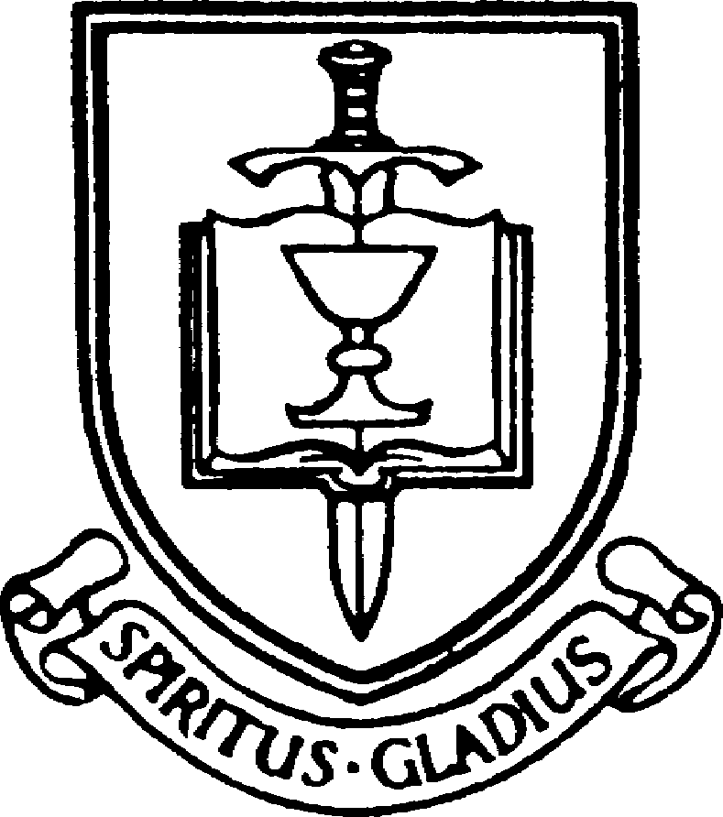

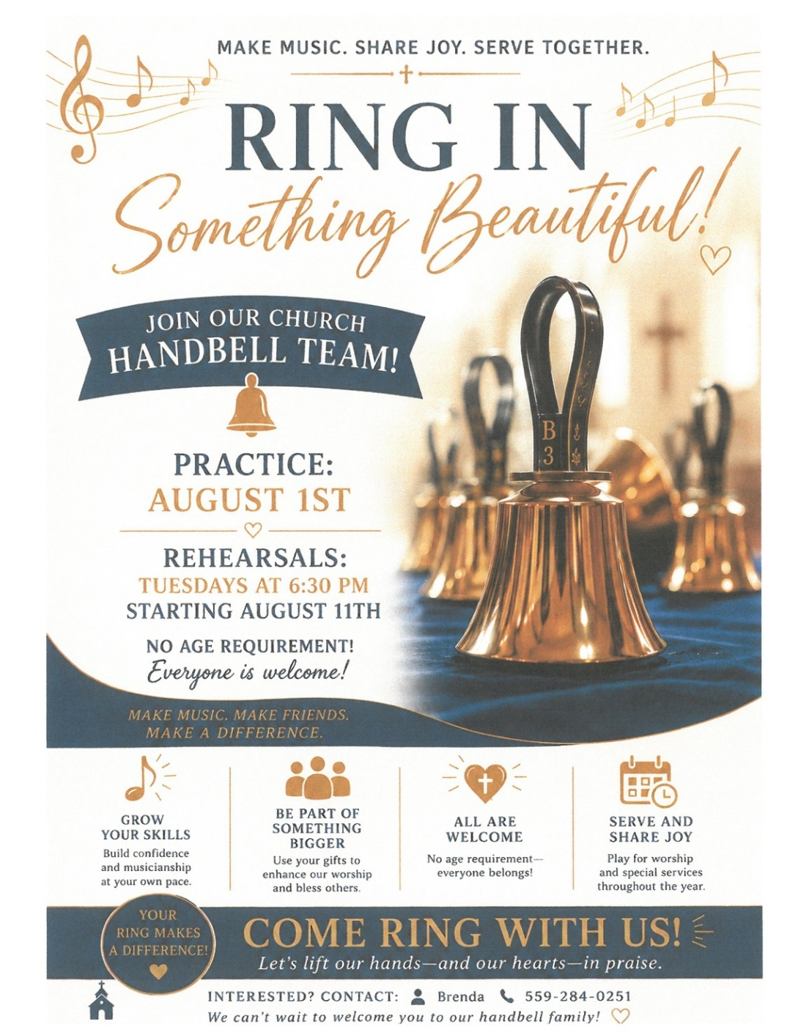

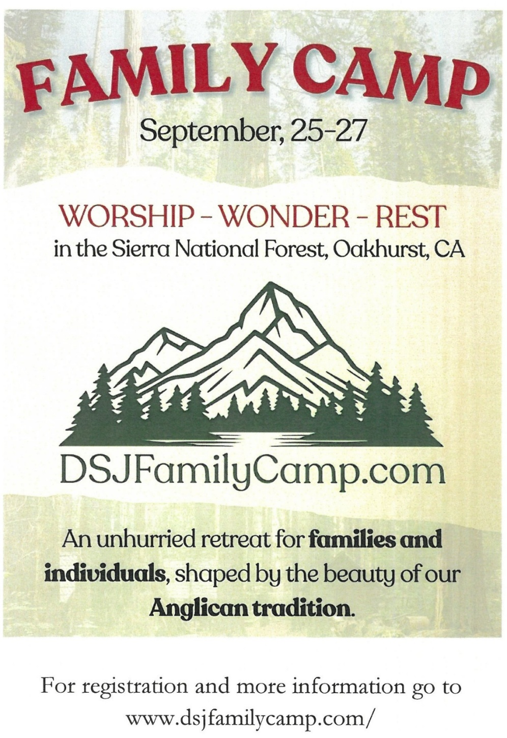

Anglican Diocese of San Joaquin Family Camp,
Out Of the Noise and Into the Wonder
September 27-29, Calvin Crest Sherwood Forrest, Oakhurst, CA
Join your friends from St. Paul’s for an unhurried retreat for families and individuals, shaped by the beauty of our Anglican tradition. Calvin Crest Sherwood Forrest is outside Oakhurst, CA near Yosemite. Each day flows from Morning Prayer to Compline. The family camp will feature tent and rustic cabin accommodations and will feel very much like the old Camp San Joaquin. The Camp will be led by our friend Rev. Paul Gibbons so we know that it will be a wonderful time.

The Cost cannot be beat:
Bring your own Tent or RV: $75 for the whole family
Rustic Cabin Accommodations: $150 for the whole family

Accommodation and bathroom facilities

Tent & RV Sites: Pitch a tent or park your rig in the scenic Sherwood Forest area.
Rustic Cabins: Each cabin features 10 bunks with mattresses. Cabins are non-electric.
Bathrooms and Showers: Clean, private bathrooms and hot showers are available throughout camp.

What is included for this price:

The flat rate covers lodging, firewood, a sub sandwich dinner on Friday evening, breakfast on Saturday morning and a BBQ on Saturday evening.
How do I sign up or find out more?
Talk with Fr. Rob Longbottom or go to the Family Camp website at:
dsjfamilycamp.com

St. Paul’s Anglican Church
Parish Office
6436 W. Hurley Ave
Visalia, California 93291
559-732-4821
Office Hours: 8:00 – 4:00
Monday – Thursday

Worship: Sundays at 10:30AM
Livestream: Link at spvisalia.com
and on our Facebook page
Please be advised that this service is being recorded for broadcast
and/or archival purposes. By attending, you consent
to the inclusion of your likeness in these recordings.

St. Paul’s Clergy and Staff
The Rev. Robert Longbottom, Rector
rector@spvisalia.com
(559)802-2928
The Rev. John Iseman, Pastoral Associate for Family Ministries
family@spvisalia.com
The Rev. Kashy Rowland-Smith, Deacon
kashyrs@aol.com
Antoinette Horsting, Parish Administrator
bookkeeper@spvisalia.com
Marguerite Crownover, Organist and Accompanist
Ellen Daniels, Choral Director
Jackie Iseman, Nursery Coordinator
Shane Motl, Sexton

St. Paul’s is a member church of the
Anglican Diocese of San Joaquin
The Rt. Rev. Eric V. Menees, Bishop

Next Week’s Lessons
Nehemiah 9:16-21
Psalm 78
Romans 8:35.39
Matthew 14:13.21

