ST. PAUL’S
ANGLICAN CHURCH
VISALIA, CALIFORNIA

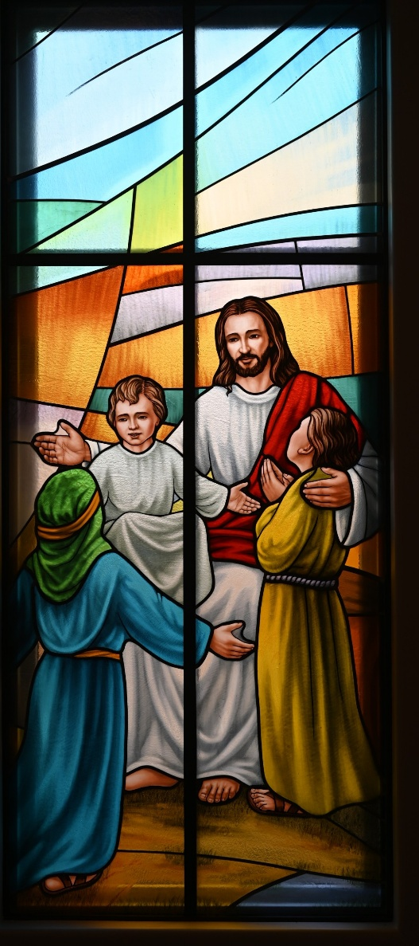

Sixth Sunday after Pentecost
July 5, 2026
10:30 A.M

Welcome!

St. Paul’s Anglican Church extends a warm welcome to all visitors and newcomers, whether worshiping in person or at home via livestream.

Visitors’ Guide

St. Paul’s Church is a parish in the Diocese of San Joaquin of the Anglican Church in North America, which includes both Catholic and Protestant traditions. We accept Jesus Christ as Savior, and we promise to follow him as Lord. We believe in One God,

- the Father who created us and all things,
- the Son who redeems us from sin and death,
- the Holy Spirit who renews and sanctifies us.

We believe the Holy Scriptures to be the Word of God and to contain all things necessary for salvation, and we accept the Apostles’ and Nicene Creeds as essential beliefs of the Christian faith.

Those not desiring to receive Holy Communion, and those who have not been baptized into the Christian faith, are invited to cross their arms across their chest, and a blessing will be given instead.

Visitors are invited to sign the guest book at the entrance table and introduce themselves to the clergy following the service.

The Holy Eucharist

Prelude: “Andante” Handel
Opening Hymn: # 450 – “All Hail the Power of Jesus’ Name!” p. 4
Opening Acclamation p. 6
The Collect for Purity p. 6
Summary of the Law p. 6
Kyrie p. 6
Gloria p. 7
Collect of the Day p. 8
Lesson: Zechariah 9:9-12 p. 8
Gradual: Psalm 145 p. 8
Epistle: Romans 7:21-8:6 p. 10
Sequence Hymn: 516 – “Come Down, O Love Divine” p. 11
Gospel: Matthew 11:25-30 p. 12
Sermon: The Rev Robert Longbottom
Nicene Creed p. 12
Prayers of the People p. 13
The Peace p. 16
Offertory Hymn 680 – “O God Our Help in Ages Past”
The Offertory p. 17
Sursum Corda p. 17
Sanctus p. 18
The Lord’s Prayer p. 20
Fraction p. 20
Prayer for Humble Access p. 21
Agnus Dei p. 21
Communion Hymn: #693 – “Just as I Am” p. 22
Post Communion Prayer p. 23
Blessing p. 23
Closing Hymn: #717 – “My Country ‘Tis of Thee” p. 24
Dismissal p. 24
Postlude: “Trumpet Voluntary” Purcell

Opening Hymn: All Hail the Power of Jesus’ Name!
(Verse 1-3 only)

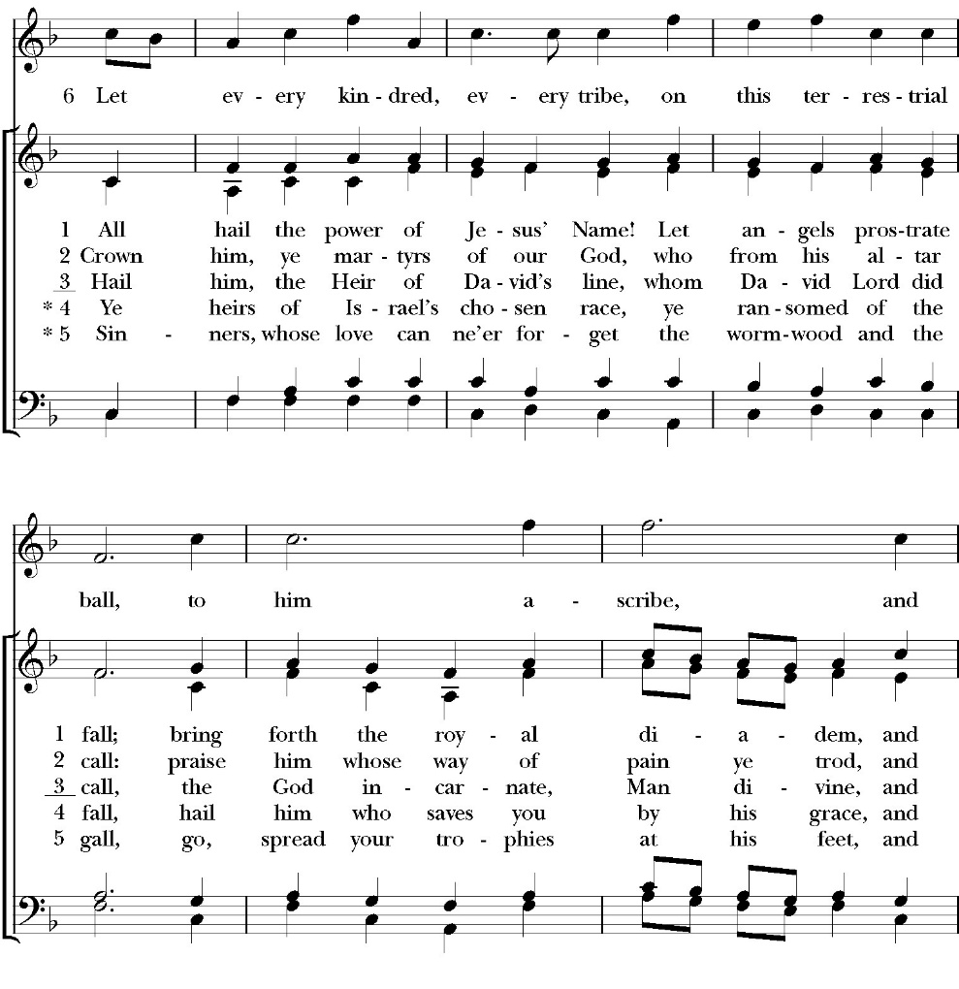

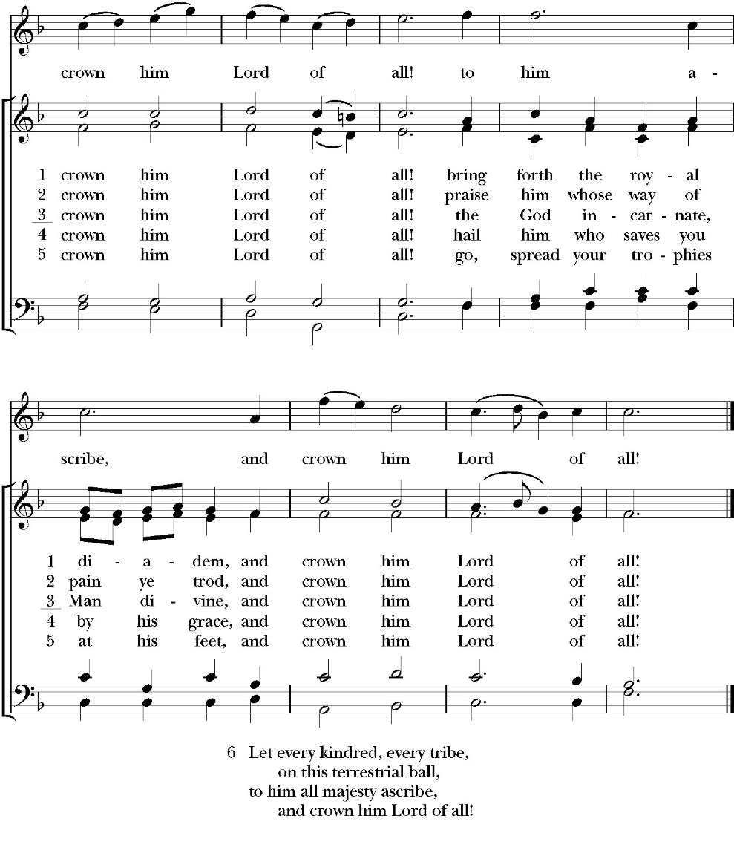

Opening Acclamation

Celebrant Blessed be God, the Father, the Son and the Holy Spirit. People And blessed be his kingdom, now and forever. Amen.

Collect for Purity

Almighty God, to you all hearts are open, all desires
known, and from you no secrets are hid: Cleanse the thoughts
of our hearts by the inspiration of your Holy Spirit, that we
may perfectly love you, and worthily magnify your holy Name;
through Christ our Lord. Amen.

Summary of the law

Hear what our Lord Jesus Christ says: You shall love the Lord your
God with all your heart and with all your soul and with all your mind.
This is the first and great commandment. And the second is like it:
You shall love your neighbor as yourself. On these two
commandments depend all the Law and the Prophets.

Kyrie
Gloria

Celebrant The Lord be with you.
People And with your spirit.
Celebrant Let us pray.

The Collect of the Day

Grant us, O Lord, we pray, the spirit to think and do always those things that are right, that we, who can do no good thing apart from you, may by you be enabled to live according to your will; through Jesus Christ our Lord, who lives and reigns with you and the Holy Spirit, one God, for ever and ever. Amen.

Lesson: Zechariah 9:9-12

Rejoice greatly, O daughter of Zion! Shout aloud, O daughter of Jerusalem! Behold, your king is coming to you; righteous and having salvation is he, humble and mounted on a donkey, on a colt, the foal of a donkey. ¹⁰ I will cut off the chariot from Ephraim and the war horse from Jerusalem; and the battle bow shall be cut off, and he shall speak peace to the nations; his rule shall be from sea to sea, and from the River to the ends of the earth. ¹¹ As for you also, because of the blood of my covenant with you, I will set your prisoners free from the waterless pit. ¹² Return to your stronghold, O prisoners of hope; today I declare that I will restore to you double.

Reader: The word of the Lord.
People: Thanks be to God.

Gradual: Psalm 145
1 I will magnify you, O God my King, *
and I will praise your Name for ever and ever.
2 Every day will I give thanks to you, *
and praise your Name for ever and ever
3 Great is the LORD, and most worthy to be praised; *
there is no end of his greatness.
4 One generation shall praise your works to another, *
and shall declare your power.
5 As for me, I will be talking of the glorious splendor of your majesty, *
and of all your wondrous works.

6 They shall speak of the might of your marvelous acts, *
and I also will tell of your greatness.
7 The remembrance of your abundant goodness shall they
proclaim, *
and they shall sing of your righteousness.
8 The LORD is gracious and merciful, *
long-suffering, and of great kindness.
9 The LORD is loving to everyone, *
and his mercy is over all his works.
10 All your works praise you, O LORD, *
and your faithful servants give thanks to you.
11 They speak of the glory of your kingdom *
and talk of your power,
12 That your power may be known to the children of men, *
even the glorious splendor of your kingdom.
13 Your kingdom is an everlasting kingdom, *
and your dominion endures throughout all ages.
14 The LORD upholds all those who fall *
and lifts up all those who are bowed down.
15 The eyes of all wait upon you, O Lord, *
and you give them their food in due season.
16 You open wide your hand, *
and fill all things living with plenteousness.
17 The LORD is righteous in all his ways *
and merciful in all his works.
18 The LORD is near to all those who call upon him, *
to all who call upon him faithfully.
19 He will fulfill the desire of those who fear him; *
he also will hear their cry and will help them.
20 The LORD preserves all those who love him, *
but he will destroy all the ungodly.
21 My mouth shall speak the praise of the LORD; *
and let all flesh give thanks unto his holy Name
for ever and ever.

Glory be to the Father, and to the Son, and to the Holy Spirit;
as it was in the beginning, is now, and ever shall be, world
without end. Amen

Epistle: Romans 7:21-8:6
So, I find it to be a law that when I want to do right, evil lies close at hand. ²² For I delight in the law of God, in my inner being, ²³ but I see in my members another law waging war against the law of my mind and making me captive to the law of sin that dwells in my members. ²⁴ Wretched man that I am! Who will deliver me from this body of death? ²⁵ Thanks be to God through Jesus Christ our Lord! So then, I myself serve the law of God with my mind, but with my flesh I serve the law of sin.

8 There is therefore now no condemnation for those who are in Christ Jesus. ² For the law of the Spirit of life has set you free in Christ Jesus from the law of sin and death. ³ For God has done what the law, weakened by the flesh, could not do. By sending his own Son in the likeness of sinful flesh and for sin, he condemned sin in the flesh, ⁴ in order that the righteous requirement of the law might be fulfilled in us, who walk not according to the flesh but according to the Spirit. ⁵ For those who live according to the flesh set their minds on the things of the flesh, but those who live according to the Spirit set their minds on the things of the Spirit. ⁶ For to set the mind on the flesh is death, but to set the mind on the Spirit is life and peace.

Reader: The Word of the Lord
People: Thanks be to God

Sequence Hymn: Come Down, O Love Divine
(Verses 1-2 before gospel verse 3 after gospel)
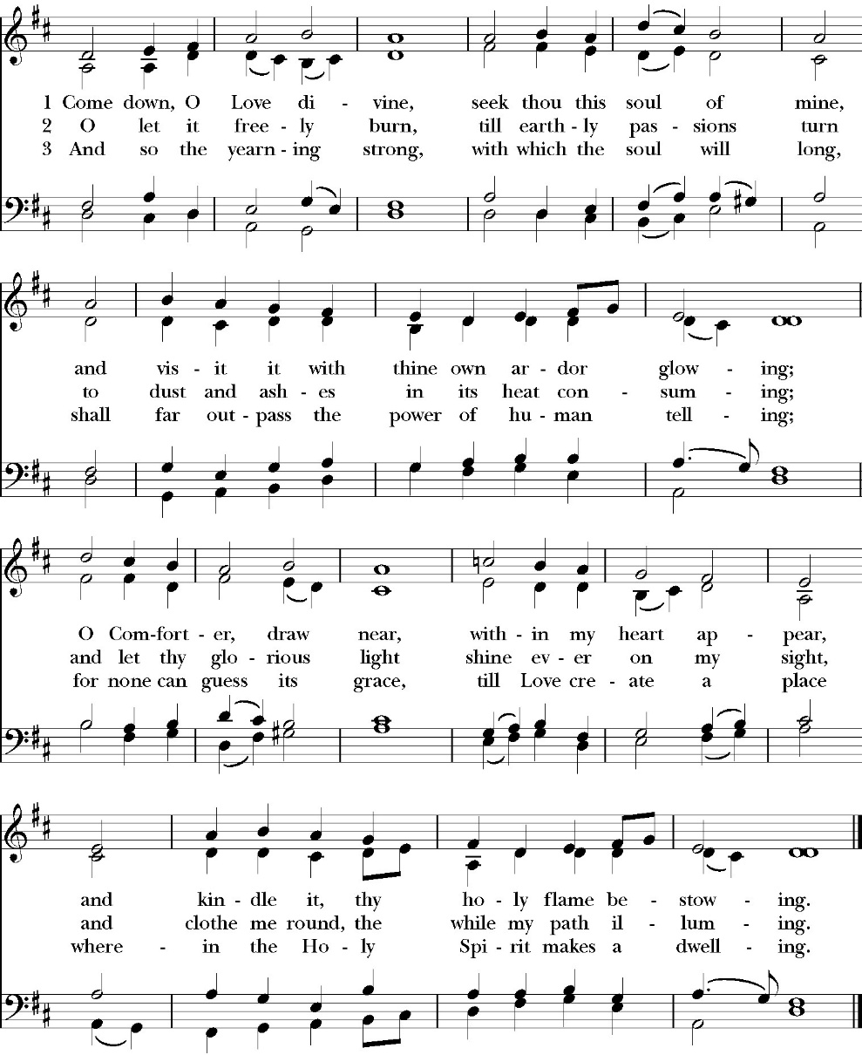

Clergy: The Holy Gospel of Our Lord Jesus Christ,
according to St. Matthew
People: Glory to you, Lord Christ.

Gospel: Matthew 11:25-30
At that time Jesus declared, “I thank you, Father, Lord of heaven and earth, that you have hidden these things from the wise and understanding and revealed them to little children; ²⁶ yes, Father, for such was your gracious will. ²⁷ All things have been handed over to me by my Father, and no one knows the Son except the Father, and no one knows the Father except the Son and anyone to whom the Son chooses to reveal him. ²⁸ Come to me, all who labor and are heavy laden, and I will give you rest. ²⁹ Take my yoke upon you, and learn from me, for I am gentle and lowly in heart, and you will find rest for your souls. ³⁰ For my yoke is easy, and my burden is light.”

Clergy: The Gospel of the Lord
People: Praise to you, Lord Christ

Sermon
The Rev. Robert Longbottom

The Nicene Creed

We believe in one God,
the Father, the Almighty,
maker of heaven and earth,
of all that is, visible and invisible.

We believe in one Lord, Jesus Christ,
the only-begotten Son of God,
eternally begotten of the Father,
God from God, Light from Light,
true God from true God,
begotten, not made,
of one Being with the Father.
through him all things were made.

For us and for our salvation he came down from heaven:
was incarnate from the Holy Spirit and the Virgin Mary,
and was made man.
For our sake he was crucified under Pontius Pilate;
he suffered death and was buried.
On the third day he rose again in accordance with the
Scriptures;

he ascended into heaven
and is seated at the right hand of the Father.
He will come again in glory to judge the living and the dead,
and his kingdom will have no end.
We believe in the Holy Spirit, the Lord, the giver of life,
who proceeds from the Father and the Son,
who with the Father and the Son is worshiped and glorified.
who has spoken through the Prophets.
We believe in one holy catholic and apostolic Church.
We acknowledge one Baptism for the forgiveness of sins.
We look for the resurrection of the dead,
and the life of the world to come. Amen.

The Prayers of the People

Leader Let us pray for the Church and for the world, saying, “hear our prayer.”
For the peace of the whole world, and for the well-being and unity of the people of God.
Lord, in your mercy:
People Hear our prayer.

Leader For Stephen our archbishop, Julian our provincial dean, and Eric our bishop. For Fr. Rob, Deacon John, Deacon Kashy, and for all the clergy and people of our diocese and congregation and for the worldwide Anglican Communion.
Lord, in your mercy:
People Hear our prayer.

Leader For all those who proclaim the Gospel at home and abroad; and for all who teach and disciple others.
Lord, in your mercy:
People Hear our prayer.

Leader For our brothers and sisters in Christ who are persecuted for their faith.
Lord, in your mercy:
People Hear our prayer.

Leader For our nation, for those in authority, and for all in public service especially Donald our president and Gavin our governor.
Lord, in your mercy:
People Hear our prayer.

Leader: In the St. Paul’s cycle of prayer, we pray for all ministries to children, youth and families both in our church and through our church into the community around us. We pray for Sunday Funday, Sunday School, Youth Group and we pray for all our family ministry volunteers. We pray for the children and youth you have given to our care and for their formation in the Christian faith. We pray for all children and youth to whom we are reaching out with the Good News of Jesus Christ.
Lord, in your mercy:
People Hear our prayer.

Leader In the ACNA Cycle of Prayer today we pray for the Province of South Sudan and The Most Rev. Justin Arama, Archbishop, and his wife, Joyce.
Lord, in your mercy:
People Hear our prayer.

Leader For all those who are in trouble, sorrow, need, sickness, or
any other adversity [especially ____________]. We also
pray for all who are currently serving in our armed forces
and serving as first responders.
Lord, in your mercy:
People Hear our prayer.

Leader For all those who have departed this life in the certain hope
of the resurrection, (we pray especially for ____________),
in Thanksgiving let us pray.
Lord, in your mercy:
People Hear our prayer.
Celebrant will add a concluding prayer

A Prayer for Our Nation (BCP page 657)

Almighty God, who hast given us this good land for our heritage: We
humbly beseech thee that we may always prove ourselves a people
mindful of thy favor and glad to do thy will. Bless our land with
honorable industry, sound learning, and pure conduct. Save us from
violence, discord, and confusion; from pride and arrogance, and from
every evil way. Defend our liberties, and fashion into one united
people the multitudes brought hither out of many kindreds and
tongues. Endue with the spirit of wisdom those to whom, in thy
Name, we entrust the authority of government, that there may be
justice and peace at home, and that, through obedience to thy law, we
may show forth thy praise among the nations of the earth. In the
time of prosperity, fill our hearts with thankfulness, and in the day of
trouble, suffer not our trust in thee to fail; all of which we ask
through Jesus Christ our Lord. Amen.

Heavenly Father, grant these our prayers for the sake of Jesus Christ,
our only Mediator and Advocate, who lives and reigns with you in
the unity of the Holy Spirit, one God, now and for ever. Amen.

The Confession and Absolution

Celebrant Let us humbly confess our sins to Almighty God.

Most merciful God,
we confess that we have sinned against you
in thought, word and deed,
by what we have done, and by what we have left undone.
We have not loved you with our whole heart;
we have not loved our neighbors as ourselves.
We are truly sorry and we humbly repent.
For the sake of your Son Jesus Christ,
have mercy on us and forgive us;
that we may delight in your will, and walk in your ways,
to the glory of your Name. Amen.

Almighty God, our heavenly Father, who in his great mercy has
promised forgiveness of sins to all those who sincerely repent and
with true faith turn to him, have mercy upon you, pardon and deliver
you from all your sins, confirm and strengthen you in all goodness,
and bring you to everlasting life; through Jesus Christ our Lord.
Amen.

Hear the Word of God to all who truly turn to him.

God so loved the world, that he gave his only-begotten Son, that
whoever believes in him should not perish but have eternal life.
John 3:16

Celebrant The Peace of the Lord be always with you.
People And with your spirit.

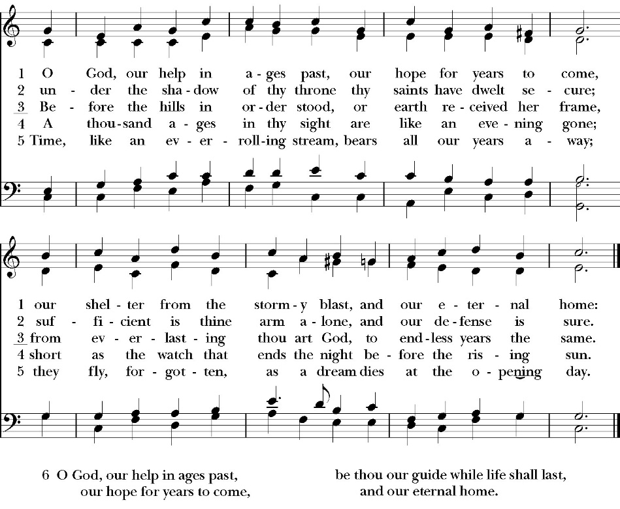
Congregational Hymn: O God, Our Help in Ages Past

The Doxology
(Verse 3 only)

Offertory Sentences

Celebrant All things come from you, O Lord,
People And of your own have we given you.

The Eucharistic Liturgy

Celebrant The Lord be with you.
People And with your spirit.
Celebrant Lift up your hearts.
People We lift them up to the Lord.
Celebrant Let us give thanks to the Lord our God.
People It is right to give him thanks and praise.

It is right, our duty and our joy, always and everywhere to give thanks to you, Father Almighty, Creator of heaven and earth.

Because you have made us in your image, that we might serve you on earth in freedom, justice, and peace; and have given us the hope of our eternal citizenship with you in your heavenly kingdom.

Therefore we praise you, joining our voices with Angels and Archangels and with all the company of heaven, who for ever sing this hymn to proclaim the glory of your Name:

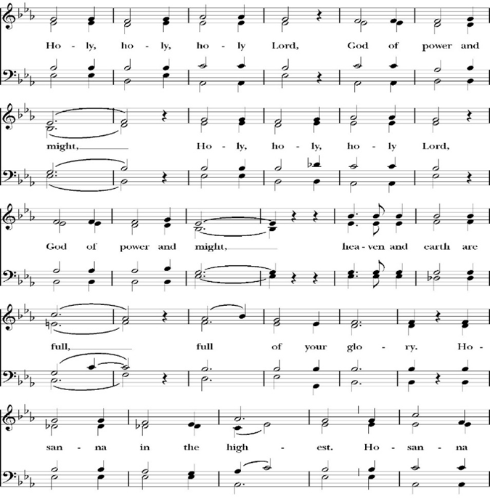
Sanctus

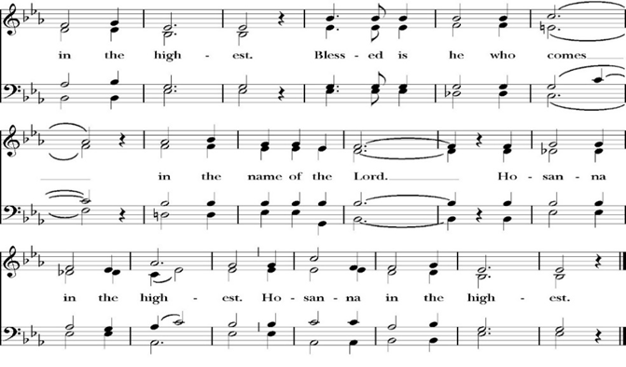
Holy and gracious Father: In your infinite love you made us for yourself; and when we had sinned against you and become subject to evil and death, you, in your mercy, sent your only Son Jesus Christ into the world for our salvation. By the Holy Spirit and the Virgin Mary he became flesh and dwelt among us. In obedience to your will, he stretched out his arms upon the Cross and offered himself once for all, that by his suffering and death we might be saved. By his resurrection he broke the bonds of death, trampling Hell and Satan under his feet. As our great high priest, he ascended to your right hand in glory, that we might come with confidence before the throne of grace.

On the night that he was betrayed, our Lord Jesus Christ took bread; and when he had given thanks, he broke it,* and gave it to his disciples, saying, “Take, eat; this is my Body, which is given for you: Do this in remembrance of me.”

Likewise, after supper, Jesus took the cup, and when he had given thanks, he gave it to them, saying, “Drink this, all of you; for this is my Blood of the New Covenant, which is shed for you, and for many, for the forgiveness of sins: Whenever you drink it, do this in remembrance of me.”

Therefore we proclaim the mystery of faith:

Christ has died.
Christ is risen.
Christ will come again.

We celebrate the memorial of our redemption, O Father, in this sacrifice of praise and thanksgiving, and we offer you these gifts.

Sanctify them by your Word and Holy Spirit to be for your people the Body and Blood of your Son Jesus Christ. Sanctify us also, that we may worthily receive this holy Sacrament, and be made one body with him, that he may dwell in us and we in him. In the fullness of time, put all things in subjection under your Christ, and bring us with all your saints into the joy of your heavenly kingdom, where we shall see our Lord face to face.

All this we ask through your Son Jesus Christ: By him, and with him, and in him, in the unity of the Holy Spirit, all honor and glory is yours, Almighty Father, now and for ever. Amen.

And now, as our Savior Christ has taught us, we are bold to pray,

Our Father, who art in heaven,
hallowed be thy Name,
thy kingdom come,
thy will be done,
on earth as it is in heaven.
Give us this day our daily bread.
And forgive us our trespasses,
as we forgive those
who trespass against us.
And lead us not into temptation,
but deliver us from evil.
For thine is the kingdom,
and the power, and the glory,
for ever and ever. Amen.

Fraction

Celebrant Alleluia! Christ our Passover is sacrificed for us.
People Therefore let us keep the feast. Alleluia!
The Prayer for Humble Access

We do not presume to come to this your table, O merciful Lord,
trusting in our own righteousness,
but in your abundant and great mercies.
We are not worthy so much as to gather up
the crumbs under your table;
but you are the same Lord
whose character is always to have mercy.
Grant us, therefore, gracious Lord,
so to eat the flesh of your dear Son Jesus Christ,
and to drink his blood,
that our sinful bodies may be made clean by his body,
and our souls washed through his most precious blood,
and that we may evermore dwell in him, and he in us.
Amen.

Agnus Dei

The Ministration of Communion

The gifts of God for the People of God. Take them in remembrance that Christ died for you and feed on him in your hearts by faith, with thanksgiving.

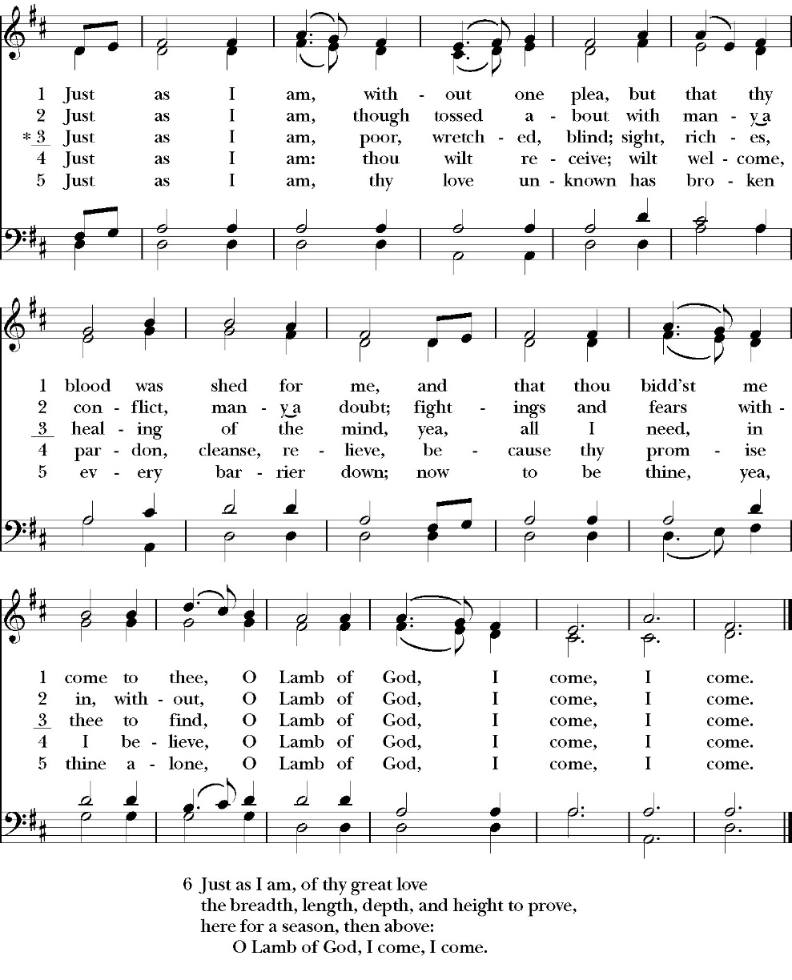
Communion Hymn: Just as I Am

The Post Communion Prayer

Let us pray.

Heavenly Father,
We thank you for feeding us with the spiritual food
of the most precious Body and Blood
of your Son our Savior Jesus Christ;
and for assuring us in these holy mysteries
that we are living members of the body of your Son,
and heirs of your eternal Kingdom.
And now, Father, send us out to do the work you have
given us to do,
to love and serve you as faithful witnesses of Christ our
Lord.
To him, to you, and to the Holy Spirit,
be honor and glory, now and for ever. Amen.

The Blessing

The blessing of God Almighty, the Father, the Son, and the Holy
Spirit, be among you, and remain with you always. Amen.

Closing Hymn: My Country ‘Tis of Thee
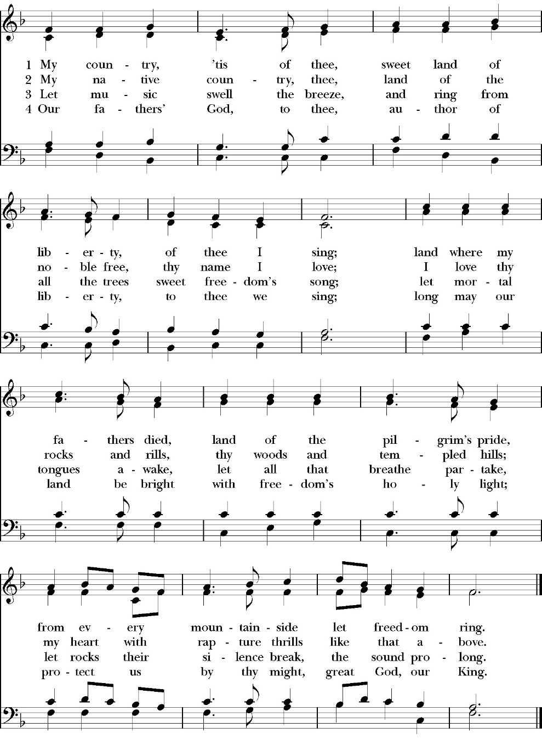

Dismissal

Deacon Alleluia, Alleluia. Let us go forth into the world, rejoicing
in the power of the Holy Spirit.
People Thanks be to God. Alleluia, alleluia.

St. Paul’s Parish Calendar
Sunday July 5– Sunday July 12

SUNDAY, July 5 – Sixth Sunday after Pentecost
10:30 AM Children’s Sunday School, Chapel
Pre-K –2nd Grade, Sunday School Room
3rd -5th Grade, Youth Room
10:30 AM Holy Eucharist, Church

MONDAY, July 6

TUESDAY, July 7

WEDNESDAY, July 8
9:30 AM Holy Eucharist with healing prayer, Chapel
10:15 AM Bible Study, Conference Room

THURSDAY, July 9

FRIDAY, July 10
6:30 AM Men’s Bible Study, Valhalla Restaurant

SATURDAY, July 11

SUNDAY, July 12 – Seventh Sunday after Pentecost
10:30 AM Children’s Sunday School, Chapel
Pre-K –2nd Grade, Sunday School Room
3rd -5th Grade, Youth Room
10:30 AM Holy Eucharist, Church

Church Office Hours
Monday-Thursday 8:00 AM-4:00 PM

Upcoming staff Vacations and church ministry time away
Antoinette Horsting July 6-9 (Vacation)
Dcn. John Iseman July 6-10 (Vacation)
July 23-26 (Youth Camp)
Fr. Rob Longbottom July 9-11 (Anglican 4th Day)
July 13-14 (Vacation)
July 23-26 (Youth Camp)
August 6-10 (Vacation)
Dcn. Kashy Rowland-Smith July 9-12 (Anglican 4th Day)
July 23-26 (Youth Camp)

In Case of Pastoral emergencies here are the cell phone numbers of our pastors:
Fr. Rob Longbottom (559)802-2928
Dcn. John Iseman (518)222-6722
Dcn. Kashy Rosland-Smith (559)733-1229

Explore Bells in James Hall, July 19
Come and ring bells with us after church on July 19. The Bell Choir will be showcasing their bells and their ministry after Church in James Hall on July 19 for all. This opportunity invites members of the church to get to know the bell choir more and learn that even with no experience you can be a part of this wonderful ministry.

Bell Skill Day Saturday, August 1, 9-11AM
The Bell choir is inviting its members and all those interested in learning more about the ministry of bell choir to join them for an introductory skills day. This will be a day for beginners and current members alike to learn and hone their bell playing skills. If you have any questions, feel free to come to the Exploring Bells program after church in James Hall in July, our bell choir director Brenda or talk to our bell choir members.

The Gospel of John Sunday morning Bible study, 9:15-10:00AM Resumes Sunday August 2
The Sunday morning Gospel of John bible study resumes Sunday, August 2 from 9:15am-10:00am. The Class finished through chapter 7 in June and is currently working through chapter 8.

School Supply drive for Hurley Elementary
Begins now and runs through Sunday, August 9
Did you know that 1/3 of all students at Hurley elementary are from low-income households? Help us serve these students with a school supply drive to help teachers make sure all their students have the supplies they need for a great school year. School supplies can be brought to Church on Sundays or to the church office Monday-Thursday 8am-4pm.

List of School Supplies needed are:

Backpacks, Crayons, Pencils Erasers, Glue Sticks, Scissors, Composition books, 1-inch binders, Expo markers, Lined paper, Pencil pouch.

Anglican Diocese of San Joaquin Family Camp,
Out Of the Noise and Into the Wonder
September 27-29, Calvin Crest Sherwood Forrest, Oakhurst, CA
Join your friends from St. Paul’s for an unhurried retreat for families and individuals, shaped by the beauty of our Anglican tradition. Calvin Crest Sherwood Forrest is outside Oakhurst, CA near Yosemite. Each day flows from Morning Prayer to Compline. The family camp will feature tent and rustic cabin accommodations and will feel very much like the old Camp San Joaquin. The Camp will be led by our friend Rev. Paul Gibbons so we know that it will be a wonderful time.

The Cost cannot be beat:
Bring your own Tent or RV: $75 for the whole family
Rustic Cabin Accommodations: $150 for the whole family

Accommodation and bathroom facilities

Tent & RV Sites: Pitch a tent or park your rig in the scenic Sherwood Forest area.
Rustic Cabins: Each cabin features 10 bunks with mattresses. Cabins are non-electric.
Bathrooms and Showers: Clean, private bathrooms and hot showers are available throughout camp.

What is included for this price:
The flat rate covers lodging, firewood, a sub sandwich dinner on Friday evening, breakfast on Saturday morning and a BBQ on Saturday evening.
How do I sign up or find out more?
Talk with Fr. Rob Longbottom or go to the Family Camp website at:
dsjfamilycamp.com

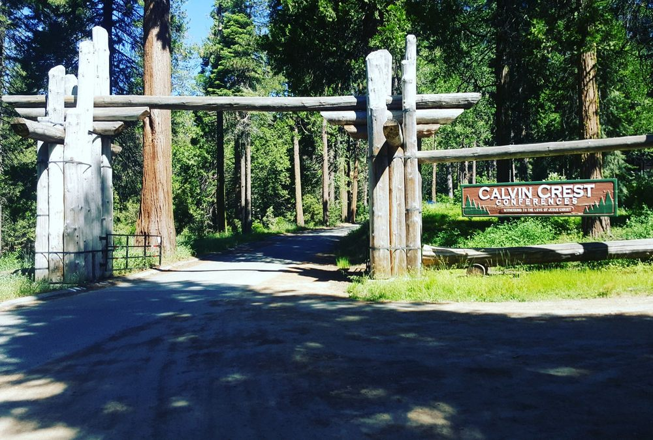
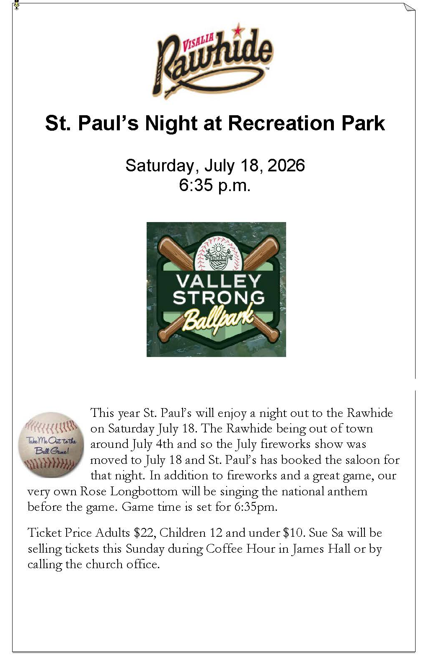

St. Paul’s Anglican Church
Parish Office
6436 W. Hurley Ave
Visalia, California 93291
559-732-4821
Office Hours: 8:00 – 4:00
Monday – Thursday

Worship: Sundays at 10:30AM
Livestream: Link at spvisalia.com
and on our Facebook page
Please be advised that this service is being recorded for broadcast
and/or archival purposes. By attending, you consent
to the inclusion of your likeness in these recordings.

St. Paul’s Clergy and Staff
The Rev. Robert Longbottom, Rector
rector@spvisalia.com
(559)802-2928
The Rev. John Iseman, Pastoral Associate for Family Ministries
family@spvisalia.com
The Rev. Kashy Rowland-Smith, Deacon
kashyrs@aol.com
Antoinette Horsting, Parish Administrator
bookkeeper@spvisalia.com
Marguerite Crownover, Organist and Accompanist
Cynthia Culp, Choral Director
Jackie Iseman, Nursery Coordinator
Shane Motl, Sexton

St. Paul’s is a member church of the
Anglican Diocese of San Joaquin
The Rt. Rev. Eric V. Menees, Bishop

Next Week’s Lessons
Isaiah 55
Psalm 65
Romans 8:7-17
Matthew 13:1-9, 18-23

