ST. PAUL’S
ANGLICAN CHURCH
VISALIA, CALIFORNIA

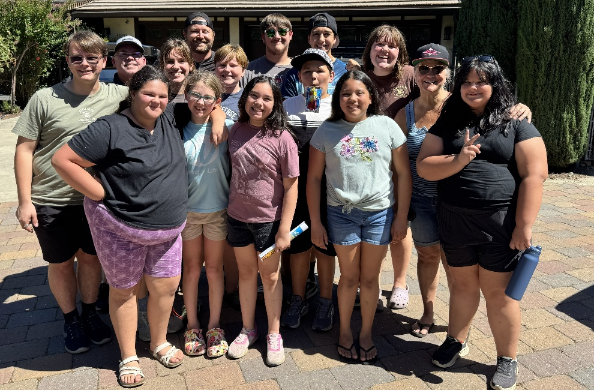

Youth Sunday
&
Blessing of the Backpacks

Twelfth Sunday after Pentecost
August 16, 2026
10:30 A.M

Welcome!

St. Paul’s Anglican Church extends a warm welcome to all visitors and newcomers, whether worshiping in person or at home via livestream.

Visitors’ Guide

St. Paul’s Church is a parish in the Diocese of San Joaquin of the Anglican Church in North America, which includes both Catholic and Protestant traditions. We accept Jesus Christ as Savior, and we promise to follow him as Lord. We believe in One God,

- the Father who created us and all things,
- the Son who redeems us from sin and death,
- the Holy Spirit who renews and sanctifies us.

We believe the Holy Scriptures to be the Word of God and to contain all things necessary for salvation, and we accept the Apostles’ and Nicene Creeds as essential beliefs of the Christian faith.

Those not desiring to receive Holy Communion, and those who have not been baptized into the Christian faith, are invited to cross their arms across their chest, and a blessing will be given instead.

Visitors are invited to sign the guest book at the entrance table and introduce themselves to the clergy following the service.

The Holy Eucharist

Prelude: “Fantasy in C Major” Bach
Opening Hymn: “My Lighthouse” p. 4
Opening Acclamation p. 5
The Collect for Purity p. 5
Summary of the Law p. 5
Kyrie p. 5
Gloria p. 6
Collect of the Day p. 7
Lesson: Isaiah 56:1-8 p. 7
Gradual: Psalm 67 p. 8
Epistle: Romans 11:13-24 p. 8
Sequence Hymn: “Open the Eyes of My Heart” p. 9
Gospel: Matthew 15:21-28 p. 10
Sermon: The Rev Robert Longbottom
Nicene Creed p. 10
Prayers of the People p. 11
The Peace p. 14
Offertory: “You Say” Rose Longbottom
The Offertory p. 15
Sursum Corda p. 15
Sanctus p. 16
The Lord’s Prayer p. 18
Fraction p. 18
Prayer for Humble Access p. 19
Agnus Dei p. 19
Communion Hymn: “The Goodness of God” p. 20
Post Communion Prayer p. 21
Blessing p. 21
Closing Hymn: “I Thank God” p. 22
Dismissal p. 22
Postlude: “Allegro Moderato” Handel

All music this morning was used for our youth camping trip and will be led by youth of the church

Opening Hymn: My Lighthouse
CCLI Song # 7002032

Verse 1
In my wrestling and in my doubts
In my failures You won't walk out
Your great love will lead me through
You are the peace in my troubled sea whoa oh
You are the peace in my troubled sea

Verse 2
In the silence You won't let go
In the questions Your truth will hold
Your great love will lead me through
You are the peace in my troubled sea whoa oh
You are the peace in my troubled sea

Chorus
My Lighthouse my Lighthouse
Shining in the darkness
I will follow You oh
My Lighthouse my Lighthouse
I will trust the promise
You will carry me safe to shore
Safe to shore safe to shore safe to shore

Verse 3
I won't fear what tomorrow brings
With each morning I'll rise and sing
My God's love will lead me through
You are the peace in my troubled sea whoa oh
You are the peace in my troubled sea
(Chorus)

Opening Acclamation

Celebrant Blessed be God, the Father, the Son and the Holy Spirit. People And blessed be his kingdom, now and forever. Amen.

Collect for Purity

Almighty God, to you all hearts are open, all desires
known, and from you no secrets are hid: Cleanse the thoughts
of our hearts by the inspiration of your Holy Spirit, that we
may perfectly love you, and worthily magnify your holy Name;
through Christ our Lord. Amen.

Summary of the law

Hear what our Lord Jesus Christ says: You shall love
the Lord your God with all your heart and with all your soul
and with all your mind. This is the first and great
commandment. And the second is like it: You shall love your
neighbor as yourself. On these two commandments depend all
the Law and the Prophets.

Kyrie
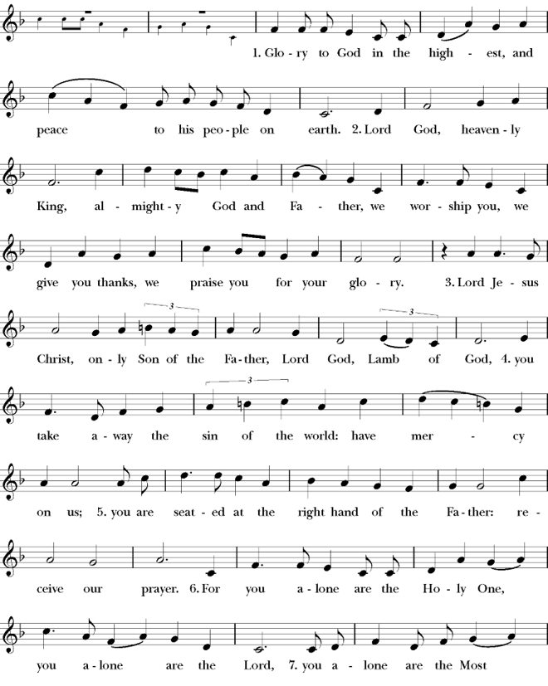
Gloria

Celebrant The Lord be with you.
People And with your spirit.
Celebrant Let us pray.

The Collect of the Day

Keep your Church, O Lord, by your perpetual mercy; and because without you the frailty of our nature causes us to fall, keep us from all things hurtful, and lead us to all things profitable for our salvation; through Jesus Christ our Lord, who lives and reigns with you and the Holy Spirit, one God, for ever and ever. Amen.

Lesson: 56:1-8
Thus says the LORD: “Keep justice, and do righteousness, for soon my salvation will come, and my righteousness be revealed. 2 Blessed is the man who does this, and the son of man who holds it fast, who keeps the Sabbath, not profaning it, and keeps his hand from doing any evil.”
3 Let not the foreigner who has joined himself to the LORD say, “The LORD will surely separate me from his people”; and let not the eunuch say, “Behold, I am a dry tree.” 4 For thus says the LORD: “To the eunuchs who keep my Sabbaths, who choose the things that please me and hold fast my covenant, 5 I will give in my house and within my walls a monument and a name better than sons and daughters; I will give them an everlasting name that shall not be cut of “And the foreigners who join themselves to the LORD, to minister to him, to love the name of the LORD, and to be his servants, everyone who keeps the Sabbath and does not profane it, and holds fast my covenant— 7 these I will bring to my holy mountain, and make them joyful in my house of prayer; their burnt offerings and their sacrifices will be accepted on my altar; for my house shall be called a house of prayer for all peoples.” 8 The Lord God, who gathers the outcasts of Israel, declares, “I will gather yet others to him besides those already gathered.”

Reader: The Word of the Lord
People: Thanks be to God

Gradual: Psalm 67
1 May God be merciful unto us, and bless us, *
and show us the light of his countenance, and be merciful unto us.
2 Let your way be known upon earth, *
your saving health among all nations.
3 Let the peoples praise you, O God; *
indeed, let all the peoples praise you.
4 O let the nations rejoice and be glad, *
for you shall judge the peoples righteously, and govern the nations upon earth.
5 Let the peoples praise you, O God; *
let all the peoples praise you.
6 Then shall the earth bring forth her increase, *
and God, even our own God, shall give us his blessing.
7 God shall bless us, *
and all the ends of the world shall fear him.

Glory be to the Father, and to the Son, and to the Holy Spirit;
as it was in the beginning, is now, and ever shall be, world
without end. Amen

Epistle: Romans 11:13-24
Now I am speaking to you Gentiles. Inasmuch then as I am an apostle to the Gentiles, I magnify my ministry 14 in order somehow to make my fellow Jews jealous, and thus save some of them. 15 For if their rejection means the reconciliation of the world, what will their acceptance mean but life from the dead? 16 If the dough offered as firstfruits is holy, so is the whole lump, and if the root is holy, so are the branches.
17 But if some of the branches were broken off, and you, although a wild olive shoot, were grafted in among the others and now share in the nourishing root of the olive tree, 18 do not be arrogant toward the branches. If you are, remember it is not you who support the root, but the root that supports you. 19 Then you will say, “Branches were broken off so that I might be grafted in.” 20 That is true. They were broken off because of their unbelief, but you stand fast through faith. So do not become proud, but fear. 21 For if God did not spare the natural branches, neither will he spare you. 22 Note then the kindness and the severity of God: severity toward those who have
fallen, but God's kindness to you, provided you continue in his kindness. Otherwise you too will be cut off. 23 And even they, if they do not continue in their unbelief, will be grafted in, for God has the power to graft them in again.
24 For if you were cut from what is by nature a wild olive tree, and grafted, contrary to nature, into a cultivated olive tree, how much more will these, the natural branches, be grafted back into their own olive tree.
Reader: The Word of the Lord
People: Thanks be to God

Sequence Hymn:
Open the Eyes of My Heart
CCLI Song # 2298355

Chorus
Open the eyes of my heart Lord
Open the eyes of my heart
I want to see You
I want to see You

Verse
To see You high and lifted up
Shining in the light of Your glory
Pour out Your power and love
As we sing holy holy holy

Bridge
Holy holy holy
Holy holy holy
Holy holy holy
I want to see You

Clergy: The Holy Gospel of Our Lord Jesus Christ,
according to St. Matthew
People: Glory to you, Lord Christ.

Gospel: Gospel: Matthew 15:21-28
And Jesus went away from there and withdrew to the district of Tyre and Sidon. 22 And behold, a Canaanite woman from that region came out and was crying, “Have mercy on me, O Lord, Son of David; my daughter is severely oppressed by a demon.” 23 But he did not answer her a word. And his disciples came and begged him, saying, “Send her away, for she is crying out after us.” 24 He answered, “I was sent only to the lost sheep of the house of Israel.” 25 But she came and knelt before him, saying, “Lord, help me.”
26 And he answered, “It is not right to take the children's bread and throw it to the dogs.” 27 She said, “Yes, Lord, yet even the dogs eat the crumbs that fall from their masters' table.” 28 Then Jesus answered her, “O woman, great is your faith! Be it done for you as you desire.” And her daughter was healed instantly.

Clergy: The Gospel of the Lord
People: Praise to you, Lord Christ

Sermon
The Rev. Robert Longbottom

The Nicene Creed

We believe in one God,
the Father, the Almighty,
maker of heaven and earth,
of all that is, visible and invisible.

We believe in one Lord, Jesus Christ,
the only-begotten Son of God,
eternally begotten of the Father,
God from God, Light from Light,
true God from true God,
begotten, not made,
of one Being with the Father.
through him all things were made.

For us and for our salvation he came down from heaven:
was incarnate from the Holy Spirit and the Virgin Mary,
and was made man.
For our sake he was crucified under Pontius Pilate;
he suffered death and was buried.
On the third day he rose again in accordance with the
Scriptures;
he ascended into heaven
and is seated at the right hand of the Father.
He will come again in glory to judge the living and the dead,
and his kingdom will have no end.
We believe in the Holy Spirit, the Lord, the giver of life,
who proceeds from the Father and the Son,
who with the Father and the Son is worshiped and glorified. who has spoken through the Prophets.
We believe in one holy catholic and apostolic Church.
We acknowledge one Baptism for the forgiveness of sins.
We look for the resurrection of the dead,
and the life of the world to come. Amen.

The Prayers of the People

Leader Let us pray for the Church and for the world, saying, “hear our prayer.”
For the peace of the whole world, and for the well-being and unity of the people of God.
Lord, in your mercy:
People Hear our prayer.

Leader For Stephen our archbishop, Julian our provincial dean, and Eric our bishop. For Fr. Rob, Deacon John, Deacon Kashy, and for all the clergy and people of our diocese and congregation and for the worldwide Anglican Communion.
Lord, in your mercy:
People Hear our prayer.

Leader For all those who proclaim the Gospel at home and abroad; and for all who teach and disciple others.
Lord, in your mercy:
People Hear our prayer.

Leader For our brothers and sisters in Christ who are persecuted for their faith.
Lord, in your mercy:
People Hear our prayer.

Leader For our nation, for those in authority, and for all in public service especially Donald our president and Gavin our governor.
Lord, in your mercy:
People Hear our prayer.

Leader In the St. Paul’s cycle of prayer, we pray for all ministries to children, youth and families both in our church and through our church into the community around us. We pray for Sunday Funday, Sunday School, Youth Group and. We pray for all our family ministry volunteers. We pray for the children and youth you have given to our care and for their formation in the Christian faith. We pray for all children and youth to whom we are reaching out with the Good News of Jesus Christ.
Lord, in your mercy:
People Hear our prayer.

Leader In the ACNA Cycle of Prayer, today we pray for the Anglican Network in Canada and Bishop Daniel Gifford, his wife, Cathryn; Bishop Mike Stewart and his wife Marianne; Bishop Stephen Leung and his wife, Nona; Bishop Grant LeMarquand and his wife, Wendy Bishop Charles Masters, his wife, Judy; Bishop Trevor Walters and his wife, Dede; Bishop Ron Ferris and his wife, Jan; Bishop Don Harvey and his wife, Trudy; and Bishop Malcolm Harding and his wife, Marylou.
Lord, in your mercy:
People Hear our prayer.

Leader For all those who are in trouble, sorrow, need, sickness, or
any other adversity [especially ____________]. We also
pray for all who are currently serving in our armed forces
and serving as first responders.
Lord, in your mercy:
People Hear our prayer.

Leader For all those who have departed this life in the certain hope
of the resurrection, (we pray especially for ____________),
in Thanksgiving let us pray.
Lord, in your mercy:
People Hear our prayer.

Celebrant will add a concluding prayer

Celebrant: A Prayer for Children (BCP page 77)

O Lord Jesus Christ, who took little children into your arms and
blessed them: Bless the children of this family, that they may grow up
in godly fear and love. Give them your strength and guidance day by
day, that they may continue in your love and service to their lives’
end. Grant this, O blessed Savior, for your own Name’s sake. Amen.

Heavenly Father, grant these our prayers for the sake of Jesus Christ,
our only Mediator and Advocate, who lives and reigns with you in
the unity of the Holy Spirit, one God, now and for ever. Amen.

The Confession and Absolution

Celebrant Let us humbly confess our sins to Almighty God.

Most merciful God,
we confess that we have sinned against you
in thought, word and deed,
by what we have done, and by what we have left undone.
We have not loved you with our whole heart;
we have not loved our neighbors as ourselves.
We are truly sorry and we humbly repent.
For the sake of your Son Jesus Christ,
have mercy on us and forgive us;
that we may delight in your will, and walk in your ways,
to the glory of your Name. Amen.

Almighty God, our heavenly Father, who in his great mercy has
promised forgiveness of sins to all those who sincerely repent and
with true faith turn to him, have mercy upon you, pardon and deliver
you from all your sins, confirm and strengthen you in all goodness,
and bring you to everlasting life; through Jesus Christ our Lord.
Amen.

Hear the Word of God to all who truly turn to him.

God so loved the world, that he gave his only-begotten Son, that
whoever believes in him should not perish but have eternal life.
John 3:16
Celebrant The Peace of the Lord be always with you.
People And with your spirit.

offertory
you say – rose longbottom

The Doxology
(Verse 3 only)

Offertory

Celebrant All things come from you, O Lord,
People And of your own have we given you.

The Eucharistic Liturgy

Celebrant The Lord be with you.
People And with your spirit.
Celebrant Lift up your hearts.
People We lift them up to the Lord.
Celebrant Let us give thanks to the Lord our God.
People It is right to give him thanks and praise.

It is right, our duty and our joy, always and everywhere to give thanks to you, Father Almighty, Creator of heaven and earth.

Through Jesus Christ our Lord, who on the first day of the week overcame death and the grave, and by his glorious resurrection opened to us the way of everlasting life.

Therefore we praise you, joining our voices with Angels and Archangels and with all the company of heaven, who for ever sing this hymn to proclaim the glory of your Name:

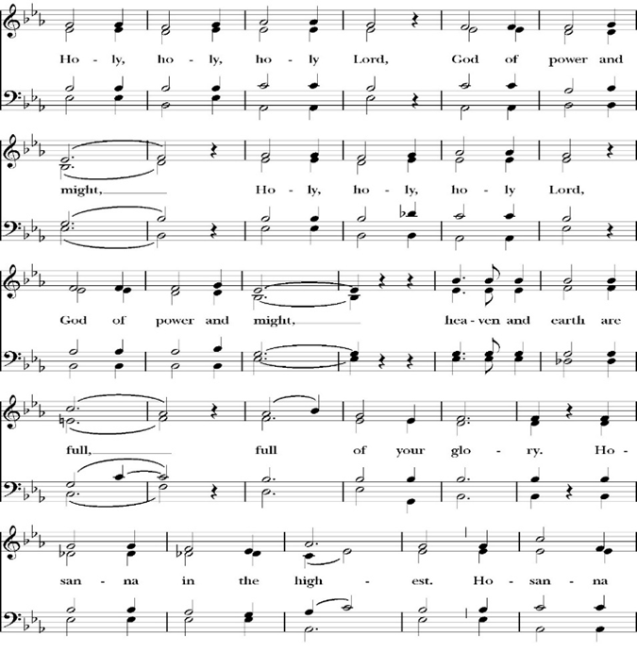
Sanctus

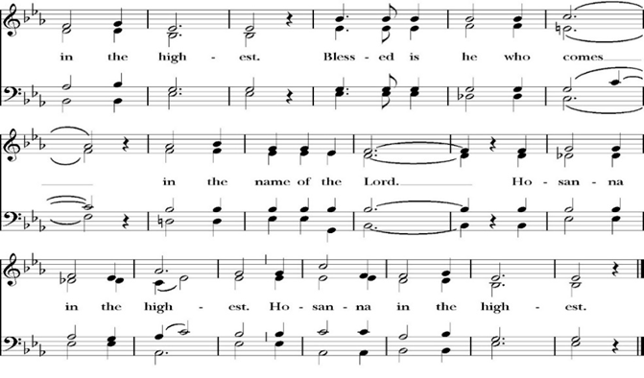
Holy and gracious Father: In your infinite love you made us for yourself; and when we had sinned against you and become subject to evil and death, you, in your mercy, sent your only Son Jesus Christ into the world for our salvation. By the Holy Spirit and the Virgin Mary he became flesh and dwelt among us. In obedience to your will, he stretched out his arms upon the Cross and offered himself once for all, that by his suffering and death we might be saved. By his resurrection he broke the bonds of death, trampling Hell and Satan under his feet. As our great high priest, he ascended to your right hand in glory, that we might come with confidence before the throne of grace.

On the night that he was betrayed, our Lord Jesus Christ took bread; and when he had given thanks, he broke it,* and gave it to his disciples, saying, “Take, eat; this is my Body, which is given for you: Do this in remembrance of me.”

Likewise, after supper, Jesus took the cup, and when he had given thanks, he gave it to them, saying, “Drink this, all of you; for this is my Blood of the New Covenant, which is shed for you, and for many, for the forgiveness of sins: Whenever you drink it, do this in remembrance of me.”

Therefore we proclaim the mystery of faith:

Christ has died.
Christ is risen.
Christ will come again.

We celebrate the memorial of our redemption, O Father, in this sacrifice of praise and thanksgiving, and we offer you these gifts.

Sanctify them by your Word and Holy Spirit to be for your people the Body and Blood of your Son Jesus Christ. Sanctify us also, that we may worthily receive this holy Sacrament, and be made one body with him, that he may dwell in us and we in him. In the fullness of time, put all things in subjection under your Christ, and bring us with all your saints into the joy of your heavenly kingdom, where we shall see our Lord face to face.

All this we ask through your Son Jesus Christ: By him, and with him, and in him, in the unity of the Holy Spirit, all honor and glory is yours, Almighty Father, now and for ever. Amen.

And now, as our Savior Christ has taught us, we are bold to pray,

Our Father, who art in heaven,
hallowed be thy Name,
thy kingdom come,
thy will be done,
on earth as it is in heaven.
Give us this day our daily bread.
And forgive us our trespasses,
as we
forgive those
who trespass against us.
And lead us not into temptation,
but deliver us from evil.
For thine is the kingdom,
and the power, and the glory,
for ever and ever. Amen.

Fraction

Celebrant Alleluia! Christ our Passover is sacrificed for us.
People Therefore let us keep the feast. Alleluia!
The Prayer for Humble Access

We do not presume to come to this your table, O merciful Lord,
trusting in our own righteousness,
but in your abundant and great mercies.
We are not worthy so much as to gather up
the crumbs under your table;
but you are the same Lord
whose character is always to have mercy.
Grant us, therefore, gracious Lord,
so to eat the flesh of your dear Son Jesus Christ,
and to drink his blood,
that our sinful bodies may be made clean by his body,
and our souls washed through his most precious blood,
and that we may evermore dwell in him, and he in us.
Amen.

Agnus Dei

The Ministration of Communion

The gifts of God for the People of God. Take them in remembrance that Christ died for you and feed on him in your hearts by faith, with thanksgiving.

Communion Hymn: The Goodness of God
CCLI Song # 7117726

Verse 1
I love You Lord, Oh Your mercy never fails me
All my days I've been held in Your hands
From the moment that I wake up
Until I lay my head
I will sing of the goodness of God

Chorus
All my life You have been faithful
All my life You have been so so good
With every breath that I am able
I will sing of the goodness of God

Verse 2
I love Your voice, You have led me through the fire
In darkest night, You are close like no other
I've known You as a father
I've known You as a friend
I have lived in the goodness of God
(Chorus)

Bridge
Your goodness is running after, It’s running after me
Your goodness is running after
It’s running after me
With my life laid down
I’m surrendered now
I give You everything
Your goodness is running after
It's running after me

The Post Communion Prayer
Let us pray.

Heavenly Father,
We thank you for feeding us with the spiritual food
of the most precious Body and Blood
of your Son our Savior Jesus Christ;
and for assuring us in these holy mysteries
that we are living members of the body of your Son,
and heirs of your eternal Kingdom.
And now, Father, send us out to do the work you have
given us to do,
to love and serve you as faithful witnesses of Christ our
Lord.
To him, to you, and to the Holy Spirit,
be honor and glory, now and for ever. Amen.

The Blessing

The peace of God, which passes all understanding, keep your hearts and minds in the knowledge and love of God, and of his Son Jesus Christ our Lord; and the blessing of God Almighty, the Father, the Son, and the Holy Spirit, be among you, and remain with you always. Amen.

Closing Hymn: I Thank God
CCLI Song # 7169680

Verse 1
Wandering into the night wanting a place to hide
This weary soul this bag of bones
I try with all of my might
But I just can't win the fight
I'm slowly drifting a vagabond

Pre-Chorus 1
And just when I ran out of road
I met a man I didn't know
And He told me that I was not alone

Chorus
You picked me up You turned me around
And placed my feet on solid ground
I thank the Master I thank the Savior
Because You healed my heart You changed my name
Forever free I'm not the same
I thank the Master I thank the Savior I thank God

Verse 2
I cannot deny what I've seen
Got no choice but to believe
My doubts are burnin' like ashes in the wind
So so long to my old friends burden and bitterness
You can just keep them moving
Nah you ain't welcome here

Pre-Chorus 2
From now till I walk streets of gold
I'll sing of how You saved my soul
This wayward son has found his way back home
(Chorus)

Dismissal
Deacon Alleluia, Alleluia. Let us go forth into the world,
rejoicing in the power of the Holy Spirit.
People Thanks be to God Alleluia, Alleluia.

St. Paul’s Parish Calendar
Sunday August 16 – Sunday August 23

SUNDAY, August 16 – Twelfth Sunday after Pentecost
9:15 AM Sunday Funday, Youth Room
9:15 AM Gospel of John Bible Study, Conference Room
10:30 AM Children’s Sunday School, Chapel
Pre-K –2nd Grade, Sunday School Room
3rd -5th Grade, Youth Room
10:30 AM Holy Eucharist, Church
Blessing of the Backpacks

MONDAY, August 17

TUESDAY, August 18
6:30 PM Bell Choir Rehearsals, Music Room

WEDNESDAY, August 19
9:30 AM Holy Eucharist with healing prayer, Chapel
10:15 AM Bible Study, Conference Room

THURSDAY, August 20

FRIDAY, August 21
6:30 AM Men’s Bible Study, Valhalla Restaurant

SATURDAY, August 22

SUNDAY, August 23 – Thirteenth Sunday after Pentecost
9:15 AM Sunday Funday, Youth Room
9:15 AM Gospel of John Bible Study, Conference Room
10:30 AM Children’s Sunday School, Chapel
Pre-K –2nd Grade, Sunday School Room
3rd -5th Grade, Youth Room
10:30 AM Holy Eucharist, Church

Church Office Hours
Monday-Thursday 8:00 AM-4:00 PM
In Case of Pastoral emergencies here are the cell phone numbers of our pastors. Dcn. John Iseman (518)222-6722 Dcn. Kashy Rosland-Smith (559)909-3305

The Gospel of John Sunday morning Bible study, 9:15-10:00AM
The Sunday morning Gospel of John bible study has resumed and is working through chapter 8 in August. Fr. Rob will be our leader through August. Deacon John will lead the class in September.
No Gospel of John Class September 6 due to Labor Day weekend.

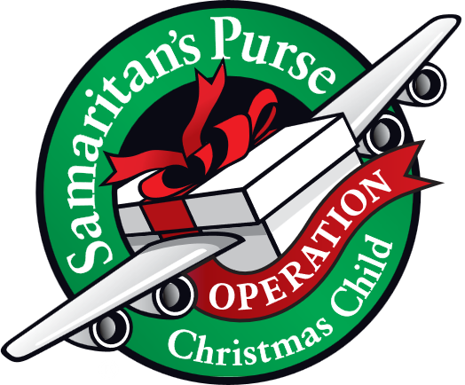
Operation Christmas Child donations begin in August
August Donations: School Supplies

Operation Christmas Child is a ministry of Samaritan’s Purse. The mission of Operation Christmas Child is to demonstrate God’s love in a tangible way to children in need around the world through partnering with the local church worldwide to provide shoe box size containers fill with school supplies, hygiene products and a small gift so to share the Good News of Jesus Christ and make disciples of the nations.

St. Paul’s Anglican Church is committed to providing 100 boxes to children throughout the world and will do this through monthly themed donations from August through November. We will then have a ‘Filling the box” party when we will gather together and fill 100 boxes with school supplies, hygiene products and small toys.

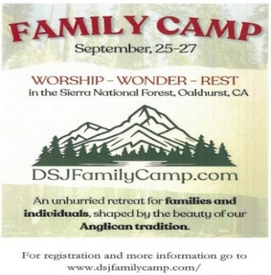
of San Joaquin Family Camp, Out of the Noise and Into the Wonder, September 25-27, Calvin Crest Sherwood Forest, Oakhurst, CA
Join your friends from St. Paul’s for an unhurried retreat for families and individuals, shaped by the beauty of our Anglican tradition. Calvin Crest Sherwood Forest is outside Oakhurst, CA near Yosemite. Each day flows from Morning Prayer to Compline. The family camp will feature tent and rustic cabin accommodations and will feel very much like the old Camp San Joaquin. The camp will be led by our friend Rev. Paul Gibbons, so we know that it will be a wonderful time.

The cost cannot be beat:
Bring your own Tent or RV: $75 for the whole family
Rustic Cabin Accommodations: $150 for the whole family

Accommodations and bathroom facilities

Tent & RV Sites: Pitch a tent or park your rig in the scenic Sherwood Forest area.
Rustic Cabins: Each cabin features 10 bunks with mattresses. Cabins are non-electric.
Bathrooms and Showers: Clean, private bathrooms and hot showers are available throughout camp.

What is included for this price:

The flat rate covers lodging, firewood, a sub sandwich dinner on Friday evening, breakfast on Saturday morning and a BBQ on Saturday evening.
How do I sign up or find out more?
Talk with Fr. Rob Longbottom or go to the Family Camp website at:
dsjfamilycamp.com


St. Paul’s Anglican Church
6436 W Hurley Ave
Visalia, CA


Friday October 2, 8:00 AM to 4:00 PM
Saturday October 3, 8:00 AM to 2:00 PM
Drop Off Donated Items in James Hall on:
Wednesday, September 30, and Thursday, October 1
Between 9:00 AM – 4:00 PM
Items need to be in Good Condition: clean, gently worn clothing, household items, toys in working order gladly accepted!
Volunteers Needed for Set Up:
Wednesday, September 30 and Thursday, October 1
Between 9:00 AM – 4:00 PM
If you have any questions,
Contact: Mary Murray at 799-6973

Bass Lake Youth Camp 2026

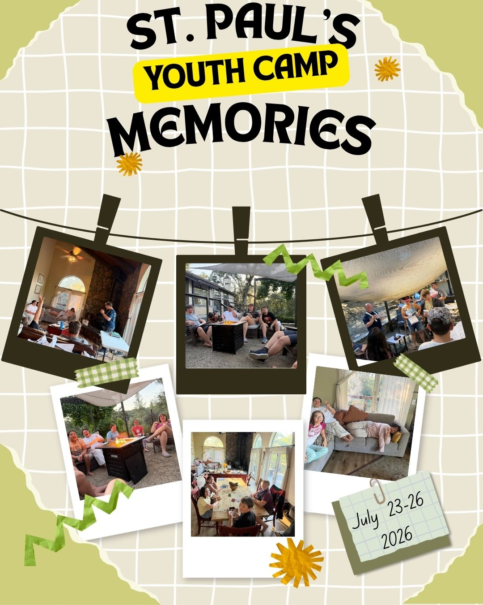

St. Paul’s Anglican Church
Parish Office
6436 W. Hurley Ave
Visalia, California 93291
559-732-4821
Office Hours: 8:00 – 4:00
Monday – Thursday

Worship: Sundays at 10:30AM
Livestream: Link at spvisalia.com
and on our Facebook page
Please be advised that this service is being recorded for broadcast
and/or archival purposes. By attending, you consent
to the inclusion of your likeness in these recordings.

St. Paul’s Clergy and Staff
The Rev. Robert Longbottom, Rector
rector@spvisalia.com
(559)802-2928
The Rev. John Iseman, Pastoral Associate for Family Ministries
family@spvisalia.com
The Rev. Kashy Rowland-Smith, Deacon
kashyrs@aol.com
Antoinette Horsting, Parish Administrator
bookkeeper@spvisalia.com
Marguerite Crownover, Organist and Accompanist
Ellen Daniels, Choral Director
Jackie Iseman, Nursery Coordinator
Shane Motl, Sexton

St. Paul’s is a member church of the
Anglican Diocese of San Joaquin
The Rt. Rev. Eric V. Menees, Bishop

Next Week’s Lessons
Isaiah 51:1-6
Psalm 138
Romans 11:25-36
Matthew 16:13-20

